CERTIFICATION
(Building Permit)

To Whom It May Concern.

This is to certify that {{HONORIFIC}} {{FULL_NAME}}, Build a building, with a lot No. {{LOT_NUMBER}} located at {{ADDRESS}}, {{BARANGAY}}, Bilar, Bohol.
This certification is issued upon the request of {{HONORIFIC}} {{FULL_NAME}} to support his application for building Permit.
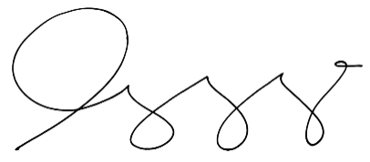
Issued on this {{DATE_DAY}} of {{DATE_MONTH}}, {{DATE_YEAR}} at {{BARANGAY}}, Bilar, Bohol.

HON. {{CAPTAIN_NAME}}
Barangay Captain

Receipt No. {{OR_NUMBER}}
Issued On.. {{DATE}}
Issued At.. Barangay {{BARANGAY}}, Bilar, Bohol.

NOT VALID WITHOUT DRY SEAL

