OFFICE OF THE PUNONG BARANGAY

CERTIFICATION OF NO ADVERSE CLAIM

TO WHOM IT MAY CONCERN:

This is to certify that based on the records on the file in this office as of {{DATE}}, there is no adverse claim or any other annotation of a parcel of land that declared under the name of {{FULL_NAME}} with lot. No. {{LOT_NUMBER}} located at sitio {{SITIO}} {{BARANGAY}} Bilar, Bohol with a land area of {{LAND_AREA}} sq. meter.

This certification is issued upon the request of {{HONORIFIC}} {{FULL_NAME}} for whatever legal purposes it may serve {{PRONOUN_POSSESSIVE}} best.

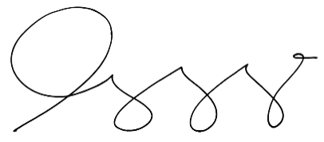
Issued on this {{DATE_DAY}} of {{DATE_MONTH}}, {{DATE_YEAR}} at {{BARANGAY}}, Bilar, Bohol.

HON. {{CAPTAIN_NAME}}
Barangay Captain

Receipt No. {{OR_NUMBER}}
Issued On.. {{DATE}}
Issued At.. Barangay {{BARANGAY}}, Bilar, Bohol.

NOT VALID WITHOUT DRY SEAL

