OFFICE OF THE PUNONG BARANGAY

CERTIFICATION

To Whom It May Concern.

This is to certify that based on the official records and to the best knowledge of the barangay officials of Barangay {{BARANGAY}}, Bilar, Bohol. There has been NO RECORDED OR REPORTED INCIDENT involving the sale, possession, distribution, or trading of smuggled cigarettes within the jurisdiction of this barangay.
Furthermore, NO COMPLAINTS, CASE or OPERATION related to smuggled or illegal cigarettes has been filed or recorded in this barangay.
This certification is issued for LEGAL and OFFICIAL PURPOSES and may be presented to any government or private agency where it may be required.
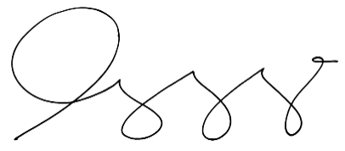
Issued on this {{DATE_DAY}}{{DATE_DAY_SUFFIX}} of {{DATE_MONTH}}, {{DATE_YEAR}} at {{BARANGAY}}, Bilar, Bohol.

HON. {{CAPTAIN_NAME}}
Barangay Captain

