CERTIFICATION

To Whom It May Concern.
This is to certify that {{HONORIFIC}} {{FULL_NAME}}, of legal age, married to Mrs. {{SPOUSE_NAME}} and father of {{CHILD_NAME}}, Filipino and a bonafide resident of {{ADDRESS}}, {{BARANGAY}}, Bilar, Bohol.

This is to certify further that {{HONORIFIC}} {{FULL_NAME}}, is a senior citizen who is unemployed and is only depending on the monthly pension amounting to {{MONTHLY_PENSION}} per month.

This Certification is issued upon the request of the above-mentioned person in support of DOST Scholarship application of {{CHILD_NAME}}.

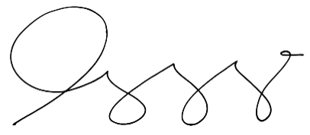
Issued on this {{DATE_DAY}}{{DATE_DAY_SUFFIX}} day of {{DATE_MONTH}}, {{DATE_YEAR}} at Barangay {{BARANGAY}}, Bilar, Bohol, Philippines.

HON. {{CAPTAIN_NAME}}
Barangay Captain
Paid under O.R NO. : {{OR_NUMBER}}
Issued on : {{DATE}}
Issued at : {{ISSUED_AT}}

Documentary Stamp Paid | OR.NO;  {{OR_NUMBER}}
Documentary Stamp Paid | Date Issued;  {{DATE_SHORT}}

NOT VALID WITHOUT DRY SEAL

