**Amplitude coding – cumulative report**

1. **Testing PSTH and TC (between TSC and own implementation)**

Source unit: M017, 0002, El_10, U2 (red) -> U17

|  |
| --- |
|  |
|  |
| Figure 1 – PSTH for U17, condition: Contrast-100 & Direction-270 (10 trials) |

Observation: near perfect match – what algorithm do you use for discretization in TSC?

|  |
| --- |
|  |
|  |
| Figure 2 – Firing rate TC for U17, Contrast-100 (10 trials per orientation) |

Observation: identical values (sadly polar plot not yet implemented)

|  |
| --- |
|  |
|  |
| Figure 3 – Average spike amplitude TC for U17, Contrast-100 (10 trials per orientation) |

Observation: identical values

1. **Assessment: does the observed mean amplitude depend upon firing rate?**

Procedure: For U17, obtain the average tuning curve (preferably at contrast 100), see Figure 3. Then compare it with randomized spikes, obtained as follows: pool (by appending at end) the spikes for all conditions into a single list, making a note of where the spikes for each condition begin (the index in said list). Then shuffle the spikes in the list. This makes it so that even if we shuffle the spikes, we have the same number of spikes per condition (firing rate stays the same). Disentangle the specific conditions and compute the metric (average amplitude).

|  |
| --- |
|  |
|  |
|  |
| Figure 4 – top: unshuffled TC (see Figure 3), middle: shuffled TC, bottom: SD of the shuffled TC. |

Note that each attempt to compute the shuffled measure produces different results (the apparent correlation at orientation 135 – in this example – may be due to chance alone).

Bootstrapping the analysis confirms the above speculation. The analysis has been repeated a thousand times, reshuffling the spikes at each step. The average over the runs is reported in Figure 5.

|  |
| --- |
|  |
|  |
| Figure 5 – the bootstrap result. Top – scaled (min-max), bottom – unscaled (absolute values, for display purposes). |

This procedure must be repeated over multiple units and datasets.

Next we computed two metrics to see how the average spike amplitude relates to the total spike counts (of spikes within trials, per unit) and the firing rate.

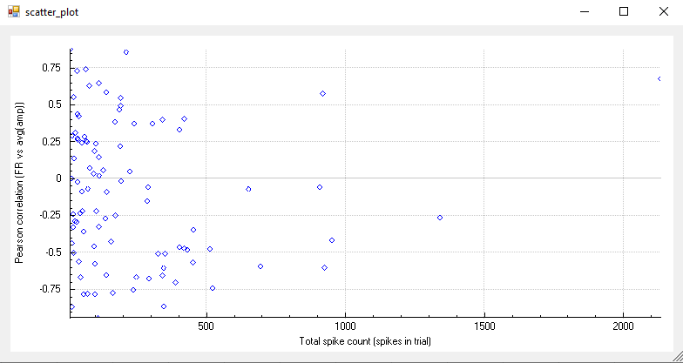

1. **High-throughput scanning for tuned units**

Orientation (OI) and direction indices (DI) were computed using the formulae from the Frontiers paper.

For clarification, the terms *orientation* and *direction* are defined as follows:

* Orientation – the angle of the bars (from 0 to 180 degrees, 180-360 are symmetrical).
* Direction – the phase of the movement vector (0 – 360 degrees)

We computed the distributions of the orientation and direction indices over all available units, using the firing rate and the average amplitude values.

|  |  |
| --- | --- |
|  |  |
| Firing rate orientation tuning | Firing rate direction tuning |
|  |  |
| Average amplitude orientation tuning | Average amplitude direction tuning |

The indices for the average amplitude values are very low, < 0.1. Our explanation is that the mean of the amplitude values is very large compared to their standard deviation. For example, if we have a maximum firing rate of 5 for one specific orientation/direction and low (~1) for all others, then the maximum is higher than the trend by a factor of 5. But when we have a maximum amplitude of 66 while all others are ~60, the maximum is higher than the trend, but by a very small margin. Therefore we have to normalize the values to a unique interval.

|  |  |
| --- | --- |
|  |  |
| Firing rate orientation tuning | Firing rate direction tuning |
|  |  |
| Average amplitude orientation tuning | Average amplitude direction tuning |

Now we are screening for units that are tuned for either orientation or direction, with an index higher than 0.5. The normalization method in this case was subunit (all values are normalized between 0 and 1 then the indices are computed using the normalized values).

Firing rates:

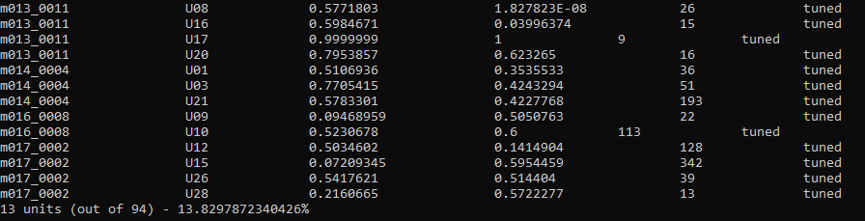

Average amplitudes:



Header is as follows:

Dataset Unit Orientation Index Direction Index Spike Count Is it tuned?

Next we reduced the threshold to 0.25 and tried the same. Listing the tuned units is not really necessary, for they are more than 50% of all available units:

* Firing rate: 72 out of 94 units (76%).
* Average amplitude: 53 out of 94 units (56%).

Next, we identified 15 units whose ORIENTATION tuning is above 0.3 for both firing rate and average amplitude. We used orientation because we suspect that the mouse visual cortex is more sensitive to orientation than it is to direction. We thus identified 15 units that meet the aforementioned criteria.

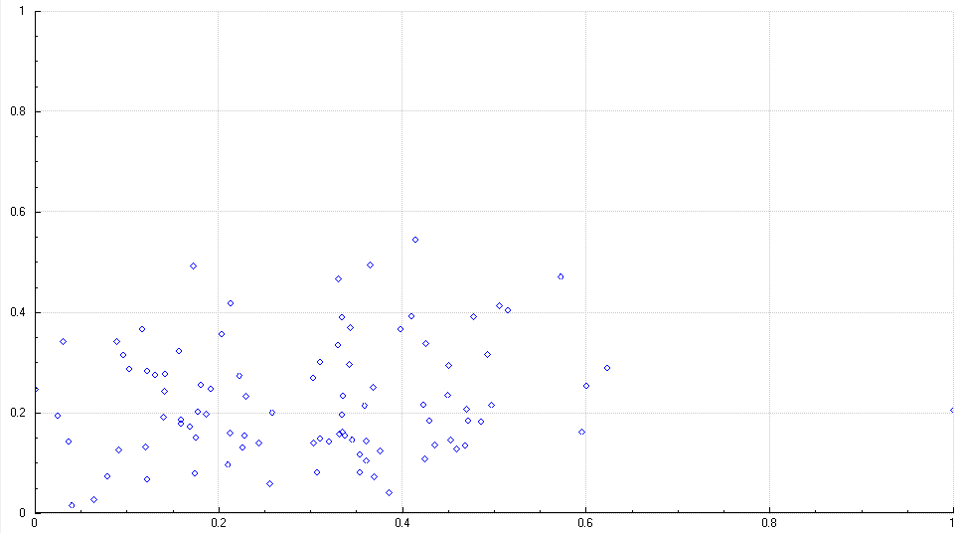

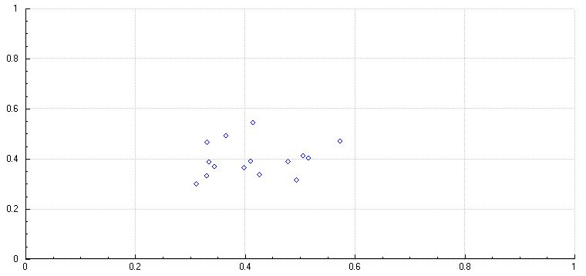

The above scatter plots show the correlation for the orientation tuning for firing rate (x-axis) and average amplitude (y-axis). Above: all available units, below: units meeting the criteria (OI for amplitude and FR > 0.3).

Below we list the units that meet the aforementioned criteria:

|  |  |  |  |
| --- | --- | --- | --- |
| **Dataset** | **Unit** | **Firing rate OI** | **Average amp OI** |
| m013_0011 | U04 | 0.409659 | 0.392356 |
| m014_0004 | U19 | 0.425323 | 0.338126 |
| m014_0004 | U20 | 0.329704 | 0.467653 |
| m014_0004 | U22 | 0.3644 | 0.494816 |
| m016_0008 | U08 | 0.343194 | 0.370171 |
| m016_0008 | U09 | 0.505076 | 0.414164 |
| m017_0002 | U09 | 0.333585 | 0.390731 |
| m017_0002 | U13 | 0.397576 | 0.367068 |
| m017_0002 | U14 | 0.310429 | 0.302279 |
| m017_0002 | U17 | 0.413695 | 0.545259 |
| m017_0002 | U22 | 0.329404 | 0.335262 |
| m017_0002 | U25 | 0.477098 | 0.391499 |
| m017_0002 | U26 | 0.514404 | 0.404554 |
| m017_0002 | U28 | 0.572228 | 0.471868 |
| m017_0002 | U29 | 0.492548 | 0.316378 |