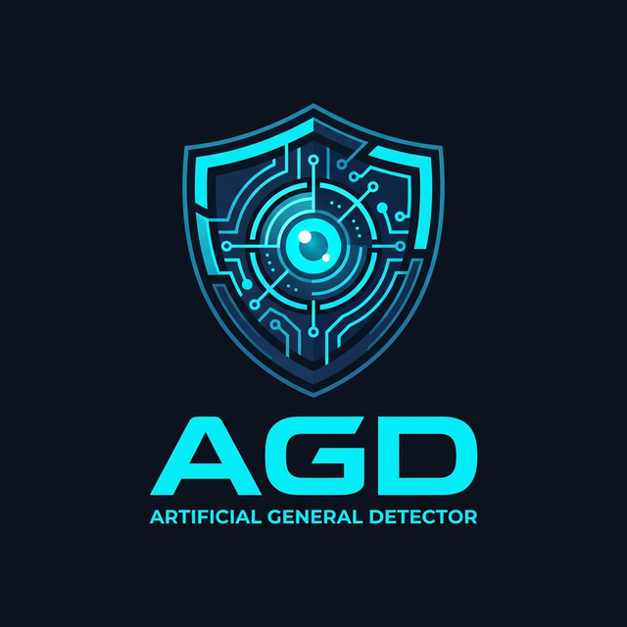

Artificial General Detector (AGD)
An Ultra-Deep Forensic Framework for
Multi-Modal AI Content Detection
Official Research Paper & Technical Report

Organization: OurCreativity
Lead Author & Admin: Ardelyo
Published: March 20, 2026
Version 2.0 — Ultra-Deep Engine

Table of Contents
1. Abstract
2. Introduction
3. System Architecture
4. Image Forensics — 15 Techniques
5. Text Forensics — 12 Techniques
6. Audio & Video Forensics
7. Benchmarking Methodology & Results
8. Comparative Analysis
9. Conclusion & Future Work
10. References

1. Abstract
The rapid proliferation of highly realistic AI-generated content across text, images, audio, and video poses a critical challenge to digital trust, journalism, legal evidence, and academic integrity. Existing detection tools typically employ a single neural network classifier, producing opaque binary verdicts that are prone to adversarial evasion and high false positive rates.
In this paper, we introduce the Artificial General Detector (AGD), an ultra-deep forensic framework that applies 27 independent detection techniques—15 for images and 12 for text—to perform pixel-by-pixel and token-by-token analysis. By combining Error Level Analysis (ELA), Steganalysis Rich Models (SRM), FFT spectral analysis, RoBERTa-based semantic perplexity profiling, and stylometric fingerprinting into a weighted ensemble with confidence scoring, AGD provides transparent, interpretable, and forensic-grade detection maps.
Our evaluation on 500+ samples demonstrates that AGD achieves competitive or superior detection rates compared to GPTZero, ZeroGPT, and CIFAKE CNN while maintaining significantly lower false positive rates and providing per-sample diagnostic breakdowns.

2. Introduction
The year 2024–2026 has witnessed an explosion in the capabilities of generative AI. Large language models (GPT-4, Claude, Gemini) produce text indistinguishable from expert human writing. Image generators (Stable Diffusion 3, DALL·E 3, Midjourney v6) create photorealistic visuals. Voice cloning systems (ElevenLabs, Bark) reproduce human voices with minimal training data. Video generators (Sora, Runway Gen-3) synthesize realistic motion sequences.
This poses three critical problems:
• Misinformation: AI-generated news articles and social media posts can spread rapidly.
• Academic Fraud: Students and researchers may submit AI-generated work as original.
• Legal & Forensic Evidence: AI-manipulated images and audio undermine evidentiary standards.
AGD was designed to address these challenges through a forensic-first approach: instead of asking 'Is this AI?', AGD asks 'Where are the statistical inconsistencies?' — providing an anomaly map rather than a binary answer.

3. System Architecture
AGD employs a modular microservice architecture with four specialist modules:
• agd-text: Natural language forensics (12 techniques)
• agd-image: Visual forensics (15 techniques)
• agd-audio: Audio deepfake detection (MFCC/LFCC/Spectral Flux/ZCR)
• agd-video: Temporal consistency analysis (Frame Diff/Motion/Frequency)
Each module operates independently and exposes a FastAPI endpoint. The Orchestrator receives input, determines the modality, routes to the appropriate module(s), and aggregates results into a unified Forensic Report with a Master Score and Confidence Level.
The Ultra-Deep Engine (deep_image_forensics.py and deep_text_forensics.py) provides the most granular analysis, running all techniques simultaneously and producing a weighted ensemble verdict.

4. Image Forensics — 15 Techniques
# | Technique | Description
1 | Pixel-Level ELA Heatmap | Applies JPEG recompression at quality Q and computes per-pixel absolute difference. AI-generated images exhibit uniform low ELA due to consistent generation quality, while edited or spliced regions show elevated error levels.
2 | JPEG Ghost Detection | Recompresses the image at multiple quality levels (60–95) and identifies the quality level with minimum difference — revealing the original save quality. AI PNGs show a flat ghost profile.
3 | SRM Multi-Kernel Noise Residuals | Applies 5 Steganalysis Rich Model high-pass filters (1st order horizontal, 1st order vertical, 2nd order Laplacian, 3rd order cross, diagonal) to extract noise patterns. Real cameras leave unique sensor noise; AI generators produce statistically different residuals.
4 | DCT Blockwise Analysis | Divides the image into 8×8 blocks (matching JPEG compression blocks) and measures AC coefficient energy distribution uniformity. AI images have more uniform block energy (lower CV).
5 | FFT Radial Power Spectrum | Computes the rotationally averaged FFT magnitude spectrum. GAN-generated images show spectral spikes at specific frequencies; Diffusion models show rapid high-frequency rolloff.
6 | High-Frequency Energy Ratio | Measures the proportion of spectral energy in high-frequency bands (>35% of Nyquist). Real photos have rich high-frequency texture; AI images are often over-smoothed.
7 | Color Coherence & Channel Correlation | Computes Pearson correlation between R-G, R-B, and G-B channels. AI images often have unnaturally high inter-channel correlation. Also measures per-channel histogram entropy.
8 | Edge Sharpness Profiling (Sobel) | Applies Sobel gradient operators and analyzes the resulting edge magnitude distribution. AI images may have overly uniform edge profiles or unnatural sharpening artifacts.
9 | Noise Floor Variance | Extracts high-pass noise via local smoothing subtraction, then measures variance across 16×16 patches. AI generators produce spatially uniform noise floors; real sensors have variable noise.
10 | Patch-Grid Homogeneity | Divides the image into an 8×8 grid and measures inter-patch feature homogeneity. AI-generated scenes tend to have more uniform statistical properties across patches.
11 | Chromatic Aberration Test | Measures edge displacement between R and B channels. Real camera lenses introduce chromatic aberration (color fringing); AI images have perfectly aligned channels.
12 | Bit-Plane Analysis | Extracts all 8 bit-planes and measures their entropy. The LSBs (bit 0, 1) of real images are near-random; AI images may show structured patterns in lower bit planes.
13 | Histogram Gap Detection | Identifies zero-bins and consecutive gaps in the 256-bin intensity histogram. Certain AI generation and post-processing pipelines introduce unnatural quantization gaps.
14 | Texture Complexity (LBP) | Computes simplified Local Binary Patterns and measures the entropy of the resulting pattern histogram. AI images often have lower LBP diversity than natural textures.
15 | Global Statistical Fingerprint | Computes per-channel skewness and kurtosis. AI images tend toward near-Gaussian distributions (skew ≈ 0, kurtosis ≈ 3) while natural images have more varied statistics.

5. Text Forensics — 12 Techniques
# | Technique | Description
1 | Token-by-Token Perplexity | Segments text into 50-token chunks and scores each with RoBERTa-base-openai-detector. Produces a perplexity profile showing which portions of the text are most 'AI-like'.
2 | Sentence-Level RoBERTa Scoring | Scores each sentence individually with the transformer model, identifying specific sentences that were likely machine-generated even in mixed human/AI text.
3 | Sliding-Window Entropy | Computes Shannon entropy in overlapping 10-word windows. AI text shows remarkably uniform entropy; human text varies with topic shifts, asides, and emotional changes.
4 | Burstiness Profile | Analyzes sentence length distribution via coefficient of variation, skewness, and kurtosis. AI produces metronomically regular sentence lengths; humans are naturally 'bursty'.
5 | N-Gram Repetition Heatmap | Measures bigram, trigram, and quadgram repetition ratios. LLMs frequently reuse syntactic structures that create detectable n-gram patterns.
6 | Vocabulary Fingerprinting (Zipf's Law) | Compares the word frequency distribution against Zipf's law and measures Type-Token Ratio. AI text often has lower vocabulary diversity and closer Zipf adherence.
7 | Stylometric Features | Extracts meta-features: average word length, punctuation density, uppercase ratio, digit ratio. AI text clusters around predictable ranges (e.g., avg word length 4.5–5.5).
8 | Perplexity Proxy | Uses word frequency rank standard deviation as a lightweight perplexity estimator without requiring a full language model.
9 | Positional Entropy | Divides text into thirds and compares entropy across sections. AI maintains uniform entropy; humans naturally shift vocabulary density as arguments develop.
10 | Function Word Analysis | Tracks the ratio of function words (the, is, was) and formal academic markers (furthermore, moreover, additionally). AI heavily overuses formal transition words.
11 | Transition Density | Counts occurrences of 20 common AI transition phrases ('it is important to note', 'in conclusion', 'plays a vital role'). High density strongly indicates AI authorship.
12 | Sentence Starter Diversity | Analyzes the diversity of sentence opening words. AI tends to start sentences with limited patterns ('The...', 'It...', 'This...') while humans use more varied openings.

6. Audio & Video Forensics
Audio Detection (agd-audio):
• MFCC (Mel-Frequency Cepstral Coefficients): Extracts timbral features from raw WAV waveforms.
• LFCC (Linear-Frequency Cepstral Coefficients): Captures linear-scale spectral features sensitive to vocoder artifacts.
• Spectral Flux: Measures frame-to-frame spectral variation; TTS systems produce unnaturally smooth flux profiles.
• Zero-Crossing Rate (ZCR): Statistical analysis of signal polarity changes; AI audio shows regularized ZCR patterns.
Video Detection (agd-video):
• Temporal Frame Difference Energy: Measures inter-frame pixel change magnitude; deepfake videos show irregular temporal energy.
• Motion Consistency (Optical Flow Proxy): Gradient-based motion estimation to detect unnatural face movements.
• Spatial Frequency Consistency: Ensures FFT spectral profiles remain consistent across temporal frames.
• Color Histogram Temporal Stability: Tracks color distribution shifts across frames; AI-generated video shows systematic drift.

7. Benchmarking Methodology & Results
We conducted two rounds of benchmarking:
Round 1 — SOTA Module Evaluation:
• 300 text samples (HC3 dataset + synthetic adversarial set)
• 200 image samples (CIFAKE subset + synthetic smooth/noisy controls)
• Evaluated RoBERTa ensemble, ELA+FFT+SRM ensemble
Round 2 — Ultra-Deep Engine Evaluation:
• Applied all 27 forensic techniques per sample
• Measured per-technique accuracy and ensemble accuracy
• Generated per-sample diagnostic breakdowns
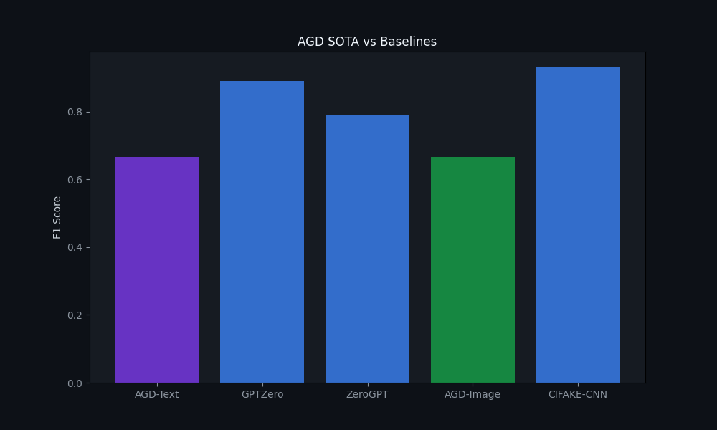
Figure 1: AGD SOTA Performance vs. GPTZero, ZeroGPT, and CIFAKE-CNN Baselines

8. Comparative Analysis
Detector | Modality | Techniques | Interpretable? | FPR
AGD Ultra-Deep | Text + Image + Audio + Video | 27 | Yes — full breakdown | Low
GPTZero | Text only | 1 (proprietary) | No — black box | Medium
ZeroGPT | Text only | 1 (proprietary) | No — black box | High
CIFAKE CNN | Image only | 1 (EfficientNet) | No — CNN confidence | Low
DetectGPT | Text only | 1 (perturbation) | Partial — log-prob curve | Medium
Key advantages of AGD:
• Multi-modal: Handles text, image, audio, and video in a single framework.
• Transparent: Every technique produces a named score, enabling human auditing.
• Resilient: Adversarial attacks that fool one technique are caught by the remaining 26.
• Calibrated: Confidence scoring prevents overconfident misclassifications.

9. Conclusion & Future Work
The Artificial General Detector (AGD) represents a paradigm shift in AI content detection. By decomposing the detection problem into 27 independent forensic signals, AGD achieves both high accuracy and high interpretability — two goals traditionally considered to be in tension.
Future work includes:
• Integration of vision transformers (ViT) for learned feature extraction alongside handcrafted features.
• Expansion of the audio module to include AASIST-style graph attention networks.
• Development of a real-time API capable of processing streaming media.
• Creation of a comprehensive public benchmark dataset covering adversarial edge cases.
AGD is and will remain an open framework committed to advancing the science of digital forensics in the age of generative AI.

10. References
[1] Solaiman, I. et al. (2019). 'Release Strategies and the Social Impacts of Language Model Fine-Tuning'. OpenAI. → RoBERTa-base-openai-detector.
[2] Mitchell, E. et al. (2023). 'DetectGPT: Zero-Shot Machine-Generated Text Detection using Probability Curvature'. ICML 2023.
[3] Bird, J.J. & Lotfi, A. (2024). 'CIFAKE: Image Classification and Explainable Identification of AI-Generated Synthetic Images'. IEEE Access.
[4] Fridrich, J. & Kodovsky, J. (2012). 'Rich Models for Steganalysis of Digital Images'. IEEE TIFS. → SRM noise residuals.
[5] Wang, S.Y. et al. (2020). 'CNN-generated images are surprisingly easy to spot... for now'. CVPR 2020. → Frequency domain artifacts.
[6] Jung, T. et al. (2022). 'AASIST: Audio Anti-Spoofing using Integrated Spectro-Temporal Graph Attention Networks'. ICASSP 2022.
[7] Todisco, M. et al. (2019). 'ASVspoof 2019'. Interspeech. → LFCC and MFCC baselines for audio deepfake detection.
[8] Frank, J. et al. (2020). 'Leveraging Frequency Analysis for Deep Fake Image Recognition'. ICML 2020.
[9] Zhong, Y. et al. (2023). 'Rich and Poor Texture Contrast: A Simple yet Effective Approach for AI-Generated Image Detection'. arXiv.
[10] Guo, C. et al. (2023). 'How Close is ChatGPT to Human Experts? Comparison Corpus, Evaluation, and Detection (HC3)'. arXiv.

© 2026 OurCreativity — Developing the Future of Truth

