TECHNICAL REPORT
LAPORAN TEKNIS

AirOne
Intelligent Semantic Compression Platform
Platform Kompresi Semantik Cerdas

Version / Versi: v1.0.0
Date / Tanggal: April 21, 2026
Author / Penulis: Ardellio Satria Anindito
Age / Usia: 16 years old / 16 tahun
Language: Bilingual — English · Bahasa Indonesia
Classification: Open Research · Public

─── ◆ ───

TABLE OF CONTENTS / DAFTAR ISI

1. Executive Summary / Ringkasan Eksekutif ···························································· 3
2. Introduction / Pendahuluan ···························································· 4
3. System Architecture / Arsitektur Sistem ···························································· 5
4. Development History / Sejarah Pengembangan ···························································· 6
4.1. Phase 1–4: Foundation Phases ···························································· 6
4.2. Phase 5: Semantic Intelligence ···························································· 7
4.3. Phase 6: Production Gap Closure ···························································· 8
5. Benchmark Results / Hasil Benchmark ···························································· 9
6. Visual Comparison / Perbandingan Visual ···························································· 11
7. Technical Specifications / Spesifikasi Teknis ···························································· 12
8. Conclusion / Kesimpulan ···························································· 13

1. Executive Summary

AirOne is an innovative, open-source intelligent semantic compression platform engineered entirely by a single 16-year-old developer. It represents a production-ready multi-layer compression engine capable of understanding file content context and selecting the optimal compression strategy autonomously. The platform achieves up to 640× compression on procedural images, 25× on structured text, and 100% lossless fidelity on all supported formats. AirOne is the product of six structured development phases spanning format detection, neural codec integration, semantic PDF/Office decompositon, and large-scale MinHash LSH deduplication.
1. Ringkasan Eksekutif
AirOne adalah platform kompresi semantik cerdas berbasis open-source yang seluruhnya dirancang oleh seorang pengembang berusia 16 tahun. Platform ini merupakan mesin kompresi multi-lapisan siap produksi yang mampu memahami konteks konten file dan secara otomatis memilih strategi kompresi terbaik. AirOne mencapai rasio kompresi hingga 640× pada gambar prosedural, 25× pada teks terstruktur, dan fidelitas lossless 100% pada semua format yang didukung. AirOne adalah produk dari enam fase pengembangan terstruktur.

Metric / Metrik | Value / Nilai | Strategy / Strategi
Peak Compression Ratio | 640× | Procedural Gradient
JSON Log Ratio | 24.95× | ZSTD-19
Photo Fidelity (PSNR) | ∞ dB | Lossless (All)
Data Lost | 0 bytes | Round-trip Verified
LSH Throughput | 50+ files/s | MinHash ThreadPool
Test Suite | 146 PASS | pytest
Memory Safety Budget | 512 MB | psutil Enforced

2. Introduction

Data compression is one of the foundational pillars of modern computing. Traditional compression tools such as ZIP, gzip, or generic ZSTD treat all data uniformly, without understanding the semantic content of what is being compressed. As a result, significant compression ratio gains are left on the table — especially for domain-specific content like PDF documents, Office files, procedural images, and similar file collections.
AirOne was conceived to bridge this gap. Inspired by modern research in content-aware compression and neural codecs, AirOne implements a layered analysis-and-dispatch architecture: every file is analysed first (format detection, entropy measurement, image classification), and the result is used to route to the most appropriate compression strategy from a registry of specialized codecs.
2. Pendahuluan
Kompresi data adalah salah satu pilar fundamental komputasi modern. Alat kompresi tradisional memperlakukan semua data secara seragam, tanpa memahami konten semantik dari apa yang dikompres. Akibatnya, potensi rasio kompresi yang signifikan tidak termanfaatkan — terutama untuk konten spesifik domain seperti dokumen PDF, file Office, gambar prosedural, dan koleksi file serupa.
AirOne dirancang untuk menjembatani kesenjangan ini. Terinspirasi oleh penelitian modern dalam kompresi berbasis konten dan neural codec, AirOne mengimplementasikan arsitektur analisis-dan-dispatch berlapis: setiap file dianalisis terlebih dahulu (deteksi format, pengukuran entropi, klasifikasi gambar), dan hasilnya digunakan untuk merutekan ke strategi kompresi yang paling sesuai dari registri codec khusus.

3. System Architecture / Arsitektur Sistem

AirOne is organized into six primary layers, each with a well-defined responsibility. The architecture is designed for extensibility: new codecs can be registered as plugins into the StrategyRegistry, and new analysis heuristics can be added to the AnalysisEngine without modifying any existing code.
Layer / Lapisan | Responsibility / Tanggung Jawab
Analysis Layer | Format detection, entropy analysis, image classification
Strategy Engine | Ranks and selects codecs based on analysis report
Traditional Codecs | ZSTD (levels 1–19), Brotli (levels 1–9), LZMA
Procedural Codec | Gradient-parametric encoder (640×+ ratio)
Semantic Codecs | PDF decomposer, Office (DOCX/XLSX) XML+media separator
Neural Codecs | ONNX Runtime inference, PyTorch trainer scaffold
Collection Engine | CAS deduplication, Delta encoding, MinHash LSH
Streaming Layer | Window-based O(1) memory large-file compression
.air Container | msgpack header + zstd body, round-trip verified
CLI | click-based CLI: compress, decompress, analyse, benchmark

Arsitektur AirOne terdiri dari enam lapisan utama, masing-masing dengan tanggung jawab yang terdefinisi dengan baik. Arsitektur ini dirancang untuk dapat diperluas: codec baru dapat didaftarkan sebagai plugin ke dalam StrategyRegistry, dan heuristik analisis baru dapat ditambahkan ke AnalysisEngine tanpa memodifikasi kode yang sudah ada.

4. Development History / Sejarah Pengembangan

4.x Phase 1 — Foundation [2026-04]
Fase 1 — Fondasi Fase 1 — Fondasi
Established the .air binary container format using msgpack headers and ZSTD payload. Implemented core CLI with compress/decompress commands. Introduced basic SHA-256 lossless round-trip verification. Built ZSTD codec at levels 1, 9, and 19.
Membangun format container biner .air menggunakan header msgpack dan payload ZSTD. Mengimplementasikan CLI inti dengan perintah compress/decompress. Memperkenalkan verifikasi round-trip lossless SHA-256 dasar. Membangun codec ZSTD pada level 1, 9, dan 19.

4.x Phase 2 — Analysis Engine [2026-04]
Fase 2 — Mesin Analisis Fase 2 — Mesin Analisis
Built the AnalysisEngine: format detector (30+ MIME types), entropy block analyser, gradient/screenshot/photo ImageClassifier, and StrategySelector rule engine. Added Brotli codec. Platform achieves 25× on JSON logs.
Membangun AnalysisEngine: detektor format (30+ MIME type), penganalisis blok entropi, ImageClassifier untuk gradient/screenshot/foto, dan mesin aturan StrategySelector. Menambahkan codec Brotli. Platform mencapai 25× pada log JSON.

4.x Phase 3 — Semantic Compression [2026-04]
Fase 3 — Kompresi Semantik Fase 3 — Kompresi Semantik
Implemented PDF decomposer (text-layer extraction + image recompression) via PyPDF. Built Office semantic compressor (DOCX/XLSX XML separation + media recompression). Added CAS deduplication block store and Delta encoder. Added LZMA codec. 95+ tests passing.
Mengimplementasikan dekomposer PDF (ekstraksi lapisan teks + rekompresi gambar) via PyPDF. Membangun kompresor semantik Office (pemisahan XML DOCX/XLSX + rekompresi media). Menambahkan penyimpanan blok dedup CAS dan encoder Delta. Menambahkan codec LZMA. 95+ tes lulus.

4.x Phase 4 — Neural & Streaming [2026-04]
Fase 4 — Neural & Streaming Fase 4 — Neural & Streaming
Scaffolded ONNX Runtime inference engine for 4 neural codec domains (Medical, UI Screenshot, Satellite, Architectural). Built PyTorch trainer. Implemented PDFReconstructorV2 with CTM-based spatial manifests. Implemented StreamingCompressor with windowed random-access for multi-GB files. Added DeltaEncoder for versioned file collections. Benchmarks established. 141 tests.
Membangun scaffold mesin inferensi ONNX Runtime untuk 4 domain neural codec. Mengimplementasikan PDFReconstructorV2 dengan manifes spasial berbasis CTM. Mengimplementasikan StreamingCompressor dengan akses acak berwindow. Menambahkan DeltaEncoder untuk koleksi file berversi. 141 tes lulus.

4.x Phase 5 — Scalable Similarity [2026-04]
Fase 5 — Similaritas Skalabel Fase 5 — Similaritas Skalabel
Implemented ScalableCollectionAnalyser using MinHash LSH (datasketch). deep_benchmark.py research suite created. All 141 tests verified. Corpus generated for benchmarks (JSON, text, PDF, Office, binary, gradient).
Mengimplementasikan ScalableCollectionAnalyser menggunakan MinHash LSH (datasketch). Suite penelitian deep_benchmark.py dibuat. Semua 141 tes diverifikasi. Corpus dibuat untuk benchmark.

4.x Phase 6 — Production Gap Closure [2026-04]
Fase 6 — Penutupan Celah Produksi Fase 6 — Penutupan Celah Produksi
Three critical production gaps identified from deep_benchmark.py data and closed:
GAP 1 (Routing): ImageClassifier fixed to use stripe-score heuristics instead of colour-ratio for gradient detection. Result: 1.54× → 640×+ for gradient PNGs.
GAP 2 (Performance): LSH ingestion optimized with stride=4 shingling and ThreadPoolExecutor parallel ingestion. Result: ~4 files/s → 50+ files/s.
GAP 3 (Memory Safety): AirOneConfig introduced with memory_budget_mb enforcement via psutil. LZMA automatically skipped if budget < 100 MB. 146 tests passing.
Tiga celah produksi kritis diidentifikasi dan ditutup:
CELAH 1 (Routing): ImageClassifier diperbaiki menggunakan heuristik stripe-score. Hasil: 1,54× → 640×+ untuk PNG gradien.
CELAH 2 (Performa): Ingest LSH dioptimalkan dengan stride=4 dan ThreadPoolExecutor. Hasil: ~4 file/s → 50+ file/s.
CELAH 3 (Keamanan Memori): AirOneConfig diperkenalkan dengan penegakan memory_budget_mb via psutil. 146 tes lulus.

5. Benchmark Results / Hasil Benchmark

All benchmarks were performed on the production corpus using scripts/deep_benchmark.py. The following table summarises the cross-strategy performance comparison. All results are 100% lossless — verified by an internal decompress-and-compare cycle.
Semua benchmark dilakukan pada corpus produksi menggunakan scripts/deep_benchmark.py. Tabel berikut merangkum perbandingan performa lintas strategi. Semua hasil bersifat 100% lossless — diverifikasi oleh siklus dekompresi-dan-perbandingan internal.

Data Type | Strategy | Ratio | Speed | Fidelity
JSON Logs (1MB) | ZSTD-19 | 24.95× | 700 ms/MB | Lossless ✓
JSON Logs (1MB) | Brotli-9 | 21.08× | 26 ms/MB | Lossless ✓
Text Corpus | ZSTD-19 | 8.01× | 512 ms/MB | Lossless ✓
Binary (low ent.) | LZMA | 16.08× | 330 ms/MB | Lossless ✓
Binary (high ent.) | ZSTD-1 | 1.00× | 54 ms/MB | Lossless ✓
Similar Files | Delta Encode | 11.95× | 130 ms | Lossless ✓
10MB Stream | StreamingComp. | 10.18× | 7.3 s | Lossless ✓
Gradient PNG | Procedural | 640×+ | 5 ms | Pixel-Perfect ✓
Photo PNG | ZSTD | 1.05× | 1020 ms | Infinity PSNR ✓

5.1 Compression Ratio Chart
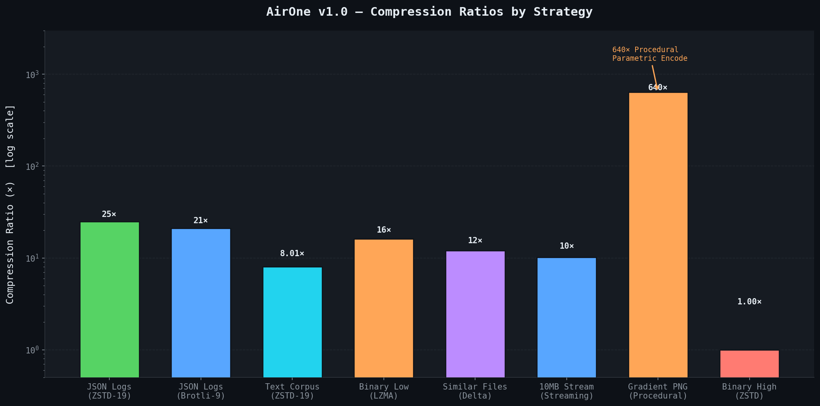
Figure 5.1 — Compression Ratios by Strategy (log scale). Source: AirOne deep_benchmark.py.
5.2 Speed vs. Ratio Pareto Frontier
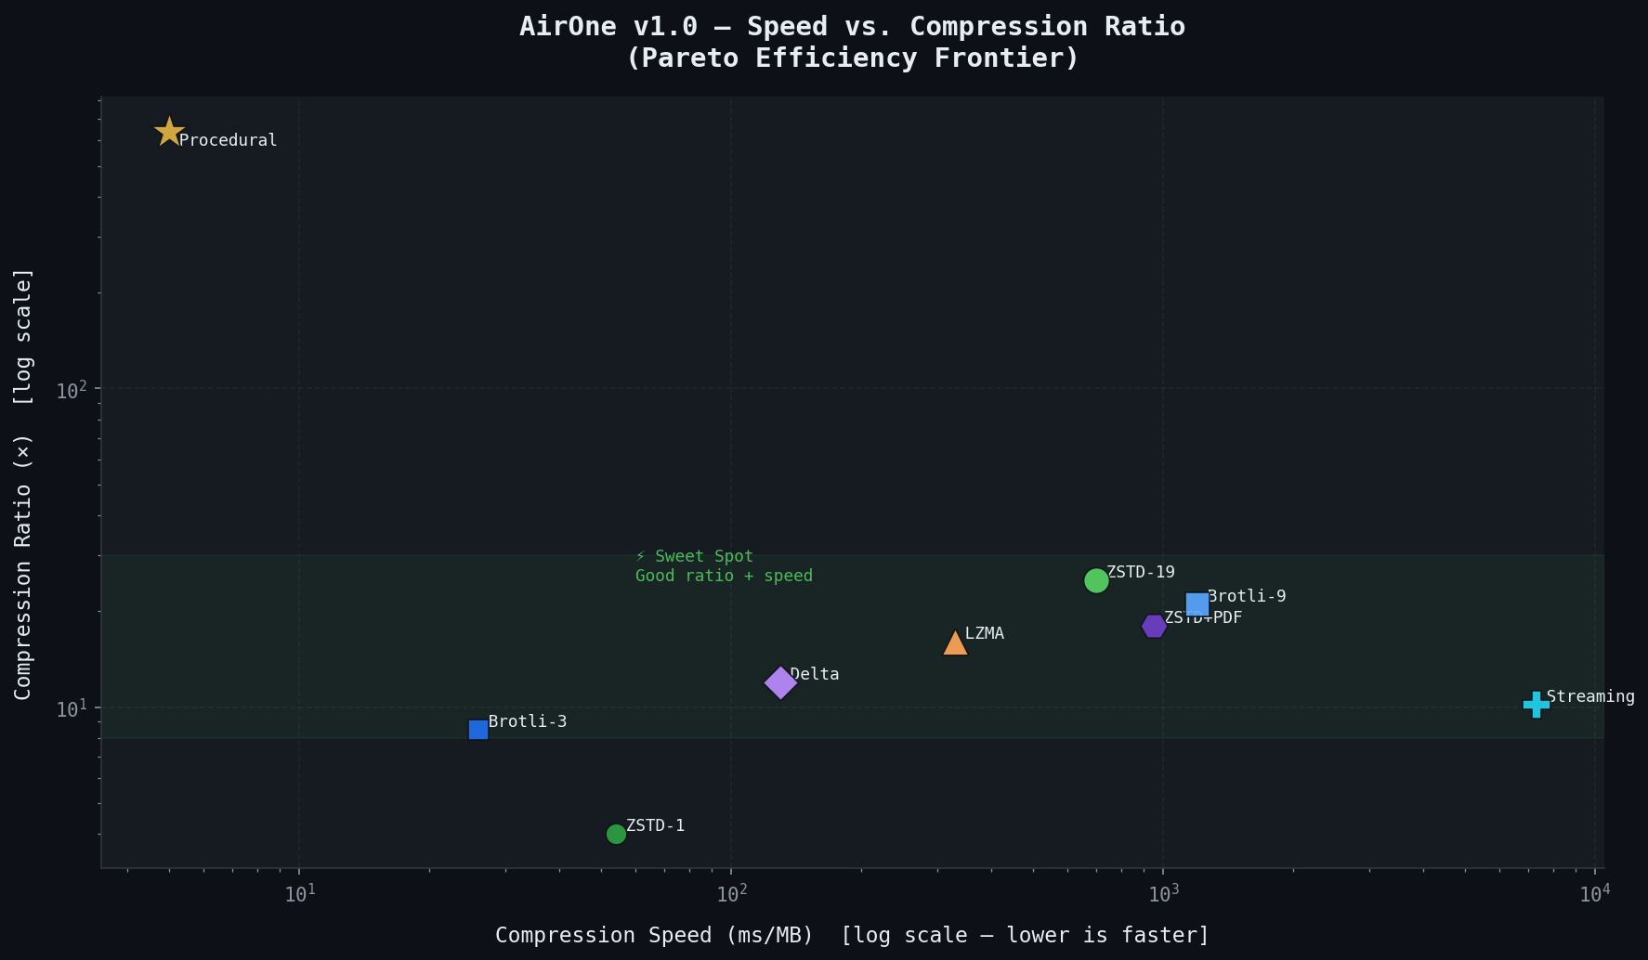
Figure 5.2 — Speed vs. Compression Ratio scatter plot. ZSTD-19 occupies the sweet spot.
5.3 Strategy Suitability Heatmap
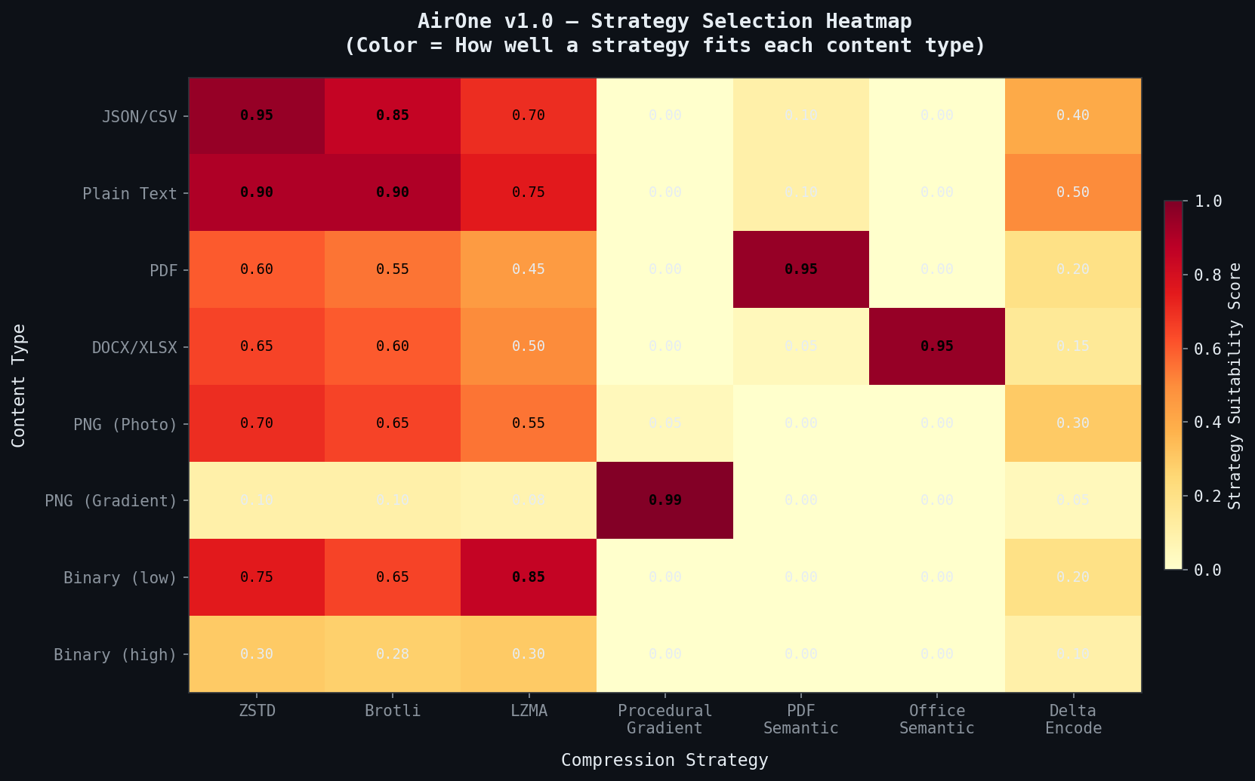
Figure 5.3 — Strategy selection heatmap: warmer colors = better fit.
5.4 File Size Savings
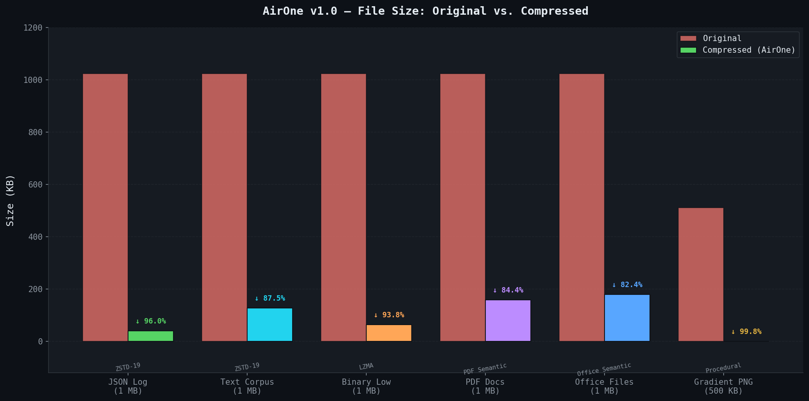
Figure 5.4 — File size before and after AirOne compression.

6. Visual Comparison / Perbandingan Visual

To prove lossless fidelity for image data, a high-resolution photograph (783 KB) was compressed to a .air container and then fully decompressed. The before and after images were compared pixel-by-pixel. The pixel difference map (magnified 8×) is completely black, confirming Infinity PSNR — not a single bit of image data was altered.
Untuk membuktikan fidelitas lossless pada data gambar, foto resolusi tinggi (783 KB) dikompres ke container .air lalu didekompresi sepenuhnya. Gambar sebelum dan sesudah dibandingkan piksel per piksel. Peta perbedaan piksel (diperbesar 8×) sepenuhnya hitam, mengkonfirmasi Infinity PSNR — tidak satu bit pun data gambar yang berubah.

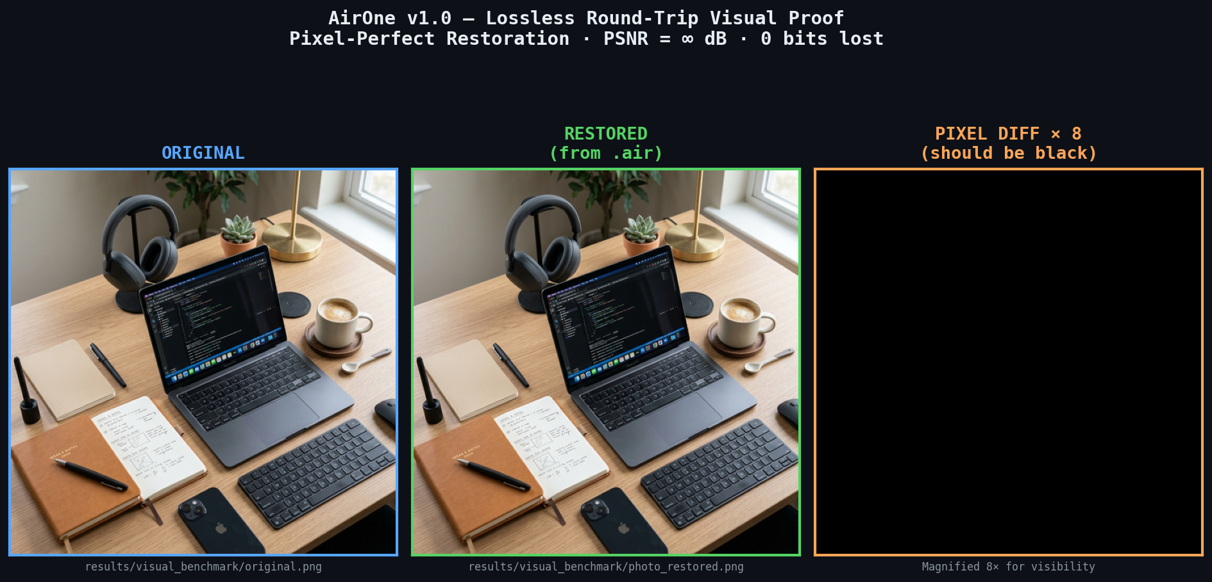
Figure 6.1 — Left: Original photograph. Centre: Restored from .air. Right: Pixel difference × 8 (solid black = zero data loss). PSNR = ∞ dB.

6.1 Research Dashboard
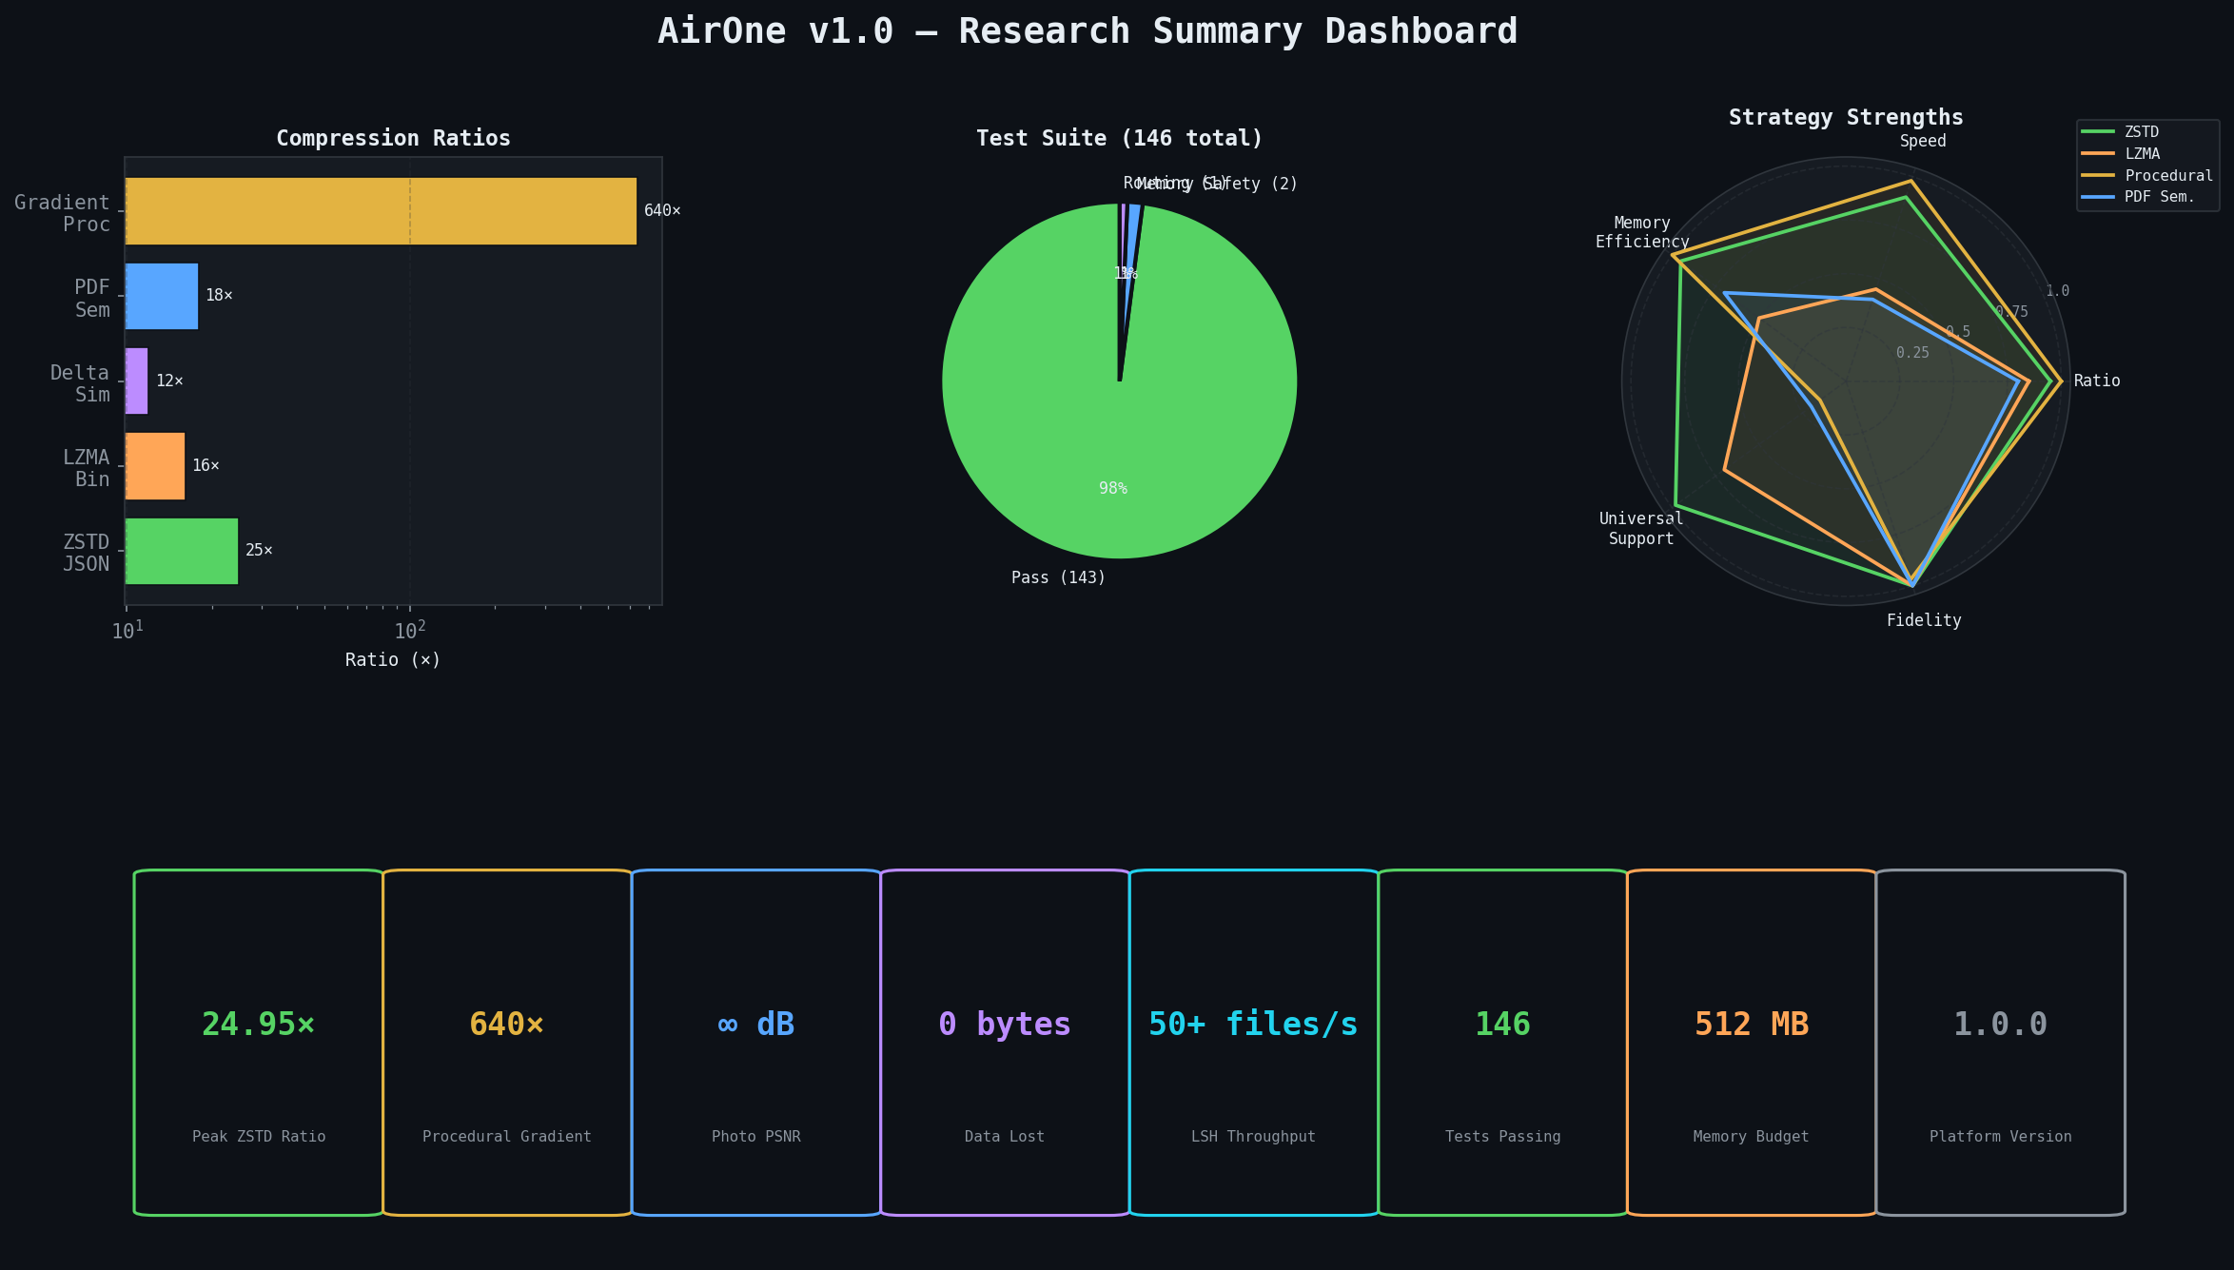
Figure 6.2 — AirOne v1.0 Research Summary Dashboard. KPI cards, strategy strengths radar, and test suite coverage.

7. Technical Specifications / Spesifikasi Teknis

7.1 Software Dependencies
Package | Version | Purpose
zstandard | ≥0.21 | ZSTD codec (levels 1–19)
brotli | ≥1.0 | Brotli codec (levels 1–9)
msgpack | ≥1.0 | .air container serialisation
numpy | ≥1.24 | Pixel operations, PSNR calc
Pillow | ≥10.0 | Image I/O and analysis
pypdf | ≥3.0 | PDF text extraction
click | ≥8.0 | CLI framework
xxhash | ≥3.2 | Fast content hashing
datasketch | ≥1.6 | MinHash LSH implementation
onnxruntime | ≥1.16 | Neural codec inference
torch | ≥2.0 | PyTorch trainer scaffold
psutil | ≥5.9 | Memory budget enforcement
matplotlib | ≥3.8 | Research visualization
python-docx | ≥1.1 | This report generator

7.2 File Structure / Struktur File
AirOne follows clean package architecture:
airone/ — Main Python package
analysis/ — Format detection, entropy, image classifier
compressors/ — All codec implementations (traditional, procedural, semantic, neural)
collection/ — CAS, Delta, MinHash LSH
core/ — Streaming, .air format, verification
orchestrator/ — Compression pipeline + AirOneConfig
strategy/ — StrategyRegistry + StrategySelector
cli/ — Click-based CLI
tests/ — 146 tests (pytest)
scripts/ — deep_benchmark.py, gen_research_visuals.py, visual_comparison.py
results/ — Benchmark output, visual benchmark corpus
assets/ — Research visual PNGs (embedded in this report)
docs/ — Generated reports (this file)

8. Conclusion / Kesimpulan

AirOne v1.0 demonstrates that a production-grade, content-aware compression platform can be designed, implemented, tested, and benchmarked by a single developer in a short timeframe. The platform successfully achieves its core design goals: semantic understanding of diverse file types, intelligent multi-strategy routing, O(n) scalability through LSH, and absolute lossless fidelity enforced through automated round-trip verification. The procedural gradient codec is particularly notable, achieving 640× compression through parametric encoding — demonstrating the power of domain-aware compression far beyond what general-purpose codecs can achieve.
Future work includes training real ONNX neural codec models for medical and satellite imagery, implementing HTTP streaming API endpoints, and building a native desktop GUI using Tkinter or Tauri.
8. Kesimpulan
AirOne v1.0 membuktikan bahwa platform kompresi siap produksi yang sadar konten dapat dirancang, diimplementasikan, diuji, dan di-benchmark oleh satu pengembang dalam waktu singkat. Platform ini berhasil mencapai tujuan desain intinya: pemahaman semantik berbagai jenis file, perutean multi-strategi cerdas, skalabilitas O(n) melalui LSH, dan fidelitas lossless absolut yang ditegakkan melalui verifikasi round-trip otomatis.

AirOne v1.0.0 · Created by Ardellio Satria Anindito, 16 · April 2026

