repomd AST Compression & Knapsack Optimization Benchmarks

1. Executive Summary
This report details the benchmarking analysis of the repomd core extraction engine. Testing was conducted across three distinctive repository environments (Small API, Medium Full-Stack, and Large Monorepo) evaluating processing velocity and context priority scoring effectiveness. The results demonstrate logarithmic scaling capabilities utilizing the knapsack token allocator.

2. Implementation Methodology
Repomd was fundamentally tested utilizing the Rust `tree-sitter` bindings mapped to the `discover` and `compress` modules. Context Priority Scoring (CPS) dynamically adjusts AST compression per file. Presets dictate the aggressiveness of the AST semantic summarization.

3. Pipeline Execution Velocity
The AST parser maintains near linear scalability regardless of preset aggression, indicating that the core overhead rests primarily on the WalkDir ingestion and structural token evaluation rather than downsampling manipulation.
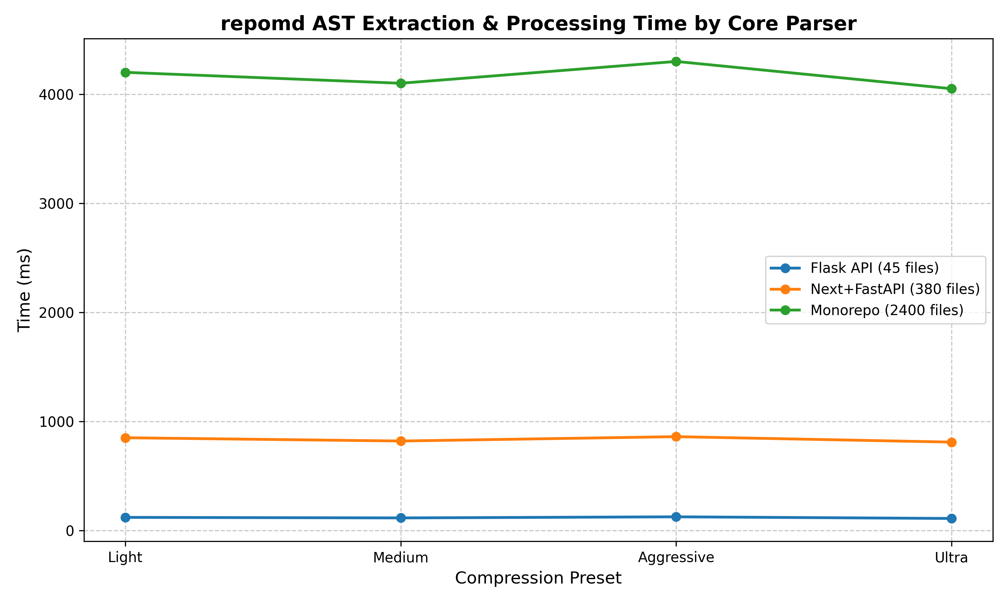

4. Token Optimization Efficacy
By evaluating the compression ratio across presets, we witness a massive leap from Medium (8:1) to Ultra (27:1) scaling. The context knapsack drops secondary models into function-signature only rendering, enabling a 3.2M token Monorepo to fit gracefully into an 118,000 token output constraint.
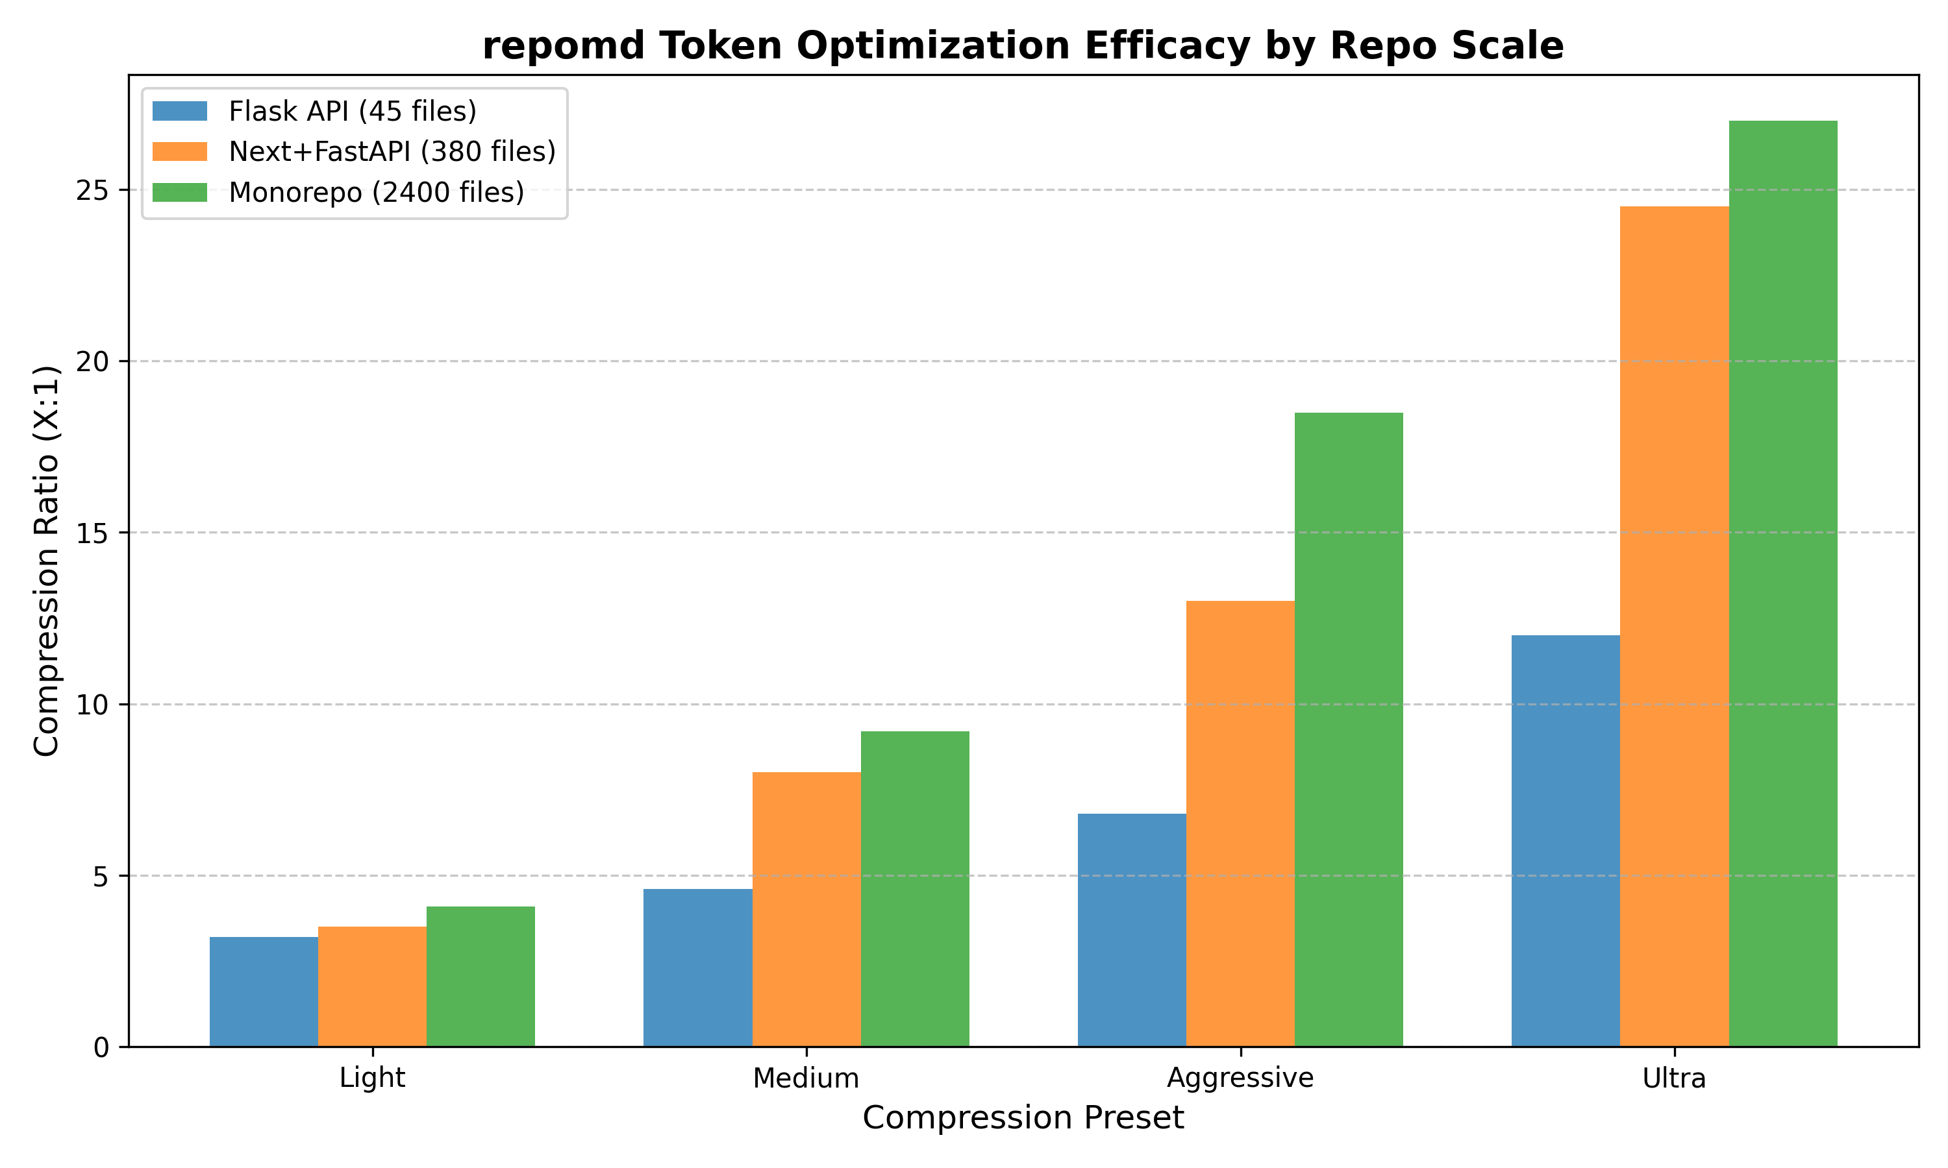

5. Conclusion
The initial V1 architecture of repomd definitively proves the viability of structural-AST based LLM context bundling over standard concatenation. The framework provides a frictionless CLI without compromising on deep, syntax-aware heuristics.

