

CAPSTONE PROJECT REPORT
Report 3 Software Requirement Specification

Arden Enterprise Knowledge Platform
with Human in the Loop Governance
and Permission Aware Retrieval

Ho Chi Minh, October 2026
Table of Contents
I. Project Report 3
1. Record of Changes 3
2. Status Report 3
3. Team Involvements 4
4. Issues and Suggestions 5
II. Software Requirement Specification 6
1. Product Overview 6
1.1 Scope and Implementation Status 7
1.2 Glossary 7
1.3 Assumptions and Dependencies 8
1.4 Known Limitations 9
2. User Requirements 9
2.1 Actors 9
2.2 Use Cases 9
3. Functional Requirements 13
3.1 System Functional Overview 13
3.2 Account and Session 18
3.3 Organization and Membership 24
3.4 Audiences, Reviewer Grants and System Administration 31
3.5 Personal Knowledge 37
3.6 Shared Drafts and Submission 42
3.7 Review and Publication 50
3.8 Library and Search 60
3.9 Ask Arden (AI Assistant) 64
3.10 Dashboard and Analytics 69
4. Non-Functional Requirements 72
4.1 External Interfaces 72
4.2 Quality Attributes 72
5. Requirement Appendix 74
5.1 Business Rules 74
5.2 Common Requirements 76
5.3 Application Messages List 77
5.4 Other Requirements 78
5.5 Requirement Traceability Matrix 78

I. Project Report

1. Record of Changes
Date | A*, M, D | In charge | Change Description
29 Sep 2026 | A | Project Team | Initial SRS covering organization setup, governed documents, review, handover, access control and permission-aware AI retrieval.
18 Oct 2026 | M | Project Team | Aligned with code and decisions 0004–0009: multi-organization tenancy, actors, invitations, reviewer grants, Personal Workspace, contribution copy, automatic publication.
22 Oct 2026 | M | Project Team | Aligned with registration form v2.0 and decision 0010: audiences replace custom roles, Arden System Admin, scope changes, acceptance criteria, six measurable NFRs, redrawn diagrams.
27 Oct 2026 | M | Ngô Quang Khôi | Review feedback: added Project Report; aligned with decisions 0011–0015 (approve/reject only, Organization Admin final authority, derived responsible department, Department/Organization reviewer grants, PREPARING → indexed ACTIVE publication, Arden-AI service); detailed specification of every function with screen layouts; action-level authorization; new non-screen functions; Usability NFR; glossary, assumptions, known limitations and requirement traceability matrix.
31 Oct 2026 | M | Ngô Quang Khôi | Aligned with the staging branch (commit e9e4b3a): registration, password reset with single-use code, PDF indexing and Ask Arden are Implemented; department deletion (archive) and invitations without a department added to FR-ORG-03/04, rules and entities; issues and known limitations updated; migrations 0001–0023.

*A - Added M - Modified D - Deleted

2. Status Report
Reporting date: 31/10/2026, end of Iteration 1. Status is taken from the staging branch of the Arden repository (commit e9e4b3a, 31/10/2026), which is deployed to the staging environment. It contains the knowledge workflow (decisions 0011–0015), the durable indexing pipeline, PDF indexing, permission-aware Ask Arden, registration and password reset, department deletion and invitations without a department (migrations 0001–0023). The separate Arden-AI repository (main, commit cc0b4d2) holds the Python AI service. Status values in this report: Implemented = present on the staging branch; Partial = only an API or a preview; Planned = not implemented.
Feature group | Status | Evidence and scope | Next step
Accounts, sign-in and sessions | Implemented | Email/password registration with email confirmation, Google sign-in, password setup, password reset with a single-use emailed code, sign-out and cookie sessions. | Profile screen (FR-AUTH-05) is planned.
Organizations, invitations and members | Implemented | Create organization, create and delete (archive) departments, email invitations with an optional department (send, resend, revoke, accept), primary department change. | Member removal and admin promotion are disabled in the UI.
Audiences and reviewer grants | Implemented | Organization, Department and Group audiences; Department and Organization reviewer grants (decision 0015). | Keep the disposable PostgreSQL CI job required for pull requests.
Private notes and contribution copy | Implemented | Owner-only notes with versions and search; separate shared copy. | Personal PDF documents and collections are planned.
Shared drafts, submission and review | Implemented | Text and PDF drafts, reader picker, submit snapshot, approve/reject, Organization Admin final authority, contribution history. | Withdraw submission is planned.
Publication preparation and activation | Implemented | Approval → PREPARING; durable index job → Arden-AI → atomic ACTIVE; failures stay invisible. Verified locally on 27/10/2026 with a stub AI endpoint. | Text and PDF snapshots are indexed; unpublish and restore are planned.
Library and reader | Implemented | Authorized publication list and reader. | Keyword and semantic search are planned.
Ask Arden (permission-aware RAG) | Implemented | Live answers on staging in organization scope: Arden-AI retrieves only from the asker’s allowed publications and Core rechecks every citation before showing it. | Run the NFR-03 evaluation on staging; Personal/Hybrid modes, rating and history are planned.
Personal/hybrid AI, summary, rating, history | Planned | — | Iteration 2–3.
Archive/unpublish and restore | Planned | — | Iteration 2.
Dashboard and analytics | Planned | — | Iteration 3, minimal level.
Arden System Admin | Partial | Bootstrap command and /api/v1/system/administrators API. | System Administration screen.

Verification performed on 27/10/2026 (before the branches were merged into staging): all migrations 0001–0020 of the working branch were applied to a clean PostgreSQL 16 database without error; the web client and API were run in local test mode with four synthetic accounts; a member created, submitted and contributed drafts, a Department reviewer approved and rejected, an Organization reviewer approved an organization-wide policy, the indexing worker activated both approved snapshots, and a member of another department could read only the organization-wide publication. The screen layouts in section 3 are screenshots of that run (synthetic data, no real personal data). On 31/10/2026 the statuses were re-checked against the staging source code by reading the code; migrations 0021–0023 were not re-run in that check.

3. Team Involvements
Contribution is summarised from the commit history of the Arden repository (all branches, merges excluded) and the Arden-AI repository on 27/10/2026. Commit counts are evidence, not a measure of effort; the share column is a proposal for the team to confirm.
Member | Role | Main contributions | Commits (Arden / Arden-AI) | Share (to confirm)
Ngô Quang Khôi | Team leader; product owner of the knowledge workflow; UI design | Product blueprint and Mainflow 1 workspace previews; Mainflow 2 governance (shared drafts, submission, review, PDF drafts, cross-actor review fix); workspace, administration and Island UI redesigns; review-authority decisions 0013–0015; SRS/SDD/test documents. | 31 / 0 | 30%
Đặng Trường Hưng | Backend and AI engineer | Scoped audiences and replacement of custom roles (decision 0010); Google OAuth and password setup; Flow 2 publication handoff; durable Flow 3 indexing pipeline; Arden-AI service (compiler, Chroma indexing, permission-aware RAG, PDF indexing); Ask Arden citations. | 21 / 10 | 30%
Mai Quốc Anh | DevOps and repository maintainer | Repository scaffold and standards; hosted development workflow on Coolify (remote CLI, slot fencing); CI hardening; contribution, branch and specification-continuity rules; feature index; approved brand package. | 27 / 2 | 20%
Lâm Gia Kiệt | Frontend and authentication | Mainflow 1 implementation; login, invitation and register UI; HTML invitation email; registration and password reset; migration 0005 documentation. | 11 / 0 | 20%

4. Issues and Suggestions
ID | Issue | Impact | Action / suggestion
I-01 | The working branch, feat/PERMISSION-AWARE-RAG and the auth fixes were merged into staging on 30–31/10/2026; one UI commit of feat/ard-16-knowledge-workflow-updates (9bee5cd) is still outside staging, and main is behind staging. | The demo build may miss that UI change; main does not reflect the reviewed build. | Merge the remaining commit into staging through a pull request, then tag review-2 on staging.
I-02 | Decisions 0013–0015 were accepted in working sessions; the project lead's confirmation is to be recorded in the pull request. | Reviewers may ask who approved the change of review rules. | Record the confirmation in the PR and in BM03.
I-03 | Resolved: CI now runs a disposable PostgreSQL job for the authorization and migration tests. | — | Keep the job required for pull requests to staging.
I-04 | Department deletion: the API declares CANNOT_DELETE_BASE_DEPARTMENT, but the repository never returns it, so the organization’s first department can also be archived. | An organization can lose its base department; its members become unassigned. | Return BASE_DEPARTMENT from deleteDepartment and add a test.
I-05 | Legacy schema remains: classification, reviewer level and role tables. | Extra columns and a broader SQL review gate (decision 0015 known debt). | Schedule the contraction migration after no legacy submission is pending.
I-06 | UI defects found during the screenshot run: Workspace Select shows raw role codes (DEPT_DEFAULT_BOOTSTRAP, ORG_ADMIN) and a hard-coded welcome name; a reviewer who is not in a group sees "Inactive audience"; My Work is disabled for signed-in users. | Confusing for users and reviewers. | Fix the copy and enable My Work with server data.
I-07 | Ask Arden sends authorized excerpts and questions to the OpenAI API. | Data leaves the customer environment; conflicts with a strictly self-hosted reading of the product. | Document the data flow, add an organization-level AI opt-in and record it in Report 4.
I-08 | Many registered features are still planned (personal/hybrid AI, summary, rating, history, archive, collections, dashboard). | Risk to the Defense 1.1 scope. | Freeze the mandatory list in BM01; implement minimal versions first.

Support requested from the supervisor and the department:
• Supervisor confirmation of the scope changes in BM03 (classification removed, approve/reject only).
• An OpenAI API budget for the evaluation set and the demo.
• Access to a staging slot with a disposable PostgreSQL database for CI integration tests.

II. Software Requirement Specification

1. Product Overview
Arden is an open-source, self-hosted knowledge management and retrieval system for small and medium-sized enterprises. One installation can host several organizations. Any verified account can create an organization and becomes its first Organization Admin. Every organization is an isolated tenant: its members, departments, audiences, notes, knowledge, review records and audit events are never visible to another organization.
Arden manages knowledge as governed documents rather than project records. The required hierarchy inside an organization is Organization → Department. Each member has a private Personal Workspace and at most one primary department; a member may be unassigned after being invited without a department or after their department is deleted. Team and project values are optional tags only.
Shared knowledge follows one governed lifecycle: a member writes a shared draft (or contributes a separate copy of a private note), chooses who may read it, and submits an immutable snapshot. An eligible reviewer, or the Organization Admin, approves or rejects that exact snapshot. Approval does not publish immediately: the snapshot is prepared and indexed by the Arden-AI service, and only a complete index generation is activated atomically. Search and the Ask Arden assistant use the same active publications under the same access policy, and every AI answer cites its sources.
Arden distinguishes four actors: Member, Knowledge Reviewer, Organization Admin and Arden System Admin. Readers are defined by audiences (the whole organization, a whole department or an audience group), review authority by reviewer grants (Department or Organization scope), and organization management by the Organization Admin capability. None of these capabilities opens another member's private notes. Arden does not provide project planning, ad-hoc per-user sharing, autonomous publication by AI or autonomous permission changes.
The context diagram shows Arden (web/desktop clients, Arden core API and the Arden-AI service) and the external entities it exchanges data with.
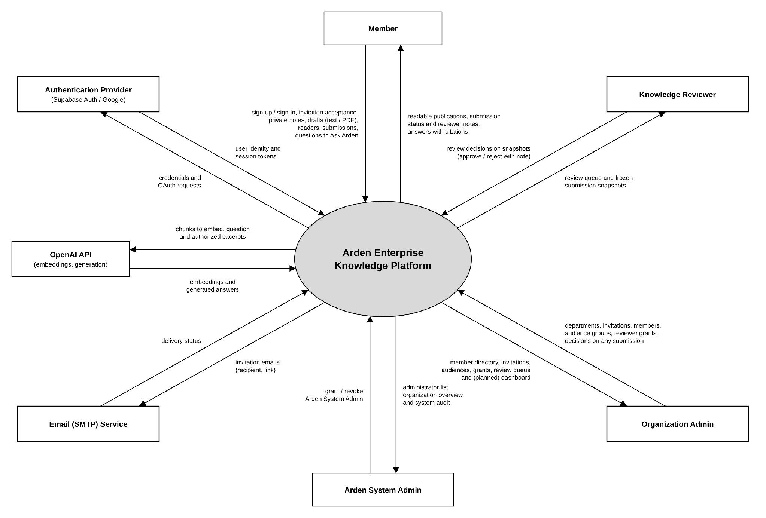
Figure 1: Context diagram

1.1 Scope and Implementation Status
Scope follows the proposed registration form version 2.0. Every functional requirement, use case and screen carries a status: Implemented (on the staging branch), Partial (API or preview only) or Planned. The detailed status by feature group and the open issues are given in Part I. Out of scope: Knowledge Handover, Knowledge Graph, external work-source connectors, notifications other than invitation email, and OCR of scanned PDFs.

1.2 Glossary
Term | Meaning
Organization | An isolated tenant inside one Arden installation.
Department / primary department | Organizational unit; each member has at most one primary department, which owns the member's shared drafts. Deleting a department archives it.
Audience | Defines who may read a publication: Organization (all active members), Department (active members of one department) or Group.
Audience group | An Organization Admin-managed list of members used only as a reader audience.
Reviewer grant | Authority to decide submissions. Department scope covers department and group-only snapshots of one department; Organization scope covers snapshots readable by the whole organization.
Private note | An owner-only item in the Personal Workspace.
Shared draft / working version | An author-owned document that becomes shared knowledge only through review; every save creates an immutable numbered version.
Semantic Document | Arden's canonical block-based document format (version 1) with stable block IDs.
Submission snapshot (release candidate) | The exact frozen version, metadata and audiences sent for review; at most one is open per draft.
Self-approval | An Organization Admin approving their own submission; recorded with selfApproved evidence.
Publication states | NONE, PREPARING (approved, being indexed), ACTIVE (visible), FAILED (index failed, invisible).
Index generation / index job | The durable record and queue item that send an approved snapshot to Arden-AI and hold its manifest.
Current publication pointer | The single active published version of a knowledge item, changed only by atomic activation.
Arden-AI | The separate Python 3.11 service that compiles, chunks, embeds, indexes (ChromaDB) and answers with OpenAI.
Allow-list | The generation IDs the asker may read, computed by Arden core before retrieval; Arden-AI may narrow but never broaden it.
RLS | PostgreSQL row-level security, used as defense in depth behind API authorization.
Idempotency-Key / If-Match | Request headers that prevent duplicate creation and lost updates.

1.3 Assumptions and Dependencies
ID | Type | Description
AD-01 | Dependency | Supabase Auth provides email/password accounts, email confirmation and Google sign-in; the Arden API is the only client of Supabase.
AD-02 | Dependency | A third-party SMTP service delivers invitation emails; credentials are runtime secrets.
AD-03 | Dependency | PostgreSQL 16 with row-level security stores all business state; migrations 0001–0023 are applied in order.
AD-04 | Dependency | The Arden-AI service (Python 3.11, FastAPI, LangChain) runs on the private network and is called only by Arden core with a service token.
AD-05 | Dependency | ChromaDB (self-hosted, persistent volume) stores chunks and embeddings; it is a derived index and never an authorization source.
AD-06 | Dependency | The OpenAI API provides embeddings and answer generation; only the question and authorized excerpts are sent.
AD-07 | Dependency | Langfuse (self-hosted) records AI traces and cost for the Arden operations team.
AD-08 | Dependency | Deployment uses Docker Compose on Coolify (Ubuntu); the desktop client is Electron for Windows.
AD-09 | Assumption | Each member has at most one primary department, set by the Organization Admin or by the invitation.
AD-10 | Assumption | Demo and test data are synthetic; no real personal or partner data is used.
AD-11 | Assumption | Users use a current Chrome or Edge browser on a screen at least 1280 px wide, or the Windows desktop client.

1.4 Known Limitations
ID | Limitation
KL-01 | Ask Arden answers in organization scope only; Personal and Hybrid modes, answer rating and durable chat history are not implemented.
KL-02 | Members without a primary department (invited without one, or whose department was deleted) cannot open Private Notes or Reviews until an Organization Admin assigns a department.
KL-03 | Used password-reset codes are remembered in API memory for 24 hours, so the single-use check is lost when the API restarts.
KL-04 | My Work is disabled for signed-in users (preview data only).
KL-05 | Withdraw, unpublish/archive and restore have database states but no API or screen yet.
KL-06 | Reviewer levels and classification columns remain only for legacy submissions.
KL-07 | Removing members and promoting another Organization Admin are not available in the UI.
KL-08 | Scanned PDFs (OCR) and files over 5 MB are not supported.
KL-09 | The System Administration screen is not built; the API is available.

2. User Requirements

2.1 Actors
# | Actor | Description
1 | Member | An active member of an organization. Writes private notes; creates text or PDF shared drafts; contributes a separate copy of a private note; chooses readers and submits snapshots; edits the working draft and resubmits after a rejection; reads published knowledge in their audiences; (Partial/Planned) asks Ask Arden, summarizes documents, rates answers and keeps personal documents and collections.
2 | Knowledge Reviewer | A member holding an active reviewer grant. A Department grant covers department and group-only snapshots owned by one department; an Organization grant covers snapshots readable by the whole organization. Approves or rejects pending snapshots within the grant. Cannot review their own submission; approval does not make the reviewer a reader.
3 | Organization Admin | The final authority of an organization; the creator becomes the first Organization Admin. Manages departments, invitations, members, audience groups and reviewer grants, and may decide any pending submission, including their own (audited as self-approval). (Planned) Unpublishes and restores knowledge and views the dashboard. Gains no readership or private-note access from this capability.
4 | Arden System Admin | A member of the Arden operations team who administers the installation from outside every organization (capability INSTANCE_ADMIN). The first is created by a one-time bootstrap command; later ones are granted by an active System Admin; the last active one cannot be revoked. Has no organization, content, review or AI access through this capability.

2.2 Use Cases

2.2.1 Diagrams
Members are specialised by Knowledge Reviewer and Organization Admin (generalization). The implementation status of each use case is given in section 2.2.2.
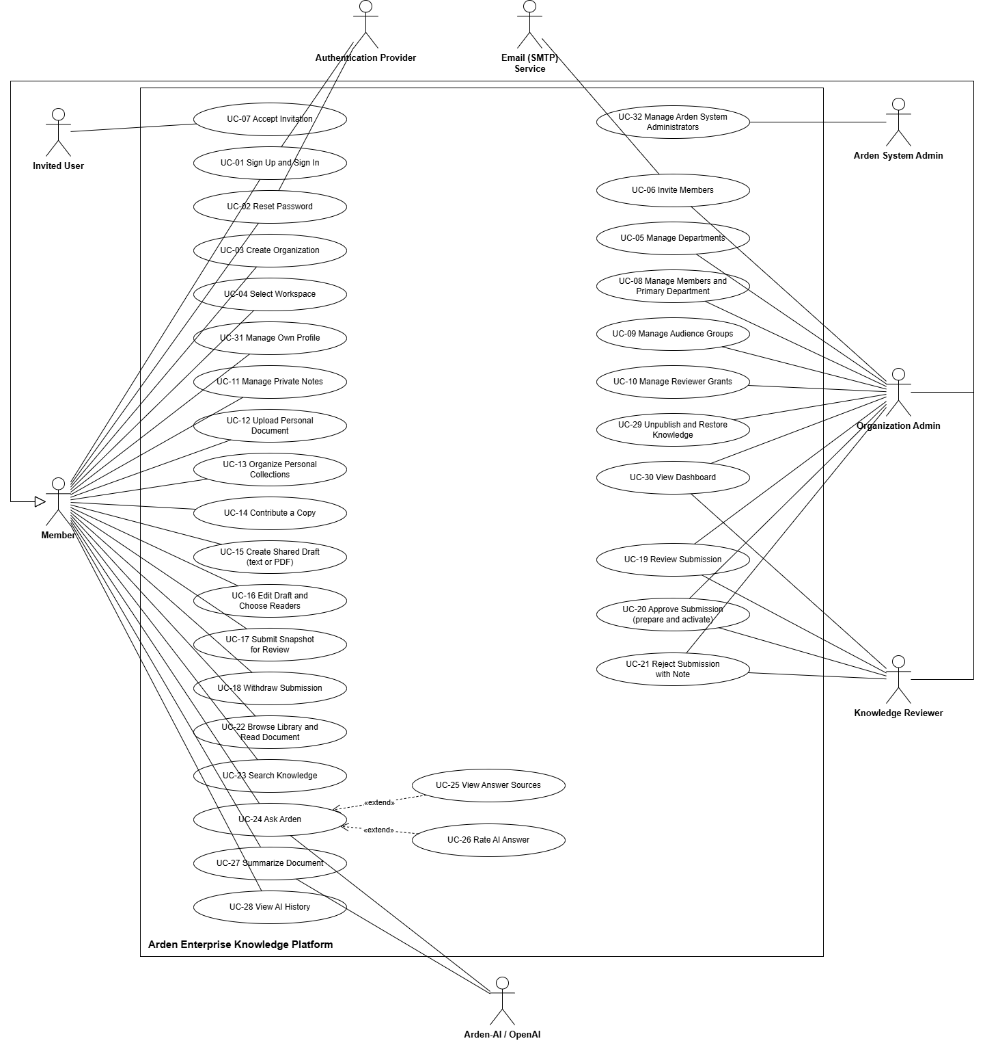
Figure 2: Use case diagram

2.2.2 Descriptions
ID | Use Case | Actors | Description | Status
UC-01 | Sign Up and Sign In | All users | Create an account, sign in with email/password or Google, set a password after Google sign-in, sign out. | Implemented
UC-02 | Reset Password | All users | Request a reset code and set a new password. | Implemented
UC-03 | Create Organization | Member | Create an organization with its first department and become its Organization Admin. | Implemented
UC-04 | Select Workspace | Member | Choose one of the user's organizations with an active membership. | Implemented
UC-05 | Manage Departments | Organization Admin | Create or delete (archive) departments; each receives its managed Department audience. | Implemented
UC-06 | Invite Members | Organization Admin | Send, resend or revoke a single-use, 7-day invitation, optionally for a department. | Implemented
UC-07 | Accept Invitation | Invited user | Sign in or create an account with the invited email and accept. | Implemented
UC-08 | Manage Members and Primary Department | Organization Admin | View members and move a member to another primary department. | Implemented
UC-09 | Manage Audience Groups | Organization Admin | Create, rename or deactivate groups and add or remove members. | Implemented
UC-10 | Manage Reviewer Grants | Organization Admin | Create or revoke Department or Organization grants with optional tags and validity. | Implemented
UC-11 | Manage Private Notes | Member | Create, search, open and edit owner-only notes. | Implemented
UC-12 | Upload Personal Document | Member | Upload a private PDF to the Personal Workspace. | Planned
UC-13 | Organize Personal Collections | Member | Group own notes and documents in collections. | Planned
UC-14 | Contribute a Copy | Member | Copy a saved private note version into a separate shared draft. | Implemented
UC-15 | Create Shared Draft | Member | Start a text draft or create one from a PDF up to 5 MB. | Implemented
UC-16 | Edit Draft and Choose Readers | Member | Edit the working version, choose scope, audiences and optional tags. | Implemented
UC-17 | Submit Snapshot for Review | Member | Freeze the current version, metadata and audiences into a release candidate. | Implemented
UC-18 | Withdraw Submission | Member; Organization Admin | Cancel a pending submission. | Planned
UC-19 | Review Submission | Knowledge Reviewer; Organization Admin | Open a pending snapshot covered by a grant (or any, for the Organization Admin). | Implemented
UC-20 | Approve Submission | Knowledge Reviewer; Organization Admin; System | Approve the exact snapshot; the system prepares, indexes and activates it. | Implemented
UC-21 | Reject Submission | Knowledge Reviewer; Organization Admin | Reject with a mandatory note to the author. | Implemented
UC-22 | Browse Library and Read Document | Member | List and read active publications in the member's audiences. | Implemented
UC-23 | Search Knowledge | Member | Keyword and semantic search over readable knowledge. | Planned
UC-24 | Ask Arden | Member; AI service | Ask a question and receive an answer grounded in readable publications. | Implemented
UC-25 | View Answer Sources | Member | Extends UC-24: open the cited document and page. | Implemented
UC-26 | Rate AI Answer | Member | Extends UC-24: rate 1–5 with a comment. | Planned
UC-27 | Summarize Document | Member; AI service | Summarize a readable publication or own note. | Planned
UC-28 | View AI History | Member | List own questions and answers. | Planned
UC-29 | Unpublish and Restore Knowledge | Organization Admin | Remove an active publication from reading and AI, or restore it. | Planned
UC-30 | View Dashboard | Organization Admin; Knowledge Reviewer | View counts, AI usage, feedback and quality reports. | Planned
UC-31 | Manage Own Profile | Member | Change the display name. | Planned
UC-32 | Manage Arden System Administrators | Arden System Admin | List, grant and revoke System Admins. | Partial (API)

3. Functional Requirements

3.1 System Functional Overview

3.1.1 Screen Flow
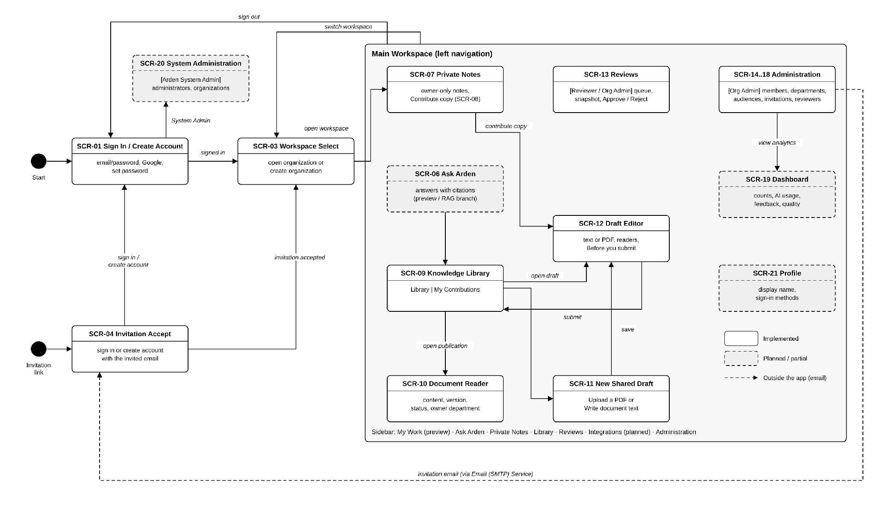
Figure 3: Screen flow

3.1.2 Screen Descriptions
ID | Screen | Description | Status
SCR-01 | Sign In / Create Account | Email/password sign-in, Google sign-in, account creation and password setup. | Implemented
SCR-02 | Reset Password | Request a reset code by email and set a new password. | Implemented
SCR-03 | Workspace Select | List the user's organizations and create a new organization. | Implemented
SCR-04 | Invitation Accept | Show the invitation and let the invited account sign in or create an account and accept. | Implemented
SCR-05 | My Work | Home overview of drafts, submissions and assigned reviews. | Partial (preview)
SCR-06 | Ask Arden | Question box, answers with citations and starter prompts. | Implemented
SCR-07 | Private Notes | Owner-only note list with search and editor. | Implemented
SCR-08 | Contribute a Copy (dialog) | Confirms the saved version that becomes a separate shared draft. | Implemented
SCR-09 | Knowledge Library | Tabs Library (readable publications) and My Contributions (own drafts and their review status). | Implemented
SCR-10 | Document Reader | Content, version selector, status, effective date and owner department of an active publication. | Implemented
SCR-11 | New Shared Draft | Choose Upload a PDF or Write document text, enter title and text. | Implemented
SCR-12 | Draft Editor and Before You Submit | Rich-text editor, reader picker, tags, readiness checklist, Save version and Submit. | Implemented
SCR-13 | Reviews | Review queue, frozen snapshot, decision panel (Approve/Reject with note). | Implemented
SCR-14 | Administration – Members | Member list with filters; member detail with department, grants and audiences. | Implemented
SCR-15 | Administration – Departments | Department list and creation. | Implemented
SCR-16 | Administration – Audiences | Managed audiences and audience groups with members. | Implemented
SCR-17 | Administration – Invitations | Invitation list by status; invite, resend and revoke. | Implemented
SCR-18 | Administration – Reviewer Access | Active/inactive grants and the New grant form. | Implemented
SCR-19 | Dashboard | Organization statistics, AI usage, feedback and quality lists. | Planned
SCR-20 | System Administration | Arden System Admin list and organization overview. | Planned
SCR-21 | Profile | Display name and sign-in information. | Planned

3.1.3 Screen Authorization
Authorization is evaluated on the server for every request and again by PostgreSQL row-level security. The table lists screens and the activities inside them. X = allowed; Own = only own items; Grant = only within an active reviewer grant; Audience = only items whose audiences include the user; — = not allowed. Knowledge Reviewer and Organization Admin also have every Member right.
Screen / activity | Member | Knowledge Reviewer | Organization Admin | Arden System Admin
Sign In / Workspace Select / Invitation Accept | X | X | X | Sign in only
Create organization | X | X | X | —
Private Notes: create, read, edit, search | Own | Own | Own | —
Contribute a copy | Own | Own | Own | —
Library: list and read publications | Audience | Audience | Audience | —
New draft (text or PDF), edit, choose readers | Own | Own | Own | —
Submit snapshot | Own | Own | Own | —
Withdraw submission (planned) | Own | Own | X | —
Reviews: view queue and snapshot | — | Grant | X | —
Approve / reject | — | Grant, not own | X (own: audited) | —
Unpublish / restore (planned) | — | — | X | —
Administration: view members and departments | — | — | X | —
Create department | — | — | X | —
Invite, resend, revoke invitation | — | — | X | —
Change primary department | — | — | X | —
Create, edit, deactivate audience group; add/remove members | — | — | X | —
Create / revoke reviewer grant | — | — | X | —
Ask Arden | Audience | Audience | Audience | —
Dashboard (planned) | — | Grant (quality lists) | X | —
System Administration: list, grant, revoke System Admin | — | — | — | X
Organization overview (planned) | — | — | — | X

3.1.4 Non-Screen Functions
ID | System function | Description
NSF-01 | Session and authentication context | Signs users in through Supabase Auth behind the Arden API, keeps access and refresh tokens in HttpOnly cookies, refreshes expired access tokens on request, and derives membership, primary department, group memberships, grants and System Admin status on the server for each request. Untrusted browser origins are refused (UNTRUSTED_ORIGIN).
NSF-02 | Authorization decision | Applies ownership, audience, grant and administrator rules in the API before any content, metadata, count or citation is returned; PostgreSQL RLS repeats the check under the non-bypass role arden_runtime. Unauthorized and missing resources return the same RESOURCE_NOT_AVAILABLE response.
NSF-03 | Invitation email delivery | Creates a random 43-character token stored only as a SHA-256 hash, expiring after 7 days, and sends the link through SMTP. A delivery failure keeps the invitation and returns INVITATION_DELIVERY_FAILED so the admin can resend.
NSF-04 | Private content storage | Stores note and draft content and PDF files in private storage behind the API with a SHA-256 content hash; integrity is checked on every read.
NSF-05 | Semantic Document normalization | Converts plain-text input into Semantic Document v1 and validates stored documents (stable block IDs, at most 2,000 blocks, depth 8, 131,072 characters, safe links).
NSF-06 | Idempotency and concurrency control | Requires Idempotency-Key on create, submit and decision requests and If-Match on edits; repeats return the first result and stale versions return VERSION_CONFLICT.
NSF-07 | Review decision and publication preparation | In one transaction records the decision and audit event, checks the frozen snapshot hash, and on approval creates the PREPARING publication, an index generation and an index job.
NSF-08 | Index-generation background job | A Node.js worker polls every second, leases one job for 180 s, reads the snapshot, verifies its hash and calls Arden-AI POST /v1/index-generations (timeout 120 s). Retryable failures are retried up to 3 attempts; non-retryable failures mark the generation FAILED.
NSF-09 | Manifest validation and atomic activation | Validates the returned manifest (identity, chunk ordinals, chunk digest) and, in one transaction, marks the generation READY, sets the publication ACTIVE and replaces the current-publication pointer. A failed or partial generation never becomes visible.
NSF-10 | Permission-aware answer (Arden-AI) | Computes the READY generations the asker may read, sends the question and allow-list to Arden-AI POST /v1/answers, and rechecks every citation against current access before responding; if access changed, the answer is refused (KNOWLEDGE_ACCESS_CHANGED).
NSF-11 | Audit logging | Records actor, time, object, action and outcome for organization, invitation, membership, audience, grant, submission, decision (with selfApproved), activation and System Admin events.
NSF-12 | System Admin bootstrap | One-time server command system-admin:bootstrap; refuses when any System Admin exists.
NSF-13 | Health checks | GET /api/health/live and /api/health/ready for Coolify; Arden-AI exposes /health/live and /health/ready.
NSF-14 | Analytics aggregation | (Planned) Computes dashboard counts from knowledge, review, audit and AI records without exposing unreadable content.

3.1.5 Entity Relationship Diagram
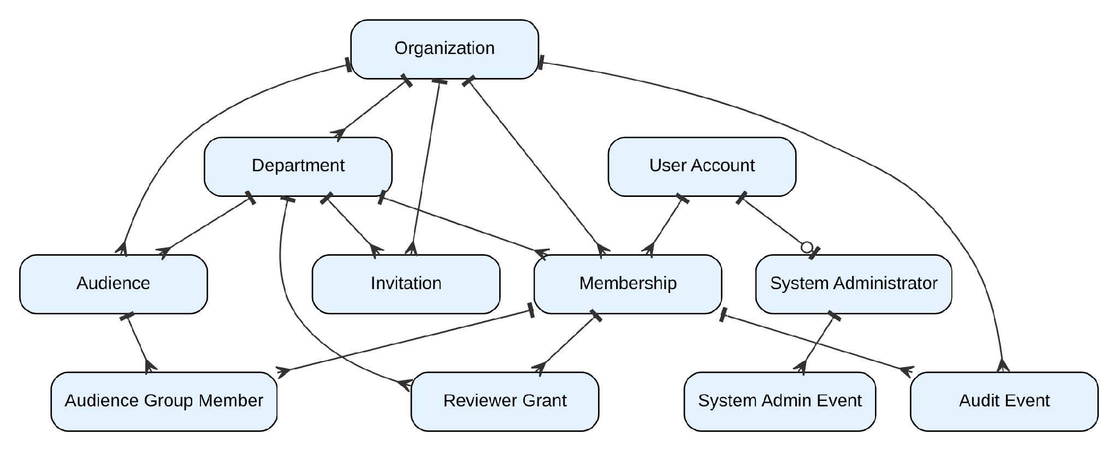
Figure 4: Logical ERD – organization, access and administration
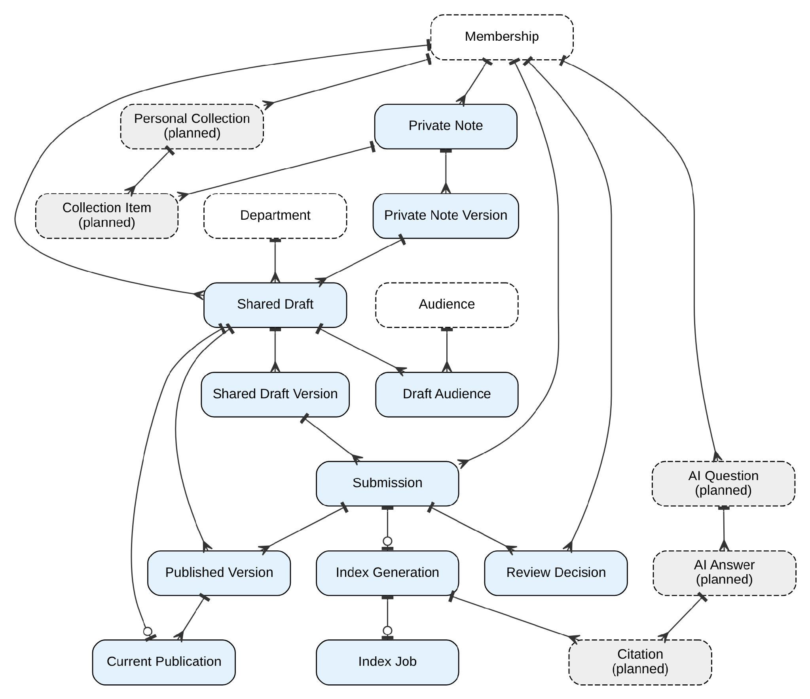
Figure 5: Logical ERD – personal workspace, knowledge lifecycle, indexing and AI
Shaded, dashed entities are planned. Legacy tables (role, permission, role_permission, access_scope, role_assignment, authorization_policy) and legacy columns (classification, reviewer level) remain only for compatibility and are not part of the logical model. Physical names are given in Report 4.
Entity Descriptions
# | Entity | Description
1 | Organization | An isolated tenant.
2 | Department | Unit inside an organization; has one managed Department audience.
3 | User Account | An authenticated identity (Supabase Auth); may belong to several organizations.
4 | Membership | A user in an organization with status (Invited, Active, Suspended, Left) and at most one primary department.
5 | Invitation | Hashed single-use token for one email and an optional department; status Pending, Accepted, Revoked or Expired.
6 | Audience | Organization, Department or Group reader set; Active or Inactive.
7 | Audience Group Member | A member in an audience group (Active, Revoked, Expired).
8 | Reviewer Grant | Review authority with scope Department (one department) or Organization, optional tags, validity and status.
9 | System Administrator / System Admin Event | Installation administrator (Active, Revoked) and the audit of its changes.
10 | Private Note / Private Note Version | Owner-only item with immutable versions.
11 | Personal Collection / Collection Item | (Planned) Owner-only grouping of private items.
12 | Shared Draft | Author-owned shared item with title, responsible department, scope, tags and status (Active, Archived).
13 | Shared Draft Version | Immutable content version (Semantic Document or PDF) with content hash.
14 | Draft Audience | The audiences chosen for a shared draft.
15 | Submission | Immutable snapshot with frozen metadata, audiences and review rule; status Pending Review, Approved, Rejected, Withdrawn; publication state None, Preparing, Active, Failed.
16 | Review Decision | Approve or Reject, note, reviewer, time and selfApproved flag.
17 | Published Version / Current Publication | The approved snapshot and the single active pointer per knowledge item.
18 | Index Generation / Index Job | Durable indexing record (Pending, Processing, Ready, Failed) with manifest, and its leased job (Pending, Running, Succeeded, Failed; max 3 attempts).
19 | Audit Event | Traceable record of a governed action and its outcome.
20 | AI Question / Answer / Citation | (Planned in core) Question, answer status (Answered, Insufficient evidence), citations to generation, chunk and block, rating and comment.

3.2 Account and Session
Lets people create an Arden account, sign in, keep a secure session and recover access.
ID | Function | Actor | Status
FR-AUTH-01 | Sign up and sign in with email and password | Anyone (unauthenticated). After sign-in the user acts as a Member of their organizations. | Implemented
FR-AUTH-02 | Sign in with Google and set a password | Anyone with a Google account. | Implemented
FR-AUTH-03 | Reset a forgotten password | Anyone. | Implemented
FR-AUTH-04 | Keep and refresh the session | System. | Implemented
FR-AUTH-05 | Manage own profile | Member | Planned

3.2.1 FR-AUTH-01 Sign up and sign in with email and password
Item | Specification
Status | Implemented
Related UC / screen / NSF | UC-01; SCR-01; NSF-01
Function trigger | The user opens Arden without a session, or clicks Sign out.
Actor and permission | Anyone (unauthenticated). After sign-in the user acts as a Member of their organizations.
Function description | Create an account with email and password, confirm the email, sign in and sign out. Arden calls Supabase Auth on the server and stores the session in HttpOnly cookies.
Preconditions | For sign-in, the account exists and its email is confirmed.
Postconditions | A session cookie pair is set; the user reaches Workspace Select or their last organization.
Main flow | 1. User enters email and password and selects Sign in.  2. API forwards the credentials to Supabase Auth.  3. On success, API sets the access and refresh cookies and returns the user profile.  4. Client loads /api/v1/me and the user's organizations and opens the workspace.  5. Sign out: POST /auth/sign-out revokes the session and clears both cookies.
Alternate and error flows | • Wrong email or password → 401 INVALID_CREDENTIALS "Email or password is incorrect." (does not reveal whether the email exists).  • Supabase unavailable → 503 AUTH_UNAVAILABLE.  • Request from an untrusted origin → 403 UNTRUSTED_ORIGIN.  • Weak password at sign-up → PASSWORD_REJECTED.
Inputs and validation | Email (valid format, ≤320); password 1–1,024 characters at sign-in; Supabase password policy at sign-up.
Data read / changed | Reads/creates the Supabase user and the Arden user_account record; no organization data is changed.
Business rules | BR-ROLE-001; CR-01.
Screen / API / job | POST /api/v1/auth/sign-up, /auth/sign-in, /auth/sign-out; GET /api/v1/me. Figure: Sign In.
Acceptance criteria | AC1: A confirmed account signs in and reaches its workspace.  AC2: A wrong password returns the generic message and sets no cookie.  AC3: After sign-out, any protected request with the old cookies returns 401 UNAUTHENTICATED.
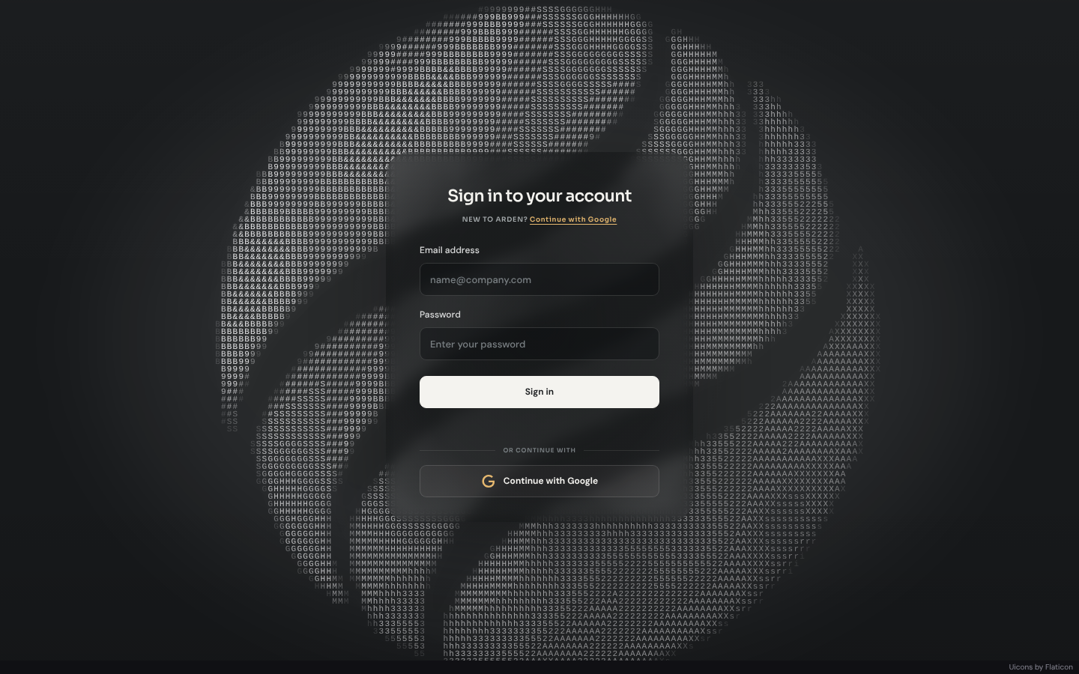
Figure 6: Sign In / Create Account (SCR-01)

3.2.2 FR-AUTH-02 Sign in with Google and set a password
Item | Specification
Status | Implemented
Related UC / screen / NSF | UC-01; SCR-01
Function trigger | The user selects Continue with Google.
Actor and permission | Anyone with a Google account.
Function description | OAuth sign-in through Supabase (PKCE). On first Google sign-in the user must set an Arden password so the account also works with email sign-in; the desktop client completes the flow in its main process.
Preconditions | Google sign-in is configured for the installation.
Postconditions | Authenticated session; password initialized.
Main flow | 1. Client calls GET /auth/google/start (web or desktop).  2. User consents at Google; Supabase redirects to /auth/google/callback.  3. API exchanges the code, sets cookies and redirects to the web app (or to /auth/google/desktop-complete).  4. If no password exists, the Set password screen requires one (POST /auth/password).
Alternate and error flows | • Callback without a valid code or flow ID → sign-in refused.  • Password already set → PASSWORD_ALREADY_INITIALIZED.  • Password shorter than 8 characters → validation error.
Inputs and validation | New password 8–1,024 characters.
Data read / changed | Supabase identity; user_account.
Business rules | BR-ROLE-001.
Screen / API / job | GET /auth/google/start, /auth/google/callback, /auth/google/desktop-complete; POST /auth/password.
Acceptance criteria | AC1: A first Google sign-in cannot reach the workspace before a password is set.  AC2: The desktop client never exposes tokens to the renderer.

3.2.3 FR-AUTH-03 Reset a forgotten password
Item | Specification
Status | Implemented
Related UC / screen / NSF | UC-02; SCR-02
Function trigger | The user selects Forgot password on the sign-in screen.
Actor and permission | Anyone.
Function description | Send a reset code by email and let the user set a new password; each code can be used once.
Preconditions | The email belongs to an account.
Postconditions | The new password works; old sessions are refused.
Main flow | 1. User enters email (POST /auth/forgot-password).  2. Supabase sends a reset code to the email.  3. User enters the code and a new password (POST /auth/reset-password); a code that was already used is refused.
Alternate and error flows | • Unknown email → the same neutral confirmation (no account disclosure).  • Expired link → user must request a new one.
Inputs and validation | Email; new password per Supabase policy.
Data read / changed | Supabase user.
Business rules | CR-06.
Screen / API / job | POST /auth/forgot-password, /auth/reset-password, /auth/verify.
Acceptance criteria | AC1: The response is identical for known and unknown emails.  AC2: After reset, the old password is rejected.  AC3: A reset code that was already used is refused.

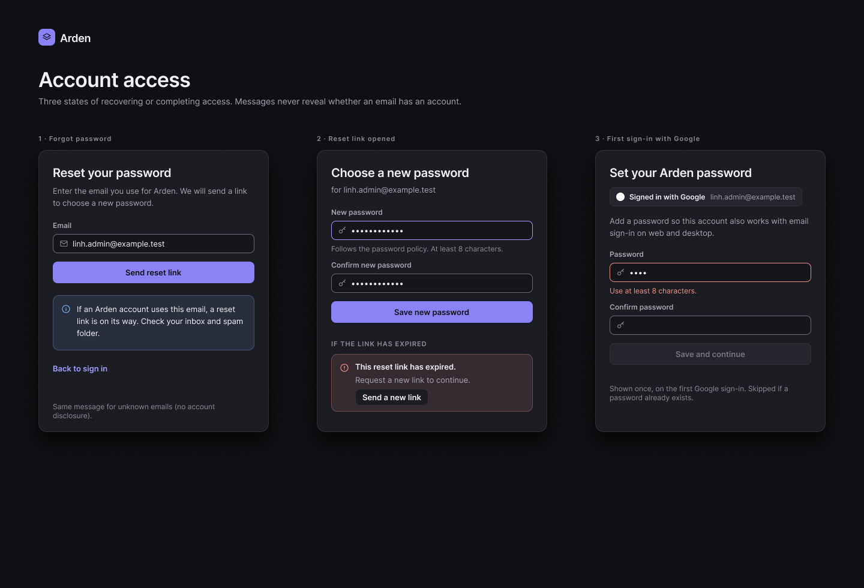
Figma screen R3-02: Password reset and Google sign-in

3.2.4 FR-AUTH-04 Keep and refresh the session
Item | Specification
Status | Implemented
Related UC / screen / NSF | NSF-01
Function trigger | Any API request with session cookies.
Actor and permission | System.
Function description | Resolve the user from the access token; when it has expired, refresh it with the refresh token and rotate both cookies.
Preconditions | Cookies present.
Postconditions | Valid session or 401.
Main flow | 1. API reads the access and refresh cookies.  2. API validates the access token with Supabase.  3. If expired, API calls refreshSession, verifies the new token and sets rotated cookies.
Alternate and error flows | • Invalid or revoked refresh token → 401 UNAUTHENTICATED; the client returns to Sign In.
Inputs and validation | Cookies only.
Data read / changed | None.
Business rules | CR-01.
Screen / API / job | Cookie names arden_access / arden_refresh (__Host- prefix in production).
Acceptance criteria | AC1: An expired access token with a valid refresh token is renewed without signing in again.  AC2: A revoked session cannot be refreshed.

3.2.5 FR-AUTH-05 Manage own profile
Item | Specification
Status | Planned
Related UC / screen / NSF | UC-31; SCR-21
Function trigger | The user opens Profile from the sidebar.
Actor and permission | Member
Function description | View email and sign-in methods and change the display name.
Preconditions | Signed in.
Postconditions | Display name updated everywhere it is shown.
Main flow | 1. User edits the display name (1–100 characters) and saves.  2. API updates the user account and returns the profile.
Alternate and error flows | • Empty or too long name → validation message MSG-001.
Inputs and validation | Display name 1–100 characters.
Data read / changed | user_account.full_name.
Business rules | —
Screen / API / job | Planned screen SCR-21.
Acceptance criteria | AC1: The new name appears in member lists and review history.  AC2: A user cannot change another user's profile.

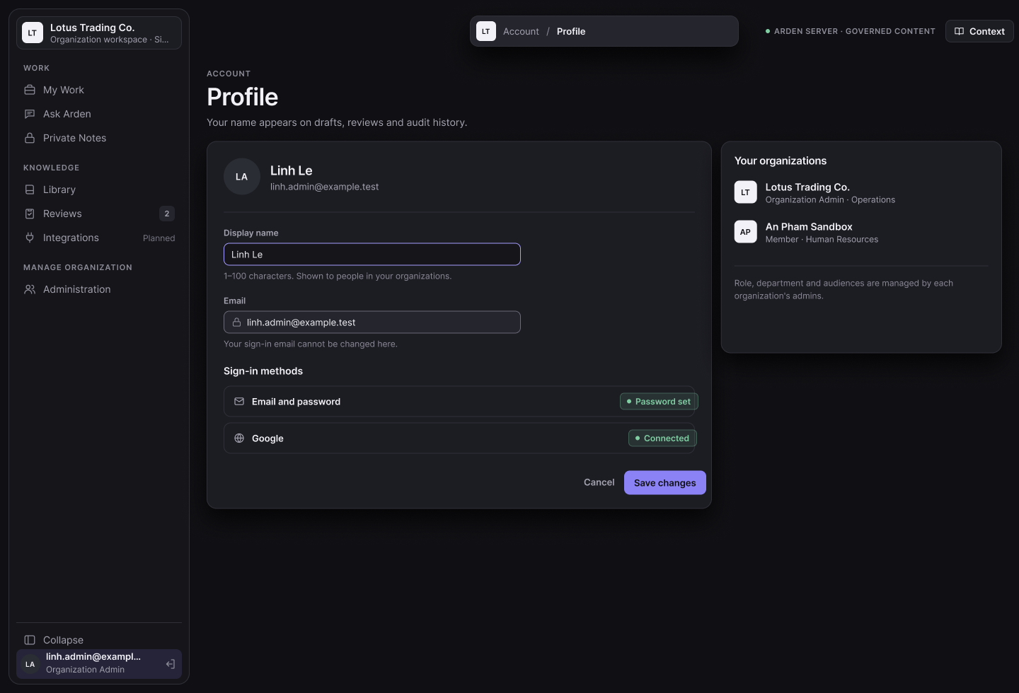

3.3 Organization and Membership
Creates isolated organizations and controls who joins them and in which department.
ID | Function | Actor | Status
FR-ORG-01 | Create an organization | Any signed-in user with a verified email. | Implemented
FR-ORG-02 | Select a workspace | Member | Implemented
FR-ORG-03 | Manage departments | Organization Admin | Implemented
FR-ORG-04 | Invite members | Organization Admin with a verified email | Implemented
FR-ORG-05 | Accept an invitation | Invited user | Implemented
FR-ORG-06 | Manage members and primary department | Organization Admin | Implemented (removal and admin promotion disabled)

3.3.1 FR-ORG-01 Create an organization
Item | Specification
Status | Implemented
Related UC / screen / NSF | UC-03; SCR-03
Function trigger | The user selects Create organization on Workspace Select.
Actor and permission | Any signed-in user with a verified email.
Function description | Create a new isolated organization with its first department. The creator becomes the first Organization Admin; the Organization audience and the first Department audience are created automatically.
Preconditions | Signed in, verified email.
Postconditions | Organization, department, membership (Organization Admin, primary department), managed audiences and audit events exist.
Main flow | 1. User enters the organization name and the primary department name.  2. API validates and creates all records in one transaction.  3. Client opens the new organization.
Alternate and error flows | • Empty name → 400 INVALID_ORGANIZATION.  • Conflicting details → 409 ORGANIZATION_CONFLICT.
Inputs and validation | Organization name 1–120; department name 1–80 characters.
Data read / changed | Creates organization, department, organization_membership, department_membership, audiences, audit_event.
Business rules | BR-ORG-001, BR-ORG-002, BR-ORG-005.
Screen / API / job | POST /api/v1/organizations. Figure: Workspace Select.
Acceptance criteria | AC1: The creator can open Administration of the new organization.  AC2: Another user without membership receives RESOURCE_NOT_AVAILABLE for every route of it.
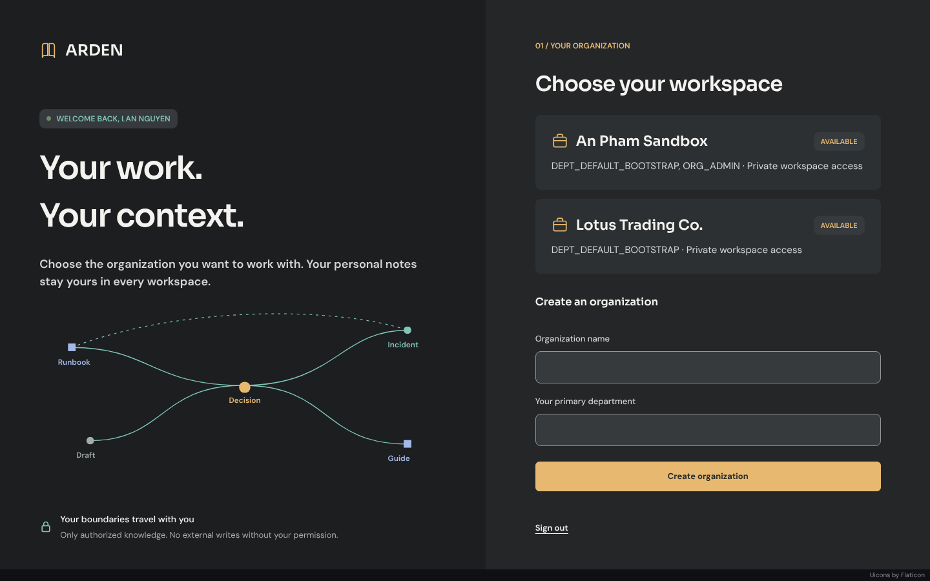
Figure 7: Workspace Select with Create organization (SCR-03)

3.3.2 FR-ORG-02 Select a workspace
Item | Specification
Status | Implemented
Related UC / screen / NSF | UC-04; SCR-03
Function trigger | After sign-in when the user has zero or several organizations, or via Switch workspace.
Actor and permission | Member
Function description | List the user's organizations and open one.
Preconditions | Signed in.
Postconditions | The chosen organization becomes the context of every request.
Main flow | 1. Client lists organizations from /api/v1/me.  2. User selects one marked Available.
Alternate and error flows | • Suspended or Left membership → organization not enterable.
Inputs and validation | Organization ID.
Data read / changed | Reads memberships.
Business rules | BR-MEM-001.
Screen / API / job | GET /api/v1/me.
Acceptance criteria | AC1: Only the user's own organizations are listed.  AC2: A Suspended membership cannot open the organization.

3.3.3 FR-ORG-03 Manage departments
Item | Specification
Status | Implemented
Related UC / screen / NSF | UC-05; SCR-15
Function trigger | Administration → Departments → New department.
Actor and permission | Organization Admin
Function description | Create or delete a department. Arden creates its managed "Everyone in <department>" audience; deleting a department archives it instead of removing it.
Preconditions | Actor is Organization Admin of the organization.
Postconditions | Department and Department audience exist; after deletion the department is Archived, its audience, access scope and reviewer grants are inactive, and its members have no primary department until reassigned.
Main flow | 1. Admin enters a name and selects Create department.  2. API creates the department and its audience; the list shows members, primary members and reviewers per department.  3. Delete: Admin confirms; API archives the department, ends its department memberships and default-role assignments, clears it from pending invitations, deactivates its audience, access scope and reviewer grants, and records DEPARTMENT_DELETED.
Alternate and error flows | • Empty name → "Enter a valid department name."  • Non-admin → RESOURCE_NOT_AVAILABLE.
Inputs and validation | Name 1–80 characters.
Data read / changed | department, audience (DEPARTMENT_ALL), department_membership, role_assignment, organization_invitation, access_scope, reviewer_grant, audit_event.
Business rules | BR-ORG-003, BR-ORG-005.
Screen / API / job | POST /api/v1/organizations/{organizationId}/departments; POST …/departments/{departmentId}/delete; GET /api/v1/organizations/{organizationId}/administration.
Acceptance criteria | AC1: The new department appears as a primary-department and reader option.  AC2: A Member calling the API is denied.  AC3: After deletion the department is Archived, its members can no longer read its Department publications on the next request, and they appear as unassigned.
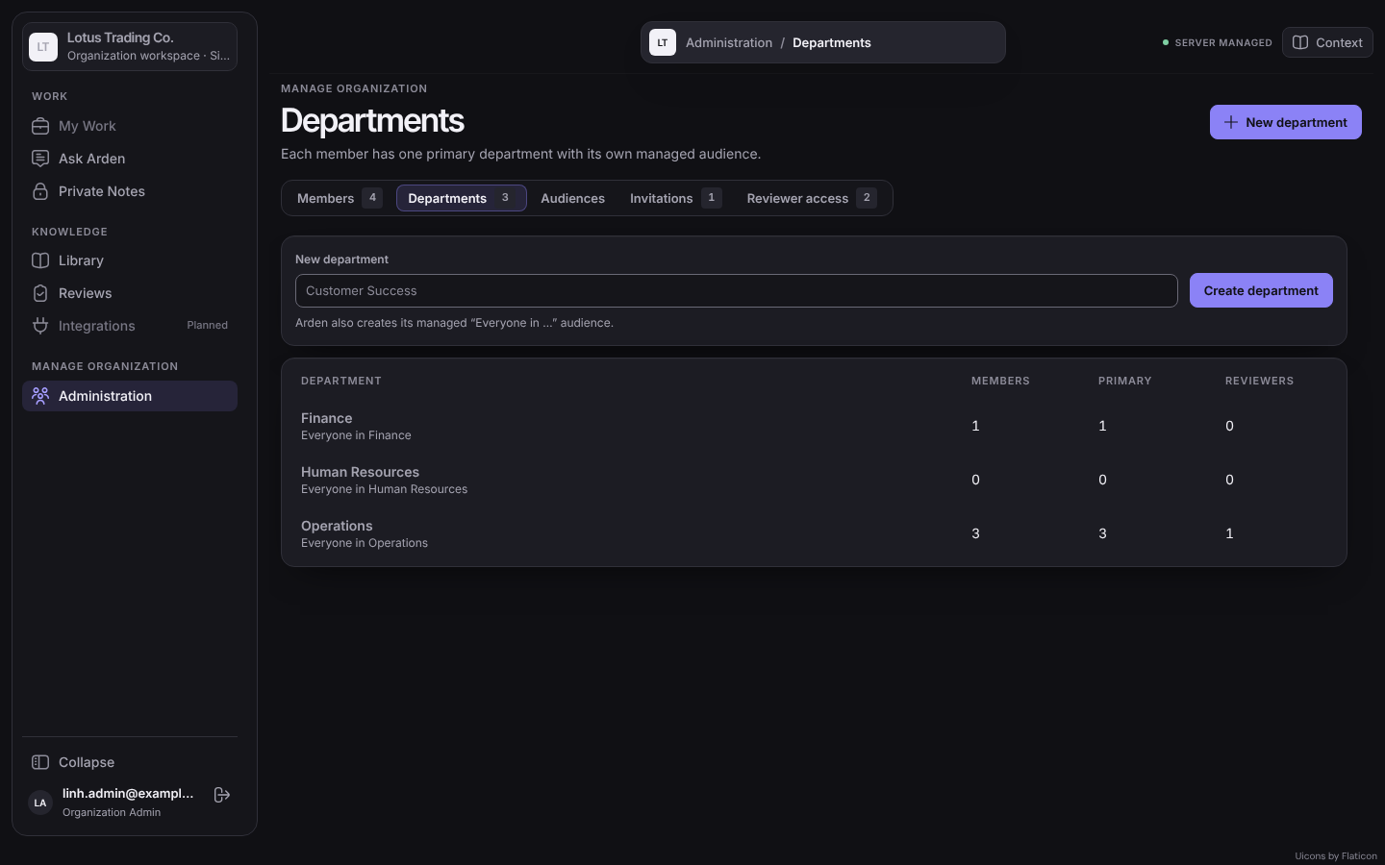
Figure 8: Administration – Departments (SCR-15)

3.3.4 FR-ORG-04 Invite members
Item | Specification
Status | Implemented
Related UC / screen / NSF | UC-06; SCR-17; NSF-03
Function trigger | Administration → Invitations → Send invitation, or Resend / Revoke on a row.
Actor and permission | Organization Admin with a verified email
Function description | Invite a person by email, optionally into a primary department. The link is single-use and expires after 7 days.
Preconditions | No pending invitation exists for the same email in the organization.
Postconditions | Invitation Pending; email sent.
Main flow | 1. Admin enters the work email and, optionally, a primary department.  2. API stores the hashed token and expiry, then sends the email.  3. The Invitations tab lists the invitation with status, department and expiry.  4. Resend creates a new link; Revoke makes the old link unusable.
Alternate and error flows | • Pending invitation exists → 409 INVITATION_CONFLICT.  • Admin email not verified → 403 VERIFIED_EMAIL_REQUIRED.  • SMTP failure → 502 INVITATION_DELIVERY_FAILED (invitation kept; can be resent).  • SMTP not configured → 503 INVITATIONS_UNAVAILABLE.
Inputs and validation | Email (valid, ≤320); department ID of an active department.
Data read / changed | organization_invitation (token_hash, status, expires_at), audit_event.
Business rules | BR-MEM-002, BR-MEM-003.
Screen / API / job | POST /api/v1/organizations/{organizationId}/invitations; POST …/invitations/{id}/resend; POST …/invitations/{id}/revoke.
Acceptance criteria | AC1: The recipient receives a link valid for 7 days (MSG-017).  AC2: A second invitation to the same pending email is refused.  AC3: A revoked link no longer works.  AC4: An invitation without a department creates an Active membership with no primary department when accepted.
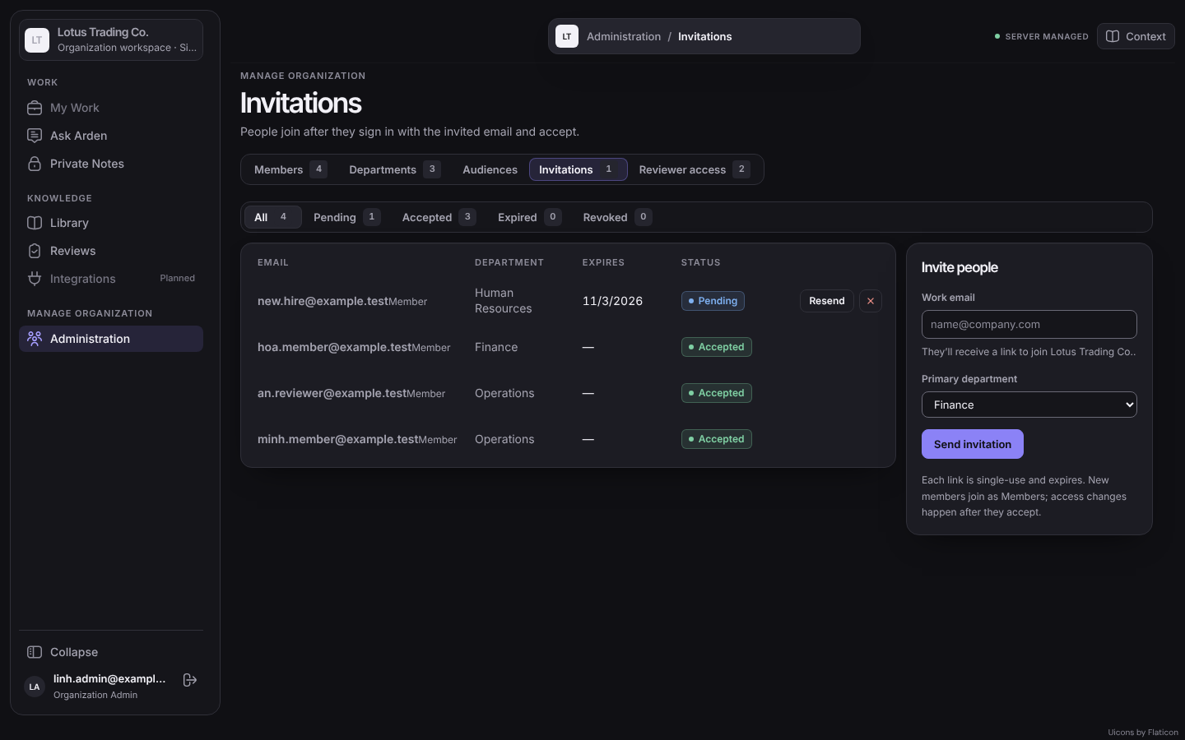
Figure 9: Administration – Invitations with the invite form (SCR-17)

3.3.5 FR-ORG-05 Accept an invitation
Item | Specification
Status | Implemented
Related UC / screen / NSF | UC-07; SCR-04
Function trigger | The invited person opens the email link /invite/{token}.
Actor and permission | Invited user
Function description | Sign in or create an account with the invited email and explicitly accept to become a Member of the invited department.
Preconditions | Invitation Pending and not expired.
Postconditions | Active membership with the invited primary department, or with no department if none was invited; invitation Accepted.
Main flow | 1. Page shows Continue to Arden with Sign in / Create account.  2. User authenticates with the invited email and selects Sign in and accept.  3. API verifies the token hash, expiry and verified email match, then creates the membership.
Alternate and error flows | • Expired, revoked, already used or other-account invitation → INVITATION_NOT_AVAILABLE (MSG-016), nothing created.
Inputs and validation | Token: 43 URL-safe characters.
Data read / changed | organization_invitation, organization_membership, department_membership, audit_event.
Business rules | BR-MEM-001.
Screen / API / job | POST /api/v1/invitations/accept.
Acceptance criteria | AC1: Accepting with the invited verified email creates exactly one Active membership.  AC2: Another account cannot accept the link.
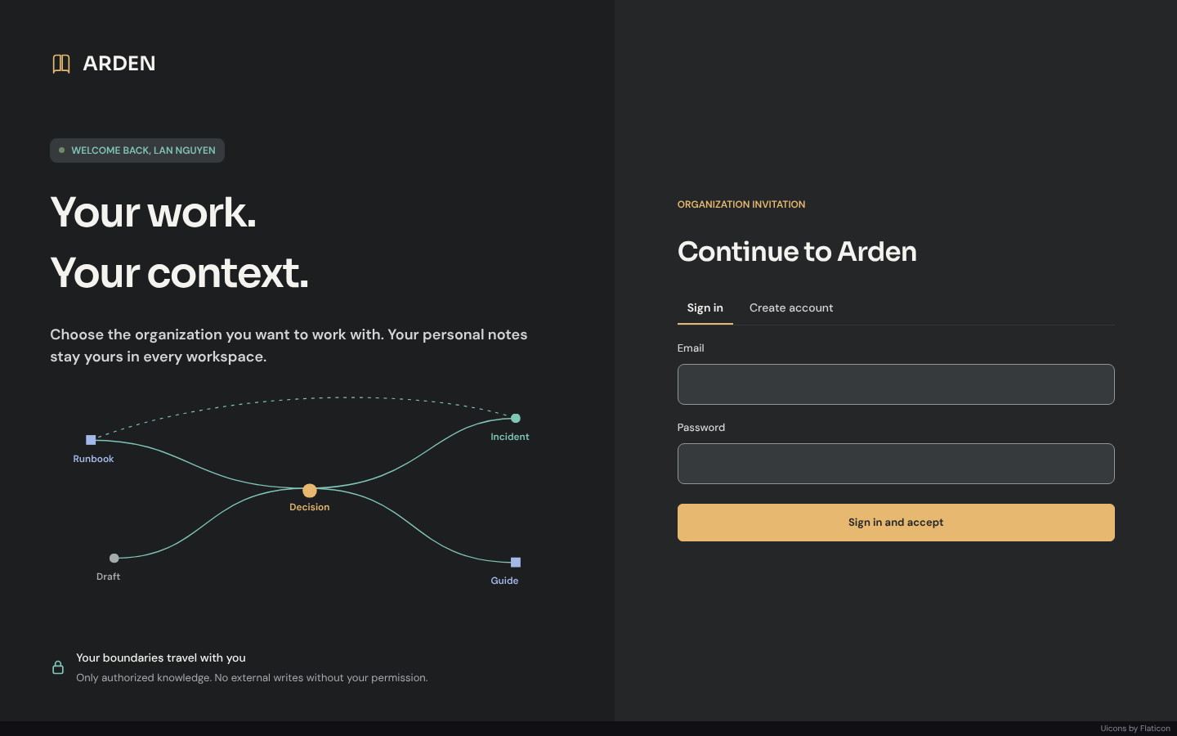
Figure 10: Invitation Accept (SCR-04)

3.3.6 FR-ORG-06 Manage members and primary department
Item | Specification
Status | Implemented (removal and admin promotion disabled)
Related UC / screen / NSF | UC-08; SCR-14
Function trigger | Administration → Members → Manage.
Actor and permission | Organization Admin
Function description | View members with department, access, grants and audiences; move a member to another primary department.
Preconditions | Target is an Active member.
Postconditions | New primary department; Department-audience readership and the responsible department of new drafts follow it.
Main flow | 1. Admin filters or searches members and opens Manage.  2. Admin selects Move and a department.  3. API changes the primary department and records audit.
Alternate and error flows | • Unknown member or department → RESOURCE_NOT_AVAILABLE.  • "Remove from organization" and "Make Org Admin" are shown disabled.
Inputs and validation | Department ID.
Data read / changed | department_membership, audit_event.
Business rules | BR-ORG-005, BR-MEM-004, BR-ACC-006.
Screen / API / job | GET /api/v1/organizations/{organizationId}/administration; POST /api/v1/organizations/{organizationId}/members/{membershipId}/department.
Acceptance criteria | AC1: After the move the member reads Department publications of the new department only, on the next request.  AC2: Pending submissions keep their frozen responsible department.
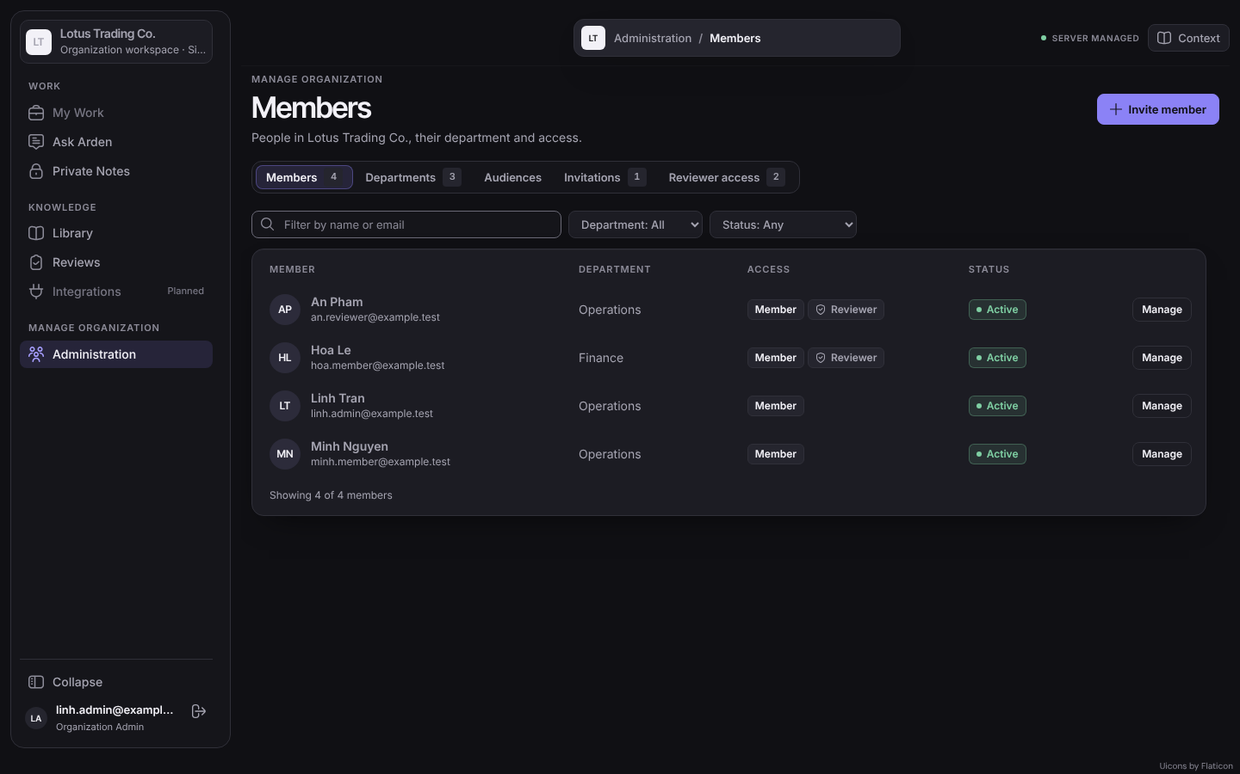
Figure 11: Administration – Members (SCR-14)
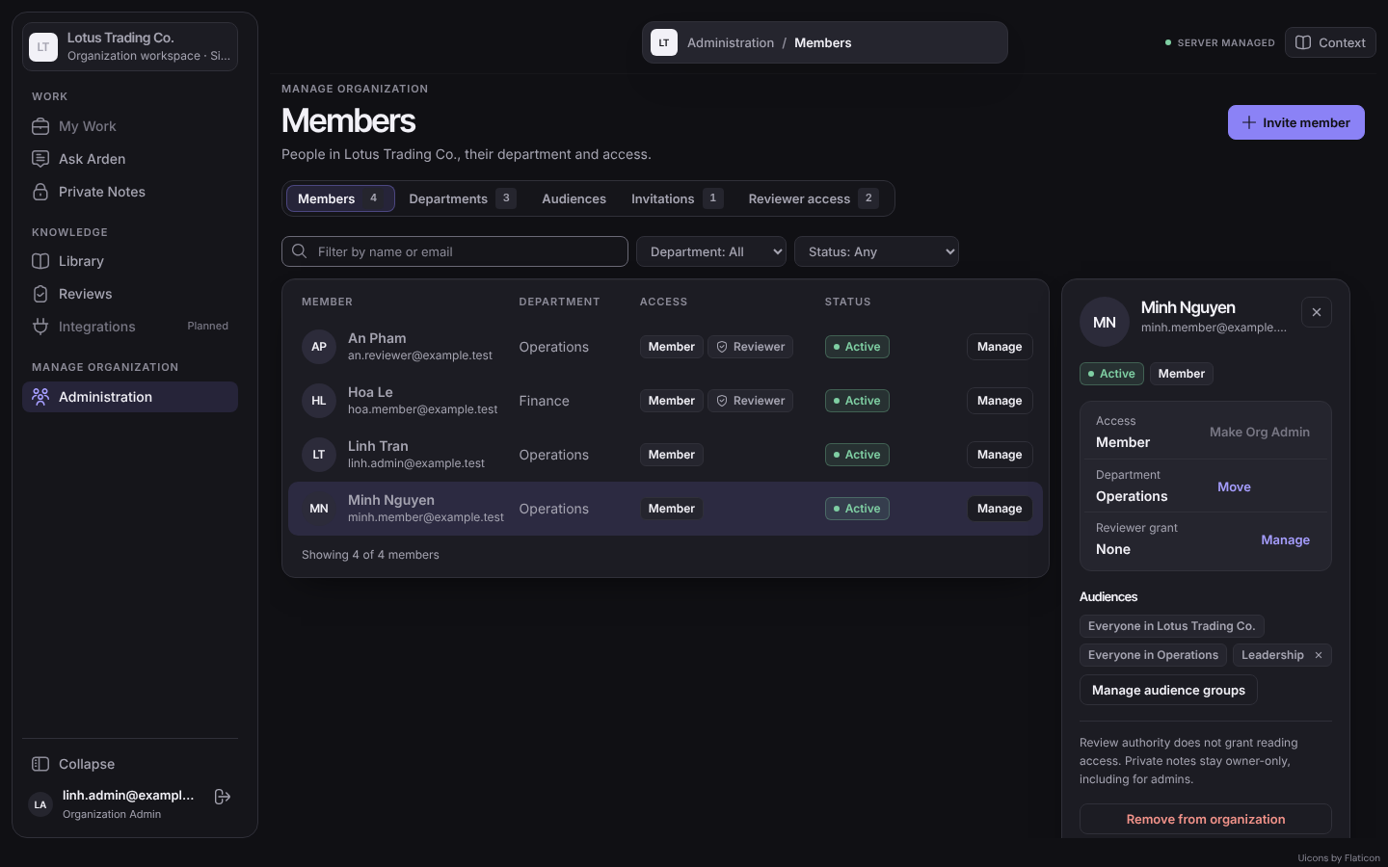
Figure 12: Member detail

3.4 Audiences, Reviewer Grants and System Administration
Defines who may read, who may review, and who administers the installation.
ID | Function | Actor | Status
FR-ACC-01 | Manage audience groups | Organization Admin | Implemented
FR-ACC-02 | Manage reviewer grants | Organization Admin | Implemented
FR-SYS-01 | Bootstrap the first Arden System Admin | Server operator | Implemented
FR-SYS-02 | Manage Arden System Admins | Arden System Admin | Partial (API only)
FR-SYS-03 | View the organization overview | Arden System Admin | Planned

3.4.1 FR-ACC-01 Manage audience groups
Item | Specification
Status | Implemented
Related UC / screen / NSF | UC-09; SCR-16
Function trigger | Administration → Audiences → New audience group, or select a group.
Actor and permission | Organization Admin
Function description | Create, rename (with version check) or deactivate groups and add or remove active members. Managed Organization and Department audiences are shown but cannot be edited.
Preconditions | Actor is Organization Admin.
Postconditions | Group membership changes take effect on the next request.
Main flow | 1. Admin creates a group with name and description.  2. Admin selects a group, chooses an active member and selects Add, or removes a member.  3. Deactivate requires the current version.
Alternate and error flows | • Stale version → 428/409 "Reload the audience group before saving."  • Member or admin of another organization → non-enumerating denial.
Inputs and validation | Name 1–80; description ≤300 characters; membership ID of an active member.
Data read / changed | audience (GROUP), audience_group_membership, audit_event.
Business rules | BR-ACC-003, BR-ACC-004, BR-ACC-006.
Screen / API / job | GET/POST /api/v1/organizations/{organizationId}/audience-groups; PATCH …/{id}; POST …/{id}/members; POST …/members/{id}/remove; POST …/{id}/deactivate.
Acceptance criteria | AC1: A member added to a group reads publications shared with it on the next request.  AC2: After removal the member is denied on the next request.
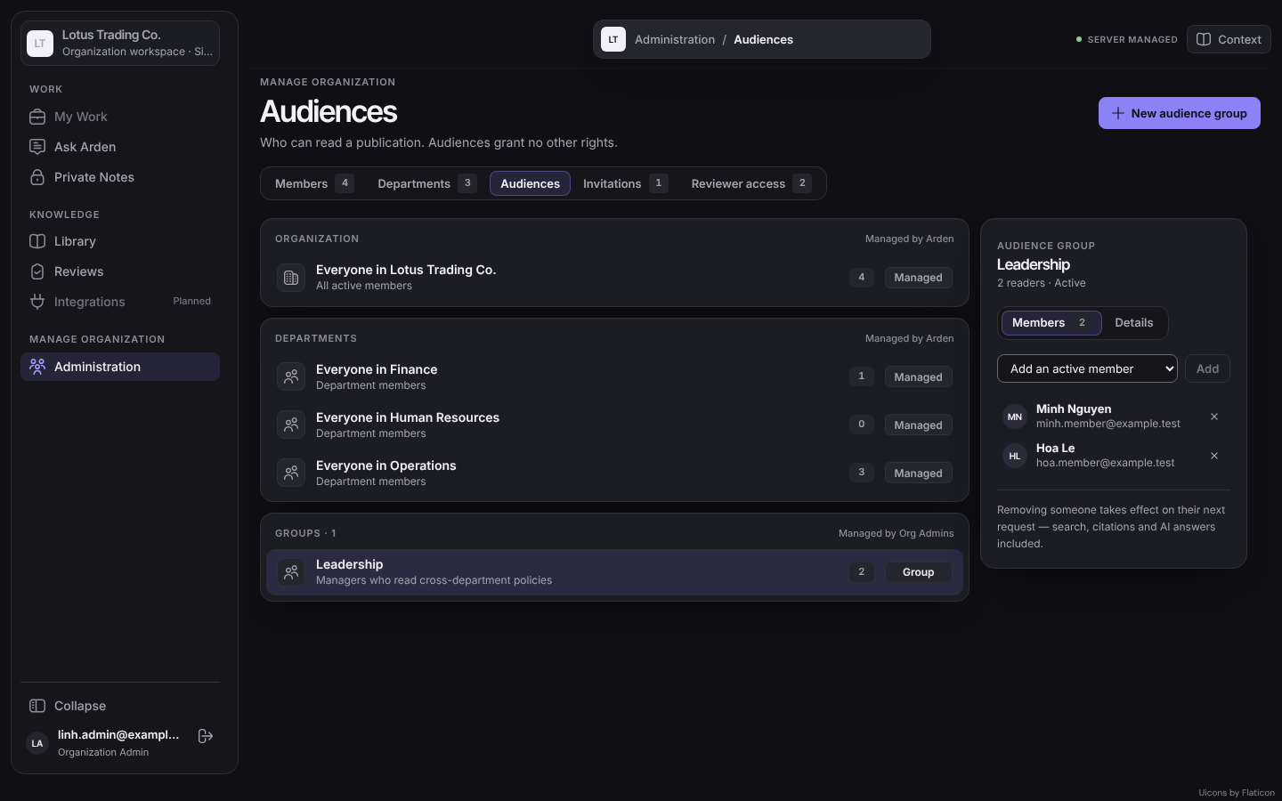
Figure 13: Administration – Audiences (SCR-16)

3.4.2 FR-ACC-02 Manage reviewer grants
Item | Specification
Status | Implemented
Related UC / screen / NSF | UC-10; SCR-18
Function trigger | Administration → Reviewer access → New grant, or Revoke.
Actor and permission | Organization Admin
Function description | Grant review authority with scope One department (department and group-only snapshots owned by that department) or Whole organization (snapshots readable by everyone). Optional team and project tags and an expiry narrow the grant.
Preconditions | Reviewer is an active member.
Postconditions | Grant Active; queues and decisions recheck it on every request.
Main flow | 1. Admin chooses reviewer, scope, department (department scope only), optional tags and expiry.  2. The form previews what the grant covers.  3. Create grant; Revoke deactivates it.
Alternate and error flows | • Department scope without department, Organization scope with a department, or past expiry → "The reviewer grant is invalid."  • The authoring screen warns when an organization-wide audience is chosen and no Organization grant exists.
Inputs and validation | Reviewer membership ID; scope DEPARTMENT/ORGANIZATION; tags 1–100 characters; expiry in the future.
Data read / changed | reviewer_grant (scope, department_id, tags, valid_until, status), audit_event.
Business rules | BR-GOV-002, BR-GOV-003.
Screen / API / job | GET/POST /api/v1/organizations/{organizationId}/knowledge/reviewer-grants; POST …/reviewer-grants/{id}/deactivate.
Acceptance criteria | AC1: A Department grant for Operations sees Operations department and group-only snapshots only.  AC2: An Organization grant sees only snapshots that include the Organization audience.  AC3: After revoke the reviewer's queue is empty.
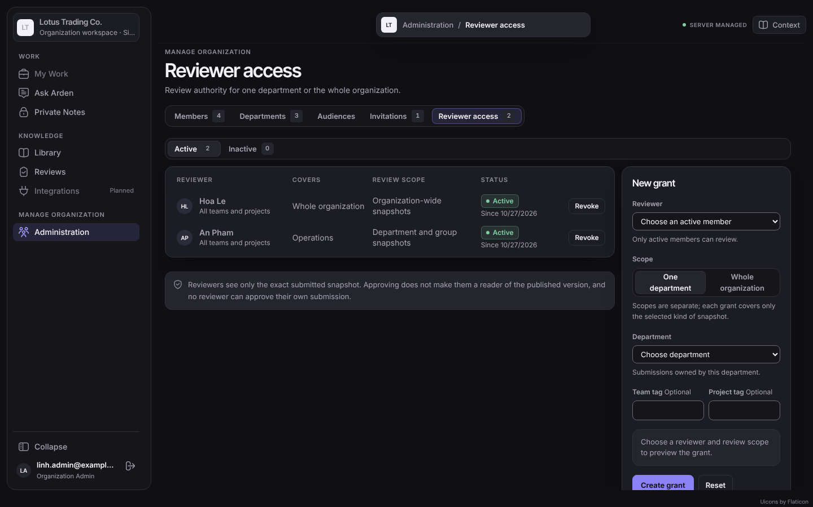
Figure 14: Administration – Reviewer access (SCR-18)

3.4.3 FR-SYS-01 Bootstrap the first Arden System Admin
Item | Specification
Status | Implemented
Related UC / screen / NSF | NSF-12
Function trigger | An operator runs pnpm system-admin:bootstrap on the server.
Actor and permission | Server operator
Function description | Create the first installation administrator for an existing active user account.
Preconditions | Migration 0017 applied; no System Admin exists.
Postconditions | One Active System Admin.
Main flow | 1. Operator sets the migration database URL and the target user ID.  2. Command locks, checks preconditions and inserts the administrator.
Alternate and error flows | • A System Admin already exists → command fails, nothing changes.  • Unknown or inactive account → fails.
Inputs and validation | User ID (UUID).
Data read / changed | system_administrator.
Business rules | BR-ROLE-003.
Screen / API / job | Command-line only; no HTTP route.
Acceptance criteria | AC1: A second run fails.  AC2: No HTTP route can create the first System Admin.

3.4.4 FR-SYS-02 Manage Arden System Admins
Item | Specification
Status | Partial (API only)
Related UC / screen / NSF | UC-32; SCR-20
Function trigger | System Administration screen (planned) or API call.
Actor and permission | Arden System Admin
Function description | List, grant and revoke System Admins; every change is recorded as a system administration event.
Preconditions | Actor is an Active System Admin.
Postconditions | Administrator list changed.
Main flow | 1. GET /api/v1/system/administrators.  2. POST /api/v1/system/administrators {userId}.  3. POST /api/v1/system/administrators/{userId}/revoke.
Alternate and error flows | • Non-administrator → 404 "The resource is not available."  • Revoking the last active System Admin → 409 SYSTEM_ADMINISTRATOR_LAST_ACTIVE (MSG-020).
Inputs and validation | User ID.
Data read / changed | system_administrator, system_administration_event.
Business rules | BR-ROLE-003.
Screen / API / job | /api/v1/system/administrators.
Acceptance criteria | AC1: Organization Admins and Members cannot enumerate or change System Admins.  AC2: The last active System Admin cannot be revoked.  AC3: A System Admin without membership cannot open any organization.

3.4.5 FR-SYS-03 View the organization overview
Item | Specification
Status | Planned
Related UC / screen / NSF | SCR-20
Function trigger | System Administration → Organizations.
Actor and permission | Arden System Admin
Function description | List organizations with status and member count only.
Preconditions | Active System Admin.
Postconditions | None.
Main flow | 1. Open the overview.
Alternate and error flows | • Non-administrator → not available.
Inputs and validation | —
Data read / changed | Reads organization and membership counts.
Business rules | BR-ROLE-003.
Screen / API / job | Planned API under /api/v1/system.
Acceptance criteria | AC1: No document title, content or private item is returned.

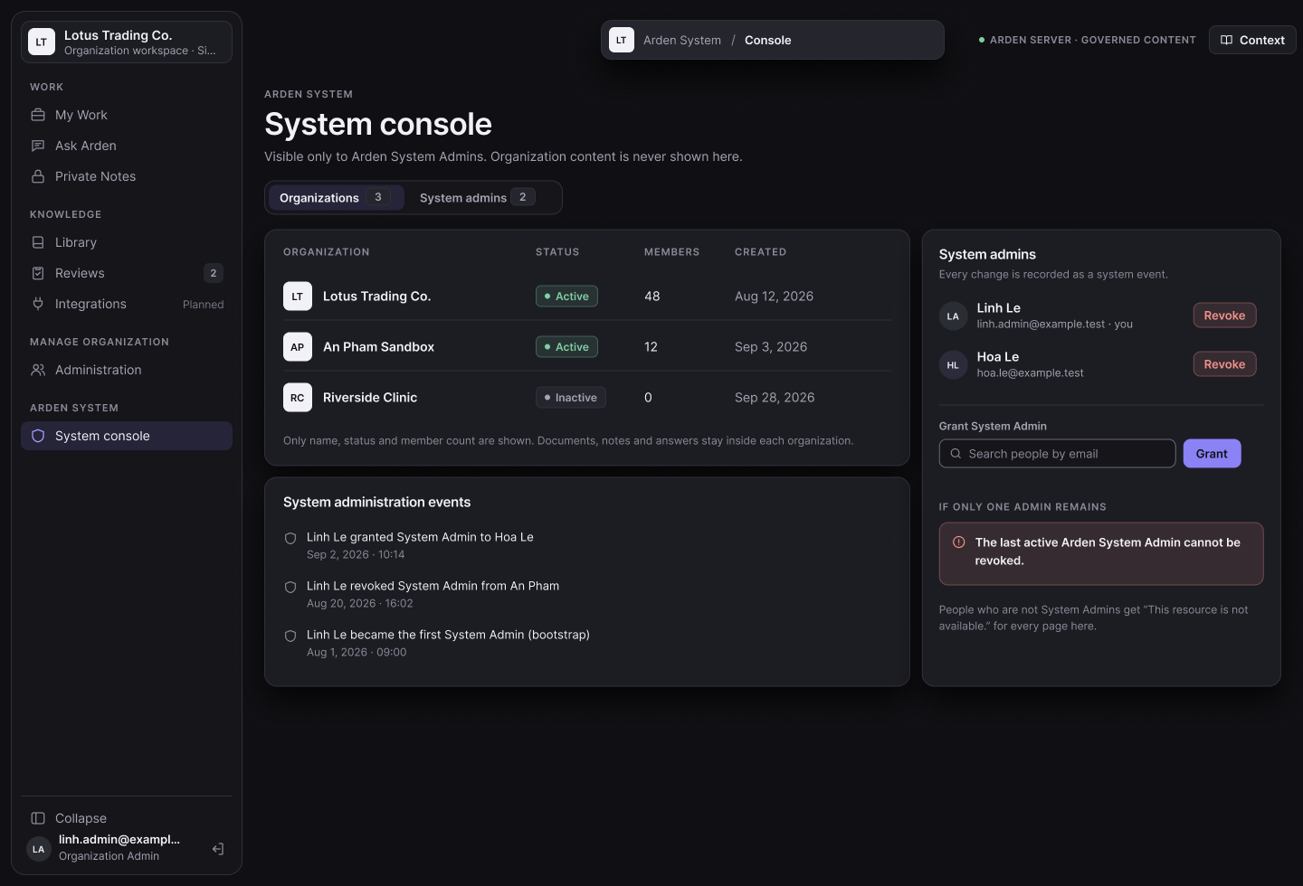
Figma screen R3-11: System console and organization overview

3.5 Personal Knowledge
Keeps each member's own notes private and lets them share a separate copy through governance.
ID | Function | Actor | Status
FR-PKM-01 | Manage private notes | Member (owner) | Implemented
FR-PKM-02 | Contribute a copy | Member (owner) | Implemented
FR-PKM-03 | Upload a personal document | Member | Planned
FR-PKM-04 | Organize personal collections | Member | Planned

3.5.1 FR-PKM-01 Manage private notes
Item | Specification
Status | Implemented
Related UC / screen / NSF | UC-11; SCR-07
Function trigger | Sidebar → Private Notes.
Actor and permission | Member (owner)
Function description | Create, list, search, open and edit owner-only notes. Each save creates a new version.
Preconditions | Active membership.
Postconditions | New note version saved.
Main flow | 1. Member selects + to create a note, or selects a note.  2. Member edits title and text and selects Save.  3. Search filters the member's notes (Ctrl K).
Alternate and error flows | • Stale version → VERSION_CONFLICT "This note changed. Reload it before saving again." (MSG-018).  • Missing If-Match → PRECONDITION_REQUIRED.  • Another user opening the note → RESOURCE_NOT_AVAILABLE.
Inputs and validation | Title ≤800; body ≤100,000 bytes.
Data read / changed | draft_document, draft_version (private workspace), private storage.
Business rules | BR-ACC-001, BR-PKM-001.
Screen / API / job | GET/POST /api/v1/organizations/{organizationId}/private-workspace/drafts; GET/PATCH …/drafts/{draftId}.
Acceptance criteria | AC1: Another member, the Organization Admin and the System Admin cannot open the note.  AC2: Each save increases the version by one.
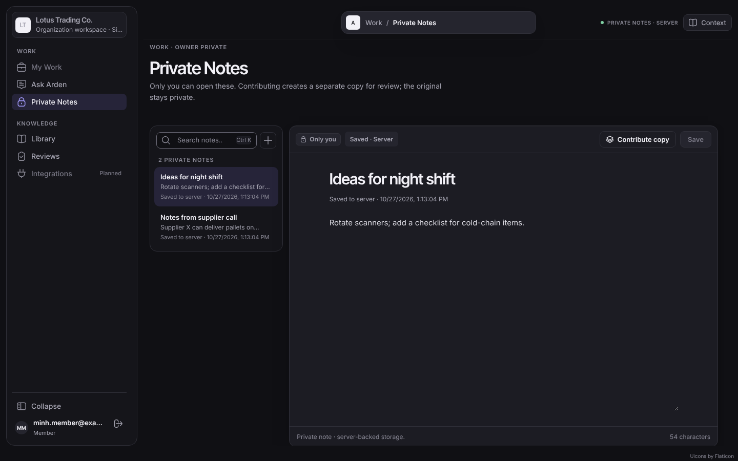
Figure 15: Private Notes (SCR-07)

3.5.2 FR-PKM-02 Contribute a copy
Item | Specification
Status | Implemented
Related UC / screen / NSF | UC-14; SCR-08
Function trigger | Private Notes → Contribute copy.
Actor and permission | Member (owner)
Function description | Create a separate shared draft from the exact saved version of a private note. Nothing is submitted, approved or published; readers and reviewers are chosen later in the draft.
Preconditions | The note version is saved and owned by the actor.
Postconditions | New shared draft (version 1) authored by the actor; the private original is unchanged.
Main flow | 1. Member selects Contribute copy.  2. Dialog shows the saved version to copy.  3. Member selects Create shared draft.  4. API copies the version with an Idempotency-Key.
Alternate and error flows | • Unsaved or unsupported note format → SOURCE_NOT_SUPPORTED.  • Repeated request with the same key → the first draft is returned.
Inputs and validation | Source private version ID; Idempotency-Key.
Data read / changed | shared_draft, shared_draft_version, audit_event.
Business rules | BR-ACC-001, BR-DOC-003.
Screen / API / job | POST /api/v1/organizations/{organizationId}/knowledge/drafts {sourcePrivateVersionId}.
Acceptance criteria | AC1: The new draft has the same content hash as the copied version.  AC2: Later edits of either side do not affect the other.
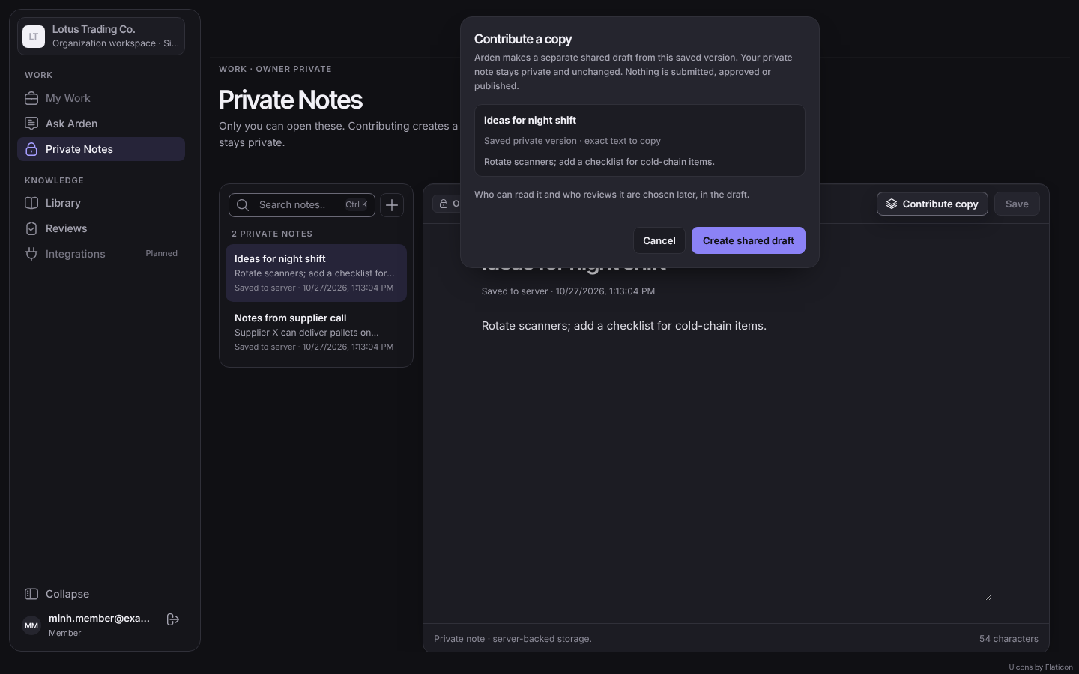
Figure 16: Contribute a copy dialog (SCR-08)

3.5.3 FR-PKM-03 Upload a personal document
Item | Specification
Status | Planned
Related UC / screen / NSF | UC-12; SCR-07
Function trigger | Private Notes → Upload PDF.
Actor and permission | Member
Function description | Store a text-based PDF (≤5 MB) as an owner-only item.
Preconditions | Active membership.
Postconditions | Private item stored.
Main flow | 1. Member chooses a PDF and confirms.
Alternate and error flows | • Non-PDF → MSG-013; >5 MB → MSG-014.
Inputs and validation | PDF ≤5 MB.
Data read / changed | Private item and version.
Business rules | BR-DOC-002, BR-PKM-001.
Screen / API / job | Planned.
Acceptance criteria | AC1: Only the owner can open or download the document.

3.5.4 FR-PKM-04 Organize personal collections
Item | Specification
Status | Planned
Related UC / screen / NSF | UC-13; SCR-07
Function trigger | Private Notes → Collections.
Actor and permission | Member
Function description | Create, rename and delete collections and add or remove own items.
Preconditions | Active membership.
Postconditions | Collection changed; items unaffected by deletion.
Main flow | 1. Member creates a collection and adds items.
Alternate and error flows | • Adding another member's item → refused.
Inputs and validation | Name 1–80.
Data read / changed | Personal collection, collection item.
Business rules | BR-PKM-001.
Screen / API / job | Planned.
Acceptance criteria | AC1: Collections are visible only to the owner.  AC2: Deleting a collection keeps its items.

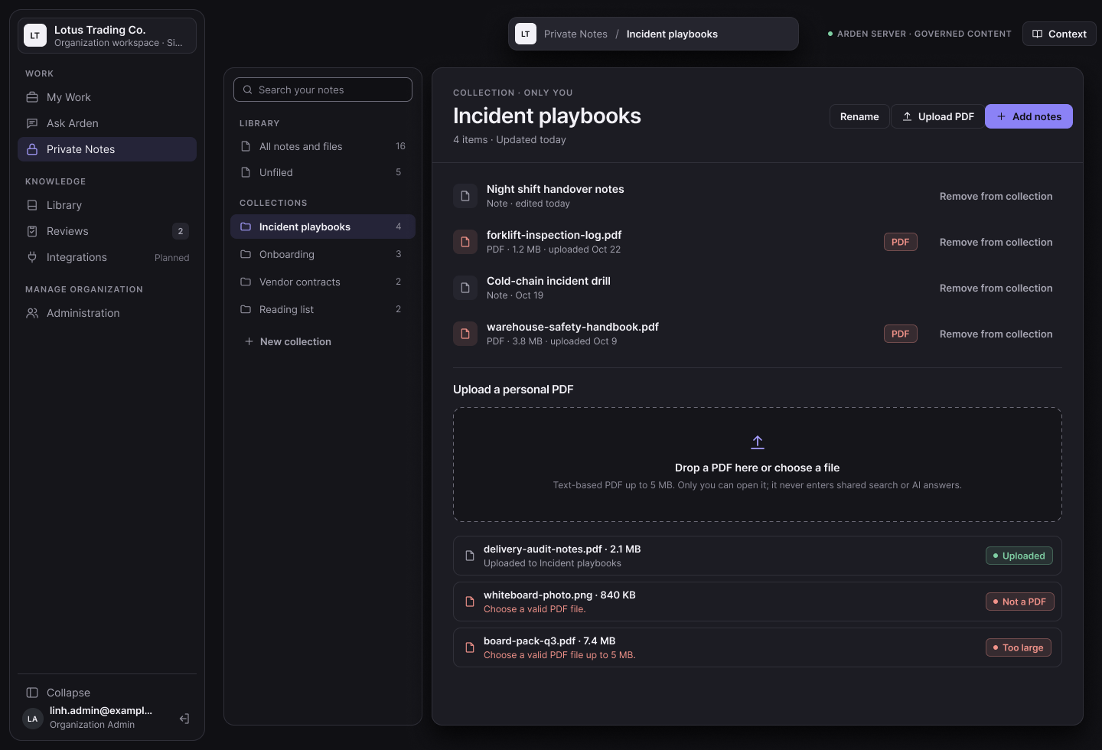
Figma screen R3-13: Upload personal document and organize collections

3.6 Shared Drafts and Submission
Lets members author shared knowledge, choose its readers and freeze an exact snapshot for review.
ID | Function | Actor | Status
FR-DOC-01 | Create a shared draft from text | Member | Implemented
FR-DOC-02 | Create a shared draft from a PDF | Member | Implemented
FR-DOC-03 | Edit the draft and choose readers | Author | Implemented
FR-DOC-04 | Submit a snapshot for review | Author | Implemented
FR-DOC-05 | Track contributions and history | Author | Implemented
FR-DOC-06 | Withdraw a pending submission | Author; Organization Admin | Planned

3.6.1 FR-DOC-01 Create a shared draft from text
Item | Specification
Status | Implemented
Related UC / screen / NSF | UC-15; SCR-11
Function trigger | Library → New draft → Write document text.
Actor and permission | Member
Function description | Create an author-owned draft. Plain text is normalized to Semantic Document v1.
Preconditions | Active membership.
Postconditions | Draft version 1 exists in My Contributions with status "Draft · metadata incomplete".
Main flow | 1. Member enters a title and text.  2. Client sends POST …/drafts/new with an Idempotency-Key.  3. API normalizes and stores the content and returns the draft.
Alternate and error flows | • Empty title or invalid text → INVALID_REQUEST / INVALID_DOCUMENT.  • Same Idempotency-Key with different content → IDEMPOTENCY_CONFLICT.
Inputs and validation | Title 1–160 characters in the UI (server ≤200 code points); body ≤100,000 bytes.
Data read / changed | shared_draft, shared_draft_version, storage, audit_event.
Business rules | BR-DOC-001.
Screen / API / job | POST /api/v1/organizations/{organizationId}/knowledge/drafts/new.
Acceptance criteria | AC1: A valid request creates exactly one draft at version 1.  AC2: Repeating it with the same key creates no second draft.
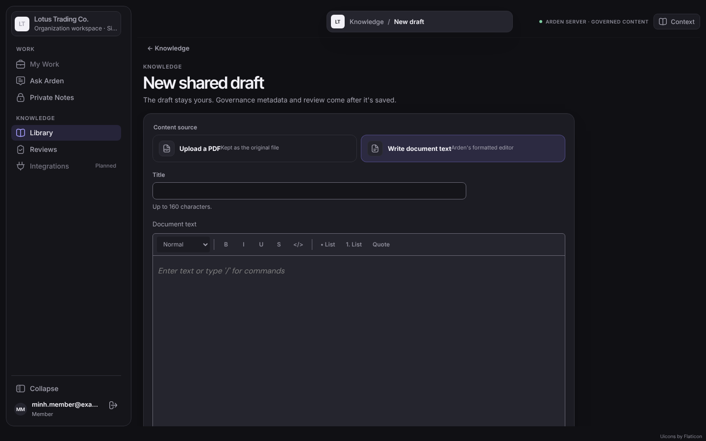
Figure 17: New shared draft (SCR-11)

3.6.2 FR-DOC-02 Create a shared draft from a PDF
Item | Specification
Status | Implemented
Related UC / screen / NSF | UC-15; SCR-11
Function trigger | Library → Create from PDF, or New draft → Upload a PDF.
Actor and permission | Member
Function description | Upload a PDF kept as the original file; the PDF is the draft content and cannot be edited as text.
Preconditions | Active membership.
Postconditions | PDF draft version 1.
Main flow | 1. Member chooses the file and title.  2. Client sends the file (base64) with an Idempotency-Key.  3. API checks type and size and stores the file.
Alternate and error flows | • Not a PDF → INVALID_PDF (MSG-013).  • Larger than 5 MB → INVALID_PDF / REQUEST_TOO_LARGE (MSG-014).  • Text edit of a PDF draft → "Uploaded PDFs cannot be edited as text."
Inputs and validation | PDF only, non-empty, ≤5 MB; title as FR-DOC-01.
Data read / changed | shared_draft, shared_draft_version (application/pdf), storage.
Business rules | BR-DOC-002.
Screen / API / job | POST /api/v1/organizations/{organizationId}/knowledge/drafts/pdf.
Acceptance criteria | AC1: A 2 MB PDF becomes a draft; a 6 MB PDF and a .docx are rejected with the correct message.

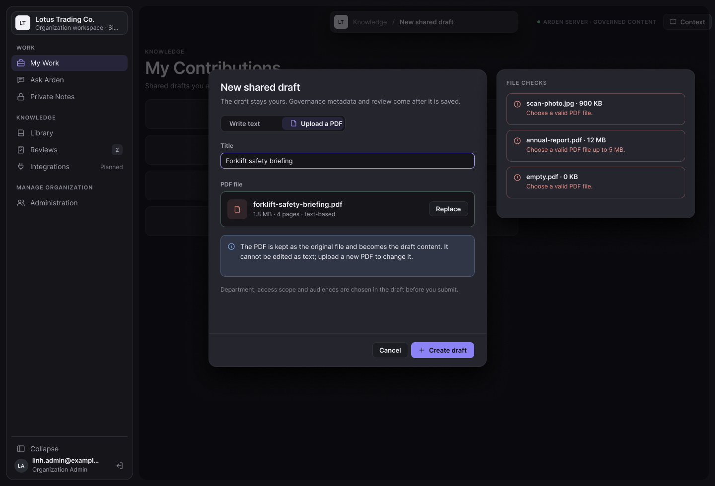
Figma screen R3-15: Create a shared draft from PDF

3.6.3 FR-DOC-03 Edit the draft and choose readers
Item | Specification
Status | Implemented
Related UC / screen / NSF | UC-16; SCR-12
Function trigger | My Contributions → select a draft → Open draft.
Actor and permission | Author
Function description | Edit the working version and choose who can read it: the Organization audience, the author's Department audience and/or audience groups the author belongs to. The responsible department is not chosen: it is the author's primary department ("Owned by you · reviewed by <department>"). The working draft stays editable while a snapshot is under review.
Preconditions | Actor is the author.
Postconditions | New immutable version with metadata.
Main flow | 1. Author edits text (rich-text toolbar: heading, bold, italic, lists, quote, code).  2. Author types in Who can read it and picks audiences; optional team/project tags.  3. Readiness checklist shows Title, Your department, Readers.  4. Save version (If-Match) creates the next version.
Alternate and error flows | • Stale version → VERSION_CONFLICT (MSG-018).  • Audience not readable by the author, Organization audience with Department scope, or another department → INVALID_METADATA.  • Author without primary department can save but not submit.
Inputs and validation | Audience IDs 1–100 (unique); scope ORGANIZATION/DEPARTMENT; tags ≤100 characters.
Data read / changed | shared_draft, shared_draft_version, shared_draft_audience.
Business rules | BR-ACC-002, BR-ACC-004, BR-ACC-005, BR-GOV-001.
Screen / API / job | GET /api/v1/organizations/{organizationId}/knowledge/options; PATCH /api/v1/organizations/{organizationId}/knowledge/drafts/{draftId}.
Acceptance criteria | AC1: The reader list offers only audiences the author can read.  AC2: A Department publication shared with a group is readable only by group members of that department.  AC3: Editing during review does not change the submitted snapshot.
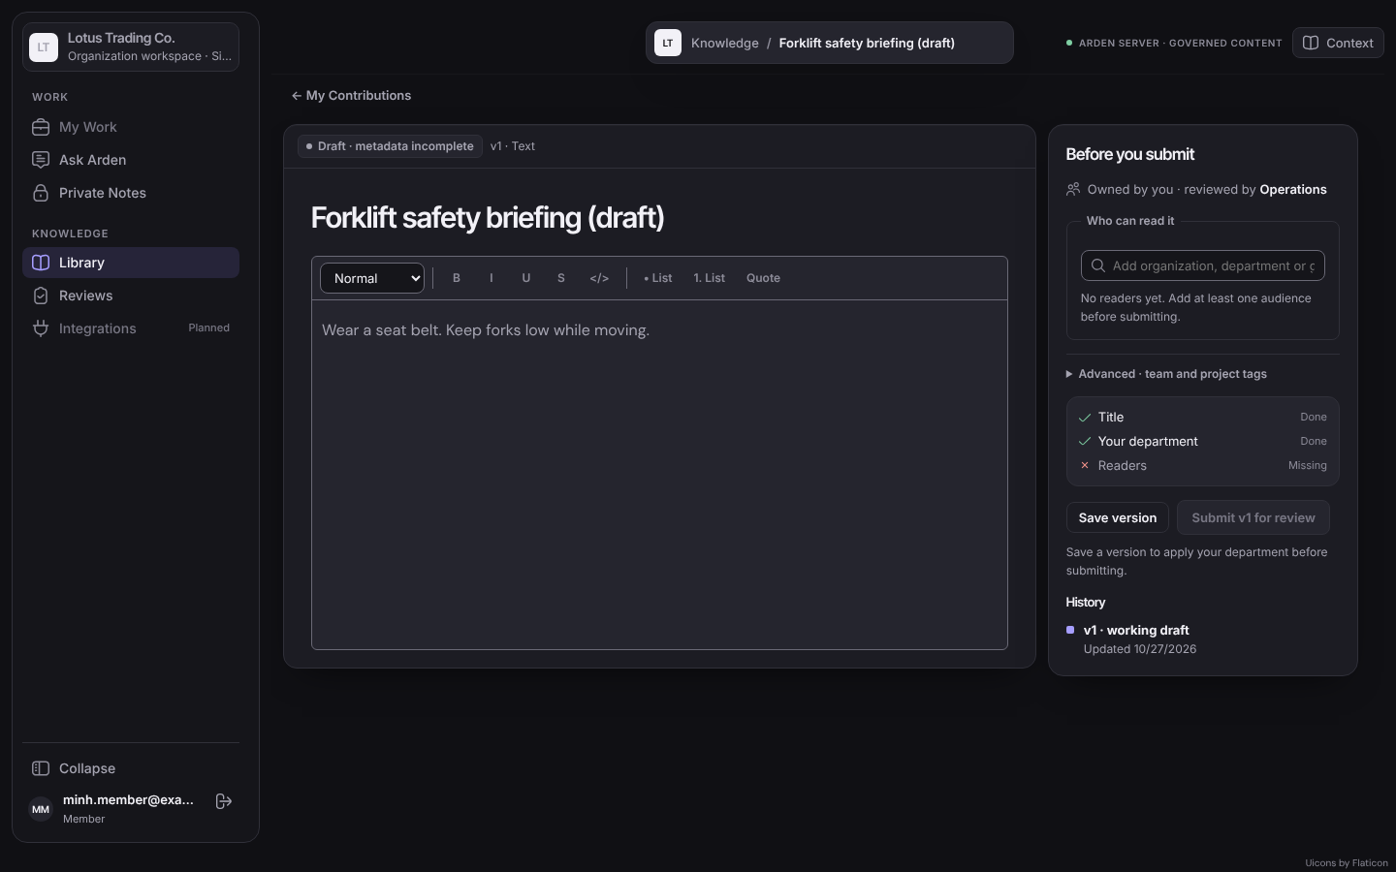
Figure 18: Draft editor with Before you submit (SCR-12)
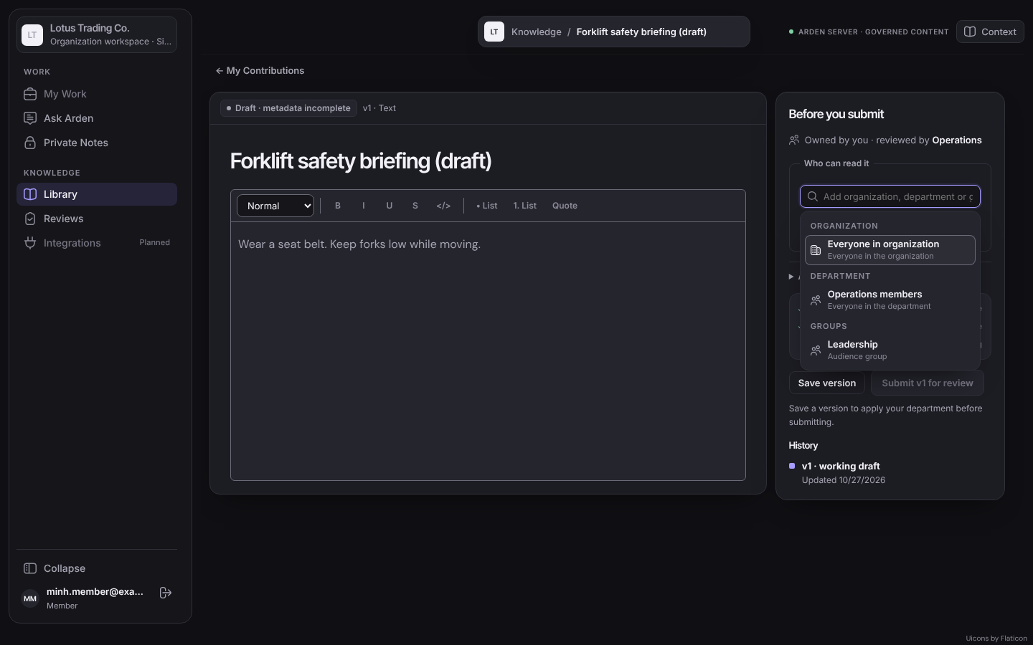
Figure 19: Reader picker

3.6.4 FR-DOC-04 Submit a snapshot for review
Item | Specification
Status | Implemented
Related UC / screen / NSF | UC-17; SCR-12
Function trigger | Draft editor → Submit vN for review.
Actor and permission | Author
Function description | Freeze the exact current version, title, responsible department, scope, tags, audiences, review rule and content hash into an immutable submission.
Preconditions | All checklist items done; no other open submission for the draft; the stored department equals the author's current primary department.
Postconditions | Submission Pending Review; appears in eligible review queues.
Main flow | 1. Author selects Submit (If-Match, Idempotency-Key).  2. API checks readiness and creates the snapshot.  3. My Contributions shows Awaiting review.
Alternate and error flows | • Missing department, scope or audience → DRAFT_NOT_READY (MSG-004).  • Open candidate exists or stale version → SUBMISSION_CONFLICT.
Inputs and validation | Draft ID, version (If-Match).
Data read / changed | shared_submission, audit_event.
Business rules | BR-GOV-001, BR-GOV-005, BR-LIFE-001.
Screen / API / job | POST /api/v1/organizations/{organizationId}/knowledge/drafts/{draftId}/submit.
Acceptance criteria | AC1: A second concurrent submit of the same draft gets a conflict; exactly one candidate is open.  AC2: The submission keeps its hash even if the draft is edited later.

3.6.5 FR-DOC-05 Track contributions and history
Item | Specification
Status | Implemented
Related UC / screen / NSF | SCR-09
Function trigger | Library → My Contributions.
Actor and permission | Author
Function description | List own drafts with version, readers, department, status (Draft · metadata incomplete, Awaiting review, Rejected, Published) and the reviewer note; open the history of versions and submissions.
Preconditions | Signed in.
Postconditions | None.
Main flow | 1. Open My Contributions.  2. Select a row to see details, reviewer note and history.
Alternate and error flows | • No drafts → empty state.
Inputs and validation | —
Data read / changed | Reads shared_draft, shared_submission, review_decision.
Business rules | BR-LIFE-001.
Screen / API / job | GET /api/v1/organizations/{organizationId}/knowledge/drafts; GET …/knowledge/submissions.
Acceptance criteria | AC1: A rejected draft shows the reviewer note.  AC2: Versions and history entries cannot be edited.
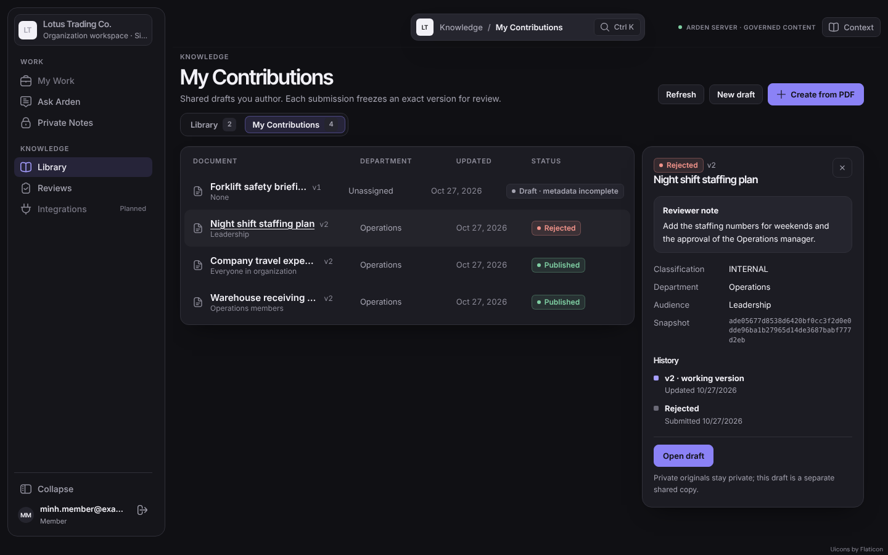
Figure 20: My Contributions with a rejected draft (SCR-09)

3.6.6 FR-DOC-06 Withdraw a pending submission
Item | Specification
Status | Planned
Related UC / screen / NSF | UC-18
Function trigger | My Contributions → Withdraw.
Actor and permission | Author; Organization Admin
Function description | Cancel a pending submission (status Withdrawn).
Preconditions | Submission Pending Review.
Postconditions | Submission Withdrawn; removed from queues.
Main flow | 1. Select Withdraw and confirm.
Alternate and error flows | • Already decided → conflict.
Inputs and validation | Submission ID.
Data read / changed | shared_submission, audit_event.
Business rules | BR-GOV-005.
Screen / API / job | Planned API.
Acceptance criteria | AC1: A withdrawn submission disappears from every review queue.

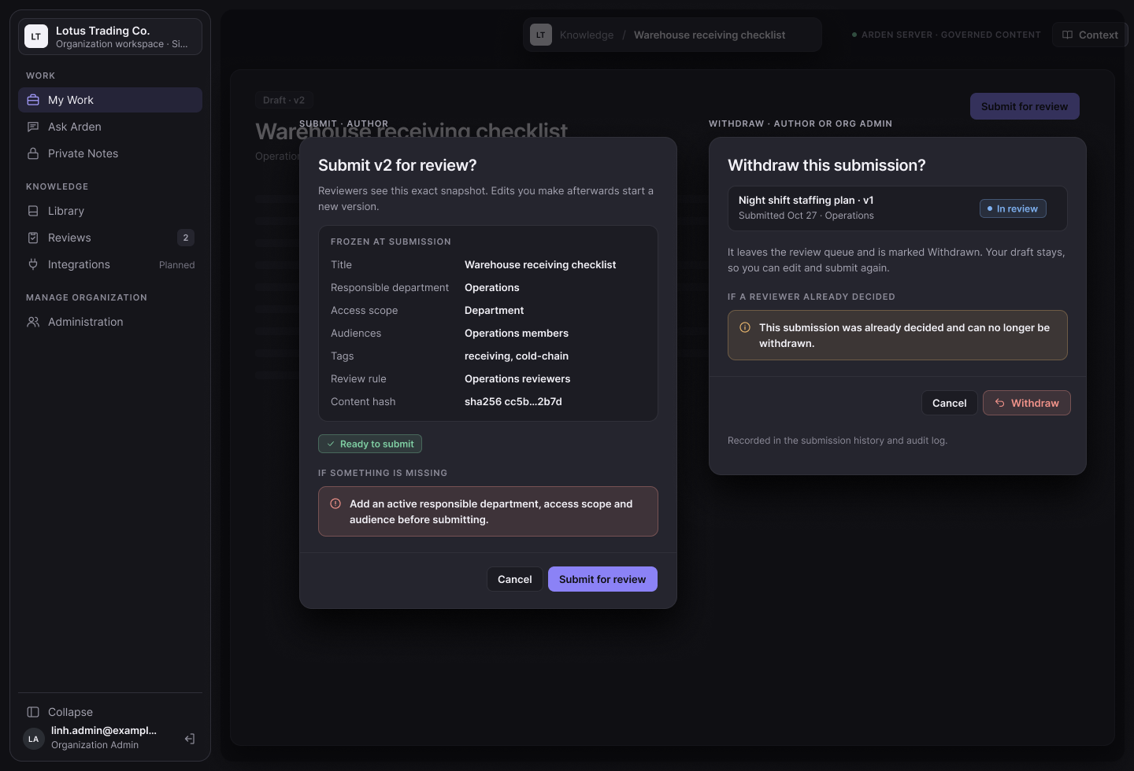
Figma screen R3-17: Submit and withdraw a pending submission

3.7 Review and Publication
Lets authorized people decide the exact snapshot and makes approved knowledge visible only after it is indexed.
ID | Function | Actor | Status
FR-REV-01 | Open the review queue | Knowledge Reviewer; Organization Admin | Implemented
FR-REV-02 | Inspect a submission | Knowledge Reviewer; Organization Admin | Implemented
FR-REV-03 | Approve a submission | Knowledge Reviewer (grant, not own); Organization Admin (any, own audited) | Implemented
FR-REV-04 | Reject a submission | Knowledge Reviewer; Organization Admin | Implemented
FR-PUB-01 | Index and activate an approved snapshot | System (indexing worker, Arden-AI) | Implemented (text and PDF)
FR-PUB-02 | Unpublish and restore knowledge | Organization Admin | Planned

3.7.1 FR-REV-01 Open the review queue
Item | Specification
Status | Implemented
Related UC / screen / NSF | UC-19; SCR-13
Function trigger | Sidebar → Reviews.
Actor and permission | Knowledge Reviewer; Organization Admin
Function description | List pending submissions the actor may decide: for an ordinary reviewer those covered by a current grant (Department grant: the responsible department's department/group-only snapshots; Organization grant: snapshots that include the Organization audience), never their own; for the Organization Admin every pending submission. Metadata only.
Preconditions | Active membership.
Postconditions | None.
Main flow | 1. Open Reviews.  2. Queue shows title, department and date; the count is shown in the sidebar.
Alternate and error flows | • No eligible submissions → "Queue is clear".  • Snapshot whose audience is no longer enforceable is marked approval-blocked.
Inputs and validation | —
Data read / changed | Reads shared_submission, reviewer_grant.
Business rules | BR-GOV-002, BR-GOV-003.
Screen / API / job | GET /api/v1/organizations/{organizationId}/knowledge/reviews.
Acceptance criteria | AC1: A Department reviewer for Operations does not see an organization-wide snapshot; an Organization reviewer does.  AC2: The reviewer's own submissions never appear.
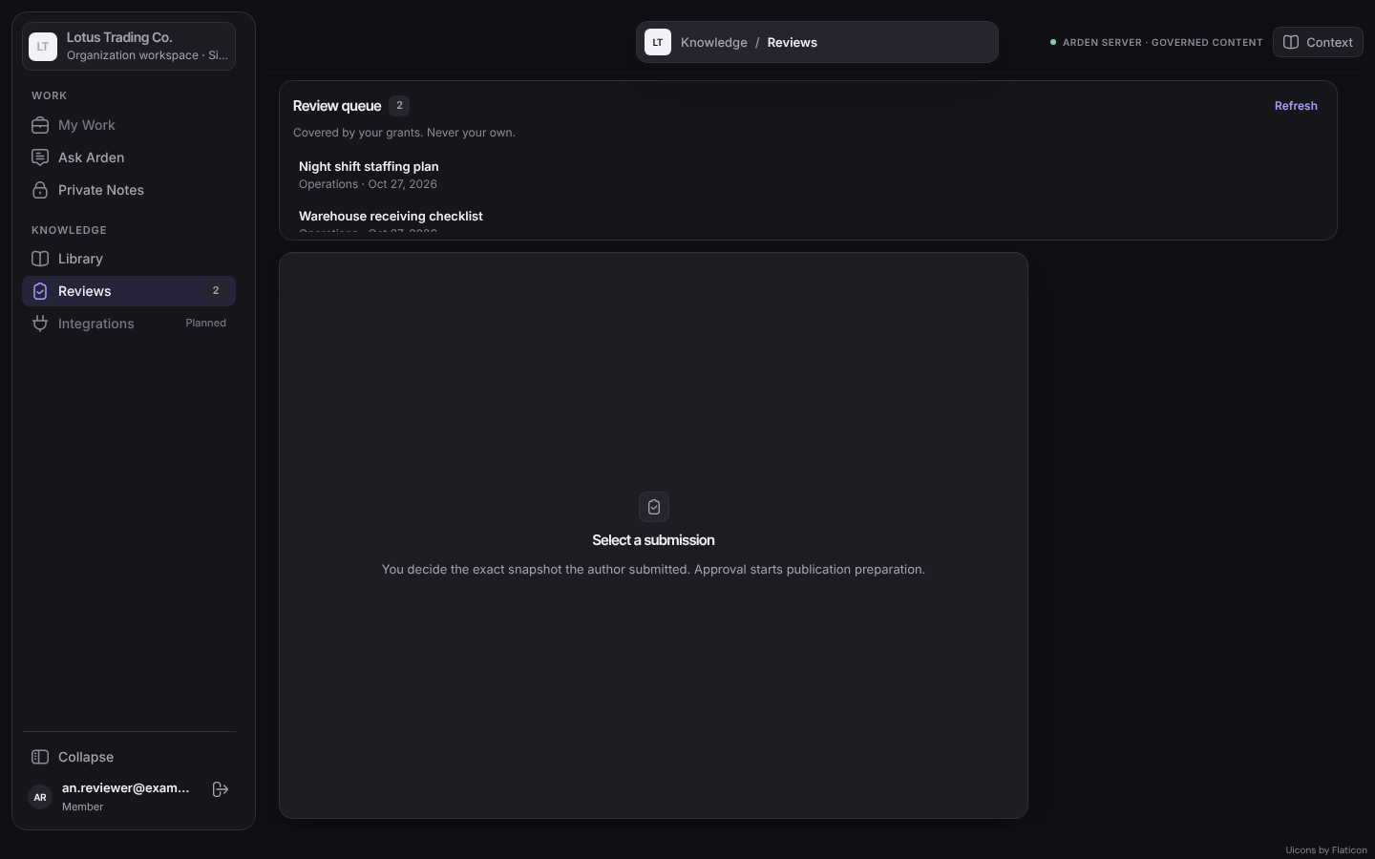
Figure 21: Review queue (SCR-13)

3.7.2 FR-REV-02 Inspect a submission
Item | Specification
Status | Implemented
Related UC / screen / NSF | UC-19; SCR-13
Function trigger | Select a submission in the queue.
Actor and permission | Knowledge Reviewer; Organization Admin
Function description | Show the exact frozen content and facts: required reviewer, department, access scope, audiences, tags and snapshot hash.
Preconditions | Actor eligible.
Postconditions | None.
Main flow | 1. API reauthorizes, loads the immutable snapshot and reauthorizes again.  2. Decision panel shows frozen facts and the note field.
Alternate and error flows | • Grant revoked meanwhile → RESOURCE_NOT_AVAILABLE.
Inputs and validation | —
Data read / changed | Reads shared_submission and stored content.
Business rules | BR-GOV-006.
Screen / API / job | GET /api/v1/organizations/{organizationId}/knowledge/reviews/{submissionId}.
Acceptance criteria | AC1: The displayed content hash equals the submitted hash.
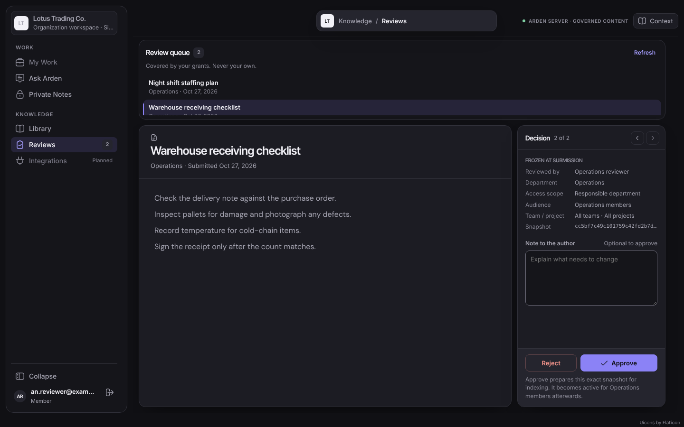
Figure 22: Submission detail and decision panel

3.7.3 FR-REV-03 Approve a submission
Item | Specification
Status | Implemented
Related UC / screen / NSF | UC-20; SCR-13; NSF-07
Function trigger | Decision panel → Approve → Approve for preparation.
Actor and permission | Knowledge Reviewer (grant, not own); Organization Admin (any, own audited)
Function description | Approve the exact snapshot. The server rechecks authority and audiences, records the decision and moves the snapshot to PREPARING. It is not visible until indexing finishes (FR-PUB-01).
Preconditions | Submission Pending Review; actor eligible; audiences enforceable.
Postconditions | Submission Approved, publication PREPARING, index job queued; toast "Approved. The exact reviewed snapshot is preparing for indexing; it is not active yet."
Main flow | 1. Reviewer selects Approve; a confirmation explains that indexing follows.  2. Client sends the action, expected snapshot version ID and content hash with an Idempotency-Key.  3. API locks the submission, rechecks and commits decision, audit, PREPARING state and index job.
Alternate and error flows | • Snapshot changed → REVIEW_CONFLICT.  • Audience not enforceable or author no longer eligible → AUDIENCE_NOT_ENFORCEABLE (MSG-019).  • Ordinary reviewer on own submission → not available.
Inputs and validation | Action APPROVE; expectedSnapshotVersionId; expectedContentHash; optional note ≤2,000.
Data read / changed | review_decision, shared_submission, knowledge_index_generation, knowledge_index_job, audit_event.
Business rules | BR-GOV-002…008, BR-LIFE-002.
Screen / API / job | POST /api/v1/organizations/{organizationId}/knowledge/reviews/{submissionId}/decisions.
Acceptance criteria | AC1: After approval the item is not in the Library until activation.  AC2: An Organization Admin self-approval is recorded with selfApproved = true.  AC3: A reviewer outside the audiences still cannot read the published item.
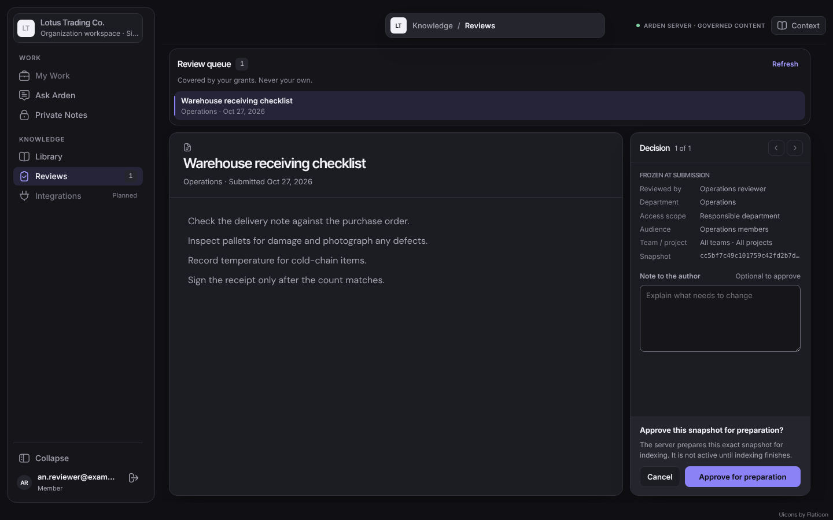
Figure 23: Approve confirmation
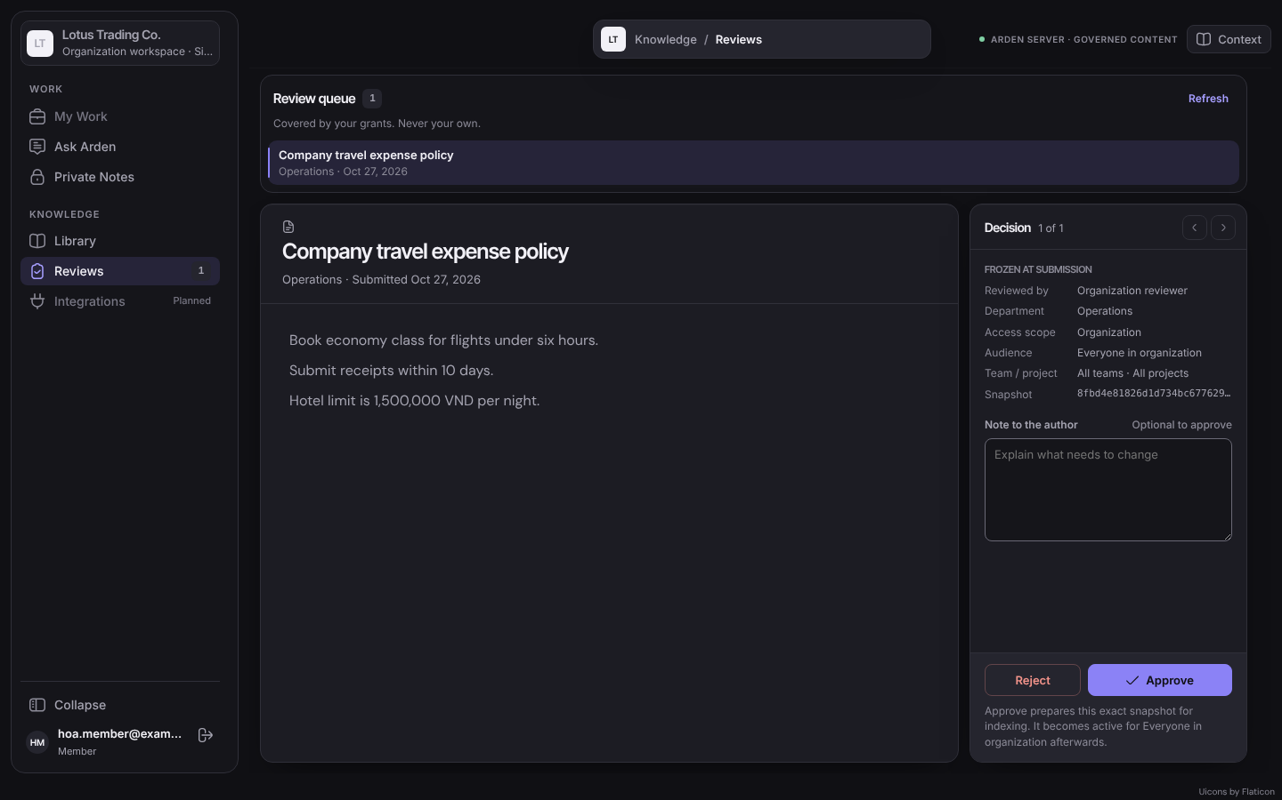
Figure 24: Organization-wide snapshot in an Organization reviewer's queue

3.7.4 FR-REV-04 Reject a submission
Item | Specification
Status | Implemented
Related UC / screen / NSF | UC-21; SCR-13
Function trigger | Decision panel → enter Note to the author → Reject → Reject with note.
Actor and permission | Knowledge Reviewer; Organization Admin
Function description | Reject the snapshot with a mandatory note. The candidate closes; the author keeps editing the working draft and may submit a new snapshot. There is no separate request-revision decision.
Preconditions | Submission Pending Review; actor eligible.
Postconditions | Submission Rejected; note visible to the author; nothing published.
Main flow | 1. Reviewer writes the note and selects Reject.  2. Confirmation "Reject this snapshot?"  3. API records decision and audit.
Alternate and error flows | • Empty note → client message "Explain why this snapshot is rejected." and server 400 COMMENT_REQUIRED (MSG-015).
Inputs and validation | Action REJECT; note 1–2,000 characters; expected version and hash.
Data read / changed | review_decision, shared_submission, audit_event.
Business rules | BR-GOV-004.
Screen / API / job | POST /api/v1/organizations/{organizationId}/knowledge/reviews/{submissionId}/decisions.
Acceptance criteria | AC1: Reject without a note is refused.  AC2: The rejected content never appears in the Library, search or AI answers.
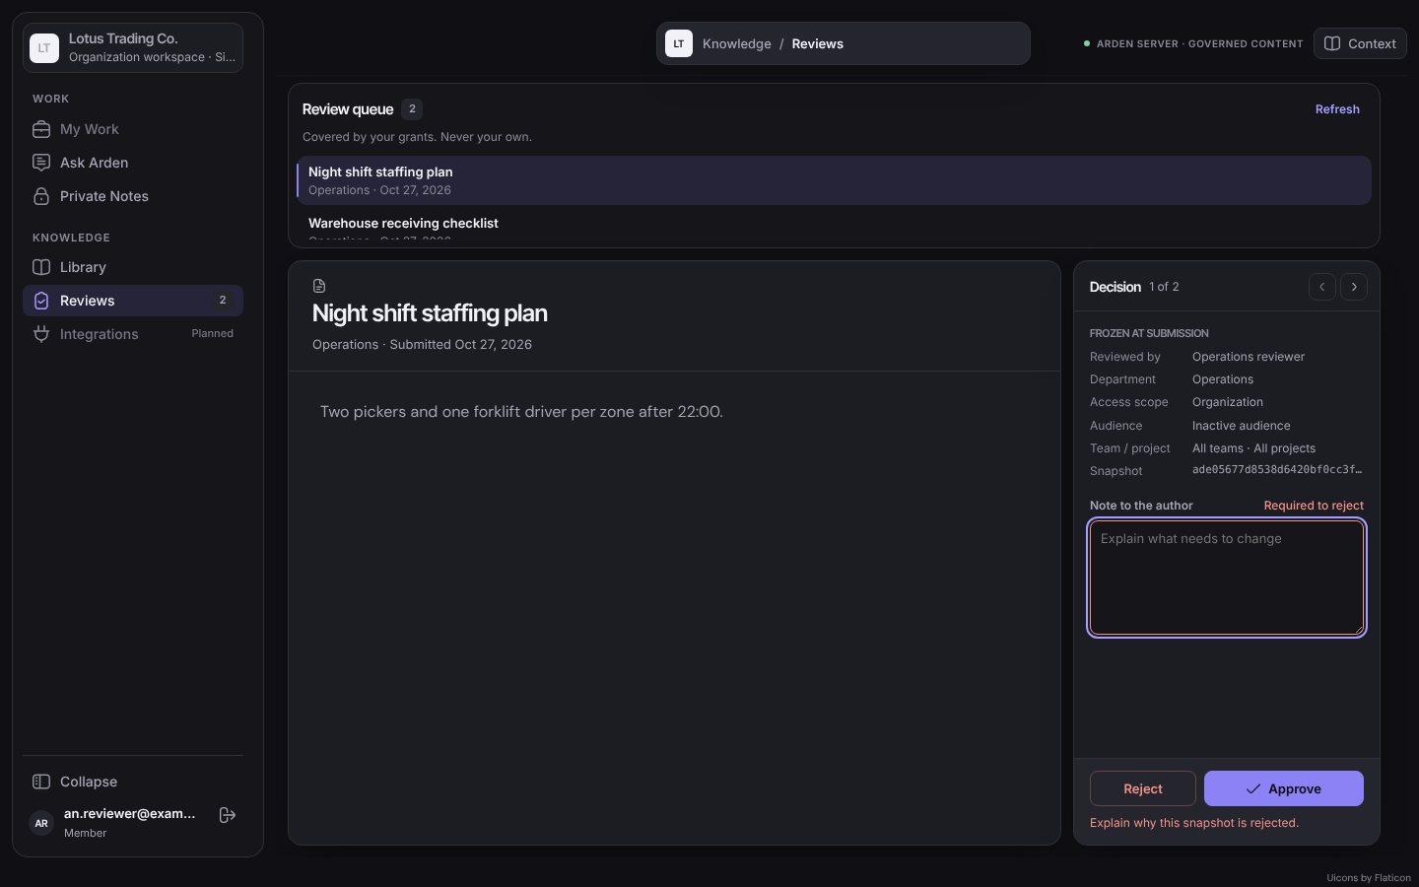
Figure 25: Reject without a note is blocked
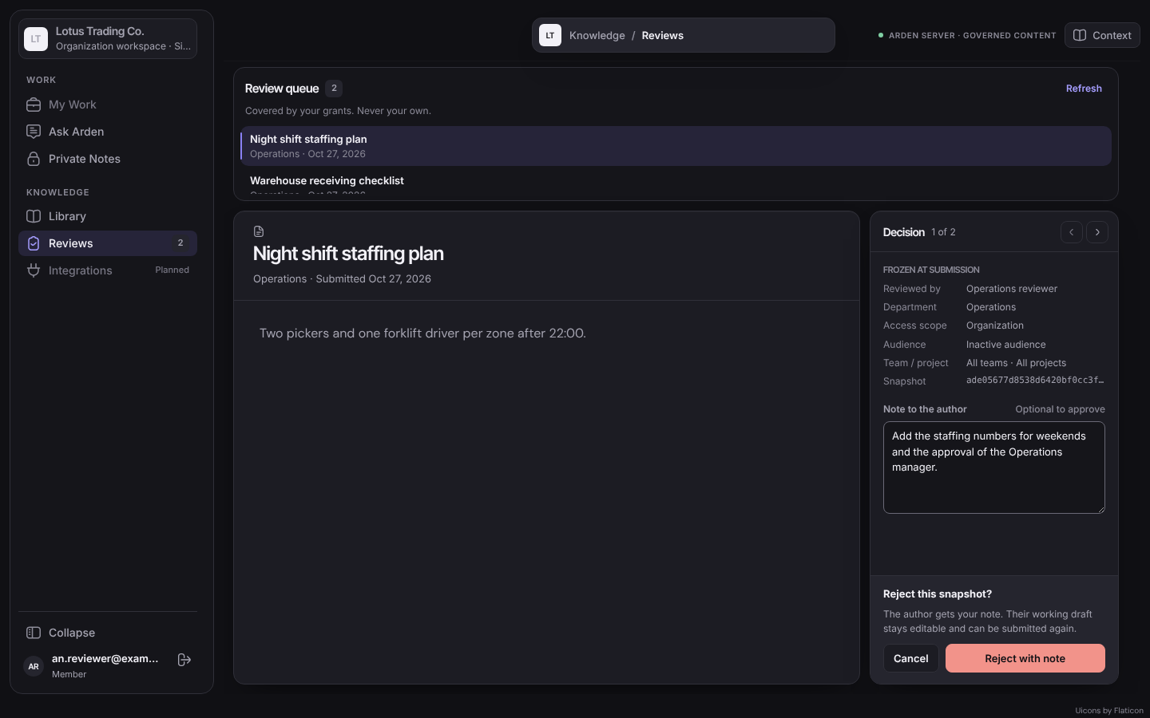
Figure 26: Reject confirmation

3.7.5 FR-PUB-01 Index and activate an approved snapshot
Item | Specification
Status | Implemented (text and PDF)
Related UC / screen / NSF | NSF-08, NSF-09
Function trigger | Background worker poll (every 1 s) finds a pending index job.
Actor and permission | System (indexing worker, Arden-AI)
Function description | Send the approved snapshot to Arden-AI, validate the returned manifest and atomically activate the publication.
Preconditions | Index job Pending.
Postconditions | Generation READY, publication ACTIVE, current pointer replaced; or generation FAILED with the previous active version unchanged.
Main flow | 1. Worker leases the job for 180 s and reads the snapshot (hash verified).  2. Worker calls Arden-AI POST /v1/index-generations with a service token.  3. Arden-AI compiles, chunks, embeds and writes the candidate generation to ChromaDB, then returns the manifest.  4. Worker validates the manifest and activates in one transaction.
Alternate and error flows | • AI unavailable, timeout, HTTP 408/429/5xx → retried up to 3 attempts.  • Invalid manifest or integrity failure → FAILED, not retried.  • Arden-AI fails → the job is retried; after 3 attempts the generation is FAILED and the previous version stays readable.
Inputs and validation | Snapshot content, generation ID, job ID.
Data read / changed | knowledge_index_job, knowledge_index_generation, published_knowledge_version, knowledge_current_publication.
Business rules | BR-LIFE-002, BR-AI-003.
Screen / API / job | Background job; Arden-AI /v1/index-generations.
Acceptance criteria | AC1: A partially indexed generation never becomes visible.  AC2: After activation the item appears in the Library of its audiences.

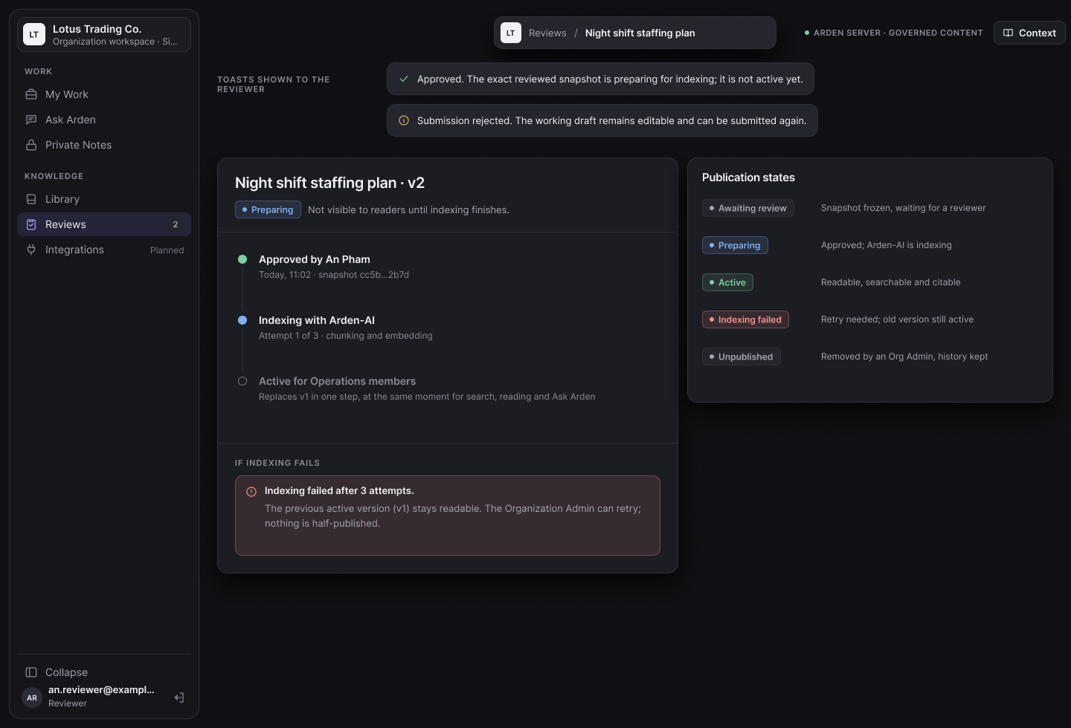
Figma screen R3-22: Preparing an approved snapshot for activation

3.7.6 FR-PUB-02 Unpublish and restore knowledge
Item | Specification
Status | Planned
Related UC / screen / NSF | UC-29
Function trigger | Document reader → Unpublish / Restore.
Actor and permission | Organization Admin
Function description | Remove an active publication from reading, search, AI and citations with a reason, or restore the last published version after rechecking its audiences. History is kept.
Preconditions | Publication Active (unpublish) or archived (restore).
Postconditions | Pointer removed or re-created; audit.
Main flow | 1. Admin selects Unpublish, enters a reason, confirms.
Alternate and error flows | • Missing reason → MSG-015; audience inactive → restore blocked (MSG-021).
Inputs and validation | Reason ≤2,000.
Data read / changed | shared_draft.status, knowledge_current_publication, audit_event.
Business rules | BR-LIFE-004.
Screen / API / job | Planned API.
Acceptance criteria | AC1: After unpublish the item disappears for every reader on the next request.  AC2: Restore makes it visible again to its audiences only.

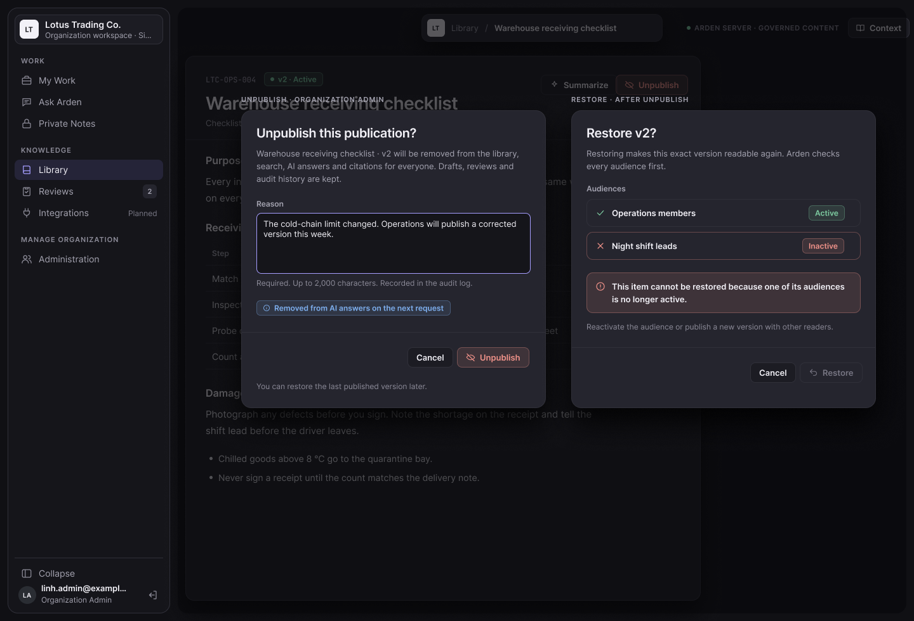
Figma screen R3-23: Unpublish and restore knowledge

3.8 Library and Search
Shows only the knowledge each member may read.
ID | Function | Actor | Status
FR-LIB-01 | Browse the library | Member | Implemented
FR-LIB-02 | Read a published document | Member | Implemented
FR-LIB-03 | Search and filter knowledge | Member | Planned

3.8.1 FR-LIB-01 Browse the library
Item | Specification
Status | Implemented
Related UC / screen / NSF | UC-22; SCR-09
Function trigger | Sidebar → Library.
Actor and permission | Member
Function description | List active publications whose audiences include the member, with owner department, version label, effective date and status.
Preconditions | Active membership.
Postconditions | None.
Main flow | 1. Open Library.  2. The header shows the number of readable publications.
Alternate and error flows | • No readable publication → "No accessible publication".
Inputs and validation | —
Data read / changed | Reads published_knowledge_version, knowledge_current_publication, audiences.
Business rules | BR-ACC-003, BR-LIFE-003.
Screen / API / job | GET /api/v1/organizations/{organizationId}/knowledge/published.
Acceptance criteria | AC1: A Finance member sees the organization-wide policy but not an Operations-only checklist.  AC2: Approval or grant never adds readership.
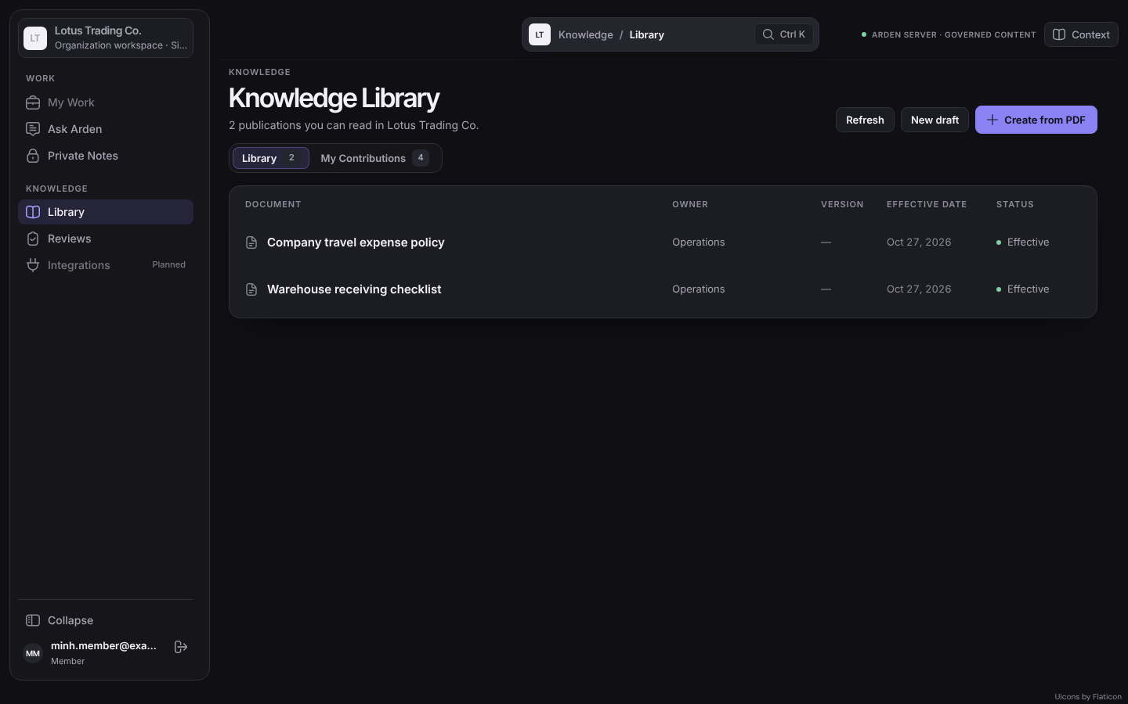
Figure 27: Knowledge Library (Operations member)
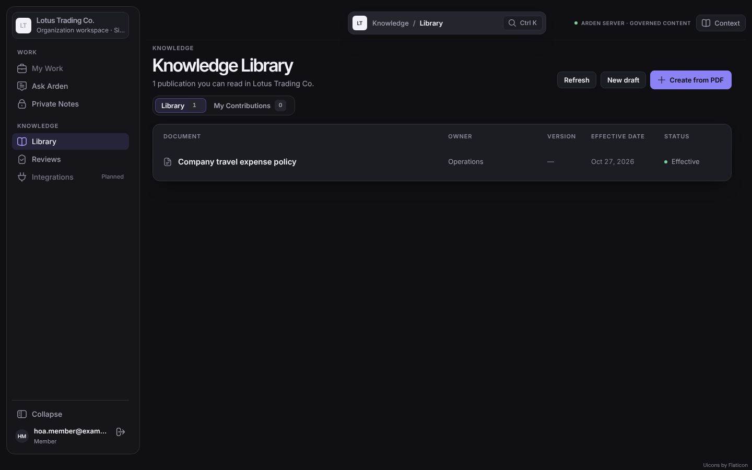
Figure 28: Knowledge Library (Finance member)

3.8.2 FR-LIB-02 Read a published document
Item | Specification
Status | Implemented
Related UC / screen / NSF | UC-22; SCR-10
Function trigger | Select a publication in the Library or a citation.
Actor and permission | Member
Function description | Show content (Semantic Document or PDF viewer), version selector, status, effective date, owner department and summary.
Preconditions | Actor may read the publication.
Postconditions | None.
Main flow | 1. API reads the publication, rechecks authorization and returns it.
Alternate and error flows | • Unauthorized or unknown ID → identical RESOURCE_NOT_AVAILABLE (MSG-010).
Inputs and validation | —
Data read / changed | Reads publication and stored content.
Business rules | BR-ACC-003.
Screen / API / job | GET /api/v1/organizations/{organizationId}/knowledge/published/{publishedVersionId}.
Acceptance criteria | AC1: A direct link to a document of another department returns MSG-010.
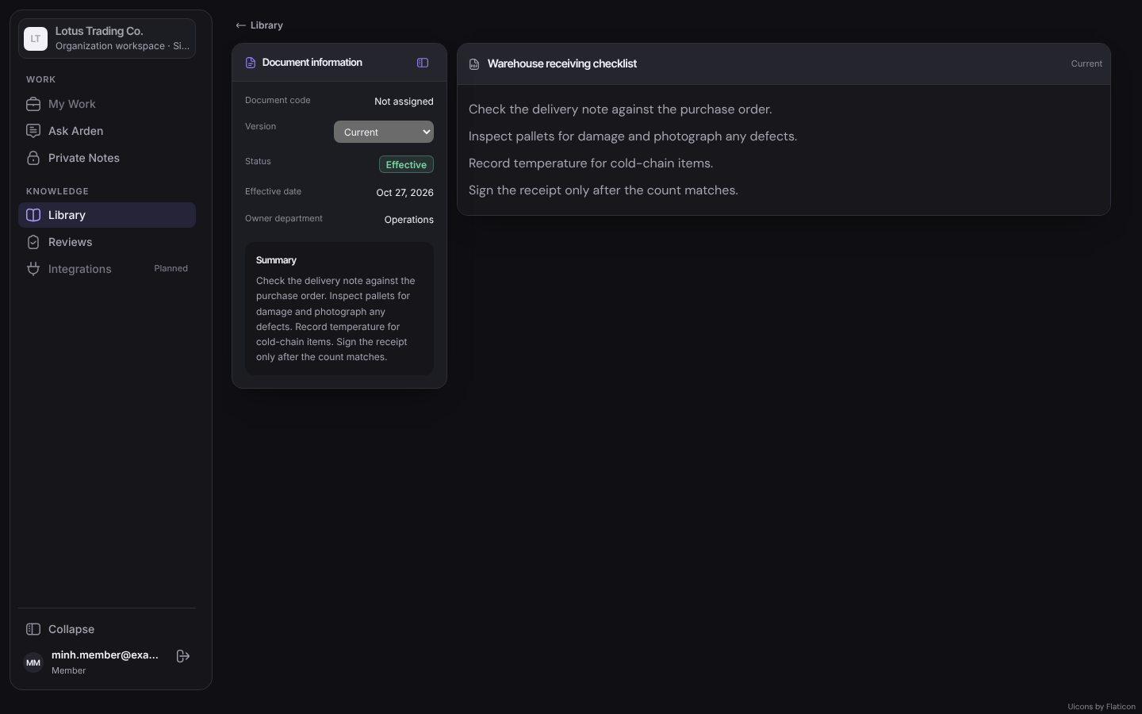
Figure 29: Document reader (SCR-10)

3.8.3 FR-LIB-03 Search and filter knowledge
Item | Specification
Status | Planned
Related UC / screen / NSF | UC-23
Function trigger | Library search field (Ctrl K) or filters.
Actor and permission | Member
Function description | Keyword (PostgreSQL full-text) and semantic (ChromaDB) search over readable active publications, and optionally the member's own notes; filters by department, scope and tag.
Preconditions | Active membership.
Postconditions | None.
Main flow | 1. Member types a query.  2. Core computes the readable allow-list and returns ranked results with snippets.
Alternate and error flows | • No result → MSG-011.
Inputs and validation | Query 1–500 characters.
Data read / changed | Reads publications, chunks.
Business rules | BR-AI-001.
Screen / API / job | Planned API.
Acceptance criteria | AC1: A query matching only an unreadable document returns no result and no count.  AC2: Unpublished or failed items never appear.

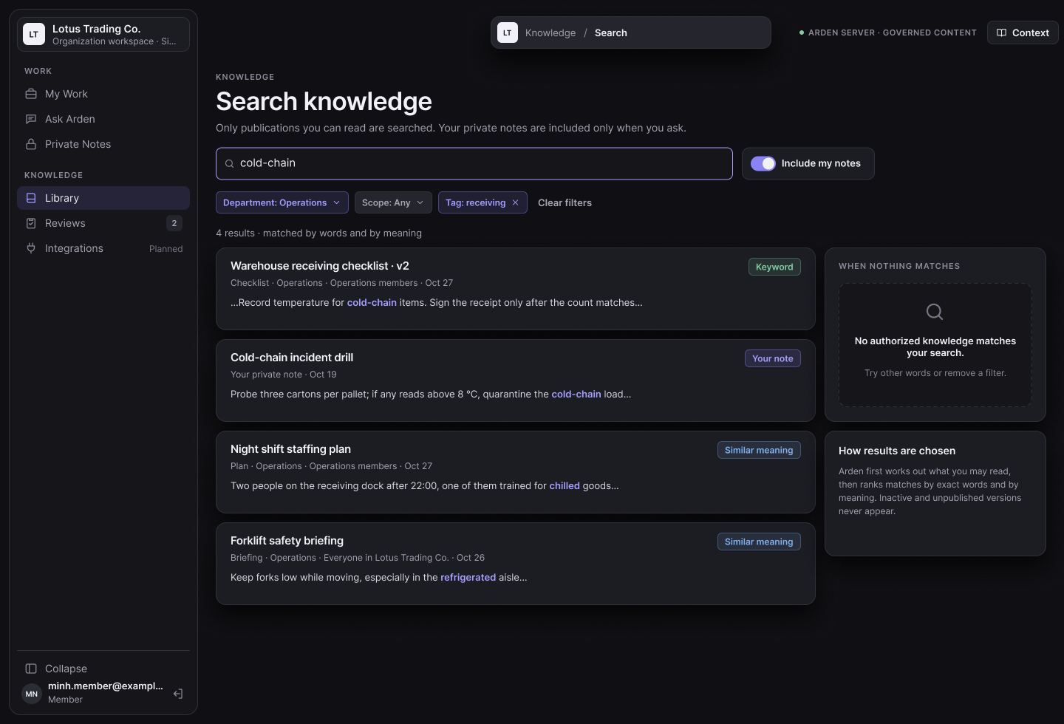
Figma screen R3-26: Search and filter knowledge

3.9 Ask Arden (AI Assistant)
Answers questions from knowledge the member may read, always with sources.
ID | Function | Actor | Status
FR-AI-01 | Ask a question | Member | Implemented (organization scope)
FR-AI-02 | Open answer sources | Member | Implemented
FR-AI-03 | Personal and hybrid modes | Member | Planned
FR-AI-04 | Summarize a document | Member | Planned
FR-AI-05 | Rate an answer | Member | Planned
FR-AI-06 | View AI history | Member | Planned

3.9.1 FR-AI-01 Ask a question
Item | Specification
Status | Implemented (organization scope)
Related UC / screen / NSF | UC-24; SCR-06; NSF-10
Function trigger | Sidebar → Ask Arden → type a question.
Actor and permission | Member
Function description | Answer from active publications the member may read. Core computes the allow-list of READY generations, Arden-AI retrieves from ChromaDB within that list and generates with OpenAI, and Core rechecks every citation before showing it.
Preconditions | Active membership; Arden-AI configured.
Postconditions | Answer with status Answered (≥1 citation) or Insufficient evidence.
Main flow | 1. Member enters a question (≤4,000 characters).  2. Core lists authorized sources; if none, returns Insufficient evidence.  3. Core calls Arden-AI /v1/answers with the question and allow-list.  4. Core rechecks each citation (same publication, version and hash) and returns answer and citations.
Alternate and error flows | • Empty question → INVALID_REQUEST.  • AI not configured or failing → 503 AI_UNAVAILABLE "Ask Arden is temporarily unavailable."  • Access changed during generation → 409 KNOWLEDGE_ACCESS_CHANGED "Please ask again."
Inputs and validation | Question 1–4,000 characters.
Data read / changed | Reads knowledge_index_generation, publications; no answer is stored yet.
Business rules | BR-AI-001…006.
Screen / API / job | POST /api/v1/organizations/{organizationId}/ai/answers; Arden-AI POST /v1/answers.
Acceptance criteria | AC1: Every Answered response has at least one citation to a readable publication.  AC2: A question answerable only from an unreadable document returns Insufficient evidence.
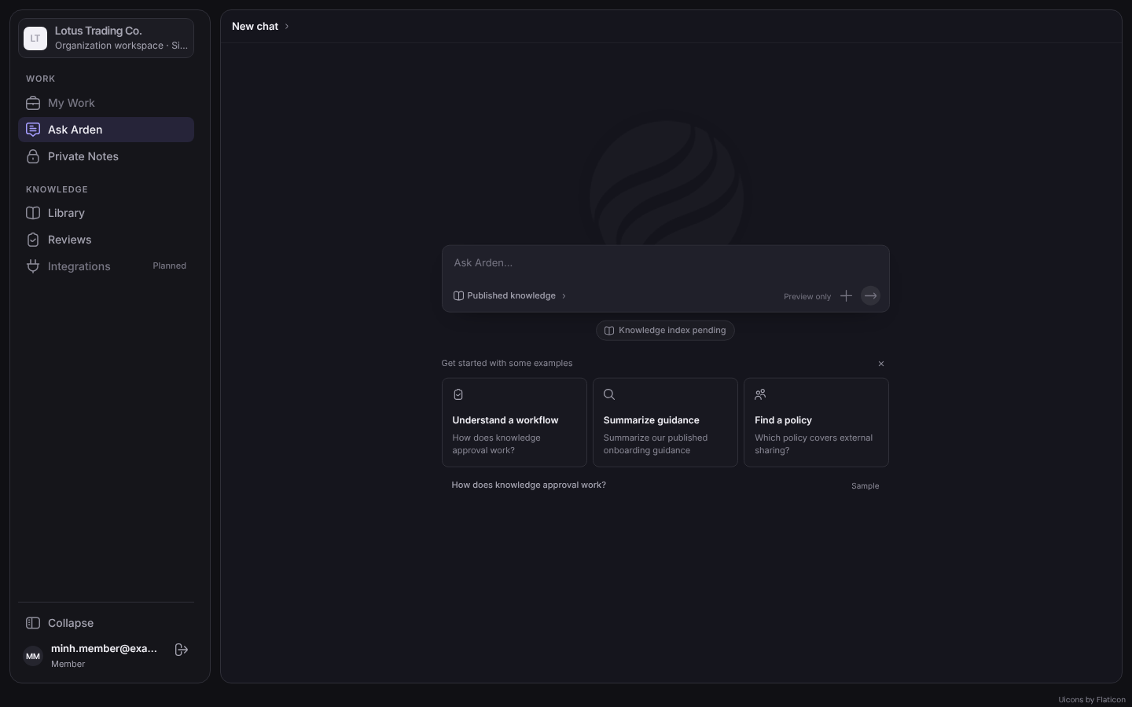
Figure 30: Ask Arden (screenshot of the 27/10 preview build; the staging build returns live answers)

3.9.2 FR-AI-02 Open answer sources
Item | Specification
Status | Implemented
Related UC / screen / NSF | UC-25
Function trigger | Select a citation chip.
Actor and permission | Member
Function description | Open the cited publication at the cited block or PDF page.
Preconditions | Citation returned by FR-AI-01.
Postconditions | Reader opens.
Main flow | 1. Client opens the reader with version and block/page.
Alternate and error flows | • Source no longer readable → MSG-010.
Inputs and validation | —
Data read / changed | Reads publication.
Business rules | BR-AI-002.
Screen / API / job | Document reader deep link.
Acceptance criteria | AC1: A citation opens the exact version and page.

3.9.3 FR-AI-03 Personal and hybrid modes
Item | Specification
Status | Planned
Related UC / screen / NSF | UC-24
Function trigger | Ask Arden → mode selector.
Actor and permission | Member
Function description | Answer from the member's own private notes (Personal) or from both private notes and readable publications (Hybrid).
Preconditions | —
Postconditions | —
Main flow | 1. Member selects the mode and asks.
Alternate and error flows | • —
Inputs and validation | Mode.
Data read / changed | Private note chunks (owner only).
Business rules | BR-PKM-001.
Screen / API / job | Planned.
Acceptance criteria | AC1: Another member's private note is never retrieved.

3.9.4 FR-AI-04 Summarize a document
Item | Specification
Status | Planned
Related UC / screen / NSF | UC-27
Function trigger | Document reader → Summarize.
Actor and permission | Member
Function description | Generate a summary of a readable publication or own note, citing the version used.
Preconditions | Actor may read the document.
Postconditions | Summary shown; not stored as knowledge.
Main flow | 1. Member selects Summarize.
Alternate and error flows | • Unreadable document → MSG-010.
Inputs and validation | Document ID.
Data read / changed | —
Business rules | BR-AI-005.
Screen / API / job | Planned.
Acceptance criteria | AC1: The summary names the document and version it was generated from.

3.9.5 FR-AI-05 Rate an answer
Item | Specification
Status | Planned
Related UC / screen / NSF | UC-26
Function trigger | Answer → rating control.
Actor and permission | Member
Function description | Rate 1–5 with an optional comment (≤500).
Preconditions | Answer exists.
Postconditions | Feedback stored; permissions unchanged.
Main flow | 1. Member selects a rating and optional comment.
Alternate and error flows | • Out-of-range rating → validation error.
Inputs and validation | Rating 1–5; comment ≤500.
Data read / changed | AI answer feedback.
Business rules | BR-AI-005.
Screen / API / job | Planned.
Acceptance criteria | AC1: One rating per user and answer, updatable.

3.9.6 FR-AI-06 View AI history
Item | Specification
Status | Planned
Related UC / screen / NSF | UC-28
Function trigger | Ask Arden → Recent.
Actor and permission | Member
Function description | List own questions, answers, citations and ratings, newest first.
Preconditions | Signed in.
Postconditions | None.
Main flow | 1. Open Recent.
Alternate and error flows | • —
Inputs and validation | —
Data read / changed | AI question/answer records.
Business rules | BR-PKM-001.
Screen / API / job | Planned.
Acceptance criteria | AC1: Nobody else, including administrators, can read the history.  AC2: Citations opened from history are rechecked.

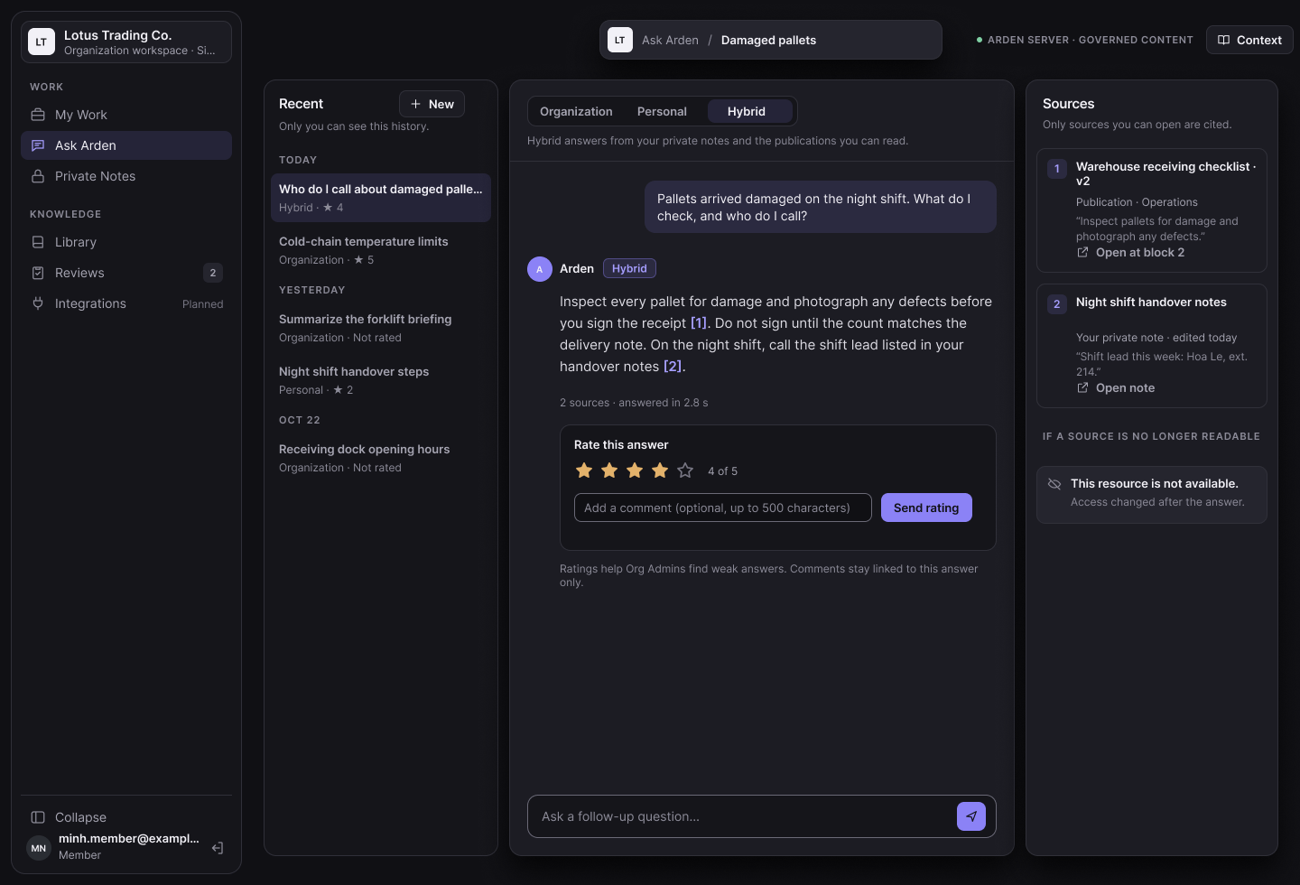
Figma screen R3-27: Ask Arden modes, sources, rating and history

3.10 Dashboard and Analytics
Gives administrators and reviewers minimal, permission-safe statistics.
ID | Function | Actor | Status
FR-DASH-01 | Organization statistics | Organization Admin | Planned
FR-DASH-02 | Feedback and quality lists | Organization Admin; Knowledge Reviewer | Planned

3.10.1 FR-DASH-01 Organization statistics
Item | Specification
Status | Planned
Related UC / screen / NSF | UC-30; SCR-19
Function trigger | Sidebar → Dashboard.
Actor and permission | Organization Admin
Function description | Counts of knowledge by state (draft, pending, active, unpublished) and department; submissions and decisions per department per month; questions per day, answered vs insufficient evidence and average rating for the last 30 days.
Preconditions | Organization Admin.
Postconditions | None.
Main flow | 1. Open Dashboard; choose the period.
Alternate and error flows | • No data → zero values.
Inputs and validation | Period.
Data read / changed | Aggregates only.
Business rules | BR-DASH-001.
Screen / API / job | Planned API.
Acceptance criteria | AC1: Numbers equal database counts on the seed dataset.  AC2: No title or content is shown.

3.10.2 FR-DASH-02 Feedback and quality lists
Item | Specification
Status | Planned
Related UC / screen / NSF | UC-30; SCR-19
Function trigger | Dashboard → Feedback / Quality.
Actor and permission | Organization Admin; Knowledge Reviewer
Function description | List rated answers and publications cited by answers rated ≤2 in the last 30 days. Text and titles are shown only when the viewer can read every cited source; reviewers see only documents within their grants.
Preconditions | Role as stated.
Postconditions | None.
Main flow | 1. Open the list.
Alternate and error flows | • Unreadable source → shown as Hidden.
Inputs and validation | —
Data read / changed | Aggregates over AI feedback.
Business rules | BR-DASH-001.
Screen / API / job | Planned API.
Acceptance criteria | AC1: A viewer without access to a cited source sees Hidden.  AC2: A document cited by three low-rated answers shows the count 3.

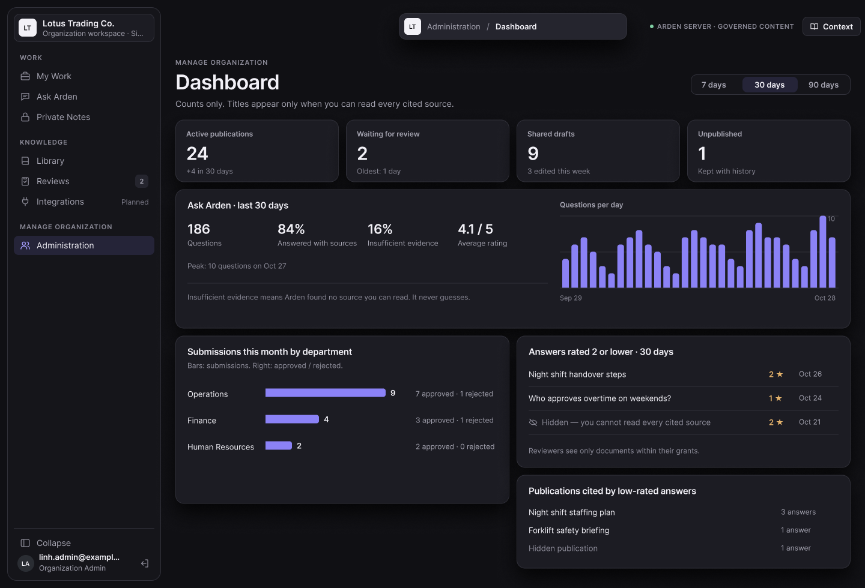
Figma screen R3-28: Dashboard and quality analytics

4. Non-Functional Requirements

4.1 External Interfaces
ID | Interface | Requirement
IF-01 | Web user interface | Responsive React application. Signed-in workspace uses the Island design: left navigation (My Work, Ask Arden, Private Notes, Library, Reviews, Integrations (planned), Administration for Organization Admins) and a central work area; sign-in and onboarding use the Living Archive design.
IF-02 | Windows desktop client | Electron application sharing the same UI; calls only allowlisted API routes and keeps tokens in the main process.
IF-03 | Authentication provider | Supabase Auth (email/password, email confirmation, Google OAuth PKCE), called only by the Arden API.
IF-04 | Email (SMTP) | Configurable SMTP relay for HTML invitation emails; all six SMTP settings are runtime secrets.
IF-05 | Database | PostgreSQL 17 (pgvector image) with versioned SQL migrations 0001–0023 and row-level security under the non-bypass role arden_runtime; indexing uses the role arden_indexer.
IF-06 | Arden-AI service | Private HTTP API (FastAPI, Python 3.11): POST /v1/index-generations and POST /v1/answers with a bearer service token; versioned JSON contracts (contractVersion 1).
IF-07 | ChromaDB | Self-hosted vector index on the private network with a persistent volume; written and queried only by Arden-AI.
IF-08 | OpenAI API | Embeddings and answer generation called only by Arden-AI; receives the question and authorized excerpts only.
IF-09 | Langfuse | Self-hosted AI tracing and cost monitoring for the Arden operations team.

4.2 Quality Attributes
Each non-functional requirement is stated with its metric, threshold and measurement method so that it can be verified. Rules that are not measurable quality attributes are listed as business rules or common requirements in section 5.

4.2.1 Usability
ID | Requirement
NFR-01 | A first-time user completes the main tasks without help outside the product, on web and desktop, with mouse or keyboard.
Metric | (a) Task success of first-time users for four tasks: create and submit a draft, approve a submission, invite a member, find and open a published document; (b) share of main screens without overlap or horizontal scrolling at 1280, 1024 and 390 px; (c) share of actions reachable by keyboard; (d) share of error messages that name the field and the corrective action; (e) behaviour differences between web and desktop.
Threshold | (a) at least 4 of 5 participants finish each task within 5 minutes; (b) 100%; (c) 100%; (d) 100%; (e) 0.
Method | Moderated usability test with 5 students outside the team; responsive and keyboard checklist (system test ST-24); desktop parity scenarios (ST-22).

4.2.2 Security and Privacy
ID | Requirement
NFR-02 | No user can read, count or receive in AI context any item outside their authorization (other organization, other department, group not joined, another member's private item, inactive publication). Organization Admin and Arden System Admin have no content override.
Metric | Unauthorized disclosures in the permission test matrix covering list, detail, search, AI retrieval, citations and dashboard.
Threshold | 0 disclosures; 100% of denial test cases pass.
Method | Automated API and PostgreSQL row-level-security tests in CI on every pull request; two-department demo script.

4.2.3 AI Answer Quality
ID | Requirement
NFR-03 | Ask Arden answers only from authorized sources and cites them.
Metric | (a) Share of Answered responses with at least one valid citation; (b) share of answers containing information that exists only in documents the asker cannot read; (c) share of unanswerable questions returning Insufficient evidence.
Threshold | (a) 100%; (b) 0%; (c) at least 90%.
Method | Evaluation script with at least 30 fixed questions on the synthetic demo corpus, at least 10 answerable only from documents the asker cannot read; run before each release; results traced in Langfuse.

4.2.4 Performance
ID | Requirement
NFR-04 | Common operations respond quickly.
Metric | 95th percentile response time at the API; time from approval to ACTIVE.
Threshold | Ask Arden answer ≤ 5 s; library and document reads ≤ 500 ms; other API requests ≤ 500 ms; approval to ACTIVE ≤ 60 s for a document under 50 pages; with 10 concurrent users and up to 1,000 published documents.
Method | k6 load-test script on the staging environment with the seed corpus; worker logs for activation time.

4.2.5 Reliability
ID | Requirement
NFR-05 | Governance actions are atomic and never duplicated, and a failed index never becomes visible.
Metric | Partial or duplicate drafts, submissions, decisions or publications after repeated requests with the same Idempotency-Key, after concurrent submit, and after forced failures of Arden-AI; failed or partial generations that become ACTIVE.
Threshold | 0 in every case; the previous active version remains readable during failures.
Method | Automated integration tests that repeat requests, run concurrent submissions and inject AI failures (timeout, HTTP 500, invalid manifest).

4.2.6 Auditability
ID | Requirement
NFR-06 | Every governance and security action is audited without leaking content.
Metric | Share of action types (invitation, membership change, audience group change, grant change, submission, decision incl. selfApproved, activation, System Admin change) that create an audit event with actor, time, object, action and outcome; events or logs containing content, tokens or secrets.
Threshold | 100% of action types; 0 events or logs with content or secrets.
Method | Automated tests asserting one audit row per action type; log review on staging before each release.

4.2.7 Deployability and Maintainability
ID | Requirement
NFR-07 | The system can be built, tested and deployed from the repositories.
Metric | (a) CI result of typecheck, unit and integration tests for Arden and Arden-AI; (b) time to deploy a clean staging environment (core, worker, Arden-AI, ChromaDB), apply all migrations and load seed data.
Threshold | (a) 100% pass on staging and on tag review-2, with at least 50% of test cases automated; (b) ≤ 30 minutes without manual SQL.
Method | GitHub Actions (Ubuntu and Windows); scripted Docker Compose deployment on Coolify, timed and recorded in the runbook.

5. Requirement Appendix

5.1 Business Rules
ID | Rule Definition
BR-ORG-001 | One installation may host several organizations; each organization is an isolated tenant.
BR-ORG-002 | Any verified account may create an organization and becomes its first Organization Admin.
BR-ORG-003 | The hierarchy is Organization → Department. A member may temporarily have no department; deleting a department archives it, unassigns its members, clears it from pending invitations and deactivates its Department audience and reviewer grants.
BR-ORG-004 | Team and project are optional tags only and never create hierarchy or grant access.
BR-ORG-005 | Each department has exactly one managed Department audience. Each member has at most one primary department, which decides Department-audience membership and the responsible department of the member's drafts.
BR-MEM-001 | A membership is created only after authentication, verified-email match and explicit acceptance of a valid invitation.
BR-MEM-002 | At most one pending invitation exists per email in an organization. An invitation link is single-use, expires after 7 days and its token is stored only as a hash.
BR-MEM-003 | Only an Organization Admin with a verified email may invite or resend.
BR-MEM-004 | The last active Organization Admin of an organization cannot be removed or demoted.
BR-ROLE-001 | The actors are Member, Knowledge Reviewer, Organization Admin and Arden System Admin; contributing knowledge is a Member capability.
BR-ROLE-002 | The Organization Admin manages the organization and may decide any pending submission, including their own (recorded as self-approval). This capability gives no readership and no private-note access.
BR-ROLE-003 | Arden System Admin is an installation capability outside every organization; it gives no membership, content, review or AI access. The first is created only by the bootstrap command; the last active one cannot be revoked.
BR-ACC-001 | A private item is readable only by its owner. Contribution creates a separate shared copy; the original never becomes shared.
BR-ACC-002 | A shared draft needs a target scope, 1–100 audiences and the author's active primary department before submission.
BR-ACC-003 | A member may read an active publication when at least one of its audiences includes them; a Department publication also requires active membership in its department. Empty, inactive or unknown audiences grant nothing.
BR-ACC-004 | The Organization audience is valid only with Organization scope and a Department audience only with Department scope of the same department; groups are valid with either scope.
BR-ACC-005 | An author may target only audiences they can currently read; hidden groups are not listed.
BR-ACC-006 | Membership, department and group changes take effect on the next request for reading, search, AI and citations.
BR-GOV-001 | The responsible department is the author's primary department; it is not chosen and is frozen at submission.
BR-GOV-002 | Reviewer grants have disjoint scopes: a snapshot whose audiences include the Organization audience needs an Organization grant; any other snapshot needs a Department grant for its responsible department. Grants also respect tags, validity and status. Reviewer levels and classifications apply only to legacy submissions.
BR-GOV-003 | An ordinary reviewer cannot see or decide their own submission.
BR-GOV-004 | A decision is Approve or Reject; Reject requires a note (≤2,000 characters). There is no request-revision decision; the author edits the working draft and submits a new snapshot.
BR-GOV-005 | A draft has at most one open submission (release candidate).
BR-GOV-006 | A decision must quote the exact snapshot version ID and content hash; a changed snapshot is refused.
BR-GOV-007 | Approval is blocked when an audience is no longer enforceable or the author can no longer target it; rejection stays possible.
BR-GOV-008 | One eligible decision is final; there is no second approval step and no human publisher.
BR-LIFE-001 | Saved versions and submissions are immutable; the working draft stays editable while a snapshot is under review.
BR-LIFE-002 | Approval moves the snapshot to PREPARING. Only a complete index generation followed by atomic activation makes it ACTIVE; a FAILED generation stays invisible.
BR-LIFE-003 | The current active version stays readable until a newer version is activated or the item is unpublished.
BR-LIFE-004 | Unpublish and restore (planned) are Organization Admin actions that keep all versions, decisions and audit events.
BR-DOC-001 | Semantic Document v1 is the only stored editable format: at most 2,000 blocks, nesting depth 8, 131,072 characters, links only http, https or mailto.
BR-DOC-002 | Uploaded files must be text-based PDFs of at most 5 MB; uploaded PDFs cannot be edited as text.
BR-DOC-003 | A shared draft has at most one source: a private-note version or a published version.
BR-PKM-001 | Personal documents, collections and AI history are owner-only and never used in another member's search or answers.
BR-AI-001 | Arden core computes the allow-list of active generations the asker may read before any retrieval; Arden-AI may narrow but never broaden it.
BR-AI-002 | Arden core rechecks every citation after generation; if access changed, the answer is refused.
BR-AI-003 | ChromaDB is a derived index, never an authorization source.
BR-AI-004 | An Answered response has at least one citation; without authorized evidence the status is Insufficient evidence.
BR-AI-005 | AI never approves, publishes, unpublishes or changes audiences, grants or permissions.
BR-AI-006 | Only the question and authorized excerpts are sent to the AI provider; provider credentials stay on the server.
BR-DASH-001 | Dashboards show aggregates; titles and text appear only when the viewer may read the source.
BR-DEM-001 | The demo uses at least two departments and one audience group and shows that unauthorized members cannot see department, group or private content through list, detail, search or AI.

5.2 Common Requirements
ID | Common Requirement
CR-01 | Every mutating action validates the current membership, group memberships, grants, ownership and System Admin status on the server.
CR-02 | Inputs are validated on client and server; server validation is authoritative and uses strict JSON schemas (unknown fields rejected).
CR-03 | List, detail, count, citation and dashboard views use the same access decision.
CR-04 | Unauthorized and missing resources return the same RESOURCE_NOT_AVAILABLE response.
CR-05 | Create, submit and decision requests require an Idempotency-Key; edits require If-Match.
CR-06 | User-facing errors state the corrective action without revealing restricted data or internals; every error carries a request ID.
CR-07 | Governance state changes record actor, time, object, prior and new state and outcome.
CR-08 | Responses with protected data are sent with Cache-Control: no-store.
CR-09 | Lists and AI answers distinguish private items, drafts, pending, active and failed knowledge.
CR-10 | Automated tests and the demo include cross-organization, cross-department, group, private-item, admin-override and self-review attempts.

5.3 Application Messages List
Code | Type | Context | Content
MSG-001 | Inline | Required field missing | This field is required.
MSG-002 | Inline | Audience does not match scope | The draft metadata is invalid.
MSG-003 | Inline | Author has no primary department | You have no primary department yet. Ask an Org Admin to assign one before submitting.
MSG-004 | Inline | Submission lacks governance data | Add an active responsible department, access scope and audience before submitting.
MSG-005 | Toast | Version saved | Draft v{n} saved on the server.
MSG-006 | Toast | Snapshot submitted | Version {n} submitted for review (Awaiting review).
MSG-007 | Toast | Approved | Approved. The exact reviewed snapshot is preparing for indexing; it is not active yet.
MSG-008 | Toast | Rejected | Submission rejected. The working draft remains editable and can be submitted again.
MSG-009 | Inline | Approve confirmation | The server prepares this exact snapshot for indexing. It is not active until indexing finishes.
MSG-010 | Inline | Unauthorized or missing item | This resource is not available.
MSG-011 | Inline | No search results (planned) | No authorized knowledge matches your search.
MSG-012 | Inline | AI insufficient evidence | I could not find any indexed published knowledge you are allowed to read.
MSG-013 | Inline | Wrong file type | Choose a valid PDF file.
MSG-014 | Inline | File too large | Choose a valid PDF file up to 5 MB.
MSG-015 | Inline | Reject note missing | Explain why this snapshot is rejected.
MSG-016 | Inline | Invitation not usable | This invitation is not available for this account.
MSG-017 | Toast | Invitation sent | Invitation email sent to {email}.
MSG-018 | Inline | Version conflict | This draft changed. Reload it before saving again.
MSG-019 | Inline | Approval blocked | This review decision cannot be applied.
MSG-020 | Inline | Last System Admin | The last active Arden System Admin cannot be revoked.
MSG-021 | Inline | Restore blocked (planned) | This item cannot be restored because one of its audiences is no longer active.
MSG-022 | Inline | Wrong credentials | Email or password is incorrect.
MSG-023 | Inline | Invitation delivery failed | The invitation was saved but its email was not delivered. Retry sending it from organization administration.
MSG-024 | Inline | AI unavailable | Ask Arden is temporarily unavailable.
MSG-025 | Inline | Access changed during answer | Knowledge access changed while the answer was being prepared. Please ask again.
MSG-026 | Inline | Pending invitation exists | A pending invitation already exists for this email.

5.4 Other Requirements
ID | Requirement
OR-01 | Arden remains open-source and self-hosted; the only external services are those listed in section 1.3.
OR-02 | Sharing data between organizations is out of scope.
OR-03 | Project-management functions, Knowledge Handover, Knowledge Graph and external work-source integrations are out of scope (registration form v2.0).
OR-04 | Governance may be described as ISO-aligned; certification is not claimed.
OR-05 | The demo dataset is synthetic and contains Organization, Department and group publications and private notes across at least two departments.
OR-06 | Supported clients are the web application and the Windows desktop application; full offline operation is out of scope.
OR-07 | OCR of scanned PDFs is out of scope.

5.5 Requirement Traceability Matrix
FR | Use case | Screen / API / job | Main entities | Tests
FR-AUTH-01 | UC-01 | SCR-01; /auth/sign-in, sign-up, sign-out | User Account | app.test.ts (auth routes); ST-01, ST-02
FR-AUTH-02 | UC-01 | SCR-01; /auth/google/*, /auth/password | User Account | app.test.ts (Google flow); ST-03
FR-AUTH-03 | UC-02 | SCR-02; /auth/forgot-password, reset-password | User Account | app.test.ts (reset routes); signInPage.test.ts
FR-AUTH-04 | — | NSF-01 | User Account | provider tests; ST-01
FR-AUTH-05 | UC-31 | SCR-21 | User Account | Planned
FR-ORG-01 | UC-03 | SCR-03; POST /organizations | Organization, Department, Membership, Audience | app.test.ts; repository integration; ST-04
FR-ORG-02 | UC-04 | SCR-03; /me | Membership | ST-04
FR-ORG-03 | UC-05 | SCR-15; /departments | Department, Audience | app.test.ts; ST-05
FR-ORG-04 | UC-06 | SCR-17; /invitations | Invitation | app.test.ts; smtp-mailer.test.ts; ST-06
FR-ORG-05 | UC-07 | SCR-04; /invitations/accept | Invitation, Membership | app.test.ts; ST-06, ST-07
FR-ORG-06 | UC-08 | SCR-14; /members/{id}/department | Membership | app.test.ts; ST-21
FR-ACC-01 | UC-09 | SCR-16; /audience-groups | Audience, Audience Group Member | app.test.ts (audience groups); ST-14, ST-21
FR-ACC-02 | UC-10 | SCR-18; /knowledge/reviewer-grants | Reviewer Grant | policy.test.ts; review-queue.test.ts; ST-15
FR-SYS-01 | — | system-admin:bootstrap | System Administrator | ST-23
FR-SYS-02 | UC-32 | /system/administrators | System Administrator, System Admin Event | app.test.ts (system admin); ST-23
FR-SYS-03 | — | SCR-20 | Organization | Planned
FR-PKM-01 | UC-11 | SCR-07; /private-workspace/drafts | Private Note, Version | app.test.ts; content-storage.test.ts; ST-08, ST-09
FR-PKM-02 | UC-14 | SCR-08; POST /knowledge/drafts | Shared Draft | app.test.ts; ST-12
FR-PKM-03 | UC-12 | SCR-07 | Private Note | Planned
FR-PKM-04 | UC-13 | SCR-07 | Personal Collection | Planned
FR-DOC-01 | UC-15 | SCR-11; /knowledge/drafts/new | Shared Draft, Version | app.test.ts; semantic-document.test.ts; ST-10
FR-DOC-02 | UC-15 | SCR-11; /knowledge/drafts/pdf | Shared Draft, Version | app.test.ts; ST-11
FR-DOC-03 | UC-16 | SCR-12; PATCH /knowledge/drafts/{id}; /knowledge/options | Shared Draft, Draft Audience | policy.test.ts; readerSelection.test.ts; ST-10
FR-DOC-04 | UC-17 | SCR-12; /knowledge/drafts/{id}/submit | Submission | app.test.ts; policy.test.ts; ST-10, ST-13
FR-DOC-05 | — | SCR-09; /knowledge/drafts, /knowledge/submissions | Shared Draft, Submission | knowledgeStatus.test.ts; ST-18
FR-DOC-06 | UC-18 | — | Submission | Planned
FR-REV-01 | UC-19 | SCR-13; /knowledge/reviews | Submission, Reviewer Grant | review-queue.test.ts; ST-16
FR-REV-02 | UC-19 | SCR-13; /knowledge/reviews/{id} | Submission | app.test.ts; ST-16
FR-REV-03 | UC-20 | SCR-13; /decisions | Review Decision, Index Generation | review-decision.test.ts; ST-17; AT-02
FR-REV-04 | UC-21 | SCR-13; /decisions | Review Decision | review-decision.test.ts; ST-18, ST-19
FR-PUB-01 | UC-20 | NSF-08, NSF-09; Arden-AI /v1/index-generations | Index Generation, Index Job, Published Version | worker.test.ts; contracts.test.ts; ST-17
FR-PUB-02 | UC-29 | — | Current Publication | Planned
FR-LIB-01 | UC-22 | SCR-09; /knowledge/published | Published Version, Audience | app.test.ts; knowledgeLibrary.test.ts; ST-20; AT-03
FR-LIB-02 | UC-22 | SCR-10; /knowledge/published/{id} | Published Version | app.test.ts; knowledgeDocumentDetail.test.ts; ST-20
FR-LIB-03 | UC-23 | — | Knowledge Chunk | Planned
FR-AI-01 | UC-24 | SCR-06; /ai/answers; Arden-AI /v1/answers | Index Generation, Citation | contracts.test.ts; AT-07
FR-AI-02 | UC-25 | SCR-10 deep link | Citation | citation-page.test.ts
FR-AI-03 | UC-24 | SCR-06 | Knowledge Chunk | Planned
FR-AI-04 | UC-27 | SCR-10 | — | Planned
FR-AI-05 | UC-26 | SCR-06 | AI Answer | Planned
FR-AI-06 | UC-28 | SCR-06 | AI Question, Answer | Planned
FR-DASH-01 | UC-30 | SCR-19 | Aggregates | Planned
FR-DASH-02 | UC-30 | SCR-19 | Aggregates | Planned
Test references: automated test files are in the Arden repository (apps/api, packages/ui, packages/domain), including apps/api/src/answers for Ask Arden. ST-xx and AT-xx are the system and acceptance scenarios of Report 5; scenarios ST-10, ST-15, ST-17 and ST-18 must be updated to the approve/reject and grant-scope rules described here.

