Individual Differences in Cue Interaction: A Data-Driven Analysis of Facilitation and Competition in Association Learning

Hao Zhu

2025-05-25

# Introduction

Human learning hinges on the ability to recognize and interpret predictive cues in the environment. Classic work in associative learning has shown that when two or more cues consistently appear together, their interactions can be competitive—where a dominant cue “blocks” another from acquiring associative strength—or facilitative, in which cues mutually boost each other’s predictive value. These phenomena play a fundamental role not only in understanding how people learn cause-effect relationships but also in broader psychological processes such as selective attention, cognitive inference, and clinical outcomes related to anxiety and stress. In the dissertation by Alhazmi (2022), a series of experiments explored the interplay between these different styles of cue interaction—particularly examining why some individuals tend toward facilitative (or “noncompetitive”) learning while others exhibit more canonical patterns of cue competition. The present paper focuses on Experiment 4 of that work, in which I conducted a detailed data analysis to investigate individual differences in cue interaction style (competitive vs. facilitative) and whether their styles are related to anxiety, depression, and stress measures, and how reversal learning might influence these interactions.

This introductory section provides an overview of the theoretical basis for cue interaction, including both classical associative models and more contemporary accounts that incorporate higher-order cognitive processes.

Theoretical accounts of cue interaction have historically emphasized how cues compete for associative strength, a process often referred to as “cue competition.” Early associative models (e.g., Bush & Mosteller, 1951, 1955) proposed that the predictive value of any given cue depends solely on its individual correlation with the outcome. This view was challenged by the influential Rescorla-Wagner model (Rescorla & Wagner, 1972), which introduced the concept of a summed prediction error. According to this model, cues presented in compound share a limited pool of associative strength; a cue that is already a strong predictor of an outcome will “block” new cues from acquiring substantial associative strength (Kamin, 1968; Rescorla & Wagner, 1972). Later theories, particularly attentional models (Mackintosh, 1975; Pearce & Hall, 1980), posited that competition stems not just from summed prediction errors but also from changes in the amount of attention allocated to each cue.

However, accumulating evidence suggests that cues can also facilitate one another—rather than compete—under certain circumstances (Bouton et al., 1987; Durlach & Rescorla, 1980). Such “cue facilitation” occurs when the presence of a well-established cue enhances the predictive value of a novel cue (Batsell Jr & Batson, 1999). Models addressing both competition and facilitation often incorporate within-compound associations—that is, direct links formed between cues presented together. In the Sometimes-Competing Retrieval (SOCR) model (Stout & Miller, 2007), these within-compound associations may either suppress or augment responding, depending on a “switching operator” that governs whether indirect cue activation will interfere with or bolster responding. Similarly, Pineño’s (2007) extension of the Rescorla-Wagner model assumes that a cue’s novelty moderates how strongly it draws on within-compound associations for its response—leading sometimes to competition, sometimes to facilitation. These dual-process models thus capture both the classic competitive phenomena and the growing body of evidence for cooperative, or facilitative, interactions among cues.

In addition to these associative mechanisms, propositional and higher-order reasoning can also influence cue interactions. According to propositional accounts, human learners form cognitive inferences about causal relationships, rather than simply accumulating associative strength through trial-by-trial error signals (Mitchell et al., 2009). Thus, learners may explicitly reason that “if Cue A by itself predicts the outcome, and Cue A together with Cue X produces no change in the outcome, then Cue X is not causally relevant,” leading to blocking-like effects (Cheng & Novick, 1990; De Houwer & Beckers, 2003). Higher-order cognition may similarly generate facilitative effects if learners reason that a known predictor could boost the effectiveness of other cues present in the same compound. These propositional processes need not replace traditional associative mechanisms; indeed, both conscious inference and lower-level associative learning may jointly shape how cues compete or facilitate one another under varying task conditions (Mitchell et al., 2009).

Another theoretical perspective on cue interaction revolves around **within-compound associations**, which are direct links formed between cues that are presented simultaneously. Rather than focusing exclusively on how each cue associates with an outcome, this view emphasizes that cues can become associated with each other—sometimes resulting in one cue retrieving the memory of its partner, which in turn activates the representation of the shared outcome (Melchers et al., 2004; Miller & Matzel, 1988). This mechanism can explain why, for instance, reinforcing one element of a compound (A) in a later stage may retrospectively weaken or enhance responses to the other (X), even when X is not explicitly retrained—an effect not easily handled by standard, purely competitive models. Recent formulations, such as Pineño’s (2007) model or the Sometimes-Competing Retrieval (SOCR) model (Stout & Miller, 2007), specifically integrate within-compound associations to account for both **competitive** interactions (when indirect retrieval suppresses responding) and **facilitative** interactions (when indirect retrieval augments responding). By focusing on how cues become interconnected, these approaches help clarify why certain learners show noncompetitive or “excessive” associative patterns that can, in clinical populations, manifest as overgeneralized fear or heightened sensitivity to redundant cues.

Taken together, these perspectives underscore how cue interaction can manifest in both competitive and facilitative patterns, shaped by propositional reasoning as well as by within-compound associations. In the fourth experiment of Alhazmi’s (2022) dissertation, these themes converge in a paradigm specifically designed to capture variability in cue interaction styles under carefully controlled conditions. The next sections detail how I reanalyzed the dataset from this experiment, leveraging advanced statistical methods to explore (1) whether individual shows differences in cue competition or facilitation, (2) how these differences might correlate with measures of anxiety, depression, and stress, and (3) how the experimental manipulation of outcome reversals might influence these interactions.

**Description of the Fourth Experiment**

Experiment 4 was developed to determine how within-compound associations might tilt cue interaction toward competitive or facilitative patterns, and whether these individual tendencies align with varying levels of anxiety, depression, and stress. The experiment utilized a two-stage training procedure—initial training followed by compound trials—culminating in a reversal manipulation that differed between two groups. What follows is a more detailed account of the procedure:

**Participants and Design.**

Over 400 adults were recruited online (via Prolific) and randomly assigned to one of two groups: Control (no outcome reversal) or Experimental (outcome reversal).

In both groups, each participant was exposed to two cues (A and B) initially reinforced with coins or bomb outcomes, respectively, so that A reliably predicted a positive outcome (coins) while B reliably predicted a negative outcome (bomb).

Stage 1 (Initial Training).

Cues A and B were each presented multiple times (e.g., eight trials per cue). Consistent with the design, Cue A was always followed by the coin outcome, while Cue B was always followed by the bomb outcome. This stage established a baseline expectation that A = coins and B = bomb.

Stage 2 (Compound Training).

Both groups next received extended training over several blocks (e.g., seven blocks). These blocks included the original cues (A→coins, B→bomb) plus newly introduced compound cues:  AW (A paired with a novel cue W), 75% resulting in coins and 25% in bombs.

BZ (B paired with a novel cue Z), 25% resulting in coins and 75% in bombs.

AX (A with novel cue X) and BY (B with novel cue Y), each reinforced 50% of the time with coins.

These compound trials tested how novel cues (W, X, Y, Z) might “inherit” more or less coin or bomb expectancy from their better-established partners (A or B). Of particular interest were X and Y, the target cues, since they were paired with opposite outcomes on half the trials and thus could trend toward coins or bombs depending on how participants integrated the companion cue’s history.

Stage 3 (Reversal Manipulation).

At this point, the Experimental group received a reversal of outcomes for Cues A and B (i.e., A became bomb, B became coins), while the Control group continued with the same contingencies (A = coins, B = bomb).

The logic behind this manipulation was to identify whether people who relied on strong within-compound associations (especially for cues X or Y) would update the predictive value of those target cues more drastically than those who did not depend on within-compound links.

Stage 4 (Final Probe Trials).

Both groups completed additional probe trials in which Cues A, B, X, and Y were tested individually without explicit feedback, to assess how much the earlier reversal or continued training influenced each cue’s perceived outcome.

**Dependent Variables**

1. **Distance.** A key behavioral measure was how close participants positioned themselves (or their avatar) to the anticipated outcome location on each trial. By standing near the center when they predicted coins (to maximize reward) or retreating toward the edge if they expected a bomb (to avoid penalty), participants generated a continuous “distance” metric that captured their outcome expectations in real time. Shorter distances indicated a higher belief in receiving coins, whereas larger distances pointed to a strong expectation of bombs.
2. **Ratings.** In addition to the distance measure, participants periodically provided explicit numeric ratings of how likely they believed it was that the cue in question predicted coins (as opposed to bombs). After each trial—or at defined “probe” trials—participants were shown a rating scale (for instance, 0 to 10) and indicated how confident they were that the current cue would lead to a coin outcome. These ratings supplemented the distance data by revealing learners’ conscious expectations about each cue’s predictive value.

**Anxiety, Depression, and Stress Measures.**

After the learning task, participants completed the DASS questionnaire (Lovibond, 1995), yielding subscales for depression, anxiety, and stress. These scores were later correlated with each participant’s “cue interaction index” (the degree to which X vs. Y showed competition or facilitation), testing the hypothesis that attenuated competition (i.e., facilitation) might be linked to higher clinical-risk traits such as anxiety or chronic stress.

# Data Analysis

## Data Preparation

Load data and packages

# install.packages('tidyverse')  
library(tidyverse)

#install.packages('tidyr');   
library(tidyr)  
#install.packages('ggplot2');   
library(ggplot2)  
#install.packages('gridExtra');   
library(gridExtra)

#install.packages("car")  
library(car)

#install.packages("corrplot")  
library(corrplot)

#install.packages("effectsize")  
library(effectsize)  
#install.packages("afex")  
library(afex)

#install.packages("emmeans")  
library(emmeans)

Import Data

df_game <- read_csv('../../data/exp4-raw.csv', show_col_types=FALSE)  
df_quest <- read_csv('../../data/exp4-raw-quest.csv', show_col_types=FALSE)  
df_attention <- read_csv('../../data/exp4-attention.csv', show_col_types=FALSE)

We used many filters to exclude bad data - Here is the data from the platform itself. Either people who did not complete the whole thing, or they were too fast for their data to be meaningful, or they skipped all the ratings/probes, all kinds of reasons.

bads <- c('594fa525f61b8e00016af178', '5a90460d1eda41000135f918',  
 '5de301515253b03390043d12', '5e87ade2da382941f3f1a621',  
 '5ed377271691ea000c548cb0', '5f3e8506cb479c0a96cf4aac',  
 '5f8f95862a4ed820d9b071ac', '60b671ce563975c4907b9c04')  
df_game = df_game %>% filter(!subjectID %in% bads)

We also have participants complete a survey called DAAS in which they answer a couple of questions and then we extract their depression, anxiety and stress scores. As you can see, we have these dimensions mapped to questions and in the following code we just add up all the scores in each dimension.

# Define the question categories  
depression <- c(3, 5, 10, 13, 16, 17, 21, 24, 26, 31, 34, 37, 38)  
anxiety <- c(2, 4, 7, 9, 15, 19, 20, 23, 25, 28, 30, 36, 40)  
stress <- c(1, 6, 8, 11, 12, 14, 18, 22, 27, 29, 32, 33, 35, 39)  
  
# Create column names for each category  
depression_cols <- paste0('DASS_', depression)  
anxiety_cols <- paste0('DASS_', anxiety)  
stress_cols <- paste0('DASS_', stress)  
  
# Sum the columns for each category and add to df_quest  
df_quest <- df_quest %>%  
 mutate(  
 depression = rowSums(select(., all_of(depression_cols)), na.rm = TRUE),  
 anxiety = rowSums(select(., all_of(anxiety_cols)), na.rm = TRUE),  
 stress = rowSums(select(., all_of(stress_cols)), na.rm = TRUE)  
 )  
  
# Drop columns that start with 'DASS'  
df_quest <- df_quest %>%  
 select(-starts_with('DASS'))

# focus on probe data  
df_prp_raw <- df_game %>% filter(outcome == 'probe')  
  
# check invalid ratings  
df_prp_raw %>%  
 filter(probeAns<0 | probeAns>1) %>%  
 select(subjectID) %>%  
 distinct()

# A tibble: 0 × 1  
# ℹ 1 variable: subjectID <chr>

# we can use this to filter out those who have lots of missing ratings..  
missing <- df_prp_raw %>%   
 group_by(subjectID) %>%  
 summarize(missing = mean(is.na(probeAns))) %>%  
 arrange(desc(missing))  
  
# here we also have issues with invalid ratings and we want to know how many bad data out there  
invalidRatings <- missing %>% filter(missing >= 0.5) %>% pull(subjectID)  
df_prp_raw %>%   
 filter(subjectID %in% invalidRatings) %>%   
 group_by(group) %>%  
 summarize(n = n_distinct(subjectID))

# A tibble: 2 × 2  
 group n  
 <chr> <int>  
1 control 3  
2 experimental 1

# filter them out...  
df_game <- df_game %>% filter(!subjectID %in% invalidRatings)  
df_prp_raw <- df_game %>% filter(outcome == 'probe')  
  
n_distinct(df_prp_raw$subjectID)

[1] 393

How many participants in each group?

df_prp_raw %>%  
 group_by(group) %>%  
 summarize(n = n_distinct(subjectID))

# A tibble: 2 × 2  
 group n  
 <chr> <int>  
1 control 203  
2 experimental 190

## Start of the analysis

df_prp_raw <- df_game %>% filter(outcome == 'probe')

We want to use an average of pre reversal and post reversal. We select 6,7,8 for pre-reversal baseline and 10,11,12 for post reversal.

df_prp_focus <- df_prp_raw %>%  
 filter(rep %in% c(6, 7, 8, 10, 11, 12)) %>%  
 mutate(rep = dplyr::recode(as.numeric(rep),  
 `6` = 'before', `7` = 'before', `8` = 'before',  
 `10` = 'after', `11` = 'after', `12` = 'after'))  
  
df_prp <- df_prp_focus %>%  
 group_by(subjectID, cue, rep) %>%  
 summarize(probeAns = mean(probeAns, na.rm = TRUE),  
 distance = mean(distance, na.rm = TRUE), .groups = 'drop')  
  
#head(df_prp)

## Stimulus

# shapes and sounds  
# symbol should be unique for each subject and cue  
df_prp_focus %>%  
 filter( cue %in% c("X", "Y")) %>%  
 group_by(subjectID, cue) %>%  
 summarise( ns = n_distinct(shape), nd = n_distinct(sound), .groups = "drop") %>%  
 filter( ns > 1 | nd > 1)

# A tibble: 0 × 4  
# ℹ 4 variables: subjectID <chr>, cue <chr>, ns <int>, nd <int>

df_stimuls <- df_prp_focus %>%  
 filter( cue %in% c("X", "Y")) %>%  
 group_by(subjectID, cue) %>%  
 summarise( shape = first(shape), sound = first(sound), .groups = "drop") %>%  
 mutate( stimulus_type = case_when(shape == 'empty' ~ 'sound', .default = 'shape'),  
 stimulus = case_when(stimulus_type == 'sound' ~ sound, .default = shape)) %>%  
 pivot_wider(names_from = cue, values_from = c(stimulus_type, stimulus), id_cols = subjectID, names_prefix = '') %>%  
 mutate( stimulus_type_X_Y = paste(stimulus_type_X, stimulus_type_Y, sep = "_"),  
 stimulus_X_Y = paste(stimulus_X, stimulus_Y, sep = "_"))

## Transform

# some magic to pivot from long to wide (easier for analysis)  
df_prp_ratings_wide <- df_prp %>%  
 pivot_wider(names_from = cue, values_from = probeAns, id_cols = c(subjectID, rep))  
  
df_prp_distance_wide <- df_prp %>%  
 pivot_wider(names_from = cue, values_from = distance, id_cols = c(subjectID, rep))  
  
df_prp_ratings_wide <- df_prp_ratings_wide %>%  
 pivot_wider(  
 names_from = rep,   
 values_from = -c(subjectID, rep),   
 names_sep = "_"   
 ) %>%  
 select(-c('AW_after', 'AX_after', 'BY_after', 'BZ_after', 'W_after', 'Z_after'))  
  
df_prp_distance_wide <- df_prp_distance_wide %>%  
 pivot_wider(  
 names_from = rep,  
 values_from = -c(subjectID, rep),  
 names_sep = "_"   
 ) %>%  
 select(-c('AW_after', 'AX_after', 'BY_after', 'BZ_after', 'W_after', 'Z_after'))

# merge the two dataframes  
df_prp_both <- df_prp_ratings_wide %>%  
 left_join(df_prp_distance_wide, by = "subjectID", suffix = c('_rating', '_dist'))

We merge because we can get all information now including group and scores…

df_prp_both <- df_prp_both %>%  
 left_join(df_quest, by = "subjectID") %>%  
 #left_join(df_attention, by = "subjectID") %>%  
 left_join(df_game %>% filter(outcome == 'probe') %>%  
 select(subjectID, group) %>%  
 distinct(), by = "subjectID") %>%  
 left_join(df_stimuls %>%   
 select(subjectID, stimulus_type_X_Y, stimulus_X_Y), by = "subjectID")

Filter out the participants who did not rating the stimuli in a meaningful way.

df_prp_both <- df_prp_both %>% filter(A_before_rating > B_before_rating,   
 A_before_rating > AW_before_rating,  
 AW_before_rating < BZ_before_rating,   
 B_before_rating < BZ_before_rating,  
 )  
  
df_prp_both <- df_prp_both %>% filter(W_before_rating < Z_before_rating)

How many participants left after the filtering?

df_prp_both %>%  
 group_by(group) %>%  
 summarize(n = n_distinct(subjectID))

# A tibble: 2 × 2  
 group n  
 <chr> <int>  
1 control 172  
2 experimental 143

## Normalized Index

We need to normalize the indexes to make them comparable. We use the following formula:

ICI_Norm <- function(Y, X) (Y - X) / sqrt(Y^2 + X^2)  
  
df_prp_both <- df_prp_both %>%  
 mutate(ICI_YX_rating_pre_norm = ICI_Norm(Y_before_rating, X_before_rating),  
 ICI_YX_dist_pre_norm = - ICI_Norm(Y_before_dist, X_before_dist),  
 ICI_YX_rating_post_norm = ICI_Norm(Y_after_rating, X_after_rating),  
 ICI_YX_dist_post_norm = - ICI_Norm(Y_after_dist, X_after_dist),  
 post_pre_Rating_norm = ICI_YX_rating_post_norm - ICI_YX_rating_pre_norm,  
 post_pre_Dist_norm = ICI_YX_dist_post_norm - ICI_YX_dist_pre_norm)  
  
df_prp_both <- df_prp_both %>%  
 mutate(ICI_WZ_rating_pre_norm = ICI_Norm(W_before_rating, Z_before_rating),  
 ICI_WZ_dist_pre_norm = - ICI_Norm(W_before_dist, Z_before_dist))

### Distributions

Plots the distributions of the indexes.

plot_distribution <- function(df, x, title) {  
 p <- ggplot(df, aes(x = !!sym(x))) +  
 geom_histogram(bins=10, fill = "grey40", color = "white") +  
 labs(title = title, x = "Scores", y = "") +  
 theme_minimal() +  
 theme(  
 plot.title = element_text(size = 14, hjust = 0.5),  
 axis.title.x = element_text(size = 12),  
 axis.title.y = element_text(size = 12)  
 )  
 return(p)  
}  
  
p1 <- plot_distribution(df_prp_both, "ICI_YX_rating_pre_norm", "Pre-Rating ICI_YX")  
p2 <- plot_distribution(df_prp_both%>%filter(group == "control"), "ICI_YX_rating_post_norm", "Post-Rating for Control")  
p3 <- plot_distribution(df_prp_both%>%filter(group == "experimental"), "ICI_YX_rating_post_norm", "Post-Rating for Experiment")  
  
p4 <- plot_distribution(df_prp_both, "ICI_YX_dist_pre_norm", "Pre-distance ICI_YX")  
p5 <- plot_distribution(df_prp_both%>%filter(group == "control"), "ICI_YX_dist_post_norm", "Post-distance ICI_YX for Control")  
p6 <- plot_distribution(df_prp_both%>%filter(group == "experimental"), "ICI_YX_dist_post_norm", "Post-distance ICI_YX for Experiment")  
  
grid.arrange(p1, p2, p3, p4, p5, p6, ncol = 3)

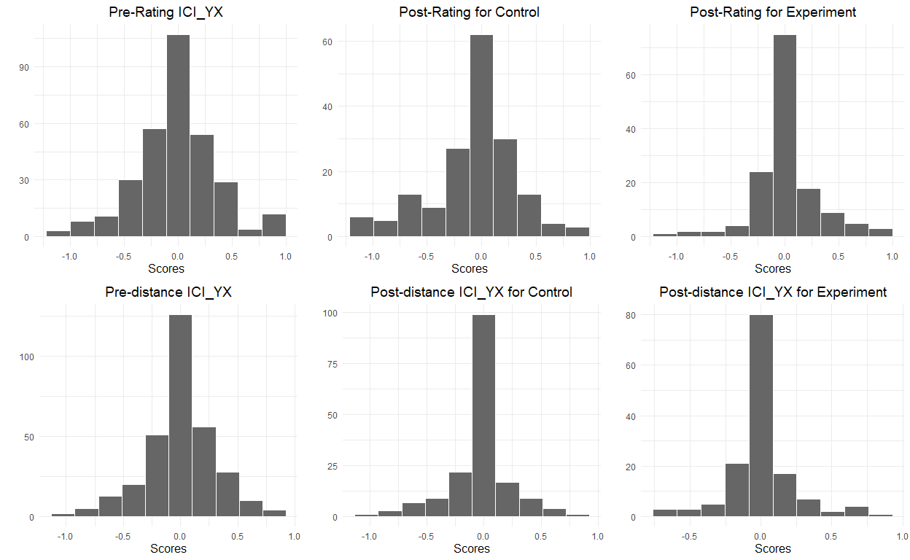

p1 <- plot_distribution(df_prp_both, "ICI_WZ_rating_pre_norm", "Pre-Rating ICI_WZ")  
  
p4 <- plot_distribution(df_prp_both, "ICI_WZ_dist_pre_norm", "Pre-distance ICI_WZ")  
  
grid.arrange(p1, p4, ncol = 2)

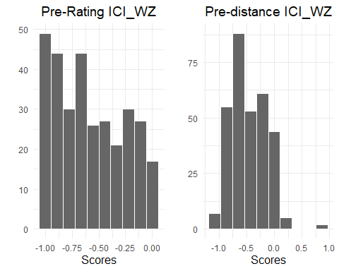

# First plot: Scatter plot of ICI_YX_rating_pre_norm vs ICI_WZ_rating_pre_norm  
ggplot(df_prp_both, aes(x = ICI_YX_rating_pre_norm, y = ICI_WZ_rating_pre_norm)) +  
 geom_point() +  
 labs(title = "Scatter plot of ICI_YX vs ICI_WZ Ratings",  
 x = "ICI_YX Rating",  
 y = "ICI_WZ Rating") +  
 theme_minimal()

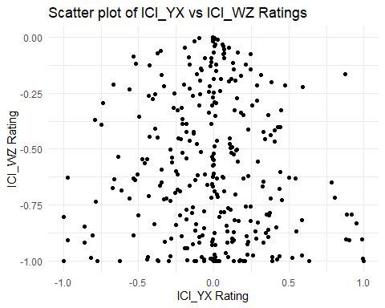

# Second plot: Scatter plot of ICI_YX_dist_pre_norm vs ICI_WZ_dist_pre_norm  
ggplot(df_prp_both, aes(x = ICI_YX_dist_pre_norm, y = ICI_WZ_dist_pre_norm)) +  
 geom_point() +  
 labs(title = "Scatter plot of ICI_YX vs ICI_WZ Distances",  
 x = "ICI_YX Distance",  
 y = "ICI_WZ Distance") +  
 theme_minimal()

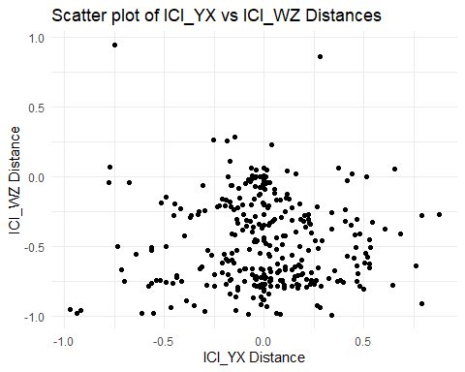

Plot accumulated probability distribution group by stimulus type

plot_accumulated_density <- function(df, x, color, title) {  
 p <- ggplot(df, aes(x = !!sym(x), color = !!sym(color))) +  
 stat_ecdf(geom = "step", size = 1) +   
 labs(title = title, x = "Scores", y = "Cumulative Probability") +  
 theme_minimal() +  
 theme(  
 plot.title = element_text(size = 14, hjust = 0.5),  
 axis.title.x = element_text(size = 12),  
 axis.title.y = element_text(size = 12)  
 )  
 return(p)  
}  
  
plot_density <- function(df, x, color, title) {  
 p <- ggplot(df, aes(x = !!sym(x), color = !!sym(color))) +  
 geom_density(aes(y = ..count..), fill = "grey40", alpha = 0.5) +  
 #stat_ecdf(geom = "step", size = 1) +   
 labs(title = title, x = "Scores", y = "Cumulative Probability") +  
 theme_minimal() +  
 theme(  
 plot.title = element_text(size = 14, hjust = 0.5),  
 axis.title.x = element_text(size = 12),  
 axis.title.y = element_text(size = 12)  
 )  
 return(p)  
}

p1 <- plot_density(df_prp_both, "ICI_YX_rating_pre_norm", "stimulus_type_X_Y", "Density\n of Pre-Rating")  
p2 <- plot_density(df_prp_both, "ICI_YX_dist_pre_norm", "stimulus_type_X_Y", "Density \n of Pre-Distance")  
  
grid.arrange(p1, p2, ncol=2)

Warning: The dot-dot notation (`..count..`) was deprecated in ggplot2 3.4.0.  
ℹ Please use `after_stat(count)` instead.

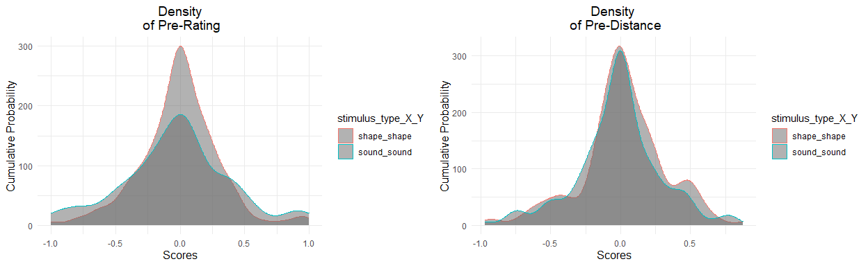

p1 <- plot_accumulated_density(df_prp_both, "ICI_YX_rating_pre_norm", "stimulus_type_X_Y", "Cumulative Density\n of Pre-Rating")

Warning: Using `size` aesthetic for lines was deprecated in ggplot2 3.4.0.  
ℹ Please use `linewidth` instead.

p2 <- plot_accumulated_density(df_prp_both, "ICI_YX_dist_pre_norm", "stimulus_type_X_Y", "Cumulative Density \n of Pre-Distance")  
  
grid.arrange(p1, p2, ncol=2)

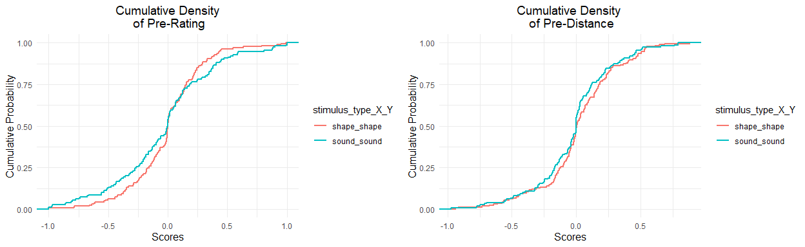

p1 <- plot_density(df_prp_both, "ICI_YX_rating_pre_norm", "stimulus_X_Y", "Density of Pre-Rating")  
  
grid.arrange(p1, ncol=1)

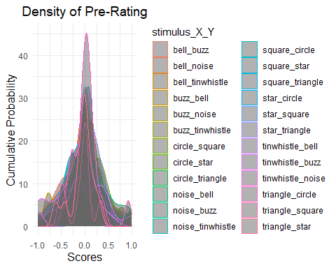

p1 <- plot_density(df_prp_both, "ICI_YX_dist_pre_norm", "stimulus_X_Y", "Density of Pre-Distance")  
  
grid.arrange(p1, ncol=1)

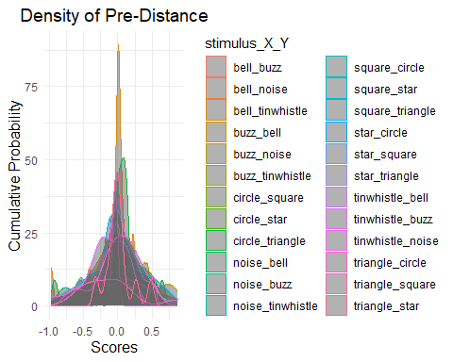

p1 <- plot_accumulated_density(df_prp_both, "ICI_YX_rating_pre_norm", "stimulus_X_Y", "Cumulative Density of Pre-Rating")  
  
grid.arrange(p1, ncol=1)

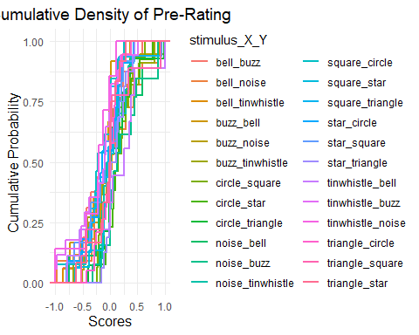

p1 <- plot_accumulated_density(df_prp_both, "ICI_YX_dist_pre_norm", "stimulus_X_Y", "Cumulative Density of Pre-Distance")  
  
grid.arrange(p1, ncol=1)

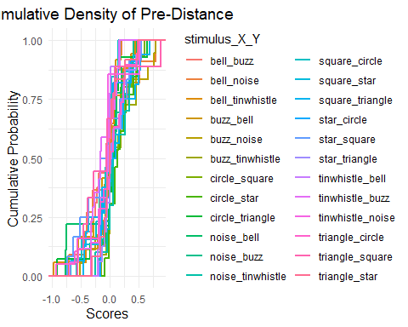

### One-way ANOVA test for normalized pre-manipulation indexes with stimulus type

summary(aov(df_prp_both$ICI_YX_rating_pre_norm ~ df_prp_both$stimulus_type_X_Y))

Df Sum Sq Mean Sq F value Pr(>F)  
df_prp_both$stimulus_type_X_Y 1 0.05 0.04751 0.358 0.55  
Residuals 313 41.48 0.13254

summary(aov(df_prp_both$ICI_YX_dist_pre_norm ~ df_prp_both$stimulus_type_X_Y))

Df Sum Sq Mean Sq F value Pr(>F)  
df_prp_both$stimulus_type_X_Y 1 0.092 0.09172 1.008 0.316  
Residuals 313 28.489 0.09102

### Normality test

Test for normality using Shapiro-Wilk Test for each index. They seems normal.

shapiro.test(df_prp_both$ICI_YX_rating_pre_norm)

Shapiro-Wilk normality test  
  
data: df_prp_both$ICI_YX_rating_pre_norm  
W = 0.97394, p-value = 1.777e-05

shapiro.test(df_prp_both$ICI_YX_dist_pre_norm)

Shapiro-Wilk normality test  
  
data: df_prp_both$ICI_YX_dist_pre_norm  
W = 0.9726, p-value = 1.056e-05

shapiro.test(df_prp_both$ICI_YX_rating_post_norm)

Shapiro-Wilk normality test  
  
data: df_prp_both$ICI_YX_rating_post_norm  
W = 0.93783, p-value = 3.192e-10

shapiro.test(df_prp_both$ICI_YX_dist_post_norm)

Shapiro-Wilk normality test  
  
data: df_prp_both$ICI_YX_dist_post_norm  
W = 0.88533, p-value = 1.257e-14

### Correlations

df_shorted_name <- df_prp_both %>%  
 mutate(rating_pre = ICI_YX_rating_pre_norm,  
 rating_post = ICI_YX_rating_post_norm,  
 distance_pre = ICI_YX_dist_pre_norm,  
 distance_post = ICI_YX_dist_post_norm)  
   
selected_columns <- df_shorted_name[, c('anxiety', 'stress', 'depression', 'Sex_0', 'age', 'rating_pre', 'rating_post', 'distance_pre', 'distance_post')]  
  
cor_matrix <- cor(selected_columns, use = "complete.obs")  
cor_matrix

anxiety stress depression Sex_0 age  
anxiety 1.00000000 0.84290961 0.84950350 0.013009678 -0.19038253  
stress 0.84290961 1.00000000 0.85358218 0.077319077 -0.22205455  
depression 0.84950350 0.85358218 1.00000000 0.083863705 -0.18094134  
Sex_0 0.01300968 0.07731908 0.08386371 1.000000000 0.07366257  
age -0.19038253 -0.22205455 -0.18094134 0.073662574 1.00000000  
rating_pre -0.07560735 -0.07443259 -0.06005502 0.049078888 0.04878348  
rating_post -0.03295682 -0.02751596 -0.02375800 -0.004242396 -0.08268928  
distance_pre -0.10107376 -0.11389789 -0.09086615 0.072636159 0.04887542  
distance_post -0.03164209 -0.02601200 -0.02175057 -0.075899821 -0.12185594  
 rating_pre rating_post distance_pre distance_post  
anxiety -0.07560735 -0.032956823 -0.10107376 -0.03164209  
stress -0.07443259 -0.027515956 -0.11389789 -0.02601200  
depression -0.06005502 -0.023758000 -0.09086615 -0.02175057  
Sex_0 0.04907889 -0.004242396 0.07263616 -0.07589982  
age 0.04878348 -0.082689278 0.04887542 -0.12185594  
rating_pre 1.00000000 0.309718470 0.55006694 0.29041970  
rating_post 0.30971847 1.000000000 0.33540380 0.59092254  
distance_pre 0.55006694 0.335403797 1.00000000 0.31594470  
distance_post 0.29041970 0.590922542 0.31594470 1.00000000

# Plot the heatmap using corrplot  
corrplot(cor_matrix, method = "color", tl.col = "black", tl.srt = 45,   
 addCoef.col = "black", number.cex = 0.7, col = colorRampPalette(c("blue", "white", "red"))(200),  
 title = "Correlation Heatmap", mar = c(0, 0, 1, 0))

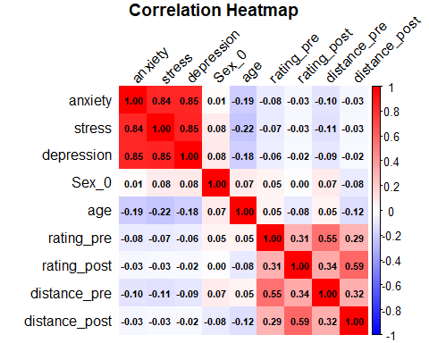

Calculate p-values for the correlation matrix

vars <- names(selected_columns)  
n <- length(vars)  
p_matrix <- matrix(NA, n, n)  
colnames(p_matrix) <- rownames(p_matrix) <- vars  
  
for (i in 1:n) {  
 for (j in 1:n) {  
 test <- cor.test(selected_columns[[i]], selected_columns[[j]], method = "pearson")  
 p_matrix[i, j] <- test$p.value  
 }  
}  
p_matrix

anxiety stress depression Sex_0 age  
anxiety 0.000000e+00 2.994172e-86 6.326143e-89 0.8180990 6.821868e-04  
stress 2.994172e-86 0.000000e+00 1.206063e-90 0.1710393 7.033532e-05  
depression 6.326143e-89 1.206063e-90 0.000000e+00 0.1375086 1.258470e-03  
Sex_0 8.180990e-01 1.710393e-01 1.375086e-01 0.0000000 1.922487e-01  
age 6.821868e-04 7.033532e-05 1.258470e-03 0.1922487 0.000000e+00  
rating_pre 1.807403e-01 1.876295e-01 2.879666e-01 0.3853263 3.881965e-01  
rating_post 5.600559e-01 6.266053e-01 6.744521e-01 0.9402179 1.431220e-01  
distance_pre 7.323881e-02 4.338042e-02 1.074777e-01 0.1985346 3.873018e-01  
distance_post 5.758213e-01 6.455810e-01 7.005745e-01 0.1790546 3.060322e-02  
 rating_pre rating_post distance_pre distance_post  
anxiety 1.807403e-01 5.600559e-01 7.323881e-02 5.758213e-01  
stress 1.876295e-01 6.266053e-01 4.338042e-02 6.455810e-01  
depression 2.879666e-01 6.744521e-01 1.074777e-01 7.005745e-01  
Sex_0 3.853263e-01 9.402179e-01 1.985346e-01 1.790546e-01  
age 3.881965e-01 1.431220e-01 3.873018e-01 3.060322e-02  
rating_pre 0.000000e+00 1.980002e-08 2.616836e-26 1.541963e-07  
rating_post 1.980002e-08 0.000000e+00 1.015451e-09 4.846184e-31  
distance_pre 2.616836e-26 1.015451e-09 0.000000e+00 9.886029e-09  
distance_post 1.541963e-07 4.846184e-31 9.886029e-09 0.000000e+00

### Assign styles

Segment the participants into three groups based on their pre-manipulation ratings and distances.

# Calculate the SD for Pre and define participants' styles  
rating_quantile <- quantile(df_prp_both$ICI_YX_rating_pre_norm, c(1/3, 2/3))  
dist_quantile <- quantile(df_prp_both$ICI_YX_dist_pre_norm, c(1/3, 2/3))  
  
df_prp_both <- df_prp_both %>%  
 mutate(# rating  
 sd_pre_rating = sd(ICI_YX_rating_pre_norm, na.rm = TRUE),  
 mean_pre_rating = mean(ICI_YX_rating_pre_norm, na.rm = TRUE),  
 style_rating = case_when(  
 #ICI_YX_rating_pre_norm > mean_pre_rating + sd_pre_rating ~ "Competitive",  
 #ICI_YX_rating_pre_norm < mean_pre_rating - sd_pre_rating ~ "Facilitative",  
 ICI_YX_rating_pre_norm > rating_quantile[2] ~ "Competitive",  
 ICI_YX_rating_pre_norm < rating_quantile[1] ~ "Facilitative",  
 .default = "No-Difference"  
 ),  
 # distance  
 sd_pre_distance = sd(ICI_YX_dist_pre_norm, na.rm = TRUE),  
 mean_pre_distance = mean(ICI_YX_dist_pre_norm, na.rm = TRUE),  
 style_distance = case_when(  
 #ICI_YX_dist_pre_norm > mean_pre_distance + sd_pre_distance ~ "Competitive",  
 #ICI_YX_dist_pre_norm < mean_pre_distance - sd_pre_distance ~ "Facilitative",  
 ICI_YX_dist_pre_norm > dist_quantile[2] ~ "Competitive",  
 ICI_YX_dist_pre_norm < dist_quantile[1] ~ "Facilitative",  
 .default = "No-Difference"  
 ))

How many participants in each style?

df_prp_both %>%  
 group_by(style_rating) %>%  
 summarize(n = n_distinct(subjectID))

# A tibble: 3 × 2  
 style_rating n  
 <chr> <int>  
1 Competitive 105  
2 Facilitative 105  
3 No-Difference 105

df_prp_both %>%  
 group_by(style_distance) %>%  
 summarize(n = n_distinct(subjectID))

# A tibble: 3 × 2  
 style_distance n  
 <chr> <int>  
1 Competitive 105  
2 Facilitative 105  
3 No-Difference 105

### One-way ANOVA test for normalized pre-manipulation rating indexes

Check assumptions: normality & homogeneity of variances

1. Shapiro-Wilk (normality within each group)

by(df_prp_both$ICI_YX_rating_pre_norm, df_prp_both$style_rating, shapiro.test)

df_prp_both$style_rating: Competitive  
  
 Shapiro-Wilk normality test  
  
data: dd[x, ]  
W = 0.83727, p-value = 2.189e-09  
  
------------------------------------------------------------   
df_prp_both$style_rating: Facilitative  
  
 Shapiro-Wilk normality test  
  
data: dd[x, ]  
W = 0.88659, p-value = 2.03e-07  
  
------------------------------------------------------------   
df_prp_both$style_rating: No-Difference  
  
 Shapiro-Wilk normality test  
  
data: dd[x, ]  
W = 0.94961, p-value = 0.0005534

All groups violate the normality assumption, the p-values are all < 0.05.

1. Levene’s test (homogeneity of variance)

df_prp_both$style_rating_factor <- as.factor(df_prp_both$style_rating)  
  
leveneTest(ICI_YX_rating_pre_norm ~ style_rating_factor, data = df_prp_both)

Levene's Test for Homogeneity of Variance (center = median)  
 Df F value Pr(>F)   
group 2 35.761 1.04e-14 ***  
 312   
---  
Signif. codes: 0 '***' 0.001 '**' 0.01 '*' 0.05 '.' 0.1 ' ' 1

The p-value is < 0.05, indicating that the variances are not equal across groups.

Run one-way ANOVA

anova_model <- aov(ICI_YX_rating_pre_norm ~ style_rating, data = df_prp_both)  
summary(anova_model)

Df Sum Sq Mean Sq F value Pr(>F)   
style_rating 2 29.35 14.677 376 <2e-16 ***  
Residuals 312 12.18 0.039   
---  
Signif. codes: 0 '***' 0.001 '**' 0.01 '*' 0.05 '.' 0.1 ' ' 1

eta_squared(anova_model)

For one-way between subjects designs, partial eta squared is equivalent  
 to eta squared. Returning eta squared.

# Effect Size for ANOVA  
  
Parameter | Eta2 | 95% CI  
----------------------------------  
style_rating | 0.71 | [0.67, 1.00]  
  
- One-sided CIs: upper bound fixed at [1.00].

A one-way between-subjects ANOVA was conducted to examine the effect of rating style (Competitive, Facilitative, No-Difference) on participants’ normalized pre-manipulation ratings index. The results revealed a statistically significant effect of rating style on normalized rating indexes, F(2, 312) = 376.00, p < .001. The effect size was large, η² = .71, 95% CI [.67, 1.00], indicating that approximately 71% of the variance in normalized pre-manipulation rating indexes can be attributed to rating style.

### One-way ANOVA test for normalized pre-manipulation distance indexes

Check assumptions: normality & homogeneity of variances

1. Shapiro-Wilk (normality within each group)

by(df_prp_both$ICI_YX_dist_pre_norm, df_prp_both$style_distance, shapiro.test)

df_prp_both$style_distance: Competitive  
  
 Shapiro-Wilk normality test  
  
data: dd[x, ]  
W = 0.90653, p-value = 1.776e-06  
  
------------------------------------------------------------   
df_prp_both$style_distance: Facilitative  
  
 Shapiro-Wilk normality test  
  
data: dd[x, ]  
W = 0.86961, p-value = 3.798e-08  
  
------------------------------------------------------------   
df_prp_both$style_distance: No-Difference  
  
 Shapiro-Wilk normality test  
  
data: dd[x, ]  
W = 0.96824, p-value = 0.0127

All groups violate the normality assumption, the p-values are all < 0.05.

1. Levene’s test (homogeneity of variance)

df_prp_both$style_distance_factor <- as.factor(df_prp_both$style_distance)  
  
leveneTest(ICI_YX_dist_pre_norm ~ style_distance_factor, data = df_prp_both)

Levene's Test for Homogeneity of Variance (center = median)  
 Df F value Pr(>F)   
group 2 38.645 1.013e-15 ***  
 312   
---  
Signif. codes: 0 '***' 0.001 '**' 0.01 '*' 0.05 '.' 0.1 ' ' 1

The p-value is < 0.05, indicating that the variances are not equal across groups.

Run one-way ANOVA

anova_model <- aov(ICI_YX_dist_pre_norm ~ style_distance, data = df_prp_both)  
summary(anova_model)

Df Sum Sq Mean Sq F value Pr(>F)   
style_distance 2 19.929 9.964 359.3 <2e-16 ***  
Residuals 312 8.652 0.028   
---  
Signif. codes: 0 '***' 0.001 '**' 0.01 '*' 0.05 '.' 0.1 ' ' 1

eta_squared(anova_model)

For one-way between subjects designs, partial eta squared is equivalent  
 to eta squared. Returning eta squared.

# Effect Size for ANOVA  
  
Parameter | Eta2 | 95% CI  
------------------------------------  
style_distance | 0.70 | [0.66, 1.00]  
  
- One-sided CIs: upper bound fixed at [1.00].

A one-way between-subjects ANOVA was conducted to examine the effect of distance style (Competitive, Facilitative, No-Difference) on participants’ normalized pre-manipulation distance index. The results revealed a statistically significant effect of distance style on distance indexes, F(2, 312) = 359.3, p < .001. The effect size was large, η² = .70, 95% CI [.66, 1.00], indicating that approximately 71% of the variance in normalized pre-manipulation distance index can be attributed to distance style.

### Two-way ANOVA test for normalized post-manipulation rating indexes

df_prp_both <- df_prp_both %>%  
 mutate(rating_change = ICI_YX_rating_post_norm - ICI_YX_rating_pre_norm)  
  
anova_change <- aov(rating_change ~ style_rating * group, data = df_prp_both)  
summary(anova_change)

Df Sum Sq Mean Sq F value Pr(>F)   
style_rating 2 13.23 6.616 49.282 <2e-16 ***  
group 1 0.00 0.004 0.032 0.8590   
style_rating:group 2 0.88 0.442 3.295 0.0384 *   
Residuals 309 41.48 0.134   
---  
Signif. codes: 0 '***' 0.001 '**' 0.01 '*' 0.05 '.' 0.1 ' ' 1

A two-way mixed design ANOVA was conducted to examine the effects of rating style (Competitive, Facilitative, No-Difference) and group (Control, Experimental) on the change in normalized rating indexes from pre- to post-manipulation.

There was a significant main effect of rating style, F(2, 309) = 49.28, p < .001, η² = .24, indicating that the amount of change differed significantly across rating styles.

There was no significant main effect of group, F(1, 309) = 0.03, p = .859, suggesting that, overall, control and experimental groups did not differ in change scores.

However, there was a significant interaction between rating styles and group, F(2, 309) = 3.30, p = .038, indicating that the effect of group on rating index change varied depending on the rating style.

### Two-way ANOVA test for normalized post-manipulation distance indexes

df_prp_both <- df_prp_both %>%  
 mutate(dist_change = ICI_YX_dist_post_norm - ICI_YX_dist_pre_norm)  
  
anova_change <- aov(dist_change ~ style_distance * group, data = df_prp_both)  
summary(anova_change)

Df Sum Sq Mean Sq F value Pr(>F)   
style_distance 2 10.558 5.279 72.953 <2e-16 ***  
group 1 0.027 0.027 0.380 0.5382   
style_distance:group 2 0.365 0.183 2.523 0.0819 .   
Residuals 309 22.359 0.072   
---  
Signif. codes: 0 '***' 0.001 '**' 0.01 '*' 0.05 '.' 0.1 ' ' 1

A two-way between-subjects ANOVA was conducted to examine the effects of distance style (Competitive, Facilitative, No-Difference) and group (Control, Experimental) on participants’ normalized distance index.

There was a significant main effect of distance style, F(2, 309) = 72.95, p < .001, η² = .32, indicating that average distance index significantly differed across styles.

There was no significant main effect of group, F(1, 309) = 0.38, p = .538, suggesting that control and experimental groups did not differ overall in distance index.

The interaction between distance style and group was marginally significant, F(2, 309) = 2.52, p = .082, η² ≈ .01, indicating a potential trend that the effect of group may differ depending on distance style, though this did not reach conventional levels of statistical significance.

## Plot for Interactions

# a function to plot ICI  
plot_ICI <- function(df, pre, post, style, title) {  
 # Classify based on the `pre` column  
 df_style <- df %>%  
 mutate(style = .data[[style]])  
   
 # df_style <- df_style %>% filter(style != 'No-Difference')  
   
 # Reshape the data  
 df_melted <- df_style %>%  
 select(all_of(c(pre, post, 'group', 'style'))) %>%  
 pivot_longer(cols = all_of(c(pre, post)), names_to = "flip", values_to = "value") %>%  
 mutate(flip = dplyr::recode(flip, !!sym(pre) := "Pre", !!sym(post) := "Post"))  
   
 # Order the levels  
 df_melted$flip <- factor(df_melted$flip, levels = c("Pre", "Post"))  
  
 # Summarize the data to calculate mean and 68% confidence interval  
 df_summary <- df_melted %>%  
 group_by(group, style, flip) %>%  
 summarize(  
 mean_value = mean(value, na.rm = TRUE),  
 se = sd(value, na.rm = TRUE) / sqrt(n()),   
 ci_68 = se * qnorm(0.84), # Approx 68% CI (1 standard error)  
 .groups = "drop"  
 )  
   
 # Plot using ggplot2 with error bars  
 g <- ggplot(df_summary, aes(x = flip, y = mean_value, color = group, group = group)) +  
 geom_point(size = 2) + # Increase point size  
 geom_line(linewidth = 1) + # Use linewidth for the main lines  
 geom_errorbar(aes(ymin = mean_value - ci_68, ymax = mean_value + ci_68), width = 0.05, linewidth = .8) + # Error bars with thinner lines  
 facet_wrap(~style, scales = "fixed", nrow = 1) + # Use "fixed" for shared y-axis  
 labs(title = title, y = "ICI", x = "") +  
 theme_minimal() +  
 theme(  
 plot.title = element_text(hjust = 0.5, size = 16, face = "bold"), # Adjust title size  
 axis.title = element_text(size = 14), # Axis title size  
 axis.text = element_text(size = 12), # Axis text size  
 strip.text = element_text(size = 14), # Facet title size  
 legend.position = "right",  
 legend.text = element_text(size = 12), # Adjust legend text size  
 panel.grid.major.x = element_blank(), # Remove major vertical grid lines  
 panel.grid.minor.x = element_blank(), # Remove minor vertical grid lines  
 panel.grid.major.y = element_line(color = "lightgrey", linewidth = 0.1), # Add major horizontal grid lines  
 panel.grid.minor.y = element_blank(), # Remove minor horizontal grid lines  
 panel.spacing = unit(1, "lines"), # Tighten space between panels  
 axis.line.x = element_line(color = "black"), # Add x-axis line  
 axis.line.y.left = element_line(color = "black") # Left y-axis  
 ) +  
 scale_color_manual(values = c("blue", "orange"))   
  
 # Display the plot  
 print(g)  
}  
  
# Example usage  
plot_ICI(df_prp_both, 'ICI_YX_rating_pre_norm', 'ICI_YX_rating_post_norm', 'style_rating', 'Normalized ICI-YX Ratings')

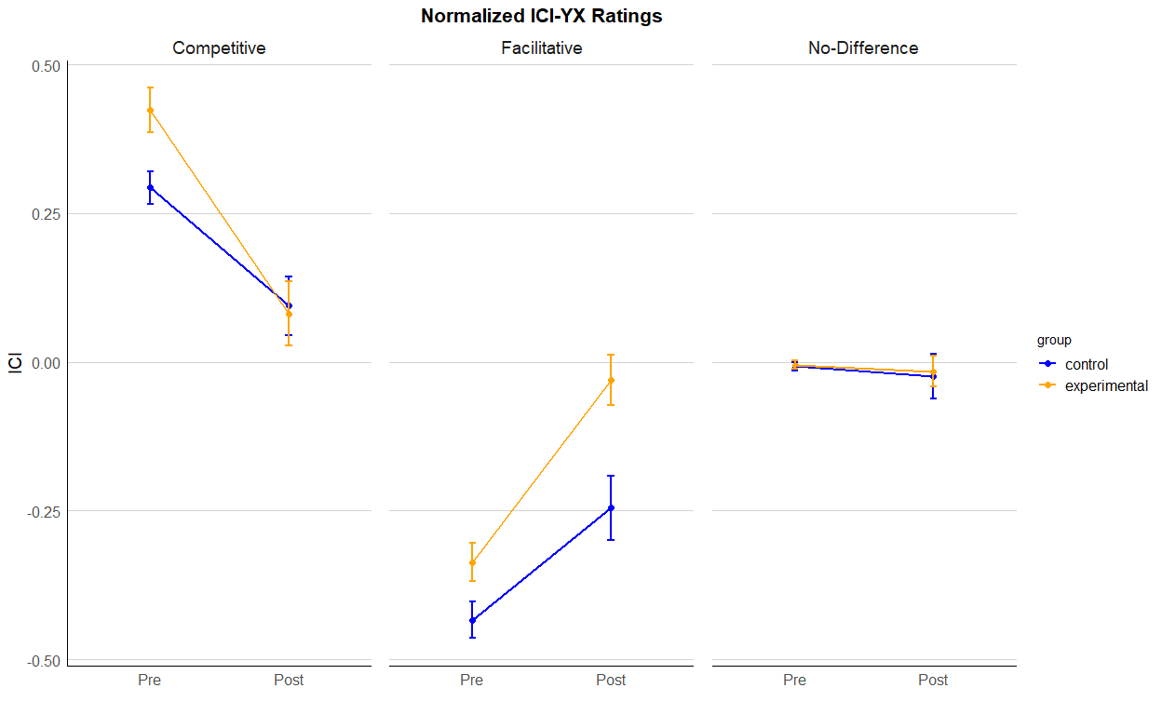

plot_ICI(df_prp_both, 'ICI_YX_dist_pre_norm', 'ICI_YX_dist_post_norm', 'style_distance', 'Normalized ICI-YX Distances')

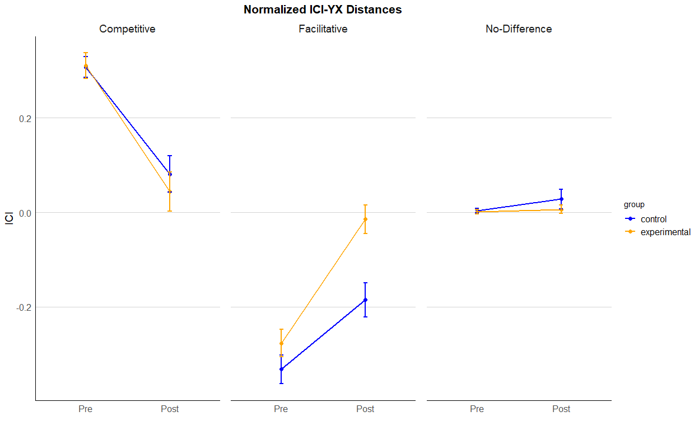

## Convert data to a long format

df_prp_long <- df_prp_both %>%  
 select(subjectID, group, style_rating, style_distance, ICI_YX_rating_pre_norm, ICI_YX_rating_post_norm, ICI_YX_dist_pre_norm, ICI_YX_dist_post_norm) %>%  
 pivot_longer(cols = c(ICI_YX_rating_pre_norm, ICI_YX_rating_post_norm, ICI_YX_dist_pre_norm, ICI_YX_dist_post_norm), names_to = "Index", values_to = "value")   
# save to CSV  
write_csv(df_prp_long, "./exp4-ICI.csv")

# Result

1. Stimulus types on normalized pre-manipulation rating indexes

A one-way between-subjects ANOVA was conducted to examine the effect of stimulus type (shape vs. sound) on normalized pre-manipulation rating indexes. The analysis revealed that the effect of stimulus type was not statistically significant, F(1, 313) = 0.36, p = .55, η² = .001.

1. Stimulus types on normalized pre-manipulation distance indexes

A one-way between-subjects ANOVA was conducted to examine the effect of stimulus type (shape vs. sound) on normalized pre-manipulation distance indexes. The analysis revealed that the effect of stimulus type was not statistically significant, F(1, 313) = 1.008, p = .36, η² = .003.

1. Correlations of anxiety, stress, and depression with rating

Anxiety was not significantly correlated with participants’ pre-manipulation ratings, r(315) = -0.08, p = .18. Stress was not significantly correlated with pre-manipulation ratings, r = -0.07, p = .19. Depression was not significantly correlated with pre-manipulation ratings, r = -0.06, p = .29.

1. Correlations of anxiety, stress, and depression with Distance

Anxiety was marginally negatively correlated with distance to the object, r = -0.10, p = .07. Stress was significantly negatively correlated with distance, r = -0.11, p = .04. Depression was not significantly correlated with distance, r = -0.09, p = .11.

1. Rating style and normalized pre-manipulation rating indexes

A one-way between-subjects ANOVA was conducted to examine the effect of rating style (Competitive, Facilitative, No-Difference) on participants’ normalized pre-manipulation ratings index. The results revealed a statistically significant effect of rating style on normalized rating indexes, F(2, 312) = 376.00, p < .001. The effect size was large, η² = .71, 95% CI [.67, 1.00], indicating that approximately 71% of the variance in normalized pre-manipulation rating indexes can be attributed to rating style.

1. Distance style on normalized pre-manipulation distance indexes

A one-way between-subjects ANOVA was conducted to examine the effect of distance style (Competitive, Facilitative, No-Difference) on participants’ normalized pre-manipulation distance index. The results revealed a statistically significant effect of distance style on distance indexes, F(2, 312) = 359.3, p < .001. The effect size was large, η² = .70, 95% CI [.66, 1.00], indicating that approximately 71% of the variance in normalized pre-manipulation distance index can be attributed to distance style.

1. Rating style and group on normalized rating indexes

A two-way mixed design ANOVA was conducted to examine the effects of rating style (Competitive, Facilitative, No-Difference) and group (Control, Experimental) on the change in normalized rating indexes from pre- to post-manipulation. There was a significant main effect of rating style, F(2, 309) = 49.28, p < .001, η² = .24, indicating that the amount of change differed significantly across rating styles. There was no significant main effect of group, F(1, 309) = 0.03, p = .859, suggesting that, overall, control and experimental groups did not differ in change scores. However, there was a significant interaction between rating styles and group, F(2, 309) = 3.30, p = .038, indicating that the effect of group on rating index change varied depending on the rating style.

1. Distance style and group on change in normalized distance indexes

A two-way between-subjects ANOVA was conducted to examine the effects of distance style (Competitive, Facilitative, No-Difference) and group (Control, Experimental) on the change in participants’ normalized distance index from pre- to post-manipulation. There was a significant main effect of distance style, F(2, 309) = 72.95, p < .001, η² = .32, indicating that average distance index significantly differed across styles. There was no significant main effect of group, F(1, 309) = 0.38, p = .538, suggesting that control and experimental groups did not differ overall in distance index. The interaction between distance style and group was marginally significant, F(2, 309) = 2.52, p = .082, η² ≈ .01, indicating a potential trend that the effect of group may differ depending on distance style, though this did not reach conventional levels of statistical significance.

# Discussion

This study analyzed individual differences in cue interaction using data from Experiment 4 of Alhazmi (2022), with a focus on how within-compound associations shape predictive behavior. By computing normalized indexes for key cue pairs (X and Y), we identified distinct cue interaction styles—competitive, facilitative, and no-difference—based on both subjective ratings and behavioral distance measures.

Our ANOVA results showed that these styles accounted for a substantial portion of variance in pre-manipulation cue responses (η² > .70), confirming that cue interaction tendencies are robust and quantifiable. Importantly, stimulus modality (shape vs. sound) did not significantly influence cue interaction, and no major demographic or psychological variables (anxiety, depression, stress) were strongly associated with style, though stress showed a marginal correlation with distance-based responding.

Post-manipulation analyses revealed a significant interaction between rating style and group assignment (reversal vs. control), suggesting that facilitative learners were more sensitive to outcome reversals. This aligns with theoretical accounts in which within-compound associations enhance cue integration, making facilitative participants more responsive to contextual change.

Together, these findings demonstrate that cue interaction style is a stable, behaviorally meaningful construct, and that facilitative learners exhibit greater flexibility following outcome reversals. Future work should examine how these styles relate to learning efficiency and adaptability in more complex or clinically relevant settings.

# Conclusion

In summary, this study shows that people differ in how they combine cues when learning, and these differences can be clearly measured. These learning styles also affect how well people adjust when the outcomes change.

# References

* Alhazmi, A. (2022). *Competitive and facilitative interactions between Pavlovian cues in human associative learning: A behavioral and neural analysis* (Unpublished doctoral dissertation). City University of New York.
* Batsell Jr, W. R., & Batson, J. D. (1999). Augmentation of taste conditioning by a preconditioned odor. *Journal of Experimental Psychology: Animal Behavior Processes, 25*(3), 374.
* Bouton, M. E., Dunlap, C. M., & Swartzentruber, D. (1987). Potentiation of taste by another taste during compound aversion learning. *Animal Learning & Behavior, 15*(4), 433–438. https://doi.org/10.3758/BF03205053
* Bush, R. R., & Mosteller, F. (1951). A mathematical model for simple learning. *Psychological Review, 58*(5), 313–323. https://doi.org/10.1037/h0054388
* Durlach, P. J., & Rescorla, R. A. (1980). Potentiation rather than overshadowing in flavor-aversion learning: An analysis in terms of within-compound associations. *Journal of Experimental Psychology: Animal Behavior Processes, 6*(2), 175–187. https://doi.org/10.1037/0097-7403.6.2.175
* Kamin, L. (1968). “Attention-like” processes in classical conditioning. *Miami Symposium on the Prediction of Behavior: Aversive Stimulation*, 9–31.
* Mackintosh, N. J. (1975a). A theory of attention: Variations in the associability of stimuli with reinforcement. *Psychological Review, 82*(4), 276.
* Mackintosh, N. J. (1975b). Blocking of conditioned suppression: Role of the first compound trial. *Journal of Experimental Psychology: Animal Behavior Processes, 1*(4), 335–345. https://doi.org/10.1037/0097-7403.1.4.335
* Mitchell, C. J., De Houwer, J., & Lovibond, P. F. (2009). The propositional nature of human associative learning. *Behavioral and Brain Sciences, 32*(2), 183–198.
* Pearce, J. M., & Hall, G. (1980). A model for Pavlovian learning: Variations in the effectiveness of conditioned but not of unconditioned stimuli. *Psychological Review, 87*(6), 532.
* Pineño, O. (2007). A response rule for positive and negative stimulus interaction in associative learning and performance. *Psychonomic Bulletin & Review, 14*(6), 1115–1124. https://doi.org/10.3758/BF03193100
* Rescorla, R. A., & Wagner, A. (1972). A theory of Pavlovian conditioning: Variations in the effectiveness of reinforcement and nonreinforcement. In *Classical Conditioning II: Current Research and Theory* (Vol. 2).
* Stout, S. C., & Miller, R. R. (2007). Sometimes-competing retrieval (SOCR): A formalization of the comparator hypothesis. *Psychological Review, 114*(3), 759–783. https://doi.org/10.1037/0033-295X.114.3.759