Hyperspectral Excellence QC Protocols
This document describes procedure for measuring the uncertainty of drone flights. It currently focuses on assessing the accuracy of existing flights in the lead up to Cali week 2026. It will also from the basis of a standard QC procedure for future flights. Initially this document focuses on the hyperspectral drones, but the procedure will expand in the future. Future flights are likely to consist of multiple sets of panes for both ELM and validation, ground control points (to test GNSS) and other reflectance targets for LIDAR calibration.

Spectral QC
Spectral QC is done by drawing polygons in GIS software over surfaces with known spectral values, then extracting and comparing them. This is done after all processing in software like GPT is complete.
CALVIS and GOBI flights conducted prior to the Operational Excellence in APPN Hyperspectral Imaging SIF likely consist of one GRYFN reflectance panel which is used to generate the ELM in Gryfn Processing Tool along with additional panels for validation. We have settled on the following naming conventions:
Name | Overview
QC_ELM_Panels.shp | The shape file of the reflectance panels used in the ELM during Gryfn Processing
QC_VAL_Grfyn_Panels.shp | When a second set of Gryfn panels is also placed in the field, a second shape file should be created. The name should be replace ‘ELM’ with ‘VAL’ for validation
QC_VAL_{PanelName}_Panels.shp | Any future validation panels, along with any tests of other panels the nods possess should be named following this pattern, where {PanelName} is replaced by the name or unique identifier of the panel.
QC_GCP_points.shp | If alternative GCP points (like aeropoints) are placed in the field, another shape file should be created. This should be a points only file and the points should match the centre of the panels.
QC_LIDAR_{TargetName}_Surface.shp | The name for any future LIDAR calibration surfaces.

Any additional information e.g. date can be added to the end of the file name with an underscore (e.g. QC_ELM_Panels_20260302.shp). This table will be update if we source panels other than GRYFN.
Any files created in the quality control steps are to be stored in a newly created QC_data folder inside T1_proc. An example full path might be:
./USYD_Narrabri/2025_SIFCal/2025IAWatson/CALVIS/20250825/run_00/T1_proc/QC_data
These shape files are meant to be created after the GPRO has been completed. The APPN storage repo has been updated to include this folder. https://github.com/ArdenB/APPN_GenricFileStorage

Creating shape files for the GOBI and CALVIS using QGIS.
The description below shows the procedure for creating shape files for the CALVIS over GRYFN reflectance panel used for ELM. For the CALVIS, in the products folder in the complete gpro there will be the .TIF files X_ _VNIR_Orthomosaic.rgb and X_calvis_sif_cal_20250925_SWIR_Orthomosaic.rgb, these are the RGB bands from the VNIR and SWIR files respectively. These can be easier to use than the full bin files, though the procedure is the same.
Below are steps to create the shape file. The process for the GOBI is the same, but there is only the VNIR orthomosaic.‎

Load the data
- Load both files into QGIS and run the following checks.
  - Do the panels in the SWIR and VNIR overlap ?
  - Make note of the CRS
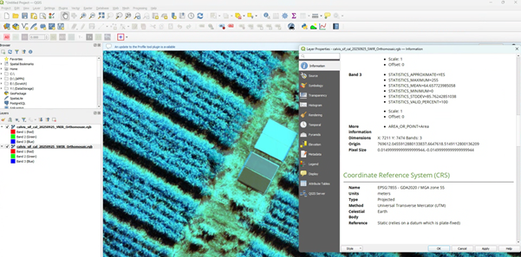
Figure: The VNIR is set to 50% opacity to confirm the panels overlap with the SWIR and the information panel is open on the SWIR to confirm the CRS (EPSG:7855 – GDA2020/ MGA zone 55) this CRS is for Narrabri NSW where this CALVIS flight was collected.

Create the shape file
- Layer -> Create Layer -> New Shapefile Layer
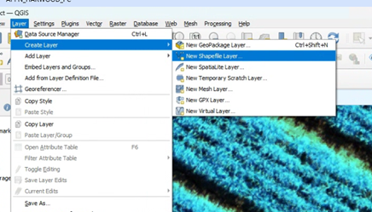

For the shape file the file name here is QC_ELM_Panels.shp (but see Table 1 for correct name given use case) the Geometry type is “Polygon” and you need to set the CRS to match your dataset.
- We only need one Field “Panel_ref”.
  - note select the prefilled “id” field in Fields list and hit “Remove Field” in the bottom right to remove it.
- We have decided to make Panel_ref an Integer between 0 – 100. It is the percentage reflectance.
  - note that you need to hit “Add to Fields List once you populate “New Field”
  - For Gryfn panels this is (e.g. 11, 30, 56, 82) ‎
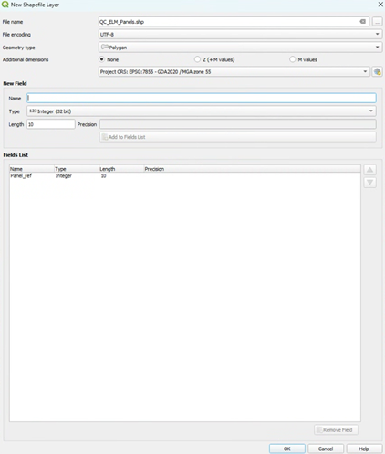

Drawing the boxes over the panels
The boxes should be polygon that is drawn inside the panel. The points should be drawn to cover as much of the panel as possible without including edge effects (2-3 pixels from the edge of the panel). If there are gaps or missing values within the panel they should be included.
To segment the panels select “QC_ELM_Panels” in the Layers menu and then click the pencil (“Toggle Editing”)
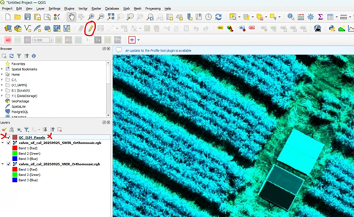
Once editing is toggled on you can click the “Add polygon feature” 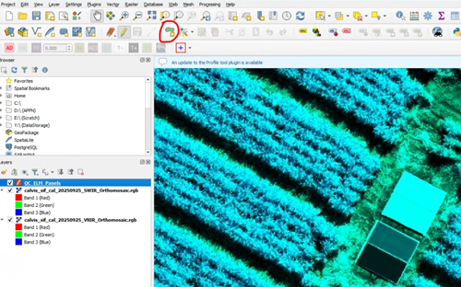

You can now click four points (and the use right click to close the polygon) around a specific reflectance panel. For Gryfn panels this is (e.g. 11, 30, 56, 82) (repeat for all panels)
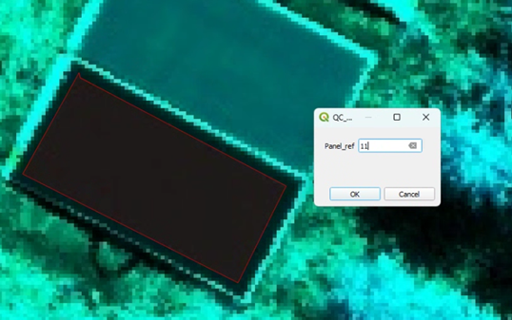

To sanity check you can double click QC_ELM_Panels in the layer menu, in Layer Properties click “Labels” and the click “Single Labels”
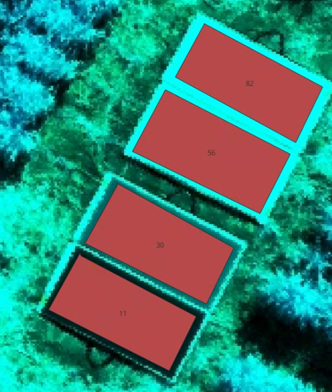

To save the shape file right click the QC_ELM_Panels in the Layers menu and navigate to Export and click “Save Feature as”

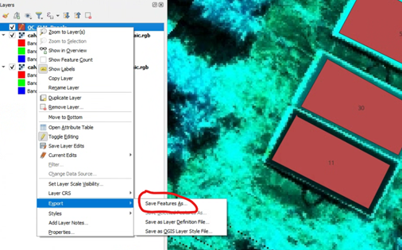

Here the presets are fine just make sure the File Name is correct and in the right folder (you can click the three dots to navigate) and double check the CRS.

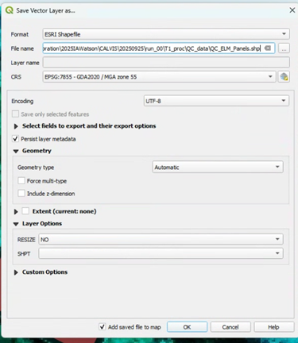

Extracting the pixels into a table
Arden Burrell has made a python script that can go though the APPN standard folder structure and extract the values into a table then save that as a .csv or .parquet files automatically. The code is available from https://github.com/ArdenB/APPN_GenricFileStorage
The python script is found in Code/DS02_DatasetQA/QA00_ELMvaliditation.py and a readme that explains how to use it is available Code/DS02_DatasetQA/README.md.
If nodes chose to extract the points using other means the tables should have the following columns:
band, wavelength, value, Panel_ref, node, project, site, sensor, date, run, panel_name, type, gpro_nu

Positional QC
NOTE. This is still a work in progress.
If alternative GCP points (like aeropoints) are placed in the field, another shape file should be created. This should be a points only file and the points should match the centre of the panels. It should be saved as:
QC_GCP_points.shp
The point name should be save in a column called point_num and number should match the point number in the matching csv file.

LIDAR QC
NOTE. This is still a work in progress.

