GRYFN Plot Extraction Tool
Standard Operating Procedure for Plot File Generation

Overview
The GRYFN Plot Extraction Tool is software that automatically generates plot boundary files for agricultural research trials. This procedure describes the complete workflow from project creation to final GeoJSON export.

Official wiki can be found at: https://gryfn.gitbook.io/gryfn-software/gryfn-plot-extraction-tool

Step 1 — Install the Software
Download and install the GRYFN Plot Extraction Tool from the official website. The licence is required from GRYFN.

Step 2 — Create a New Project
Click New Project. A new window will open. Complete the following fields:
- Output prefix: Enter a project name.
- Output path: Define the folder where outputs will be saved. For example: Q:\Adelaide\2025_SIFOzBarley\Roseworthy\Documentation\Plot_Layout
- Image layers: Add one or more image layers. Supported types include LiDAR DSM, high-resolution RGB mosaic, VNIR orthomosaic, and SWIR orthomosaic.
- Base map: Select one layer as the base map. The VNIR orthomosaic is recommended due to its smaller file size. Click Load.
- Extent: Click Create. A polygon with four corners will appear on the map. Click and drag each corner to define the site boundary.

Note: Right-click the map to pan, and scroll the mouse wheel to zoom in and out.

- Field name: Enter a name for the field.
- Unit: Ensure this is set to Metric.
- Plot dimensions: Enter the range count, row count, plot length, and plot width.
- Segments per Plot: If plots contain two or more treatment zones, enter the number of segments. Otherwise, leave it as default: 1.

Click OK to close the window, then click Open Project to load the YAML project file you just created.
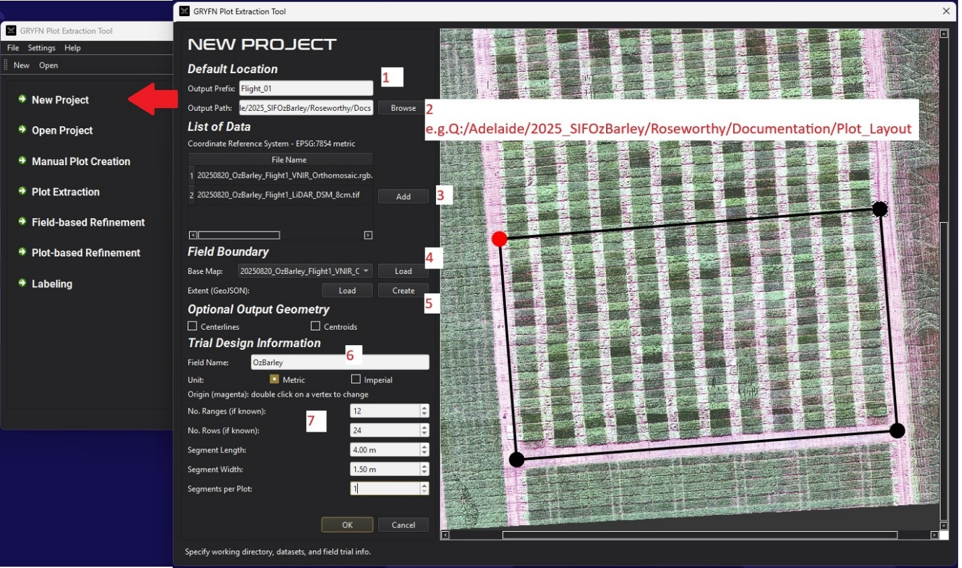

Step 3 — Create the Plots
There are two methods for creating plots: manual and automatic. Both are described below. Choose the method that best suits your data and field conditions.

Option A — Manual Plot Creation
This method creates plots with a uniform size and spacing. It is best suited for uniformly planted trials with accurately captured orthomosaic imagery.

- Click Manual Plot Creation in the GRYFN Plot Extraction Tool
- Load the base map (e.g. VNIR orthomosaic) and click Load. The map will display with a set of slim plot polygons overlaid, which will need to be adjusted.
- Plot dimensions: Enter the plot length and width. Apply standard buffer values (e.g. a 4 m × 1.5 m plot uses a 3.4 m × 1.1 m analysis area).
- Gap size: Enter the gap between plots with the appropriate buffer added. Examples:
Range gap of 2 m: gap = 2 + 0.3 + 0.3 = 2.6 m
Row gap of 0.2 m: gap = 0.2 + 0.4 + 0.4 = 1.0 m
- Rotation: Enter a rotation angle to align the plot grid with the map. Use the up and down arrow keys for fine adjustments.
- Position: Use the Move, Up, Down, Left, and Right controls to align the plot grid with the map.
- Once the plot locations are satisfactory, click Export Plots, then click OK.

Note: Minor manual adjustment in QGIS or ArcGIS may be required after export. Not all plots are perfectly planted, and GPS drift between flight lines during image collection can introduce small positional offsets.
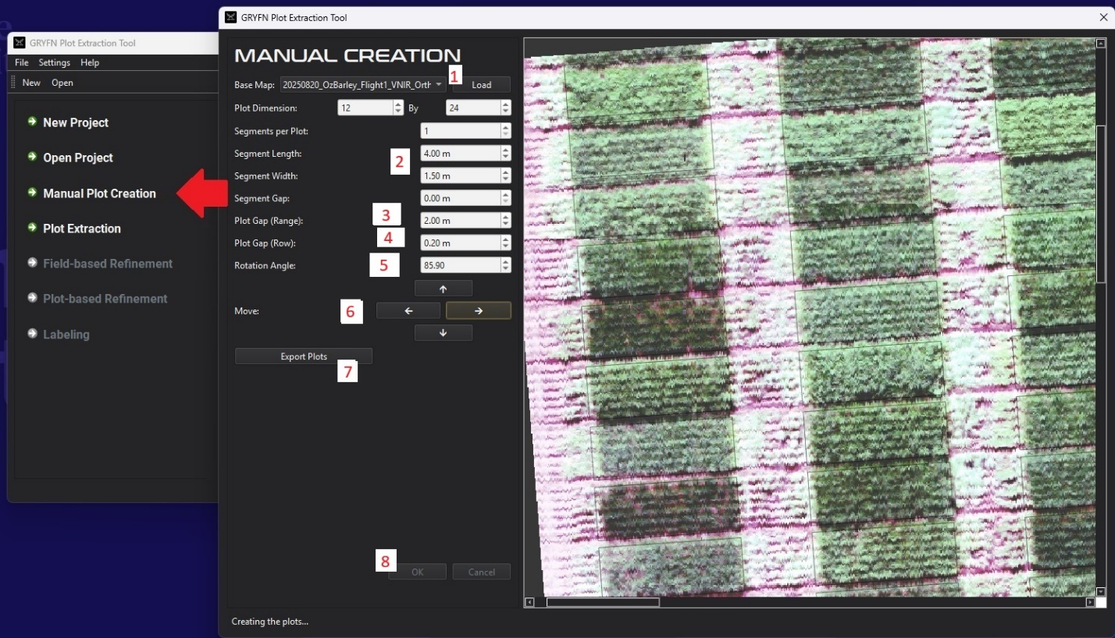

Option B — Automatic Plot Extraction
This method detects plot boundaries automatically using vegetation indices and gap detection.

- Click Plot Extraction in the GRYFN Plot Extraction Tool
- Select the VNIR Orthomosaic as the map and click Load.
- Use the default values for detection cell size and click OK.
- Select a vegetation index for detection. Both GLI and NGRDI generally produce reliable results.
- A map rotated to vertical or horizontal orientation will appear. Based on the rotation applied, select whether the row direction is vertical or horizontal. Select Gaps as the row detection option.
- Minimum spacing: Enter the minimum plot dimension (e.g. for a 1.5 m row, enter 1.4 m to avoid missed detections).
- Click Detect Rows/Alleys. A grid will appear on the map.
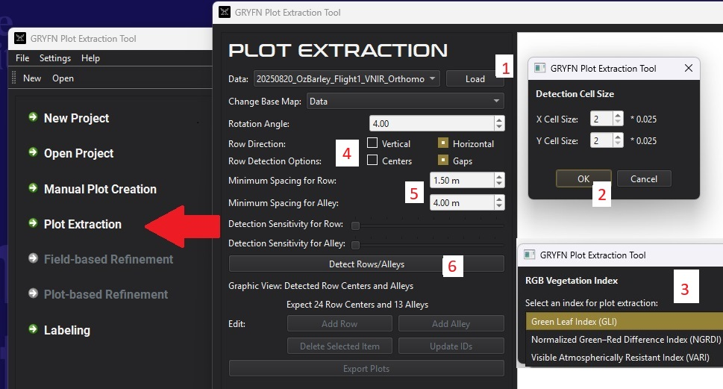

- Verify that the correct number of rows and alleys are present. Extra rows or alleys at the edges can be removed by selecting them and clicking Delete Selected Item. Missing lines can be added and dragged to the correct position.
- Click Export Plots, then click OK.

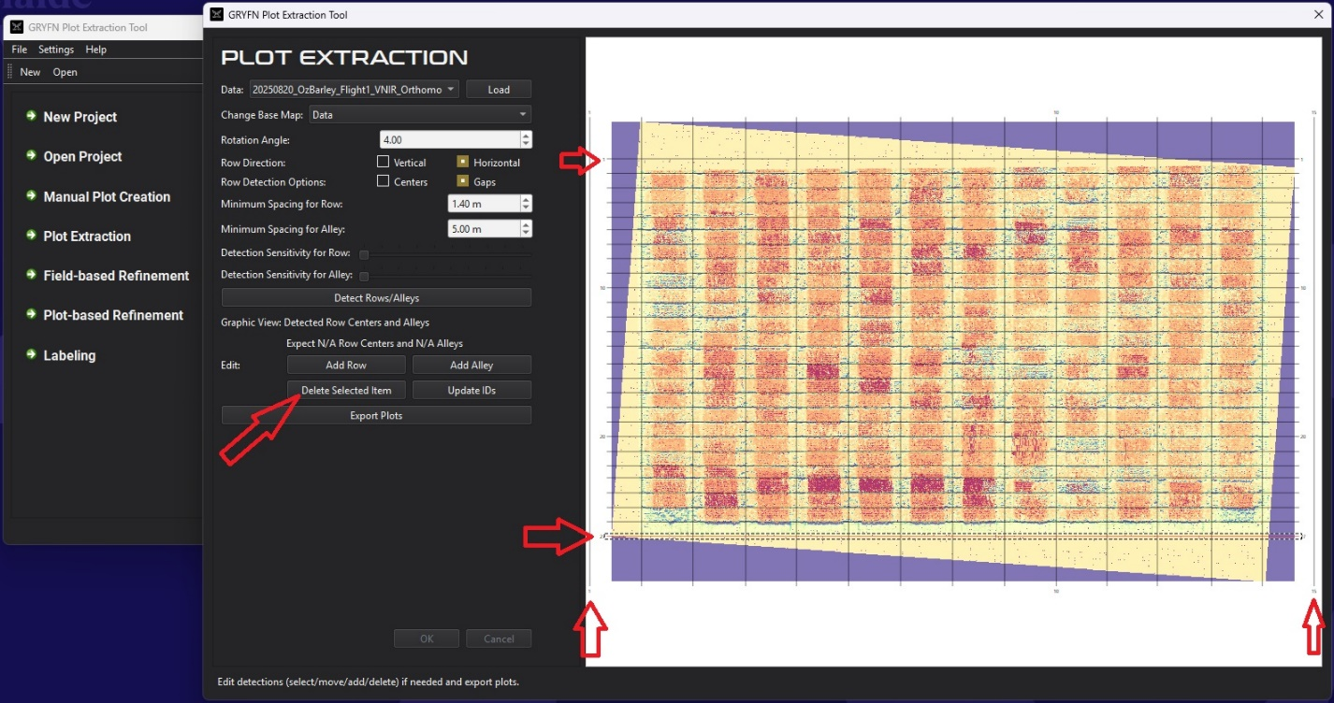

Plot-Based Refinement (Automatic Method Only)
After automatic extraction, an additional refinement step is required:

- Click Plot-based Refinement in the GRYFN Plot Extraction Tool.
- Load the map and select a vegetation index.
- Load the input plot file from: project_name\plot_extraction\project_name_plots_for_refinement.geojson
- Enter the segment width and length, using standard buffer values.
- Click Refine and Export.
- Review the output plots to confirm no plots are missing or incorrectly positioned, then click OK.
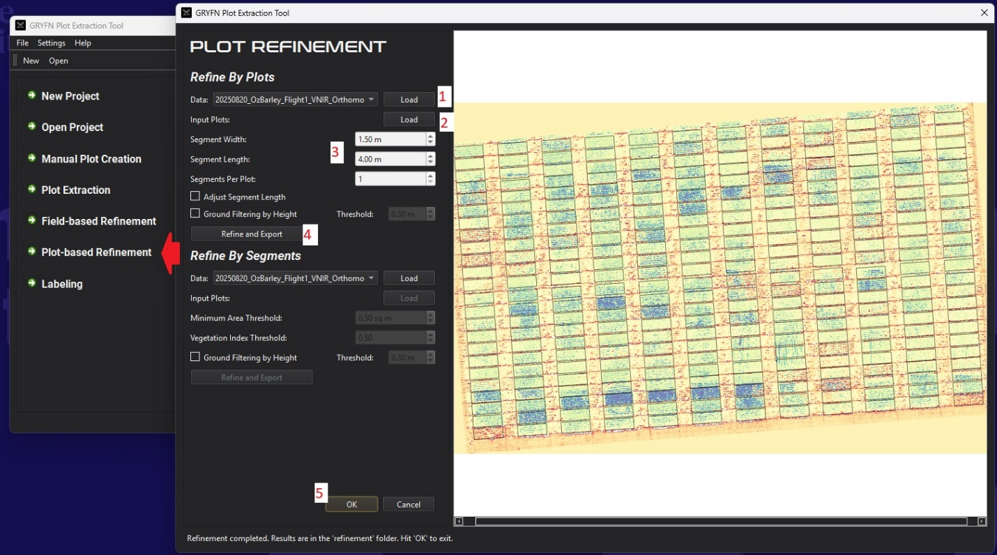

Step 4 — Label the Plots
Click Labeling in the GRYFN Plot Extraction Tool and complete the following steps:

- Load the map and click Load.
- Load the GeoJSON file created in the previous step:

Manual method: project_name\manual_creation\project_name_plots_manual
Automatic method: project_name\plot_refinement\project_name_RP-plots

- Select the plot origin (Range 1, Row 1) by choosing position 1, 2, 3, or 4 as shown on the map.
- Click Label, then Export, then OK.
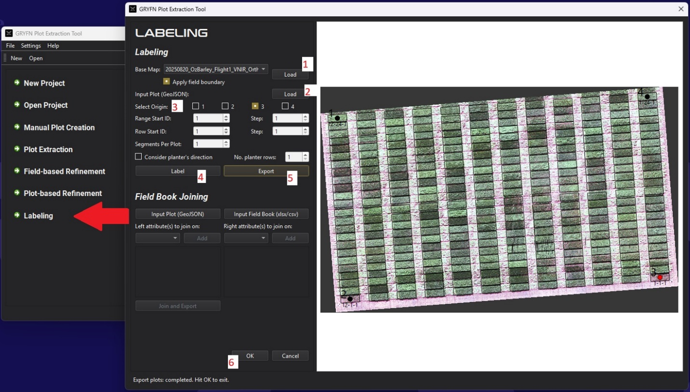

Step 5 — Add fid and plot_id Columns in QGIS
The final step adds two calculated attribute columns to the GeoJSON file using QGIS.

- Open the GeoJSON file in QGIS.
- Right-click the layer in the Layers panel and select Open Attribute Table.
- Click the pencil icon (top left of the table) to enable editing.
- Click the calculator icon to open the Field Calculator.
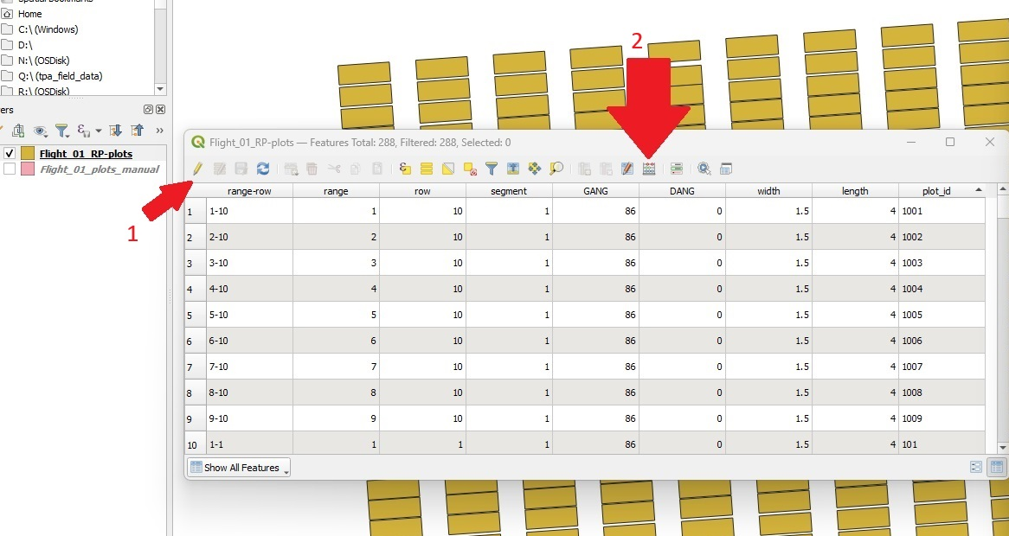
Add the fid column:

Output field name: fid
Expression: $id + 1
Click Apply, then OK.
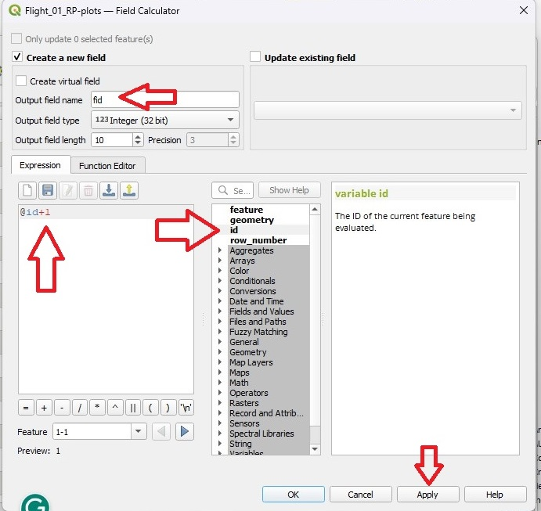
Add the plot_id column:

Output field name: plot_id
Expression: row * 100 + range
Click Apply, then OK.

- Click the Save button (or press Ctrl+S) to save the edits.
