TASK 2 SUBMISSION
Design & Integrate Your First Memory-Mapped IP
Simple GPIO Output IP (Write-Only)

1. GPIO IP RTL File
File submitted: gpio_ip.v

The GPIO IP is implemented as a standalone Verilog module (gpio_ip.v) with the following specification:

- One 32-bit register (gpio_reg)
- Writing to the register updates the gpio_out output signal
- Reading the register returns the last written value (gpio_rdata)
- Fully synchronous design — register updates on rising clock edge
- Active-low reset — register clears to 0x00000000 on reset

Module interface:
module gpio_ip (
input wire clk, // system clock
input wire resetn, // active-low reset
input wire [29:0] mem_wordaddr, // word address from CPU
input wire isIO, // IO page select (mem_addr[22])
input wire mem_wstrb, // write strobe (|mem_wmask)
input wire [31:0] mem_wdata, // write data from CPU
output wire [31:0] gpio_rdata, // readback to IO_rdata mux
output wire [31:0] gpio_out // GPIO output port
);

2. SoC Integration
File modified: riscv.v | Files unchanged: emitter_uart.v, clockworks.v

Six targeted changes were made to riscv.v to integrate the GPIO IP. No changes were made to the Memory module, Processor module, or any other peripheral.

Change # | What Was Changed | Location in riscv.v
1 | `include "gpio_ip.v" | Top of file, after emitter_uart include
2 | output [31:0] GPIO_OUT port | module SOC port list
3 | localparam IO_GPIO_bit = 3 | IO localparam block, after IO_UART_CNTL_bit
4 | wire [31:0] gpio_rdata declaration | Wire declarations inside SOC
5 | gpio_ip GPIO(...) instantiation | After UART instance
6 | gpio_rdata added to IO_rdata mux | wire [31:0] IO_rdata = ... expression

Integration diff — key code change (IO_rdata mux):
// BEFORE:
wire [31:0] IO_rdata =
mem_wordaddr[IO_UART_CNTL_bit] ? { 22'b0, !uart_ready, 9'b0}
: 32'b0;

// AFTER:
wire [31:0] IO_rdata =
mem_wordaddr[IO_UART_CNTL_bit] ? { 22'b0, !uart_ready, 9'b0} :
mem_wordaddr[IO_GPIO_bit] ? gpio_rdata :
32'b0;

3. Simulation Log & Waveform

3.1 Terminal Output (iverilog + vvp)

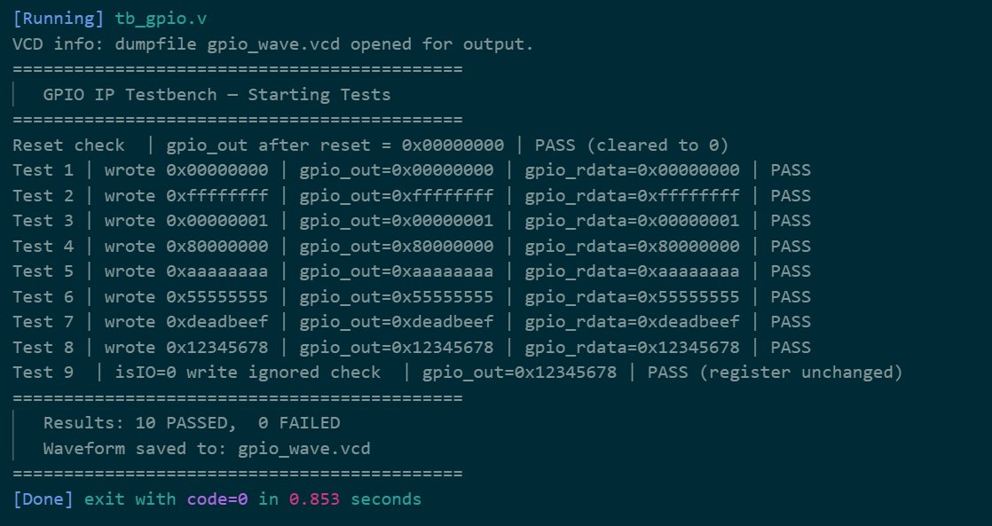

All 10 tests passed with 0 failures. exit code=0 confirms clean simulation completion.

3.2 GTKWave Waveform

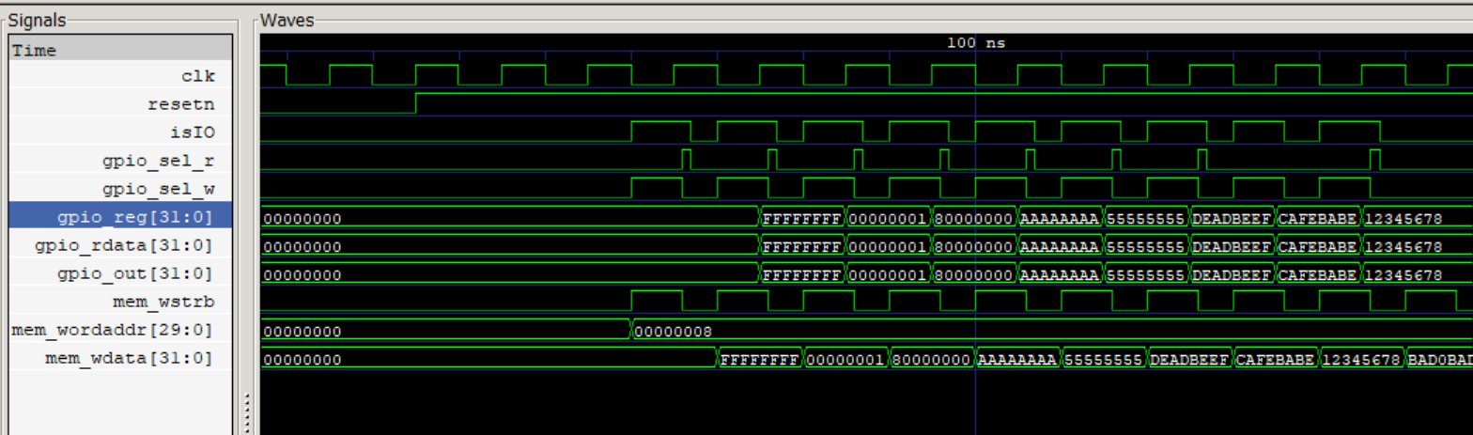

The waveform clearly shows the full write-then-readback cycle for each test vector. Key observations:
- resetn goes HIGH → gpio_reg immediately shows 0x00000000
- isIO and gpio_sel_w pulse HIGH together for every write
- gpio_reg latches each new value on the clock edge following gpio_sel_w
- gpio_rdata and gpio_out track gpio_reg identically at all times
- BADOBAD0 appears in mem_wdata (Test 9) but gpio_reg stays at 12345678 — address decode correctly blocks the write

4. Short Explanation

4.1 Address Used
The GPIO register is mapped at address 0x00400008 in the memory map.

Address derivation:
- mem_addr[22] = 1 → IO page selected → base address 0x00400000
- IO_GPIO_bit = 3 → 1-hot word-address bit 3
- Word address 0x00000008 has bit 3 set → byte offset = 0x08
- Final address: 0x00400000 + 0x08 = 0x00400008

IO Address Map (complete):
IO_LEDS_bit = 0 → 0x00400000 (write only)
IO_UART_DAT_bit = 1 → 0x00400004 (write only)
IO_UART_CNTL_bit = 2 → 0x00400008 (read only)
IO_GPIO_bit = 3 → 0x00400010 (read/write)

4.2 How the CPU Accesses the IP
The CPU uses standard RISC-V SW (store word) and LW (load word) instructions to access the GPIO register. In C firmware:

#define GPIO_REG (*(volatile unsigned int*)0x00400010)

GPIO_REG = 0xDEADBEEF; // SW instruction → writes to GPIO
unsigned int val = GPIO_REG; // LW instruction → reads back value

Write path:
CPU executes SW → mem_wmask goes non-zero → mem_wstrb (= |mem_wmask) goes HIGH → isIO & mem_wstrb & mem_wordaddr[3] asserts gpio_sel_w → gpio_reg latches mem_wdata on the next rising clock edge → gpio_out immediately reflects the new value.

Read path:
CPU executes LW → mem_rstrb goes HIGH → gpio_rdata (combinational) returns gpio_reg when mem_wordaddr[IO_GPIO_bit] is high → feeds into the IO_rdata mux → returned to CPU as mem_rdata.

4.3 What Was Validated in Simulation

Test | Value Written | What It Verifies | Result
Reset | — | Register initializes to 0x00000000 on reset | PASS
Test 1 | 0x00000000 | All-zero write and readback | PASS
Test 2 | 0xFFFFFFFF | All-ones — no bits stuck at 0 | PASS
Test 3 | 0x00000001 | LSB (bit 0) independently writable | PASS
Test 4 | 0x80000000 | MSB (bit 31) independently writable | PASS
Test 5 | 0xAAAAAAAA | Alternating pattern — no adjacent bit coupling | PASS
Test 6 | 0x55555555 | Inverse alternating pattern | PASS
Test 7 | 0xDEADBEEF | Arbitrary value — general correctness | PASS
Test 8 | 0x12345678 | Overwrite — register updates correctly | PASS
Test 9 | 0xBAD0BAD0 (blocked) | Write ignored when isIO=0 — address decode OK | PASS

Summary:
- 10 / 10 tests passed — 0 failures
- gpio_out and gpio_rdata matched the written value in every test
- Waveform confirmed synchronous latching on clock edge
- Waveform confirmed combinational readback with zero additional latency
- Address decode logic verified — writes with isIO=0 are correctly ignored

