*Game design document*

## Introduction

*Brant* is a group of five guys studying different bachelors at the TU Delft. As the final project of our computer science minor, we chose to create ‘Gullface: the game’. Earlier during this minor, we have created somewhat of a game, but now we want to take it to the next level! This results in a runner game on a water-based parkour in which the player must outrun a boogeyman while traversing all kinds of water-based obstacles and using water-based weapons to do so.

## Table of contents

**Introduction** **1**

**Table of contents** **1**

**Target Audience** **2**

**Platform & Controls** **2**

**Story, characters and setting of the game** **2**

**Artificial Intelligence** **2**

**Level / environment design** **3**

How will the levels look? 3

What is the feel of the levels? 3

Are there multiple levels? 3

**Gameplay and mechanics** **3**

**Art** **5**

Style 5

List of all models, textures, sprites 6

How do they fit into the setting? 7

**Sound and Music** **8**

**User Interface, Game Controls** **8**

**Appendix 1: Requirements (in MoSCoW)** **10**

## Target Audience

The game is targeted at game enthusiasts who are especially into runner and/or water-based games. The game is playable and understandable for almost all ages, so there aren’t any restrictions agewise. To play the game, you must have a computer at your disposal, but this is the only restriction for potential players.

## Platform & Controls

As we all aren’t experienced creating games at this complexity, we used ‘Unity’, beginner friendly game creator software, to create our game. This software can only be run on a computer and because of our lack of experience, we aren’t going to convert it to be played on other platforms or devices during this project. Since it can only be played on a computer, the keyboard and mouse will be used to control the gameplay.

## Story, characters and setting of the game

You play as Gullface, a half man half seagull with literally zero talents. But, even though he is absolutely incompetent, he is not without hobbies: fishing. However, on one of his fishing trips he hooked the wrong fish: a horrible sea monster! Gullface has to outrun Gillface, as he’s trying to have our hero for lunch! All of this takes place at the endless docks, so it is a marine setting. The docks are filled with all kinds of peril, such as evil octopi, fish and crabs. However, when Gillface catches you, he drags you to his lair: a scary underwater cave.

Those are the two settings of the game: a marine dock setting and an underwater cave.

## Artificial Intelligence

Different levels of AI are present in the game. The enemies you face during the game vary from very simple AI structures like a fish jumping in front of you to a complex character like Gillface. Where the jumping fish is an enemy with the same behaviour during the whole game, Gillface will learn based on the player’s behaviour and be harder to beat every time you fight him during a game run.

## Level / environment design

### How will the levels look?

We will have two “levels”: the docks and the cave.

Docks:

In the docks the level is very linear: the only way to go is forward and of course you can go to left and right. But (as will be seen in the picture below) it will be a narrow map meant as a setting for an endless runner. As the map will be procedurally generated the map can go on for as long as the player wants (as we will talk about later on). While the player traverses the map, elements will spawn to make the gameplay exciting. The player will encounter enemies that will hinder, shoot at, or chase the player as well as natural elements that will boost the player either up or forwards. There will also be higher platforms that the player can jump onto by being boosted up by the fountain. Lastly, there will be pickups to aid the player.

Cave:

The cave has a very different gameplay, and it will be designed for that as well. The cave will be an enclosed space (like an arena) where the player can move freely. The monster will walk around and attack the player. To make that element interesting, there will be platforms for the player to jump onto as well as elements for the player to hide behind. periodically, pickups will spawn to aid the player.

### What is the feel of the levels?

We will have two “feels”. One is for the docks. This feel will be one filled with tension and excitement. As the player will be moving quickly without being able to stop. They will be confronted with all kinds of elements at a fast pace.

The second is for the boss room, the cave. This will also be filled with tension but in a different way. As the gameplay is less fast paced it will be more focussed on the fight with the monster, so it will be a bit more “scary” as well.

### Are there multiple levels?

As mentioned before, there are “two” levels: the docks and cave. There will be no variations of these two levels. As the docks is an endless runner, no playthrough will be exactly the same, but there will be no follow up level as you beat this one. Rather, you can adjust the distance you have to run to beat the game.

## Gameplay and mechanics

The gameplay is as follows: You play a person being chased by a horrible sea monster, his name is Gillface. To outrun him, you’ll have to grab powerups to boost your speed. However, while running, there are also minor enemies that will either block your way, shoot at you or chase after you as well. If they hit you enough times, you are dead and have to retry. These enemies can be defeated by picking up weapons, such as a water gun and bombs. But while you run and fight, the world also has obstacles like oil puddles and water fountains, that boost you either forwards or upwards. As you can see, this gameplay is meant to be a fast paced, endless runner. However, if you are slowed down you might get caught by the monster, and he drags you to his cave, where a boss fight starts. This fight plays more like a 3d platformer, where you are in a room with platforms to jump on, walls to hide behind and items to pick up. The monster will run after you, attack you and throw items at you. To fight him, you have to pick up weapons and attack him. If you deliver enough damage, you’ll return to the surface and go on with the running game. The more times the monster catches you, the harder the boss fights get. When you have reached a certain distance, the monster drags you down for the final fight, if you beat him then, you beat the game. Just as the boss fights get harder, the gameplay in the docks gets harder with time as well. Below, you can see a flowchart of the gameplay.

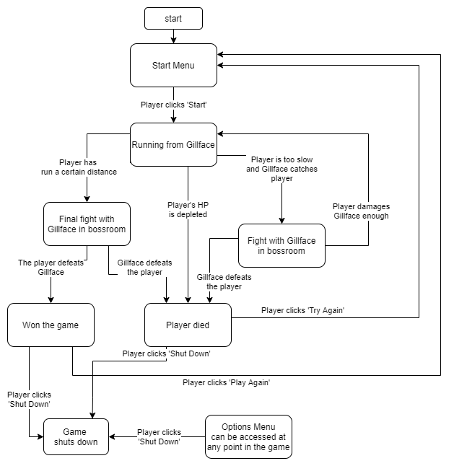

## Art

### Style

Above you see concept art for the setting of the game. The idea is to not make the game too realistic looking, given the setting, and keep it more playful and colorful. As you can see, in the docks we keep the colors bright. The enemies (safe for Gillface) will therefore also not be very threatening (such as the octopus in the picture). The cave will be more dark and threatening, given that it is the lair of the villain. But of course it will all remain a more cartoonish style.

### List of all models, textures, sprites

First a list of all the models that will be in the game, all these will have textures:

* The player model (Gullface)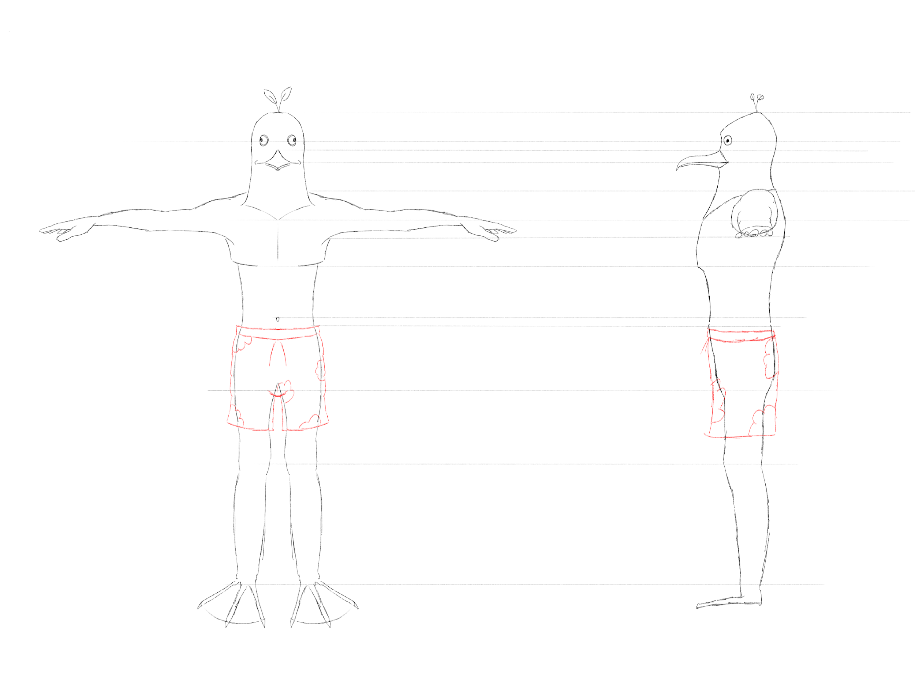
* The villain model (Gillface)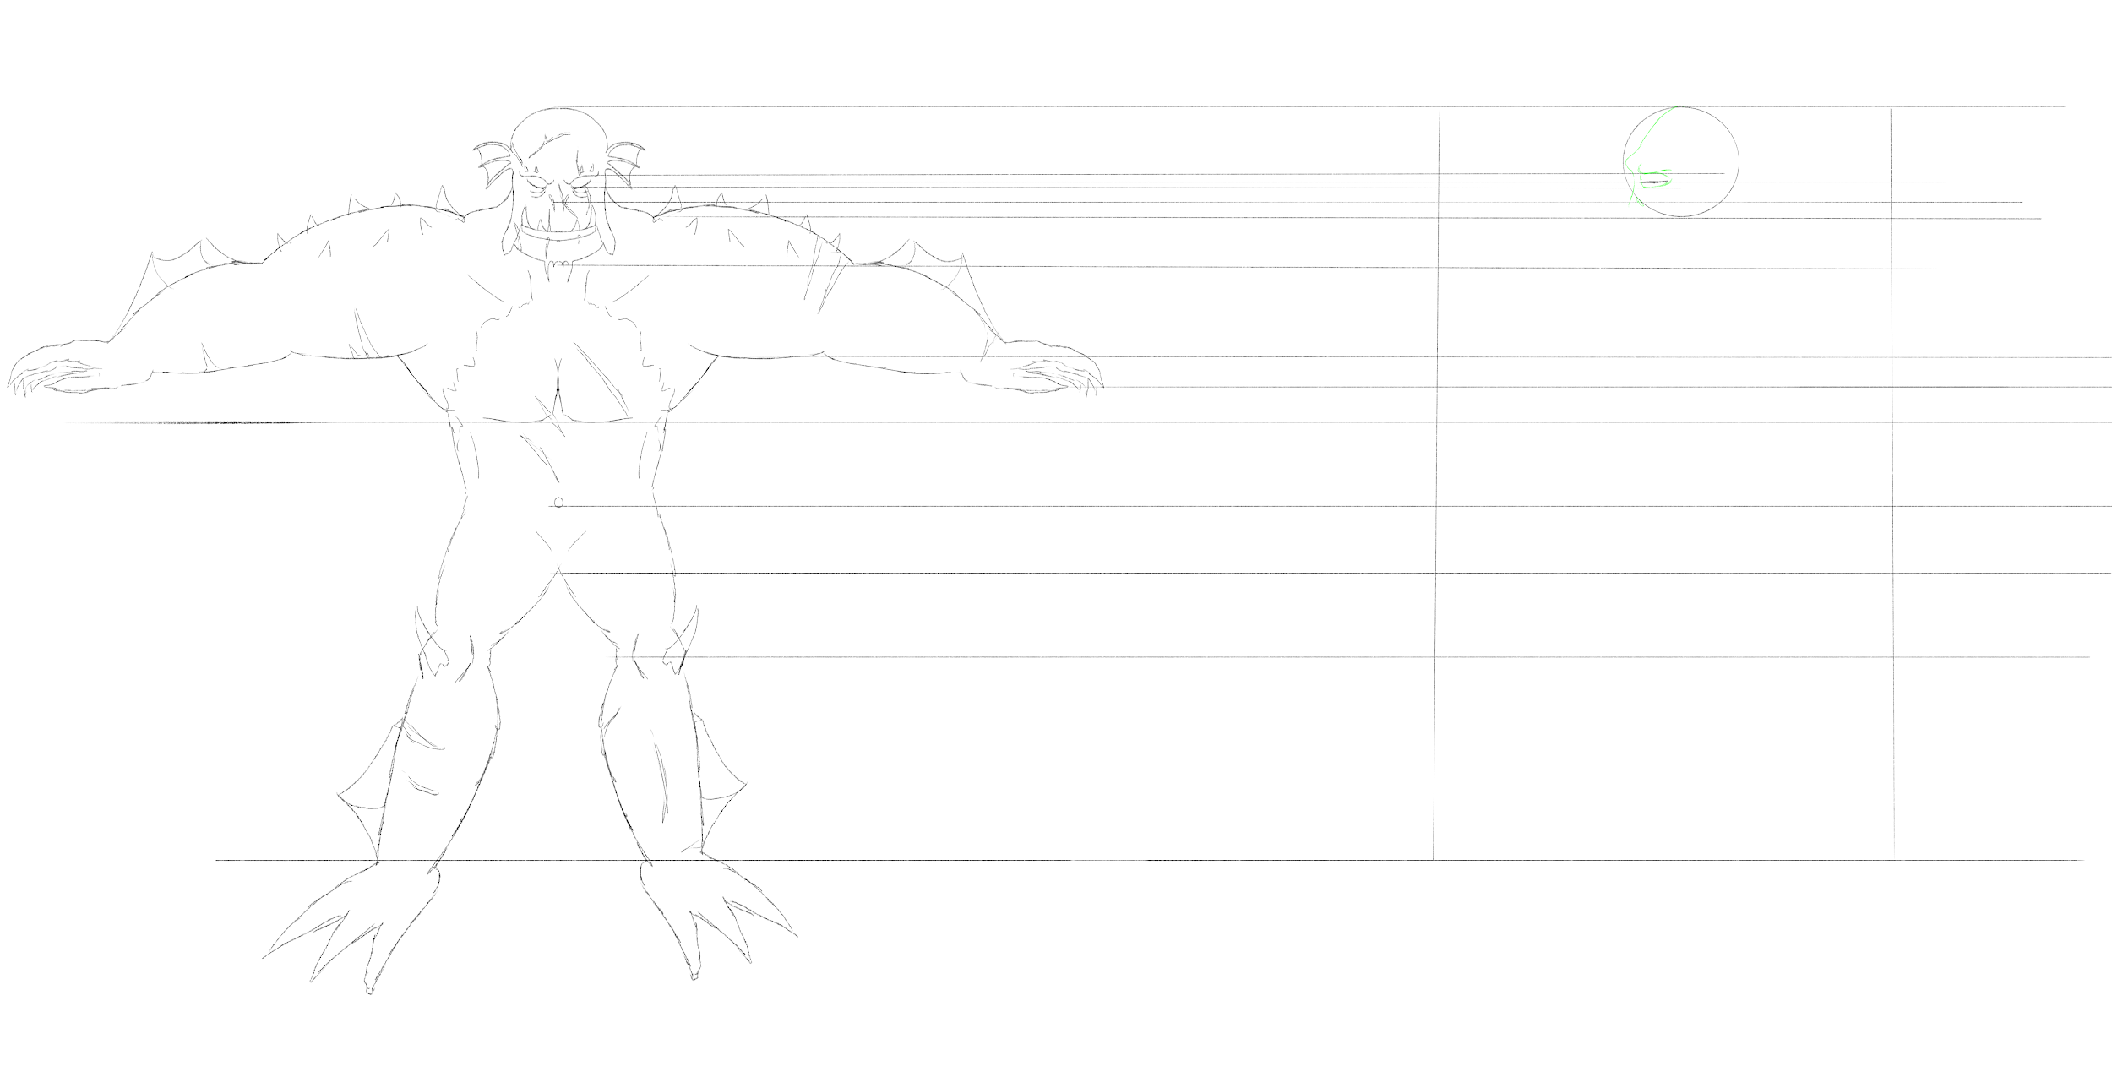
* Some smaller enemies:
  + a crab (walks side to side)
  + an octopus (shoots at the player)
  + a fish (jumps over the map)
  + a shark (jumps on the map and chases (wiggles) after the player for a bit)
* Pickups:
  + a water pistol
  + a water bazooka (shoots one powerful water beam)
  + an ice bomb (throw at enemies to freeze them)
  + a pirate cutlass (for melee attacks)
  + a rotten fish (throw for poison damage)
  + a sandwich (gives HP for during the boss fight)
  + a lightning bolt (gives a speed boost)
* Settings:
  + a piece of dock
  + a platform for the dock
  + a water fountain (probably modelled as a hole in the dock or something similar)
  + an oil spill (for the slide)
  + wall element for the cave
  + ground element for the cave
  + skulls or something similar
  + a platform element for the cave

Next to these textured models we will have the following textures as well:

* The sky
* The water

We will also have the following sprites:

* A water particle (for beams etc.)
* A water beam for out of the fountain
* An ink ball shot by the octopi

### How do they fit into the setting?

All of the enemies are meant for the marine setting. So that’s why we have fish, octopi etc.

Most of the pickups are meant for the overlapping theme: water is cool. And are therefore mostly water based. As it is also a water based setting, we thought it would fit well. All of these elements will be cartoonish, and therefore fit into the playful setting we try to create.

## Sound and Music

We will have sounds for:

* enemies
* the protagonist
* the antagonist
* pickups

Some we will get online, other sounds we will record ourselves.

We will try to find a non copyrighted tune to put under the level to give the gameplay some exciting undertone. Maybe we will have a different tune for the bossfight.

## User Interface, Game Controls

The user interface of the game consists of three parts:

* An inviting and exciting start screen, on which a tutorial option is provided, an option to enter your player name and of course the start button is placed.

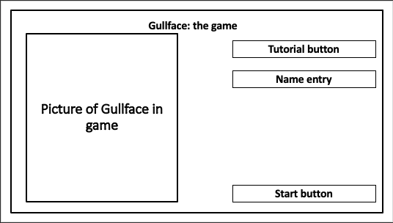

* A pausing option. By pressing the P button in game, the game is paused. By pressing the P button again, the game continues. In this window you can stop playing or continue.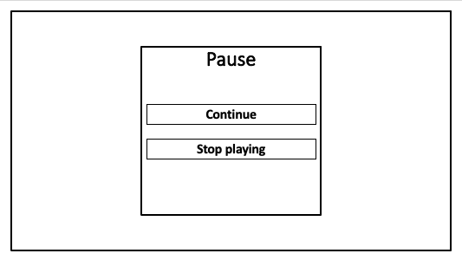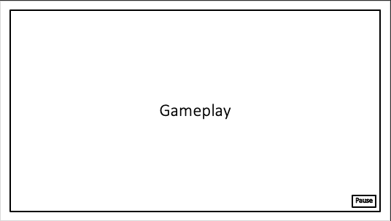
* An end screen, which provides different kinds of scores and stats like the overall score, bullets fired, times hit etc. The player is asked if they would like to submit these stats to the leaderboard. It also has a play again button and last and not least a short message is written by the developers.

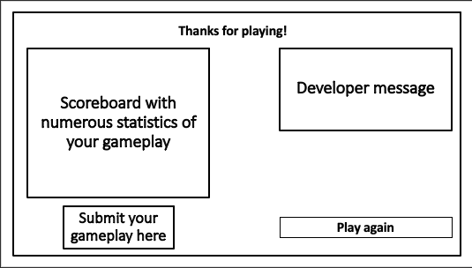

As stated earlier, the keyboard and mouse are used as the controls of the game. The player will move forward automatically, so for moving side to side the buttons ‘a’ and ‘d’ are used and jumping can be done by pressing the spacebar. The mouse and left mouse button are assigned for aiming and shooting.

## Appendix 1: Requirements (in MoSCoW)

**Must have:**

*The must have features are absolutely essential to the framework of our game and are needed to complete the most basic gameplay.*

* 3D animated models
* 3D Models
* Animated textures
* Dumb enemy
* Smart enemy
* Highscore
* Power ups
* Waterslides, water blasters and fountains
* FPS independent
* Use unity’s physics
* Create user interface

**Should have**

*Features that will make the game a lot more interesting and complete, but aren’t 100% essential to complete the gameplay.*

* Procedurally generated textures
* Smart boss
* Data analysis
* Gamer accounts
* Server for storing data
* Pre generated boss room with own view and tactics
* Dynamic difficulty

**Could have**

*Extra features that will provide the final touches to the game.*

* Particle systems
* Audio effects
* Consciousness in the level
* Local multiplayer
* Animated cutscenes

**Won’t have**

*Features which aren’t possible given the timeframe and our experience.*

* Online multiplayer
* No console gameplay
* No A+ graphics