Nodes used
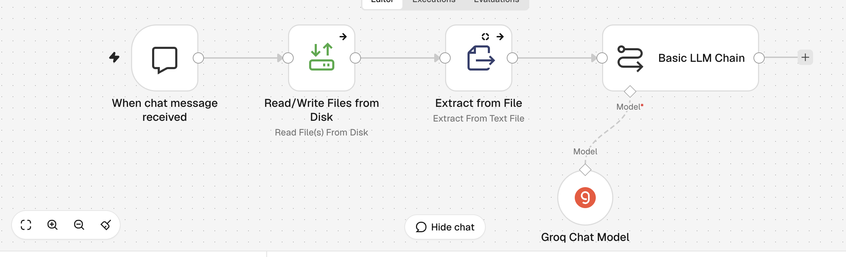
Uploaded a text file containing Playwright guide and asked questions related to the document
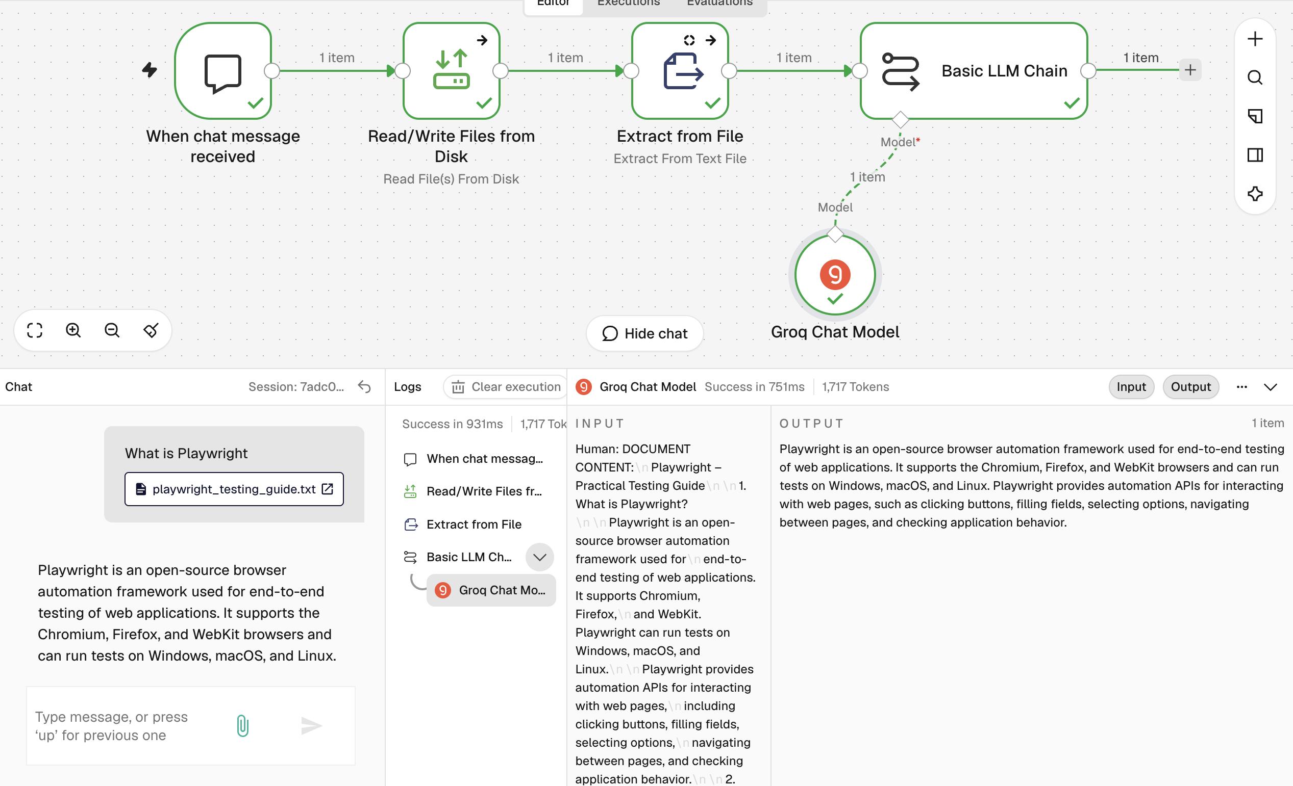
Output when asked about Selenium


