Assignment-2
I have chosen the template “AI agent chat”
This workflow employs OpenAI's language models and SerpAPI to create a responsive, intelligent conversational agent. It comes equipped with manual chat triggers and memory buffer capabilities to ensure seamless interactions.
Reference Model
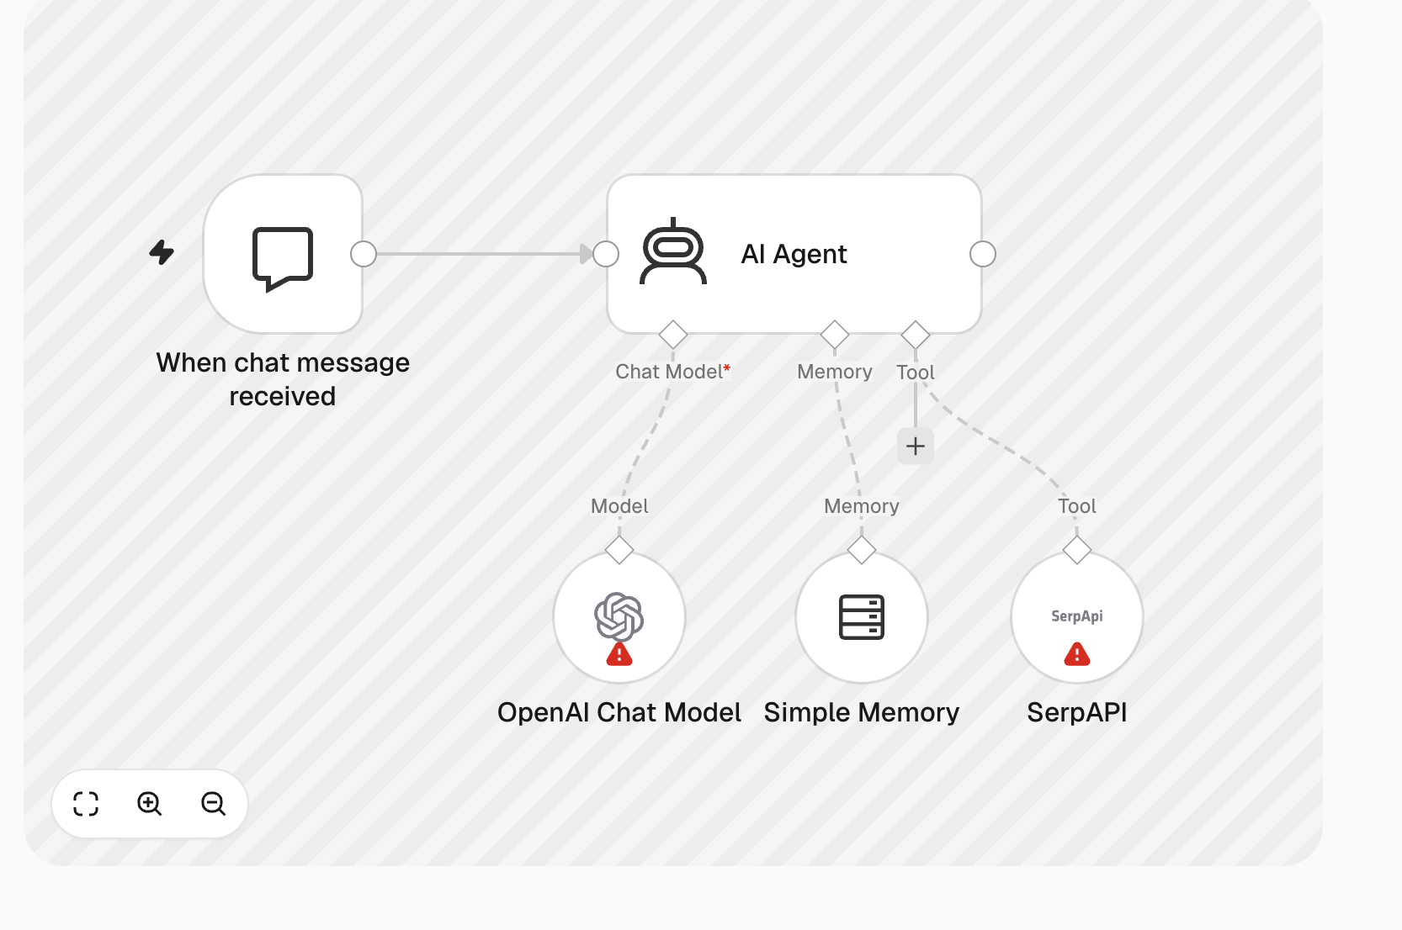
Nodes used in the reference model
- Chat
- AI Agent
- Open AI Chat Model
- Simple Memory
- SerpAPI

Below is the workflow implemented
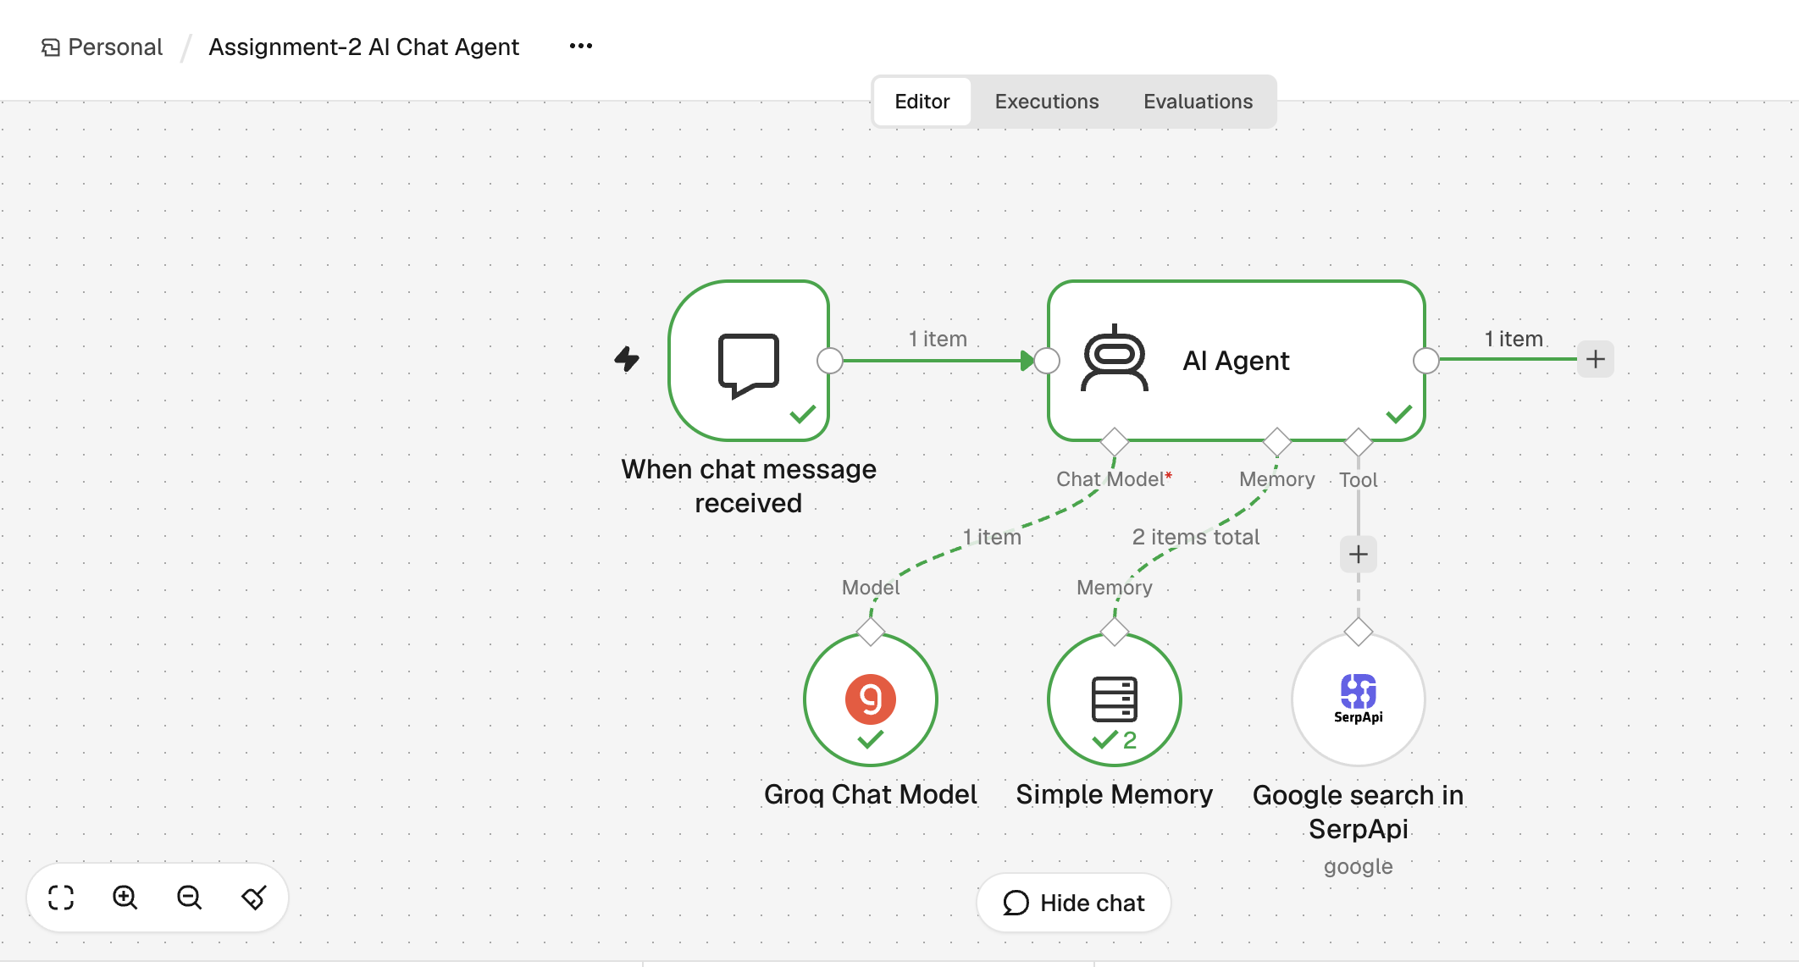
Nodes used
- Chat
- AI Agent
- Groq Chat Model
- Simple Memory
- SerpAPI
Note: Could not use Open API chat as it is paid version.
Demonstration


