**Motherboard**

A motherboard is the main printed circuit board ([PCB](https://whatis.techtarget.com/definition/printed-circuit-board-PCB)) in a computer. The motherboard is a computer’s central communications backbone connectivity point, through which all components and external peripherals connect.

The large PCB of a motherboard may include 6-14 layers of fiberglass, copper connecting traces and copper planes for power and signal isolation. Additional components can be added to a motherboard through its expansion slots. These may include processor sockets, [DIMM](https://www.techtarget.com/searchstorage/definition/DIMM), HTX, PCI, [PCIe](https://www.techtarget.com/searchdatacenter/definition/PCI-Express) and M.2 slots as well as power supply connections. Typically motherboards offer additional connectivity through a [Southbridge](https://whatis.techtarget.com/definition/Southbridge) chip such as PCI, SATA, Thunderbolt, USB and more. [CPU](https://whatis.techtarget.com/definition/processor) to [RAM](https://www.techtarget.com/searchstorage/definition/RAM-random-access-memory) and PCIe are generally connected through point-to-point interconnects such as hypertransport (HT), quick path interconnect (QPI) or Ultrapath interconnect (UPI). Often, choosing a motherboard determines many of the features a desktop will have.

The most common motherboard design in desktop computers today is [ATX](https://whatis.techtarget.com/definition/ATX), an Intel improvement on the AT design by IBM. Other form factors include extended ATX mini-ATX, microATX, BTX, microBTX mini ITX, micro ITX and nano ITX.

The integration of components has eliminated the [Northbridge](https://whatis.techtarget.com/definition/Northbridge) chips that managed memory from motherboards. With the advent of memory controllers built into CPU, integrated video too has moved from motherboard to CPU. On AMD’s new [Ryzen](https://whatis.techtarget.com/definition/Ryzen-AMD-Ryzen), even the Southbridge is optional due to the [SOC](https://internetofthingsagenda.techtarget.com/definition/system-on-a-chip-SoC) (system on a chip) nature of the CPU. This integration into the CPU reduces the cost for motherboard manufacturers who wish to offer base systems for workstations and entry level computers while also enabling highly customized implementations that support a range of processors to allow for platform upgradabillity.

**Interfaces and components on a motherboard**

* CPU socket that holds the central processing unit
* DIMM slots that hold the RAM
* SATA connector to connect the hard drive
* Power connector to plug in a power supply
* Chipset
* Floppy connector
* IO Chip
* Various types of fan connectors to connect cooling fans
* IO connectors
* USB ports
* Audio connector
* IDE connector
* CMOS battery header
* PCI express slots that you can use for many things like the graphics card or sound card
* PCI slots
* ROM to hold the Boot program
* Clock generator to synchronize components
* Expansion slots
* Heat sinks, usually made out of aluminum, that direct heat away from the electronics to prevent damage.

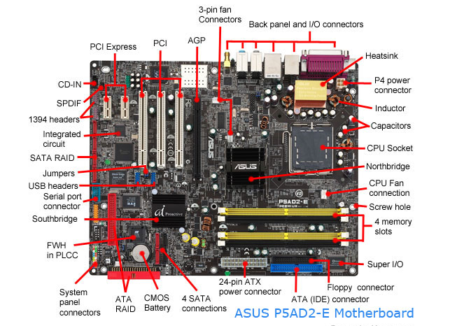

**RAM Modules**

A **memory module** or **RAM (**[**random-access memory**](https://en.wikipedia.org/wiki/Random-access_memory)**) stick** is a [printed circuit board](https://en.wikipedia.org/wiki/Printed_circuit_board) on which [memory](https://en.wikipedia.org/wiki/Computer_memory) [integrated circuits](https://en.wikipedia.org/wiki/Integrated_circuit) are mounted. Memory modules permit easy installation and replacement in electronic systems, especially computers such as [personal computers](https://en.wikipedia.org/wiki/Personal_computer), [workstations](https://en.wikipedia.org/wiki/Workstation), and [servers](https://en.wikipedia.org/wiki/Server_(computing)). The first memory modules were proprietary designs that were specific to a model of computer from a specific manufacturer. Later, memory modules were standardized by organizations such as [JEDEC](https://en.wikipedia.org/wiki/JEDEC) and could be used in any system designed to use them.

Types of memory module include:

* [Trans Flash Memory Module](https://en.wikipedia.org/wiki/TransFlash_Memory_Module)
* [SIMM](https://en.wikipedia.org/wiki/SIMM), a single in-line memory module
* [DIMM](https://en.wikipedia.org/wiki/DIMM), dual in-line memory module
  + [Rambus](https://en.wikipedia.org/wiki/Rambus) memory modules are a subset of DIMMs, but are normally referred to as RIMMs
  + [SO-DIMM](https://en.wikipedia.org/wiki/SO-DIMM), small outline DIMM, a smaller version of the DIMM, used in laptops

Distinguishing characteristics of computer memory modules include voltage, capacity, speed (i.e., [bit rate](https://en.wikipedia.org/wiki/Bit_rate)), and [form factor](https://en.wikipedia.org/wiki/Computer_form_factor). For economic reasons, the large (main) memories found in personal computers, workstations, and non-handheld game-consoles (such as PlayStation and Xbox) normally consist of dynamic RAM (DRAM). Other parts of the computer, such as [cache memories](https://en.wikipedia.org/wiki/Cache_memory) normally use [static RAM](https://en.wikipedia.org/wiki/Static_RAM) ([SRAM](https://en.wikipedia.org/wiki/Static_random_access_memory)). Small amounts of SRAM are sometimes used in the same package as DRAM. However, since SRAM has high leakage power and low density, [die-stacked](https://en.wikipedia.org/wiki/Three-dimensional_integrated_circuit) DRAM has recently been used for designing multi-megabyte sized processor caches.

Physically, most DRAM is [packaged](https://en.wikipedia.org/wiki/Integrated_circuit_packaging) in black epoxy resin.

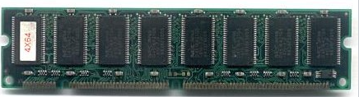

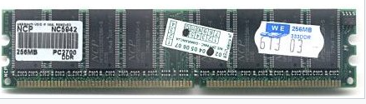

Two types of DIMMS (dual in-line memory modules): a 168- pin SDRAM module (top) and a184- pin DDR SDRAM module (bottom).

**Daughter card**

A daughter card or [daughterboard](https://www.easytechjunkie.com/what-is-a-daughterboard.htm) is a type of [circuitboard](https://www.easytechjunkie.com/what-is-a-circuit-board.htm) that gets added to an existing one. Its name is appropriate for its use, since it is connected to a “[motherboard](https://www.easytechjunkie.com/what-is-a-motherboard.htm)” or “main board.” The motherboard is the primary circuit board for a device. It is usually in the device as it is shipped from the factory. A daughter card may be added later.

Some daughter card designs are made so that engineers can add functionality to a device without requiring a lot more room inside its housing. These kinds of items are often called riser boards or risers. Some might also called Daughter cards are different from some other types of additional circuit boards that tech enthusiasts call “expansion cards.” In expansion cards, the circuit board is often plugged in through a gap in the housing of a computer or device. These expansion boards help to give a device more functionality, often for additional sound play or for better visuals on a high-tech monitor or screen.

In contrast to the way expansion boards are used, a daughter card can be a more fundamental enhancement for a device. Adding a daughtercard often requires getting into the guts of a device. That’s why some users might hire a professional to install it. Companies that make an electronic device might offer a daughtercard as part of an essential upgrade that allows the product to be used in more various ways.

With the rise of connective USB ports and other technology, it has become less necessary to upgrade devices with daughter cards or daughter boards. A lot of advanced use can be built into a wireless connection and “outsourced” to a remote server, rather than adding it physically into a desktop or laptop computer. However, some types of equipment might still get these kinds of additions as provided by the manufacturer. Computer and electronics makers choose the best ways of offering upgrades that they feel will match the needs and desires of their customer base. Since not a lot of laptop or computer users want to wrestle a daughtercard into an existing circuit board design, companies that sell to a consumer market will probably choose alternatives, or offer professional installation as a free service if they are offering a daughtercard as a way to upgrade a device.

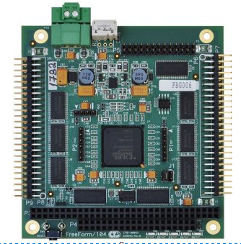

**Bus slots**

Alternatively known as a **bus slot** or **expansion port**, an **expansion slot** is a connection or port inside a [computer](https://www.computerhope.com/jargon/c/computer.htm) on the [motherboard](https://www.computerhope.com/jargon/m/mothboar.htm) or [riser card](https://www.computerhope.com/jargon/r/risecard.htm).

An expansion slot refers to any of the slots on a [motherboard](https://www.lifewire.com/motherboards-system-boards-and-mainboards-2618154) that can hold an expansion card to expand the computer's functionality, like a [video card](https://www.lifewire.com/what-is-a-video-card-2618161), network card, or sound card.

The expansion card is plugged directly into the expansion port so that the motherboard has direct access to the [hardware](https://www.lifewire.com/computer-hardware-2625895). However, since all computers have a limited number of expansion slots, it's important to [open your computer](https://www.lifewire.com/how-to-open-a-desktop-computer-case-2624589) and check what's available before you buy one.

Some older systems require the use of a riser board to add additional expansion cards; however, modern computers not only usually have enough expansion slot options, but they also have features integrated directly into the motherboard, eliminating the need for so many expansion cards.

Expansion slots are sometimes referred to as bus slots or expansion ports. The openings on the rear of a [computer case](https://www.lifewire.com/what-is-a-computer-case-2618149) also sometimes go by this term.

## Different Kinds of Expansion Slots

There have been several types of expansion slots over the years, including PCI, [AGP](https://www.lifewire.com/what-is-accelerated-graphics-port-agp-2625790), AMR, CNR, ISA, EISA, and VESA, but the most popular one used today is [PCIe](https://www.lifewire.com/pci-express-pcie-2625962). While some newer computers still have PCI and AGP slots, PCIe has basically replaced all of the older technologies.

ePCIe, or External PCI Express, is another kind of expansion method but it's an external version of PCIe. That is, it requires a specific kind of cable that extends from the motherboard out the back of the computer, where it connects with the ePCIe device.

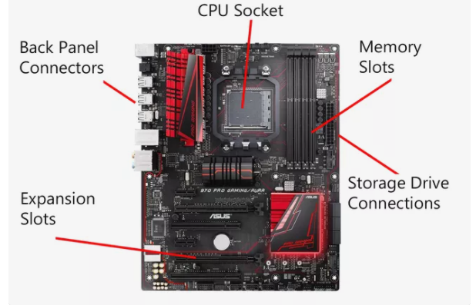

**SMPS (Switched Mode Power Supply)**

A switched-mode power supply (switching-mode power supply, switch-mode power supply, switched power supply, SMPS, or switcher) is an electronic [power supply](https://en.wikipedia.org/wiki/Power_supply) that incorporates a [switching regulator](https://en.wikipedia.org/wiki/Voltage_regulator#Switching_regulators) to [convert electrical power](https://en.wikipedia.org/wiki/Electrical_power_conversion) efficiently.

Like other power supplies, an SMPS transfers power from a DC or AC source (often [mains power](https://en.wikipedia.org/wiki/Mains_electricity), see [AC adapter](https://en.wikipedia.org/wiki/AC_adapter)) to DC loads, such as a [personal computer](https://en.wikipedia.org/wiki/Personal_computer), while converting [voltage](https://en.wikipedia.org/wiki/Voltage) and [current](https://en.wikipedia.org/wiki/Electric_current) characteristics. Unlike a [linear power supply](https://en.wikipedia.org/wiki/Linear_power_supply), the pass transistor of a switching-mode supply continually switches between low-[dissipation](https://en.wikipedia.org/wiki/Dissipation), full-on and full-off states, and spends very little time in the high dissipation transitions, which minimizes wasted energy. A hypothetical ideal switched-mode power supply dissipates no power. [Voltage regulation](https://en.wikipedia.org/wiki/Voltage_regulator) is achieved by varying the ratio of on-to-off time (also known as [duty cycles](https://en.wikipedia.org/wiki/Duty_cycle)). In contrast, a linear power supply regulates the output voltage by continually dissipating power in the pass [transistor](https://en.wikipedia.org/wiki/Transistor). This higher power conversion efficiency is an important advantage of a switched-mode power supply.

Switched-mode power supplies can also be substantially smaller and lighter than a linear supply because the transformer can be much smaller. This is because it operates on the switching frequency which ranges from several hundred kHz to several MHz in contrast to the 50-60Hz which is typical for the mains AC frequency. Despite the reduction in size, the power supply topology itself and the requirement for [electromagnetic interference (EMI) suppression](https://en.wikipedia.org/wiki/Electromagnetic_compatibility) in commercial designs result in a usually much greater component count and corresponding circuit complexity.

Switching regulators are used as replacements for linear regulators when higher efficiency, smaller size or lighter weight are required. They are, however, more complicated; switching currents can cause electrical noise problems if not carefully suppressed, and simple designs may have a poor [power factor](https://en.wikipedia.org/wiki/Power_factor).

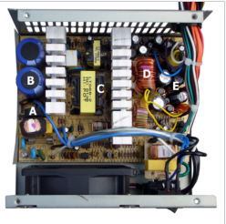

**Internal storage devices**

Some storage devices are classed as 'internal' which means they are inside the computer case.

Most computers have some form of internal storage. The most common type of internal storage is the hard disk.

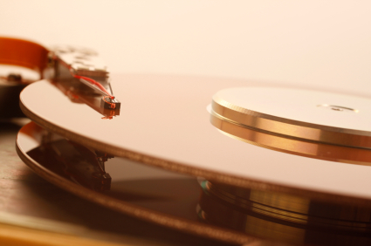

At the most basic level, internal storage is needed to hold the operating system so that the computer is able to access the input and output devices.

It will also be used to store the applications software that you use and more than likely, the original copies of your data files.

Internal storage allows the data and applications to be loaded very rapidly into memory, ready for use. The data can be accessed much faster than data which is stored on an external storage device. This is because internal storage devices are connected directly to the motherboard and its data bus whereas external devices are connected through a hardware interface such as USB, which means they are considerably slower to access.

Internal storage also means that if the computer is moved around, it will still retain its most commonly used data.

The main disadvantage of internal storage is that when the hard disk fails (and it will), all the data and applications may be lost.

This can be avoided to some extent by using more than one hard disk within the machine. Each hard disk has a copy of all the data, so if one fails the other can carry on. This is called a RAID array.  An alternative is to use external drives for backup

© www.teach-ict.com

**Interfacing ports**

A port is a physical docking point using which an external device can be connected to the computer. It can also be programmatic docking point through which information flows from a program to the computer or over the Internet.

## Characteristics of Ports

A port has the following characteristics −

* External devices are connected to a computer using cables and ports.
* Ports are slots on the motherboard into which a cable of external device is plugged in.
* Examples of external devices attached via ports are the mouse, keyboard, monitor, microphone, speakers, etc.

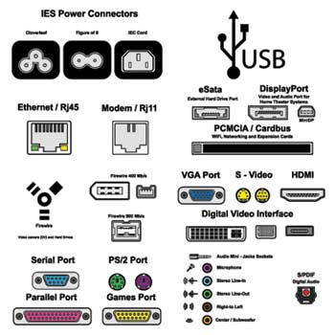

Let us now discuss a few important types of ports −

## Serial Port

* Used for external modems and older computer mouse
* Two versions: 9 pin, 25 pin model
* Data travels at 115 kilobits per second

## Parallel Port

* Used for scanners and printers
* Also called printer port
* 25 pin model
* IEEE 1284-compliant Centronics port

## PS/2 Port

* Used for old computer keyboard and mouse
* Also called mouse port
* Most of the old computers provide two PS/2 port, each for the mouse and keyboard
* IEEE 1284-compliant Centronics port

## Universal Serial Bus (or USB) Port

* It can connect all kinds of external USB devices such as external hard disk, printer, scanner, mouse, keyboard, etc.
* It was introduced in 1997.
* Most of the computers provide two USB ports as minimum.
* Data travels at 12 megabits per seconds.
* USB compliant devices can get power from a USB port.

## VGA Port

* Connects monitor to a computer's video card.
* It has 15 holes.
* Similar to the serial port connector. However, serial port connector has pins, VGA port has holes.

## Power Connector

* Three-pronged plug.
* Connects to the computer's power cable that plugs into a power bar or wall socket.

## Firewire Port

* Transfers large amount of data at very fast speed.
* Connects camcorders and video equipment to the computer.
* Data travels at 400 to 800 megabits per seconds.
* Invented by Apple.
* It has three variants: 4-Pin FireWire 400 connector, 6-Pin FireWire 400 connector, and 9-Pin FireWire 800 connector.

## Modem Port

* Connects a PC's modem to the telephone network.

## Ethernet Port

* Connects to a network and high speed Internet.
* Connects the network cable to a computer.
* This port resides on an Ethernet Card.
* Data travels at 10 megabits to 1000 megabits per seconds depending upon the network bandwidth.

## Game Port

* Connect a joystick to a PC
* Now replaced by USB

## Digital Video Interface, DVI port

* Connects Flat panel LCD monitor to the computer's high-end video graphic cards.
* Very popular among video card manufacturers.

## Sockets

* Sockets connect the microphone and speakers to the sound card of the computer.