**Q1:**

**How to start it ?**

**A1:**

**Step1:**

**Download the Smart-Robot-Car-Arduino package from**

[**https://github.com/UCTRONICS/Smart-Robot-Car-Arduino.git**](https://github.com/UCTRONICS/Smart-Robot-Car-Arduino.git)

**Step2:**

**Unzip the Smart-Robot-Car-Arduino package and copy the Arducam_Smart_Robot_Car to**

**..\Arduino\libraries path**

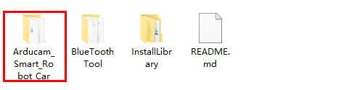

**Step3：**

**Open the InstallLibrary folder and copy AFMotor and NewPing libraries. to ..\Arduino\libraries path.**

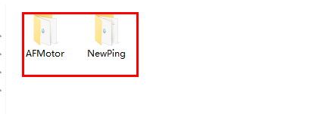

**Step4: Open your Arduino IDE and choose the Toos ->Board -> Arduino/Genuino UNO board**

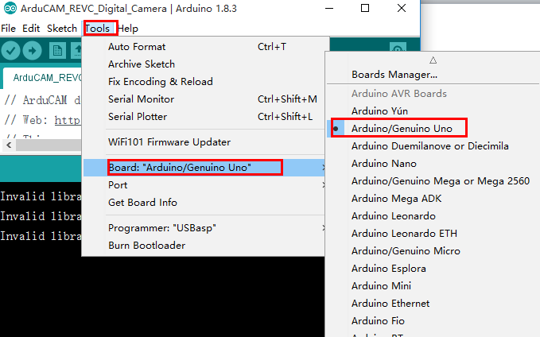

**Step5: Choose the right serial poart:**

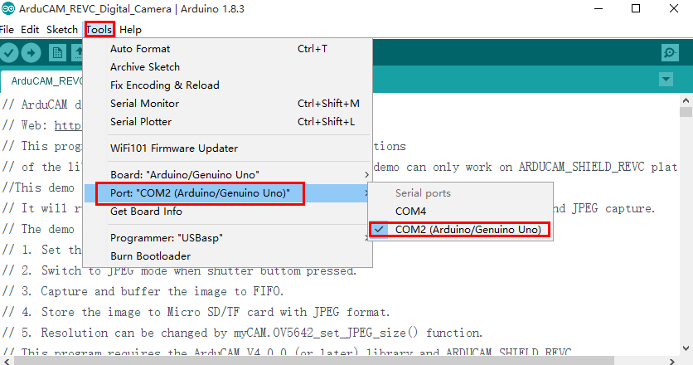

**Step5:**

**Upload the demo to Arduino UNO board:**

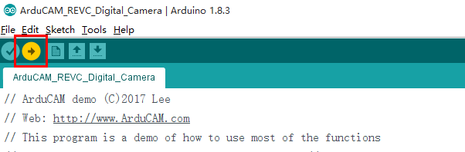

**Q2： When compiling, The following error occurred:**

C:\Users\Home\Downloads\Smart-Robot-Car-Arduino-master\Smart-Robot-Car-Arduino-master\Arducam_Smart_Robot_Car\example\Smart_Robot_Car_V1\Smart_Robot_Car_V1.ino:5:22: fatal error: AFMotor.h: No such file or directory

#include <AFMotor.h>

^

compilation terminated.

exit status 1

Error compiling for board Arduino/Genuino Uno.

**A2:**

**Before running this demo,you should install AFMotor and NewPing libraries.Just cope them to ..\Arduino\libraries path.**