Configuring TF Series LiDAR Using a TTL to UAVCAN Converter with Pixhawk
ArduPilot Firmware Configuration and Test Guide
This guide describes how to connect a Benewake TF-series LiDAR to a Pixhawk flight controller through a TTL to UAVCAN converter, configure ArduPilot, and verify altitude-hold and obstacle-avoidance data.
Applicable products: TF-Luna, TFmini-S, TFmini-Plus, TF02-Pro and TF03. Communication interface: TTL. Example device used for testing: TFmini-S.

1. Preparing the Test Setup
Item | Quantity / requirement
Windows PC | 1
4-pin Dupont cable | 1 set
TFmini-S with TTL interface | 1
Pixhawk flight controller | 1
TTL to UAVCAN converter | 1
Mission Planner | Installed
ArduPilot firmware | apm_fmvu3.px4
Before powering the system, confirm the sensor, converter and Pixhawk share the wiring required by the converter documentation. The power supply must meet the LiDAR product manual requirements.

2. Install ArduPilot Firmware
Open Mission Planner and select Initial Setup → Install Firmware → Load custom firmware. Select apm_fmvu3.px4 and follow the prompts. A success message is shown when flashing is complete. Click Connect in the upper-right corner after the controller restarts.

3. Pixhawk and Converter Connection
Connect the Pixhawk CAN interface to the TTL to UAVCAN converter, connect the TF-series LiDAR to the converter TTL port, and connect the Pixhawk to the PC running Mission Planner. Use CAN1 for the example configuration below. If CAN2 is used, select the corresponding CAN2 driver parameter.
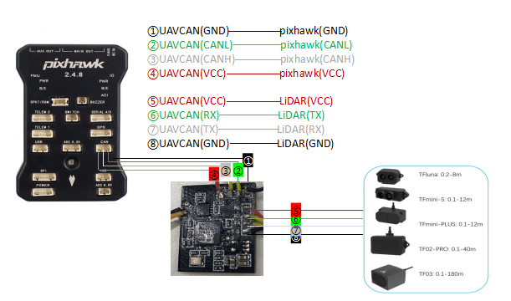
Figure 1. Example Pixhawk and TTL to UAVCAN converter wiring
The connection image is for reference. Follow the pinout and power requirements of the specific Pixhawk, converter and LiDAR models being used.

4. Altitude Hold Configuration
In Mission Planner, open Config/Tuning → Full Parameter List (or All Parameters), search for each parameter below, enter the value, and select Write Params.
Parameter | Value | Description
CAN_P1_DRIVER | 1 | Enable CAN1. Use the appropriate CAN2 driver parameter when the converter is connected to CAN2.
RNGFND1_TYPE | 24 | Use the UAVCAN rangefinder driver.
RNGFND1_ADDR | 16 | Default decimal node address of the TTL to UAVCAN converter.
RNGFND1_MIN_CM | 10 | Minimum valid distance in cm. Set it above the LiDAR blind zone.
RNGFND1_MAX_CM | 700 | Maximum valid distance in cm. Set it below the effective range of the LiDAR.
RNGFND1_GNDCLEAR | 15 | Sensor height above ground in cm when the vehicle is landed. Keep it above the blind zone.
RNGFND1_ORIENT | 25 | Sensor faces downward.
PRX1_TYPE | 0 | Do not use the proximity sensor for this altitude-hold-only configuration.
After writing the parameters, reboot the Pixhawk from Mission Planner using Ctrl+F → Reboot Pixhawk, then reconnect. This ensures the driver and parameter changes are applied.

5. Altitude Data Verification
Open Flight Data in Mission Planner. Double-click a numeric data field, select rangefinder1, and confirm that the displayed value changes when the LiDAR-to-ground distance changes.
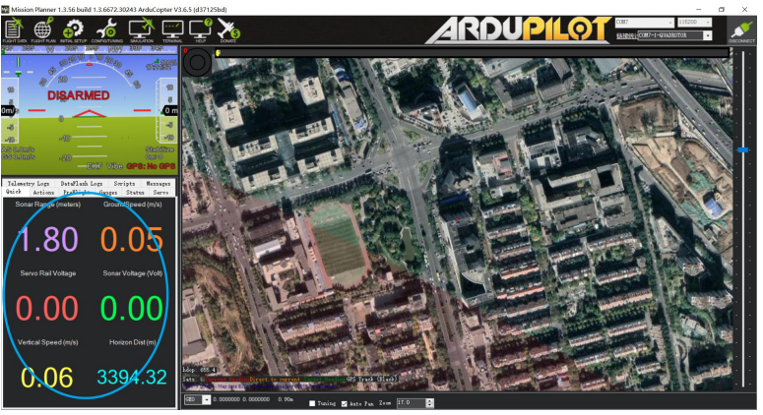
Figure 2. Example Mission Planner rangefinder data display

6. Obstacle Avoidance Configuration
Use the following configuration when the LiDAR is mounted facing forward and is intended for proximity-based obstacle detection.
Parameter | Value | Description
AVOID_BEHAVE | 1 | Stop when an obstacle is detected.
AVOID_MARGIN | 3 | Avoidance margin in GPS-enabled mode, in metres. Adjust for the application.
AVOID_DIST_MAX | 3 | Maximum avoidance distance without GPS, in metres. Adjust for the application.
AVOID_ENABLE | 2 | Enable obstacle avoidance using the proximity sensor.
CAN_P1_DRIVER | 1 | Enable CAN1 for the converter.
RNGFND1_TYPE | 24 | Use the UAVCAN rangefinder driver.
RNGFND1_ADDR | 16 | Default decimal node address of the converter.
RNGFND1_MIN_CM | 10 | Minimum valid distance in cm; keep above the blind zone.
RNGFND1_MAX_CM | 700 | Maximum valid distance in cm; keep below the effective range.
RNGFND1_GNDCLEAR | 15 | Mounting clearance in cm; use the actual installation height.
RNGFND1_ORIENT | 0 | Sensor faces forward.
PRX1_TYPE | 4 | Use the rangefinder as the obstacle-avoidance input.
Select Write Params, reboot the Pixhawk, and reconnect. If Mission Planner reports Bad LiDAR Health, check the wiring, converter power, sensor power and CAN driver selection.

7. Proximity Data Verification
Press Ctrl+F in Mission Planner and select Proximity to open the proximity display. The green numbers represent the distances used by the obstacle-avoidance function. They are not necessarily a direct real-time display of every raw LiDAR reading; if the display refreshes slowly, update Mission Planner to a current release.
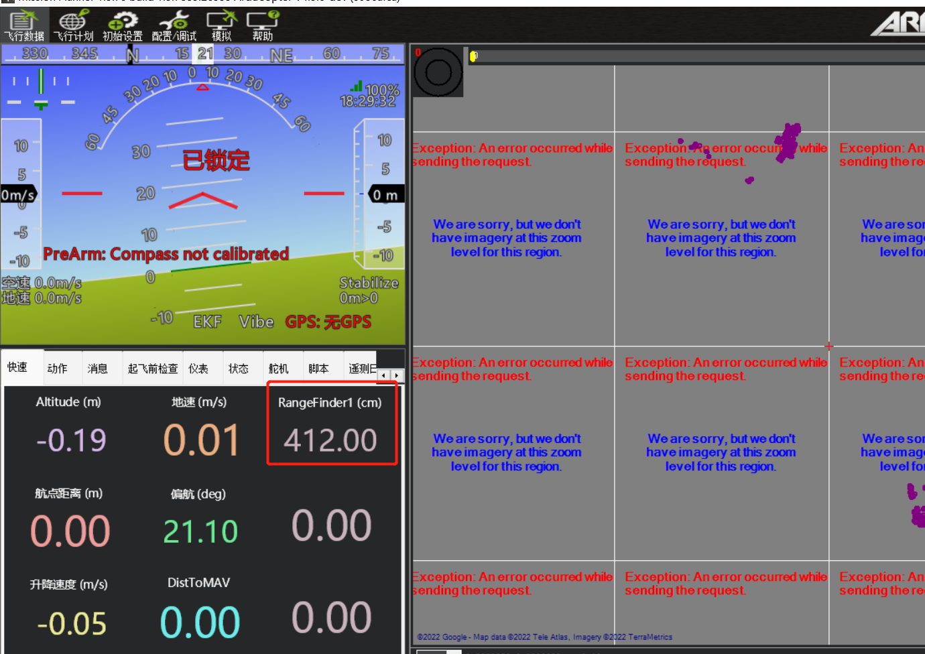
Figure 3. Example proximity display

8. Troubleshooting Checklist
- Confirm the LiDAR and converter are powered and that the supply voltage/current meets the product manual requirements.
- Confirm the Pixhawk CAN port matches the enabled CAN driver parameter.
- Confirm RNGFND1_ADDR=16 matches the converter node address.
- Confirm RNGFND1_ORIENT matches the physical mounting direction: 25 for downward, 0 for forward.
- Confirm RNGFND1_MIN_CM is larger than the LiDAR blind zone and RNGFND1_MAX_CM is smaller than the effective measurement range.
- After changing parameters, reboot the Pixhawk before testing again.
The parameter values in this guide are example values derived from the supplied test document. Adjust range limits, ground clearance and avoidance margins to the actual LiDAR model, mounting position and vehicle requirements.

