Pranshav Thakkar

**Manual Strategy HW**

**Part 1: Indicators**

For my first indicator, I selected SMA. This indicator simply looks at the prices over a certain window of time and takes their average. How we can use it is by then dividing the prices by this SMA, which gives us a ratio of how we can expect the prices to behave based on the past.

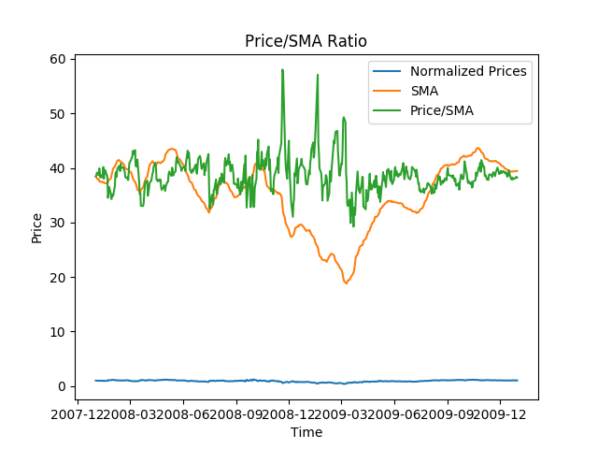

For my second indicator, I selected Bollinger Band Percentage. Bollinger bands are calculated by adding two standard deviations above and below the rolling mean of the prices. They give us thresholds to look out for, as when prices cross these thresholds they can indicate to us that it is time to buy or sell the stock.

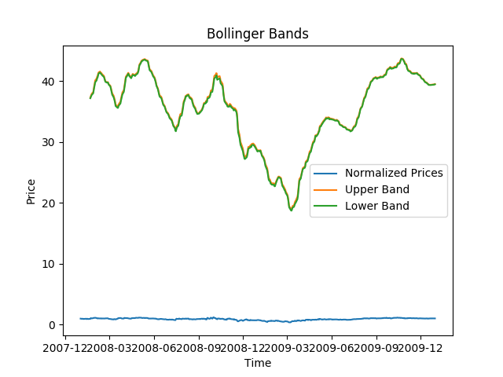

My third indicator is momentum, which is the ratio of whether the price is moving up or down over a certain window. The higher the momentum, the more confidence we can have in selling or buying the stock.

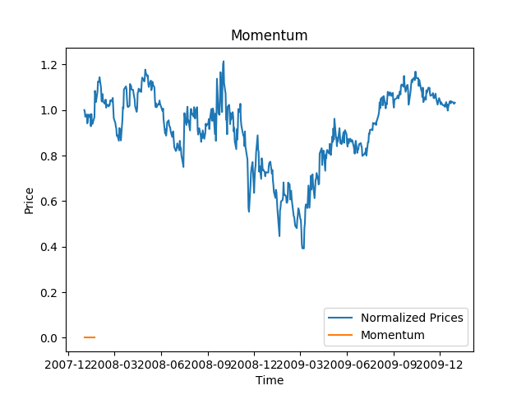

**Part 2: Theoretically Optimal Strategy**

For the theoretically optimal strategy, we are assuming that we can peek into the future and this is a very big assumption on our part. So, the strategy is to look at both today’s price and tomorrow’s price, take the ratio of today’s price over tomorrow’s price, and then subtract that ratio by 1. If this value is negative, it means that today’s price is lower than tomorrow’s price and we should buy today. So we indicate a positive sign in our trade ledger, as we want to buy. If this value is positive, it means that today’s price is higher than tomorrow’s price, and we should sell today. So, we indicate a negative sign in our trade ledger as we want to sell.

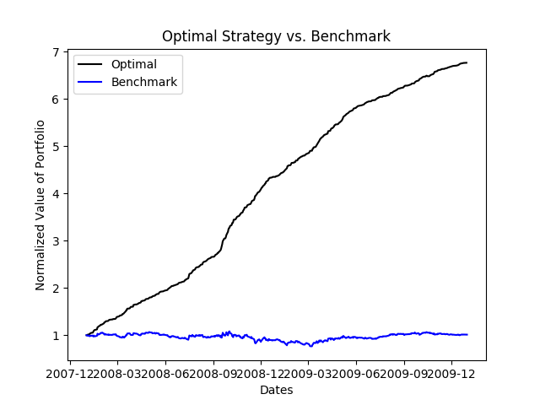

Looking at the provided chart, we clearly see that the optimal strategy provided outperforms the benchmark by almost 7 times the normalized value of the portfolios.

Performance Statistics:

Benchmark CR: 0.0123

Benchmark Mean of Daily Returns: 0.00017

Benchmark STDev of Daily Returns: 0.017

Optimal CR: 5.762

Optimal Mean of Daily Returns: 0.0038

Optimal STDev of Daily Returns: 0.00456

**Part 3: Manual Strategy**

For our manual strategy, we are utilizing two of our indicators, namely the SMA, and the BBP(or Bollinger Band percentage). After we get the SMA, we divide the prices by the SMA so that the statistic is normalized. Our strategy is as follows: if the SMA is less than 0.95 and the BBP is less than 0, then we buy stocks, or put in a long order. This is because the stock’s value has been lower than usual for a while and we can expect an uptick in price soon, or so we would hope. On the other hand, when the SMA is greater than 1.05, and the BBP is greater than 1, then we sell stocks, or we put in a short order. This is because the stocks value is high and we can expect it to fall to a lower value soon, based on the BBP. 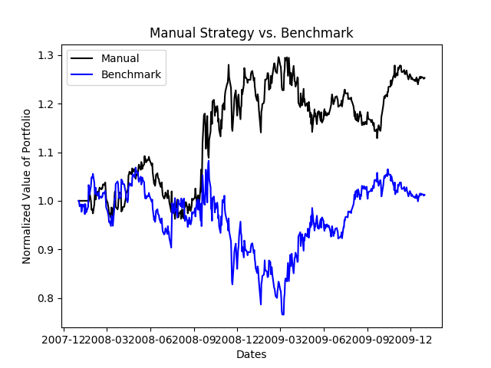

As we can see in the chart, this strategy performs better than the benchmark, although not as well as the optimal strategy. This is expected, as in the optimal strategy we made the assumption that we were allowed to look into the future and create a strategy based on that. For the manual strategy, we can only make predictions based on the past.