
Eminence Terrace I
樂翹軒 I
Content Management System
User Manual
Version | v1.0
Date | 2026-03-10
System | Eminence Terrace I — CMS
Confidentiality | Internal Use Only
This user manual was generated by Hostlink WhatsApp AI Assistant

Table of Contents
Chapter 1 System Overview
Chapter 2 Login / Logout
Chapter 3 Interface Overview
Chapter 4 Module — Static Pages (StaticPage)
Chapter 5 Module — Document Updates (Updates)
Chapter 6 Module — Gallery
Chapter 7 Module — Header Menu (HeaderMenu)
Chapter 8 Module — File Manager
Chapter 9 Frontend Website Overview
Chapter 10 System Administration
Chapter 11 Frequently Asked Questions (FAQ)
Chapter 12 Technical Support

Chapter 1: System Overview
The Eminence Terrace I Content Management System (CMS) is a web-based administration platform developed by Hostlink. It enables authorised staff to manage website content, documents, images, and system configurations without requiring technical knowledge.
1.1 Main Functions
- Static page content management (disclaimers, legal text, notices)
- Document updates — upload and publish sales-related documents
- Gallery image management for the frontend website
- Header navigation menu configuration
- File manager — centralised media asset storage
- Frontend website preview and content verification
- User account and permission management
- System configuration, logs, and audit trails
1.2 System Information
Item | Details
CMS (Admin) URL | https://hsk.hlhk.net/admin (please confirm with administrator)
Frontend URL (English) | https://hsk.hlhk.net/en
Frontend URL (Traditional Chinese) | https://hsk.hlhk.net/tc
Recommended Browsers | Google Chrome (latest), Microsoft Edge (latest)
Recommended Screen Resolution | 1280 x 800 or above
Language Support | English (EN) & Traditional Chinese (TC)
Platform | Web-based — no software installation required

Chapter 2: Login / Logout
2.1 Login Steps
To access the CMS, open your web browser and navigate to the CMS admin URL. The system may require HTTP Basic Authentication before displaying the login page — this is an additional security layer.
Step 1: Open your web browser (Google Chrome or Microsoft Edge is recommended).
Step 2: Navigate to the CMS URL: https://hsk.hlhk.net/admin
Step 3: If prompted by HTTP Basic Authentication, enter the credentials provided by your system administrator and click OK.
Step 4: On the CMS login page, enter your Username and Password.
Step 5: Click the Login button to access the system.
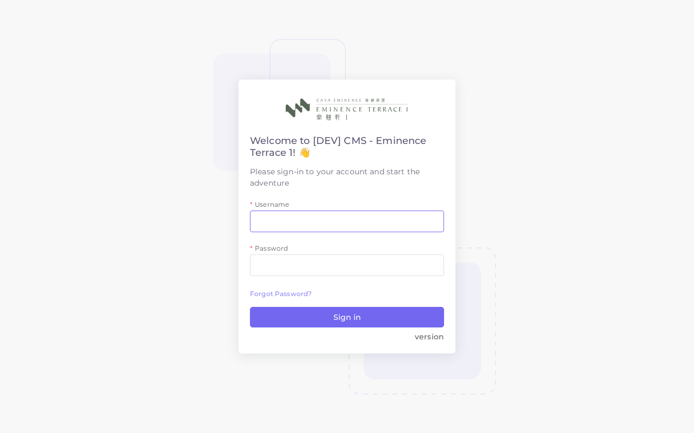
▲ CMS Login Page
🔒 HTTP Basic Authentication is an additional security layer protecting the admin area. These credentials are different from your CMS login username/password. Contact your system administrator if you do not have them.
2.2 Logout Steps
Step 1: Click on your username or the user avatar icon in the top-right corner of the screen.
Step 2: Select Logout from the dropdown menu.
Step 3: You will be redirected to the login page, confirming successful logout.
2.3 Security Recommendations
- Always log out when leaving your workstation unattended.
- Never share your CMS login credentials with others.
- Use a strong, unique password and update it periodically.
- Avoid accessing the CMS from public or shared computers.
- Contact your system administrator immediately if you suspect unauthorised access to your account.
Chapter 3: Interface Overview
After logging in, the CMS dashboard is displayed. The interface is divided into three main areas: the top navigation bar, the left sidebar, and the main content area.
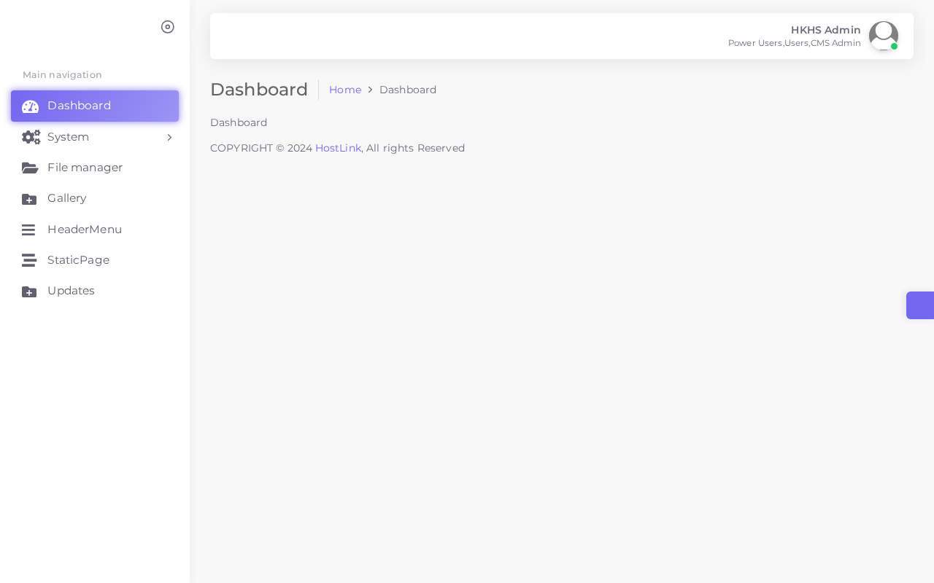
▲ CMS Dashboard Overview
3.1 Interface Areas
Area | Description
Top Navigation Bar | Displays the system name, currently logged-in user, and the Logout button. May include notification indicators.
Left Sidebar | The primary navigation menu providing access to all CMS modules and system settings. Can be expanded or collapsed.
Main Content Area | The working area showing the selected module's list view, data entry forms, or configuration panels.

3.2 Sidebar Navigation Structure
Sidebar Item | Description
Dashboard | System overview with summary statistics
Static Pages | Manage disclaimer and content pages displayed on the frontend
Updates | Upload and manage sales-related documents
Gallery | Manage images shown in the website gallery
Header Menu | Configure top navigation bar items
File Manager | Upload and organise all media files
Users | Manage CMS user accounts
User Groups | Define roles and access permissions
System Config | Global system settings
Event Log | Audit trail of all system actions
Mail Log | Record of all emails sent by the system
User Log | Login and logout history

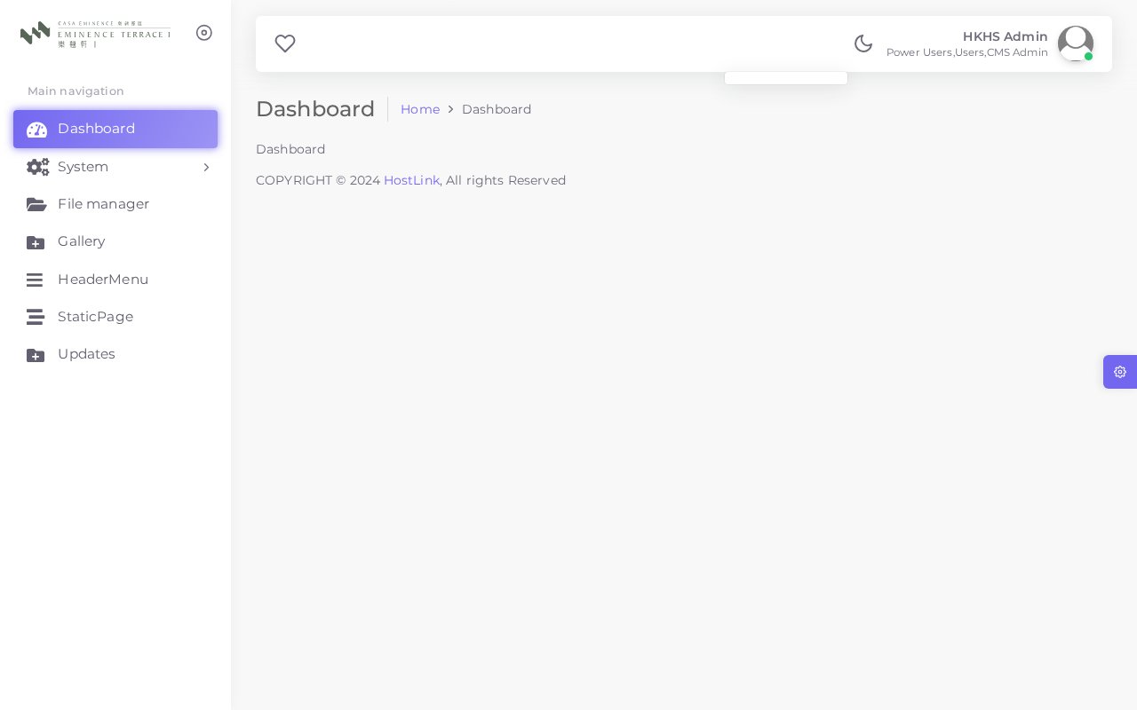
▲ Expanded Left Sidebar
Chapter 4: Module — Static Pages (StaticPage)
4.1 Overview
The Static Pages module manages fixed content pages displayed on the frontend website. These include legal disclaimers, copyright notices, accessibility statements, and other regulatory text. Each page maps to a specific location on the frontend — changes are reflected immediately.
4.2 Viewing the Page List
In the left sidebar, click Static Pages to view all configured pages. The list shows the page identifier, language versions, and last modified date.
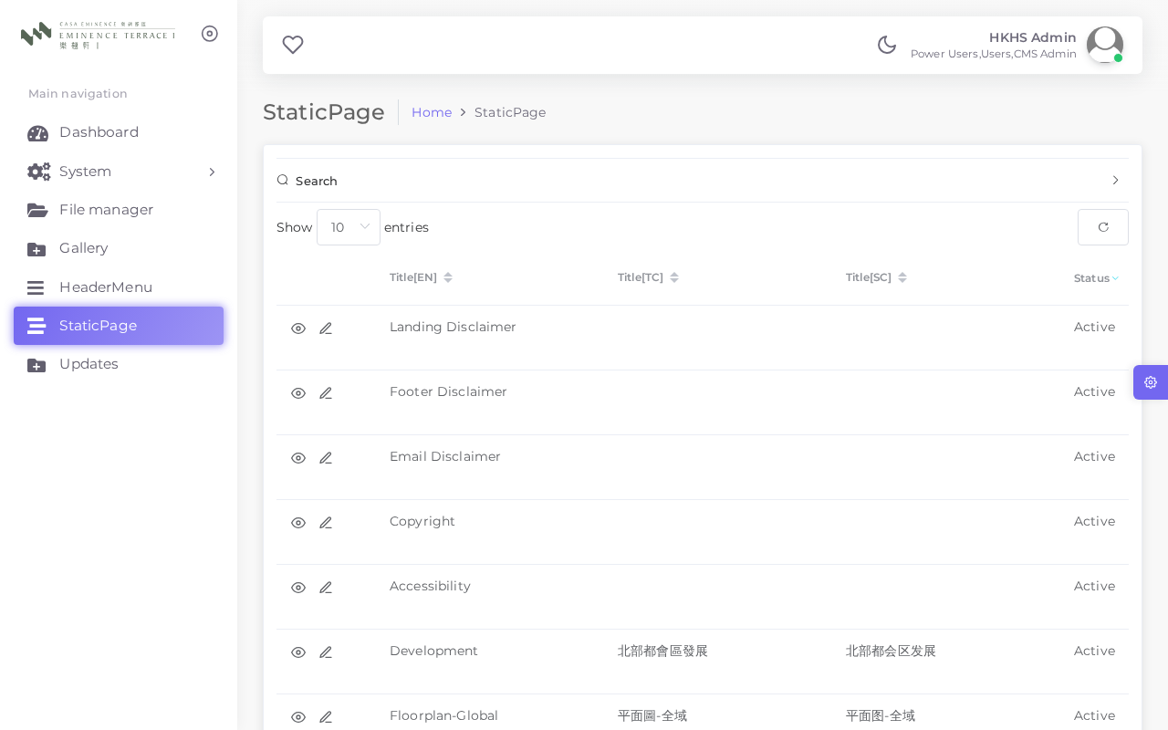
▲ Static Pages List
4.3 Static Pages and Their Frontend Locations
Understanding where each static page appears on the frontend is essential before making any edits. The sections below describe each page and its corresponding frontend location.
① Landing Disclaimer
The Landing Disclaimer is displayed as a pop-up dialog the first time a visitor arrives at the homepage. The visitor must click "Accept" before they can view the website content. This is a legal requirement for property sales websites in Hong Kong.
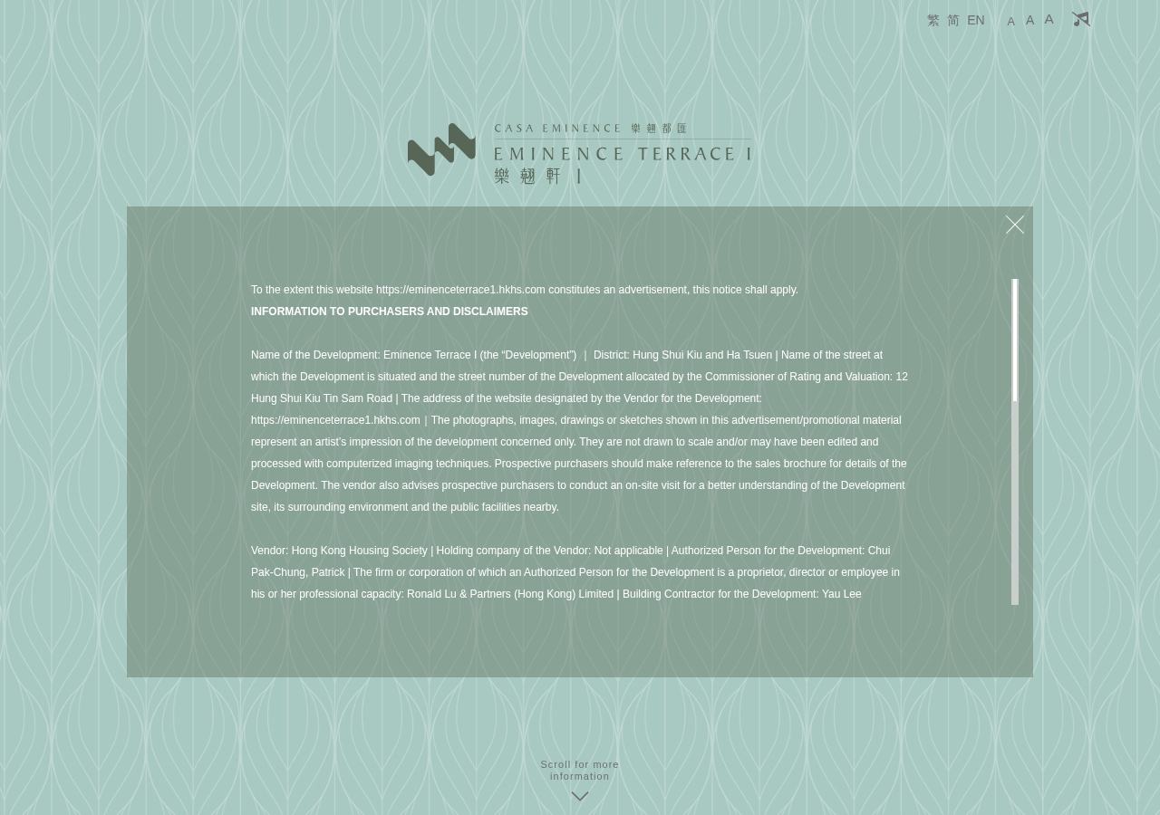
▲ Landing Disclaimer Pop-up (Homepage)
② Footer Disclaimer
The Footer Disclaimer text appears in the footer section at the bottom of every page. It contains legal notices regarding property sales, agent details, and other regulatory disclosures.
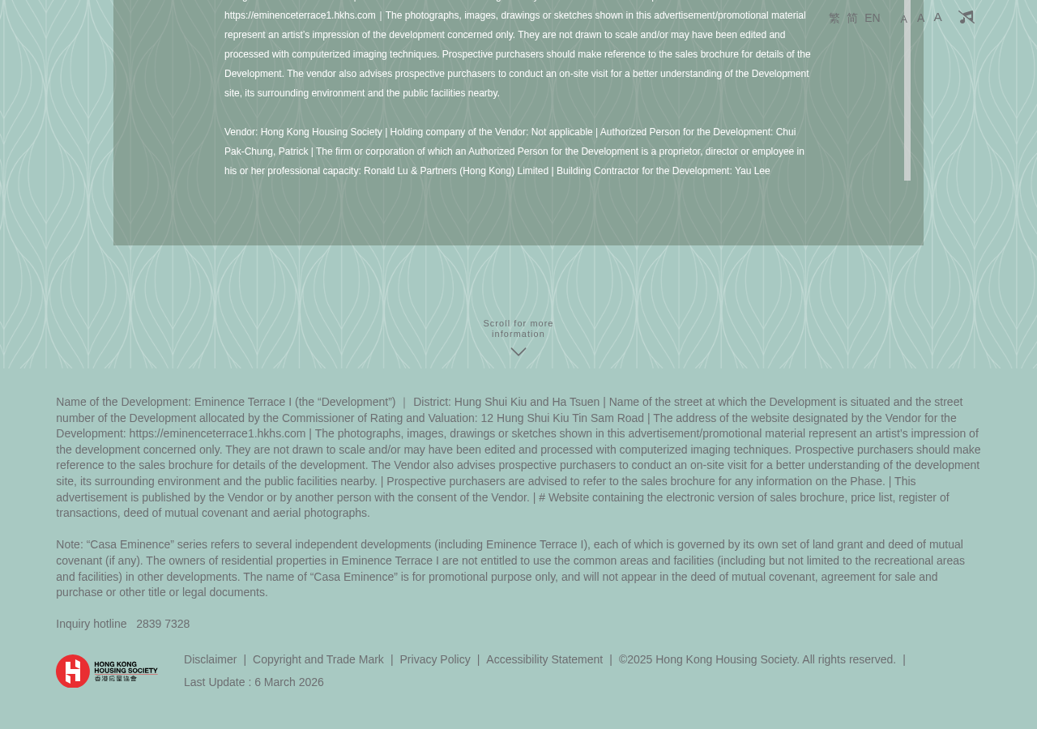
▲ Footer Disclaimer Text
③ Floorplan Disclaimer
The Floorplan Disclaimer is linked to the floor plan section. When a visitor clicks the "Disclaimer" button on the floor plan page, a pop-up appears displaying this disclaimer content. This is typically a detailed area and measurements disclaimer.
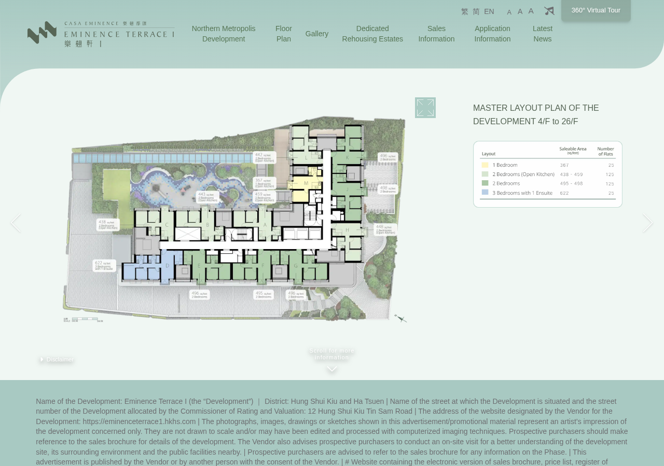
▲ Floor Plan Page with Disclaimer Button
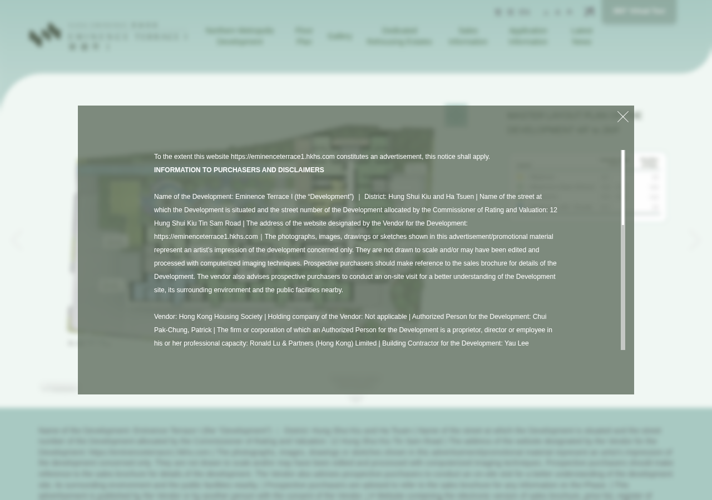
▲ Floorplan Disclaimer Pop-up Opened
④ Development
The Development page content is displayed in the Development / About section, providing background information about the property project, the developer, and the development details.

▲ Development Section on the Frontend
⑤ Other Static Pages
The following pages are managed in this module. Their content appears in the corresponding sections of the website:
- Gallery — Introductory or descriptive text for the gallery section
- Dedicated Rehousing Estates — Information related to rehousing arrangements
- Copyright — Copyright notice displayed site-wide, typically in the footer
- Accessibility — Accessibility statement available via the accessibility link
- Email Disclaimer — Disclaimer text appended to all outgoing system emails
4.4 Quick Reference Table
Page Name | Frontend Location | Impact of Changes
Landing Disclaimer | Homepage first-visit pop-up | Immediate — all new visitors
Footer Disclaimer | Footer of every page | Immediate — site-wide
Floorplan Disclaimer | Floor plan page pop-up | Immediate — on button click
Development | Development / About section | Immediate
Gallery | Gallery section intro text | Immediate
Dedicated Rehousing | Rehousing info area | Immediate
Copyright | Footer copyright notice | Immediate — site-wide
Accessibility | Accessibility statement page | Immediate
Email Disclaimer | System outgoing emails | Next email sent

4.5 Editing a Static Page
Step 1: In the Static Pages list, locate the page you wish to edit.
Step 2: Click the Edit (pencil) icon on the right side of the row.
Step 3: The page editor opens. Update the content using the text editor provided.
Step 4: Both English (EN) and Traditional Chinese (TC) versions may be present — ensure both are updated as needed.
Step 5: Click Save to apply your changes. The frontend updates immediately.
4.6 Important Notes
⚠️ Changes to static pages take effect immediately on the live frontend website. Always proofread carefully before saving.
💡 Static page content is HTML-based. Do not modify HTML tags unless you understand what they do — incorrect changes can break the page layout.
- Images cannot be embedded directly in static pages. Upload images via the File Manager first, then reference them by URL.
- Long disclaimer text should be kept as close to the original legal wording as possible. Consult your legal team before making significant changes.
Chapter 5: Module — Document Updates (Updates)
5.1 Overview
The Document Updates module manages sales-related documents published on the frontend website. It covers price lists, sales brochures, floor plans, and other statutory documents. Documents are categorised by type, versioned, and can be toggled between published and draft status.
5.2 Document List
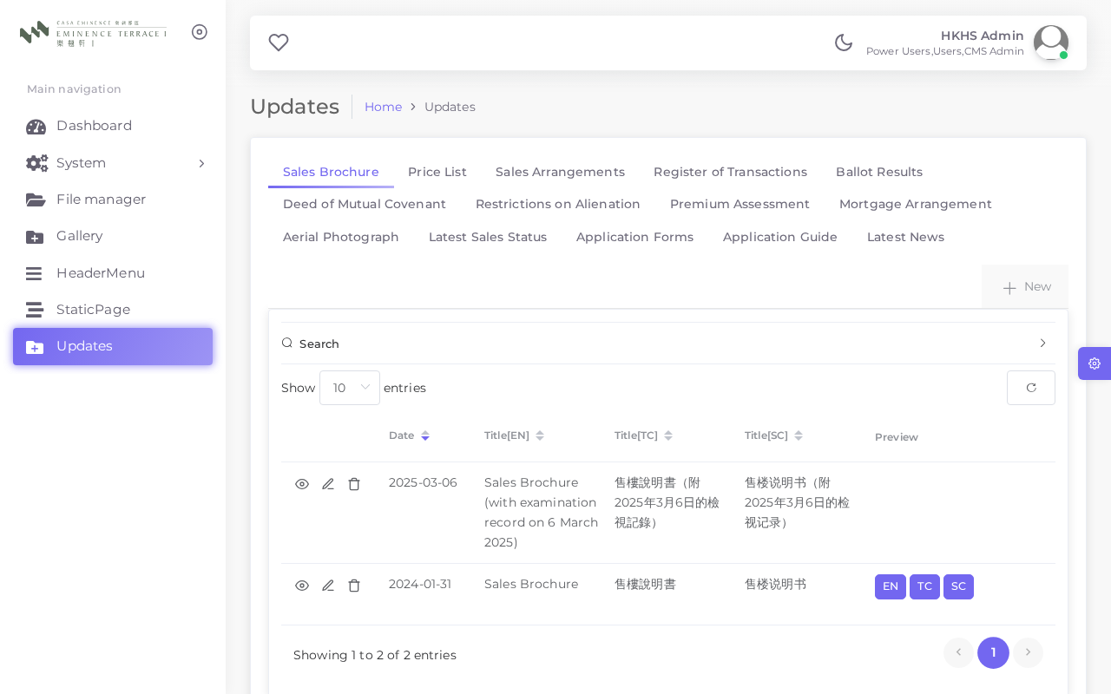
▲ Document Updates List
5.3 Supported Document Types
The system supports 14 standard document categories as required by Hong Kong property sales regulations:
# | Document Type
1 | Sales Brochure
2 | Price List
3 | Deed of Mutual Covenant
4 | Preliminary Agreement for Sale and Purchase
5 | Agreement for Sale and Purchase
6 | Approved Building Plans
7 | Consent Letter / Letter of Approval
8 | Sales Arrangements
9 | Register of Transactions
10 | Aerial Photo
11 | Location Map
12 | Site Plan
13 | Vendor Information Form
14 | Tender Notice

5.4 Adding a New Document
Step 1: Click the Add New button at the top of the Updates list.
Step 2: Select the Document Type from the dropdown menu.
Step 3: Enter the document title in both English and Traditional Chinese.
Step 4: Select the document date.
Step 5: Upload the document file (PDF format is strongly recommended).
Step 6: Set the Status to Published to make it visible on the frontend website.
Step 7: Click Save to complete the upload.
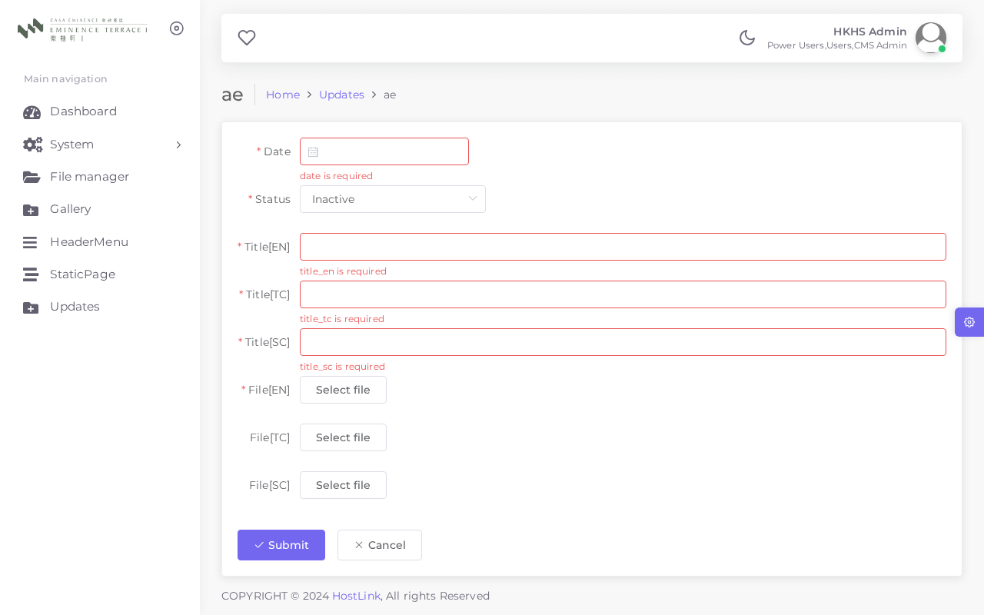
▲ Add/Edit Document Form
5.5 Document Status
Status | Visibility | Description
Published | Visible | Document is publicly accessible on the frontend website
Draft | Hidden | Document is saved but not yet shown to website visitors
Archived | Hidden | Document is retained in the system for records but removed from public view

💡 Only Published documents appear on the frontend. Use Draft status for documents that are not yet ready for public release.
Chapter 6: Module — Gallery
6.1 Overview
The Gallery module manages images displayed in the gallery section of the frontend website. Images can be uploaded with bilingual captions and sorted into the desired display sequence.
6.2 Gallery List
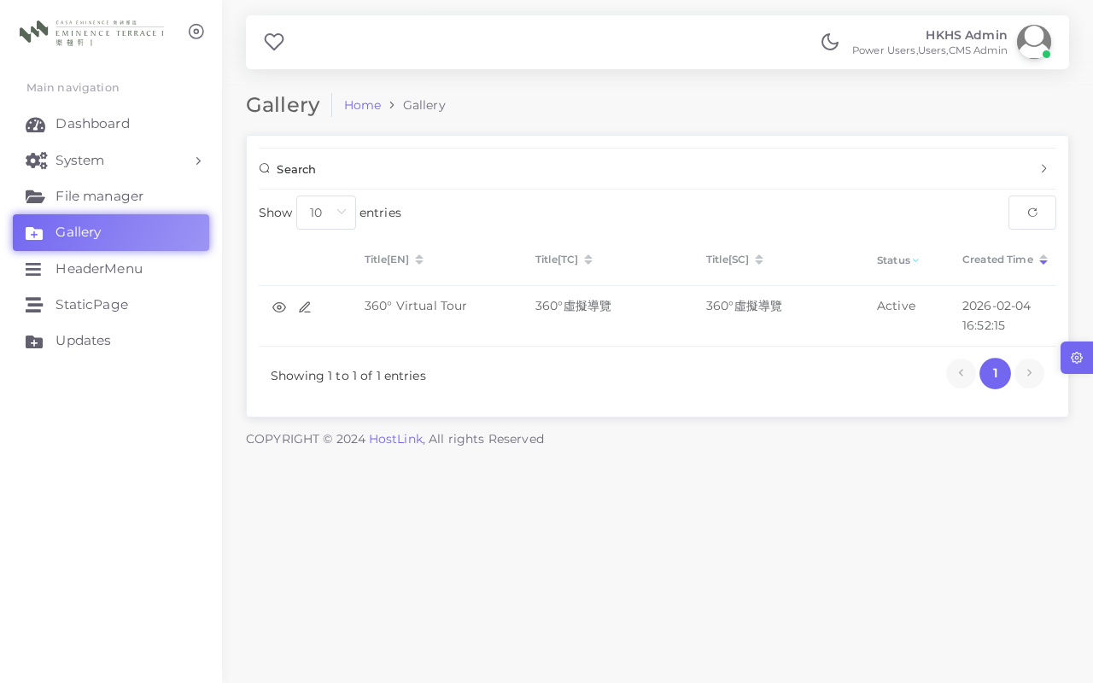
▲ Gallery Image List
6.3 Image Fields
Field | Description
Image | Upload an image file. JPG or PNG format recommended. Maximum file size: 5 MB.
Title (EN) | Image caption or label displayed to visitors in English.
Title (TC) | Image caption or label displayed to visitors in Traditional Chinese.
Sort Order | Controls the display sequence. Lower numbers appear first (from left to right or top to bottom).
Status | Published: visible on the frontend. Draft: hidden from visitors.

6.4 Adding or Editing a Gallery Image
Step 1: Click Add New in the Gallery list to add a new image, or click Edit on an existing entry.
Step 2: Upload the image file using the file picker.
Step 3: Enter the image caption in both English and Traditional Chinese.
Step 4: Set the Sort Order to position the image within the gallery sequence.
Step 5: Set Status to Published and click Save.
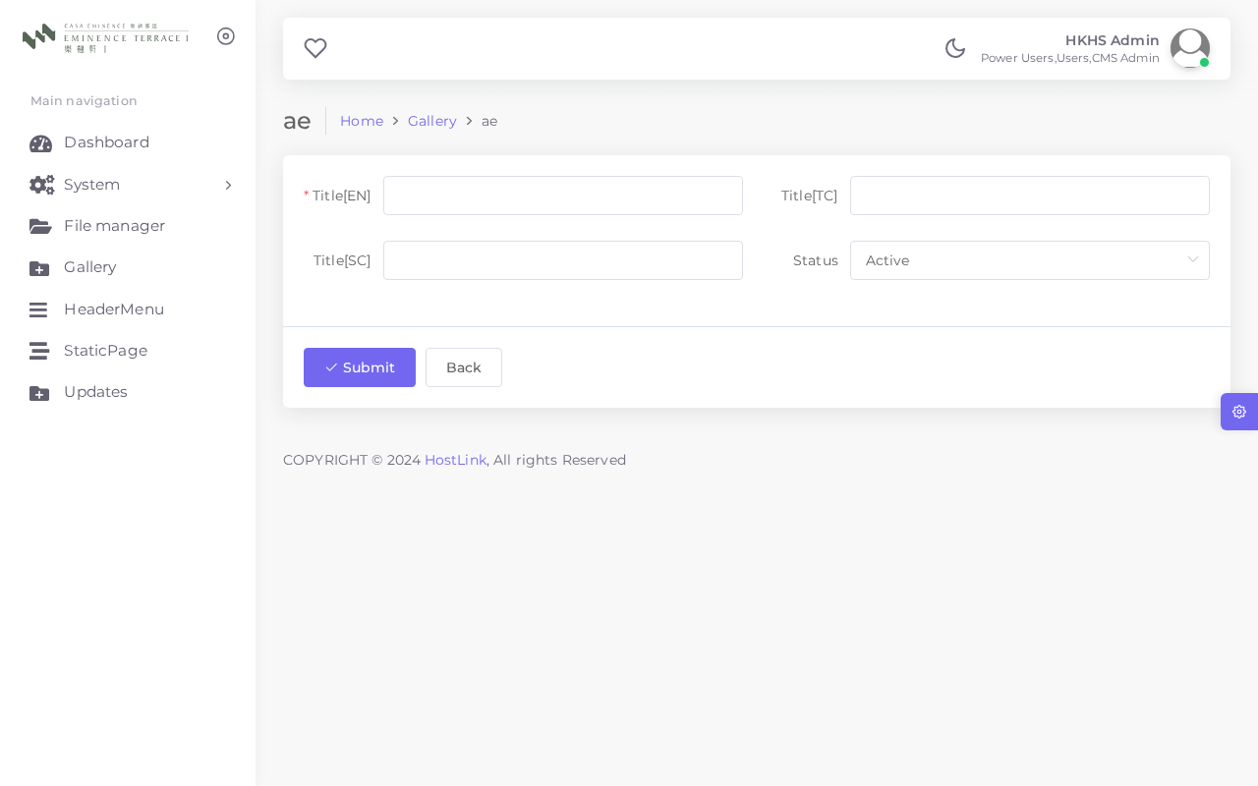
▲ Add/Edit Gallery Image
💡 For visual consistency, use images with a uniform aspect ratio (e.g. 16:9 or 4:3). Resize and compress images before uploading to improve website loading speed.
Chapter 7: Module — Header Menu (HeaderMenu)
7.1 Overview
The Header Menu module controls the top navigation bar displayed on the frontend website. Each menu item links to a website page and can be configured with separate URLs for English and Traditional Chinese versions.
7.2 Menu List
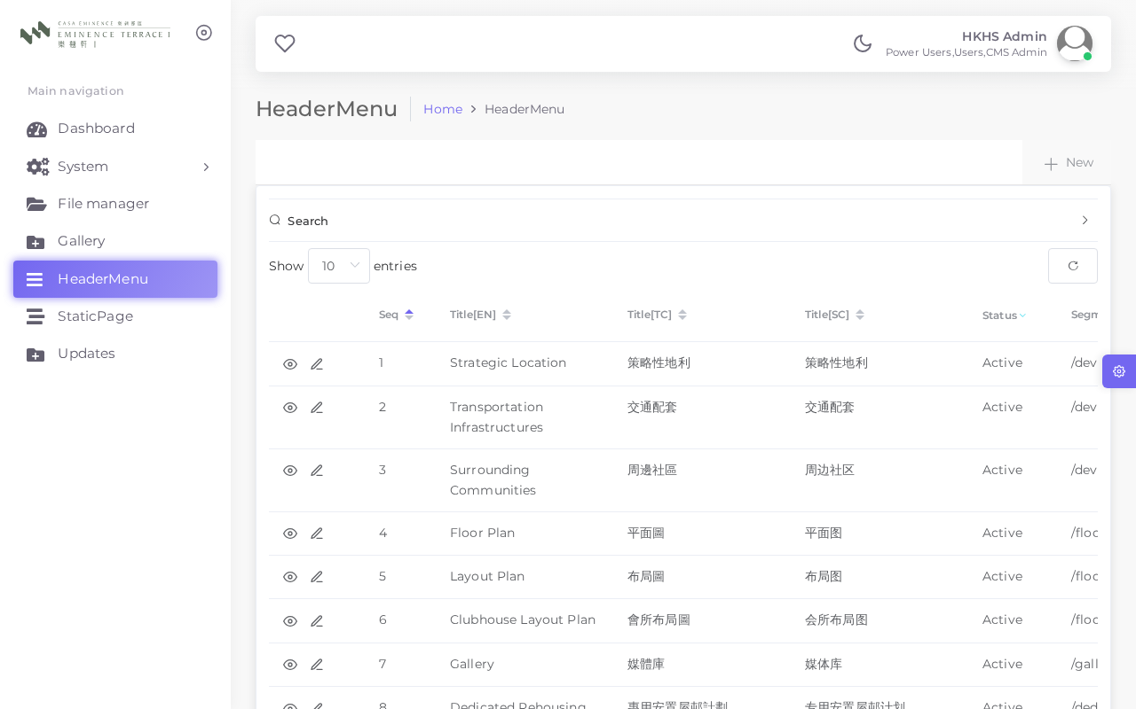
▲ Header Menu List
7.3 Menu Item Fields
Field | Description
Label (EN) | Navigation text displayed in the English version of the website.
Label (TC) | Navigation text displayed in the Traditional Chinese version.
URL (EN) | The destination link for the English menu item.
URL (TC) | The destination link for the Traditional Chinese menu item.
Target | _self: opens in the same tab. _blank: opens in a new tab.
Sort Order | Determines the left-to-right position in the navigation bar. Lower = further left.
Status | Published: visible in the menu. Draft: hidden from visitors.

7.4 Current Navigation Menu Items
# | Label | URL (EN) | Target
1 | Home | /en | _self
2 | Development | /en/development | _self
3 | Floorplan | /en/floorplan | _self
4 | Gallery | /en/gallery | _self
5 | Sales Arrangements | /en/sales | _self
6 | Register of Transactions | /en/transactions | _self
7 | Contact | /en/contact | _self

7.5 Editing a Menu Item
Step 1: Click Edit on the menu item you wish to modify.
Step 2: Update the label text and / or URL for English and Chinese versions.
Step 3: Adjust the Sort Order if you need to change the item's position.
Step 4: Click Save.
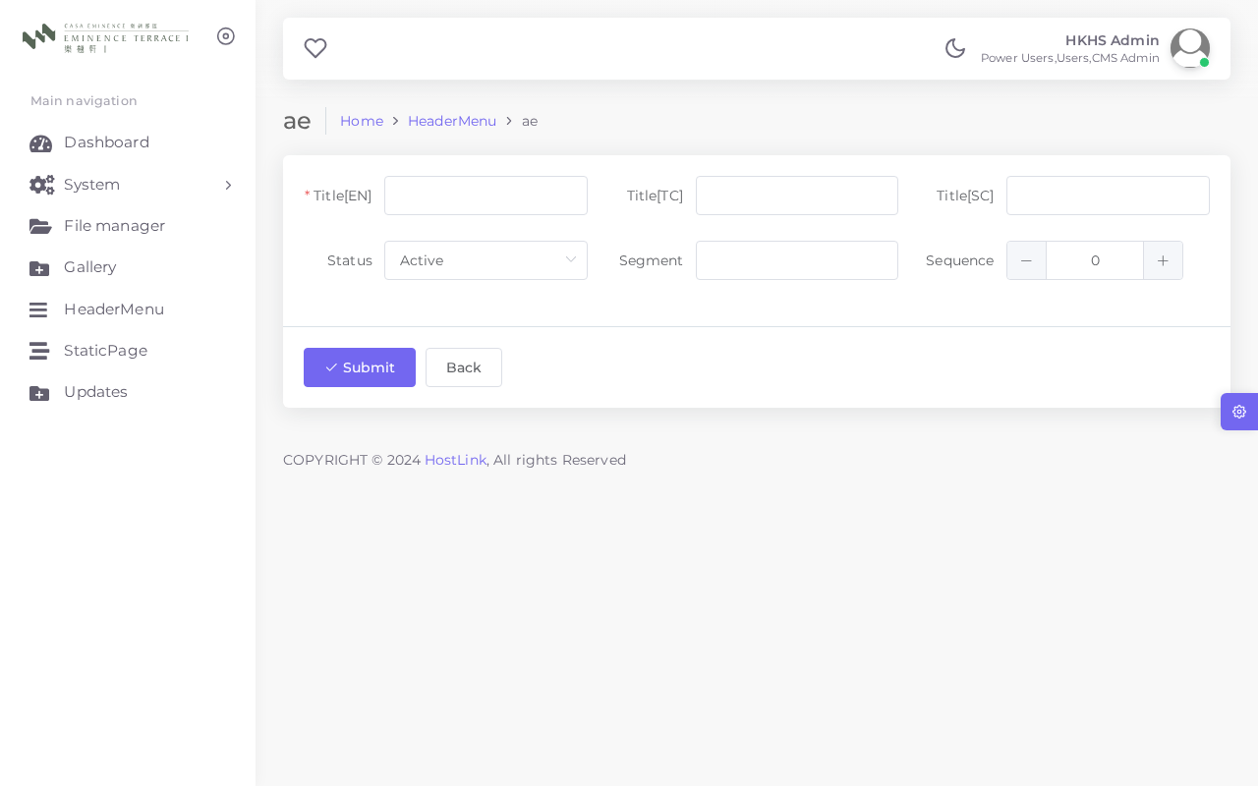
▲ Edit Header Menu Item
⚠️ Menu changes are reflected on the frontend immediately after saving. Always verify the navigation links work correctly on both language versions of the site.
Chapter 8: Module — File Manager
8.1 Overview
The File Manager provides a centralised repository for all media assets used across the website. Files uploaded here — images, PDFs, and other documents — can be linked from static pages, referenced in other modules, or shared as direct URLs.
8.2 File Manager Interface
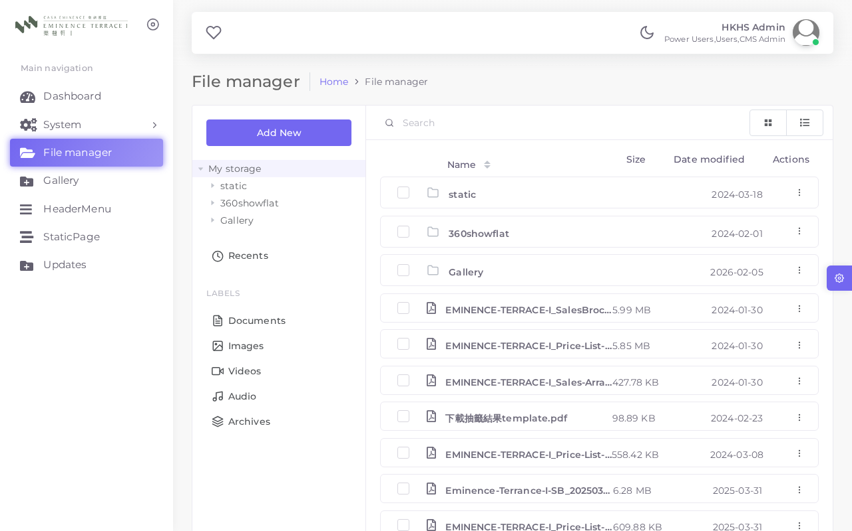
▲ File Manager — Main View

▲ File Manager — File Detail View
8.3 Key Functions
- Upload new files via the Upload button or drag-and-drop into the browser window
- Browse and filter files by folder, type, or filename
- Copy the full URL of any file for use in static page HTML or external links
- Delete unused files to keep storage organised
- Preview images directly within the browser without downloading
💡 Use descriptive, lowercase filenames without spaces before uploading (e.g., "price-list-2025-03.pdf"). This ensures clean, readable URLs.
⚠️ Deleting a file from the File Manager will break any page or module that currently references it. Always check usage before deleting.
Chapter 9: Frontend Website Overview
The frontend website is the public-facing site accessible to all visitors. Content managed in the CMS is rendered here in both English and Traditional Chinese. The site is designed to comply with Hong Kong property sales regulations.
9.1 Homepage (English)
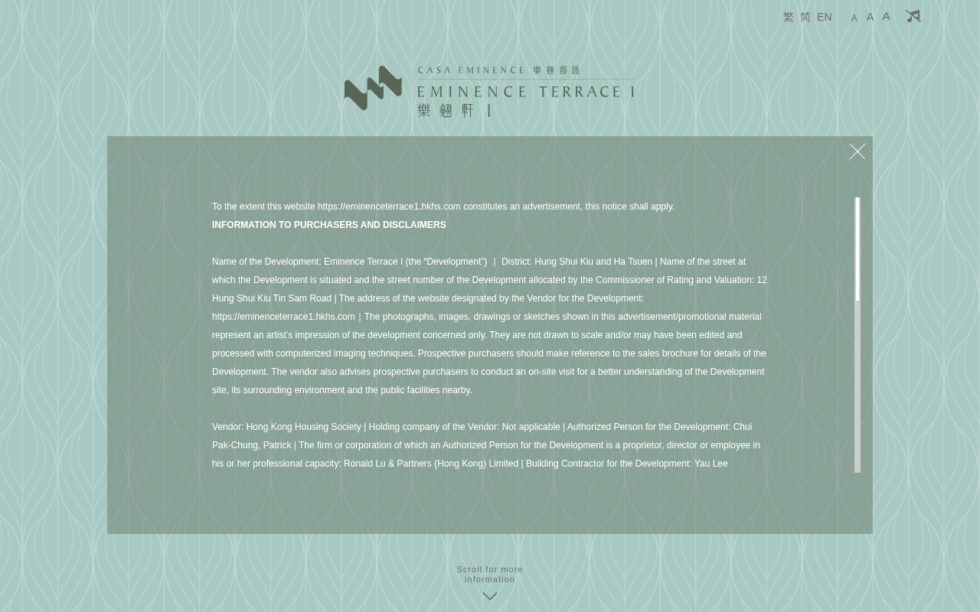
▲ Frontend Homepage — English Version
9.2 Floor Plan Page (English)
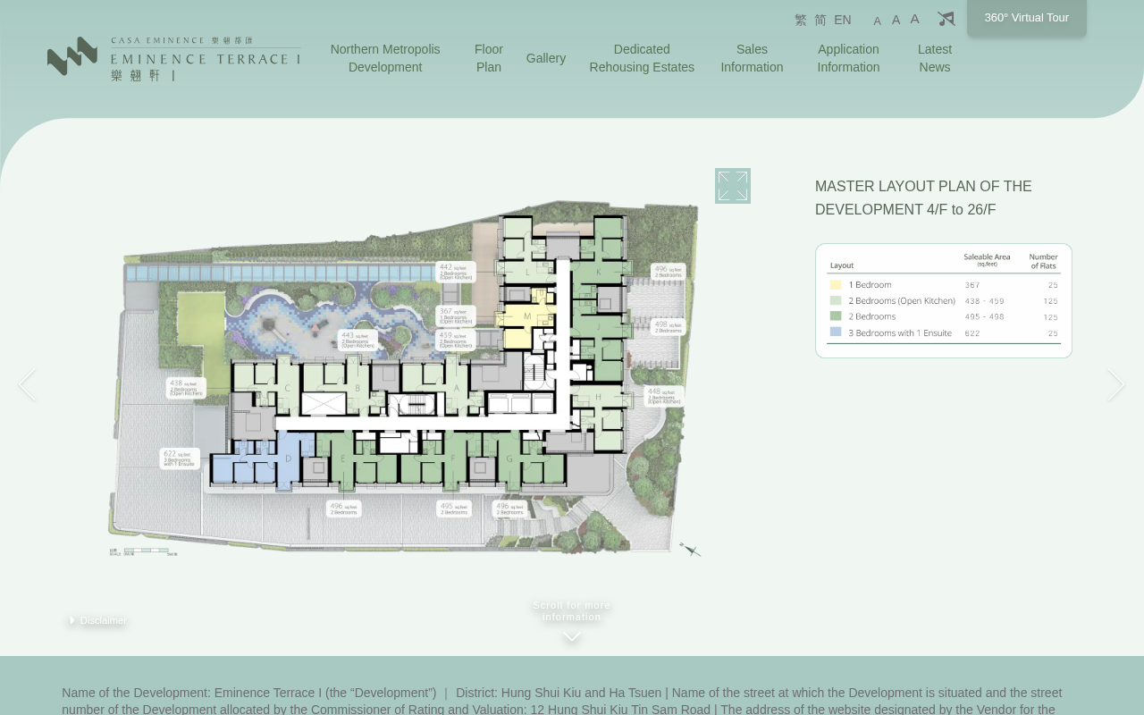
▲ Floor Plan Page — English Version
9.3 Website Page URLs
Page | URL | Language
Homepage | https://hsk.hlhk.net/en | English
Homepage | https://hsk.hlhk.net/tc | Traditional Chinese
Development | https://hsk.hlhk.net/en/development | English
Development | https://hsk.hlhk.net/tc/development | Traditional Chinese
Floor Plan | https://hsk.hlhk.net/en/floorplan | English
Floor Plan | https://hsk.hlhk.net/tc/floorplan | Traditional Chinese
Gallery | https://hsk.hlhk.net/en/gallery | English
Gallery | https://hsk.hlhk.net/tc/gallery | Traditional Chinese
Sales Arrangements | https://hsk.hlhk.net/en/sales | English
Register of Transactions | https://hsk.hlhk.net/en/transactions | English

💡 The frontend website is publicly accessible. After making CMS changes, always visit the frontend to verify the content appears correctly for visitors.
Chapter 10: System Administration
10.1 User Management
The User Management module allows system administrators to create, edit, and deactivate CMS user accounts. Each staff member should have an individual account — shared accounts are not recommended for security and audit trail purposes.
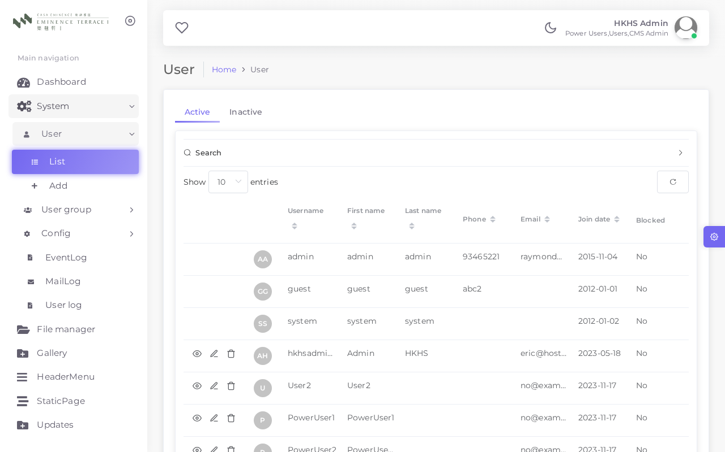
▲ User Account List
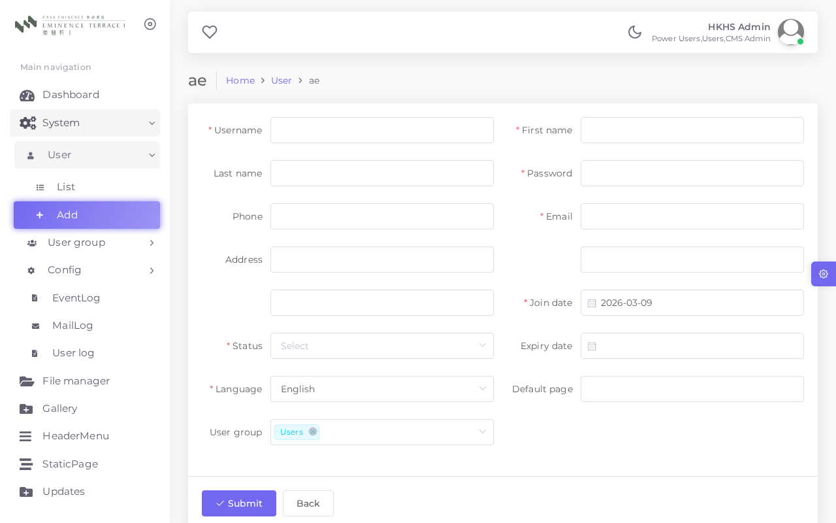
▲ Add / Edit User Form
Key tasks:
- Add new user: Click Add New, fill in username, password, email, assign a User Group, set Status to Active, and save.
- Edit user: Click Edit on the user row and update the required fields.
- Deactivate user: Set Status to Inactive. The account history is retained but login is prevented.
💡 Every new user account must be assigned to a User Group to inherit the appropriate access permissions.
10.2 User Groups
User Groups define the scope of access for each CMS user. Permissions are managed at the group level, making role management straightforward.
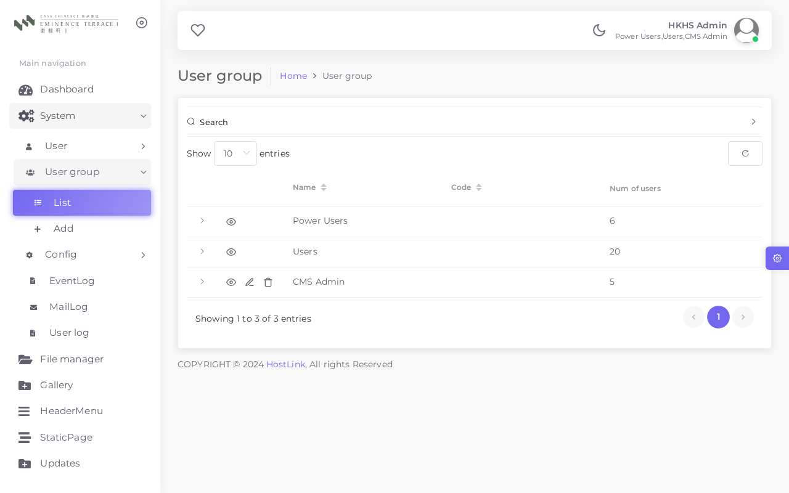
▲ User Groups List
Group | Access Level
Administrator | Full access to all modules, system settings, logs, and user management.
Editor | Access to content modules (Static Pages, Updates, Gallery, Header Menu, File Manager). No system admin access.
Viewer | Read-only access to content modules. Cannot create, edit, or delete records.

💡 Follow the principle of least privilege: grant users only the permissions they need to perform their job functions.
10.3 System Configuration
The System Config module allows administrators to update global settings that affect the entire CMS and website. Changes should be made with care.
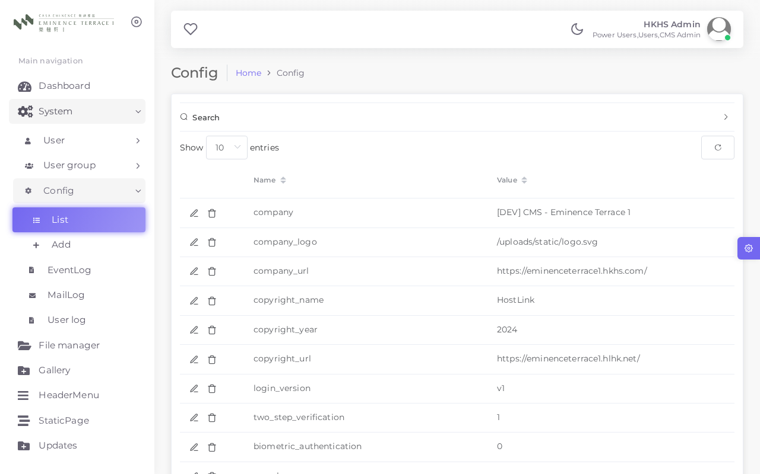
▲ System Configuration Panel
Config Key | Default Value | Description
site_name | Eminence Terrace I | Website display name shown in browser tab and emails
admin_email | admin@example.com | Email address for system notifications and alerts
maintenance_mode | OFF | Set to ON to take the frontend offline for maintenance
login_attempts_limit | 5 | Maximum failed login attempts before account lockout
session_timeout | 30 minutes | Duration of inactivity before the CMS session expires
smtp_host | mail.example.com | SMTP server hostname for sending system emails

⚠️ Only system administrators should modify these settings. Incorrect values can affect site availability and email functionality.
10.4 User Log
The User Log records all login, logout, and failed login events for every CMS user. Use this to monitor access patterns and investigate security incidents.
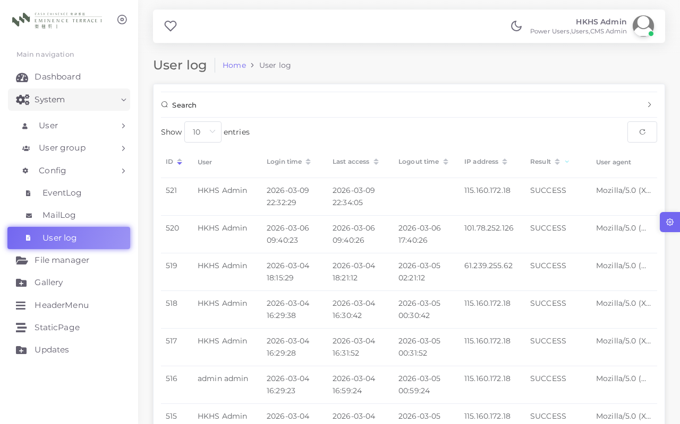
▲ User Log
Field | Description
Timestamp | Date and time of the event
Username | The CMS account that performed the action
Action | Login, Logout, or Failed Login attempt
IP Address | The IP address from which the event originated
Browser / Device | User-agent string identifying the browser and OS

10.5 Mail Log
The Mail Log records all emails dispatched by the CMS system, including automated notifications and reports. This helps verify email delivery and identify sending failures.
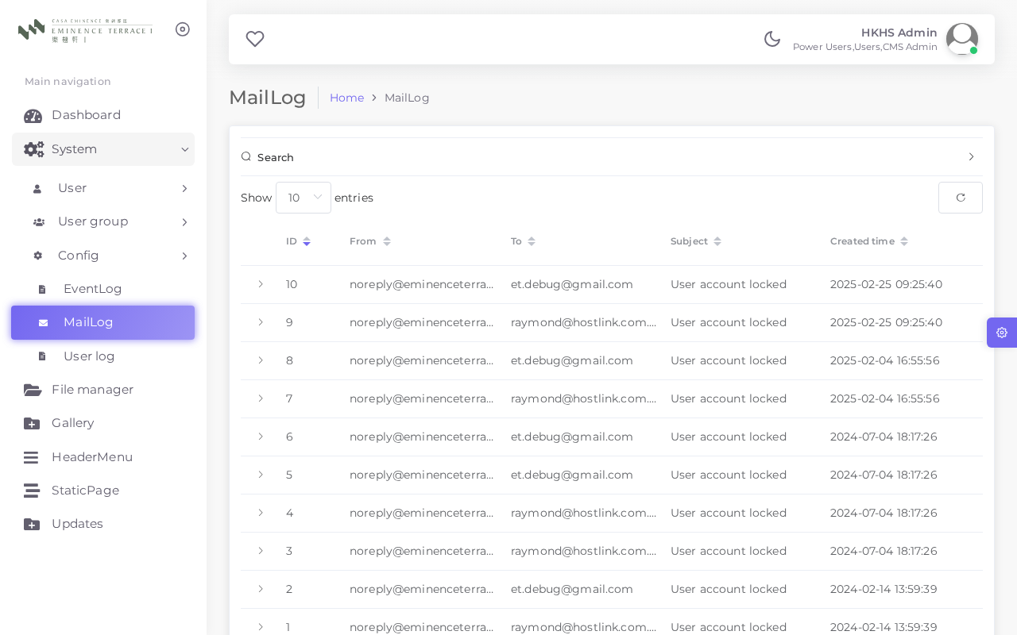
▲ Mail Log
- Each entry shows recipient address, subject, send timestamp, and delivery status
- Failed deliveries are marked with an error status, often with an error description
- Contact your system administrator or Hostlink support if emails are consistently failing
10.6 Event Log
The Event Log provides a comprehensive audit trail of all significant actions performed within the CMS. This is important for accountability and compliance.
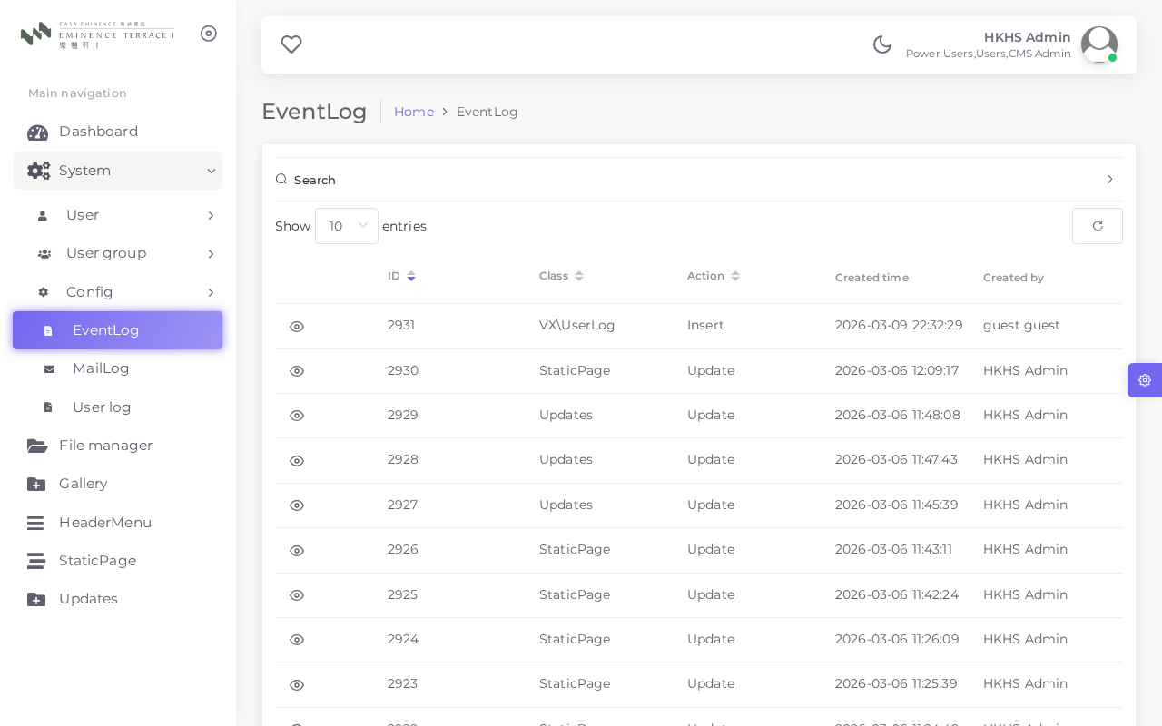
▲ Event Log
Field | Description
Timestamp | Date and time when the event occurred
User | The CMS user who performed the action
Module | The module where the action took place (e.g., Updates, Gallery)
Action | Type of action: Create, Update, Delete, Login, etc.
Description | Brief summary of what was changed or created
IP Address | The IP address from which the action was performed

💡 The Event Log is read-only. All entries are automatically recorded by the system and cannot be modified or deleted.
Chapter 11: Frequently Asked Questions (FAQ)
Q1. I cannot log in to the CMS. What should I do?
First, verify that you are entering the correct username and password. If you have forgotten your password, contact your system administrator for a reset. Note that HTTP Basic Authentication (the browser-level pop-up) requires a separate set of credentials from your CMS login — ensure you have both. After 5 consecutive failed login attempts, the system may lock your account. Contact your administrator to unlock it.
Q2. I updated a static page and saved it, but the frontend still shows the old content.
Changes to static pages take effect immediately upon saving. If you still see old content, try clearing your browser cache by pressing Ctrl + Shift + R (Windows) or Cmd + Shift + R (Mac) and refreshing the page. If the problem persists, verify that you pressed Save in the editor and check that the page status is set to Published.
Q3. How do I publish a new document for visitors to download?
Navigate to the Updates module and click Add New. Select the document type, enter the title in English and Chinese, choose the date, upload the PDF file, set the Status to Published, and click Save. The document will appear on the frontend website immediately.
Q4. Can I remove an image from the Gallery?
Yes. In the Gallery list, click the Delete icon next to the image you wish to remove and confirm the deletion when prompted. This removes the image from the gallery display. Note that the source file may still exist in the File Manager if it was uploaded separately.
Q5. How do I reorder the navigation menu items?
In the Header Menu module, edit each menu item and update its Sort Order value. Items with lower numbers appear further to the left in the navigation bar. Save each item after updating, then refresh the frontend to verify the new order.
Q6. What file formats are accepted for document uploads?
The system accepts PDF, Word (DOCX), Excel (XLSX), and common image formats (JPG, PNG). PDF format is strongly recommended for all public documents, as it ensures consistent display on all devices and prevents unintended editing by visitors.
Q7. Can multiple users edit the CMS simultaneously?
Yes, multiple users can be logged in and active at the same time. However, if two users edit and save the same record simultaneously, the later save will overwrite the earlier one without warning. Coordinate with your team to avoid accidental overwrites, especially for frequently updated content such as Price Lists.
Q8. How do I create a CMS account for a new staff member?
Log in as an Administrator, go to System Administration > Users, and click Add New. Enter the staff member's username, set a temporary password, enter their email address, and assign the appropriate User Group. Set Status to Active and click Save. Provide the new user with their login credentials and advise them to change their password upon first login.
Q9. The image I uploaded in the Gallery appears blurry or stretched. What is the recommended image size?
Image display dimensions are controlled by the frontend website design, not the CMS. For best results, upload images at the resolution recommended by your developer. Typically, gallery images should be at least 1200 pixels wide and maintain a consistent aspect ratio (e.g., 4:3 or 16:9). Compress images before uploading to balance quality and page load speed.
Q10. Is there a way to preview a page before making it public?
At present, the CMS does not have a built-in preview mode for draft content. For significant changes, consider coordinating with your developer to test on a staging environment first. Alternatively, make the change, view the live frontend immediately to verify it, and revert quickly if needed. For minor text edits, the risk of publishing directly is generally low.
Chapter 12: Technical Support
For CMS-related technical assistance, please contact Hostlink through the appropriate channel listed below. When reporting an issue, providing full details will help us resolve it faster.
Support Channel | Contact | Response Time
General Enquiries | info@hostlink.com.hk | Within 2 business days
Technical Issues | support@hostlink.com.hk | Within 1 business day
Emergency (site down) | support@hostlink.com.hk + WhatsApp | Within 4 hours

12.1 Information to Include When Reporting an Issue
- Your full name and CMS username
- Date and time the issue was first noticed
- Description of what you were trying to do
- Any error messages displayed on screen (screenshot preferred)
- Step-by-step instructions to reproduce the problem
- Browser name and version (e.g., Chrome 122)
🚨 For issues affecting the live public website, contact Hostlink by both email and WhatsApp simultaneously to ensure the fastest possible response.

— End of Document —
Eminence Terrace I CMS User Manual | Version v1.0 | 2026-03-10
Generated by Hostlink WhatsApp AI Assistant | © Hostlink Information Technology Ltd

