
Hostlink (HK) Ltd.
Sierra Terrace
樂嶺軒
Content Management System
內容管理系統
User Manual
Version | v2.0
Date | 10 March 2026
System | Sierra Terrace CMS
Confidentiality | Confidential — Authorised Users Only
Prepared by Hostlink (HK) Ltd.

Table of Contents
1. System Overview
2. Login / Logout
3. Interface Overview
4. Module: Gallery
5. Module: Header Menu (HeaderMenu)
6. Module: Static Pages (StaticPage)
7. Module: Document Updates (Updates)
8. Module: File Manager
9. Frontend Website Overview
10. System Administration
11. Frequently Asked Questions
12. Technical Support

1. System Overview
The Sierra Terrace Content Management System (CMS) is a web-based platform developed by Hostlink (HK) Ltd., enabling authorised administrators to manage website content, documents, media, and user accounts efficiently.
Main functions of this CMS:
- Gallery — Manage project photos and media
- HeaderMenu — Configure top navigation menu items
- StaticPage — Edit fixed text content and legal disclaimers across the website
- Updates — Publish and manage sales-related documents (price lists, sales agreements, etc.)
- File Manager — Upload, organise, and manage files and folders
- User Management — Add and manage administrator accounts
- System Configuration — Manage system-level settings and parameters
- Audit Logs — Review user activity, email, and system event logs
Item | Details
CMS URL | https://sierratower.hlhk.net/cms/
Frontend URL | https://sierratower.hlhk.net/
Supported Browsers | Google Chrome (recommended), Microsoft Edge, Safari
Recommended Resolution | 1280x800 or above
Language Support | Traditional Chinese / Simplified Chinese / English
Developer | Hostlink (HK) Ltd.

2. Login / Logout
2.1 How to Log In
🔒 This website requires HTTP Basic Authentication. When your browser prompts for a username and password, enter: Username: dev | Password: hostdev
Step 1: Open your browser and navigate to: https://sierratower.hlhk.net/cms/
Step 2: If prompted by your browser for Basic Authentication, enter dev / hostdev
Step 3: On the CMS login page, enter your administrator username and password
Step 4: Click the "Sign in" button to proceed
Step 5: Upon successful login, you will be redirected to the Dashboard
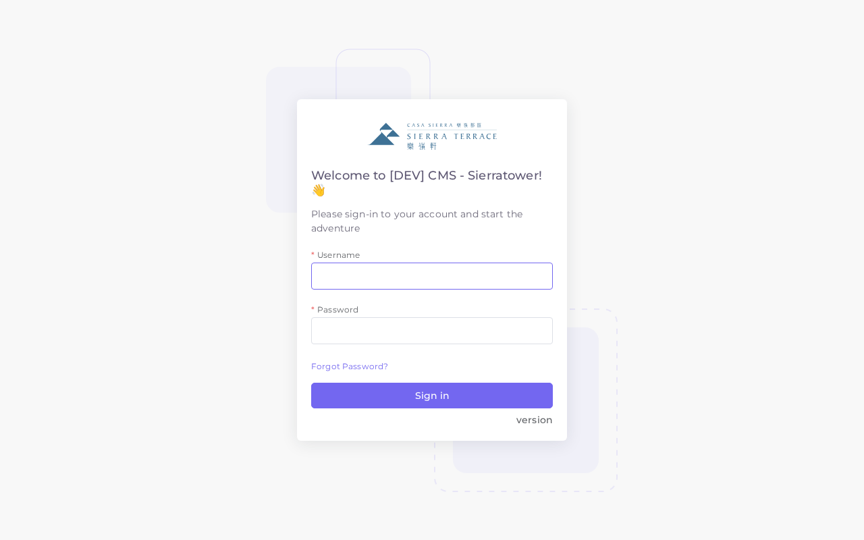
▲ CMS Login Page
2.2 How to Log Out
Step 1: Click on your username or profile icon at the top-right corner of the screen
Step 2: Select "Sign out" from the dropdown menu
Step 3: You will be redirected back to the login page
⚠️ Always log out when finished, especially on shared computers. Your session may expire automatically after a period of inactivity.

3. Interface Overview
After logging in, the CMS Dashboard provides an overview of the system interface. The layout consists of three main areas:
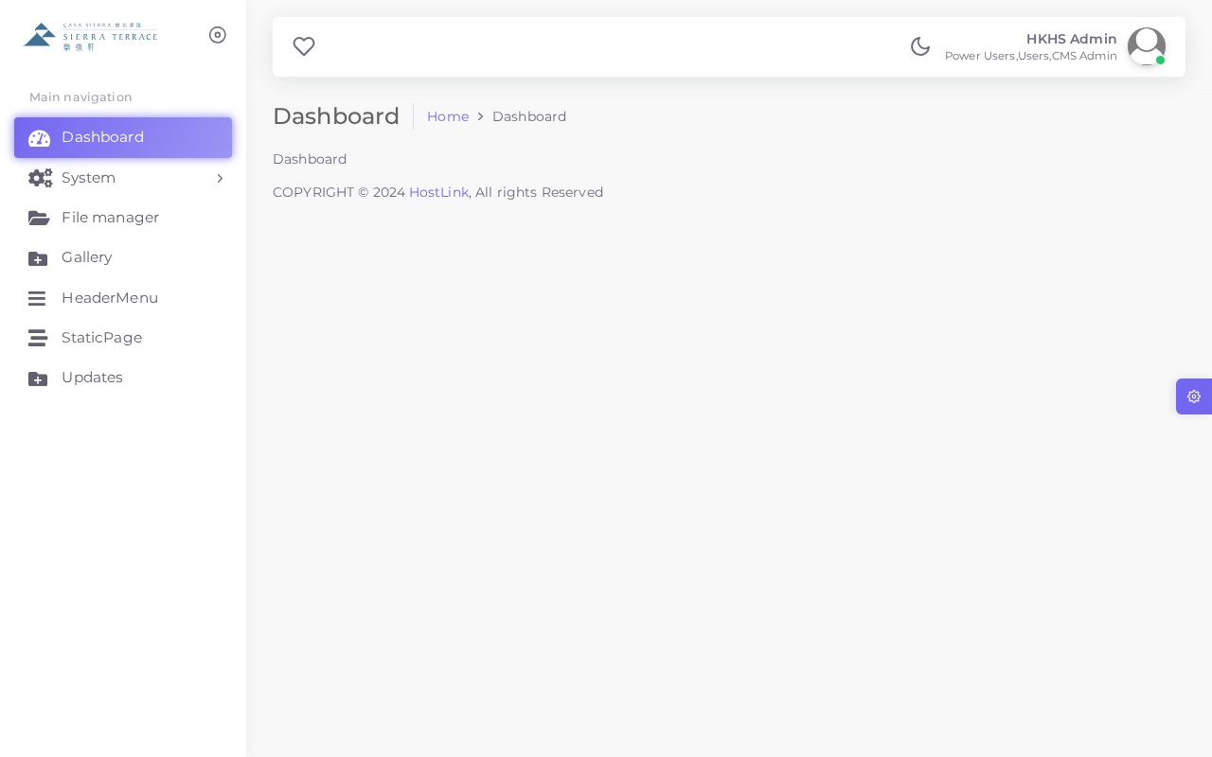
▲ CMS Dashboard
Area | Description
Top Navigation Bar | Displays the system logo, current user info, and quick-access profile/logout options
Left Sidebar | Main navigation menu with collapsible sections for all CMS modules
Main Content Area | Displays lists, forms, logs, and module content based on the selected menu item

3.1 Sidebar Navigation
The left sidebar organises all modules into logical groups. Click on a section header to expand or collapse it.
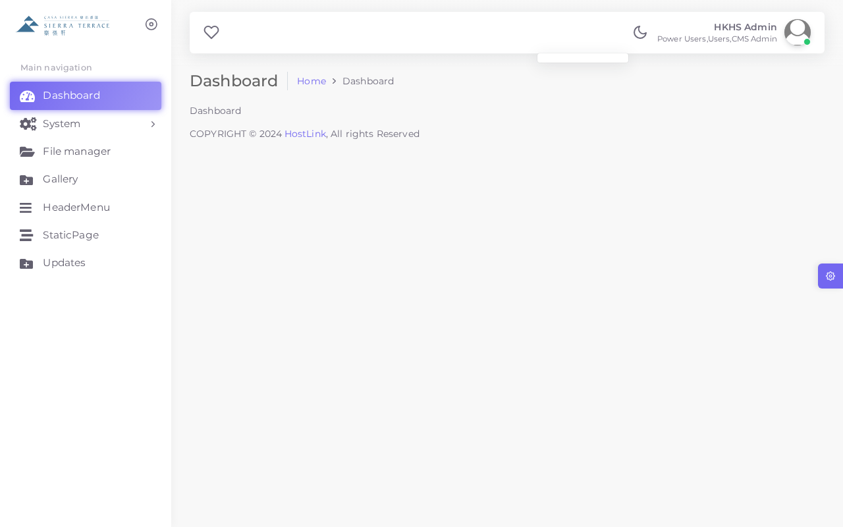
▲ Expanded Sidebar Navigation
Section | Modules
Content | Gallery, HeaderMenu, StaticPage, Updates
Files | File Manager
Administration | User, UserGroup, Config
Logs | EventLog, MailLog, UserLog

4. Module: Gallery
The Gallery module allows administrators to upload and manage project photos displayed on the frontend website. Images can be categorised and ordered for presentation.
4.1 Viewing the Gallery List
Step 1: In the left sidebar, click "Gallery"
Step 2: A list of all gallery items will be displayed
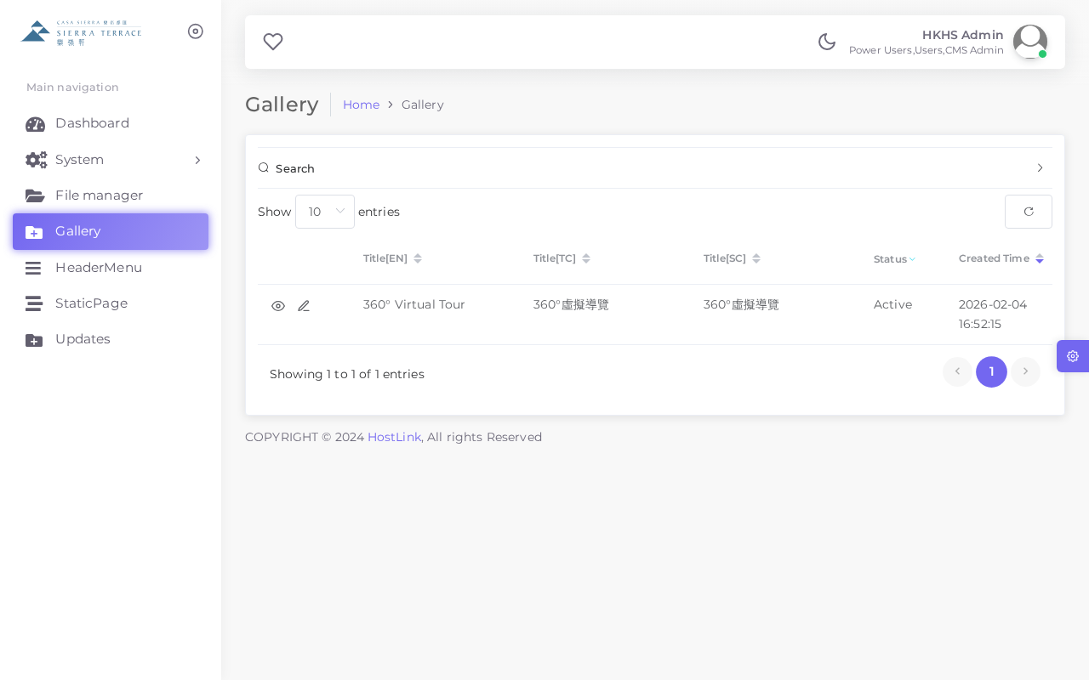
▲ Gallery List
4.2 Adding a Gallery Item
Step 1: Click the "+ Add" button at the top right of the Gallery list
Step 2: Fill in the required fields (see table below)
Step 3: Upload the image file using the Image field
Step 4: Click "SAVE" to confirm
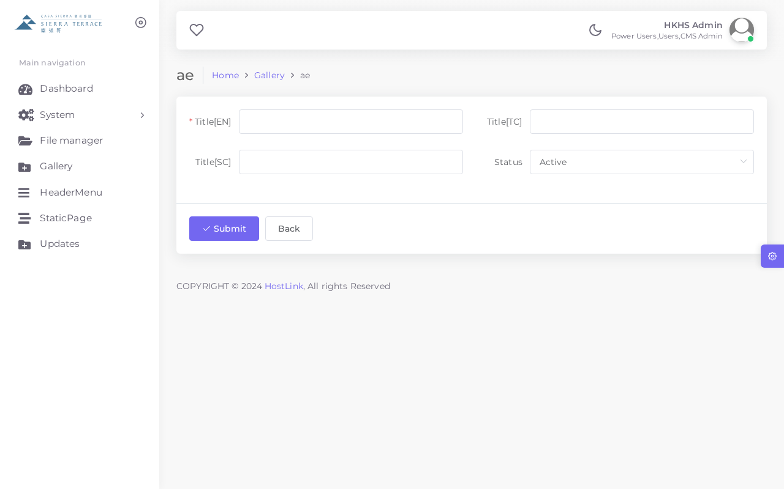
▲ Add Gallery Item Form
Field | Description
Title (EN) | Gallery item title in English
Title (TC) | Gallery item title in Traditional Chinese
Title (SC) | Gallery item title in Simplified Chinese
Image | Upload the image file (JPG/PNG recommended)
Sort Order | Numeric order for display sequence (lower = first)
Status | Active = visible on frontend; Inactive = hidden

💡 Recommended image format: JPG or PNG. For best display quality, use high-resolution images at a consistent aspect ratio.

5. Module: Header Menu (HeaderMenu)
The HeaderMenu module controls the navigation links displayed in the top header of the frontend website. Administrators can reorder, add, or modify navigation items.
5.1 Viewing the Header Menu List
Step 1: In the left sidebar, click "HeaderMenu"
Step 2: All current navigation items will be listed
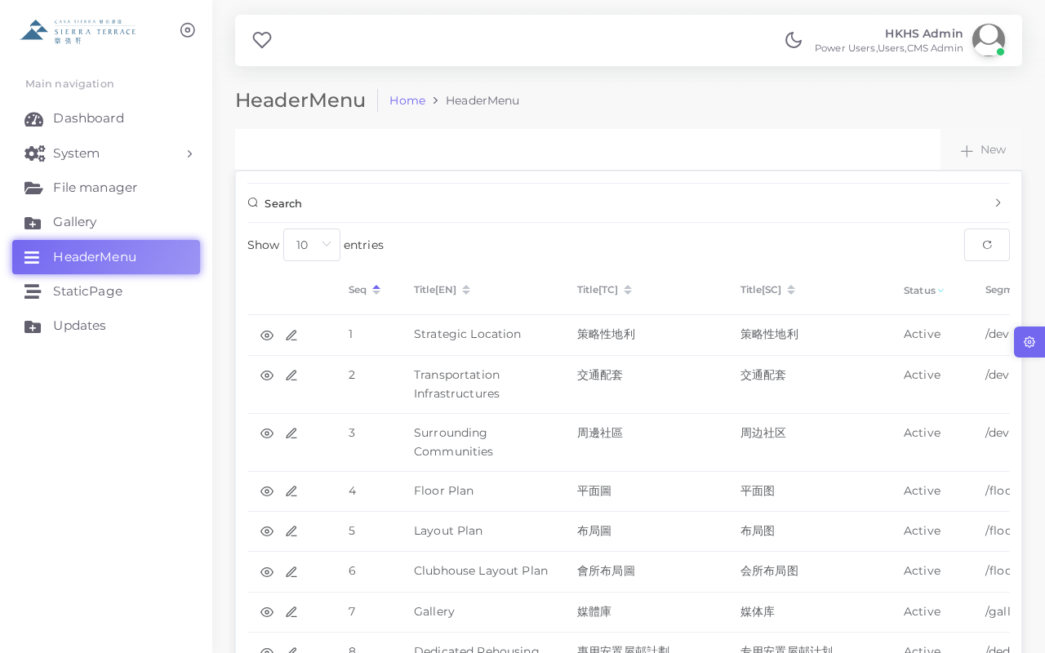
▲ Header Menu List
5.2 Adding / Editing a Menu Item
Step 1: Click "+ Add" to create a new item, or click "Edit" on an existing item
Step 2: Fill in the required fields
Step 3: Click "SAVE" to confirm
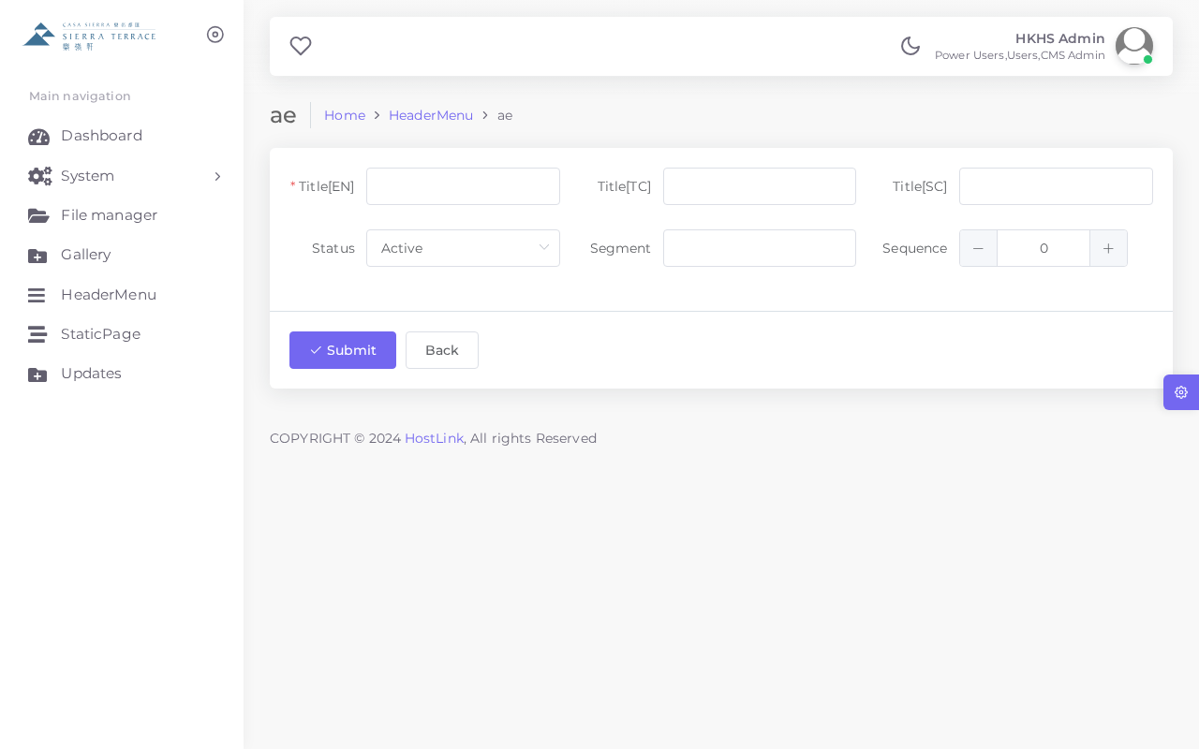
▲ Add / Edit Header Menu Item
Field | Description
Label (EN) | Menu item display text in English
Label (TC) | Menu item display text in Traditional Chinese
Label (SC) | Menu item display text in Simplified Chinese
URL | Link destination (relative path or full URL)
Sort Order | Display order (lower = first)
Status | Active = visible; Inactive = hidden

💡 Changes to the Header Menu take effect immediately after saving. Verify the frontend website to confirm the update.

6. Module: Static Pages (StaticPage)
The StaticPage module manages fixed text content displayed on various pages of the frontend website, including legal disclaimers, copyright notices, and informational text blocks. Unlike other modules, StaticPage records can only be edited (not created or deleted).
6.1 Viewing the Static Page List
Step 1: In the left sidebar, click "StaticPage"
Step 2: All static page records will be listed
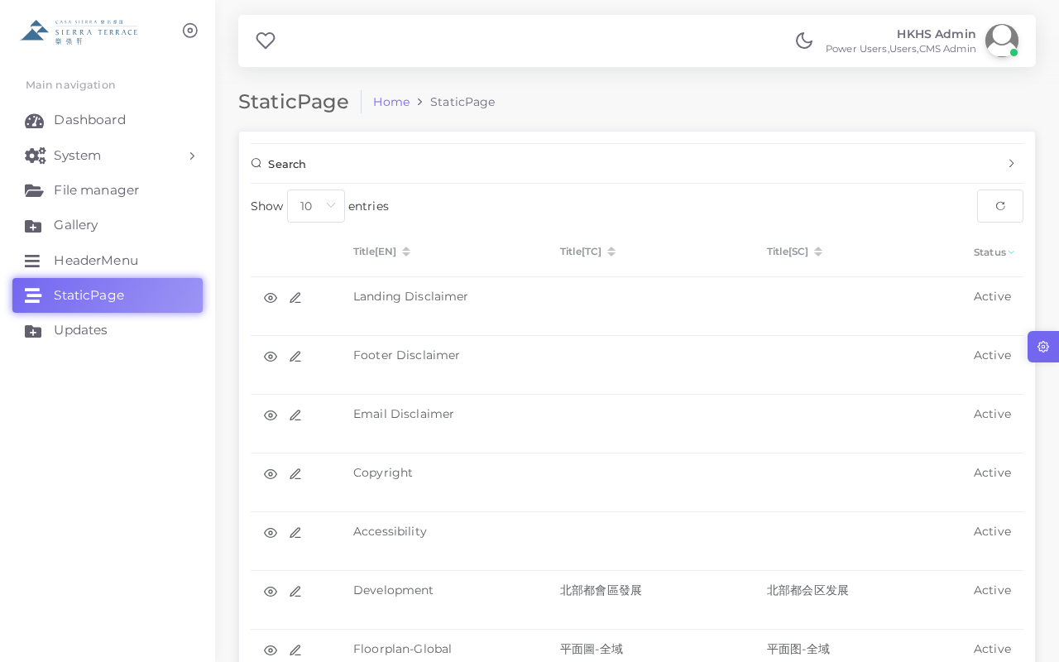
▲ Static Page List
6.2 Static Pages and Their Frontend Locations
The following section explains which area of the frontend website each StaticPage record controls, so you know exactly what will change when you edit it.
① Landing Disclaimer — Homepage Popup
When users first visit the website homepage, a disclaimer modal window automatically appears. Users must acknowledge it before proceeding. This content is controlled by the "Landing Disclaimer" record.
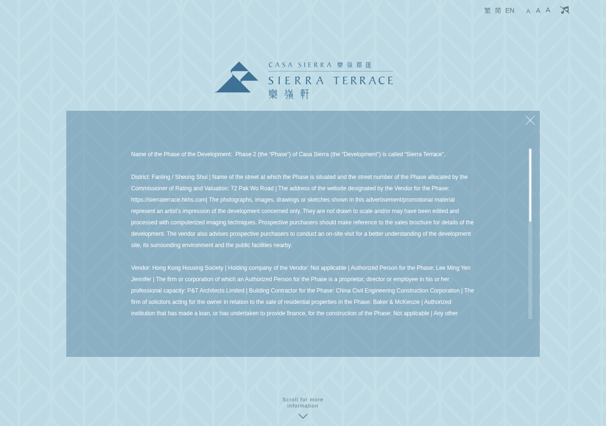
▲ Homepage — Auto-displayed Landing Disclaimer popup window
② Footer Disclaimer — Page Footer
A legal disclaimer text block is displayed at the bottom of every page in the Footer area. This content is controlled by the "Footer Disclaimer" record.
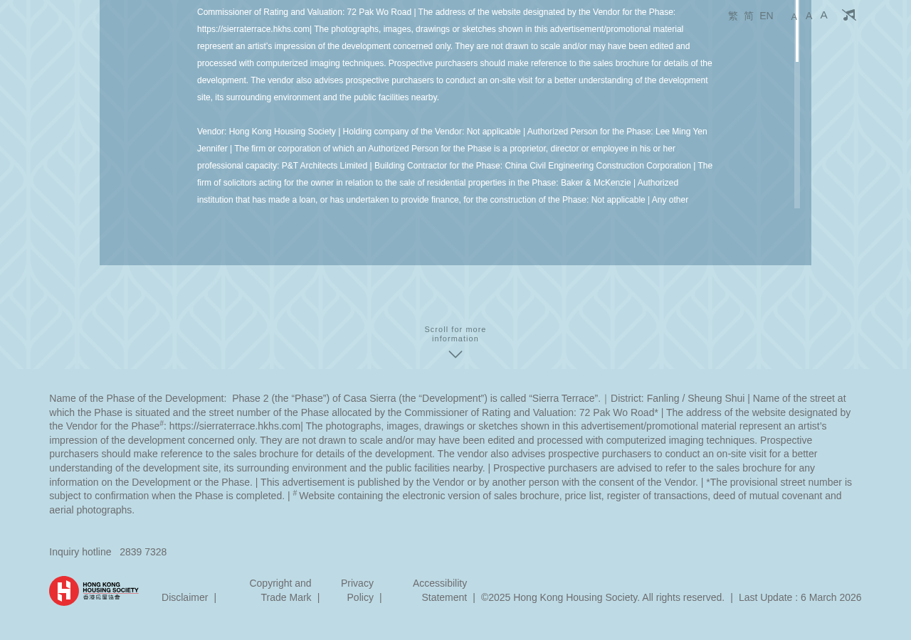
▲ Frontend Footer — Footer Disclaimer text area
③ Floorplan Disclaimer — Floor Plan Page
On the Floor Plan page, there is a "Disclaimer" button in the upper right area. Clicking it opens a modal window with the disclaimer text. This content is controlled by the "Floorplan-Global" and "Floorplan-平面圖" records.
- Floorplan-Global: Overall disclaimer for the entire floor plan page
- Floorplan-平面圖: Specific disclaimer text for the floor plan itself
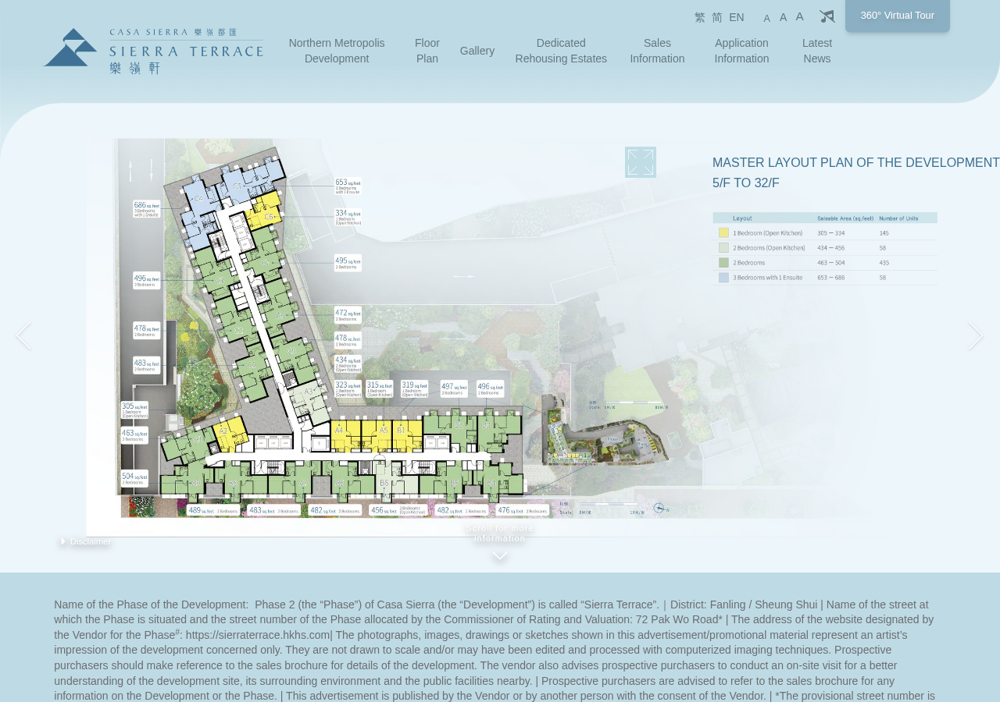
▲ Floor Plan page — "Disclaimer" button (upper right)
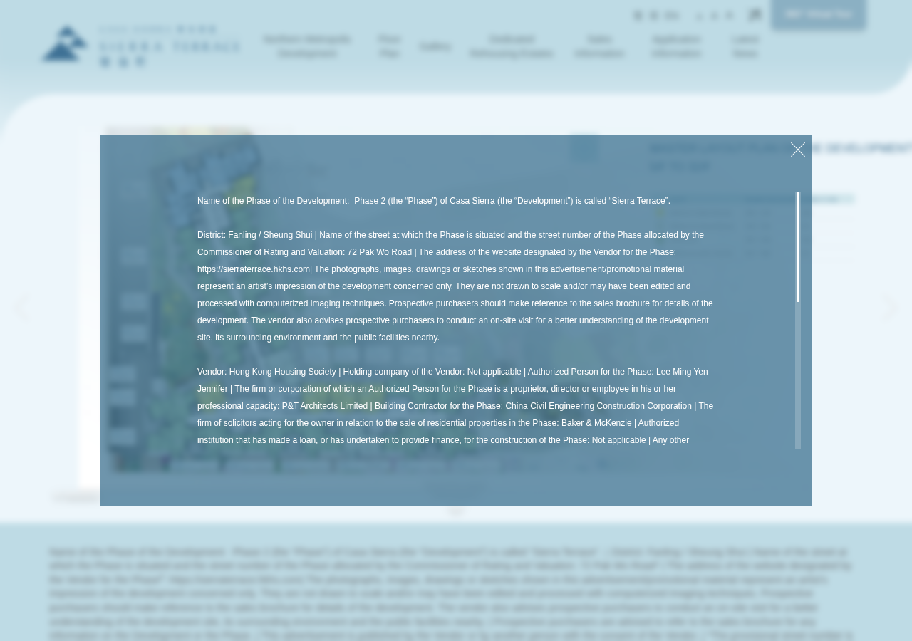
▲ Disclaimer modal window after clicking the button
④ Development — Development Section
Informational text about the Northern Metropolis development project, displayed on the homepage development section. Controlled by the "Development" record.

▲ Frontend Development Section — Development StaticPage content
⑤ Other Static Pages
The following additional pages are managed via StaticPage but are not shown with individual screenshots here:
- Gallery — Descriptive text on the gallery page
- Dedicated Rehousing Estates — Information about dedicated rehousing estate projects
- Copyright — Copyright notice in the footer or dedicated copyright page
- Accessibility — Accessibility statement page
- Email Disclaimer — Legal disclaimer appended to all outgoing system emails
6.3 Quick Reference Table
Page Name (EN) | Frontend Location | Impact of Changes
Landing Disclaimer | Homepage auto-popup modal | Disclaimer shown to users on site entry
Footer Disclaimer | Footer of every page | Legal text in footer across all pages
Email Disclaimer | Bottom of system emails | Legal text in all outgoing system emails
Copyright | Footer copyright notice | Copyright text across all pages
Accessibility | Accessibility statement page | Accessibility policy content
Development | Homepage development section | Development project description
Floorplan-Global | Floor Plan page disclaimer modal | Overall floor plan disclaimer
Floorplan-平面圖 | Floor Plan page disclaimer modal | Floor plan-specific disclaimer text
Gallery | Gallery page description | Gallery introductory text
Dedicated Rehousing Estates | Rehousing estates section | Project description text

6.4 Editing a Static Page
Step 1: Click the "Edit" button next to the desired record in the Static Page list
Step 2: Modify the content in the text editor fields (supports multilingual: EN / TC / SC)
Step 3: Click "SAVE" to confirm changes
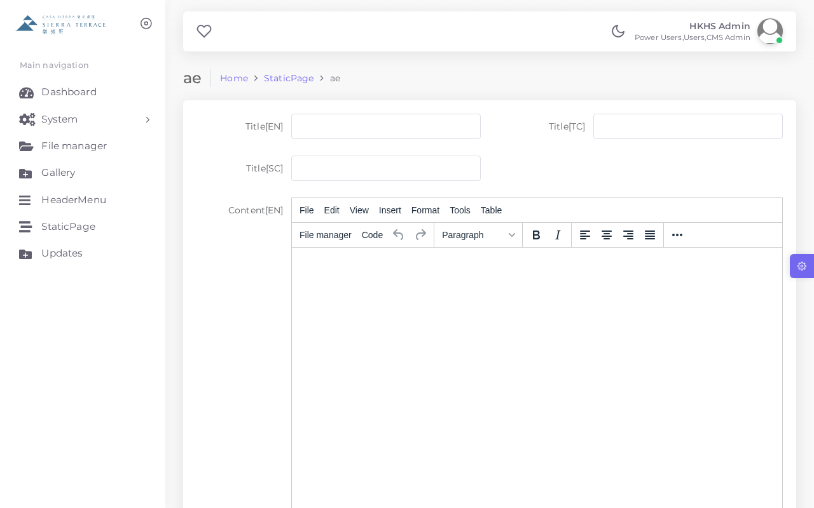
▲ Static Page Edit Form
⚠️ Static Pages can only be edited — they cannot be created or deleted. Contact technical support if new pages are required.
💡 The Content field supports HTML formatting for advanced layout requirements.

7. Module: Document Updates (Updates)
The Updates module manages all official sales and project documents published on the frontend website, including price lists, sales agreements, sales arrangements, and other required legal documents.
7.1 Viewing the Updates List
Step 1: In the left sidebar, click "Updates"
Step 2: All published documents will be listed with their type, status, and date
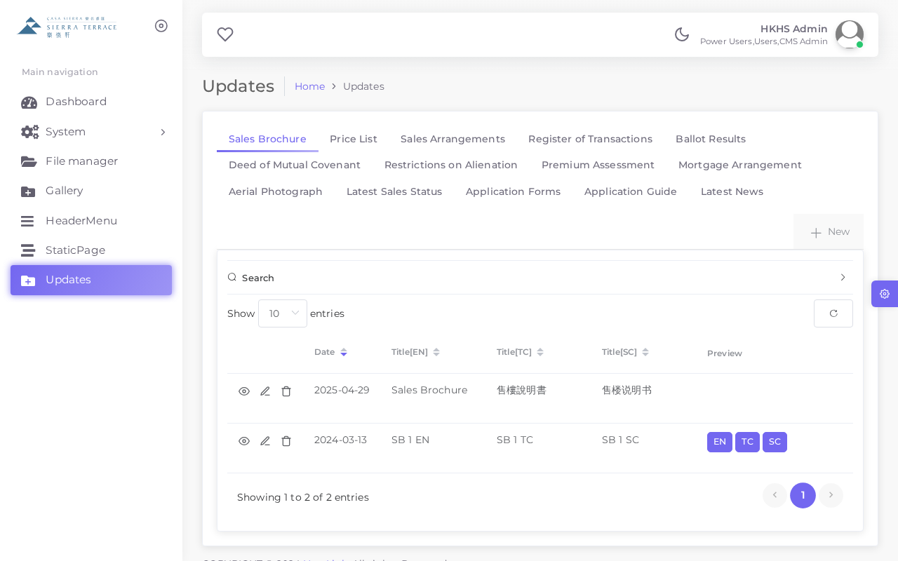
▲ Document Updates List
7.2 Document Types
The system supports 13 different document categories:
# | Document Type
1 | Price List 價格單
2 | Sales Arrangement 售樓安排
3 | Sales Agreement 買賣合約
4 | Preliminary Agreement 臨時買賣合約
5 | Deed of Mutual Covenant 公契
6 | Brochure 樓書
7 | Show Flat Viewing Arrangement 示範單位參觀安排
8 | Register of Transactions 成交記錄冊
9 | Mortgage Referral 轉介抵押
10 | Vendor Information 賣方資料
11 | Consent Scheme 同意方案
12 | Regulatory Compliance 合規文件
13 | Others 其他

7.3 Adding a Document
Step 1: Click the "+ Add" button at the top of the Updates list
Step 2: Select the document type from the dropdown
Step 3: Enter the document title in all required languages
Step 4: Upload the document file (PDF recommended)
Step 5: Set the publication date and status
Step 6: Click "SAVE" to publish
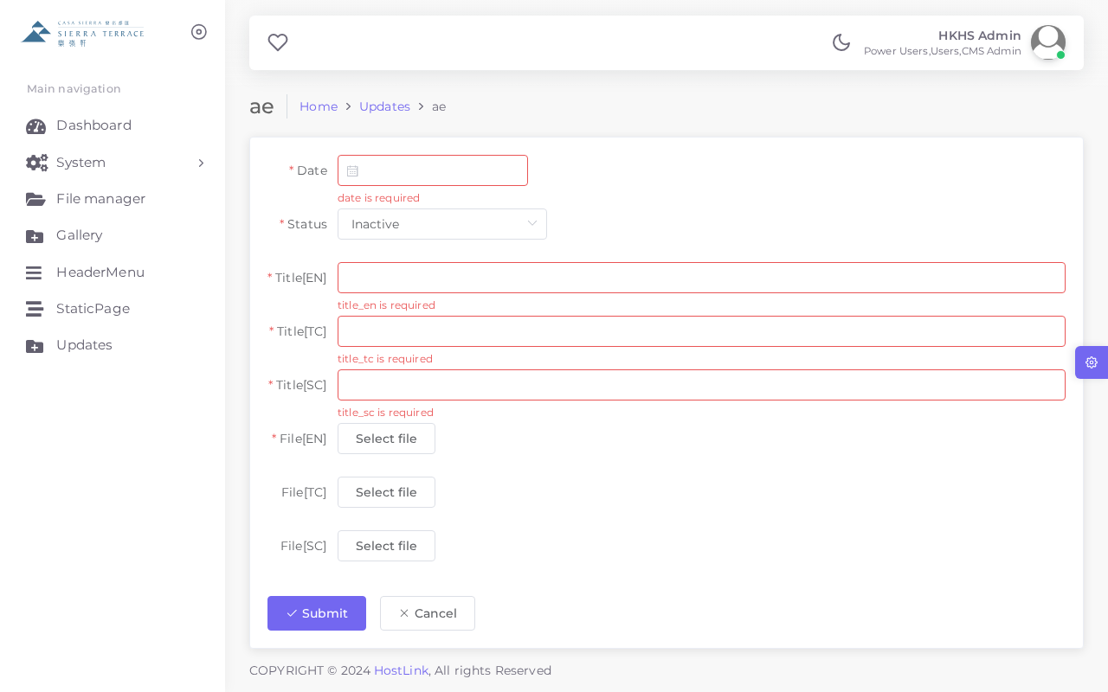
▲ Add Document Form
Status | Label | Description
1 | Active | Document is published and visible on the frontend website
0 | Inactive | Document is hidden from the frontend website
2 | Archived | Document is archived and no longer listed

💡 PDF format is recommended for all document uploads to ensure consistent display across devices.

8. Module: File Manager
The File Manager provides a centralised file storage system where administrators can upload, organise, and manage all files used across the CMS, including images, PDFs, and documents.
8.1 Using the File Manager
Step 1: In the left sidebar, click "File Manager"
Step 2: Browse folders or use the search function to locate files
Step 3: Click "Upload" to add new files, or select a file to view its details
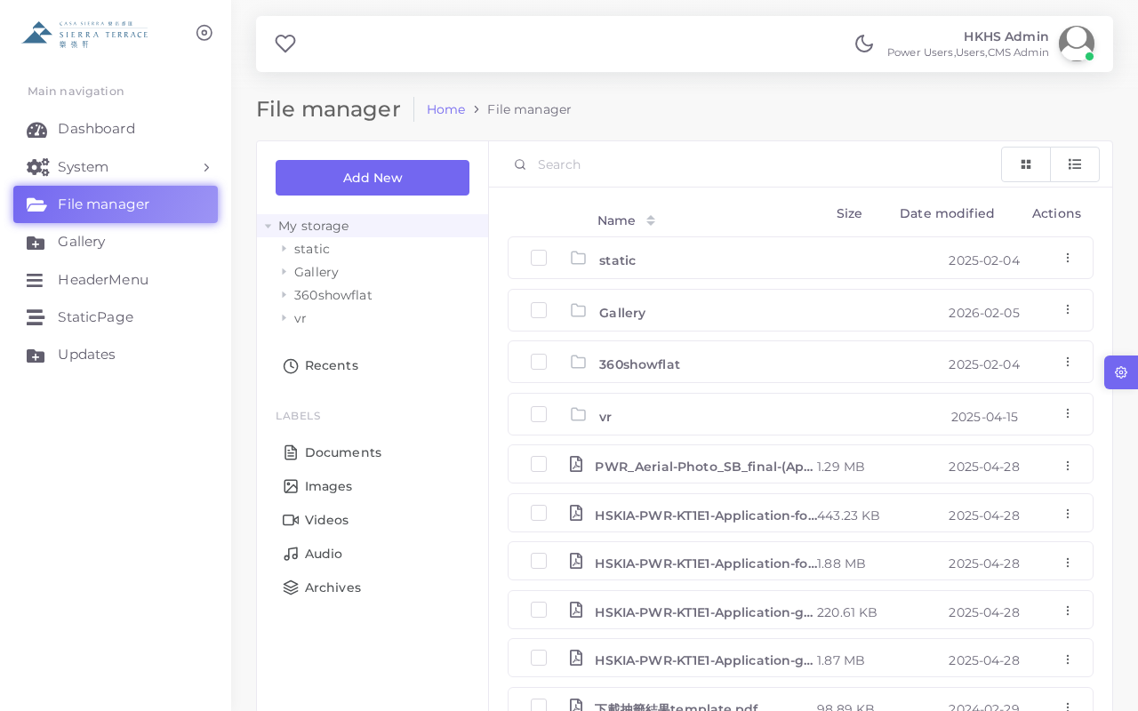
▲ File Manager Interface
Action | Description
Upload | Upload one or more files to the current folder
New Folder | Create a new sub-folder for organisation
Rename | Rename a selected file or folder
Delete | Permanently remove a selected file or folder
Copy URL | Copy the direct URL of a file for use in CMS content

⚠️ Deleted files cannot be recovered. Always verify before deleting. It is recommended to organise files into clearly named folders for easy retrieval.

9. Frontend Website Overview
The Sierra Terrace frontend website presents project information in multiple languages (English, Traditional Chinese, Simplified Chinese). Below are screenshots of the main frontend pages.
9.1 Homepage
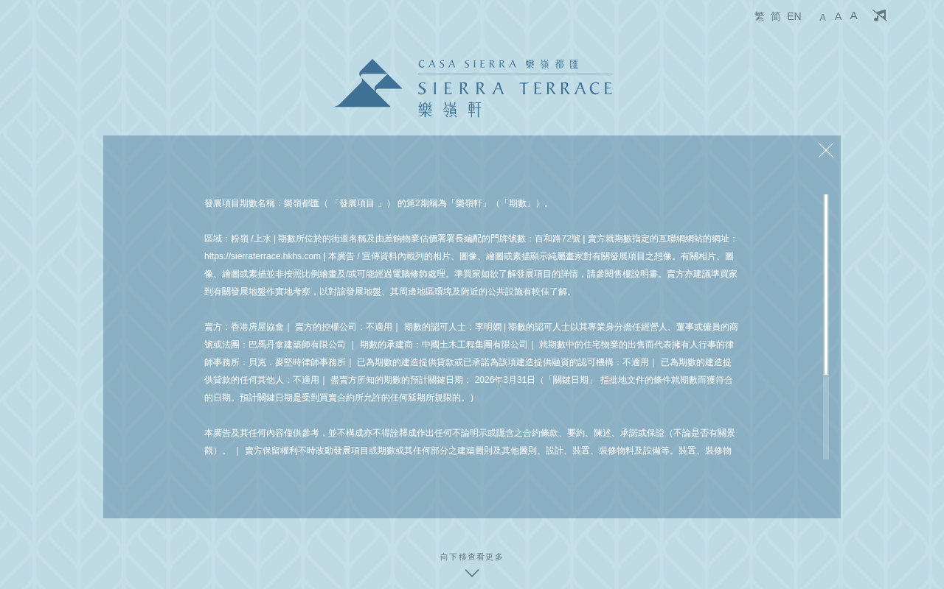
▲ Frontend Homepage (Default)
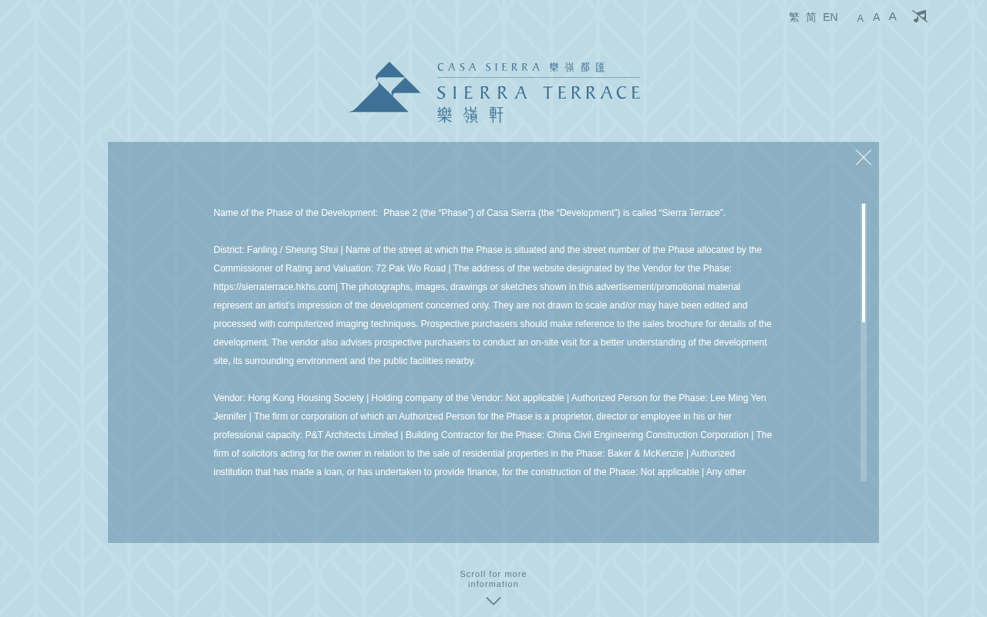
▲ Frontend Homepage (English version)
9.2 Key Pages
Page | URL | Status
Homepage (EN) | /en/ | ✅ Live
Homepage (TC) | /tc/ | ✅ Live
Homepage (SC) | /sc/ | ✅ Live
Floor Plan (EN) | /en/floorplan | ✅ Live
Floor Plan (TC) | /tc/floorplan | ✅ Live

💡 After making CMS changes, always verify the frontend website to confirm that updates are displayed correctly.

10. System Administration
10.1 User Management
The User module allows super administrators to manage CMS user accounts, including creating new accounts and assigning access roles.
Step 1: In the sidebar, expand "System" and click "User" then "List"
Step 2: All CMS user accounts will be displayed
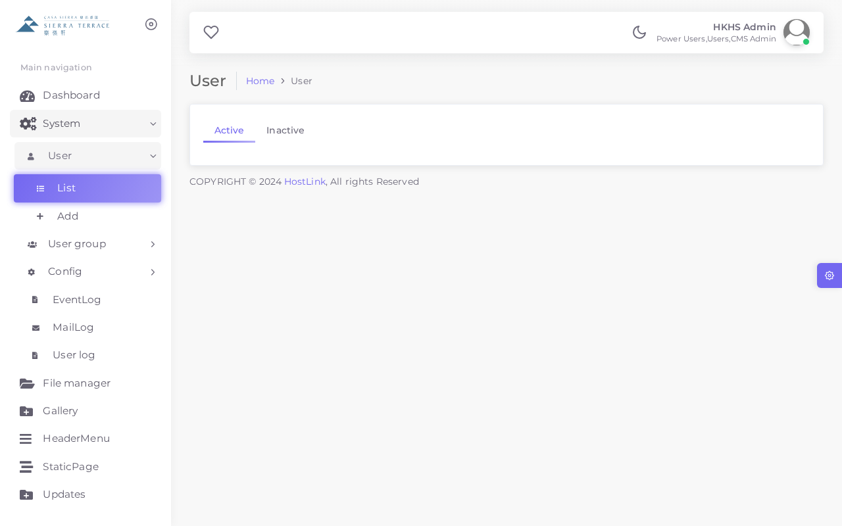
▲ User List
Adding a New User
Step 1: Click "+ Add" in the User list
Step 2: Enter the username, email address, and set a strong password
Step 3: Assign the appropriate User Group (role)
Step 4: Set status to Active and click "SAVE"
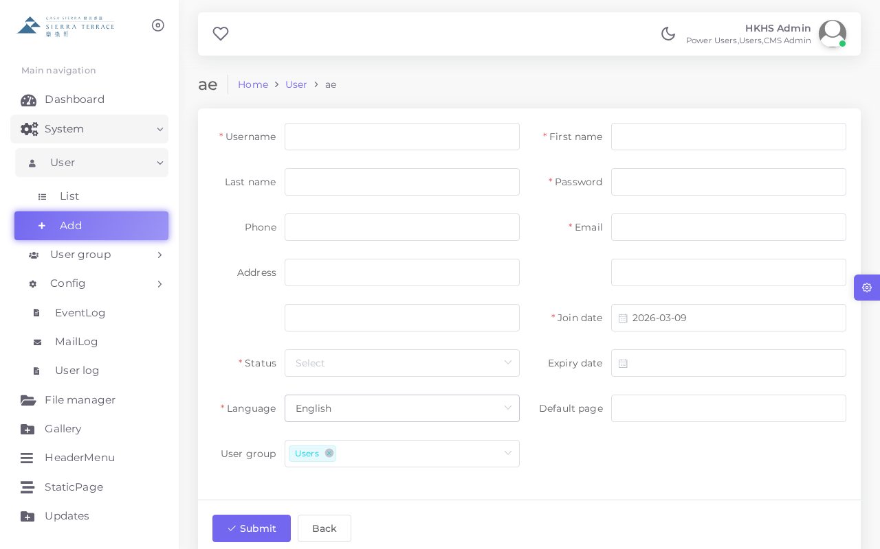
▲ Add New User Form
Field | Description
Username | Unique login identifier (no spaces, lowercase recommended)
Email | Contact email for the user account
Password | Must be strong (min. 8 characters, mix of upper/lower/numbers/symbols)
User Group | Determines access permissions (e.g. Admin, Editor)
Status | Active = can login; Inactive = account disabled

10.2 User Groups (UserGroup)
User Groups define the permission levels for CMS users. Each user must belong to a group that determines which modules they can access.
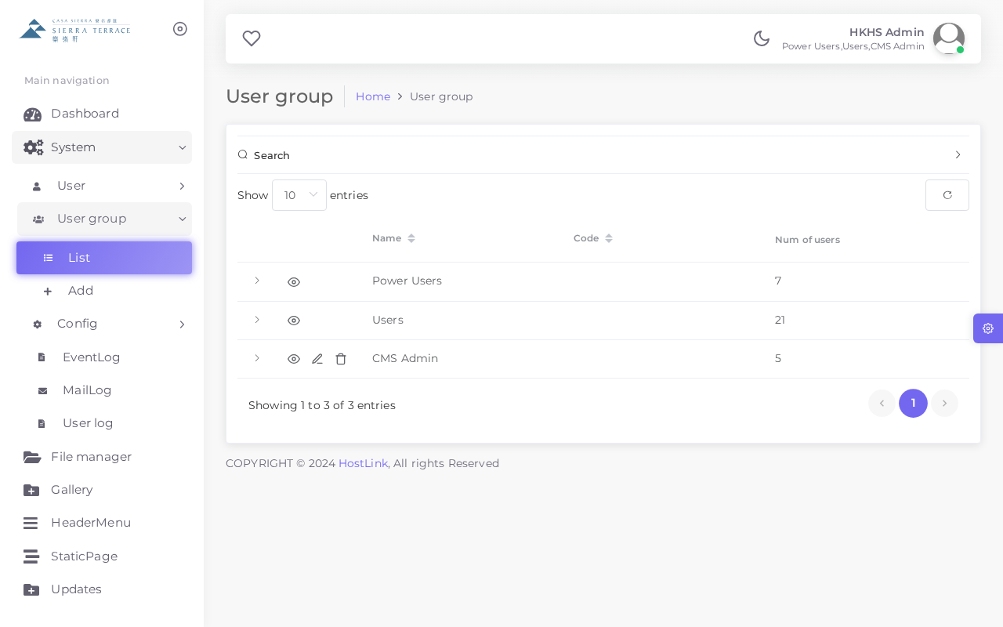
▲ User Group List
⚠️ Contact your system administrator or Hostlink support before modifying user group permissions, as changes may affect access for multiple users.
10.3 System Configuration (Config)
The Config module stores system-wide settings and parameters. Only authorised administrators should modify these settings.
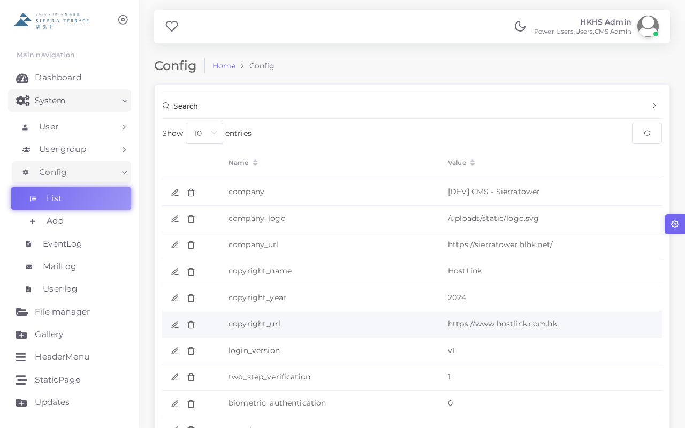
▲ System Configuration List
Parameter | Example Value | Description
site_name | Sierra Terrace | Website display name
admin_email | admin@hostlink.com.hk | System notification email address
maintenance_mode | 0 | 1 = maintenance mode on; 0 = normal
default_lang | en | Default frontend display language

⚠️ Incorrect configuration changes can disrupt the website. Always back up current values before making changes.
10.4 User Log
The UserLog records all login and logout activities by CMS users, providing a complete audit trail for security monitoring.
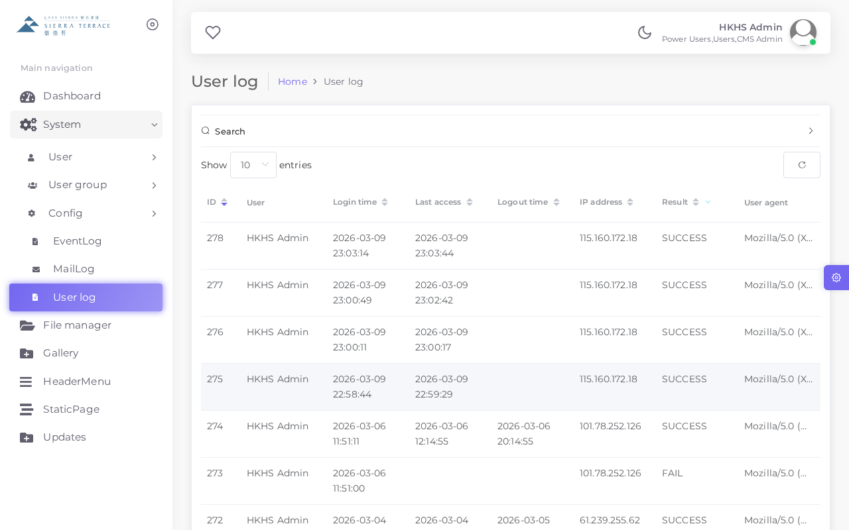
▲ User Log
Field | Description
User | The CMS username that performed the action
Action | Login, Logout, or Failed Login
IP Address | The IP address of the user's device
Timestamp | Date and time of the event (Hong Kong time)

10.5 Mail Log
The MailLog records all outgoing emails sent by the system, allowing administrators to verify delivery of notifications and automated messages.
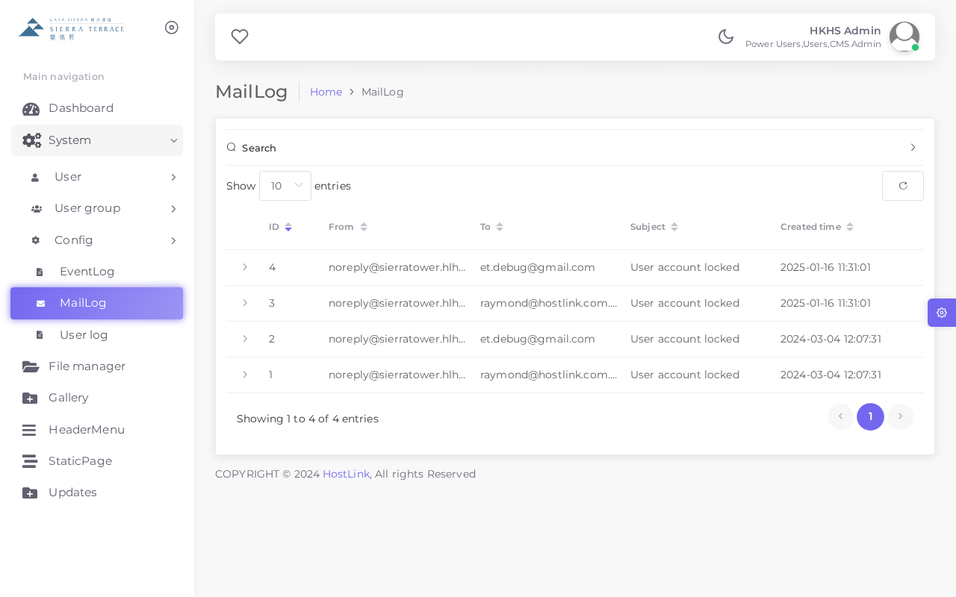
▲ Mail Log
10.6 Event Log
The EventLog records system-level events including data creation, modification, and deletion actions performed within the CMS.
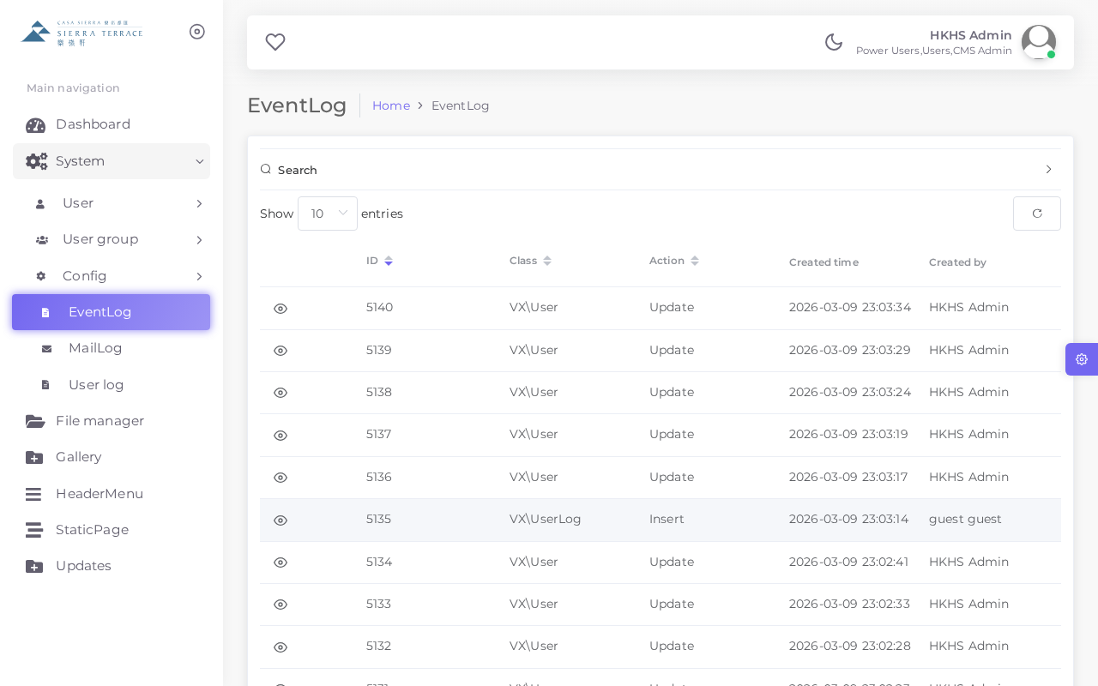
▲ Event Log
Field | Description
Event Type | CREATE, UPDATE, DELETE, or SYSTEM
Module | The CMS module where the action occurred
Record ID | The unique identifier of the affected record
User | The administrator who performed the action
Timestamp | Date and time of the event
Details | Additional information about the change

11. Frequently Asked Questions
Q1: I forgot my CMS password. What should I do?
Contact your system administrator to reset your password. For security reasons, passwords cannot be self-reset without admin assistance.
Q2: I uploaded a document but it is not showing on the website.
Check that the document status is set to "Active". Also clear your browser cache and refresh the frontend page to see the latest updates.
Q3: How do I change the order of Gallery images?
Edit each Gallery item and update the Sort Order field. Items with a lower number will appear first.
Q4: Can I delete a StaticPage record?
No. StaticPage records can only be edited. If you need to add or remove a page, please contact Hostlink technical support.
Q5: The Header Menu item I added is not visible on the frontend.
Ensure the item status is set to "Active" and the URL is correctly entered. Also check that the Sort Order places it in the correct position.
Q6: How many languages does the CMS support?
The system supports three languages: English (EN), Traditional Chinese (TC), and Simplified Chinese (SC). Most content modules have separate fields for each language.
Q7: I accidentally deleted a file in File Manager. Can it be recovered?
Unfortunately, deleted files cannot be recovered from within the CMS. Contact Hostlink support immediately — recovery may be possible from server backups.
Q8: How do I know which user made a specific change?
Use the Event Log (EventLog) module. You can filter by date range, module, or user to identify who made changes and when.
Q9: Can multiple administrators use the CMS at the same time?
Yes. The system supports concurrent users. However, if two users edit the same record simultaneously, the last save will overwrite the earlier one.
Q10: How do I publish a new sales document to the frontend website?
Navigate to Updates module, click "+ Add", select the appropriate document type, upload the PDF file, set status to Active, and click SAVE. The document will appear on the frontend immediately.

12. Technical Support
For technical issues, feature requests, or enquiries regarding the Sierra Terrace CMS, please contact Hostlink (HK) Ltd. through the following channels:
Contact Method | Details | Hours
Email | support@hostlink.com.hk | Mon–Fri 9:00–18:00
Office | Hostlink (HK) Ltd., Hong Kong | Mon–Fri 9:00–18:00

💡 When contacting support, please provide: (1) your username, (2) a description of the issue, (3) screenshot(s) if applicable, and (4) the URL of the affected page.

— End of Document —
Sierra Terrace CMS User Manual 2026-03-10 v2.0
Prepared by Hostlink (HK) Ltd.

