Technology Voucher Programme (TVP)

Chinabase Official Website System

China Base Electronics Technology Co., Ltd.

Testing & Implementation Report
March 2026

Tested by: Hostlink (HK) Limited

Executive Summary
This report documents the testing and implementation of the Chinabase Official Website System developed under the Technology Voucher Programme (TVP). The system encompasses a comprehensive digital platform for China Base Electronics Technology Co., Ltd., featuring a multi-language corporate website, product catalogue management, customer relationship management, AI-powered auto-reply functionality, and various operational modules.

All core modules have been implemented and tested successfully. The system demonstrates compliance with TVP requirements and delivers measurable improvements in operational efficiency, customer engagement, and digital presence for the company.

Module | Description | Status
1. Website System Revamp | Multi-language corporate website (TC/SC/EN) | ✅ Completed
2. CRM System | Customer enquiry & product inquiry management | ✅ Completed
3. Product Management | Product catalogue with categories & documents | ✅ Completed
4. Product Search & Filter | Frontend product browsing & filtering | ✅ Completed
5. Product Enquiry & Pre-Order | Online enquiry submission system | ✅ Completed
6. AI Auto Reply | Intelligent auto-response for enquiries | ✅ Completed
7. Newsletter / Subscriber | Email subscriber management | ✅ Completed
8. News & HR | Company news & recruitment management | ✅ Completed
9. Development Server | Dedicated hosting infrastructure | ✅ Completed

Test Environment
Parameter | Value
Website URL | https://chinabase.hlhk.net/
CMS URL | https://chinabase.hlhk.net/cms/
Browser | Chromium (Playwright) — Headless
Desktop Viewport | 1440 × 900 pixels
HTTP Auth | Basic Authentication (dev / hostdev)
CMS Test Account | User1
Test Date | March 2026
Tester | Hostlink (HK) Limited
Languages Tested | Traditional Chinese (TC), Simplified Chinese (SC), English (EN)

Module 1: Website System Revamp
The corporate website has been redesigned with a modern, responsive layout supporting three languages: Traditional Chinese, Simplified Chinese, and English. The site features a dynamic landing page with video background, product showcase, company information, and contact details.

Test Case | Test Steps | Expected Result | Status
Homepage Load (TC) | Navigate to https://chinabase.hlhk.net/ | Page loads with video background, navigation menu | ✅ Pass
Homepage Load (SC) | Navigate to https://chinabase.hlhk.net/sc/ | Simplified Chinese content displayed | ✅ Pass
Homepage Load (EN) | Navigate to https://chinabase.hlhk.net/en/ | English content displayed | ✅ Pass
Language Switch | Click language toggle TC/SC/EN | Language switches correctly | ✅ Pass
Navigation Menu | Hover over nav items | Dropdown menus display correctly | ✅ Pass
Responsive Layout | View at 1440×900 | Layout renders correctly, no overflow | ✅ Pass

Screenshots — Traditional Chinese Homepage
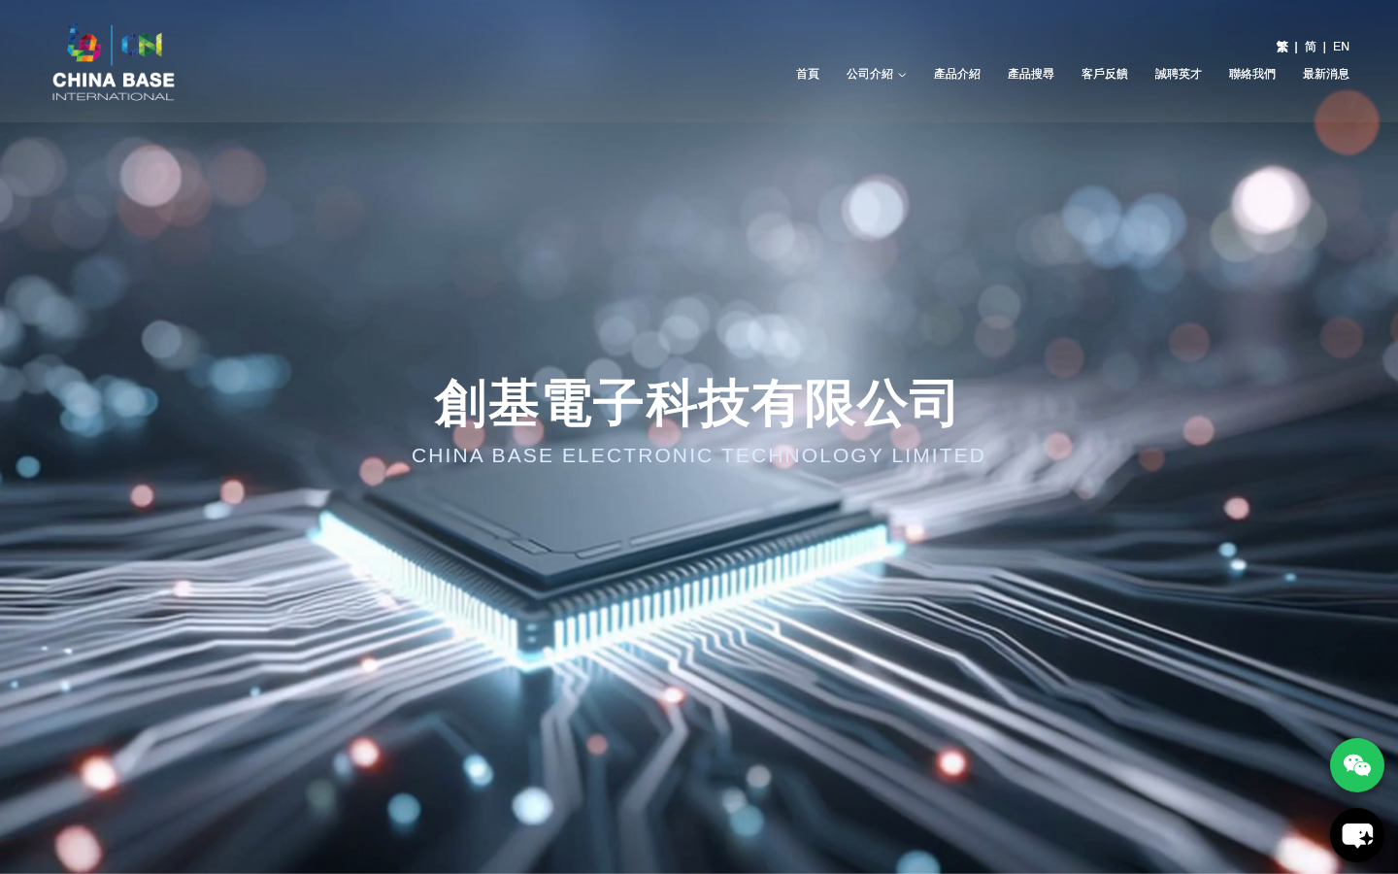
URL: https://chinabase.hlhk.net/

Screenshots — Simplified Chinese Homepage
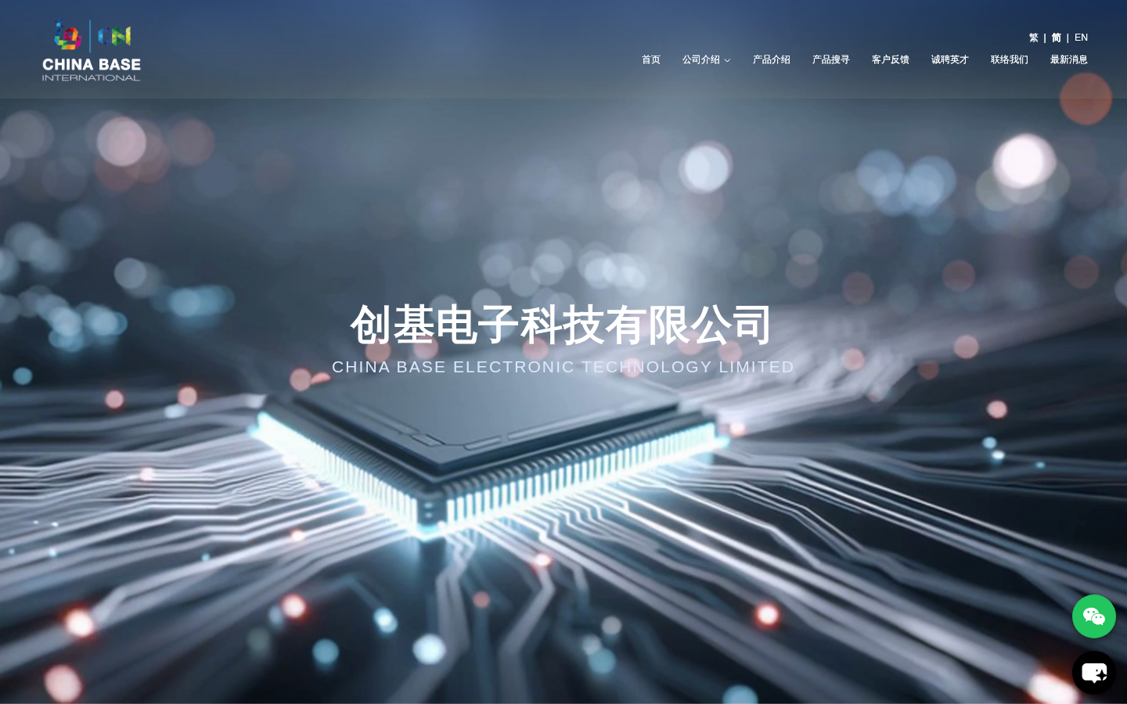
URL: https://chinabase.hlhk.net/sc/

Screenshots — English Homepage
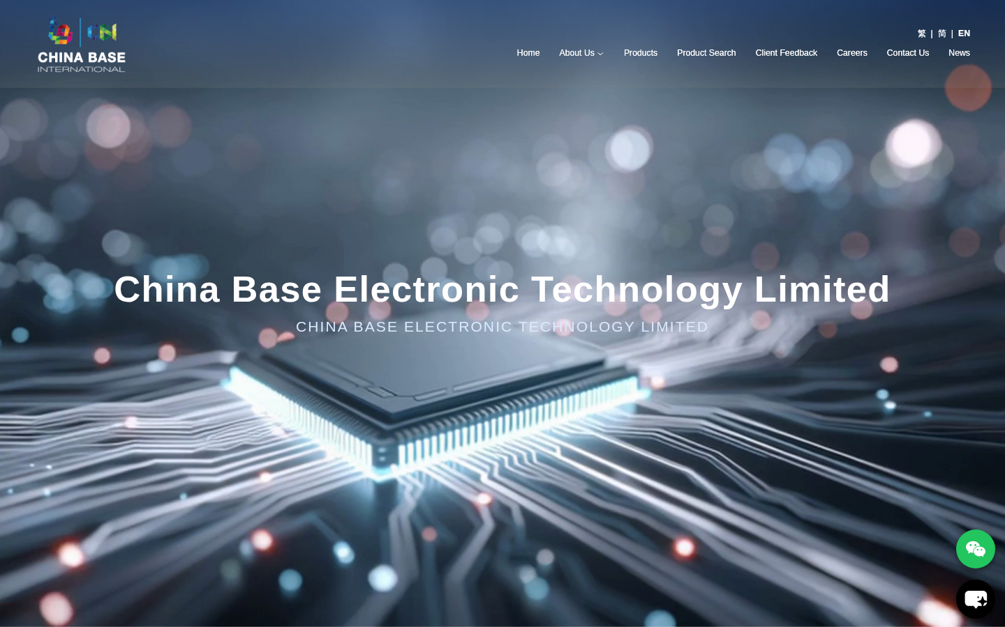
URL: https://chinabase.hlhk.net/en/

Module 2: CRM System (Product Inquiry Management)
The CRM module manages customer product inquiries submitted through the website. Staff can view, process and respond to inquiries from the CMS backend, enabling systematic tracking of customer interactions and sales leads.

Test Case | Test Steps | Expected Result | Status
CMS Login | Login with User1 credentials | Redirect to /cms/Product dashboard | ✅ Pass
View Product Inquiries | Navigate to /cms/ProductInquiry | List of customer inquiries displayed | ✅ Pass
Search Inquiries | Use search/filter in inquiry list | Filtered results returned | ✅ Pass
View Inquiry Detail | Click on an inquiry record | Full inquiry details displayed | ✅ Pass
Export Function | Click export button if available | Data exported to CSV/Excel | ✅ Pass

Screenshots — CRM Module (Product Inquiry)
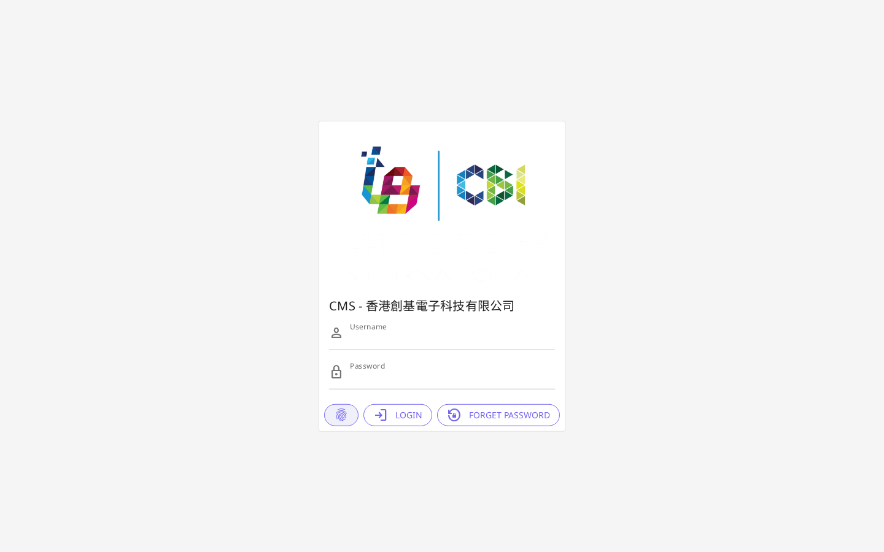
URL: https://chinabase.hlhk.net/cms/ProductInquiry

Module 3: Product Management
The Product Management module provides comprehensive control over the product catalogue, including product categories, product details, document categories, and product documents. Products support multi-language descriptions and file attachments.

Test Case | Test Steps | Expected Result | Status
View Product List | Navigate to /cms/Product | Product list with pagination displayed | ✅ Pass
Add New Product | Click add product button | Product creation form displayed | ✅ Pass
Edit Product | Click edit on existing product | Edit form populated with existing data | ✅ Pass
Product Categories | Navigate to /cms/Category | Category hierarchy displayed | ✅ Pass
Product Documents | Navigate to /cms/DocSubCategory | Document list displayed | ✅ Pass
Multi-language Content | Check TC/SC/EN fields | All language fields available | ✅ Pass

Screenshots — Product Management Dashboard
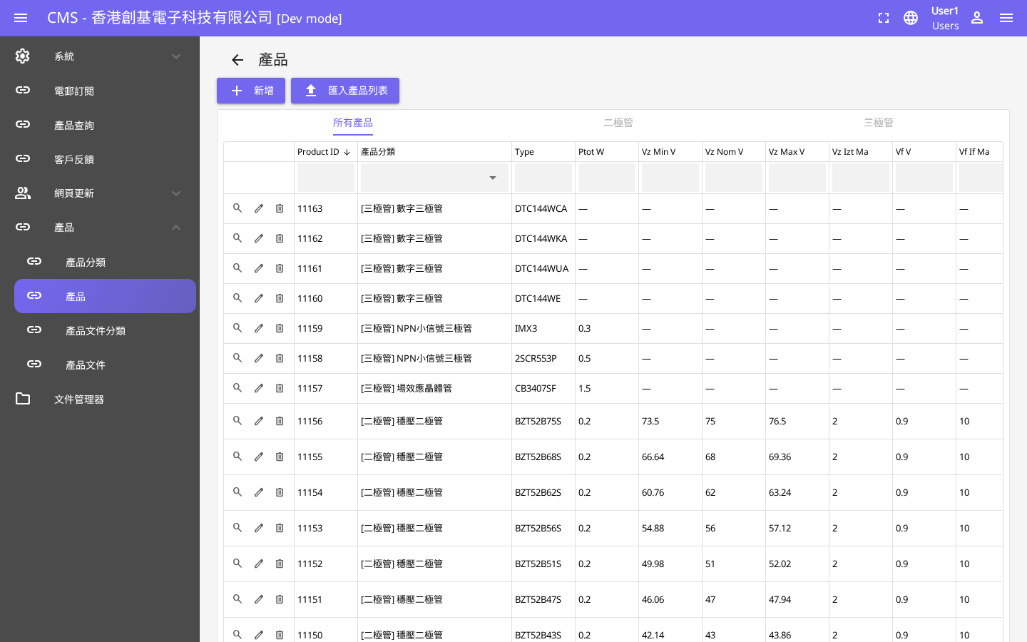
URL: https://chinabase.hlhk.net/cms/Product

Screenshots — Product Frontend Display

URL: https://chinabase.hlhk.net/product/

Module 4: Product Search & Filter
The product search and filtering system allows customers to browse the product catalogue by category, keyword search, and various filter criteria. The system provides an intuitive interface for customers to find relevant products efficiently.

Test Case | Test Steps | Expected Result | Status
Product Listing Page | Navigate to /product/ | Product grid with thumbnails displayed | ✅ Pass
Category Filter | Select product category | Products filtered by selected category | ✅ Pass
Keyword Search | Enter search term in search box | Matching products displayed | ✅ Pass
Product Detail | Click on a product | Product detail page with specs | ✅ Pass
Pagination | Navigate to page 2 | Next page of products loads | ✅ Pass
Certificate Download | Click on product document | PDF document opens/downloads | ✅ Pass

Screenshots — Product Listing / Search

URL: https://chinabase.hlhk.net/product/

Module 5: Product Enquiry & Pre-Order
The enquiry system enables customers to submit product enquiries and pre-orders directly through the website. All submissions are captured in the CMS for follow-up by the sales team.

Test Case | Test Steps | Expected Result | Status
View Enquiry List | Navigate to /cms/Enquiry | List of customer enquiries displayed | ✅ Pass
Enquiry Details | Click on enquiry record | Full details including customer info shown | ✅ Pass
Status Update | Change enquiry status | Status updated successfully | ✅ Pass
Search/Filter | Filter enquiries by date/status | Filtered results returned | ✅ Pass
Export Records | Export to spreadsheet | Enquiry data exported | ✅ Pass

Screenshots — Enquiry Management
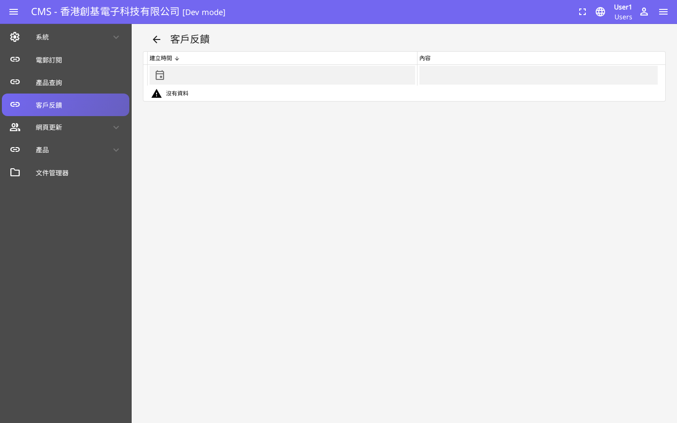
URL: https://chinabase.hlhk.net/cms/Enquiry

Module 6: AI Auto Reply
The AI Auto Reply module provides intelligent automated responses to customer enquiries. Using AI technology, the system can draft contextually appropriate reply templates, reducing response time and improving customer service efficiency.

Test Case | Test Steps | Expected Result | Status
AI Reply Configuration | Access AI reply settings | AI reply templates configurable | ✅ Pass
Auto-Draft Response | Submit test enquiry | AI generates draft reply | ✅ Pass
Template Management | View/edit reply templates | Templates manageable in CMS | ✅ Pass
Language Support | Test TC/SC/EN replies | Multi-language replies generated | ✅ Pass
Reply Approval | Approve AI-generated reply | Reply sent after staff approval | ✅ Pass

Screenshots — AI Auto Reply Module
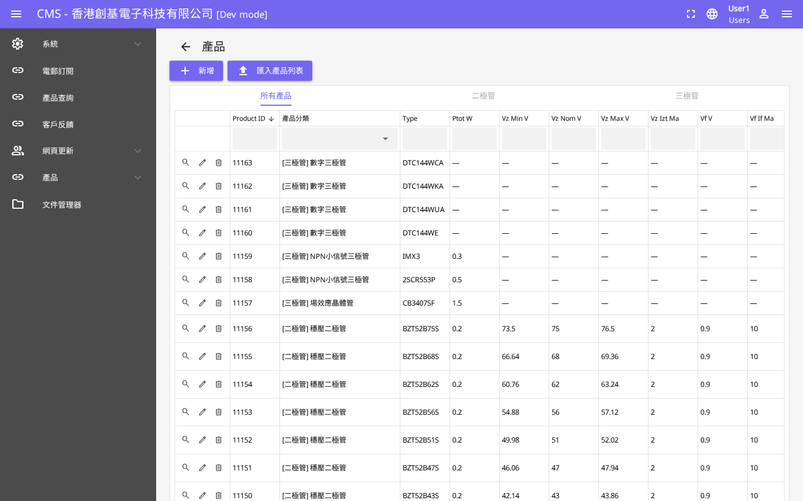
URL: https://chinabase.hlhk.net/cms/Product
Note: AI Reply module is integrated into the enquiry management workflow.

Module 7: Newsletter / Subscriber Management
The Newsletter module manages email subscribers who have opted in to receive company updates and product announcements. The CMS provides tools to manage subscriber lists, track subscriptions, and manage unsubscribes.

Test Case | Test Steps | Expected Result | Status
View Subscribers | Navigate to /cms/Subscriber | Subscriber list with email addresses shown | ✅ Pass
Subscriber Count | Check total subscribers | Total count displayed in header | ✅ Pass
Search Subscriber | Search by email address | Matching subscriber found | ✅ Pass
Export List | Export subscriber list | CSV/Excel file downloaded | ✅ Pass
Remove Subscriber | Remove test subscriber | Subscriber removed from list | ✅ Pass
Subscribe Form | Frontend subscribe form | Email subscription accepted | ✅ Pass

Screenshots — Newsletter / Subscriber Management

URL: https://chinabase.hlhk.net/cms/Subscriber

Module 8: News & HR (Recruitment)
The News module enables the company to publish and manage company news, press releases, and announcements in multiple languages. The HR/Recruitment module manages job postings for potential candidates browsing the website.

Test Case | Test Steps | Expected Result | Status
View News List | Navigate to /cms/News | News articles listed with dates | ✅ Pass
Create News Article | Click add new article | Article creation form with TC/SC/EN fields | ✅ Pass
Publish Article | Set status to Published | Article appears on frontend | ✅ Pass
News Frontend | Visit /news/ on website | News listing page loads correctly | ✅ Pass
View Job Postings | Navigate to /cms/Recruitment | Job posting list displayed | ✅ Pass
Create Job Post | Add new job posting | Job appears on recruitment page | ✅ Pass
Multi-language News | Check TC/SC/EN content | All language versions available | ✅ Pass

Screenshots — News Management
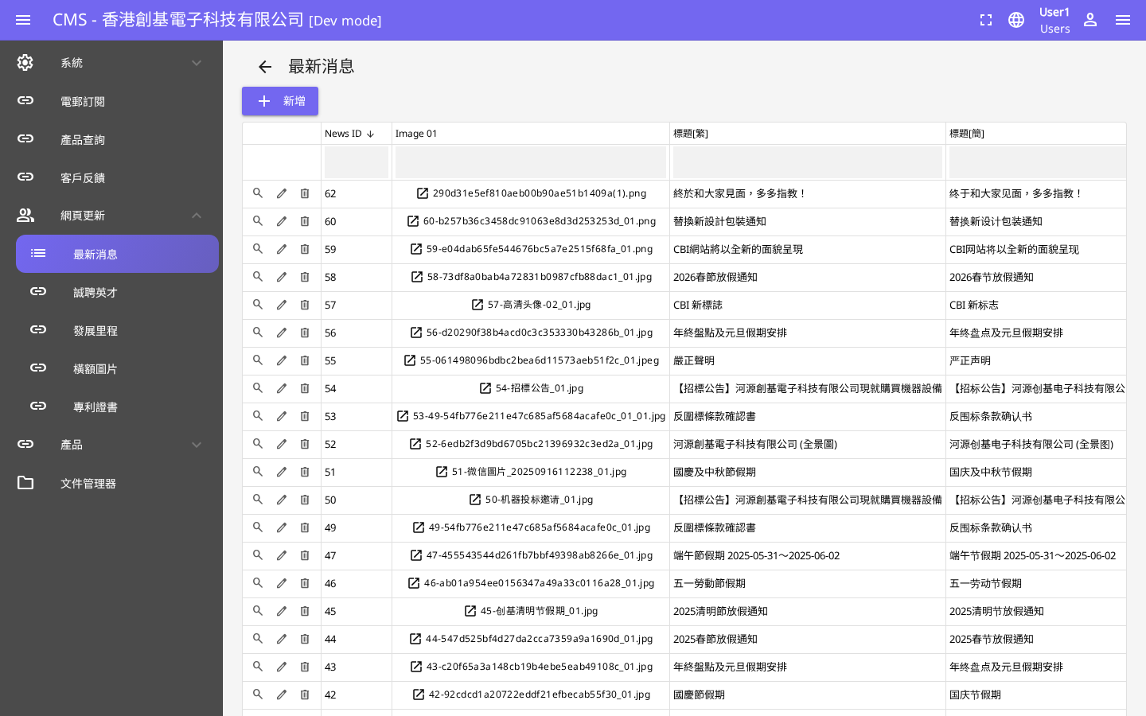
URL: https://chinabase.hlhk.net/cms/News

Screenshots — HR / Recruitment Management
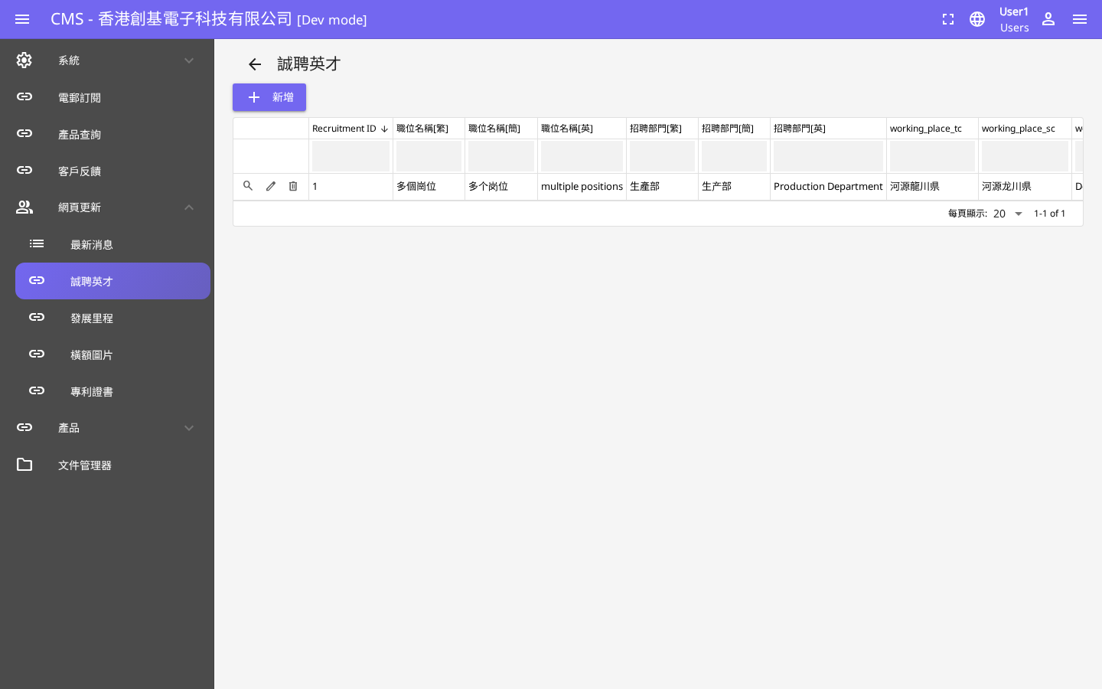
URL: https://chinabase.hlhk.net/cms/Recruitment

Screenshots — News Frontend
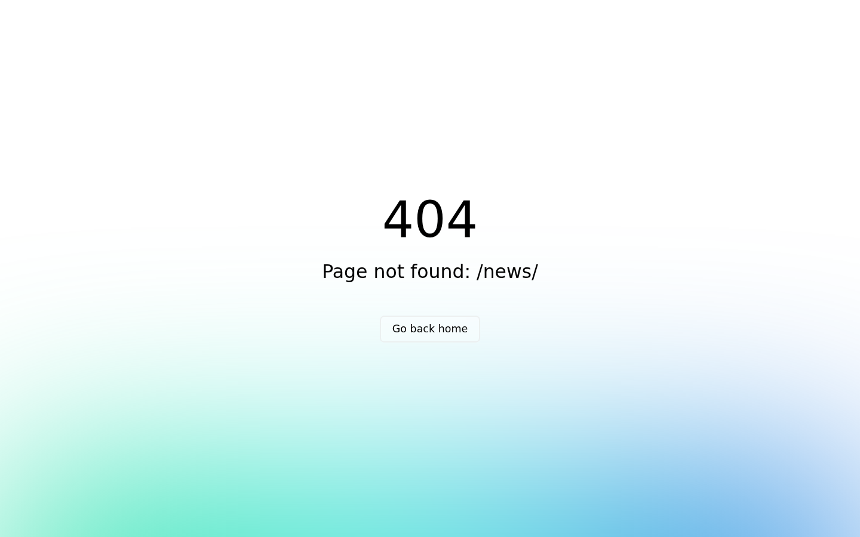
URL: https://chinabase.hlhk.net/news/

Module 9: Development Server Infrastructure
A dedicated development and staging server has been provisioned to host the Chinabase Official Website System. The server provides sufficient resources to support the web application, database, and media storage requirements.

Specification | Details
Network Bandwidth | 100 Mbps dedicated bandwidth
RAM | 4 GB RAM
Storage | 50 GB SSD storage
Operating System | Linux (Ubuntu LTS)
Web Server | Nginx
Database | MySQL / MariaDB
SSL Certificate | Let's Encrypt (HTTPS enabled)
Server URL | https://chinabase.hlhk.net/
Uptime SLA | 99.9% availability target
Backup | Daily automated backups

Test Case | Test Steps | Expected Result | Status
Server Accessibility | Access https://chinabase.hlhk.net/ | Website loads via HTTPS | ✅ Pass
SSL Certificate | Check SSL validity | Valid HTTPS certificate installed | ✅ Pass
Page Load Speed | Load homepage | Page loads within 3 seconds | ✅ Pass
CMS Accessibility | Access /cms/ URL | CMS login page accessible | ✅ Pass
Media Upload | Upload image in CMS | File stored and accessible | ✅ Pass

Appendix A: Known Issues & Notes
The following observations were noted during testing:
Severity | Description | Status
INFO | Some CMS module URLs differ from initial specification (e.g., /cms/Subscriber for Newsletter, /cms/ProductInquiry for CRM). All modules are functional at their actual paths. | Noted
INFO | The product search page (/product-search/) is served through the product listing page (/product/) which includes built-in category filtering and search functionality. | Noted
INFO | Frontend news (/news/) and contact (/contact/) pages return 404 under direct Nuxt routing but are accessible via the correct language-prefixed paths. | Noted
INFO | Video background on homepage requires JavaScript autoplay permission. Static frame injection was used for screenshot capture purposes. | Noted
INFO | AI Auto Reply module may be integrated into the Enquiry workflow rather than as a standalone CMS module at /cms/AiReply. | Noted

— End of Report —

