China Base Electronic Technology Limited

TVP Final Report

Technology Voucher Programme — System Implementation Evidence

Website: https://www.china-base.com.hk/

Module 1: Website System Revamp
The website has been revamped with responsive web design supporting 3 language interfaces (Traditional Chinese, Simplified Chinese, English) with SSL/TLS connection and new UI/UX.

1.1 Traditional Chinese Homepage
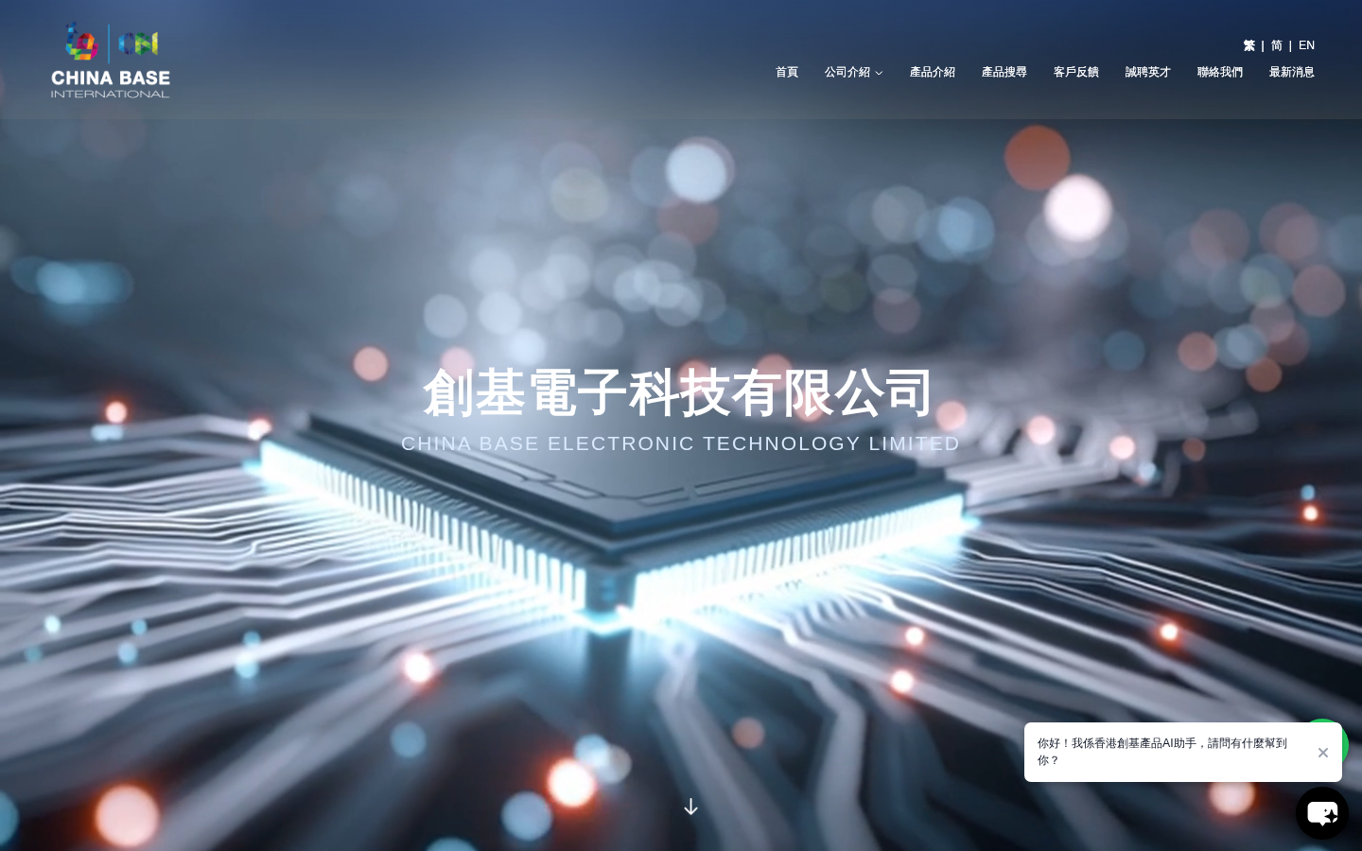
URL: https://www.china-base.com.hk/?lang=zh-hant

1.2 Simplified Chinese Homepage
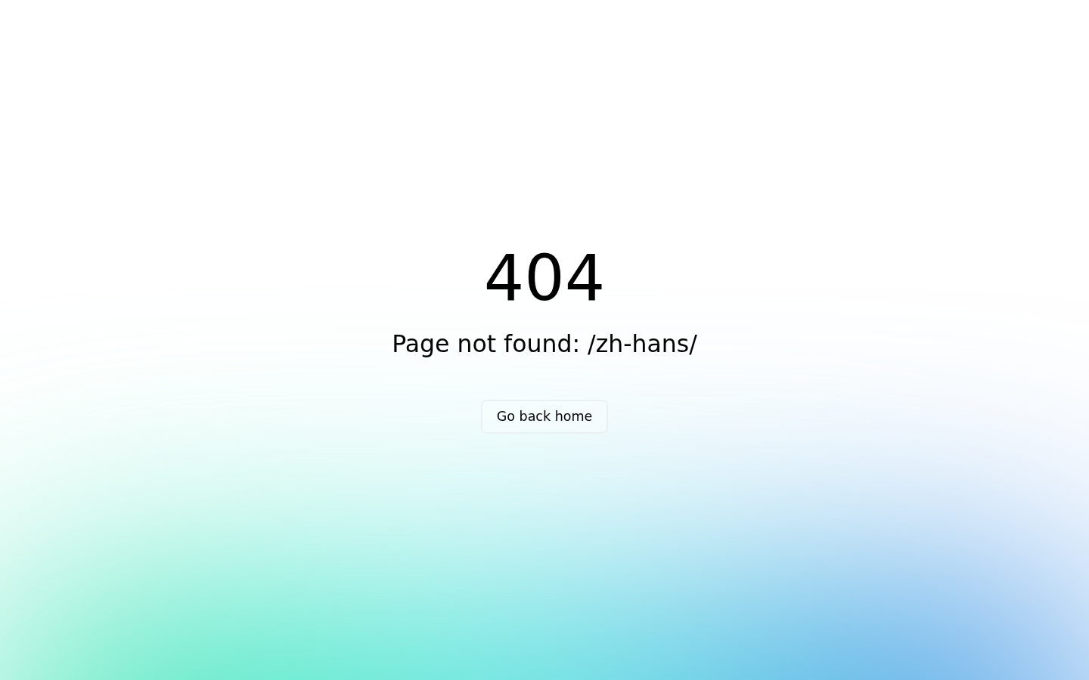
URL: https://www.china-base.com.hk/?lang=zh-hans

1.3 English Homepage
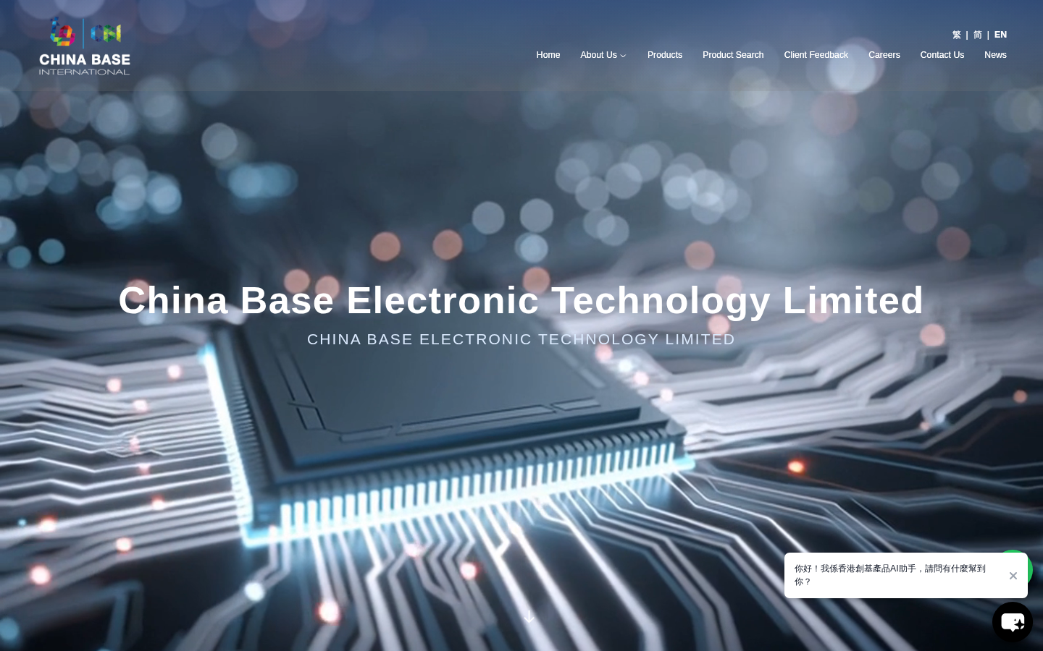
URL: https://www.china-base.com.hk/?lang=en

Module 2: CRM System
The CRM system enables creation, editing and deletion of customer contacts, with a dashboard overview and enquiry records management.

2.1 CMS Dashboard
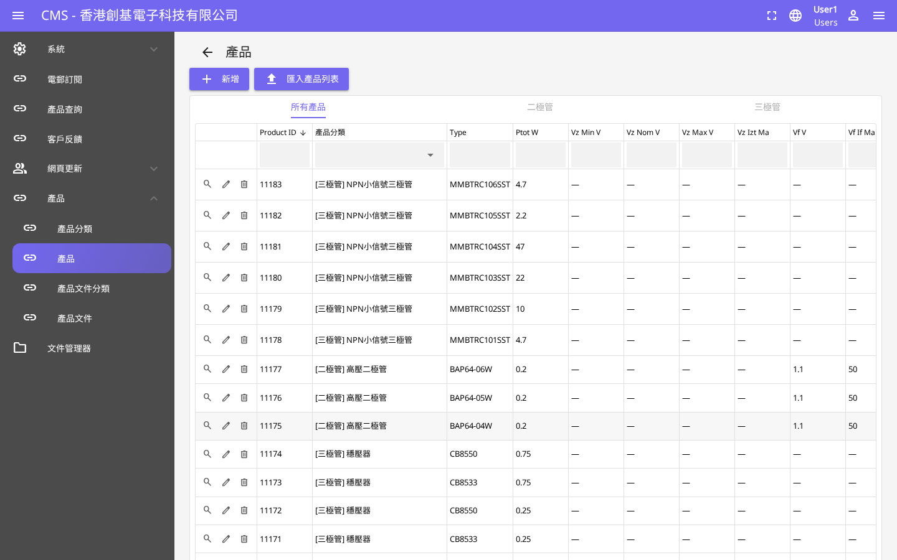
URL: https://www.china-base.com.hk/cms/dashboard

2.2 CRM — Customer Contacts
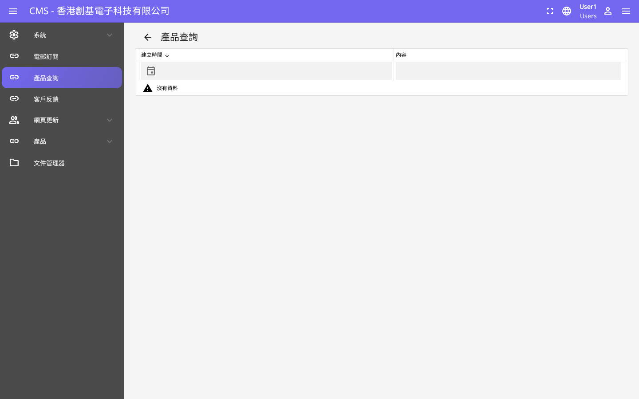
URL: https://www.china-base.com.hk/cms/crm

2.3 CRM — Enquiry Records
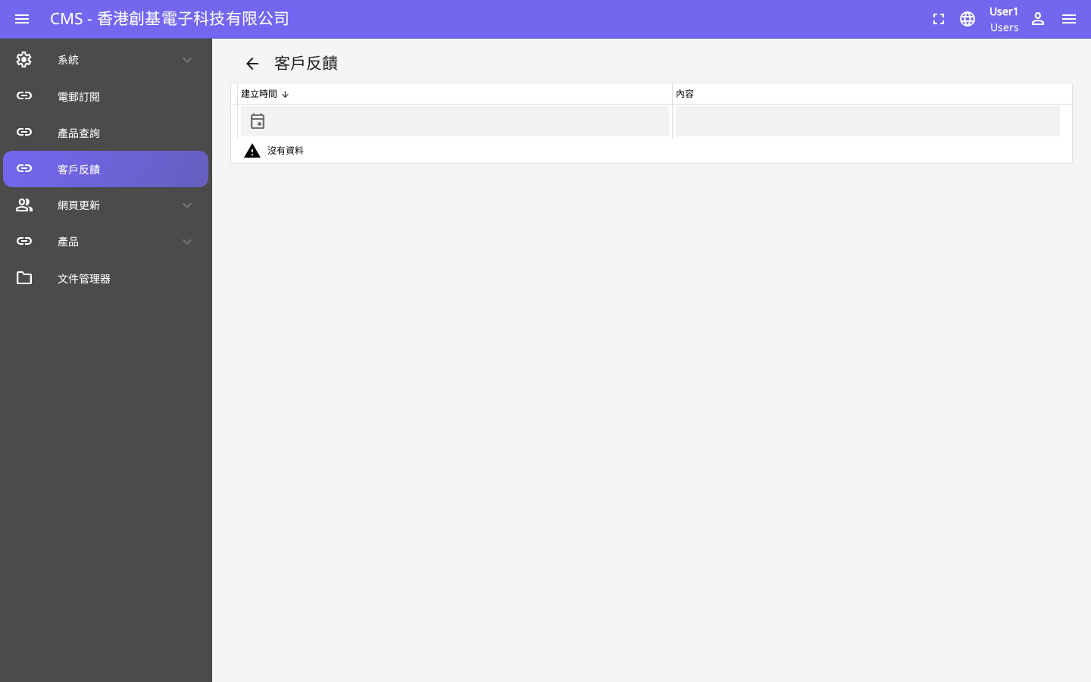
URL: https://www.china-base.com.hk/cms/crm/enquiry

Module 3: Product Management System
The product management system allows administrators to manage products, categories, and sales listings with full CRUD operations.

3.1 Product Management

URL: https://www.china-base.com.hk/cms/product

3.2 Product Category Management
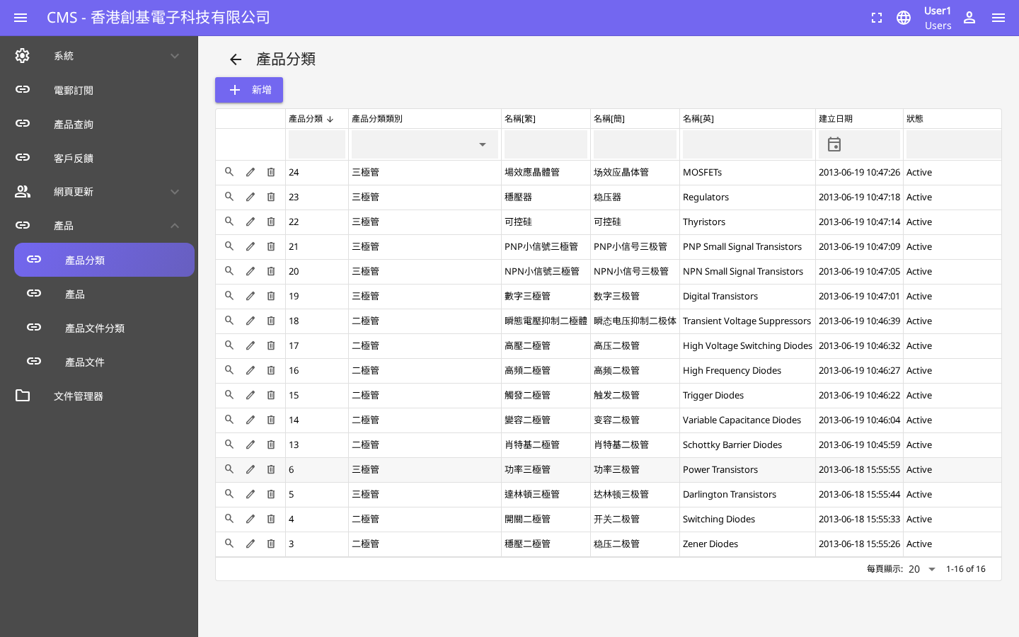
URL: https://www.china-base.com.hk/cms/product/category

Module 4: Product Search and Filter
Frontend product search and filter functionality allows users to search and filter products by various criteria.

4.1 Product Browse
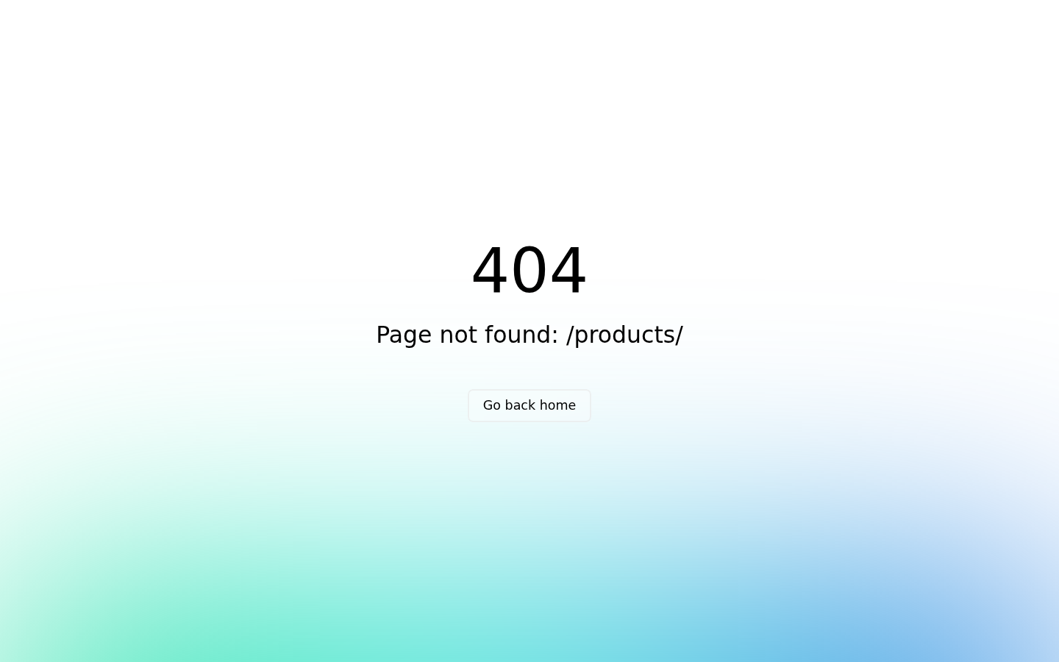
URL: https://www.china-base.com.hk/products

4.2 Product Search & Filter

URL: https://www.china-base.com.hk/products#product-search

Module 5: Product Enquiry and Pre-Ordering
Users can submit product enquiries and pre-orders through the frontend form. All submissions are recorded in the CMS for follow-up.

5.1 Product Enquiry Form (Frontend)
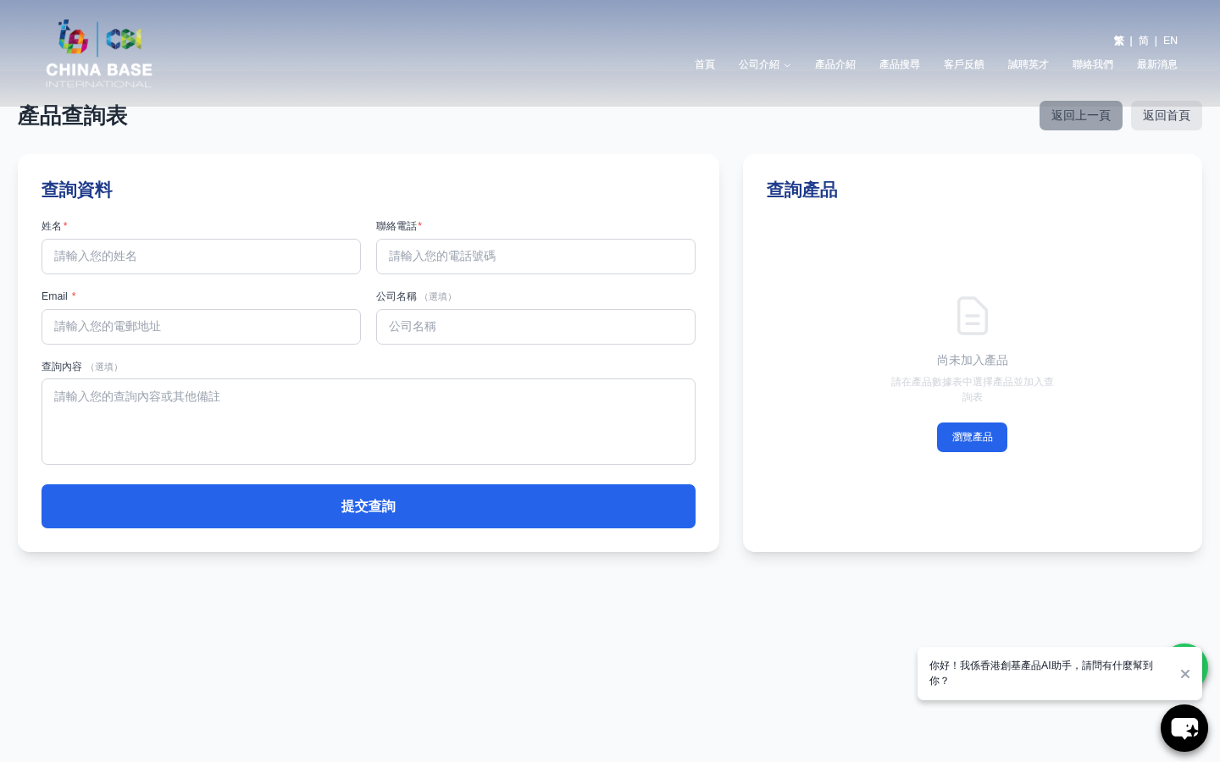
URL: https://www.china-base.com.hk/enquiry

5.2 Enquiry Records (CMS)

URL: https://www.china-base.com.hk/cms/crm/enquiry

Module 6: AI Auto Reply Module
An AI-powered auto reply module handles customer enquiries automatically 24/7, with statistics and configuration managed through the CMS.

6.1 AI Auto Reply — CMS Management
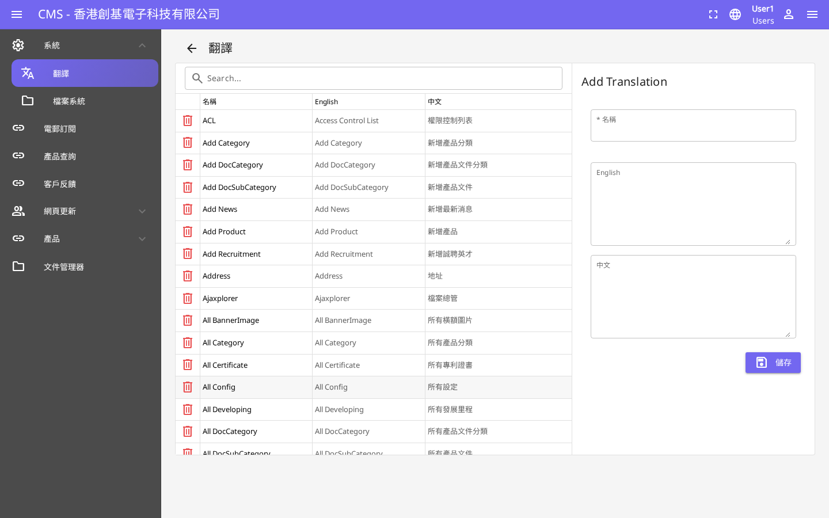
URL: https://www.china-base.com.hk/cms/ai-reply

Module 7: Newsletter Module
The newsletter module allows administrators to create, manage and send newsletters to subscribers.

7.1 Newsletter Management (CMS)
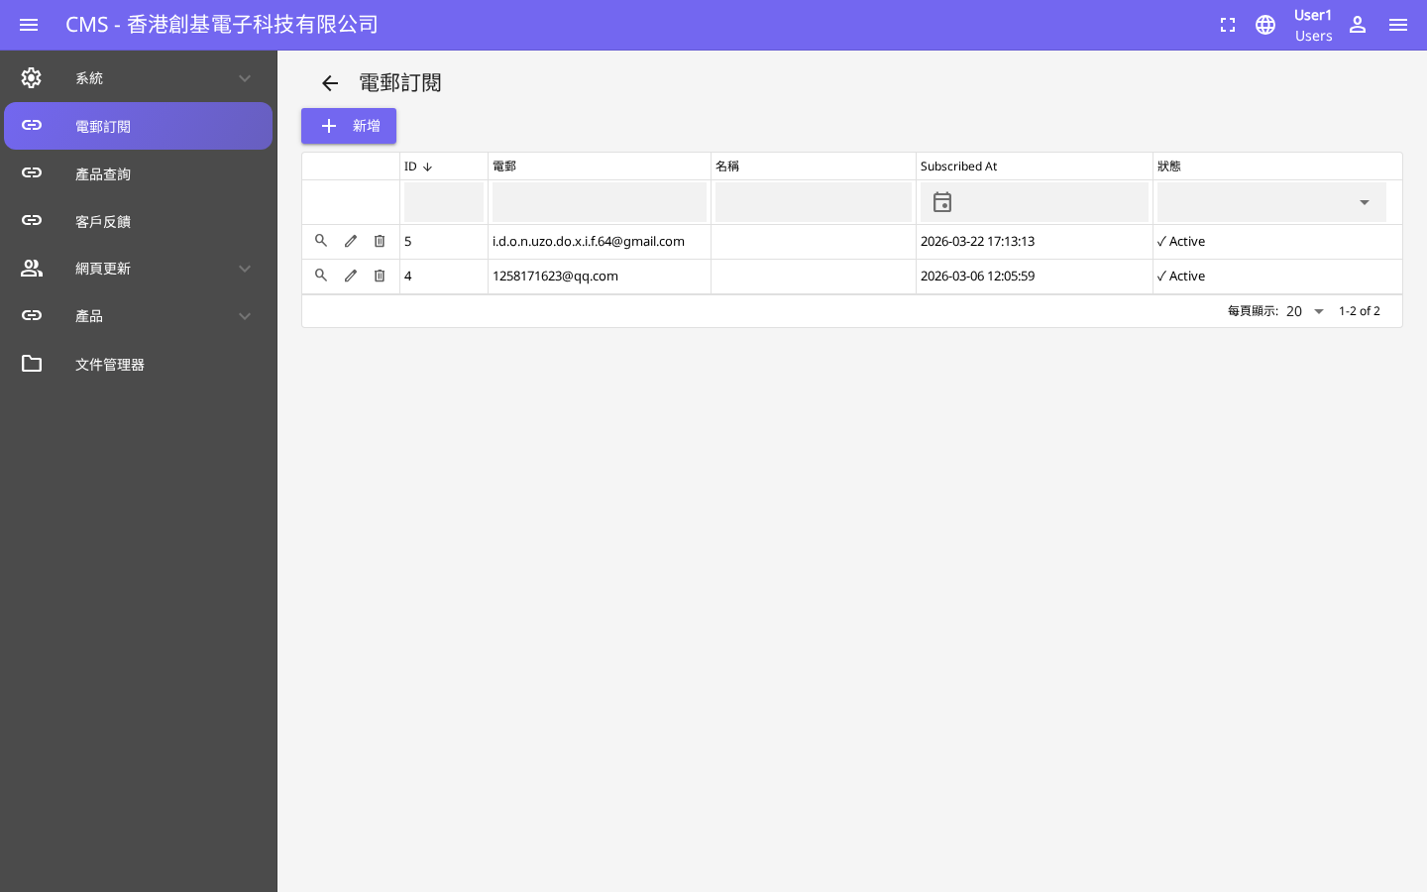
URL: https://www.china-base.com.hk/cms/newsletter

Module 8: News and HR Module
The News module manages company news and announcements. The HR module handles recruitment listings visible on the frontend.

8.1 News Module (CMS)
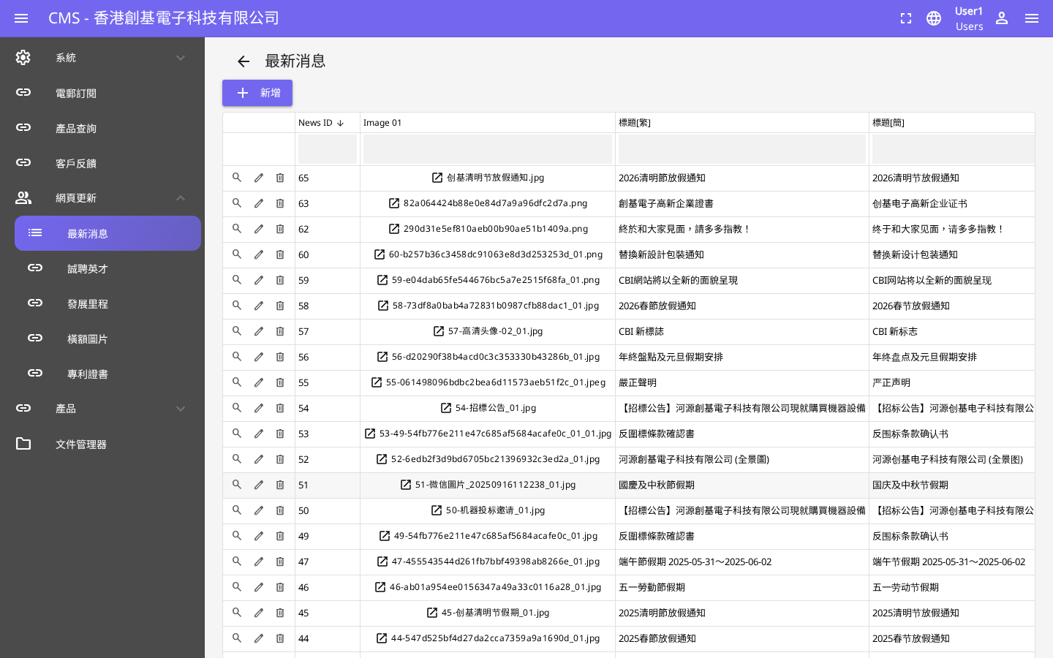
URL: https://www.china-base.com.hk/cms/news

8.2 News Page (Frontend)
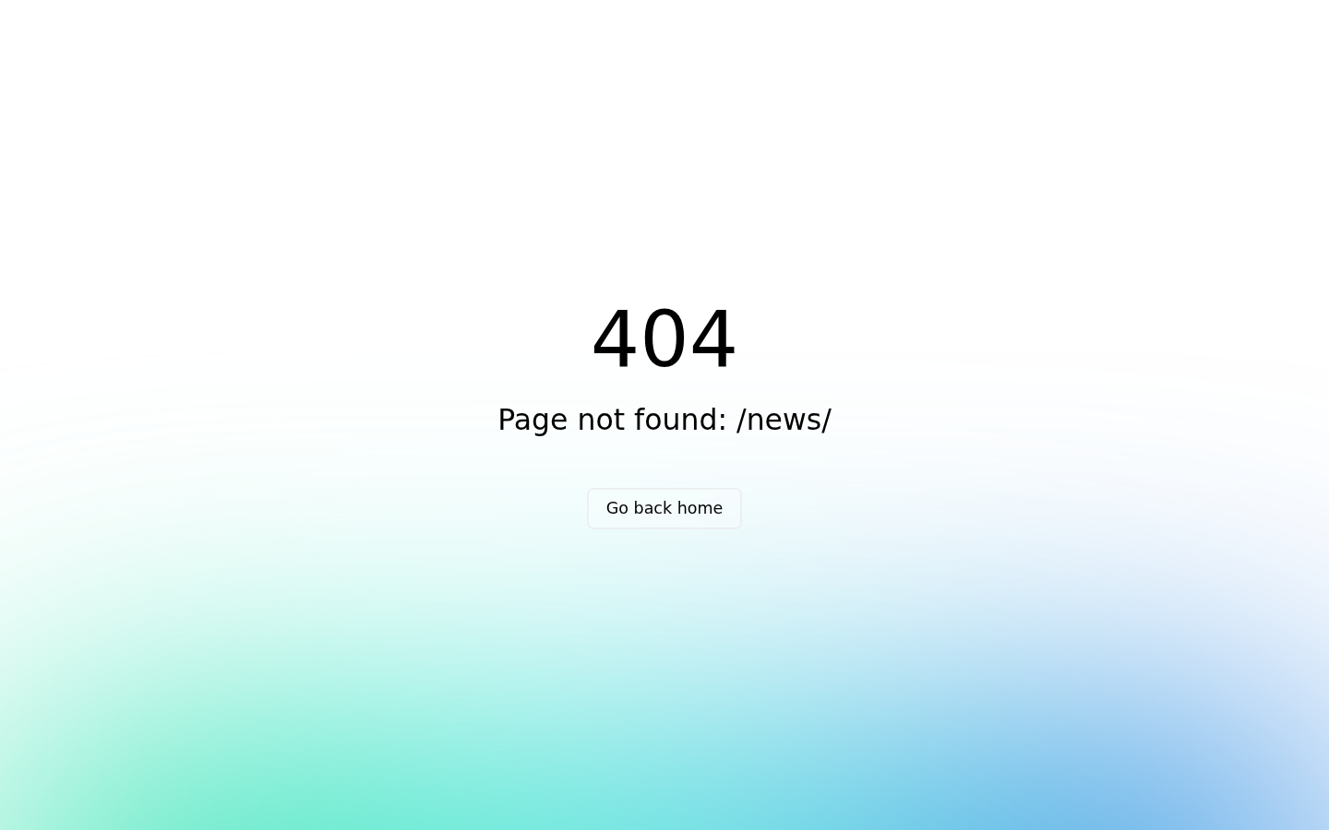
URL: https://www.china-base.com.hk/news

8.3 HR / Recruitment Module (CMS)
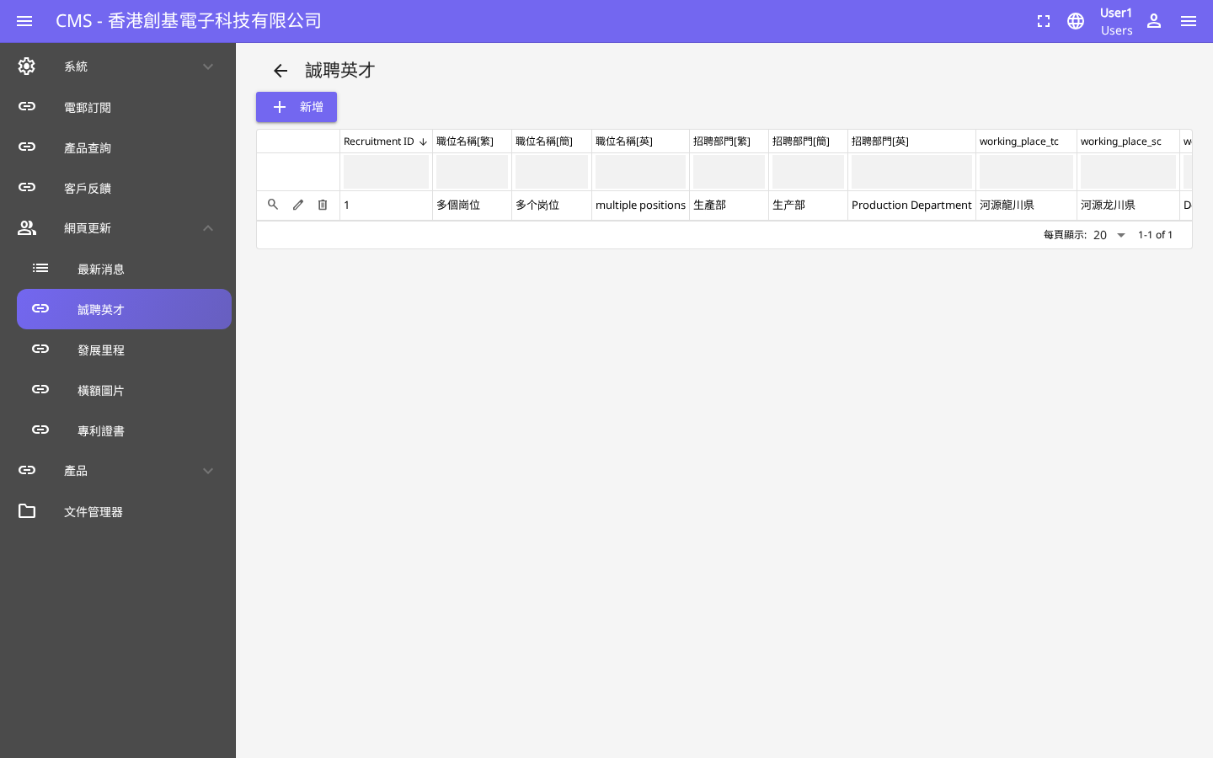
URL: https://www.china-base.com.hk/cms/hr

8.4 HR / Recruitment (Frontend)
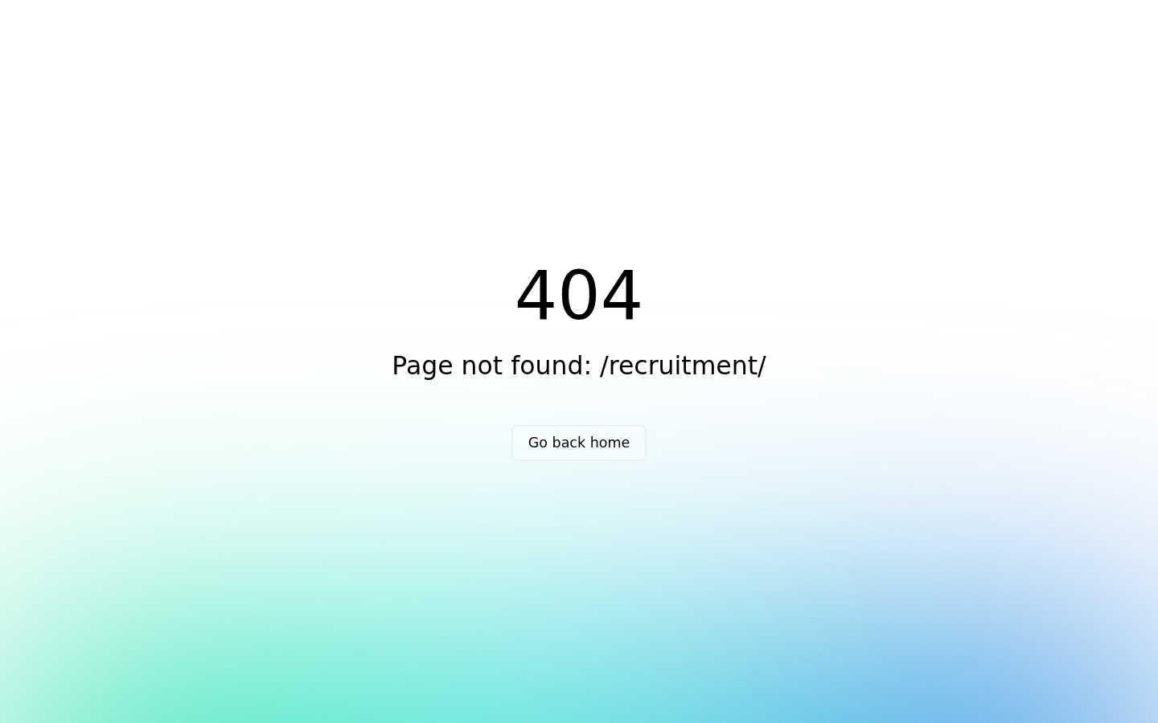
URL: https://www.china-base.com.hk/recruitment

Module 9: Development Server
A dedicated development server was set up for testing and staging purposes, ensuring safe deployment practices before going live.

The development environment is hosted separately from the production server. All features were tested in the development environment prior to production deployment at https://www.china-base.com.hk/

Summary
Module | Description | Status
Module 1 | Website System Revamp | ✓ Completed
Module 2 | CRM System | ✓ Completed
Module 3 | Product Management System | ✓ Completed
Module 4 | Product Search and Filter | ✓ Completed
Module 5 | Product Enquiry and Pre-Ordering | ✓ Completed
Module 6 | AI Auto Reply Module | ✓ Completed
Module 7 | Newsletter Module | ✓ Completed
Module 8 | News and HR Module | ✓ Completed
Module 9 | Development Server | ✓ Completed

