Name: Xinrun Zhang

ML Homework 5 Report

Instructor: Prof. Kaliappan Gopalan

Time: 23/03/2019

# Files

1. main_part1.m – Includes the main program of the homework 5 part 1.
2. main_part2.m – Includes the main program of the homework 5 part 2.
3. trainingNueron.m – This function is used to train the neuron.

# Part one

1. Theta found by training:

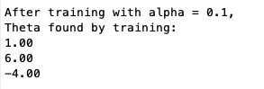

1. Training data with given data and decision boundary:

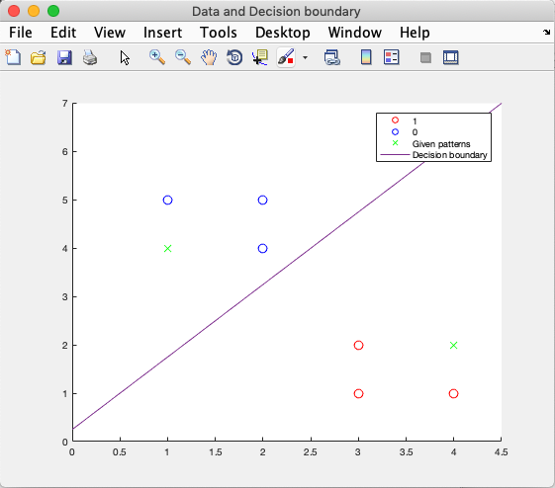

1. Predict the given patterns



# Part two

1. Theta found by training:

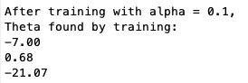

1. Training data and decision boundary:

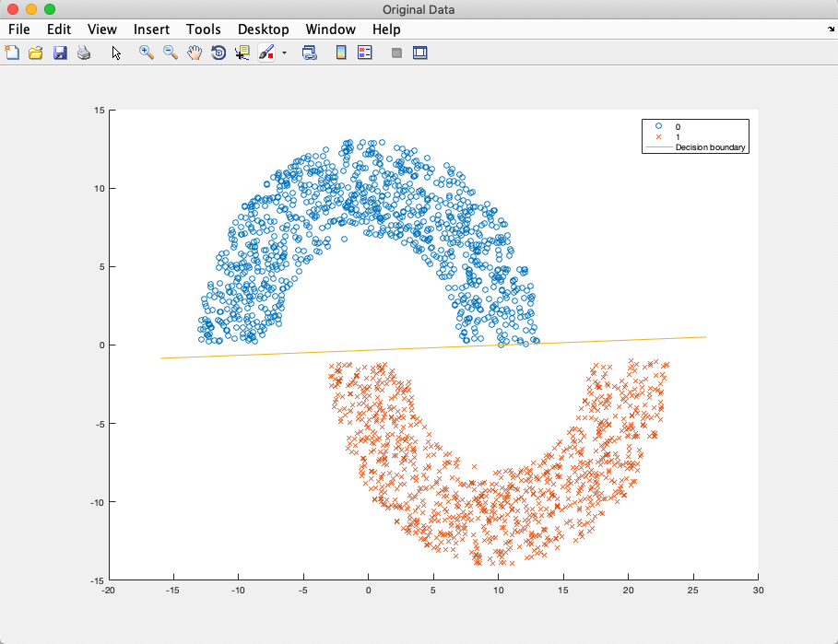

1. Validation accuracy:



# Codes

1. main_part1.m

%% Machine Learning Homework 5 part 1

% Author: Xinrun Zhang

% Time: 03/23/2019 17:20

% =====================================================================

%% Initialization

clear ; close all; clc

fprintf('Initializing...\n')

% Initial the data

p = [3 1; 3 2; 4 1; 1 5; 2 4; 2 5];

t = [1; 1; 1; 0; 0; 0];

% Initial the theta vector

theta = [0; 0; 0];

% Initial the learning rate and iteration times

alpha = 1;

iteration = 10;

% Data processing

fprintf('Data processing...\n\n')

p = [ones(6, 1), p(:,1:2)];

% =====================================================================

%% Training the neuron

fprintf('Start training the neuron...\n')

i = 0;

for i = 1:iteration

    theta = trainingNueron( theta, p, t, alpha);

end

fprintf('\nAfter training with alpha = 0.1, ')

fprintf('\nTheta found by training:\n');

fprintf('%.2f\n', theta);

fprintf('\n')

% =====================================================================

%% Prediction

u1 = [1; 1; 4];

u2 = [1; 4; 2];

predict1 = round(logsig( u1'*theta ));

predict2 = round(logsig( u2'*theta ));

fprintf('For U1 = [%d, %d], predict = %d\n',u1(2), u1(3), predict1);

fprintf('For U1 = [%d, %d], predict = %d\n',u2(2), u2(3), predict2);

% =====================================================================

%% Plot

x1 = [3; 3; 4]; y1 = [1; 2; 1];

x2 = [1; 2; 2]; y2 = [5; 4; 5];

x3 = [1; 4];  y3 = [4; 2];

m = 0:0.1:4.5;

n = 1.5*m + 0.25;

figure('Name','Data and Decision boundary','NumberTitle','off');

scatter(x1, y1, 80, 'o', 'r');

hold on;

scatter(x2, y2, 80, 'o', 'b');

hold on;

scatter(x3, y3, 80, 'x', 'g')

hold on;

plot(m, n);

hold off;

legend('1', '0', 'Given patterns', 'Decision boundary');

% =====================================================================

1. main_part2.m

%% Machine Learning Homework 5 part 2

% Author: Xinrun Zhang

% Time: 03/23/2019 21:07

% =====================================================================

%% Initialization

clear ; close all; clc

fprintf('Initializing...\n')

% Initial the data

data = importdata('halfmoon.mat'); % don't use load function

x = data(:,[1, 2]);

y = data(:, 3);

data_val = importdata('halfmoonTest.mat');

x_val = data_val(:,[1, 2]);

y_val = data_val(:, 3);

% Initial the theta vector

theta = [1; 1; 1];

% Initial the learning rate and iteration times

alpha = 1;

iteration = 10;

% Data processing

fprintf('Data processing...\n')

X = [ones(2000, 1), x(:,1:2)];

X_val = [ones(240, 1), x_val(:, 1:2)];

% =====================================================================

%% Training the neuron

fprintf('Start training the neuron...\n\n')

i = 0;

for i = 1:iteration

    theta = trainingNueron( theta, X, y, alpha);

end

fprintf('After training with alpha = 0.1,\n')

fprintf('Theta found by training:\n');

fprintf('%.2f\n', theta);

fprintf('---------------------------------------------------------\n');

% =====================================================================

%% Plot the original data

fprintf('Plotting the data...\n')

x_0 = x(1:1000, [1, 2]);

x_1 = x(1001:2000, [1, 2]);

m = -16:0.1:26;

n = 0.0323*m - 0.3322;

figure('Name','Original Data','NumberTitle','off');

scatter(x_0(:, 1), x_0(:, 2), 'o');

hold on;

scatter(x_1(:, 1), x_1(:, 2), 'x');

hold on;

plot(m, n);

legend('0', '1', 'Decision boundary');

fprintf('---------------------------------------------------------\n');

% =====================================================================

%% Validation

predict = round(logsig(X_val*theta));

accuracy = mean( double(predict == y_val) * 100);

fprintf('The accuracy is %.2f\n', accuracy);

fprintf('---------------------------------------------------------\n');

% =====================================================================

1. trainingNueron.m

function theta = trainingNueron( theta, p, t, alpha )

iter = size(t);

for i = 1:iter

    h = round(logsig(p(i, :)*theta));

    error = t(i) - h;

    theta = theta + alpha * p(i, :)' * error;

end

end