Project Reflection
Purpose
My final project is a general-purpose graphics engine, with some basic physics features included. A simple demonstration environment is included to test and showcase the features.
It requires a command-line argument pointing at the \src\assets folder (legacy from loading external files)
For use, the JSONSimple-1.1.1 library is required. It is stored in my M:/ICS4U folder.
Classes in ca.gkelly.culminating.* are the “frontend” game features
Classes in ca.gkelly.engine.* are the “backend” engine feature

Features of the engine:
- Camera that pans + zooms
- Ability to load, render and run collision detections for .tmx tilemaps
- Loads resources from xml files, and saves data to resource files
- n-Sided polygon collision detection
- Simple entity and entity w/ primitive physics
- UI system, with containers, textboxes, and buttons
- Window class, and event/render management abstracts
- Input handling built-in to management abstracts
- Separate update and render threads
- Delta-time and framerate limiting for event thread
- Feature-complete Vector class
- Logger, with:
  - 3 Levels
  - Timestamps (unlimited epochs)
  - Information about origin line
- No warnings
Instructions
As the “game” is simply a demo, there is no primary objective.
You move around using the WASD keys and can fire projectiles by clicking with left/right mouse buttons.
Collision detection features can be tested using the provided walls. There is an invisible collider to the right of start point, which can be used to test n-side collision detection. (see image)
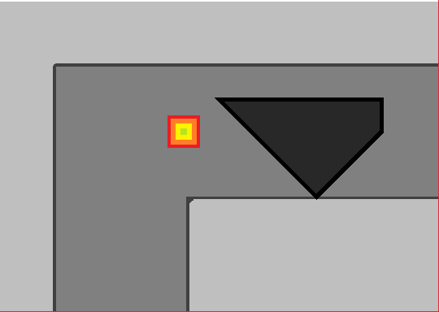
For analysing code, the best starting point is GameManager.java, and exploring the heigharchy from there
Learning
Throughout the process, I learned about:
Class heigharchy -> How to use abstract classes and interfaces, as well as extends and implements
Javadoc -> How to write, use, and generate HTML documentation site. As well as the advantages of good documentation
Instantiating from .class objects (see Loader.loadResource())
Variety of math associated with collision detection and camera features
Whole slew of other lessons learned by simply practicing programming skills
Analysis
While I did not accomplish my original goal of making a complete game to go with the engine, I modified it over time to reduce the complexity of the game in favour of a more complex engine.
There are a handful of bugs that I know of, including:
- Rendering is somewhat jerky
  - Caused by converting backend math from doubles to ints
  - Can be fixed by rendering with doubles (not hard, just takes time)
- Laggyness when zoomed out
  - For some reason loops take >20ms, not sure why
- No differentiation between left- and right- click
  - This isn’t a hard fix, just wasn’t high on priority list
- UIElements remain in Hover state when a dialog appears until mouse is moved
  - While this could be fixed, it just isn’t worth it, and is hardly noticeable
There are numerous improvements I could make with more time.
- I would love to make a proper game to go with the engine
- Optimizing engine features
- Properly using loader features
- Improving tilemap support
- Adding animations to UI system
- Adding HUD support to UI system
- Adding transparency to UI system
- Fixing the above issues

