Agents

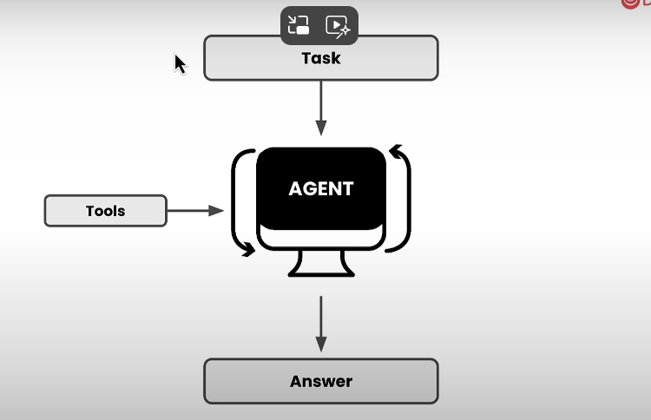

Mult-Agents System ( Agentic AI)

1. Multiple agents working and collaborating together to get a task done
2. The task can be sequentially ( one after the other (O/P of one – I/P of other ) , top down ( hybrid )

Difference between Traditional and AI software development

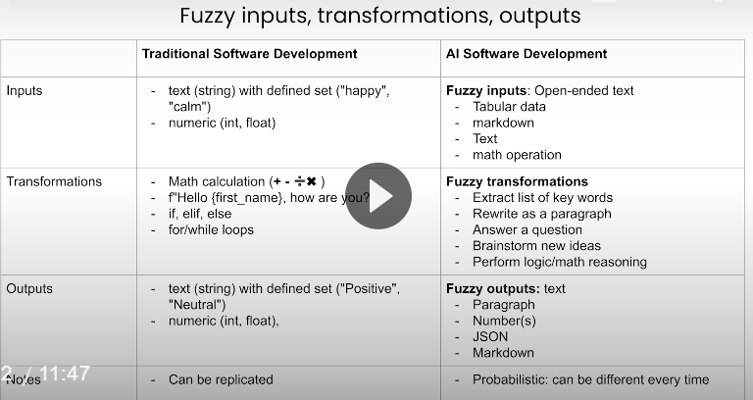

Best Practices for Agents

* Agents perform better when role-playing( Different agents for different role – like ( Editor, Researcher, Expert)
* Focus should be on goals and expectations
* One agent can do multiple task
* Task can be executed in different ways and orders

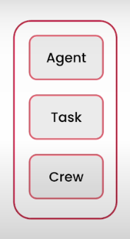

Notes

* Har agents pe ek role ( yani kya hai wo ex editor, reviewer, researcher) , ek specific goal ki wo kya Karega ( editor edit Karega, reviewer proofread Karega ) aur ek backstory ( Usko context dene ke liye ( man lo editor hai to “you are a editor and you have to create this to include this , not that, in this way in that way” aisa karke

Delegations in agents

* You can create agents that can delegate task to other agents
* However it is to be noted that setting delegation property to true doesn’t guarantee that the agent will call the other agent. It can or it cannot.

from crewai import Agent, Crew, Task

researcher = Agent(

    role="Research Specialist",

    goal="Find accurate, up-to-date information",

    backstory="Expert in sourcing and verifying data",

    allow_delegation=True,

    verbose=True

)

writer = Agent(

    role="Content Writer",

    goal="Create engaging content",

    backstory="Skilled in transforming research into readable articles",

    allow_delegation=True,

    verbose=True

)

crew = Crew(

    agents=[researcher, writer],

    tasks=[...],

    verbose=True

)

**How to create a great Multi-Agents Systems**

* Start thinking like a manager ( What are the things I need to get done)
* Then assign those task to specialist under you ( Writer to write, Senior Customer Support Specialist for customer support)

**Top Characteristics of an agent**

* Role Playing
* Focus
* Tools
* Cooperation
* Guardrails
* Memory

**Tools**

**tools can be considered external support systems** that AI agents use to perform specific tasks more effectively.

**🧰 What Are Tools in CrewAI?**

In CrewAI, **tools** are modular functions or services that agents can use to:

* Access external data (e.g., web search, APIs)
* Perform computations (e.g., math, data analysis)
* Interact with files or databases
* Communicate with other systems

Tools should have the following properties:

* Versatile
* Fault-tolerant
* Caching ( Normally tools external web( of course several other things) se baat karega to baar baar request marne se acha hai cache kar lo)

Properties of a Task

* Clear and concise explanation of what actually the task is
* Clear and realistic expectations

Serper vs Scraper

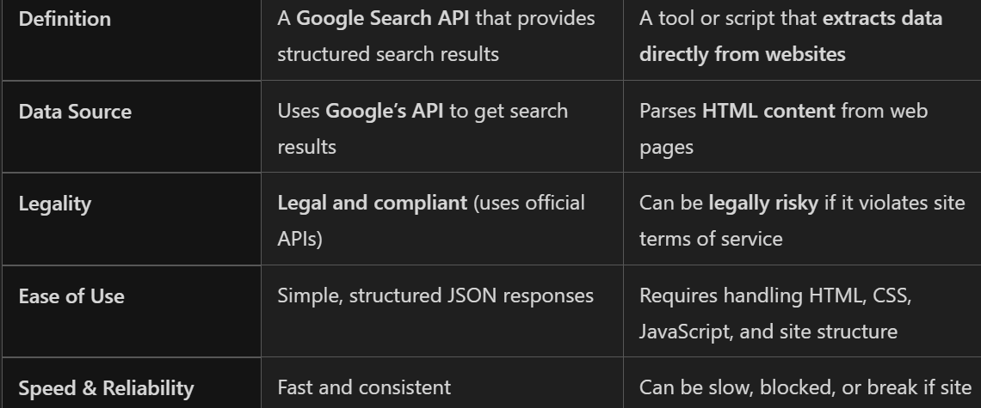

**Mental Framework for creating an agent**  
  
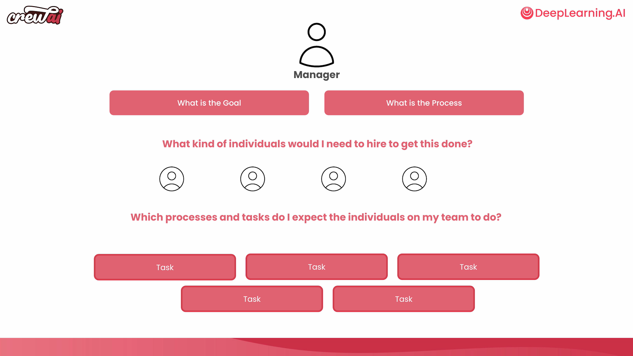

Collaboration among Agents ( Agentic Collaboration)