
COMPANY PROFILE
Textile Training • Consultancy • Troubleshooting
Precision. Quality. Performance.

Who We Are
Precision Quality Services (PQS) is a specialized textile consultancy and training company focused on helping textile organizations improve quality, productivity, process control, and operational performance.
We combine technical knowledge with hands-on problem-solving and process improvement to help manufacturers achieve consistent quality and sustainable growth. Our work is rooted in the real challenges of the factory floor — not boardroom theory.
"Better processes create better quality. Better quality creates satisfied customers. Satisfied customers create sustainable business growth."
Our Vision
To become a trusted textile industry partner recognized for delivering practical knowledge, effective solutions, and measurable improvements in quality and performance.
Our Mission
To support textile organizations through professional training, technical consultancy, and practical troubleshooting that strengthen people, processes, and product quality.

Our Core Services
Textile Training
Practical, industry-focused training programmes for production teams, supervisors, and quality personnel.
- Textile quality management
- Quality control & assurance
- Defect identification
- Root cause analysis
- Process control fundamentals
- Inspection & testing
Textile Consultancy
Helping organizations strengthen processes and build more effective, practical quality systems.
- Quality system improvement
- Process evaluation & mapping
- Quality performance improvement
- Defect & rejection reduction
- Process standardization
- CAPA implementation
Troubleshooting
Structured support to resolve recurring issues at the source, not just the symptoms.
- Problem identification
- Data collection & analysis
- Process investigation
- Defect analysis
- Root cause analysis
- Verification of results

Our Approach
A structured, practical engagement — from first conversation to sustained results.
01. Understand: We map the organization's processes, objectives, and specific challenges.
02. Analyze: We examine available data, workflows, quality issues, and contributing factors.
03. Identify: We pinpoint root causes using systematic problem-solving techniques.
04. Improve: We develop practical corrective and improvement actions.
05. Implement: Where required, we support the organization during implementation.
06. Sustain: We establish controls and practices that maintain improvement long-term.
Troubleshooting Methodology
Problem → Root Cause → Corrective Action → Preventive Action
Training Philosophy
Rather than focusing only on classroom theory, our training incorporates practical examples, real textile problems, case studies, and workplace situations — helping participants connect technical concepts with their day-to-day responsibilities.
Consultancy Philosophy
Every textile organization has different processes, people, products, and challenges. We aim to understand the actual situation, identify improvement opportunities, and develop practical solutions appropriate to each organization.

Our Value & Why PQS
Our Value to Textile Organizations
- Improved product quality: Consistent output that meets specifications
- Reduction in defects: Fewer rework cycles, lower waste
- Better process control: Stability across all production stages
- Employee development: Stronger technical capability at every level
- Root-cause identification: Problems solved at the source
Why Precision Quality Services
- Practical Industry Focus: Services designed around real textile manufacturing challenges.
- Customized Solutions: Training and consultancy adapted to each organization's specific needs.
- Quality-Oriented Approach: Focus on consistency, process control, and product quality.
- Problem-Solving Mindset: Technical problems addressed systematically to find underlying causes.
- Continuous Improvement: Sustainable gains — not temporary fixes.

Our Service Model
Who We Serve
Spinning • Weaving • Knitting • Dyeing • Processing • Printing • Garments • Home Textiles • Textile Finishing • Quality & Testing
Our Target Audience
Textile Professionals | Quality Managers | Quality Control Teams | Production Managers | Production Supervisors | Technical Managers | Process Engineers | Inspectors | Laboratory Personnel | Operators | Management Teams
Future Programmes
PQS is continuously developing new training and consultancy programmes based on industry needs and emerging challenges. Our goal is to expand our offerings while maintaining the practical, quality-focused approach that defines our work.

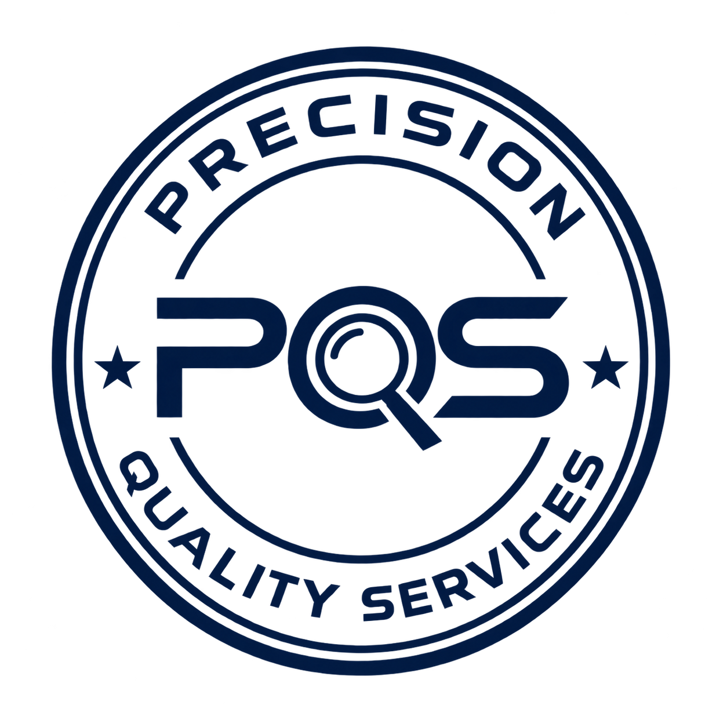
Our Commitment
Improve Knowledge.
Improve Processes.
Improve Quality.
Improve Performance.
Our Promise
Precision in Knowledge. Quality in Processes.
Solutions to Problems. Performance through Improvement.
Contact Us
Phone: [Your Phone Number]
Email: [Your Email Address]
Website: [Your Website]
Location: [City, Country]
LinkedIn: [LinkedIn Profile]
Let's Improve Textile Quality Together.

