



PRECISION QUALITY SERVICES
Textile Training | Consultancy | Troubleshooting

Precision. Quality. Performance.

WHO WE ARE  Precision Quality Services (PQS) is a premier textile consultancy and training firm dedicated to elevating the operational standards of textile manufacturers.  Born from a deep understanding of the industry's complex challenges, we deliver hands-on, practical solutions that drive measurable improvements in quality, process control, and overall productivity. We believe that better processes create better quality, better quality creates satisfied customers, and satisfied customers create sustainable business growth.  OUR VISION  To become the textile industry's most trusted partner—recognized for delivering practical knowledge, effective solutions, and measurable improvements in quality and performance.  OUR MISSION  To empower textile organizations through elite professional training, strategic technical consultancy, and systematic troubleshooting to fortify their people, processes, and products. | 

OUR CORE SERVICES
 | TEXTILE TRAINING  Equipping your workforce with the skills that matter. From quality control and defect analysis to root cause identification and supervisory development, our customized training programs bridge the gap between classroom theory and factory floor reality.  TEXTILE CONSULTANCY  Transforming operations through strategic insight. We partner with you to refine quality systems, standardize processes, and eliminate inefficiencies, replacing theoretical advice with practical, implementable solutions.  TROUBLESHOOTING  Systematic resolution for complex manufacturing challenges. We don't just treat symptoms; we investigate deep-rooted process variations to establish corrective and preventive actions (CAPA), safeguarding your production from recurring defects.

OUR APPROACH
At Precision Quality Services, we follow a structured, six-step practical approach to ensure sustained results.
01. UNDERSTAND  Map the organization's processes, objectives, and specific challenges. | 02. ANALYZE  Examine available data, workflows, and quality issues meticulously.
03. IDENTIFY  Pinpoint root causes using proven problem-solving techniques. | 04. IMPROVE  Develop actionable, corrective, and improvement strategies.
05. IMPLEMENT  Provide hands-on support during the rollout of new practices. | 06. SUSTAIN  Establish controls to guarantee long-term success and consistency.



OUR VALUE TO TEXTILE ORGANIZATIONS  - Improved product quality & consistency  - Significant reduction in defects & rework  - Better process control across all departments  - Enhanced employee technical knowledge  - Faster and effective root-cause identification  - Stronger, resilient organizational quality culture  WHO WE SERVE  Spinning • Weaving • Knitting • Dyeing • Processing • Printing • Garments • Home Textiles • Textile Finishing • Quality & Testing | 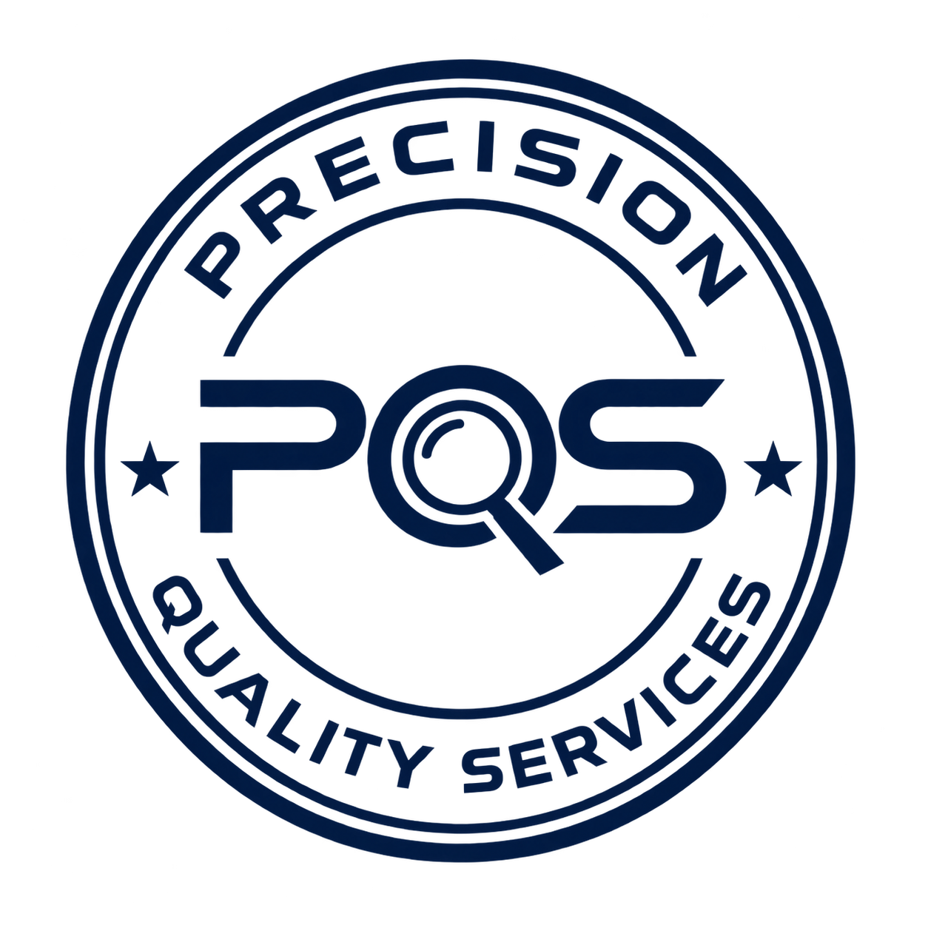

CONTACT US


OUR PROMISE
Precision in Knowledge. Quality in Processes.
Solutions to Problems. Performance through Improvement.

Precision Quality Services
Phone: +[Your Phone Number]
Email: info@pqs-textile.com
Website: www.pqs-textile.com
Location: [City, Country]
Let's Improve Textile Quality Together.

