INT 6203 – Final Project Report
House Price Prediction Using Machine Learning
1. Introduction
The purpose of this project is to predict house sale prices using machine learning methods. House price prediction is an important topic in the real estate industry because it helps buyers understand whether a house is fairly priced and helps sellers decide how to price their property. Traditionally, house prices are estimated using manual analysis and experience, which can take time and may not always be accurate. Machine learning provides a way to use past housing data to make predictions in a more consistent and data-driven manner.
In this project, machine learning models are used to study different housing features such as the size of the house, its location, construction quality, and overall condition. By examining how these features affected prices in the past, the models attempt to predict the sale price of houses that were not included in the training data. The goal is not only to build a model but also to understand how different factors influence house prices.
The dataset used for this project is House Prices: Advanced Regression Techniques, which is available on Kaggle. This dataset includes detailed information about residential houses and contains both numerical and categorical features. Because of its size and complexity, it is suitable for applying data preprocessing and regression techniques discussed in the INT 6203 course.

Primary Objectives
The main objectives of this project are:
- To explore the housing dataset using basic statistics and visualizations
- To identify which features have the strongest effect on house prices
- To clean and preprocess the data before applying machine learning models
- To train and test multiple regression models
- To compare model performance and choose the best one
- To clearly explain the modeling process and results in simple terms
These objectives follow the general steps of a machine learning project covered in INT 6203.

Training Supervision
This project uses supervised learning. In supervised learning, the dataset includes known output values that the model learns from. In this case, the output variable is SalePrice, which represents the actual selling price of each house. The model learns patterns by comparing predicted prices with the actual prices.

Type of Task
The task in this project is a regression problem. This is because SalePrice is a numerical value. Regression models are used when the goal is to predict a continuous number rather than assigning data points to categories.

Learning Technique
The models in this project use batch learning, meaning that the entire dataset is available during training. Batch learning is suitable here because the dataset is fixed and does not change over time. Online learning was not needed since there is no real-time data involved.

2. Get the Data
Dataset Description
The dataset contains information about residential houses and includes:
- 1,460 records in the training dataset
- 80 input features, not including the target variable
- Numerical features such as lot size, living area, and year built
- Categorical features such as neighborhood, zoning, and house type
The target variable SalePrice represents the final selling price of each house.

Loading the Data
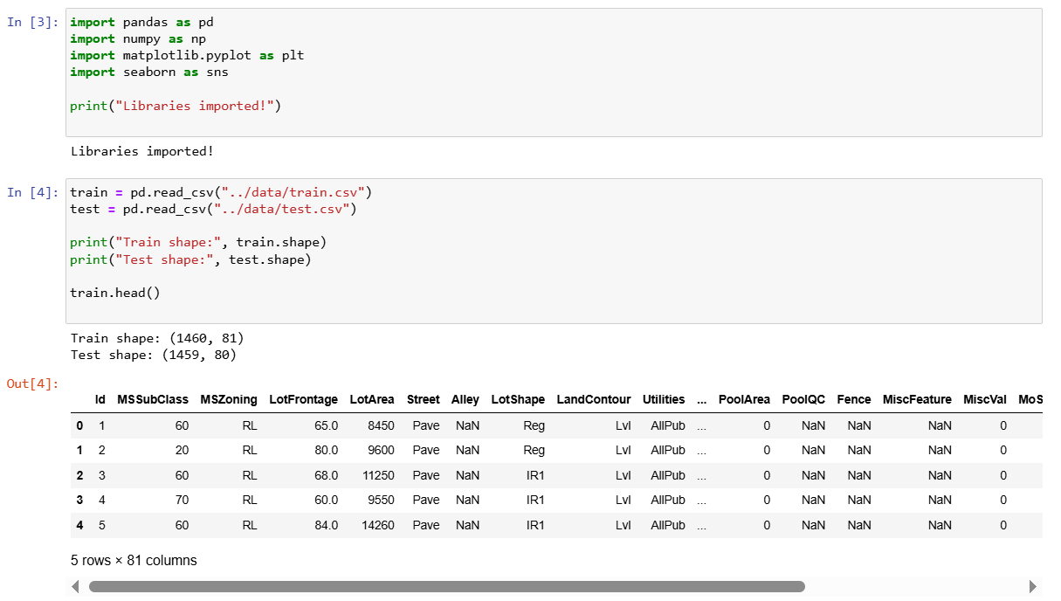
The dataset was loaded using the Pandas library in Python. Pandas allows easy reading of CSV files and provides useful functions for inspecting and analyzing data. The training and testing datasets were loaded separately to ensure that model evaluation was done correctly and without data leakage.

Assumptions About the Data
Before analysis, the following assumptions were made:
- SalePrice is numeric and suitable for regression
- Size-related attributes are numerical
- Location- and style-related attributes are categorical
- Missing values indicate unavailable information, not data entry mistakes
These assumptions helped guide data preprocessing decisions.

Initial Data Exploration
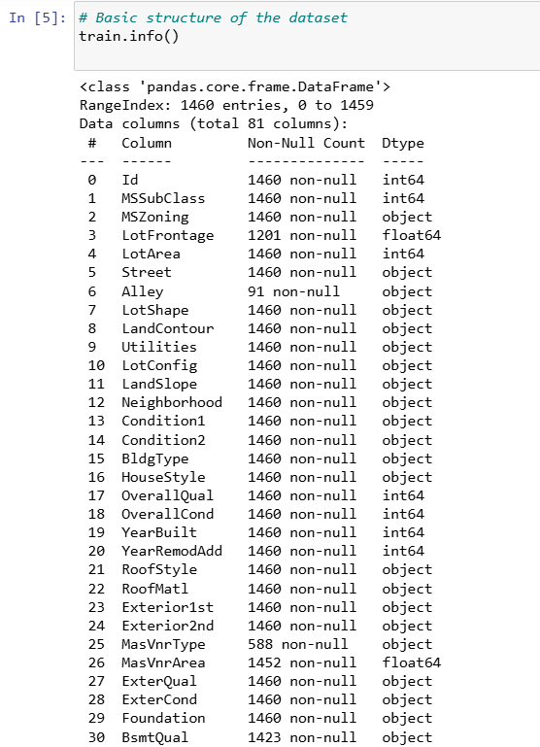
Initial exploration was done using common Pandas functions:
- head() to look at sample rows
- info() to check data types and missing values
- describe() to review summary statistics such as mean and range
This step helped identify missing values and understand the overall structure of the dataset.

3. Explore and Visualize the Data
Graphs Used
Several visualizations were created to understand the data better:
- A distribution plot of SalePrice
- A scatter plot showing the relationship between living area and sale price
- A boxplot to detect outliers
- A correlation analysis of numerical features
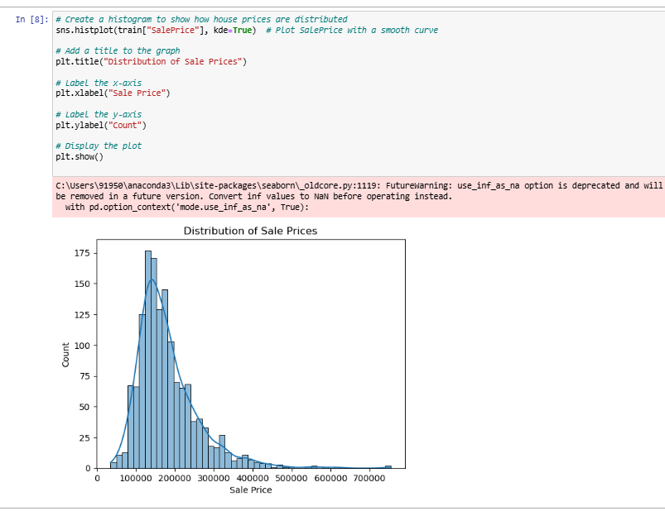
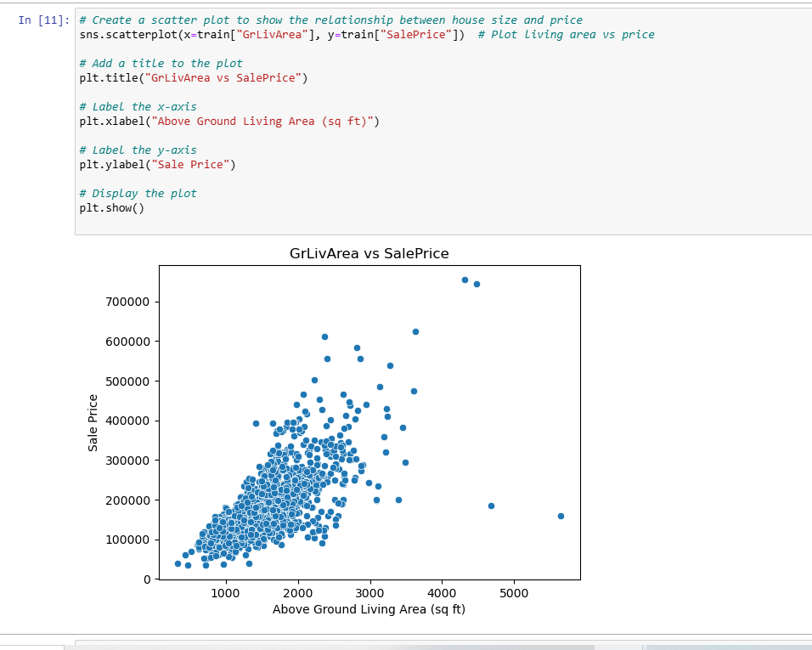
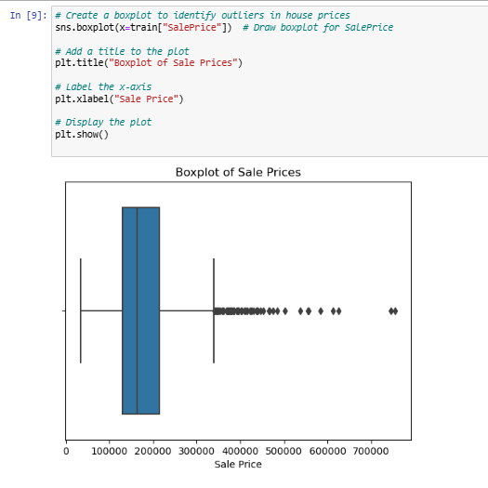

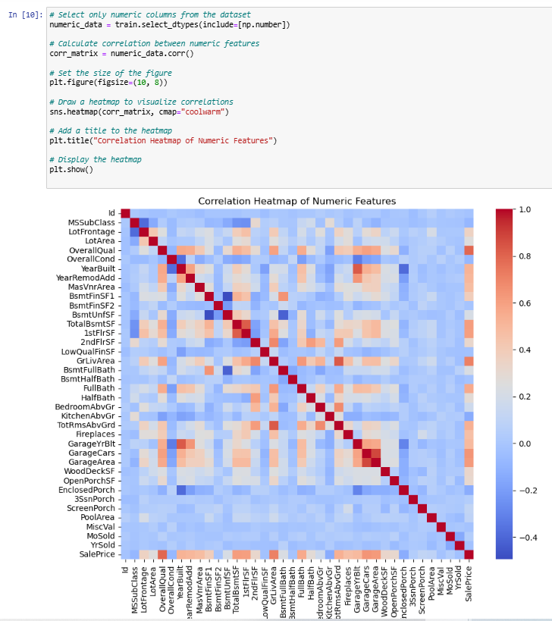
Key Findings
The exploratory analysis showed that:
- Sale prices are skewed to the right, with most houses priced in the lower to mid range
- Larger houses generally sell for higher prices
- A few houses have extremely high prices, which appear as outliers
- Some numerical features show strong relationships with SalePrice

Statistical Analysis
Basic statistics such as mean, median, variance, and standard deviation were used to understand the spread of numerical features. This analysis supported the need for scaling and using models that can handle variation in the data.

Handling Outliers and Correlation
Outliers were not removed manually. Instead, preprocessing techniques and model choices were used to reduce their influence. Correlation analysis helped identify features that were more important for prediction.

Guidance for Preprocessing
The insights from data exploration influenced decisions such as scaling numerical features, encoding categorical variables, and handling missing values.

4. Prepare the Data for Machine Learning
Preprocessing Steps
The following preprocessing steps were applied:
- Missing numerical values were replaced using the median
- Missing categorical values were replaced using the most common category
- Numerical features were scaled using StandardScaler
- Categorical features were encoded using One-Hot Encoding

Data Cleaning
Missing values were handled using automated methods to avoid losing data while keeping the dataset consistent.

Handling Outliers
Instead of removing outliers, preprocessing and model selection techniques were used to minimize their effect on predictions.

Data Partitioning
The dataset was split into:
- 80% training data
- 20% testing data
This allows the model to be tested on unseen data and helps prevent overfitting.
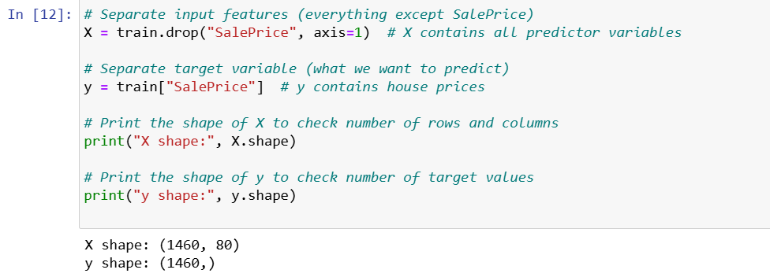
Ensuring Robust Preprocessing
A Pipeline with a ColumnTransformer was used to apply preprocessing steps consistently to both training and testing data. This helps prevent data leakage.
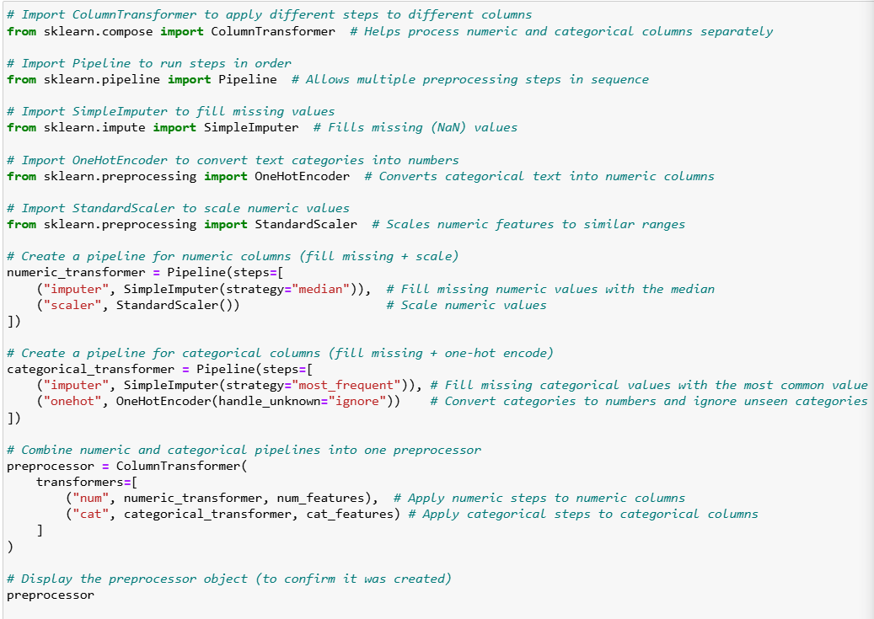

5. Select a Model and Train It
Model Selection
Two regression models were used:
- Ridge Regression, which is a linear model with regularization
- Random Forest Regressor, which is a non-linear ensemble model
Ridge Regression provides a simple baseline, while Random Forest can model more complex patterns.
Performance Measure
Model performance was measured using Root Mean Squared Error (RMSE). RMSE is suitable for regression tasks because it penalizes large prediction errors and uses the same units as house prices.

Model Results
- Ridge RMSE: 29,883
- Random Forest RMSE: 28,572
The Random Forest model produced lower error, indicating better performance.
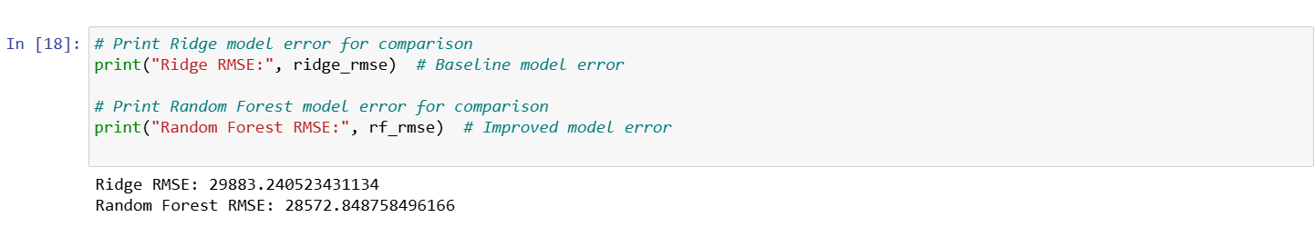

Learning Curve Analysis
A learning curve was created for the Random Forest model to study how performance changes with more training data. The results showed that validation error decreases as the dataset grows, suggesting improved generalization.
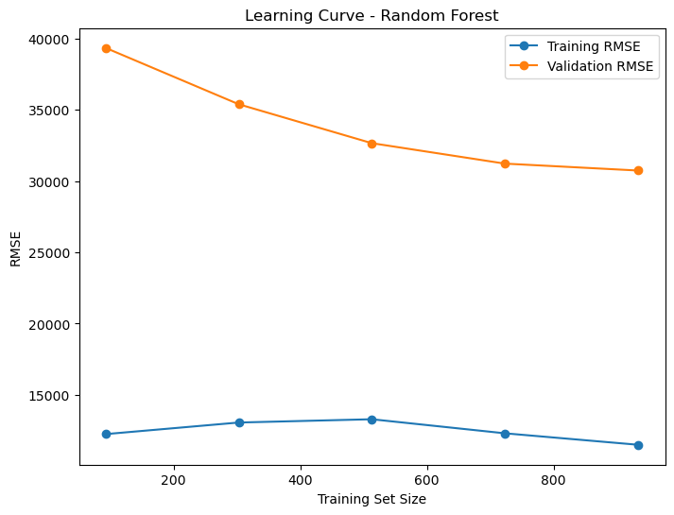

Overfitting and Regularization
Ridge Regression uses L2 regularization to reduce overfitting. The learning curve suggests some overfitting initially, which decreases as more data is used.

6. Fine-Tune the Model
Hyperparameter Tuning
After training the initial models, basic hyperparameter tuning was performed to improve performance. For the Random Forest model, key parameters such as the number of trees were adjusted manually. Different values were tested, and model performance was compared using RMSE. This process helped identify parameter settings that produced more stable and accurate predictions without making the model overly complex.
The goal of this step was not to exhaustively tune every parameter, but to understand how changes in model settings affect prediction accuracy and generalization.

Regularization Adjustments
Regularization was applied through Ridge Regression to control model complexity. By adding a penalty for large coefficient values, Ridge Regression helps prevent the model from relying too heavily on any single feature. This approach reduces the risk of overfitting and improves the model’s ability to perform well on unseen data. Regularization plays an important role when working with datasets that contain many features, as is the case with this housing dataset.

Evaluation Metrics
Root Mean Squared Error (RMSE) was consistently used as the evaluation metric during model training and fine-tuning. RMSE provides a clear measure of how far predictions are from actual values and allows easy comparison between models. Using the same metric throughout the project ensured that improvements in performance could be measured fairly and consistently.

7. Present the Solutions
Summary of Findings
Based on the results, the Random Forest Regressor achieved the lowest RMSE and was selected as the final model. Compared to Ridge Regression, Random Forest was better able to capture complex relationships between housing features and sale prices. This resulted in more accurate predictions on the test dataset.

Insights from Data
The analysis showed that house size, overall quality, and general condition have a strong influence on sale prices. Features related to living area and construction quality consistently contributed to higher predicted prices. These findings align with common expectations in the real estate market and confirm that the model learned meaningful patterns from the data.

Challenges and Limitations
One of the main challenges in this project was handling a dataset that contained both numerical and categorical features along with missing values. Careful preprocessing was required to prepare the data correctly for modeling. Another limitation is that model performance may vary when applied to housing data from different locations or time periods. Market conditions and regional differences can affect how well the model generalizes beyond the current dataset.

