Instruction Manual to use this UBX application/software

# Step-1: Download and Install PyCharm Software (Only first time)

This is the link where you can download the PyCharm software in which this application will run smoothly.

<https://www.jetbrains.com/pycharm/download/#section=windows>

On this link, you will see the screen as shown below. If your operating system is now Windows, select the different OS on this screen. Otherwise, just click blue download button.

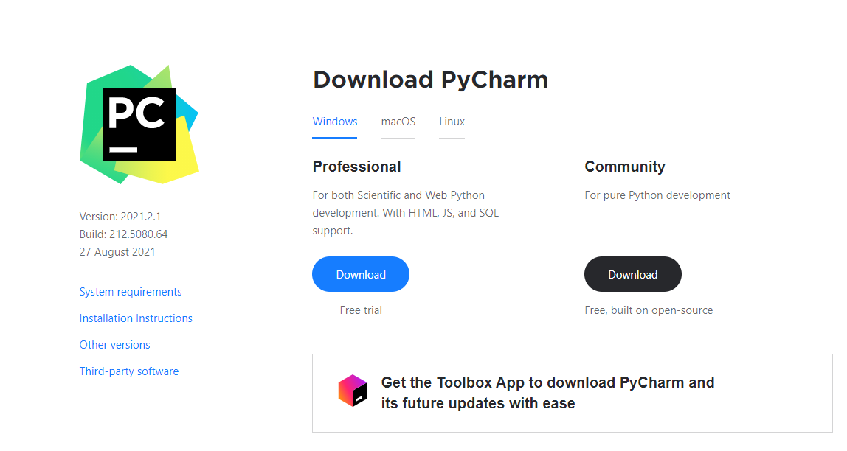

After downloading, open the downloaded file and install the software.

# Step-2: Initializing the Project in PyCharm (Only first time)

To create a new project, click on the **File->New Project**. Type desired name of the project, then click create. Here for an example, I have set “pythonProject2” as shown in picture below.

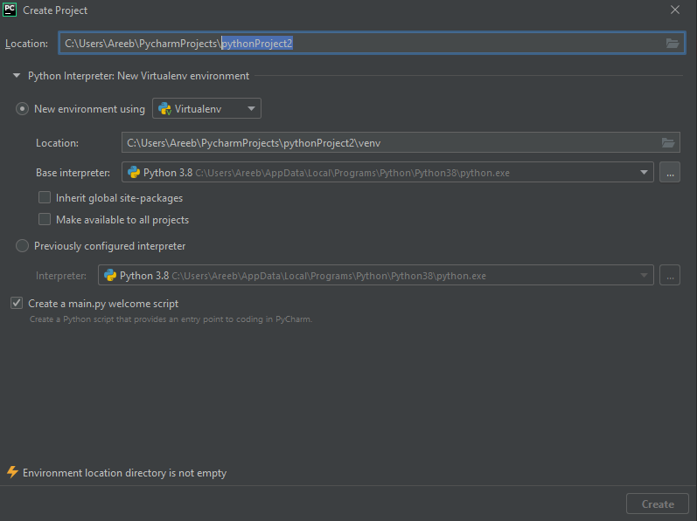

# Step-3: Add required libraries (Only first time)

Now add the required libraries for the development of the project. For this,

go to File->settings>Project:<your_project_name>

In our present case, it will be: File->Settings->Project: pythonProject2

Now click on yellow highlighted **“+”** sign in the picture below:

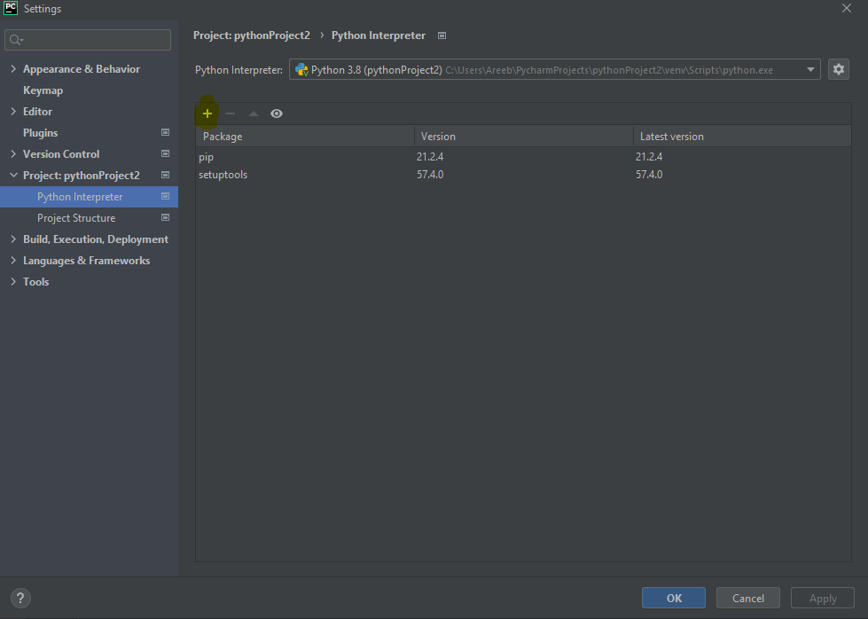

A new window will open, now type following keywords one by one. For each press “Install Package” on the bottom as shown with yellow highlight in the picture below.

* numpy
* pip
* pyserial
* setuptools
* xlwt

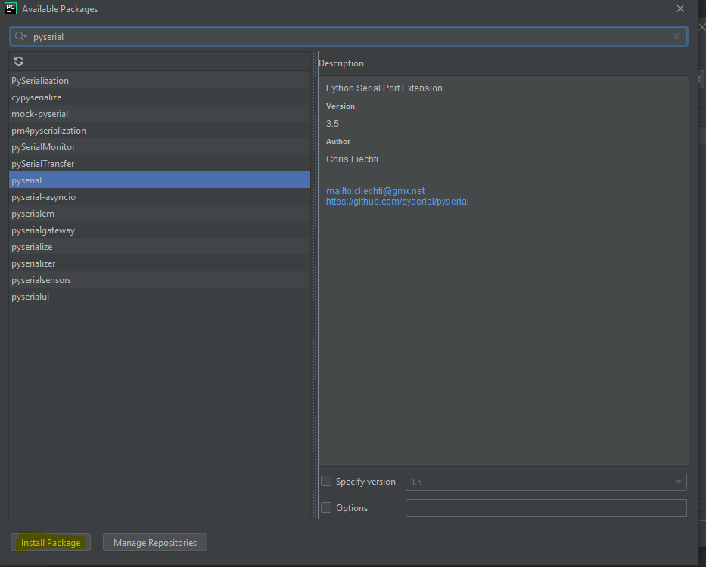

**In the available options, select the one which has just the name you typed, not the one with additional word.**

# Step-4: Download and extract the project folder/files (Only first time)

Now download the zip file and extract in your preferred location in computer. Open the folder. Open the “**config.py**” file with PyCharm software.

# Step-5: Configure the serial port

On line 14, write the port number (example PORT = ‘COM9’) of your u-blox receiver connected to your computer. To find the port, open search of windows. Type “Device Manager”

A new window will open, go to the ports and click on it to see the serial port number. In our present case, it is COM9 as shown in picture below:

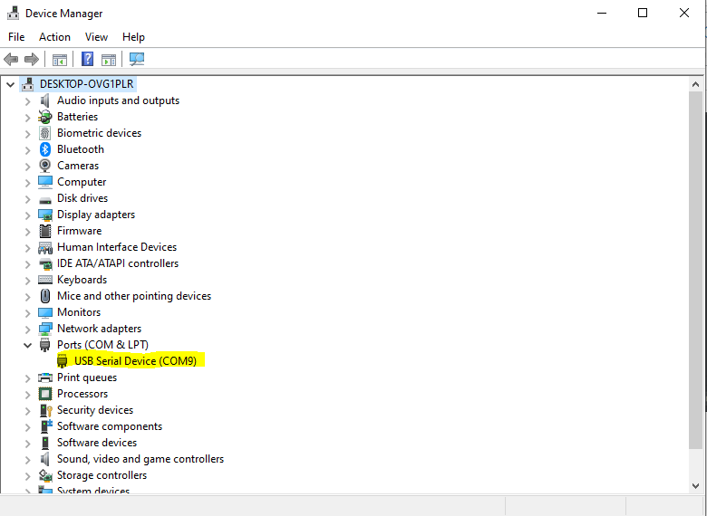

# Step-6: Run the project and see the results

Now go the extracted folder again, and open the “**getubxdata**” file in PyCharm.

The file will appear as tab in the software. **Right click on it, and then click “Run ‘getubxdata’ ”**

This will run all the project and will **autogenerate the excel file** in the same folder with **name “ubx data**”. Open the file and see the results.

If you want to **increase the data recorded**, you can increase the number of recordings with **just one change**. **In the “getubxdata” file, go to line 32 which states**:

number_of_recordings = 20

Just change the number as you wish. By default it is 20.

If you want to rerun, **close the excel file**. **(IT’S AN IMPORTANT STEP TO CLOSE EXCEL FILE BEFORE RERUN)**. Then, go back to software and repeat the **right click + run**. Now come back again in the original folder to see the updated excel file.

In case of questions, feel free to email me areeb.tariq@yahoo.com