Database Project
NASA Exoplanet Explorer Database System

Members: Syeda Shandana Shah & Areeba Ali
Program: BS Artificial Intelligence
Semester: 4th (B)
Instructor: Sir Ali Hasan

Milestone | Date | Version | Remarks
ERD Diagram  Schema | 25/April/2026 | 1.0

ERD Diagram:
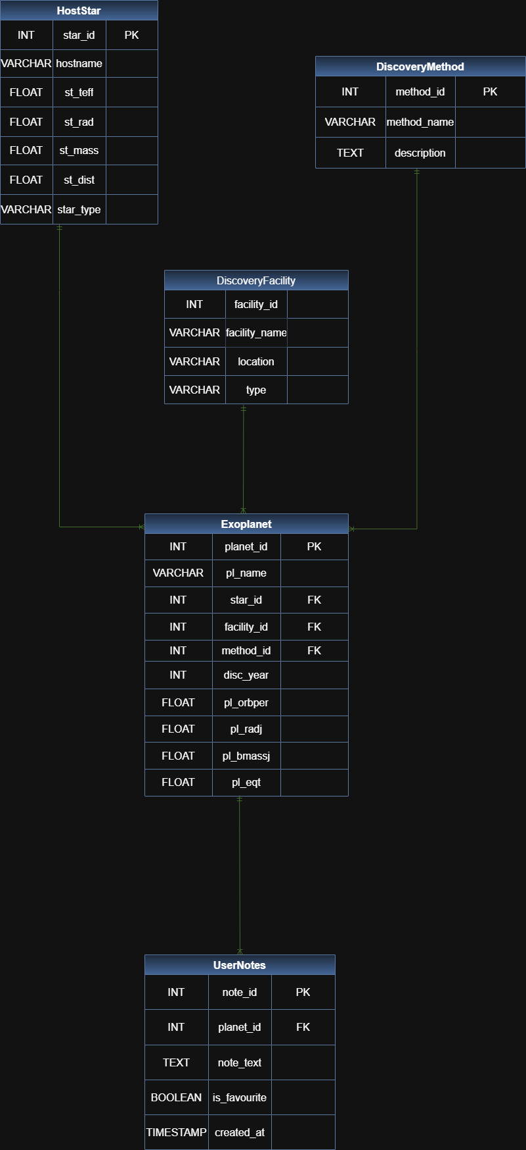
----------------------------------------------------------

Relational Database Schema Description:

Table 1: HostStar
Stores information about the star each exoplanet orbits. One star can host many exoplanets.
Attribute | Data Type | Constraints | Description
star_id | INT | PRIMARY KEY, AUTO_INCREMENT | Surrogate primary key
hostname | VARCHAR(100) | NOT NULL, UNIQUE | Star name (e.g., TRAPPIST-1)
st_teff | FLOAT | NULL | Effective temperature (Kelvin)
st_rad | FLOAT | NULL | Stellar radius (Solar radii)
st_mass | FLOAT | NULL | Stellar mass (Solar masses)
st_dist | FLOAT | NULL | Distance from Earth (parsecs)
star_type | VARCHAR(20) | NULL | Spectral class (e.g., M, G, K)

Table 2: DiscoveryFacility
Represents the telescope or instrument that detected each exoplanet (e.g., Kepler, TESS).
Attribute | Data Type | Constraints | Description
facility_id | INT | PRIMARY KEY, AUTO_INCREMENT | Surrogate primary key
facility_name | VARCHAR(150) | NOT NULL, UNIQUE | Official facility name
location | VARCHAR(100) | NULL | Geographic or orbital location
type | VARCHAR(50) | NULL | Space-based or ground-based

Table 3: DiscoveryMethod
Captures the scientific technique used to detect each exoplanet.
Attribute | Data Type | Constraints | Description
method_id | INT | PRIMARY KEY, AUTO_INCREMENT | Surrogate primary key
method_name | VARCHAR(100) | NOT NULL, UNIQUE | Method name (e.g., Transit)
description | TEXT | NULL | Explanation of the technique

Table 4: Exoplanet (central table)
The core entity. Each record is one confirmed exoplanet from the NASA Archive.
Attribute | Data Type | Constraints | Description
planet_id | INT | PRIMARY KEY, AUTO_INCREMENT | Surrogate primary key
pl_name | VARCHAR(100) | NOT NULL, UNIQUE | Planet name (e.g., TRAPPIST-1 e)
star_id | INT | FOREIGN KEY → HostStar | Host star reference
facility_id | INT | FOREIGN KEY → DiscoveryFacility | Discovery facility reference
method_id | INT | FOREIGN KEY → DiscoveryMethod | Discovery method reference
disc_year | INT | NOT NULL | Year of confirmed discovery
pl_orbper | FLOAT | NULL | Orbital period (days)
pl_radj | FLOAT | NULL | Planet radius (Jupiter radii)
pl_bmassj | FLOAT | NULL | Planet mass (Jupiter masses)
pl_eqt | FLOAT | NULL | Equilibrium temperature (Kelvin)

Table 5: UserNotes
Allows users to annotate any exoplanet record or mark it as a favourite.
Attribute | Data Type | Constraints | Description
note_id | INT | PRIMARY KEY, AUTO_INCREMENT | Surrogate primary key
planet_id | INT | FOREIGN KEY → Exoplanet, NOT NULL | Planet being annotated
note_text | TEXT | NOT NULL | User's annotation
is_favorite | BOOLEAN | DEFAULT FALSE | Marks planet as favourite
created_at | TIMESTAMP | DEFAULT CURRENT_TIMESTAMP | When the note was created

Relationships Summary:
Relationship | Cardinality | Description
HostStar → Exoplanet | 1 : M | One star hosts many exoplanets
DiscoveryFacility → Exoplanet | 1 : M | One facility discovers many exoplanets
DiscoveryMethod → Exoplanet | 1 : M | One method applies to many exoplanets
Exoplanet → UserNotes | 1 : M | One planet can have many user notes

---------------------------------------------------------------------------

