Areeba Riaz | i22-1244
CS-4015 Agentic AI - Homework 1 (Phase 1)
Semantic Search Module - Short Report
Building an AI Research Assistant for University Students

1. Problem Statement & Objective
Universities are overloaded with study material — lecture notes, course outlines, research summaries, policies, and FAQs. Students struggle to find relevant information quickly. This project builds the memory system (Phase 1) of an AI Research Assistant: a semantic search engine that retrieves relevant academic documents based on meaning rather than keywords.
The system provides a GUI-based application where users can upload text documents, configure embedding models and vector databases, perform top-k semantic retrieval, and evaluate retrieval quality across different configurations.

2. Implementation Summary

Task 1: GUI-Based Data Selection
- The GUI allows users to upload .txt documents via a file uploader. Dataset statistics (document count, total size, average character length) are displayed in stat cards. No dataset is hard-coded — all data comes from user uploads at runtime.

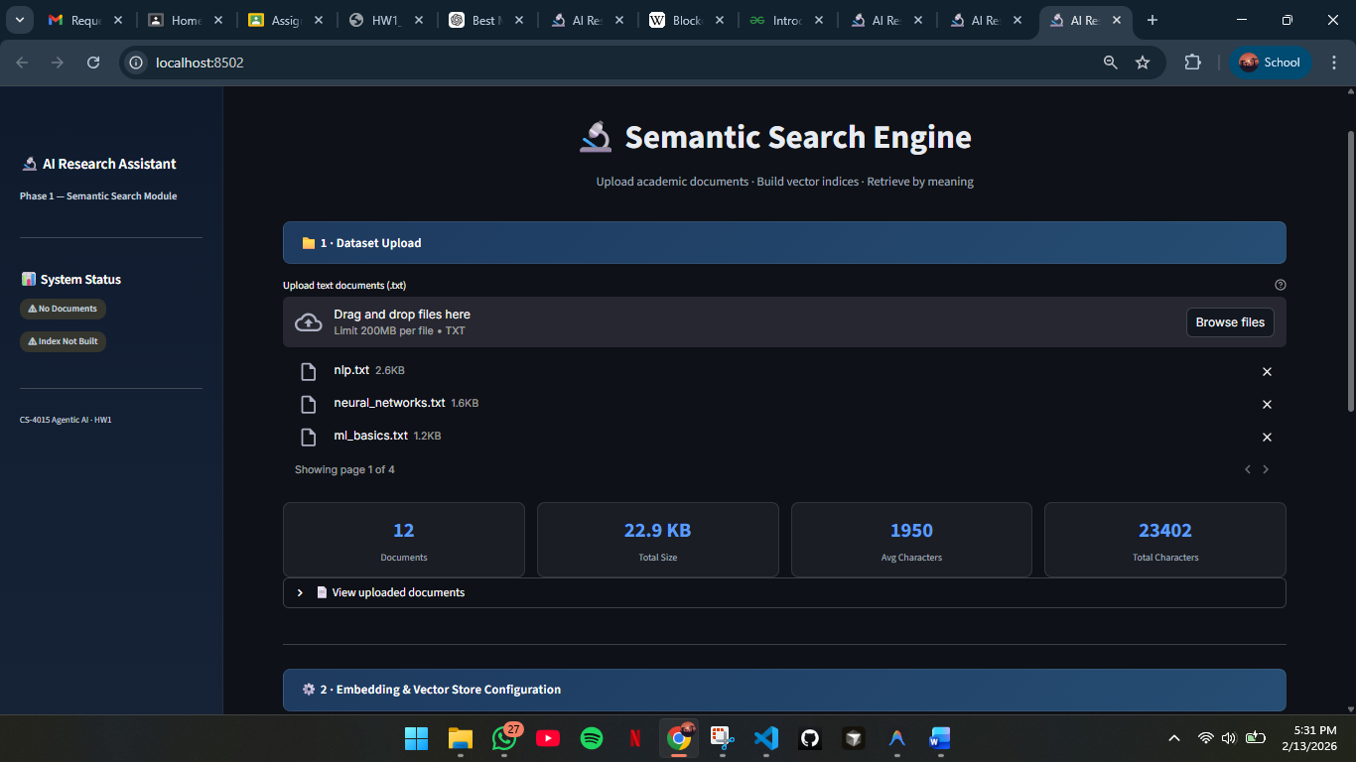

Task 2: Embedding & Vector Store Configuration
- Users select from 5 Hugging Face sentence-transformer models and choose between FAISS or Chroma as the vector database. Embeddings are generated and stored via LangChain. Chunk size and chunk overlap are also configurable.
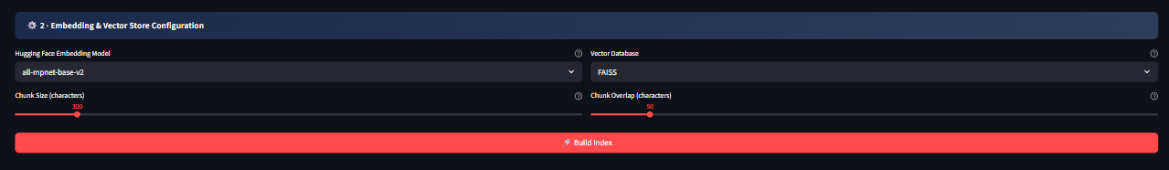

Task 3: Semantic Retrieval
- A query input box and top-k slider allow users to perform semantic similarity search. Results are displayed as ranked cards with relevance scores, source document names, and content previews — ordered by semantic similarity.
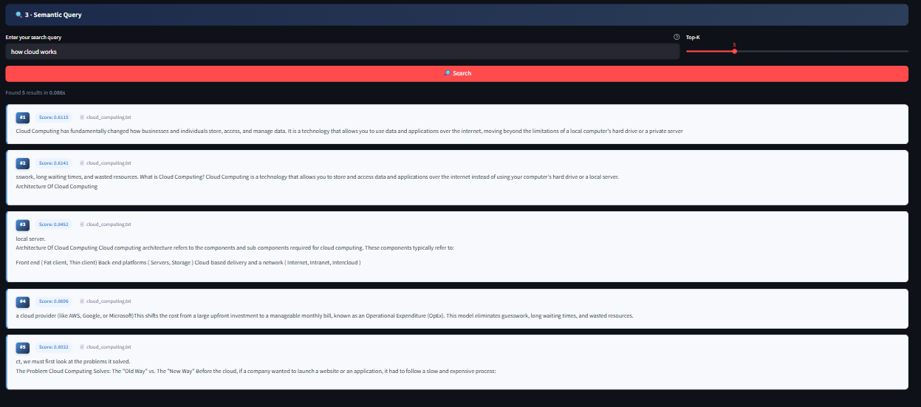

Task 4: Retrieval Evaluation & Analysis
- An integrated evaluation panel logs every query with its configuration (model, vector DB, top-k, latency). Users can run multiple queries, switch models/DBs, and compare results side-by-side for report writing.

3. Tools & Technologies
Component | Technology | Purpose
GUI | Streamlit | Web-based interface with custom CSS
Embeddings | HuggingFace + LangChain | 5 sentence-transformer models
Vector DB | FAISS / Chroma via LangChain | Similarity search & persistence
Text Splitting | Custom recursive splitter | Document chunking with overlap
Language | Python 3.10+ | Backend logic and orchestration

4. Embedding Models Used
Model | Dimensions | Key Strength
all-MiniLM-L6-v2 | 384 | Best speed/quality balance
all-mpnet-base-v2 | 768 | Highest retrieval quality
multi-qa-MiniLM-L6-cos-v1 | 384 | Optimized for question-answering
paraphrase-MiniLM-L6-v2 | 384 | Paraphrase & synonym detection
all-distilroberta-v1 | 768 | RoBERTa-based, diverse text types

5. Retrieval Evaluation & Observations
The system was tested with multiple queries across different embedding models and both vector stores. Key observations:
- Semantic understanding: The system retrieves documents based on meaning, not keywords. For example, querying "effects of global warming" surfaces documents about "climate change impacts" even without shared keywords.
- Model speed vs. quality: 384-dimension models (MiniLM family) are 2-3x faster to build indices while maintaining competitive retrieval quality. 768-dimension models (mpnet, distilroberta) provide marginal improvements for nuanced queries at higher latency.
- FAISS vs. Chroma: Both produce identical retrieval rankings for the same embeddings. FAISS is slightly faster for pure similarity search. Chroma offers automatic persistence and metadata filtering.
- Chunk size impact: Smaller chunks (200-300 chars) yield precise but fragmented results. Larger chunks (800+ chars) provide better context but may dilute relevance scores. A chunk size of 500 with 50-char overlap provides good overall balance.
- Top-K sensitivity: Increasing top-k beyond 5-7 adds diminishing value; results beyond rank 7-8 often have notably lower relevance scores.

Sample Test Results Table

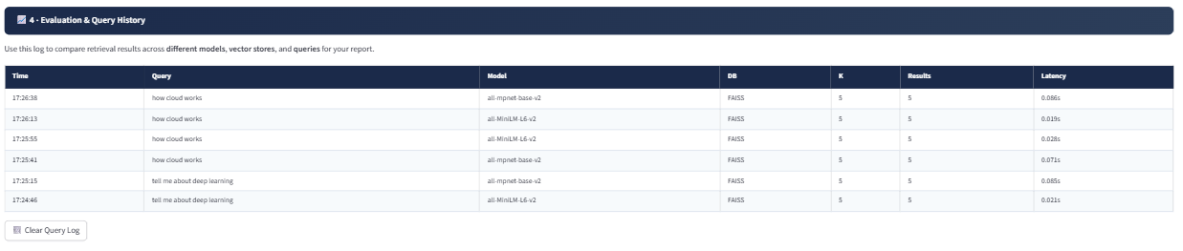

6. Conclusion
Phase 1 successfully delivers a fully functional semantic search module meeting all mandatory requirements: GUI-based data upload (no hard-coding), configurable embedding models and vector databases, top-k semantic retrieval with ranked results, and built-in evaluation logging. The modular architecture is ready for Phase 2 extension with Retrieval-Augmented Generation (RAG) capabilities.

