RIPHAH INTERNATIONAL UNIVERSITY, ISLAMABAD


Assignment 2
Bachelors of Computer science – 7th semester
Subject: Parallel and Distributed Computing

Submitted to: Ma’am Hajra Murtaza
Submitted by: Areeba Sadaqat
Sap Id: 47633
Date: 13th October, 2025

Task:
We need to implement a function that calculates the sum of elements of a 10000 array of integers serially i.e. with one thread and then with multiple threads. Note the execution times for each version and calculate the speed up with the multithreaded parallelized version. Give speed up with 4, 5 and 10 threads.
Note: We will have to initialize the array with random numbers - This will be the considered the non-parallelizable code. The sum calculation will be broken into smaller tasks assigned to each thread.

Output:
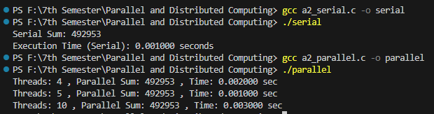
Speedup:
Serial Time = 0.001000 seconds
Parallel Time:
Threads | Parallel Time | Speed Up = 0.001000 / Parallel Time
4 | 0.002000 seconds | 0.5
5 | 0.001000 seconds | 1
10 | 0.003000 seconds | 0.3333

