

Faculty of Computing
Department of Computing
Laboratory Manual
CS-250: Data Structure and Algorithms
Class: BESE 16AB • Semester: Fall 2026 – 3rd Semester

Experiment No. 02

Dynamic Memory Allocation with Git and Unit Testing

Date  Time  Instructor(s)  Lab Engineer  Mapped CLO | 18 September 2026  09:00AM–11:50AM & 2:00PM–4:50PM  Dr Faisal Shafait  Hamza Fayyaz  CLO2 : Solve a given real time problem by applying appropriate data structure and algorithm.  CLO3 : Practice programs using the latest IDEs ensuring testing, documentation and packaging of programs as per standards practices applicable to the software industry. CLO4 : Demonstrate commitment to professional ethics by following engineering norms applicable to the software industry.:

National University of Sciences and Technology (NUST) • School of Electrical Engineering and Computer Science Laboratory Manual

1 Introduction

This lab focuses on two key aspects of software development:
- Dynamic Memory Allocation in C++ – a crucial programming concept that allows programmers to allocate and deallocate memory at runtime using the heap. This enables handling variable-sized data efficiently.
- Git & Unit Testing – professional software development practices. Git is an industry-standard version control system used for managing code changes and collaboration. Unit testing ensures correctness of individual program components.
Students will implement C++ programs using dynamic memory allocation while also managing their work with GitHub and writing simple unit tests.

2 Objectives

- Understand the difference between stack and heap memory in C++.
- Learn how to allocate and deallocate memory dynamically using new and delete.
- Practice version control using GitHub (init, clone, add, commit, push, pull, branch, merge).
- Learn to write basic unit tests to verify correctness of C++ functions.
- Integrate coding, testing, and version control into a complete workflow.

Task 1.
GitHub Account & Repository Setup (Step-by-Step) I. Create a GitHub Account:
- Go to https://github.com.
- Sign up with your email.
- Verify your email and set up your profile.
II. Create a New Repository:
- Click on New Repository.
- Repository name: DSA-Lab2.
- Choose Public.
- Check: Add README.md.
- Create the repository.

- Clone Repository to Local Machine
git clone https://github.com/<your-username>/DSA-Lab2.git cd DSA-Lab2
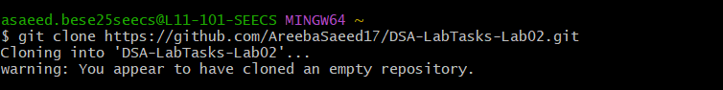
- Set Git Identity
git config --global user.name "Your Name" git config --global user.email "your@email.com"
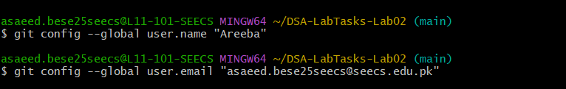

- Add a Starter Program: Create hello.cpp:
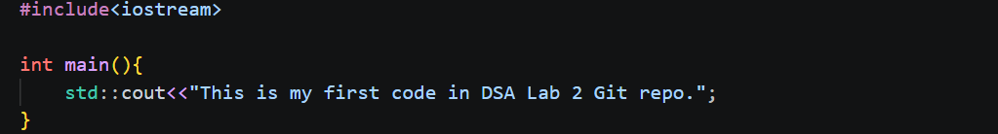

- Build and Run:
g++ hello.cpp -o hello hello

- Stage, Commit, and Push
git add hello.cpp git commit -m "Add hello.cpp starter program"
git push origin main

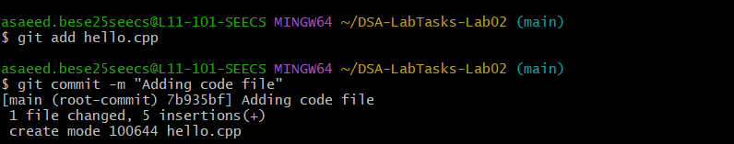
Task 2.

Task 2.
Dynamic Salary Program with Git Workflow
Rewrite the following program using pointers in place of arrays (use dynamic memory allocation operators new and delete).
Steps:
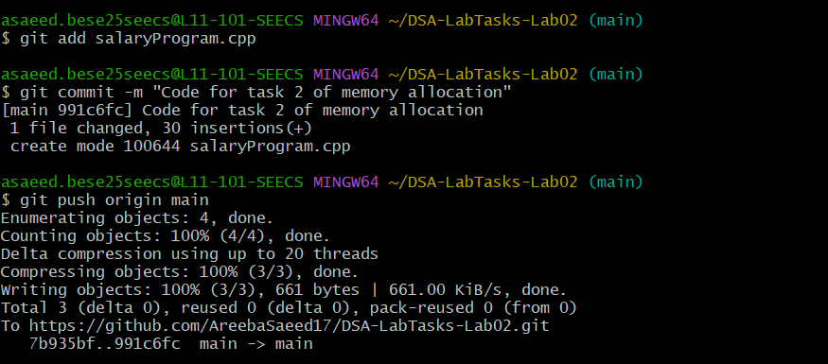
- Implement the program in salary.cpp.

// this is the program that uses dynamic memory allocation for an array to store salaries
#include <iostream>
using namespace std;
int main()
{
const int size = 20; // fixed array size
int *salary = new int[size]; // array on heap using the ptr salary

// Input salaries
for (int i = 0; i < size; i++) {
cout << "Enter Salary for employee " << (i + 1) << ": ";
cin >> salary[i];
}
// Apply increment formula
for (int i = 0; i < size; i++) {
salary[i] = salary[i] + salary[i] / (i + 1);
}
// Display updated salaries
cout << "\nUpdated Salaries: ";
for (int i = 0; i < size; i++) {
cout << salary[i] << " ";
}

// freeing memory
delete[]salary;
}

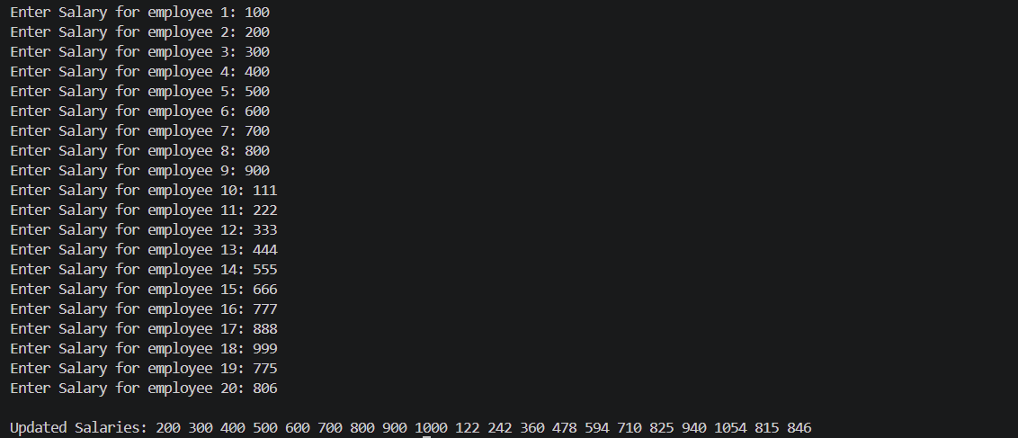
Output

Task 3.
Analyze Pointer Program with Git Workflow
Complete the following two parts for the analyze pointer problem.
Part 1: Write a function void analyze_pointer(int *ptr) that does two things:
- Write the memory location pointed to by the pointer to the console.
- Write the value of the integer (which the pointer points to) to the console.
Part 2: Use the function to complete two tasks:
- Allocate an int on the stack (e.g., int iValue;), assign a value to it, and get its memory location (with the reference operator &) to pass this value to analyze_pointer.
- Allocate an int on the heap (with the new operator). Assign a value to it and pass it to analyze_pointer.
// this program shows the working of a ptr using the analyze ptr function
#include <iostream>

// this will receive a ptr and print the following data

void analyze_pointer(int *ptr){

// write the memory address of the ptr to the console
std::cout << &ptr<<std::endl;

//write value of integer the pointer points to
std::cout << *ptr<<std::endl;
}

int main()
{
// allocating an int on stack
// testv has been declared and assigned a value
int testv = 100;

// passing address of the int variable to the function
std::cout<<"Values for 1st call of function"<<std::endl;
analyze_pointer(&testv);

// allocating int on heap
int *heapv = new int();
// assigning it value
*heapv = 1500;

// passing the heap variable address to function
std::cout<<"Values for 2nd call of function: "<<std::endl;
analyze_pointer(heapv);
}

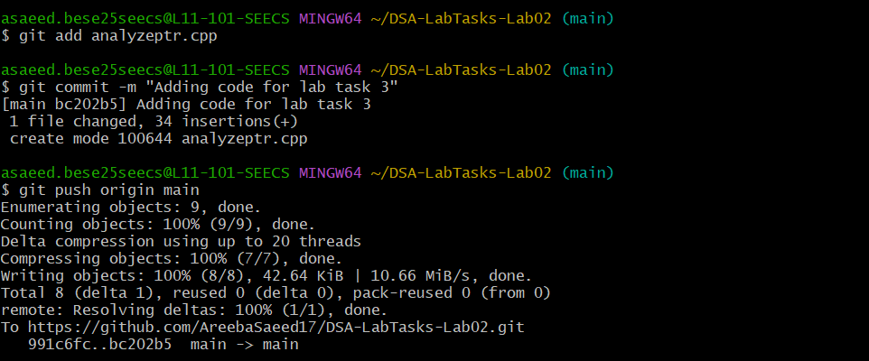
Output

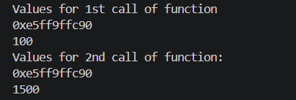

Task 4.
Dynamic String Reversal with Git Workflow
Write a program that dynamically allocates memory for a string, takes input from the user, reverses the string, displays the reversed result, and finally frees the allocated memory. You must also upload this program (string_reverse.cpp) to your GitHub repository.
// this program reverses the string given by the user
#include <iostream>
#include<string.h>
#include<utility>
using namespace std;

void StringReversal(){

// dynamically allocating memory for the string
string *Str = new string() ;

// taking user input
cout << "Enter the string of your choice to reverse it..\n";
// getting a full line input via getline
getline(cin, *Str);

// getting size of the string
// since it is on heap it can be accessed using the ptr name so for getting length
// i had to use ->length()
int size = Str->length();

// logic for swap
// get the size and find the midpoint
// i need to exchange index 0 with index 9
// index 1 with 9
// index 2 with 8 and so on
// this can be generalized as size-currentindex-1 = i mathematically
// Ive first dereferenced each element of the string using dereferencing operator
// and then swapped the individual characters at the positions using the formula

for( int i = 0; i < size / 2; i++) {
swap((*Str)[i], (*Str) [size-i-1] );
}

// printing the reversed string
cout<<"\n Following is the reversed string: \n";
cout<<*Str;

delete Str; // freeing up memory
}
int main()
{
// calling the function
StringReversal();

}

Output

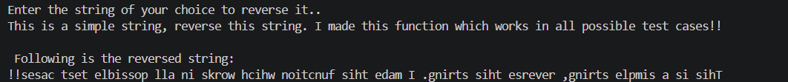

GIT WORKFLOW
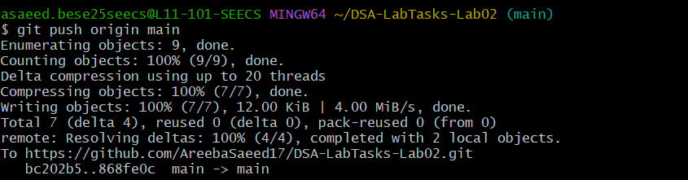
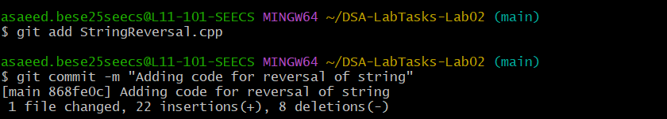

Task 5.
Test-Driven Development (TDD): Checking a Sorted Array
In this task, you will practice Test-Driven Development (TDD) by developing a function that determines whether an integer array is sorted. You must write the test cases before implementing the complete function.
Implement the following function:
bool isSorted(const int* arr, const int size);
1
The function should return true if the elements of the array are arranged in non-decreasing (ascending) order. Otherwise, it should return false. For example:
- {1, 2, 3, 4, 5}→true
- {1, 2, 2, 3, 5}→true
- {1, 4, 3, 5, 6}→false
Part 1 – Write the Tests First
Before implementing the complete isSorted() function, write test cases using assert() to verify its expected behavior.
At minimum, your test cases should cover:
- An array already sorted in ascending order.
- An unsorted array.
- A sorted array containing duplicate values.
- An array containing only one element.
- An array sorted in descending order.
- An array containing negative values.
- At least two additional test cases designed by you.
Example test:
void testSortedArray() { int arr[] = {1, 2, 3, 4, 5}; bool result = isSorted(arr, 5);
assert(result == true);
}

Students should create separate test functions, for example:
testSortedArray(); testUnsortedArray(); testDuplicateValues(); testSingleElement(); testDescendingArray(); testNegativeValues();
Part 2 – Implement the Function
After writing the initial test cases, implement the isSorted() function.
Your implementation should compare neighboring elements of the array and determine whether any element appears before a smaller element.
Run the test cases after each significant change to your implementation. Continue modifying the function until all test cases pass.
Do not modify a correct test simply because your implementation fails it. Determine why the implementation failed and modify the implementation accordingly. Part 3 – Demonstrate the TDD Cycle
Choose at least one test case that initially fails and document the TDD process in your lab report. Include:
- The test case you wrote.
- The initial result of the test (Pass/Fail).
- Why the test failed.
- The modification you made to isSorted().
- The result after modifying the implementation (Pass/Fail).
Your work should demonstrate the following TDD cycle:
Write Test → Run Test → Test Fails → Modify Code → Run Test Again → Test Passes
Part 4 – Git Workflow
Use Git to demonstrate that the test cases were written before the final implementation. Your Git commit history should clearly show the progression of your work.
Suggested commits:
Add initial tests for isSorted function
Implement isSorted function
Add edge case tests for isSorted
Handle additional edge cases
Push the completed implementation and all test cases to your Lab 2 GitHub repository.
Expected Outcome
At the end of this task, you should be able to:
- Write test cases before implementing a function.
- Identify normal, boundary, and edge cases.
- Use assert() to verify expected program behavior.
- Modify an implementation based on failing tests.
- Apply the Test-Driven Development cycle to a simple programming problem.
- Use Git commits to document the development and testing process.
