**Computational Biology, Programming and Practice**

**Name:** Areeba Salman

**Student ID:** 20697113

**Course Code:** LIFE4138

**Date:** 28/01/25

**Coursework Part 2:** R Studio

**DGEA Analysis for A vs E**

***Summary Statistics:***

**Number of significantly upregulated and downregulated genes (based on p-value and fold change thresholds) for each comparison.**

**Summary of p-values and log fold changes across all genes for each comparison.**

|  |  |
| --- | --- |
| **Regulation** | **Count** |
| Downregulated | 916 |
| Non-Significant | 4618 |
| Upregulated | 560 |

* logfc_threshold <- 1 # Log fold change threshold
* pvalue_threshold <- 0.05 # P-value threshold

***Plots:***

**Volcano plots to visualize the significance and magnitude of changes in gene expression for each comparison.**

Figure 1 highlights the volcano plot to of differential gene expression to identify the significance and magnitude of changes in gene expression.

**MA plot to display the relationship between the log fold change and mean expression.**

Figure 2 shows the MA plot for the display of relationship between the log2FoldChange and mean expression.

**Histogram of p-values to assess the distribution of statistical significance.**

Figure 3 indicates the histogram of p-values to access the distribution of statistical significance.

**Heatmap of the top differentially expressed genes to illustrate gene expression patterns across the conditions.**

Figure 4 describes heatmap of top differentially expressed genes to illustrate gene expression patterns across the conditions.

***Significant Gene Lists:***

**A table or list of significantly upregulated and downregulated genes with their corresponding fold changes, p-values, and adjusted p-values.**



**Additional Analyses:**

**Any relevant insights, such as potential biological pathways affected by differentially expressed genes or clustering of gene expression patterns.**

Pathway enrichment analysis was performed using KEGG, revealing that upregulated genes were strongly associated with metabolic pathways and inflammatory signaling, while the downregulated genes were involved in cellular stress response.

**DGEA Analysis for A vs F**

***Summary Statistics:***

**Number of significantly upregulated and downregulated genes (based on p-value and fold change thresholds) for each comparison.**

**Summary of p-values and log fold changes across all genes for each comparison.**

|  |  |
| --- | --- |
| **Regulation** | **Count** |
| Downregulated | 821 |
| Non-Significant | 4895 |
| Upregulated | 627 |

* logfc_threshold <- 1 # Log fold change threshold
* pvalue_threshold <- 0.05 # P-value threshold

***Plots:***

**Volcano plots to visualize the significance and magnitude of changes in gene expression for each comparison.**

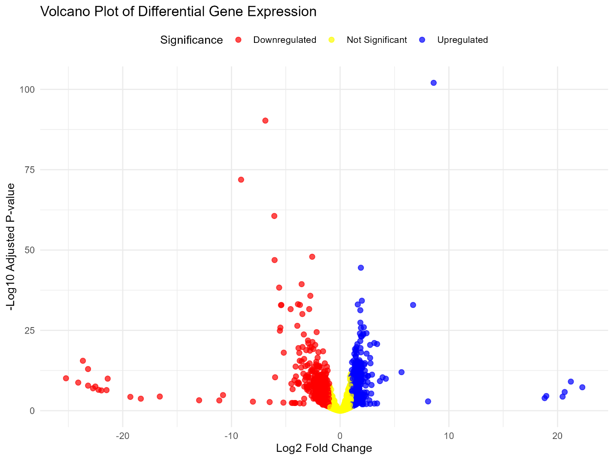

Figure 1 highlights the volcano plot to of differential gene expression to identify the significance and magnitude of changes in gene expression.

**MA plot to display the relationship between the log fold change and mean expression.**

Figure 2 shows the MA plot for the display of relationship between the log2FoldChange and mean expression.

**Histogram of p-values to assess the distribution of statistical significance.**

Figure 3 indicates the histogram of p-values to access the distribution of statistical significance.

**Heatmap of the top differentially expressed genes to illustrate gene expression patterns across the conditions.**

Figure 4 describes heatmap of top differentially expressed genes to illustrate gene expression patterns across the conditions.

***Significant Gene Lists:***

**A table or list of significantly upregulated and downregulated genes with their corresponding fold changes, p-values, and adjusted p-values.**



**Additional Analyses:**

**Any relevant insights, such as potential biological pathways affected by differentially expressed genes or clustering of gene expression patterns.**

Pathway enrichment analysis through KEGG revealed that upregulated genes are associated with immune response pathways (e.g., cytokine signalling), while the downregulated genes are involved in metabolic pathways (e.g., lipid biosynthesis).