**How to Have Multiple Chrome Versions on a Laptop**

**Prerequisites**

Before proceeding, ensure you have **7-Zip** installed on your laptop. This tool allows us to extract files from .exe installers, which is essential for this process.

**Downloading an Older Version of Chrome**

To install multiple versions of Chrome, we need to download an older version. You can find previous versions of Google Chrome at the following link:

[***Google Chrome Old Versions - Uptodown***](https://google-chrome.en.uptodown.com/windows/versions) ***(link)***

**Selecting and Downloading a Version**

Choose any version you need. For example, in this guide, we are downloading version **127.0.6533.120**. This will be in the form of .exe file.

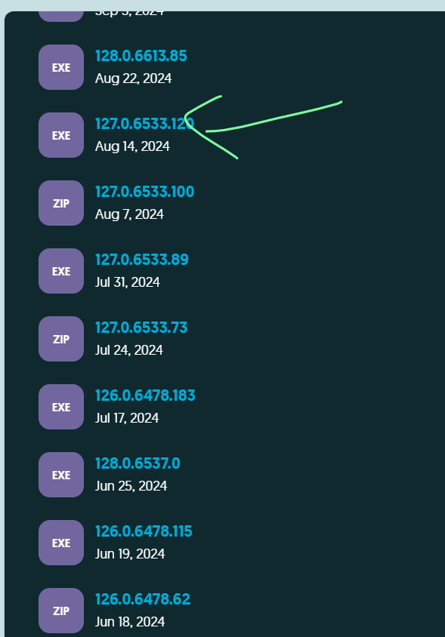

**Extracting the .exe File**

Once the .exe file is downloaded, use **7-Zip** to extract its contents. After extraction, you will have a set of files and folders required for running the selected Chrome version.

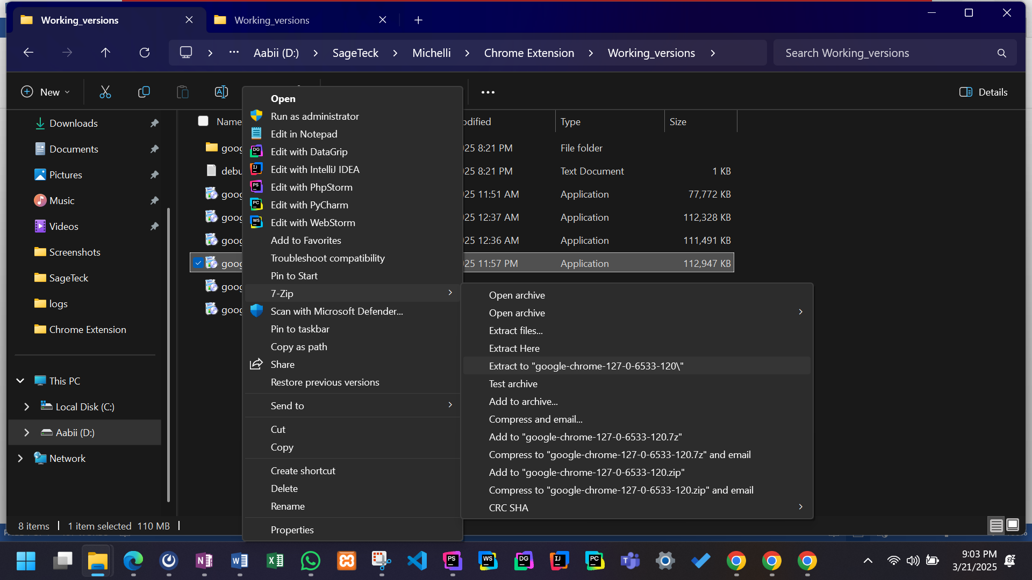

After extraction, you’ll find updater.zip file, extract that to proceed further.

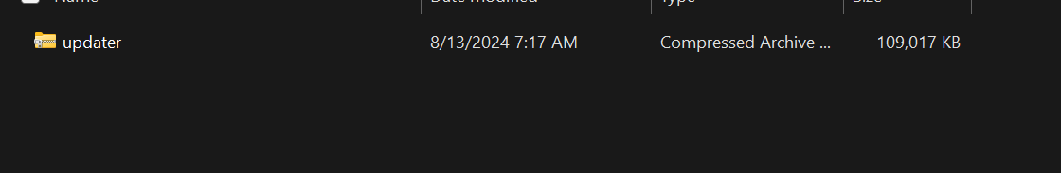

**Exploring the Extracted Files**

After extracting updater.zip, you will find a **bin** folder inside the **updater** directory. Within the **bin** folder, you will have the following files:

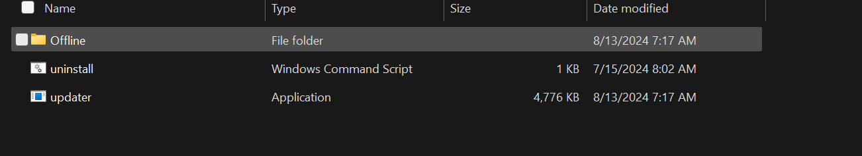

**Locating the Chrome Installer**

Navigate to the **Offline** folder and move two steps forward in the directory structure. You will find the **127.0.6533.120_chrome_installer** application, which is the installer for the selected Chrome version.

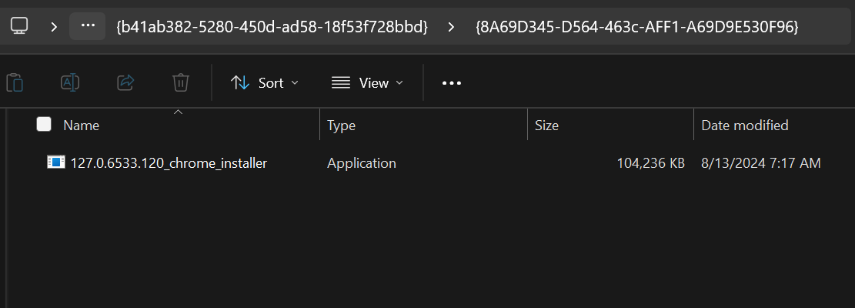

**Extracting the Chrome Installer**

Use **7-Zip** to extract the **127.0.6533.120_chrome_installer** application.

**Finding and Extracting the Chrome Zip File**

After extracting the Chrome installer, you will find another zip file named chrome.zip. Extract that too.

**Inside the Extracted Chrome Zip**

After extracting chrome.zip, you will find a folder named Chrome-bin. This folder contains the core Chrome files required to run the browser independently.

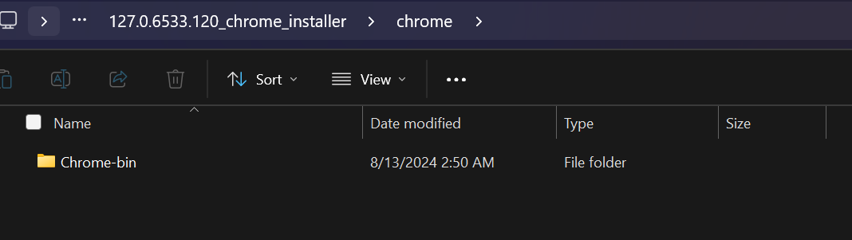

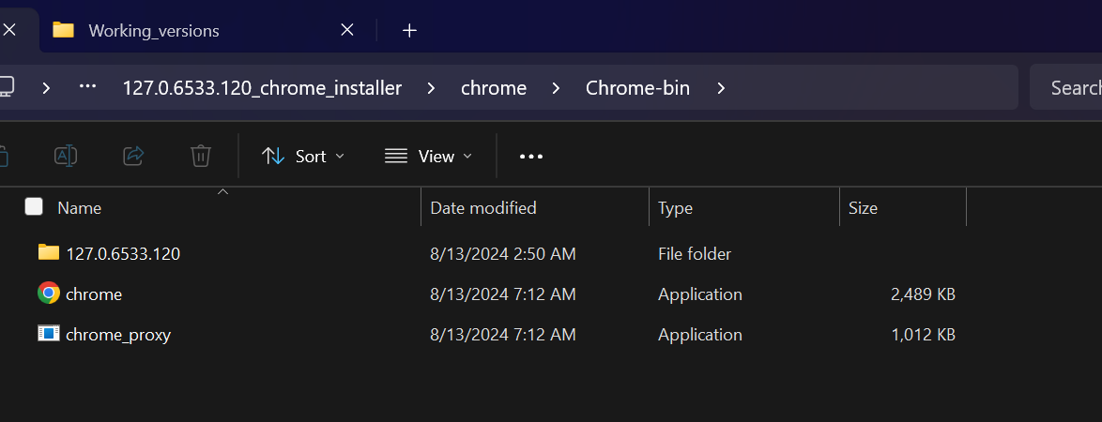

**Creating a Folder for the Chrome Version**

Before pasting the extracted files, you need to create a dedicated folder for this Chrome version:

* Navigate to C:\Program Files\Google\.
* Create a new folder and name it based on the Chrome version you are installing.
  + In this case, the folder is named **Chrome127**.
* Inside **Chrome127**, create another folder named **Application**.

**Copying the Extracted Files**

Now, copy all the files from the **Chrome-bin** folder and paste them into:  
C:\Program Files\Google\Chrome127\Application

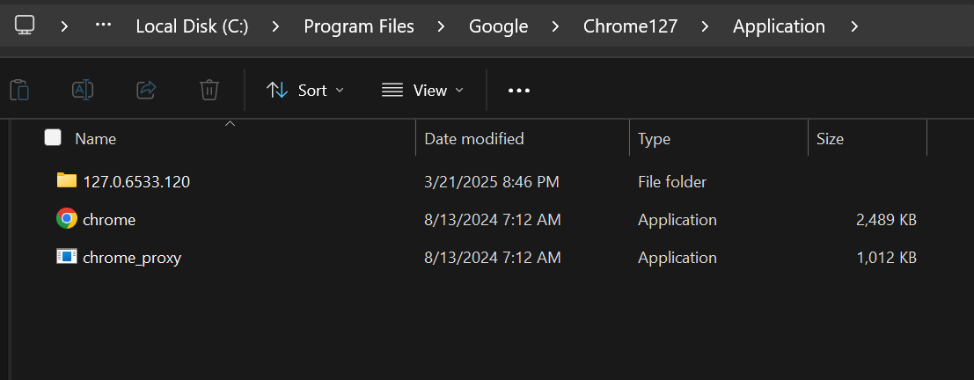

**Creating a Shortcut and Modifying Its Target**

* Navigate to C:\Program Files\Google\Chrome127\Application.
* Right-click on chrome.exe and select Create Shortcut.
* Move the shortcut to your desired location (e.g., Desktop).
* Right-click on the shortcut and select Properties.
* In the Target field, modify it by adding the following argument at the end:

***"C:\Program Files\Google\Chrome127\Application\chrome.exe" --user-data-dir="C:\ChromeTestProfile"***

Instead of ChromeTestProfile, you can specify any folder.

**Now when you’ll open that shortcut it will open your desired version.**