**NAME: SRINIVAS VENKATESH**

**ID:1001246272**

**Azure notebook link:** **https://notebooks.azure.com/sri-1111/libraries/datasciencesri**

**comparison table**

|  |  |  |  |  |  |  |
| --- | --- | --- | --- | --- | --- | --- |
| Model | Train accuracy | Test accuracy | precision | recall | F1-support | AUC |
| Logistic Regression | **0.74** | **0.71** | **0.69** | **0.71** | **0.70** | **0.72** |
| LinearSVC | **0.76** | **0.71** | **0.69** | **0.71** | **0.70** | **0.76** |
| Decision Tree | **1.00** | **0.65** | **0.66** | **0.65** | **0.65** | **0.60** |
| Random Forest | **0.70** | **0.70** | **0.49** | **0.70** | **0.58** | **0.75** |
| Multi-Layered Perceptron (Neural Network) | **0.83** | **0.68** | **0.71** | **0.68** | **0.69** | **0.74** |

Random Forest output:

Features:

1. feature checking_status (0.214156)

2. feature credit_history (0.142314)

3. feature savings_status (0.090233)

4. feature employment (0.068524)

5. feature installment_commitment (0.066034)

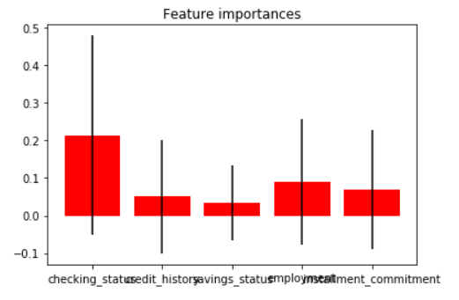

**OUTPUT:**

**LOGISTIC REGRESSION MODEL**

array([[ 45, 75],

[ 39, 241]])

LOGISTIC REGRESSION Report:

precision recall f1-score support

0 0.54 0.38 0.44 120

1 0.76 0.86 0.81 280

avg / total 0.69 0.71 0.70 400

Training set score: 0.74

Test set score: 0.71

AUC score: 0.72

# LinearSVC

array([[ 45, 75],

[ 40, 240]])

LinearSVC Report:

precision recall f1-score support

0 0.53 0.38 0.44 120

1 0.76 0.86 0.81 280

avg / total 0.69 0.71 0.70 400

Training set score: 0.76

Test set score: 0.71

AUC score: 0.76

# Decision Tree

array([[ 55, 65],

[ 75, 205]])

Decision Tree Report:

precision recall f1-score support

0 0.42 0.46 0.44 120

1 0.76 0.73 0.75 280

avg / total 0.66 0.65 0.65 400

Training set score: 1.00

Test set score: 0.65

AUC score: 0.60

# Random Forest

array([[ 0, 120],

[ 0, 280]])

In [763]:

Features:

1. feature checking_status (0.214156)

2. feature credit_history (0.142314)

3. feature savings_status (0.090233)

4. feature employment (0.068524)

5. feature installment_commitment (0.066034)



Random Forest Report:

precision recall f1-score support

0 0.00 0.00 0.00 120

1 0.70 1.00 0.82 280

avg / total 0.49 0.70 0.58 400

Training set score: 0.70

Test set score: 0.70

AUC score: 0.75

# Multi-Layered Perceptron (Neural Network)

array([[ 76, 44],

[ 84, 196]])

Multi-Layered Perceptron (Neural Network) Report:

precision recall f1-score support

0 0.47 0.63 0.54 120

1 0.82 0.70 0.75 280

avg / total 0.71 0.68 0.69 400

Training set score: 0.83

Test set score: 0.68

AUC score: 0.74