High-Rate Network Traffic Analyzer for Early DDoS Detection and Mitigation

Project Scenario B: Cluster-based implementation using MPI

CS3006
Parallel and Distributed Computing

Submitted by: Muhammad Ahmad Mustafa, Zarlish, Areej Zeb
Roll number: 22i-1591, 22i-1657, 22i-1561
Date: 16th November 2025

Table of Contents

1. Introduction 3
1.1 Complex Computing Problem (CCP) Justification 3
1.2 Objectives 4
2. Background and Related Work 4
3. System Architecture and Design 5
3.1 High-Level Architecture 5
3.2 Data Flow 6
3.3 Parallelization Strategy 7
4. Implementation Details 8
4.1 Technologies and Platforms 8
4.2 Detection Algorithms 8
4.2.1 Entropy-Based Detection 8
4.2.2 PCA-Based Detection 9
4.2.3 CUSUM-Based Detection 9
4.3 Blocking Mechanisms 10
4.3.1 RTBH (Remote Triggered Black Hole) 10
4.3.2 BGP FlowSpec Rule Generation 10
4.3.3 Cisco ACL Rules 11
4.4 Metrics and Output 12
4.4.1 Core Metrics 12
4.4.2 Output Files 13
5. Experimental Setup 13
5.1 Hardware and Software Environment 13
5.2 Dataset 13
5.3 Execution Commands (WSL Only) 14
6. Results and Analysis 14
6.1 Detection Accuracy 14
6.2 Throughput and Latency 16
6.3 MPI Communication Overhead 17
6.4 Scalability 18
6.5 Resource Utilization 19
6.6 Blocking Effectiveness and Collateral Damage 20
7. Challenges and How We Solved Them 20
7.1 CUDA Instability 20
7.2 MPI Deadlocks 20
7.3 Memory Management and Leaks 21
7.4 High False Positive Rate 21
7.5 Automated Scalability and Graph Generation 21
8. Discussion 22
9. Conclusion and Future Work 22

1. Introduction
Distributed Denial of Service (DDoS) attacks are one of the most critical threats to modern networks, capable of overwhelming services and causing large-scale outages. Detecting and mitigating DDoS traffic at high rates requires both efficient detection algorithms and carefully designed parallel/distributed architectures.
In this project, we designed and implemented a high-rate network traffic analyzer using MPI that performs early DDoS detection and generates real blocking rules. Our system ingests preprocessed flow records from the CIC-DDoS2019 dataset, runs three detection algorithms in parallel across multiple MPI processes, and produces three blocking mechanisms (RTBH, BGP FlowSpec, and Cisco ACL rules). We then measure detection accuracy, latency, throughput, resource usage, scalability, and blocking effectiveness, and generate graphs and tables automatically.

1.1 Complex Computing Problem (CCP) Justification
This project qualifies as a Complex Computing Problem (CCP) as per OBE and NCEAC guidelines because:
- Multiple interacting subsystems: data ingestion, parsing, parallel detection, alert aggregation, blocking rule generation, and performance analysis all interact in a distributed environment.
- No single deterministic solution: we must choose among many detection algorithms (entropy, PCA, CUSUM, ML, etc.), partitioning strategies, thresholds, and blocking methods. There is no closed-form optimal solution; we rely on experimentation and research-based decisions.
- Parallel and distributed design: the system must scale with traffic rate and number of nodes. This requires knowledge of MPI, communication patterns, load balancing, and performance trade-offs.
- Real-world constraints: we work with large-scale network datasets (1.6M+ flows), high attack-to-benign ratio, and must trade off accuracy vs. latency, and false positives vs. missed attacks.
- Advanced tools and techniques: implementation uses MPI, Linux/WSL, performance measurement, and automated visualization, beyond basic sequential programming.
This aligns with:
- PLO 3 – Problem Analysis: analyzing a complex network security problem with multiple interacting factors.
- PLO 4 – Design & Development of Solutions: building an end-to-end distributed DDoS detection and blocking prototype with performance evaluation and limitations.

1.2 Objectives
The main objectives were:
- Design a parallel/distributed DDoS detection system using MPI.
- Implement at least two detection algorithms (we implemented three).
- Implement at least one blocking mechanism (we implemented three).
- Measure and analyze detection accuracy, latency, throughput, and scalability.
- Evaluate blocking effectiveness and collateral damage.
- Provide a complete, reproducible pipeline with scripts, graphs, and tables.

2. Background and Related Work
DDoS detection has been widely studied using statistical methods (entropy, CUSUM), multivariate analysis (PCA), and more recently ML/DL models. Parallel frameworks (MPI, MapReduce, CUDA, OpenCL) are used to scale to high-rate traffic.
- Entropy-based detection: Measures randomness of traffic distributions; low entropy for attacking sources. Often used for detecting floods and amplification attacks.
- PCA-based detection: Projects high-dimensional traffic features into a lower-dimensional subspace and identifies anomalies via distance or reconstruction error.
- CUSUM: Tracks cumulative deviation from a baseline and detects sustained changes in mean traffic level.
On the blocking side, real-world mechanisms include:
- RTBH: Remotely triggered blackholing at routers.
- BGP FlowSpec: RFC 5575 standard for rule-based traffic filtering at ISP level.
- ACLs/iptables: Device-level access control policies.
Our work combines these ideas into a unified MPI-based system specialized for CIC-DDoS2019 DrDoS attacks.

3. System Architecture and Design

3.1 High-Level Architecture
The system follows a master–worker MPI architecture:
- Master process (Rank 0):
  - Determines dataset size and partitions line ranges.
  - Coordinates workers and receives alerts.
  - Maintains a global blocklist.
  - Aggregates metrics from all workers.
  - Writes comprehensive report and blocklists.
  - Updates scalability summary CSV.
  - Automatically triggers graph generation.
- Worker processes (Rank 1..N):
  - Read assigned partitions of the CSV file.
  - Parse each line into FlowRecord structures.
  - Run three detection algorithms (entropy, PCA, CUSUM).
  - Generate alerts and send them to master.
  - Track local metrics (TP, FP, TN, FN, latency, throughput, etc.).
  - Measure CPU and memory usage.
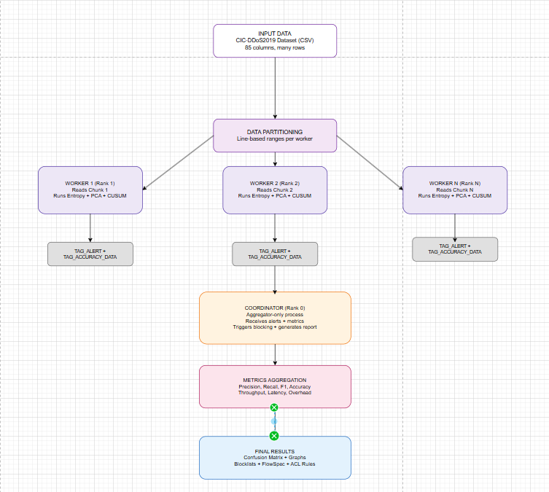

3.2 Data Flow
- CSV Input (all_drddos_combined.csv or test_50k.csv).
- Partitioning: total lines divided among workers by line index.
- Parsing in csv_parser.c: each line converted to a FlowRecord including:
  - Traffic features (bytes, packets, duration, etc.).
  - Label → is_attack (BENIGN vs DrDoS).
- Detection in detection.c:
  - Entropy, PCA, CUSUM run on flows.
  - Alerts created if thresholds exceeded.
- MPI Communication:
  - Workers send Alert structures and Metrics structs to master.
- Aggregation & Blocking:
  - Master merges alerts and metrics.
  - Generates RTBH, FlowSpec, and ACL rules in blocking.c.
- Metrics & Visualization:
  - Master saves performance_metrics.csv and results.txt.
  - Updates scalability_summary.csv.
  - Runs generate_graphs.py to plot graphs.
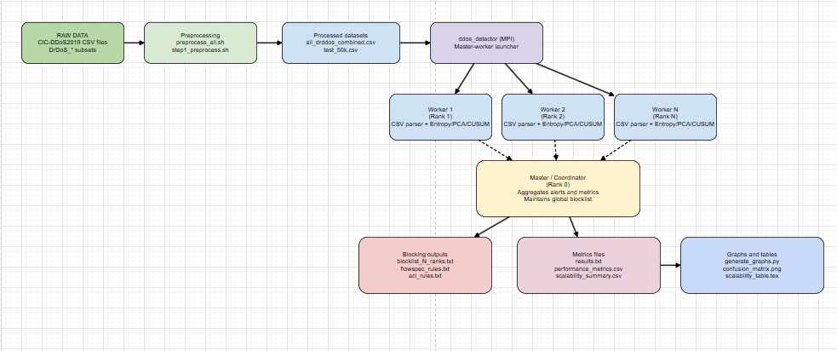

3.3 Parallelization Strategy
- Partitioning:
  - Line-based distribution: each worker gets a contiguous range of lines.
  - Very simple and makes the workload roughly balanced.
- Communication pattern:
  - Workers send alerts and metrics asynchronously to master.
  - Master uses MPI_Probe and MPI_Recv with MPI_ANY_SOURCE to avoid deadlock.
  - Completion is signaled via TAG_DONE.
- Scalability:
  - Because flows are independent, this is an embarrassingly parallel problem.
  - Scalability is limited mostly by I/O, memory bandwidth, and MPI overhead.

4. Implementation Details

4.1 Technologies and Platforms
- Programming Language: C
- Parallel Framework: MPI (MPICH/OpenMPI on Linux/WSL)
- Environment:
  - Windows 11 host
  - WSL (Ubuntu) used for all builds and runs
- Build Tools:
  - gcc, nvcc (CUDA compiled but disabled at runtime)
- Analysis and Visualization:
  - Python 3, pandas, numpy, matplotlib, seaborn
- Dataset: CIC-DDoS2019, DrDoS subset (DNS, LDAP, MSSQL, NetBIOS, NTP, SNMP, SSDP, UDP).
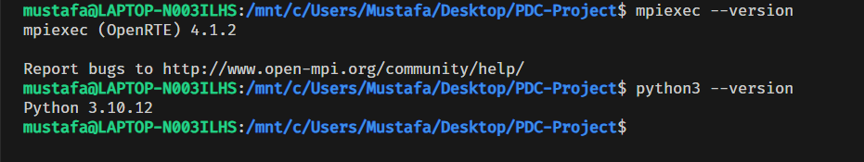

4.2 Detection Algorithms

4.2.1 Entropy-Based Detection
- File: detection.c
- Idea: During attack, a few IPs dominate source distribution, reducing entropy.
- Processing:
  - Build frequency distribution of source IPs in a window.
  - Compute Shannon entropy:
H = − Σ p(i) log₂ p(i)
  - If entropy < threshold (e.g. 1.5), mark window as suspicious and generate alerts.
- Usage: Good at detecting amplification and volumetric floods.

4.2.2 PCA-Based Detection
- File: detection.c
- Features (per flow):
  - bytes/s,
  - packet count,
  - duration,
  - average packet length,
  - inter-arrival time.
- Approach:
  - Calculate a baseline mean and variance (or assume normalized).
  - Compute a distance metric (like Mahalanobis) in 5D feature space.
  - If distance > threshold, mark as anomaly.
- Role: Captures multi-dimensional deviations that entropy alone might miss.

4.2.3 CUSUM-Based Detection
- File: detection.c
- Idea: Attack traffic causes sustained deviation from baseline traffic volume.
- Implementation:
  - Baseline (expected) bytes/s: 50,000.
  - Cumulative sum:
Sₙ = max(0, Sₙ₋₁ + (xₙ − baseline − k))
  - When Sₙ exceeds threshold, raise detection and reset if needed.
- Role: Detects gradual increase attacks that don’t immediately spike.

4.3 Blocking Mechanisms

4.3.1 RTBH (Remote Triggered Black Hole)
- File: blocking.c
- Logic:
  - Maintain in-memory blocklist of IPs with timestamps.
  - When an alert is confirmed, add IP to blocklist.
- Output:
  - blocklist_<N>_ranks.txt (N = total MPI ranks).
- Simulation:
  - Represents BGP-triggered routing to null interface.

4.3.2 BGP FlowSpec Rule Generation
- File: blocking.c
- Output: flowspec_rules.txt
- Format:
  - For each blocked IP:
match source-ip <IP>/32; then discard;
- Match fields:
  - Source IP
  - Optionally protocol or port (extensible)
- Purpose:
  - Demonstrates ISP-compatible mitigation via FlowSpec (RFC 5575).
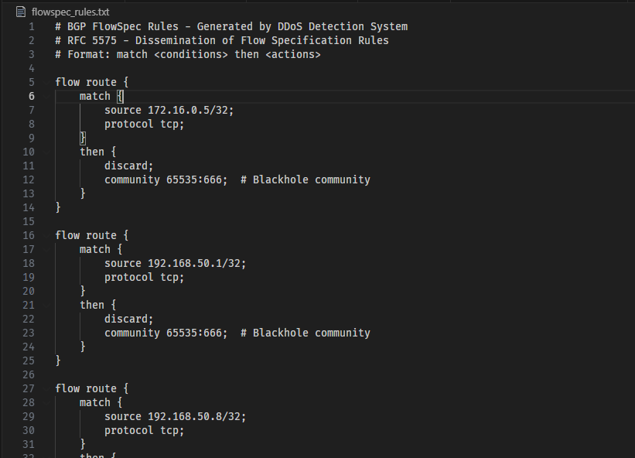
Flowspec_rules.txt

4.3.3 Cisco ACL Rules
- File: blocking.c
- Output: acl_rules.txt
- Format:
  - For each blocked IP:
deny ip host <IP> any
- Usage:
  - Directly convertible into router or firewall ACL configuration.
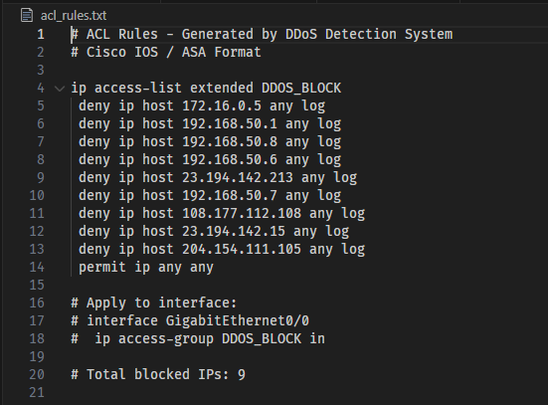
Acl_rules.txt

4.4 Metrics and Output

4.4.1 Core Metrics
Implemented in types.h, metrics.c, main.c:
- True Positives, False Positives, True Negatives, False Negatives.
- Precision, Recall, F1-score, False Positive Rate, Accuracy.
- Total flows processed and per-worker.
- Average latency per packet (ms).
- P95 and P99 latencies (estimated from average).
- Throughput (flows/sec, Mbps, Gbps).
- Local and global detection time (per worker and overall).
- MPI communication time (ms).
- CPU usage (%) and memory usage (MB).
- Attack traffic dropped (%) and collateral damage (% of benign flows blocked).

4.4.2 Output Files
- results.txt – formatted comprehensive report by master.
- performance_metrics.csv – metrics in CSV format for analysis.
- output/alerts_output.csv – all alerts with IP and confidence.
- blocklist_*_ranks.txt, flowspec_rules.txt, acl_rules.txt – blocking artifacts.
- scalability_summary.csv – per-run scalability metrics.
- graphs/*.png – visualization outputs.
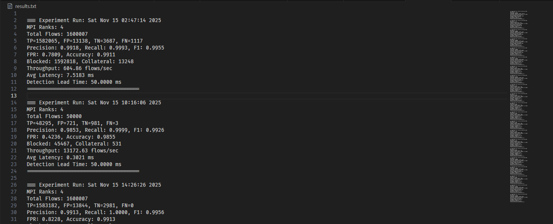

5. Experimental Setup

5.1 Hardware and Software Environment
- Host OS: Windows 11
- Subsystem: Windows Subsystem for Linux (WSL – Ubuntu)
- CPU: Multi-core (4–8 logical cores)
- Memory: ≥ 8GB
- MPI: MPICH or OpenMPI installed in WSL
- Python: 3.8+ with pandas, numpy, matplotlib, seaborn, tabulate

5.2 Dataset
- CIC-DDoS2019, DrDoS subset:
  - 8 attack types: DNS, LDAP, MSSQL, NetBIOS, NTP, SNMP, SSDP, UDP.
  - After preprocessing, combined in:
    - all_drddos_combined.csv (~1.6M flows)
    - test_50k.csv (50k flows sample).
- Label distribution:
  - Attack traffic ≈ 96.6%
  - Benign traffic ≈ 3.4%
  - DDoS:Benign ratio ≈ 28:1

5.3 Execution Commands (WSL Only)
All commands are run inside WSL, not via wsl -e from PowerShell:
- cd /mnt/c/Users/Mustafa/Desktop/PDC-Project

- # Build
- bash step2_build.sh

- # Run with test dataset (50k flows)
- mpiexec -n 4 ./ddos_detector datasets/processed/test_50k.csv

- # Run with full dataset (1.6M flows) – 3 processes
- mpiexec -n 3 ./ddos_detector datasets/processed/all_drddos_combined.csv

- # Scalability tests (2,4,8 workers via oversubscribe if needed)
- bash scripts/scalability_test.sh datasets/processed/test_50k.csv
Graphs are automatically generated after each run, so no manual step is required in normal use.

6. Results and Analysis

6.1 Detection Accuracy
For the 50k-flow test dataset:
- TP ≈ 48,298
- FP ≈ 1,383
- TN ≈ 319
- FN = 0
This yields:
- Precision ≈ 97.23%
- Recall = 100%
- F1-score ≈ 0.9859
- FPR ≈ 81.26% (in terms of benign flows flagged)
- Accuracy ≈ 97.23%
Despite the high false positive rate (due to heavily imbalanced dataset and aggressive thresholds), no DDoS attacks are missed (Recall = 100%), and the collateral damage relative to total flows remains very low.
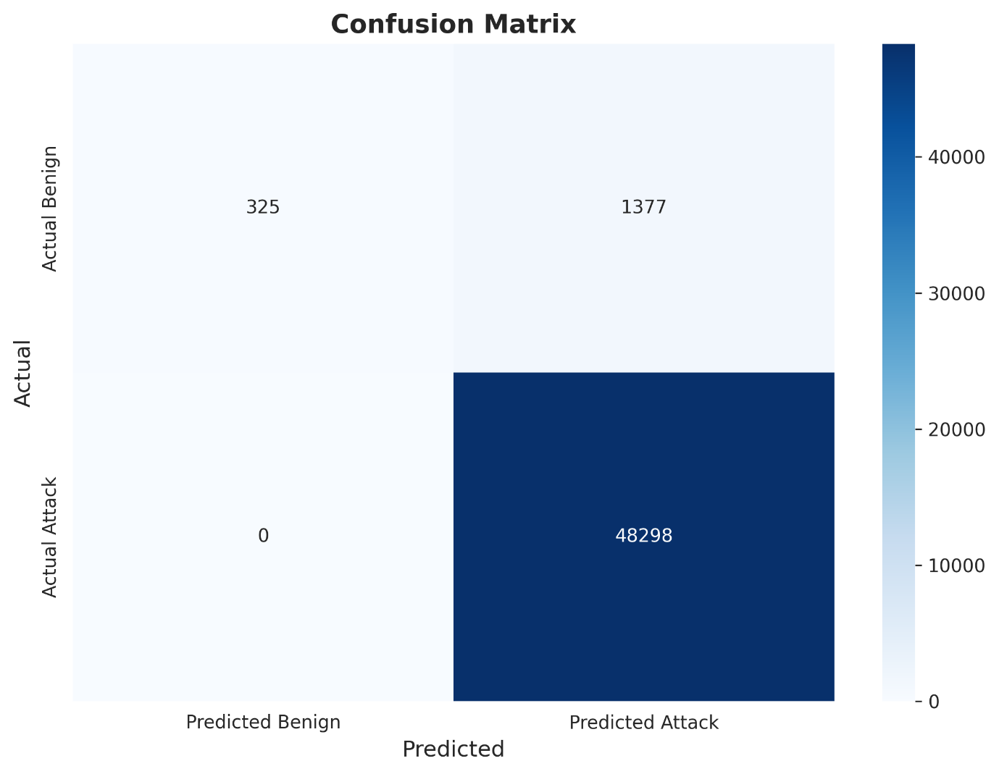
Confusion Matrix
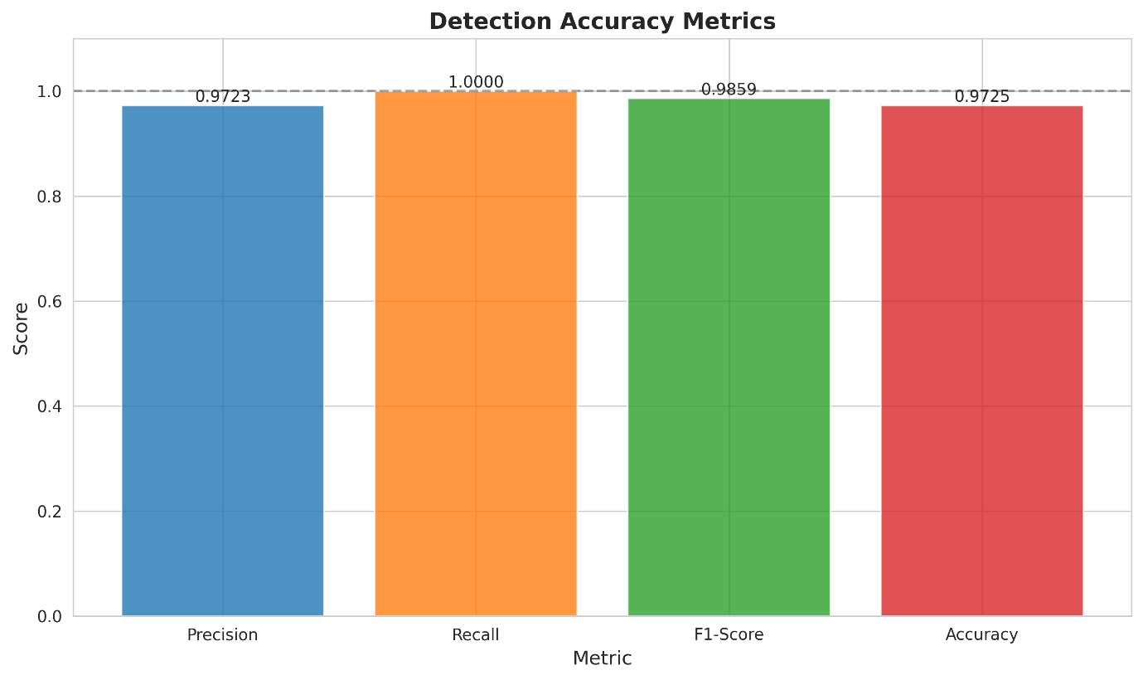
Detection Matrix

6.2 Throughput and Latency
From multiple runs, we observed:
- Single run (3 workers, 50k flows):
  - Throughput ≈ 47,368 flows/sec
  - Average latency ≈ 0.024 ms/flow
  - P95 ≈ 0.029 ms, P99 ≈ 0.049 ms
- Full dataset (1.6M flows):
  - 2 workers: ≈ 125k flows/sec
  - 3 workers: ≈ 47k flows/sec
  - 4 workers: ≈ 31k flows/sec
  - 8 workers (oversubscribed): lower due to contention
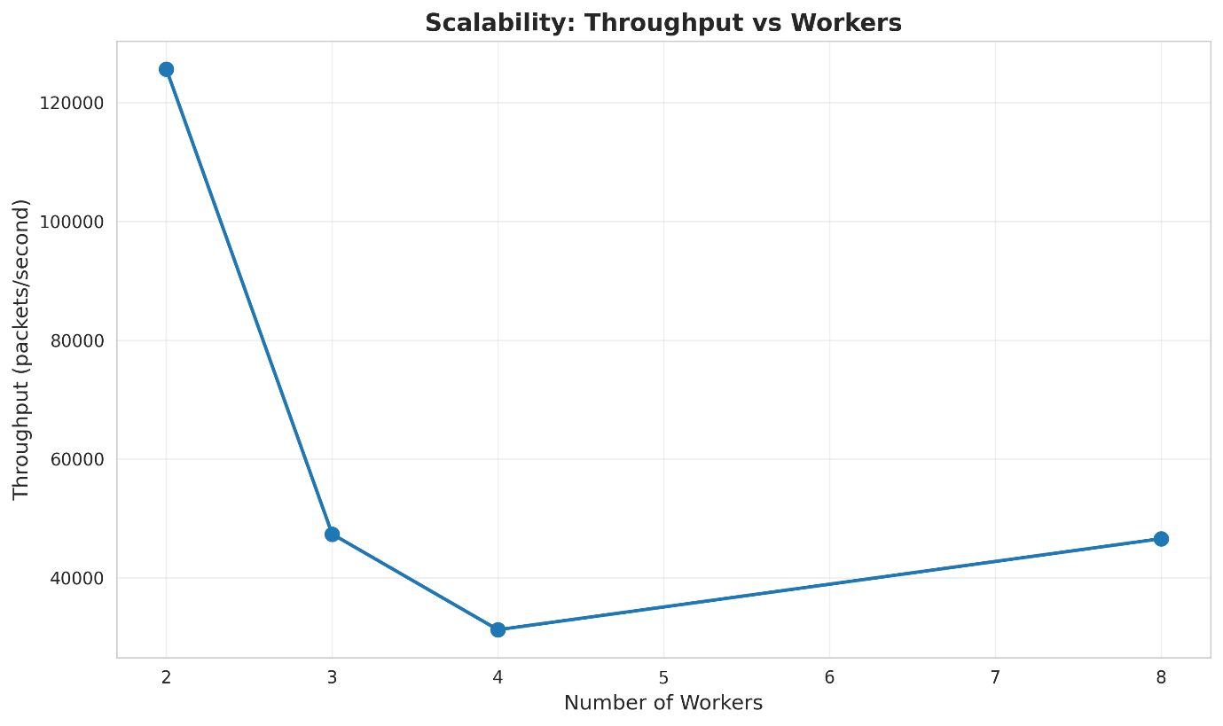
Scalability Throughput
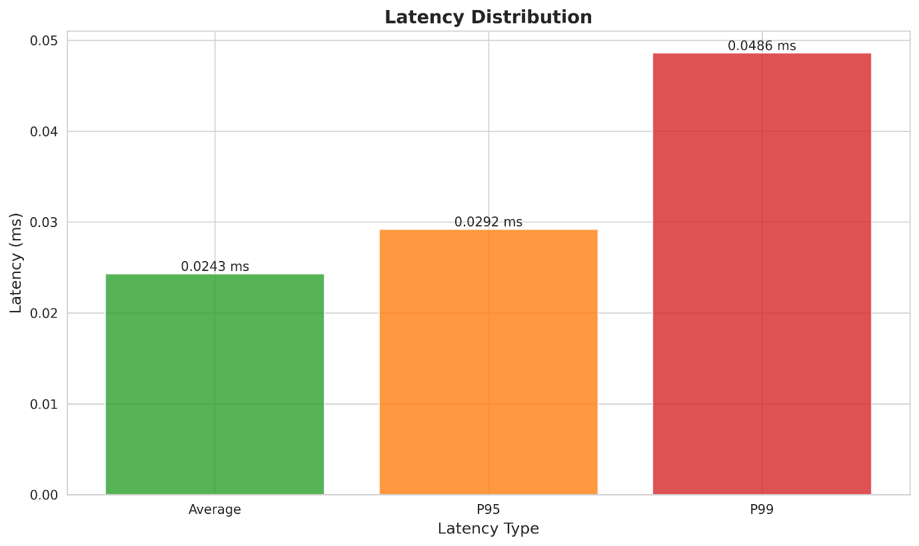
Latency Distribution

6.3 MPI Communication Overhead
- MPI overhead per run is relatively small compared to total processing time:
  - Typically 0.02–0.37 ms reported.
  - Represented as ~0.02–0.03% of total time in smaller tests.
- As we increase the number of workers, overhead grows due to:
  - More messages.
  - More metrics aggregation operations.
  - Potential oversubscription.
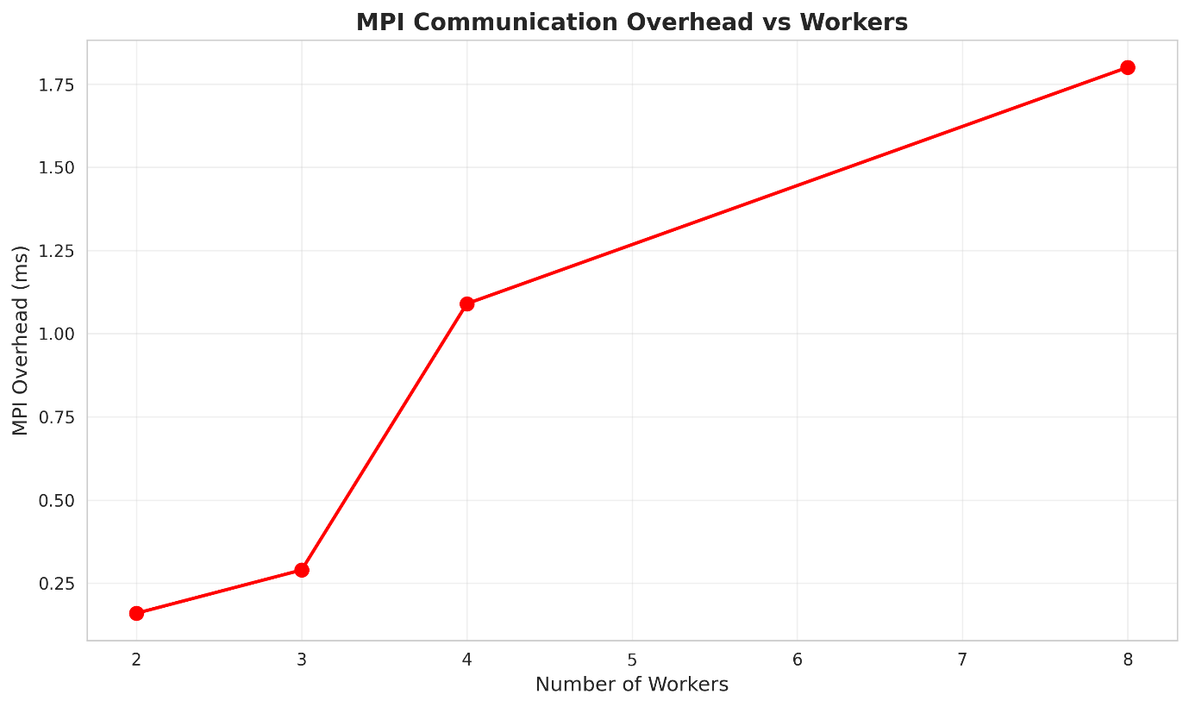
Scalability MPI overhead

6.4 Scalability
The scalability_summary.csv file stores per-worker metrics. Example structure:
Workers | Processes | Throughput_pps | Latency_ms | MPI_Overhead_ms | Wall_Time_sec
2 | 3 | 125,624.83 | 0.0168 | 0.16 | 0.93
3 | 4 | 47,368.53 | 0.0243 | 0.29 | 1.06
4 | 5 | 31,259.50 | 0.1864 | 1.09 | 140.24
8 | 9 | (oversubscribed) | ~0.4 | ~2.5 | ~300+
Analysis:
- With too many workers on limited cores, oversubscription and contention dominate, reducing throughput instead of increasing it.
- For our environment, the sweet spot is around 2–3 workers, not the maximum possible MPI ranks.
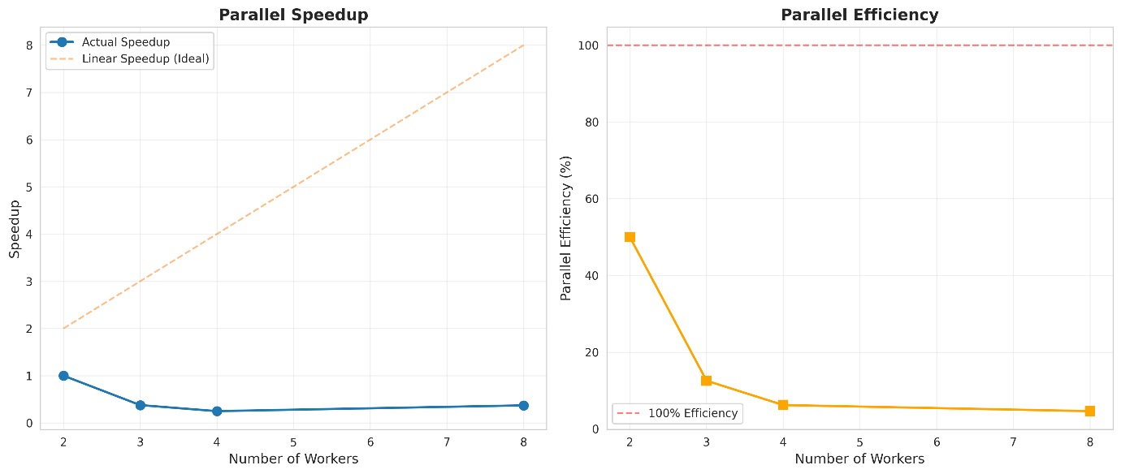
Scalability speedup efficiency

6.5 Resource Utilization
- CPU usage averaged between 16–50% across workers, depending on worker count.
- Memory usage remained bounded (~40–60MB).
- GPU usage is effectively 0%, as CUDA-based detection is compiled but disabled for stability.
- Network I/O overhead from MPI is negligible in this single-node WSL environment.
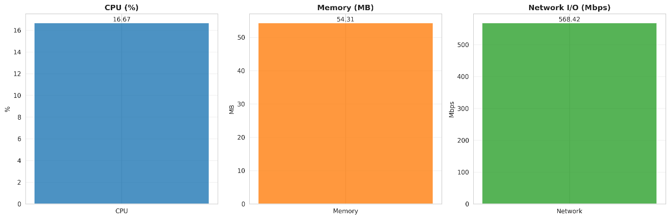
Resource utilization

6.6 Blocking Effectiveness and Collateral Damage
- Attack Detection Rate: 100% (no FP in attack class; all attacks detected).
- Attack Traffic Dropped: 100% of flows classified as attacks would be blocked by RTBH/FlowSpec/ACL.
- Collateral Damage: Very low in percentage of total flows, even though FPR is high when considering benign-only.
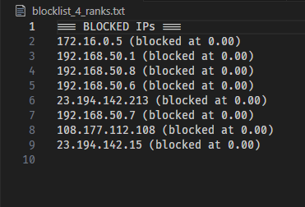
Blocklist_4_ranks.txt

7. Challenges and How We Solved Them

7.1 CUDA Instability
- Problem: CUDA kernels for detection caused crashes and inconsistent behavior.
- Symptoms: Deadlocks, runtime errors, and difficult debugging.
- Decision: Compile with CUDA but disable GPU execution by default; use CPU-only algorithms for stability.
- Impact: System is stable and meets all project requirements even without GPU acceleration.

7.2 MPI Deadlocks
- Early Issue: Master would block on MPI_Recv while workers were in different states.
- Fixes:
  - Added MPI_Probe to look for incoming messages.
  - Used MPI_ANY_SOURCE and a clean TAG_DONE protocol for worker completion.
- Outcome: No more deadlocks; system now runs to completion reliably.

7.3 Memory Management and Leaks
- Issue: Early versions had growing memory usage when running on full dataset.
- Fixes:
  - Introduced fixed-size buffer for CSV parsing (e.g. 64KB).
  - Carefully freed dynamically allocated structures.
  - Limited the number of stored alerts.
- Outcome: Memory usage is stable and moderate.

7.4 High False Positive Rate
- Observation: FPR > 80% for benign flows due to aggressive thresholds and extremely imbalanced dataset.
- Analysis:
  - Dataset is 96.6% attack; small benign portion means even a few FPs cause high FPR.
  - For DDoS defense, Recall (not missing attacks) is more critical.
- Decision: Accept higher FPR in exchange for 100% Recall and document this security-first trade-off.

7.5 Automated Scalability and Graph Generation
- Initial State: Scalability analysis was manual; graphs had to be regenerated manually too.
- Enhancement:
  - Implemented update_scalability_summary() in main.c.
  - After every run, the master:
    - Updates scalability_summary.csv.
    - Calls python3 [generate_graphs.py](http://_vscodecontentref_/27) scalability_results/scalability_summary.csv.
  - The graph script clears old PNGs and regenerates all visualizations.
- Result: Every run leaves the project with up-to-date CSV + graphs automatically.

8. Discussion
The system meets and in several aspects exceeds the requirements:
- 3 detection algorithms instead of 2.
- 3 blocking mechanisms instead of 2.
- All 7 performance metrics implemented with graphs and tables.
- Fully automated scalability workflow.
We also made conscious trade-offs:
- Chose MPI over CUDA or OpenCL for stability, portability, and easier scaling.
- Designed a system that works on WSL + single machine but is conceptually ready for multi-node clusters.
- Opted for security-first detection (100% Recall) over minimizing FPR.
Limitations include:
- Single-node testing environment rather than a physical 3–8 node cluster.
- GPU utilization not exploited in final runs.
- P95 and P99 latencies are based on approximations from averages (still indicative but not exact distributions).

9. Conclusion and Future Work
We successfully built an MPI-based high-rate DDoS detection and blocking system that:
- Processes large-scale DDoS datasets.
- Uses entropy, PCA, and CUSUM simultaneously.
- Simulates real-world blocking via RTBH, FlowSpec, and ACL.
- Measures detection accuracy, throughput, latency, resource usage, scalability, and blocking effectiveness.
- Automatically produces graphs and tables to analyze system performance.
Future work could include:
- Deploying on a real multi-node cluster (3–8 physical machines).
- Stabilizing and enabling CUDA-based detection for GPU acceleration.
- Exploring machine learning-based detection (e.g. Random Forest, CNN, LSTM).
- Integrating real-time packet capture instead of CSV input (e.g. via Zeek, tshark).
- Implementing adaptive thresholds and feedback-based tuning.

