FACULITY OF COMPUTING AND INFORMATION TECHNOLOGY



SUBMITTED TO
Dr.Asif Sohail
SUMBITTED BY
Ayesha Waqar (BCSF23M010)
Laiba Naveed (BCSF23M033)
Areej Fatima(BCSF23M039)

DATABASE SYSTEM –PROJECT REPORT

QUESTION 1: Introduction to the working of the system

HOTEL MANAGEMENT SYSTEM
1. ROOM
• Attributes:
o RoomNo (PK)
o RoomType (FK)
o Occupancy
________________________________________
2. ROOM TYPE
• Attributes:
o RoomType (PK)
o RoomPrice
o DefaultRoomPrice
o RoomDesc
________________________________________
3. BOOKING
• Attributes:
o BookingID (PK)
o HotelCode (FK)
o GuestID (FK)
o RoomNo (FK)
o BookingDate
o BookingTime
o ArrivalDate
o DepartureDate
o EstArrivalTime
o EstDepartureTime
o NumAdults
o NumOfChildren
________________________________________
4. GUEST
• Attributes:
o GuestID (PK)
o BookingID (FK)
o GuestTitle
o FirstName
o LastName
o DOB
o Gender
o PhoneNo
o Email
o PassportNo
o Address
o City
o Country
________________________________________
5. BILL
• Attributes:
o InvoiceNo (PK)
o BookingID (FK)
o GuestID (FK)
o RoomCharge
o RoomService
o RestaurantCharges
o BarCharges
o MiscCharges
o IfLateCheckout
o PaymentDate
o PaymentMode
o CreditCardNo
o ExpireDate
o ChequeNo
________________________________________
6. EMPLOYEE
• Attributes:
o EmployeeID (PK)
o RoleID (FK)
o FirstName
o LastName
o DOB
o Gender
o PhoneNo
o Email
o Salary
________________________________________
7. ROLE
• Attributes:
o RoleID (PK)
o RoleTitle
o RoleDesc
________________________________________
8. ASSOCIATIVE TABLES
Booking_Guest (Associative Table for Many-to-Many between Booking and Guest)
• Attributes:
o BookingID (FK)
o GuestID (FK)
o (Composite Key: BookingID, GuestID)
Employee_Role (Associative Table for Many-to-Many between Employee and Role)
• Attributes:
o EmployeeID (FK)
o RoleID (FK)
o (Composite Key: EmployeeID, RoleID)

2-RELATIONSHIP BETWEEN TABLES
ROOM-ROOMTYPE(ONE-ONE)
• One room could be of only one RoomType
ROOM-BOOKING
• One Booking contain one or many Rooms(ONE-MANY)
• One Room could be booked once at time
BOOKING-GUEST(MANY-MANY)
• One Booking could have one Guest or many Guests(ONE-MANY)
• One Guest Could have no Booking or many Bookings(ONE-MANY)
GUEST-BILL(ONE-MANY)
• Guest could have one Bill or many Bills
• One Bill is associated with one and only one Guest
BOOKING-BILL(ONE-MANY)
• One Booking could have one Bill or many Bills
• One Bill is associated with one Booking
EMPLOYEE-ROLE(MANY-MANY)
• One Employee could perform one role or many roles
• One Role is associated with one or more than one Employee

QUESTION 2: ERD of the system
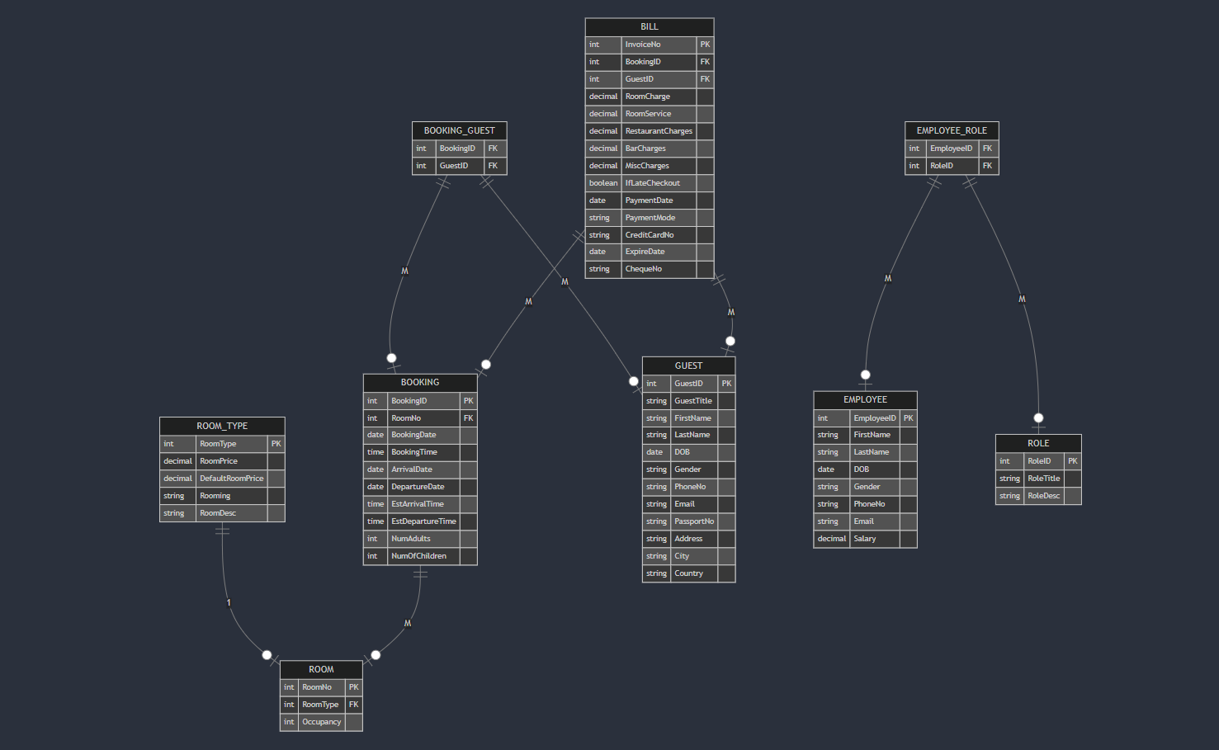

QUESTION 3: Construction of the Relational Schema by using both bottom-up approach and top-down approach. The schema must clearly mention the relational keys.

Top-Down Approach:

The top-down approach starts from the conceptual design and breaks it down into smaller relational schemas. Using the entities, attributes, and relationships from the ERD:

Entities and Attributes

1. ROOM:
ROOM(RoomNo [PK], RoomType [FK], RoomPrice)
2. ROOM_TYPE:
ROOM_TYPE(RoomType [PK], RoomTypeName, RoomDesc)
3. BOOKING:
BOOKING(BookingNo [PK], RoomNo [FK], RoomType [FK], BookingDate, BookingTime, ArrivalDate, DepartureDate, EstArrival, EstDeparture, NumAdults, NumOfChildren)
4. GUEST:
GUEST(GuestId [PK], FirstName, LastName, DOB, Passport, Email, Phone, Address, City, Country)
5. EMPLOYEE:
EMPLOYEE(EmployeeId [PK], FirstName, LastName, DOB, Email, Phone, Address, City, Country)
6. ROLE:
ROLE(RoleId [PK], RoleName, RoleDesc)
7. BILL:
BILL(BillNo [PK], BookingNo [FK], GuestId [FK], RestaurantCharges, BarCharges, MiscCharges, IfLateCheckout, PaymentDate, PaymentMode, CreditCard, ExpireDate, ChequeNo, Amount)
8. BOOKING_GUEST:
BOOKING_GUEST(BookingNo [FK], GuestId [FK])
9. EMPLOYEE_ROLE:
EMPLOYEE_ROLE(EmployeeId [FK], RoleId [FK])

Relationships
The relationships are captured through foreign keys (FK) in the schema:
RoomType links ROOM with ROOM_TYPE.
RoomNo and RoomType link BOOKING with ROOM.
BookingNo and GuestId link BOOKING_GUEST with BOOKING and GUEST.

EmployeeId and RoleId link EMPLOYEE_ROLE with EMPLOYEE and ROLE.

Bottom-Up Approach:

The bottom-up approach starts with smaller relations and combines them to form a complete schema.

Step 1: First Normal Form (1NF)
1NF ensures that:
- All values in a column are atomic (no multi-valued fields or arrays).
- Each record is unique.

Initial Issues:
The given data contains:
- Multiple RoomType columns with repeated information.
- Repeating guest and employee details for multiple bookings or roles.

Resolution:
- Separate repeating room type details into ROOM_TYPE.
- Separate guest details into GUEST.
- Separate employee details into EMPLOYEE.
- Separate billing details into BILL.
After applying 1NF:
plaintext
Copy code
ROOM(RoomNo, RoomType, RoomPrice)
ROOM_TYPE(RoomType, RoomTypeName, RoomDesc)
BOOKING(BookingNo, RoomNo, BookingDate, BookingTime, ArrivalDate, DepartureDate, EstArrival, EstDeparture, NumAdults, NumOfChildren)
GUEST(GuestId, FirstName, LastName, DOB, Passport, Email, Phone, Address, City, Country)
EMPLOYEE(EmployeeId, FirstName, LastName, DOB, Email, Phone, Address, City, Country)
BILL(BillNo, BookingNo, GuestId, RestaurantCharges, BarCharges, MiscCharges, IfLateCheckout, PaymentDate, PaymentMode, CreditCard, ExpireDate, ChequeNo, Amount)
:

Step 2: Second Normal Form (2NF)
2NF eliminates partial dependencies:
- Ensure all non-key attributes depend on the whole primary key, not just part of it.

Issues:
- RoomTypeName and RoomDesc depend on RoomType, not on the full key of ROOM.
- RoleName and RoleDesc depend on RoleId, not the full key of the employee-role relationship.

Resolution:
- Separate RoomTypeName and RoomDesc into a new ROOM_TYPE table.
- Separate RoleName and RoleDesc into a ROLE table.
- Create EMPLOYEE_ROLE to link employees with roles.
After applying 2NF:
plaintext
Copy code
ROOM(RoomNo [PK], RoomType [FK], RoomPrice)
ROOM_TYPE(RoomType [PK], RoomTypeName, RoomDesc)
BOOKING(BookingNo [PK], RoomNo [FK], BookingDate, BookingTime, ArrivalDate, DepartureDate, EstArrival, EstDeparture, NumAdults, NumOfChildren)
GUEST(GuestId [PK], FirstName, LastName, DOB, Passport, Email, Phone, Address, City, Country)
EMPLOYEE(EmployeeId [PK], FirstName, LastName, DOB, Email, Phone, Address, City, Country)
ROLE(RoleId [PK], RoleName, RoleDesc)
EMPLOYEE_ROLE(EmployeeId [FK], RoleId [FK])
BILL(BillNo [PK], BookingNo [FK], GuestId [FK], RestaurantCharges, BarCharges, MiscCharges, IfLateCheckout, PaymentDate, PaymentMode, CreditCard, ExpireDate, ChequeNo, Amount)

Step 3: Third Normal Form (3NF)
3NF removes transitive dependencies:
- Ensure that non-key attributes depend only on the primary key, not on other non-key attributes.

Issues:
- BookingNo and GuestId in BILL may have transitive dependencies.
- Guests may need a many-to-many relationship with bookings (e.g., family bookings).

Resolution:
- Create a BOOKING_GUEST table to establish a many-to-many relationship between BOOKING and GUEST.
After applying 3NF:
plaintext
Copy code
ROOM(RoomNo [PK], RoomType [FK], RoomPrice)
ROOM_TYPE(RoomType [PK], RoomTypeName, RoomDesc)
BOOKING(BookingNo [PK], RoomNo [FK], RoomType [FK], BookingDate, BookingTime, ArrivalDate, DepartureDate, EstArrival, EstDeparture, NumAdults, NumOfChildren)
GUEST(GuestId [PK], FirstName, LastName, DOB, Passport, Email, Phone, Address, City, Country)
EMPLOYEE(EmployeeId [PK], FirstName, LastName, DOB, Email, Phone, Address, City, Country)
ROLE(RoleId [PK], RoleName, RoleDesc)
EMPLOYEE_ROLE(EmployeeId [FK], RoleId [FK])
BILL(BillNo [PK], BookingNo [FK], GuestId [FK], RestaurantCharges, BarCharges, MiscCharges, IfLateCheckout, PaymentDate, PaymentMode, CreditCard, ExpireDate, ChequeNo, Amount)
BOOKING_GUEST(BookingNo [FK], GuestId [FK])

Final Tables with Dependencies
- ROOM
  - Primary Key (PK): RoomNo
  - Foreign Key (FK): RoomType
- ROOM_TYPE
  - Primary Key (PK): RoomType
- BOOKING
  - Primary Key (PK): BookingNo
  - Foreign Keys (FK): RoomNo, RoomType
- GUEST
  - Primary Key (PK): GuestId
- EMPLOYEE
  - Primary Key (PK): EmployeeId
- ROLE
  - Primary Key (PK): RoleId
- EMPLOYEE_ROLE
  - Foreign Keys (FK): EmployeeId, RoleId
- BILL
  - Primary Key (PK): BillNo
  - Foreign Keys (FK): BookingNo, GuestId
- BOOKING_GUEST
  - Foreign Keys (FK): BookingNo, GuestId

QUESTION 4: Description of the relations in the following format:
TABLE EMPLOYEE:
ATTRIBUTES | DATATYPE | SIZE | CONSTRAINTS
EMPLOYEE_ID | NUMBER | 4 | PRIMARY KEY
FIRST_NAME | VARCHAR | 10
LAST_NAME | VARCHAR | 10
DOB | DATE |  | DEFAULT SYSDATE
GENDER | CHAR | 1 | DEFAULT NULL
PHONE_NO | VARCHAR | 20
SALARY | DECIMAL | 10
TABLE ROLE:
ATTRIBUTES | DATATYPE | SIZE | CONSTRAINTS
ROLE_ID | NUMBER | 4 | PRIMARY KEY
ROLE_TITLE | VARCHAR2 | 20
ROLE_DESC | VARCHAR2 | 20
TABLE EMPLOYEE_ROLE:
ATTRIBUTES | DATATYPE | SIZE | CONSTRAINTS
EMPLOYEE_ID | NUMBER | 4 | Pk,Fk
ROLE_ID | NUMBER | 4 | Pk,Fk
TABLE ROOMTYPE:
ATTRIBUTES | DATATYPE | SIZE | CONSTRAINTS
ROOM_TYPE | NUMBER | 4 | PRIMARY KEY
ROOM_PRICE | NUMBER | (10,2)
DEFAULT_ROOM_PRICE | NUMBER | (10,2)
ROOMING | VARCHAR2 | 20
ROOM_DESC | VARCHAR2 | 20
TABLE ROOM:
ATTRIBUTES | DATATYPE | SIZE | CONSTRAINTS
ROOM_NO | NUMBER | 4 | PK
ROOM_TYPE | NUMBER | 4 | FK
OCCUPANCY | NUMBER | 2
TABLE BOOKING:
ATTRIBUTES | DATATYPE | SIZE | CONSTRAINTS
BOOKING_ID | NUMBER | 4 | PK
ROOM_NO | NUMBER | 4 | FK
BOOKING_DATE | DATE |  | DEFAULT SYSDATE
BOOKING_TIME | VARCHAR | 10
ARRIVAL_DATE | DATE |  | DEFAULT SYSDATE
DEPARTURE_DATE | DATE |  | DEFAULT NULL
ESTIMATE_ARRIVAL_TIME | VARCHAR | 10 | DEFAULT NULL
ESTIMATE_DEPARTURE_TIME | VARCHAR | 10 | DEFAULT NULL
NUM_ADULTS | NUMBER | 4
NUM_OF_CHILDREN | NUMBER | 4
TABLE GUEST:
ATTRIBUTES | DATA TYPE | SIZE | CONSTRAINTS
GUEST_ID | NUMBER | 4 | PK
GUEST_TITLE | VARCHAR2 | 20
FIRST_NAME | VARCHAR2 | 10
LAST_NAME | VARCHAR2 | 10
DOB | DATE |  | DEFAULT NULL
GENDER | CHAR | 1 | DEFAULT NULL
PHONE_NO | VARCHAR2 | 20
EMAIL | VARCHAR2 | 20
PASSPORT_NO | VARCHAR2 | 20
ADDRESS | VARCHAR2 | 20
CITY | VARCHAR2 | 20
COUNTRY | VARCHAR2 | 20
TABLE BOOKING_GUEST:
ATTRIBUTES | DATA TYPE | SIZE | CONSTRAINTS
BOOKING_ID | NUMBER | 4 | FK,PK
GUEST_ID | NUMBER | 4 | PK,FK
TABLE BILL:

ATTRIBUTES | DATA TYPE | SIZE | CONSTRAINTS
INVOICE_NO | NUMBER | 4 | PK
BOOKING_ID | NUMBER | 4 | FK
GUEST_ID | NUMBER | 4 | FK
ROOM_CHARGE | NUMBER | 10,7
ROOM_SERVICE | NUMBER | 10,7
RESTAURANT_CHARGES | NUMBER | 10,7
BAR_CHARGES | NUMBER | 10,7
MISC_CHARGES | NUMBER | 10,7
PAYMENT_DATE | DATE |  | DEFAULT SYSDATE
PAYMENT_MODE | VARCHAR | 20
CREDIT_CARD_NO | VARCHAR | 20
EXPIRE_DATE | DATE |  | DEFAULT NULL
CHEQUE_NO | VARCHAR | 20

QUESTION 5: CREATE TABLE statements for all the relations of your system

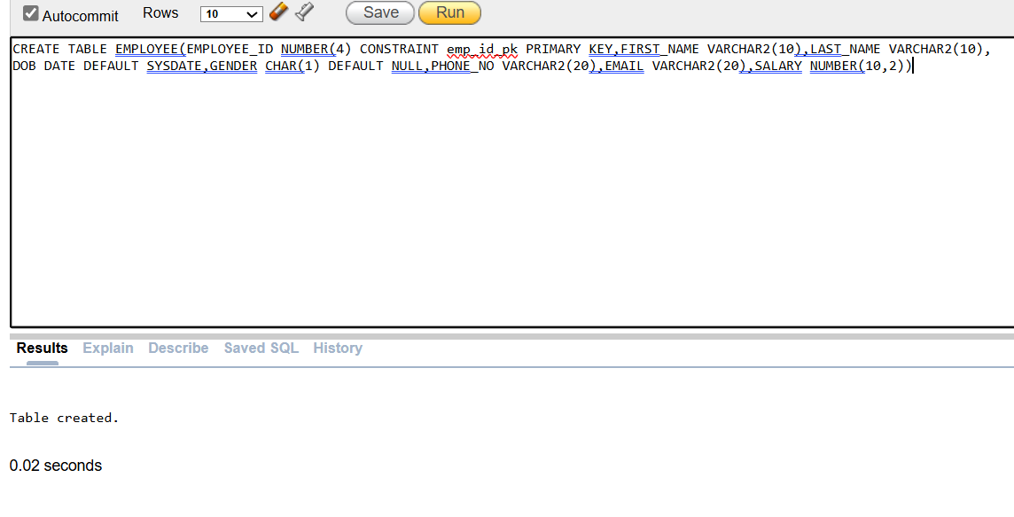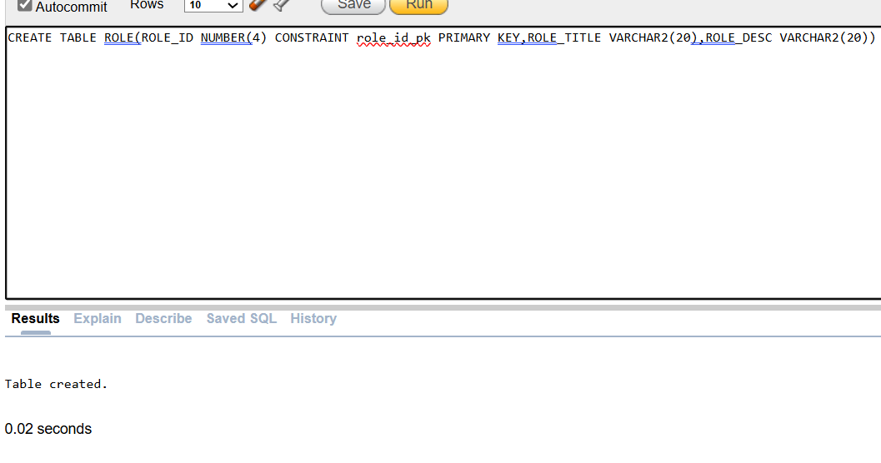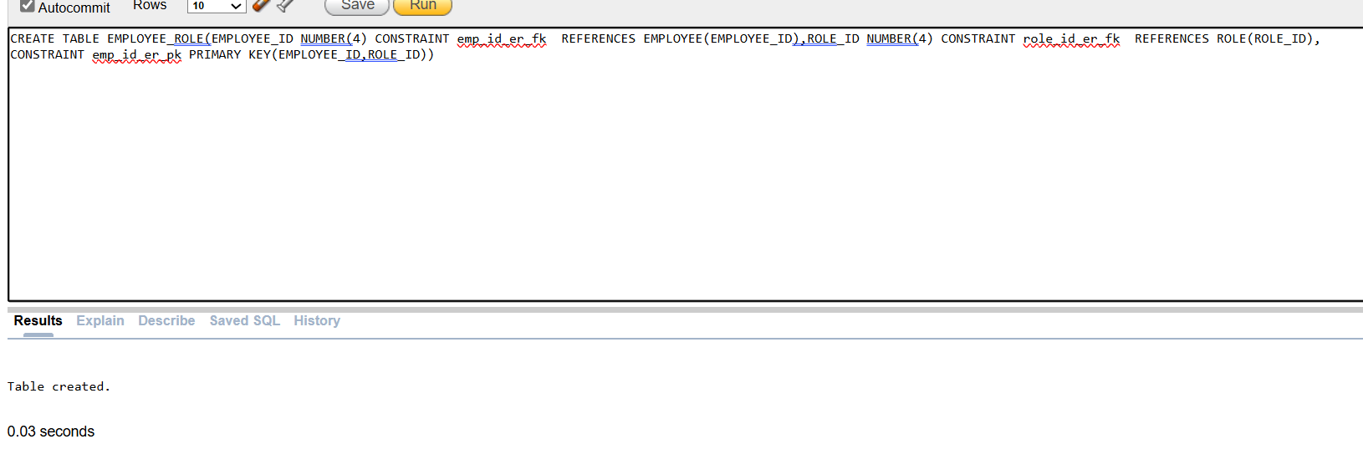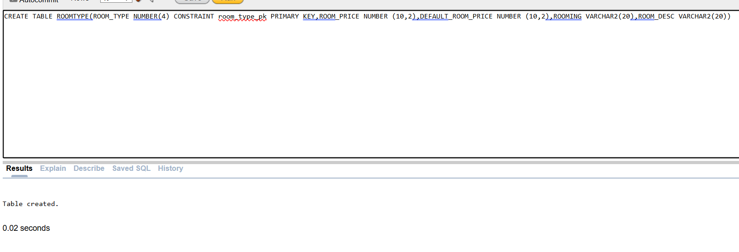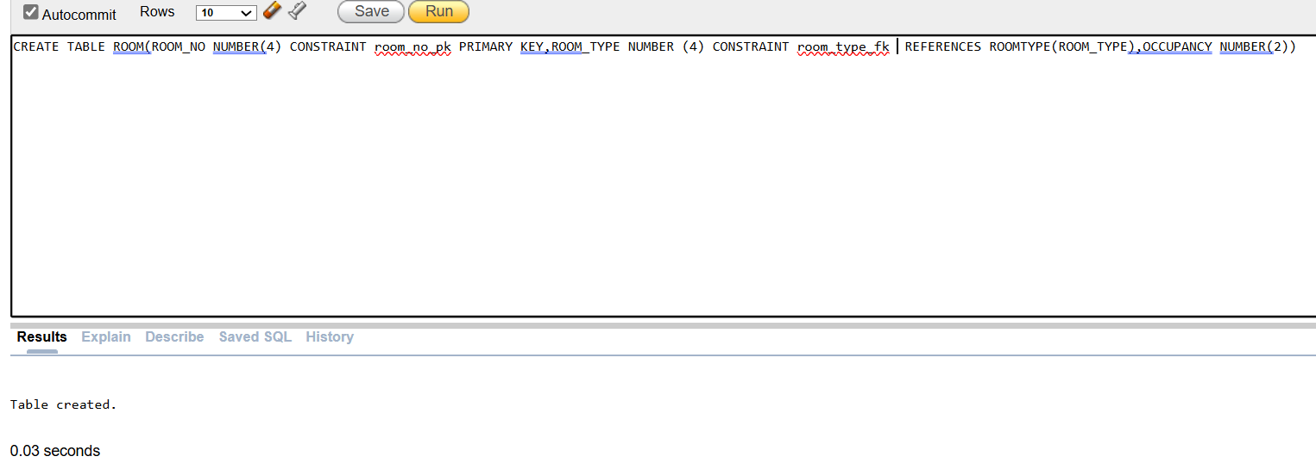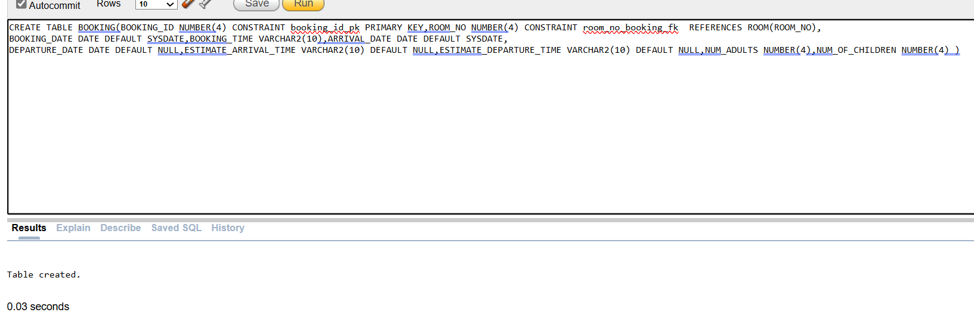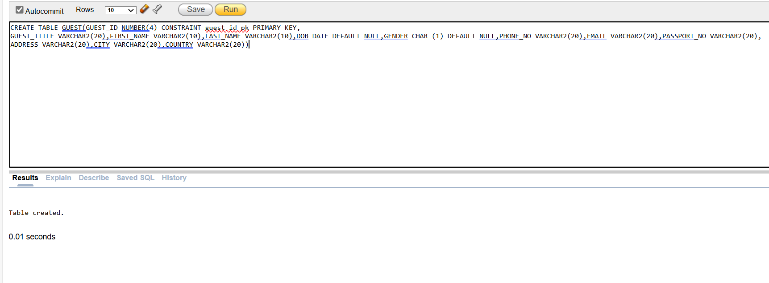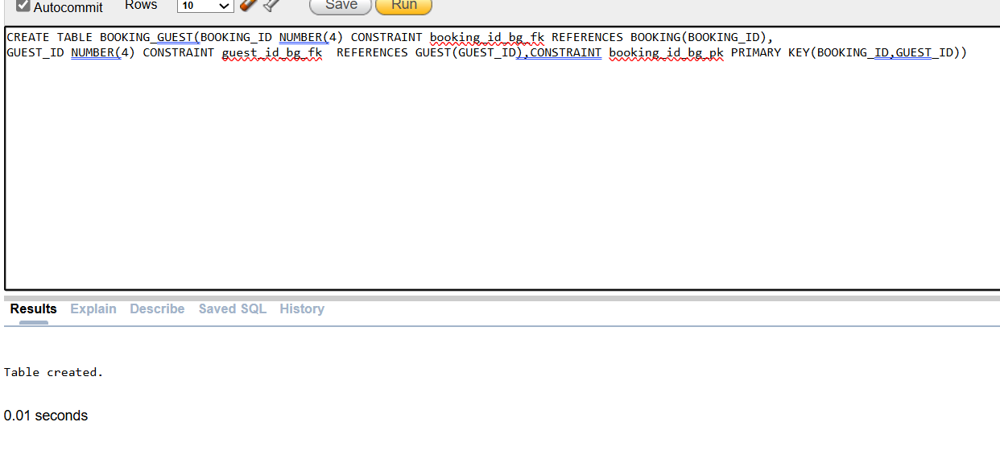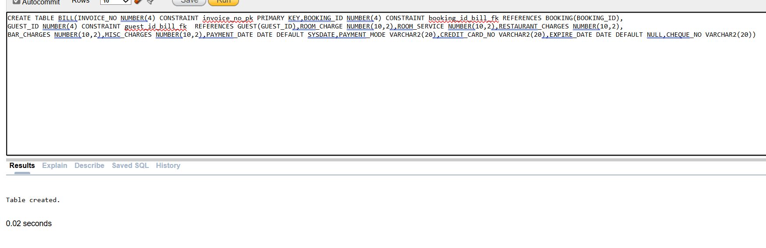

QUESTION 6: Desing of at least two VIEWS, that you feel are the most important.
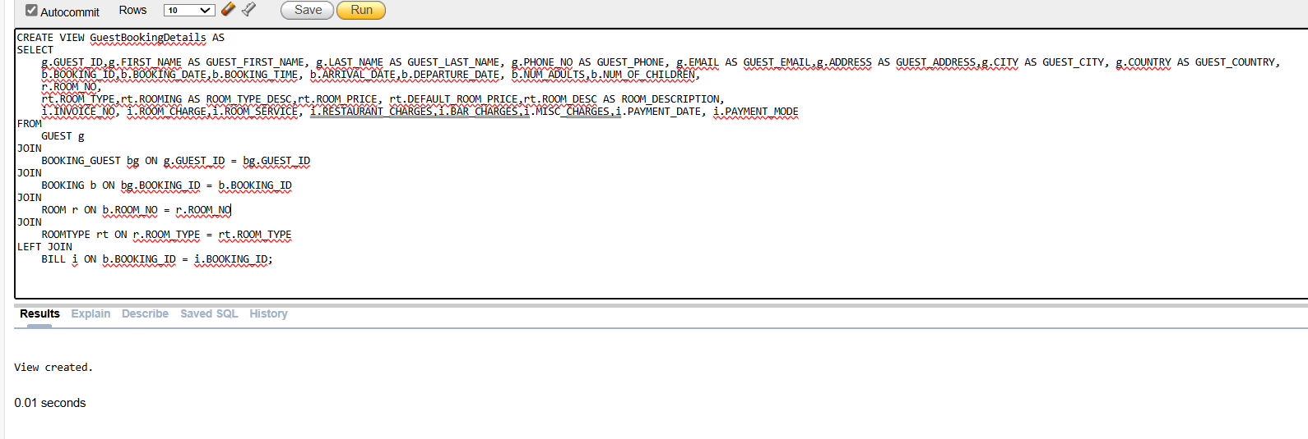
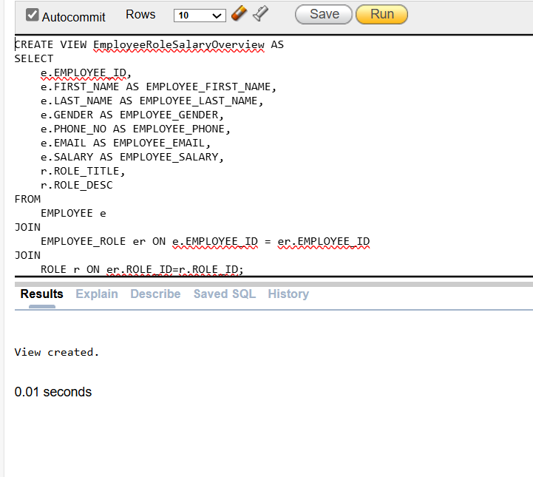

QUESTION 7: SELECT statement for at least five common reports to be generated by the system. The queries should include joins, subqueries, and other appropriate clauses as per requirement.

1. Report: Guest Booking Summary
This report provides a summary of guest bookings, including guest details, booking information, room type, and total charges.
SELECT
g.GUEST_ID,g.FIRST_NAME AS GUEST_FIRST_NAME, g.LAST_NAME AS GUEST_LAST_NAME,
b.BOOKING_ID,b.BOOKING_DATE, b.ARRIVAL_DATE,b.DEPARTURE_DATE,
r.ROOM_NO,
rt.ROOM_TYPE, rt.ROOM_DESC AS ROOM_DESCRIPTION,
i.ROOM_CHARGE + i.ROOM_SERVICE + i.RESTAURANT_CHARGES + i.BAR_CHARGES + i.MISC_CHARGES AS TOTAL_CHARGES
FROM
GUEST g
JOIN
BOOKING_GUEST bg ON g.GUEST_ID = bg.GUEST_ID
JOIN
BOOKING b ON bg.BOOKING_ID = b.BOOKING_ID
JOIN
ROOM r ON b.ROOM_NO = r.ROOM_NO
JOIN
ROOMTYPE rt ON r.ROOM_TYPE = rt.ROOM_TYPE
LEFT JOIN
BILL i ON b.BOOKING_ID = i.BOOKING_ID
WHERE b.DEPARTURE_DATE >= SYSDATE
ORDER BY
b.BOOKING_DATE DESC;

2. Report: Current Occupancy by Room Type
This report shows the current room occupancy, including room type, room number, and number of guests staying in each room.
SELECT
rt.ROOM_TYPE,
rt.ROOM_DESC,
COUNT(r.ROOM_NO) AS OCCUPIED_ROOMS,
SUM(b.NUM_ADULTS + b.NUM_OF_CHILDREN) AS TOTAL_GUESTS
FROM
ROOM r
JOIN
BOOKING b ON r.ROOM_NO = b.ROOM_NO
JOIN
ROOMTYPE rt ON r.ROOM_TYPE = rt.ROOM_TYPE
WHERE
b.DEPARTURE_DATE >= SYSDATE
GROUP BY
rt.ROOM_TYPE, rt.ROOM_DESC
ORDER BY
rt.ROOM_TYPE;

3. Report: Total Revenue per Guest
This report calculates the total revenue generated from each guest based on their bookings and charges.
SELECT
g.GUEST_ID,
g.FIRST_NAME || ' ' || g.LAST_NAME AS GUEST_NAME,
SUM(i.ROOM_CHARGE + i.ROOM_SERVICE + i.RESTAURANT_CHARGES + i.BAR_CHARGES + i.MISC_CHARGES) AS TOTAL_REVENUE
FROM
GUEST g
JOIN
BOOKING_GUEST bg ON g.GUEST_ID = bg.GUEST_ID
JOIN
BOOKING b ON bg.BOOKING_ID = b.BOOKING_ID
LEFT JOIN
BILL i ON b.BOOKING_ID = i.BOOKING_ID
GROUP BY
g.GUEST_ID, g.FIRST_NAME, g.LAST_NAME
ORDER BY
TOTAL_REVENUE DESC;

4. Report: Employee Salary Breakdown by Role
This report provides a breakdown of employee salaries by their roles.
SELECT
r.ROLE_TITLE,
r.ROLE_DESC,
COUNT(e.EMPLOYEE_ID) AS NUM_EMPLOYEES,
AVG(e.SALARY) AS AVG_SALARY,
MIN(e.SALARY) AS MIN_SALARY,
MAX(e.SALARY) AS MAX_SALARY
FROM
EMPLOYEE e
JOIN
EMPLOYEE_ROLE er ON e.EMPLOYEE_ID = er.EMPLOYEE_ID
JOIN
ROLE r ON er.ROLE_ID = r.ROLE_ID
GROUP BY
r.ROLE_TITLE, r.ROLE_DESC
ORDER BY
r.ROLE_TITLE;

5. Report: Guests Who Have Not Paid Their Bills
This report identifies guests who have bookings but have not paid their bills yet (i.e., missing payment details).
SELECT
g.GUEST_ID,
g.FIRST_NAME || ' ' || g.LAST_NAME AS GUEST_NAME,
b.BOOKING_ID,
b.ARRIVAL_DATE,
b.DEPARTURE_DATE,
i.INVOICE_NO,
i.PAYMENT_DATE,
CASE
WHEN i.PAYMENT_DATE IS NULL THEN 'Pending'
ELSE 'Paid'
END AS PAYMENT_STATUS
FROM
GUEST g
JOIN
BOOKING_GUEST bg ON g.GUEST_ID = bg.GUEST_ID
JOIN
BOOKING b ON bg.BOOKING_ID = b.BOOKING_ID
LEFT JOIN
BILL i ON b.BOOKING_ID = i.BOOKING_ID
WHERE
i.PAYMENT_DATE IS NULL
ORDER BY
b.ARRIVAL_DATE DESC;

