WEB-ENGINEERING-LAB-02:

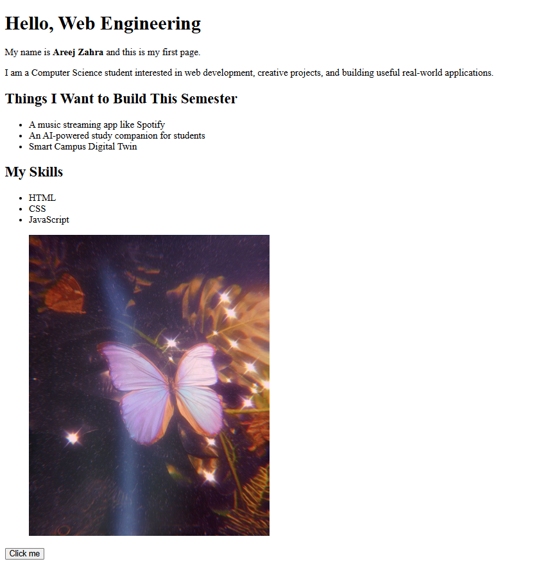

Class activity A:

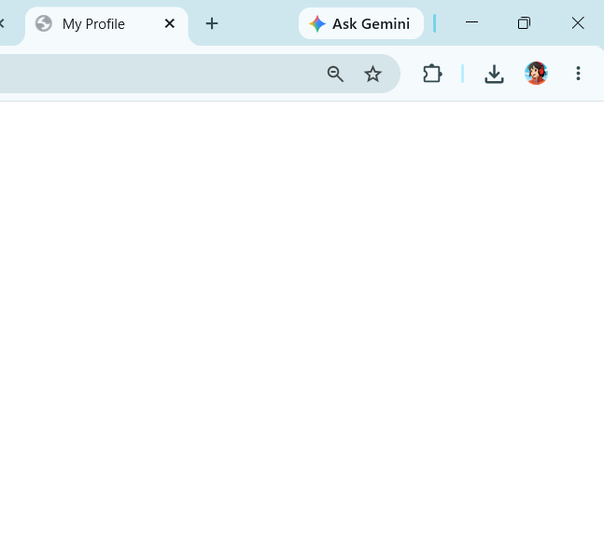
Class activity B:

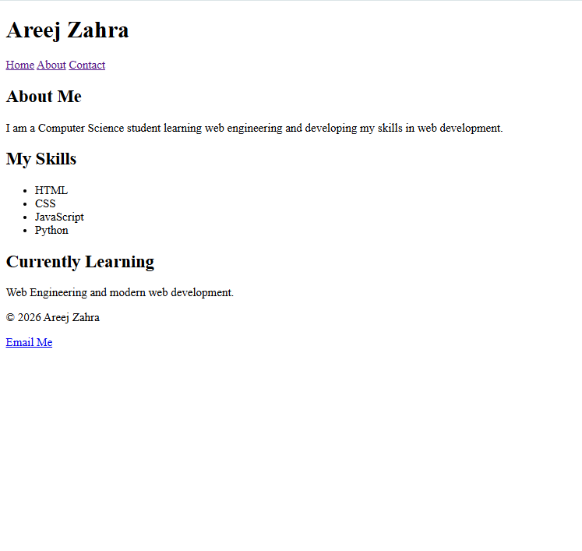

Class activity C:

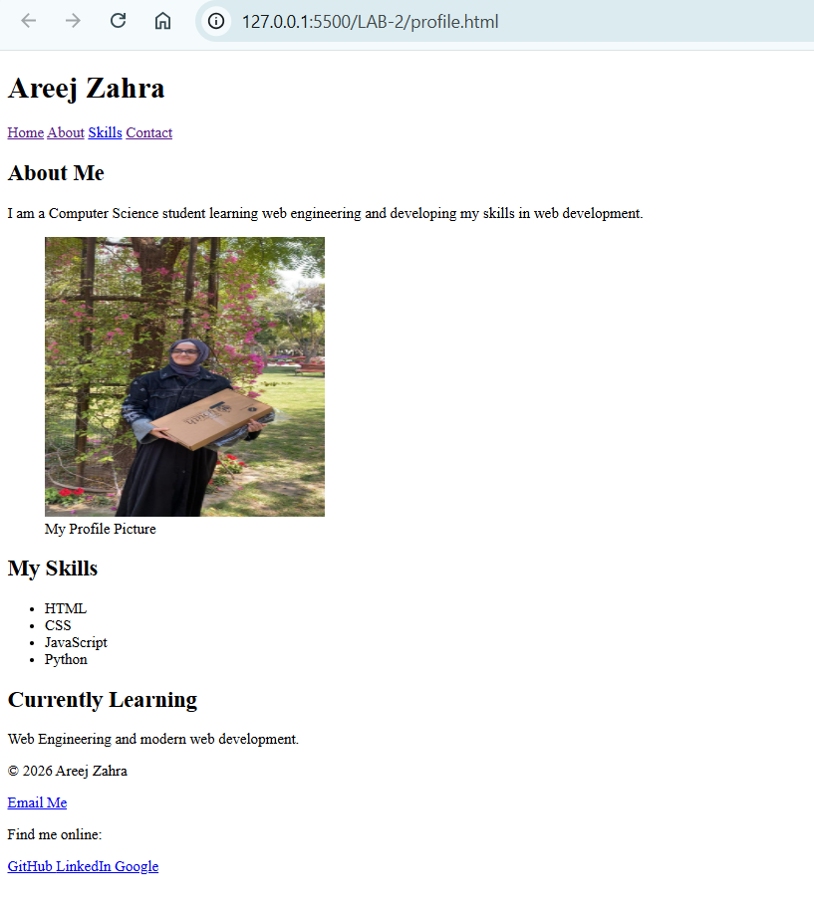

Class activity D:

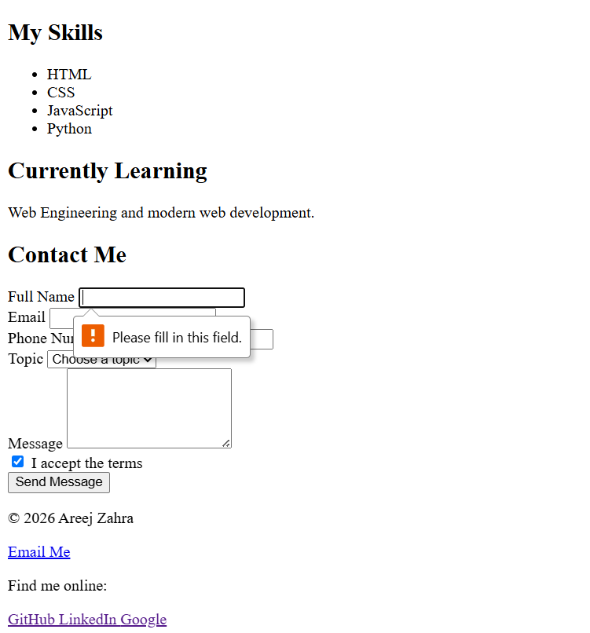

Class activity E:

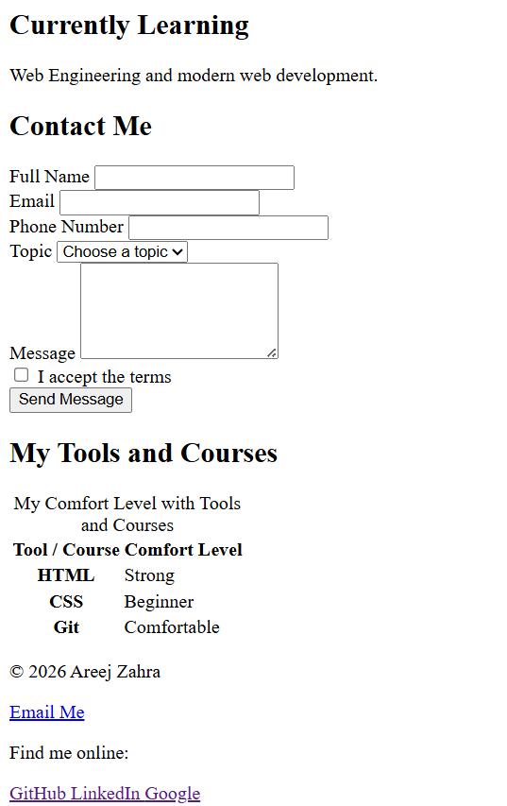

Class activity F:

Code:

<!DOCTYPE html>
<html lang="en">

<head>
<meta charset="UTF-8" />
<meta name="viewport" content="width=device-width, initial-scale=1.0" />
<meta name="description" content="My personal profile page" />
<title>My Profile</title>
</head>

<body>

<!-- Header -->

<header>

<h1>Areej Zahra</h1>

<nav>
<a href="#about">Home</a>
<a href="#about">About</a>
<a href="#skills">Skills</a>
<a href="#contact">Contact</a>
</nav>

</header>

<!-- Main Content -->

<main>

<article id="about" class="card">

<h2>About Me</h2>

<p>
I am a Computer Science student learning web engineering and
developing my skills in web development.
</p>

<figure>

<img
src="images/My_Pic.jpeg"
alt="Areej Zahra profile picture"
width="300"
height="300"
/>

<figcaption>My Profile Picture</figcaption>

</figure>

</article>

<section id="skills">

<h2>My Skills</h2>

<ul>
<li>HTML</li>
<li>CSS</li>
<li>JavaScript</li>
<li>Python</li>
</ul>

</section>

<aside>

<h2>Currently Learning</h2>

<p class="muted">
Web Engineering and modern web development.
</p>

</aside>

<!-- Contact Form -->

<section id="contact">

<h2>Contact Me</h2>

<!-- Form -->

<form action="#" method="post">

<div>

<label for="name">Full Name</label>

<input
type="text"
id="name"
name="name"
required
/>

</div>

<div>

<label for="email">Email</label>

<input
type="email"
id="email"
name="email"
required
/>

</div>

<div>

<label for="phone">Phone Number</label>

<input
type="tel"
id="phone"
name="phone"
/>

</div>

<div>

<label for="topic">Topic</label>

<select id="topic" name="topic">

<option value="">Choose a topic</option>
<option value="project">Project</option>
<option value="feedback">Feedback</option>
<option value="question">Question</option>

</select>

</div>

<div>

<label for="message">Message</label>

<textarea
id="message"
name="message"
rows="5"
></textarea>

</div>

<div>

<label>

<input
type="checkbox"
name="terms"
required
/>

I accept the terms

</label>

</div>

<button type="submit">
Send Message
</button>

</form>

</section>

<!-- Tools and Courses Table -->

<section>

<h2>My Tools and Courses</h2>

<table>

<caption>
My Comfort Level with Tools and Courses
</caption>

<thead>

<tr>

<th scope="col">
Tool / Course
</th>

<th scope="col">
Comfort Level
</th>

</tr>

</thead>

<tbody>

<tr>

<th scope="row">
HTML
</th>

<td>
Strong
</td>

</tr>

<tr>

<th scope="row">
CSS
</th>

<td>
Beginner
</td>

</tr>

<tr>

<th scope="row">
Git
</th>

<td>
Comfortable
</td>

</tr>

</tbody>

</table>

</section>

</main>

<footer>

<p>&copy; 2026 Areej Zahra</p>

<a href="mailto:your-email@example.com">
Email Me
</a>

<p>Find me online:</p>

<a
href="https://github.com"
target="_blank"
rel="noopener noreferrer"
>
GitHub
</a>

<a
href="https://www.linkedin.com"
target="_blank"
rel="noopener noreferrer"
>
LinkedIn
</a>

<a
href="https://www.google.com"
target="_blank"
rel="noopener noreferrer"
>
Google
</a>

</footer>

</body>

</html>

Lab (in class) — finish and validate:

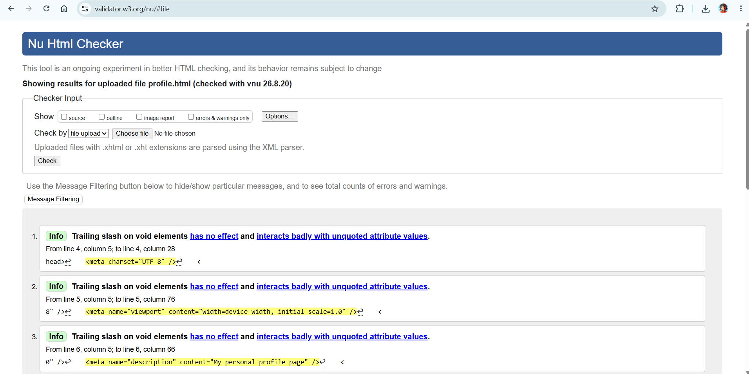

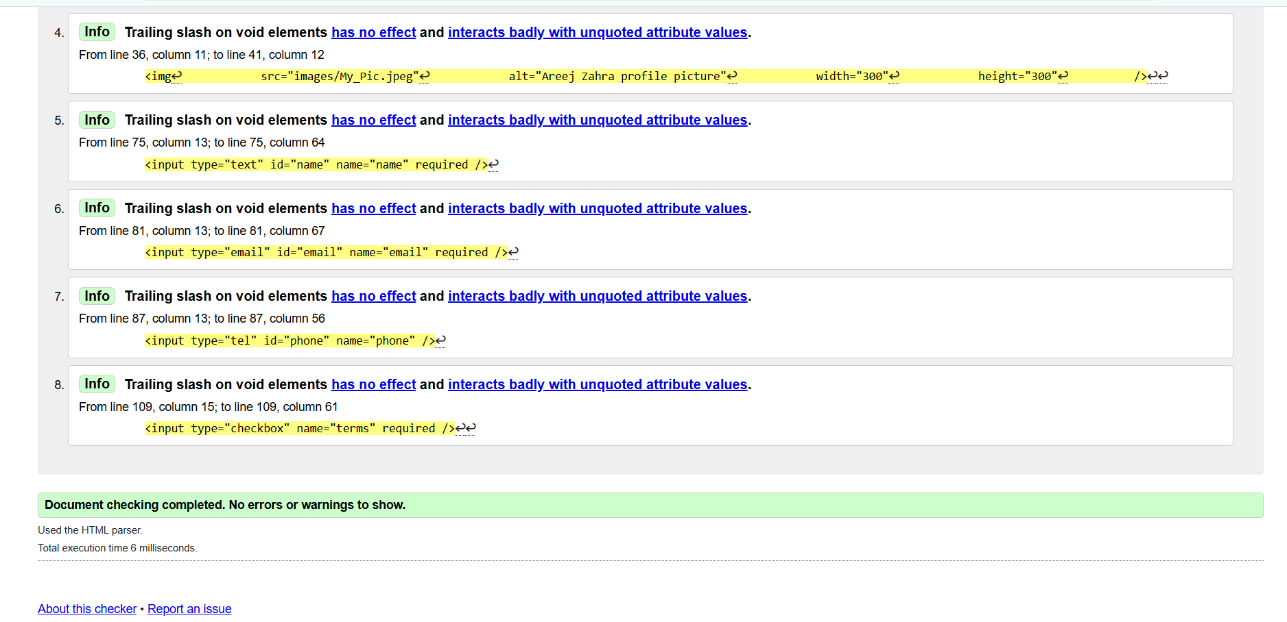

Homework:

Task 1 — Semantic teardown

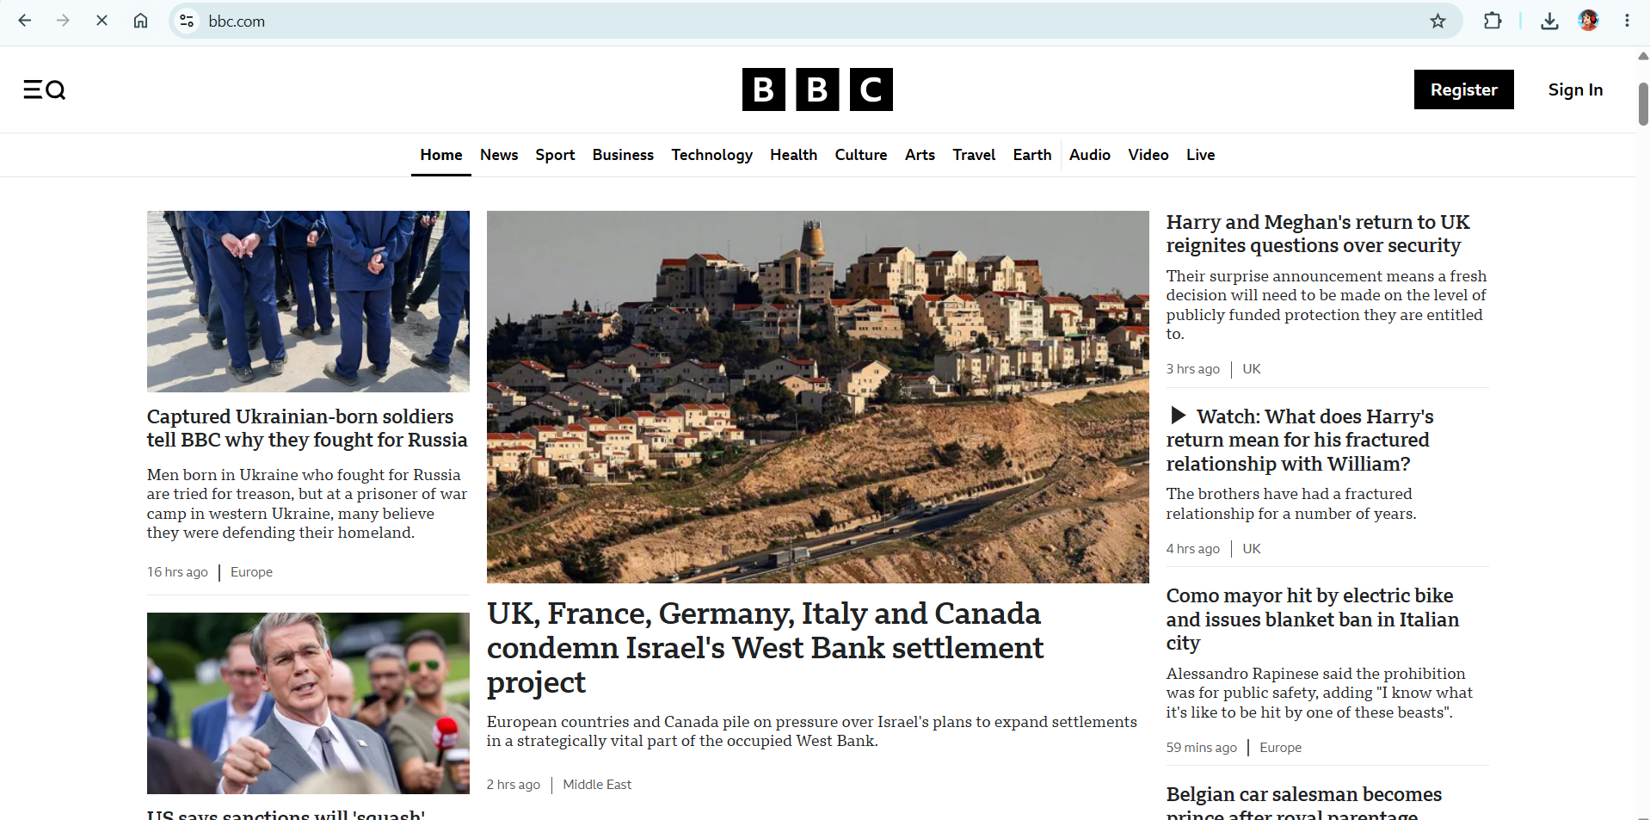

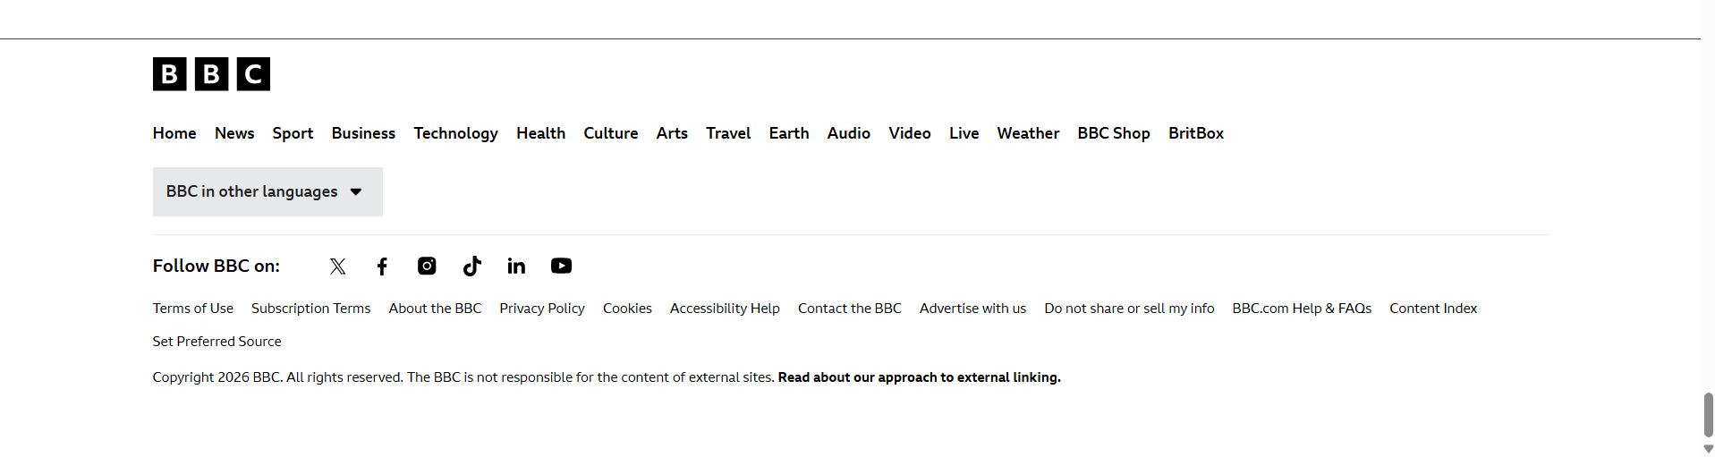

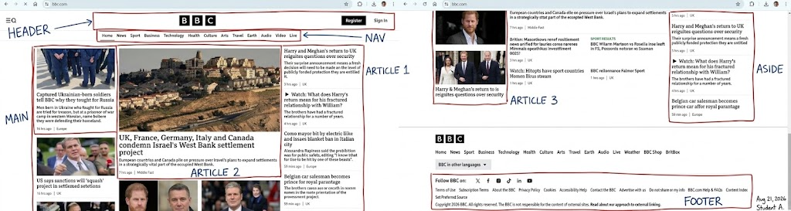

Task 2 — Fix bad HTML:

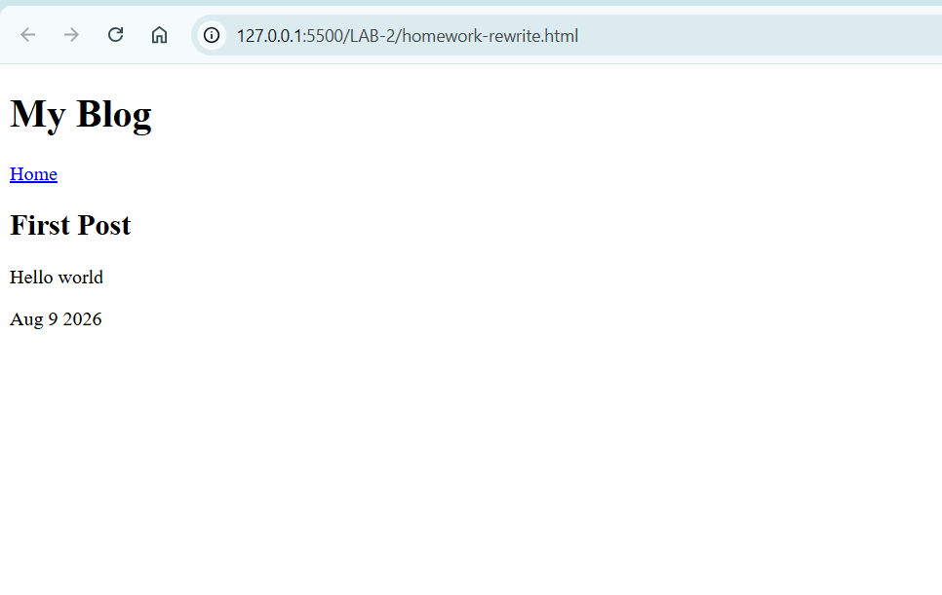

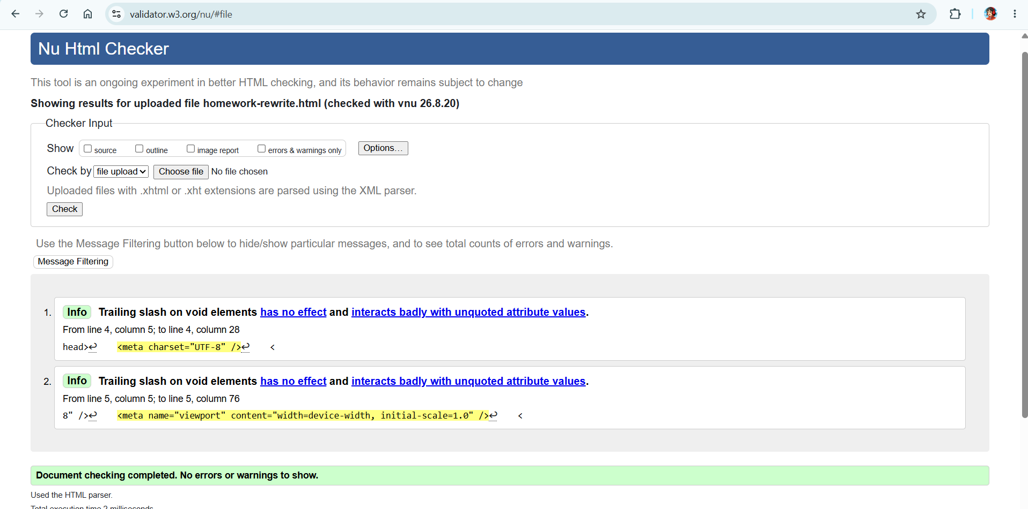

Task 3 — Second page:
Repo link:

Task 4 — Reflect (max 5 sentences):

While creating my webpages, I almost used <div> for the header, navigation, and blog content. Instead, I used semantic elements such as <header>, <nav>, <main>, <article>, and <section>. I also used <footer> for the footer area instead of a generic <div>. Using semantic tags makes the structure of my webpage clearer and more meaningful.

