WEB-ENGINEERING-LAB-1:

Warm-up:
Without installing anything yet, open any website you use daily in Chrome or Edge. Press F12. Click the Network tab and reload.
- How many requests appeared?
208

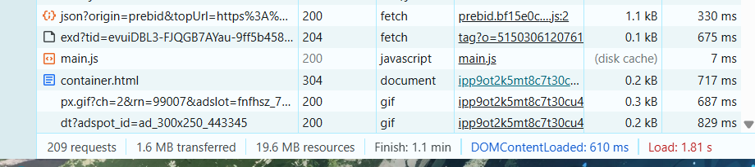

- Can you find one that says 200?

Yes

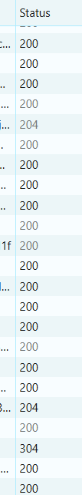

Class activity A — label the roles :

Client and Server:

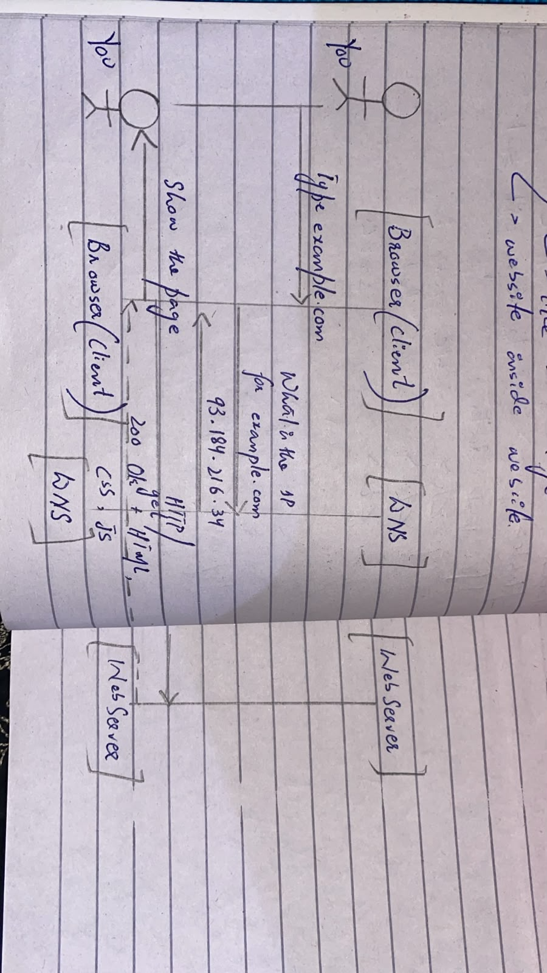
App: Spotify
- Client: The Spotify app/browser displays songs and lets the user play, pause, or search for music.
- Server: Spotify's server stores/manages music data and sends the requested song to the client.
- Network failure: The song would stop loading or streaming if the network failed while it was playing.

Class activity B — URL teardown
https://www.google.com/search?q=web+engineering#results

https:// | www.google.com | /search | ?q=web+engineering | #results
↓ ↓ ↓ ↓ ↓
protocol host path query fragment

For this Google URL, the part that would change when you search for something different is:

https://www.google.com/search?q=web+engineering#results
↑
this part changes

For example, if you searched machine learning, the URL could become:

https://www.google.com/search?q=machine+learning#results

Class activity C — status code flash drill:

1. Page file not found on the server
Answer: 404 Not Found

2. You submitted a form and it was created
Answer: 201 Created

3. Server crashed while handling your request
Answer: 5xx

4. You are not logged in to a private page
Answer: 401 Unauthorized

Class activity D — green lights:
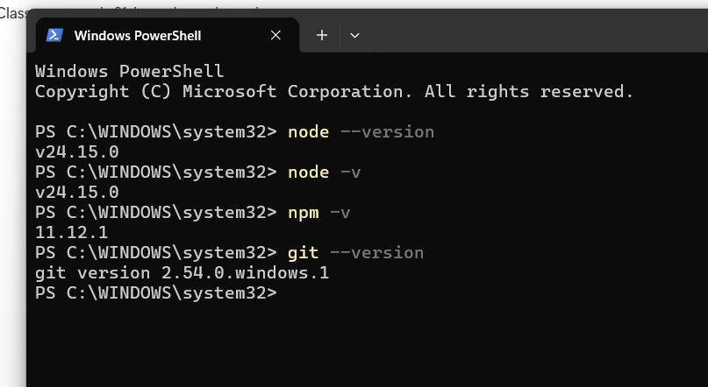

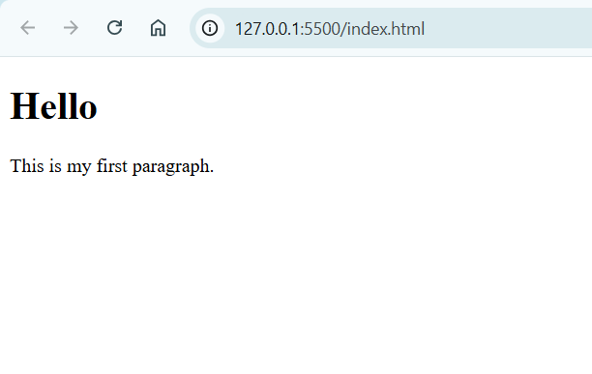

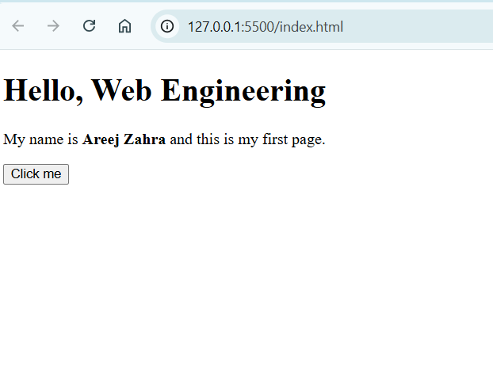

Class activity E — personalise and serve:
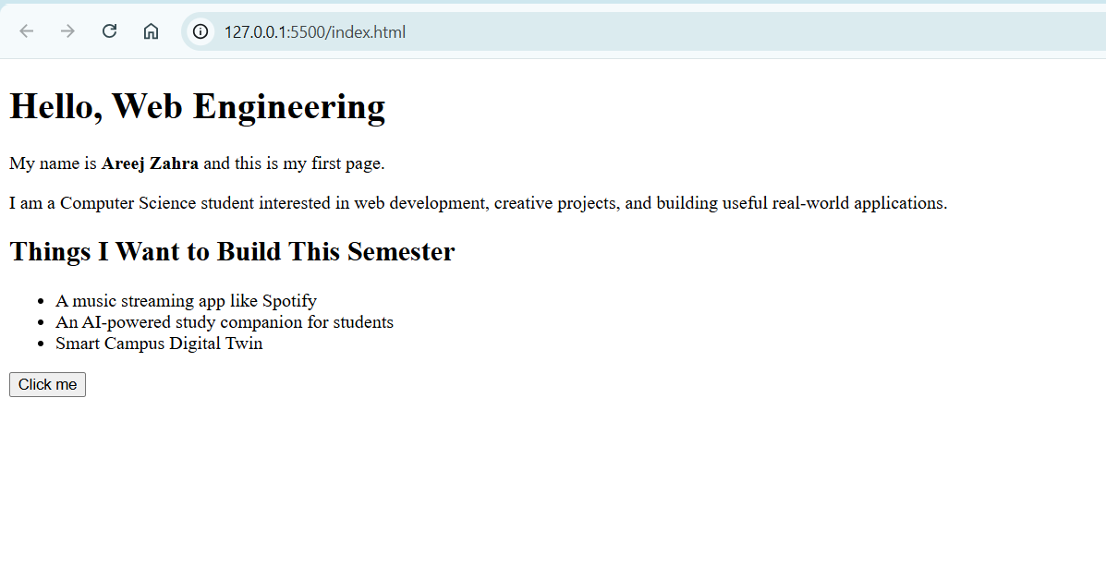
Class activity F — three DevTools drills:
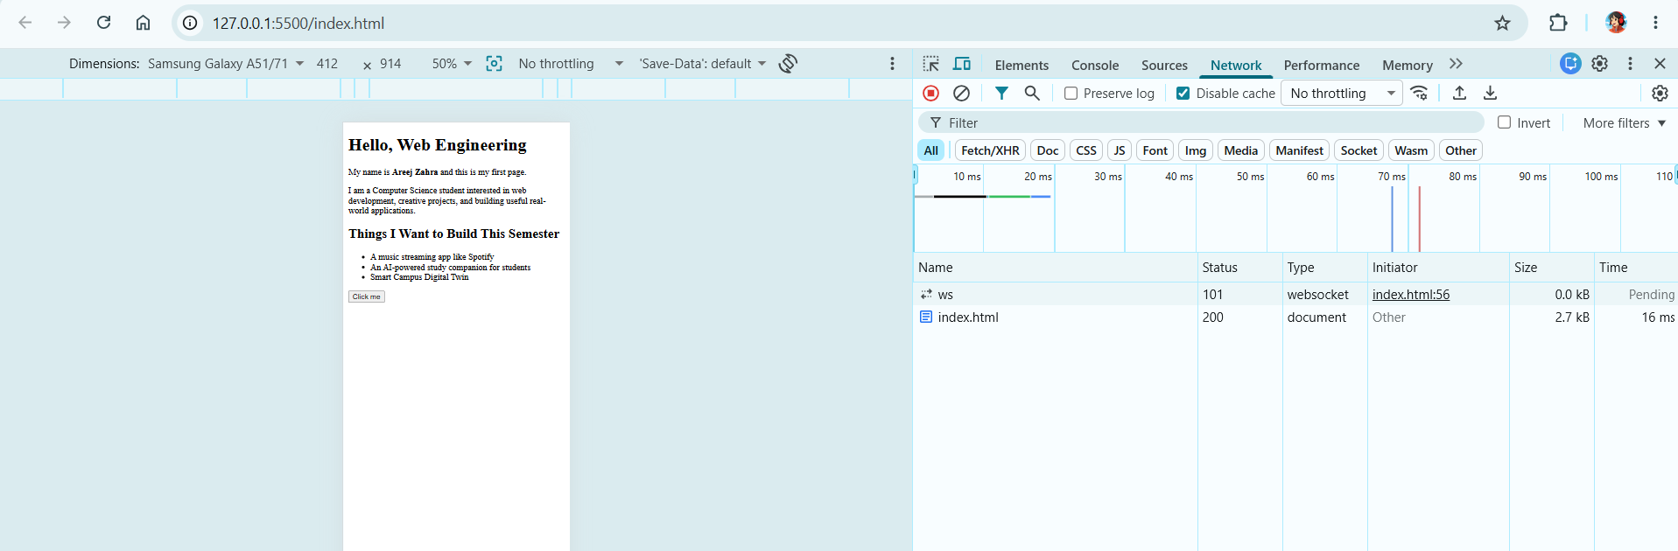

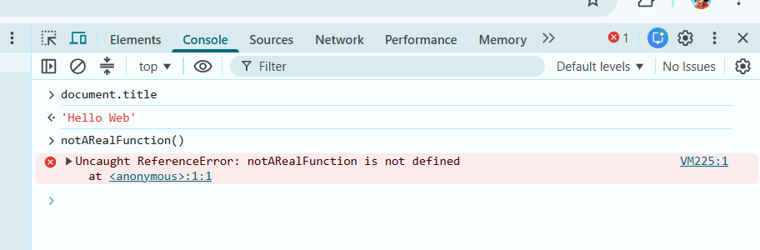

The error means that the function notARealFunction does not exist or has not been defined

The Elements edit disappeared because DevTools only changed the temporary webpage in the browser, not the actual index.html file.

Task 1 — Prove the toolchain:

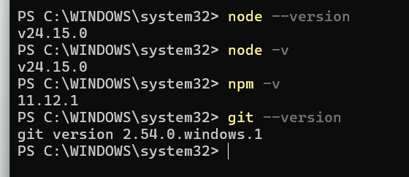

Task 2 — Network detective (hands-on):
- How many requests did the page make?
224 requests
- What is the largest file, and what type is it (JS, image, CSS…)?
206 kB
- Find one request that is not 200
What status is it, and what do you think happened?
· Status: 451
· Type: fetch
· What happened: The request was blocked/unavailable for legal reasons. HTTP status 451 means “Unavailable For Legal Reasons.”

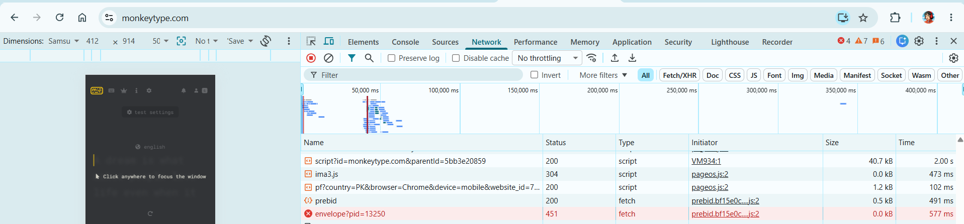

Task 3 — Reflect:
- One install or PATH issue you hit (or “none”)
- Why we refuse file:// this course
- One DevTools habit you will keep every week
I did not face any issues while installing the required tools or setting up PATH.
We refuse file:// in this course because we need to use a local web server and understand how websites work through HTTP requests.
Using a local server such as localhost gives us a more realistic web development environment.
One DevTools habit I will keep every week is checking the Network tab to inspect requests, status codes, and resources loaded by a webpage.

