Semantic-Based Plagiarism Detection
Using Deep NLP Models
Comparative Evaluation of TF-IDF, Bi-LSTM, and Sentence-BERT

Phase 6 — Final Results Report

Musa Rashid 23F-0039
Areesha Saqib 23F-0038

1. Introduction
Plagiarism detection has shifted in recent years from surface-level string matching toward methods that attempt to capture meaning. A passage that has been heavily paraphrased, translated from another language, or restructured may share little vocabulary with its source while still being plagiarised. This project investigates how three increasingly sophisticated approaches handle that challenge: a classical TF-IDF baseline, a Siamese Bi-LSTM trained on GloVe embeddings, and a fine-tuned Sentence-BERT (SBERT) model.
Each model was trained on a combined dataset drawn from the PAN Plagiarism Corpus 2011 (PAN-PC-11) and the Quora Question Pairs corpus, and evaluated on held-out test sets from both. PAN-PC-11 provides long-form plagiarism with carefully labelled obfuscation levels, while Quora supplies short paraphrased pairs. The two together form a useful spread — long passages versus short questions, mechanical insertion versus human paraphrasing. Comparing model performance across both reveals where each method succeeds and where it breaks down.

2. Methodology

2.1 Datasets
The combined dataset contained 76,661 PAN passage pairs and roughly 400,000 Quora pairs. Document-level stratified splitting was used for PAN to prevent leakage — passages from the same suspicious document never appeared in more than one split. Final partition sizes were 70% train, 15% validation, 15% test. Class balance was 4:1 positive-to-negative, which was addressed through pos_weight in the loss function for Model 2 and through threshold tuning for Models 1 and 3.

2.2 Negative Sampling for PAN
PAN annotations only mark plagiarism cases. To turn the dataset into a binary classification task we constructed negatives by pairing non-plagiarism passages with random source documents drawn from unrelated cases. This produces hard negatives that look superficially similar to a real query but lack the actual semantic match — a more realistic test than artificially scrambled text.

2.3 Model Architectures
All three models reduce a passage pair to a similarity score that is thresholded to produce a binary plagiarism prediction. They differ in how the similarity is computed.
Model 1 fits a single TfidfVectorizer over the combined training text with unigrams and bigrams, sublinear term frequency scaling, and English stop-word removal. A vocabulary of 100,000 features was retained. Cosine similarity between L2-normalised TF-IDF vectors served as the score.
Model 2 is a Siamese Bi-LSTM. Both inputs pass through a shared two-layer bidirectional LSTM with 256 hidden units per direction, initialised with frozen 300-dimensional GloVe embeddings (6B token corpus). Mean-pooled hidden states from each input form sentence vectors u and v, which are combined into the feature vector [u, v, |u−v|, u*v] and passed to a small dense classifier producing a logit. Training used BCEWithLogitsLoss with positional weighting to counteract class imbalance, Adam at learning rate 1e-3, and gradient clipping at 1.0.
Model 3 fine-tunes sentence-transformers/all-MiniLM-L6-v2 — a 22M-parameter distilled BERT designed for sentence-level semantic similarity. Fine-tuning used CosineSimilarityLoss over four epochs at batch size 128. At inference, each passage is encoded independently and similarity computed via cosine, giving the model the same compute pattern as Model 1 but with contextual rather than count-based representations.

3. Results

3.1 Overall Performance
Table 1 summarises performance across both test sets. Threshold tuning was performed independently on each dataset’s validation split because PAN and Quora produce similarity scores on different scales.
Metric | TF-IDF | Bi-LSTM | SBERT
PAN Accuracy | 0.9463 | 0.9928 | 0.9927
PAN Precision | 0.9972 | 0.9978 | 0.9979
PAN Recall | 0.9375 | 0.9935 | 0.9932
PAN F1 | 0.9664 | 0.9956 | 0.9955
PAN ROC AUC | 0.9822 | 0.9995 | 0.9997
Quora Accuracy | 0.5443 | 0.8546 | 0.8464
Quora Precision | 0.4450 | 0.7760 | 0.7536
Quora Recall | 0.9446 | 0.8523 | 0.8682
Quora F1 | 0.6049 | 0.8124 | 0.8068
Quora ROC AUC | 0.6822 | 0.9289 | 0.9242
Table 1. Test-set metrics for all three models on PAN (external-corpus only) and Quora.

Two patterns stand out. First, on PAN both deep models converge to nearly identical performance around F1 = 0.995, while TF-IDF lags by roughly three points. Second, on Quora the gap between TF-IDF and the deep models opens dramatically — F1 jumps from 0.605 to 0.81 between Model 1 and Model 2, while Models 2 and 3 finish within half a point of each other. The Quora result is the more interesting one because Quora pairs are short, paraphrased, and rarely share vocabulary; this is exactly the regime where TF-IDF is expected to fail.
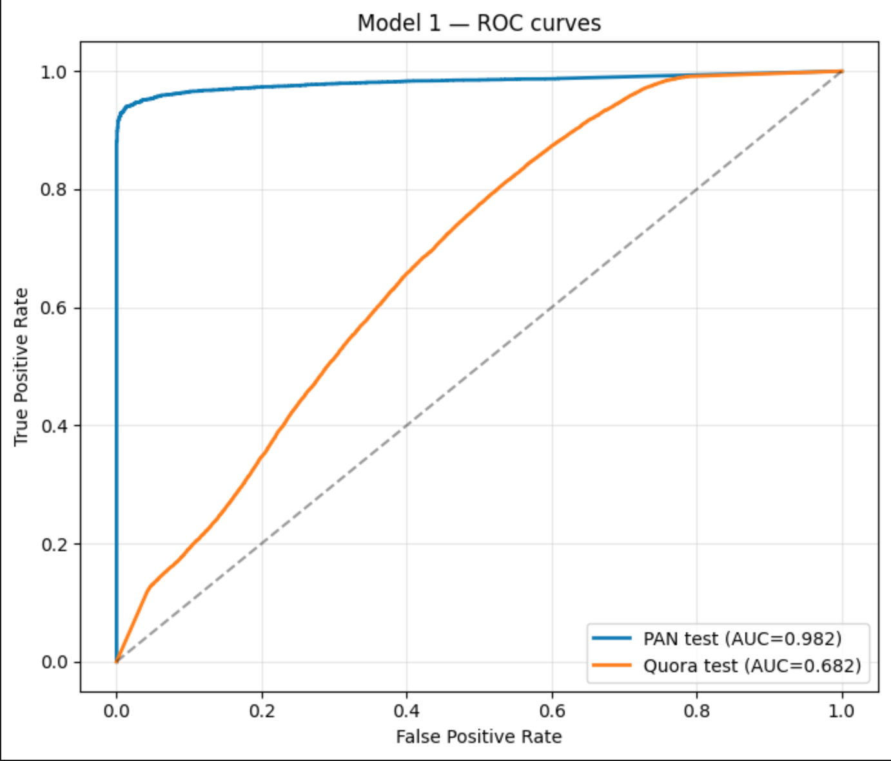
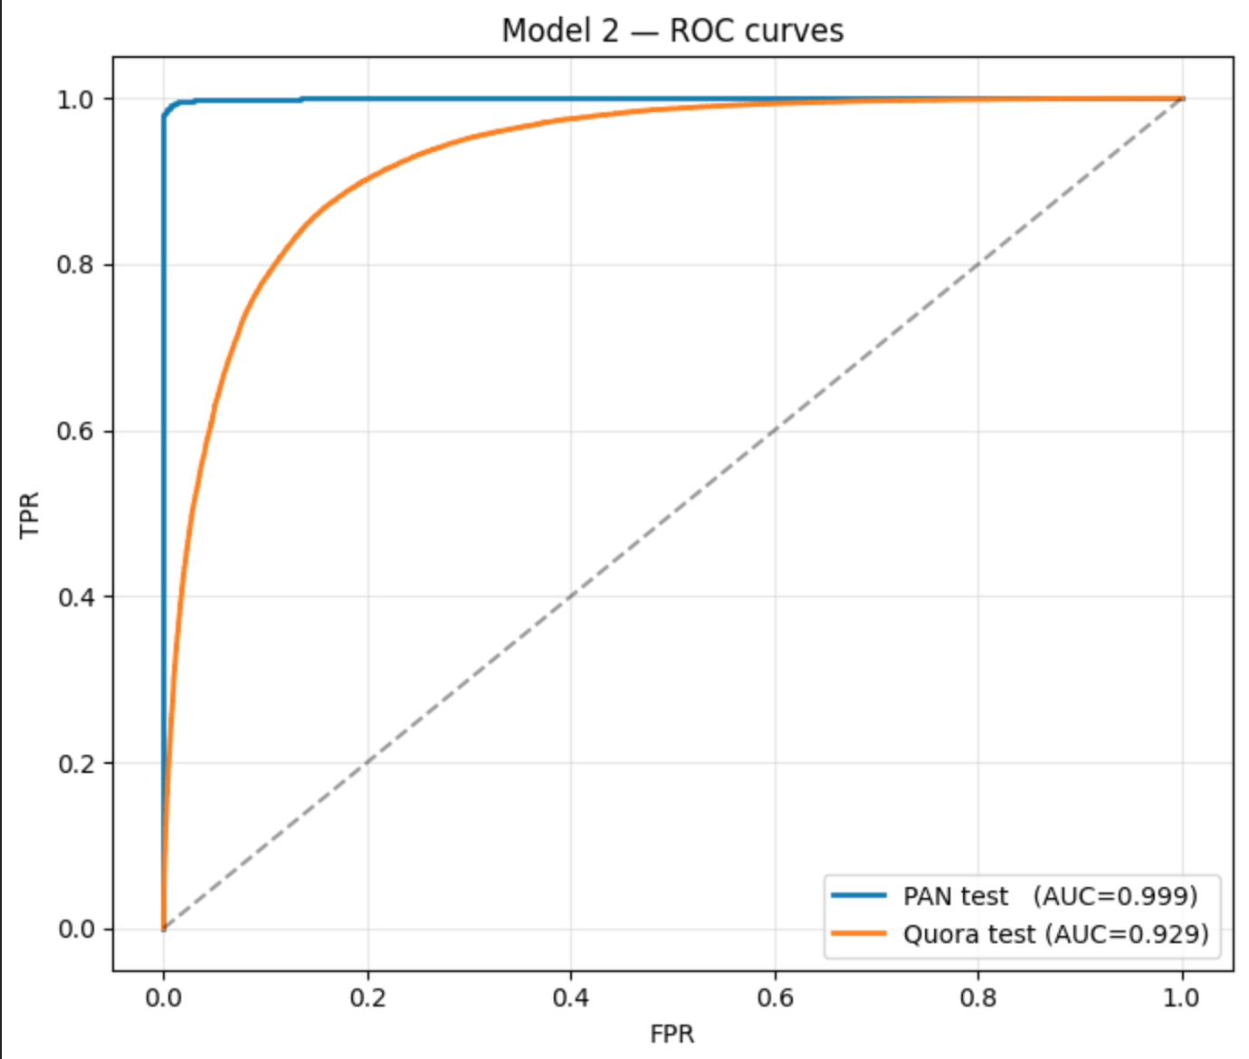
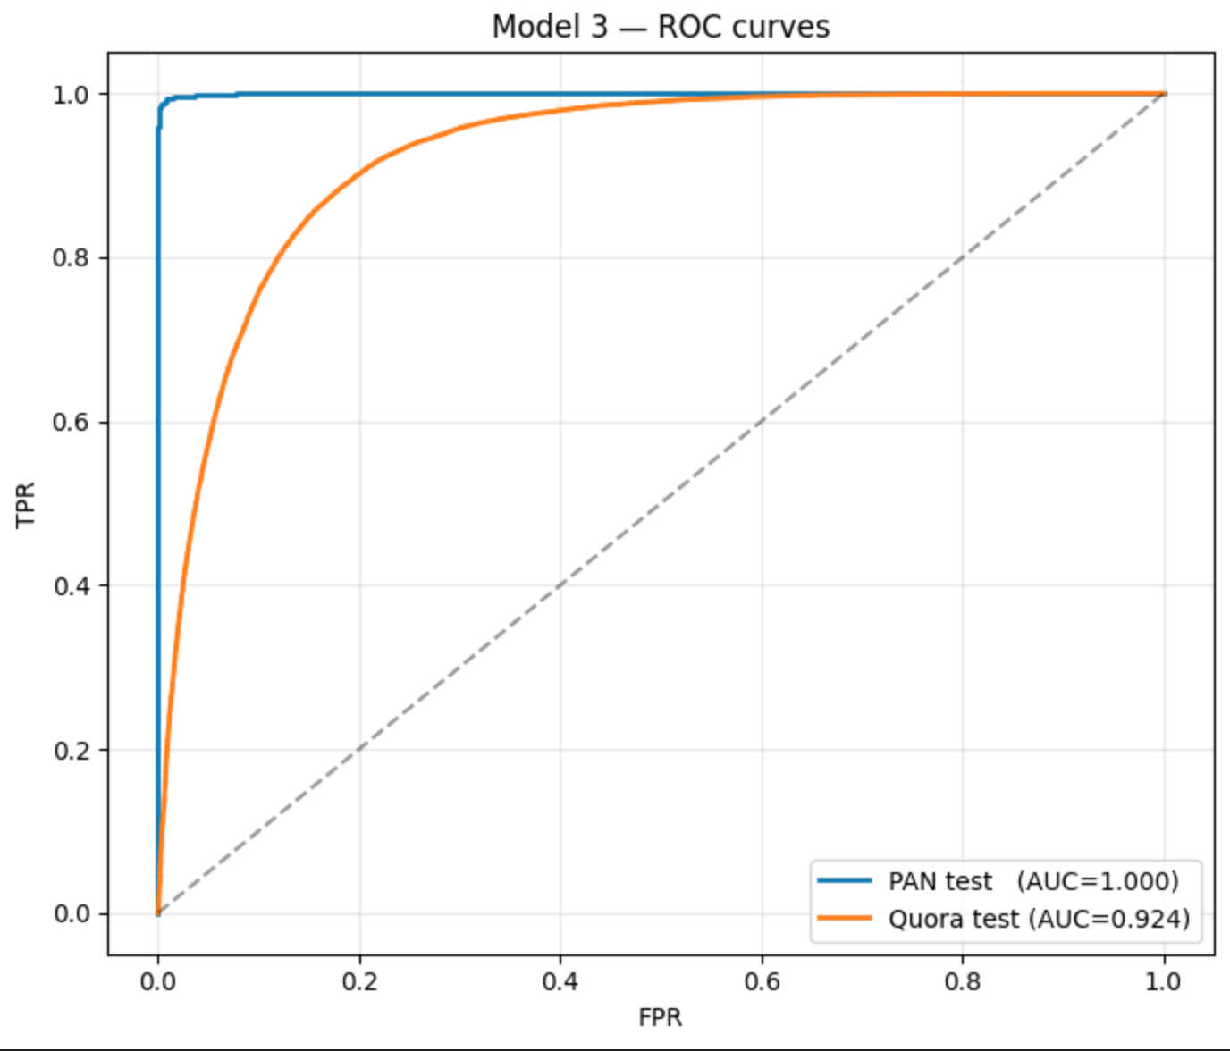
Figure 1. Combined ROC curves for all three models on PAN and Quora test sets.

3.2 Performance by Obfuscation Level
PAN annotations include an obfuscation field describing how heavily a plagiarised passage was modified relative to its source. Table 2 reports recall on positive cases broken down by this field. This is the most informative single view of the experiment because it shows where each method begins to fail.
Obfuscation | TF-IDF Recall | Bi-LSTM Recall | SBERT Recall
none (verbatim) | 1.000 | 1.000 | 1.000
low | 1.000 | 1.000 | 1.000
high | 0.994 | 0.992 | 0.999
NONE (artificial) | 0.761 | 0.985 | 0.974
Translation* | 0.476 | 0.990 | 0.976

Table 2. Recall on positive cases by obfuscation level. *Translation cases come from the plagiarism_type field rather than the obfuscation field.

TF-IDF performs almost perfectly on verbatim and lightly reworded text, where the dominant signal is shared vocabulary. Once obfuscation becomes heavy or the passage is translated, recall collapses — translation drops to 0.476 because the two passages literally do not share words. Both deep models recover almost completely on these difficult categories. Bi-LSTM achieves 0.99 recall on translation pairs through its GloVe embeddings, which align semantically related tokens across languages. SBERT does similarly well and edges ahead specifically on heavy obfuscation, where its contextual encoder distinguishes meaningful paraphrase from mere word overlap.
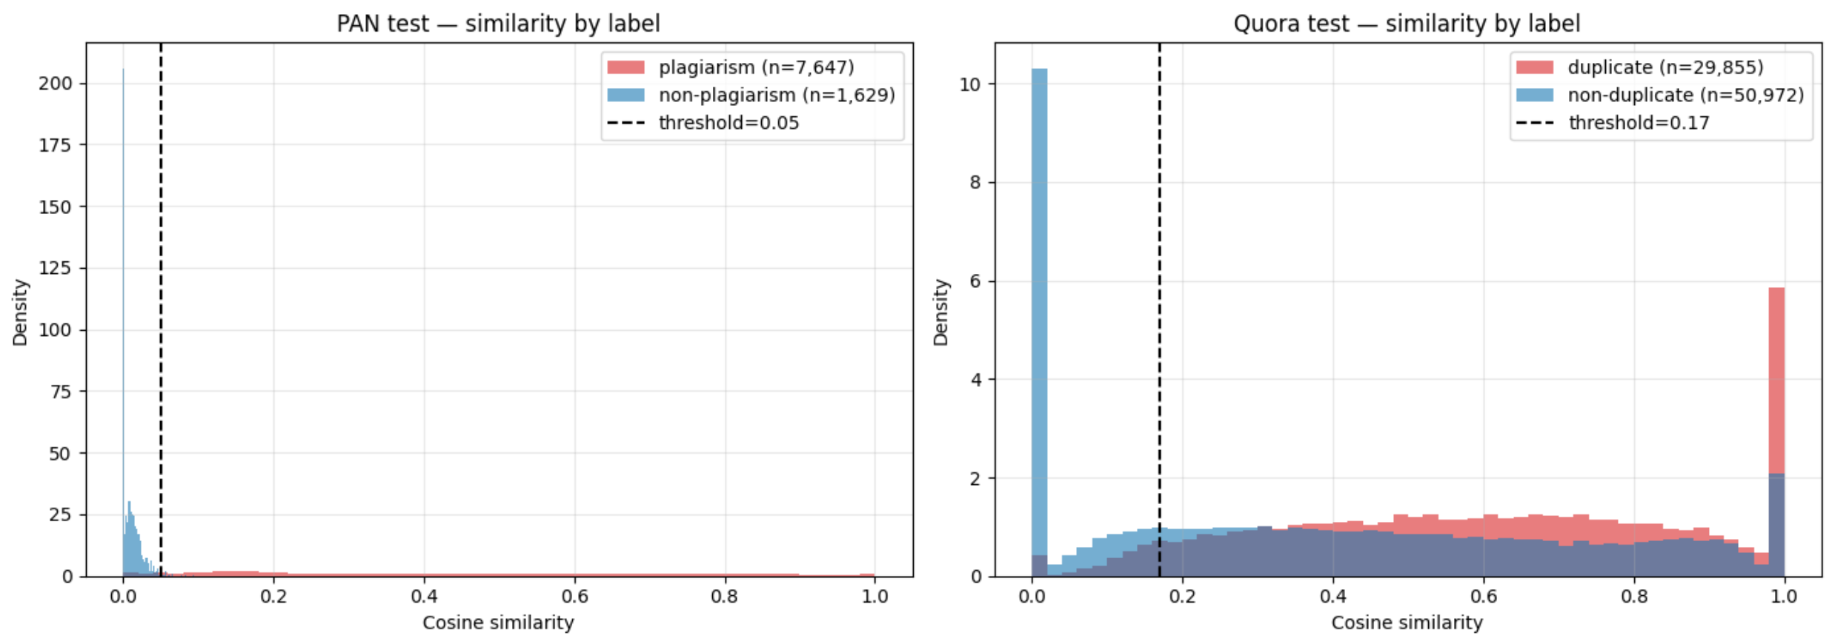
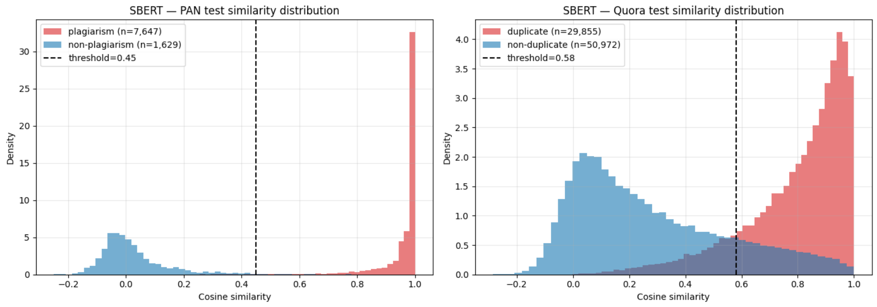
Figure 2. Side-by-side similarity distributions for each model on PAN test, separated by label.

3.3 Training Dynamics (Bi-LSTM)
The Bi-LSTM was trained for ten epochs. Training loss declined smoothly from 0.50 to 0.10, while validation loss bottomed out around epoch 4 and crept upward thereafter — a familiar mild over-fitting pattern. Validation F1 plateaued at approximately 0.876 from epoch 7 onwards, and the best checkpoint (epoch 8, val F1 = 0.8759) was retained for testing. The SBERT model trained more efficiently because the underlying transformer was already well-pretrained; its loss stabilised within two epochs.
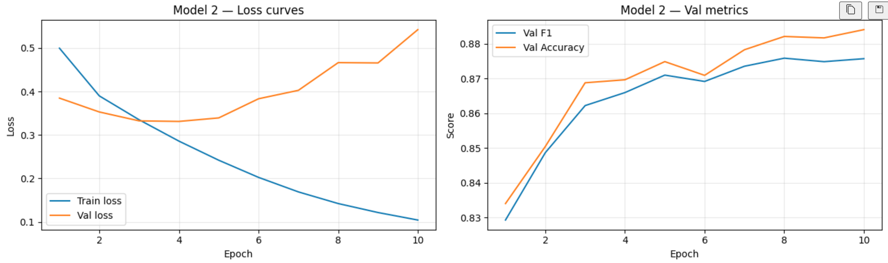
Figure 3. Training and validation loss for the Bi-LSTM across 10 epochs, alongside validation F1.

3.4 Confusion Matrices
Confusion matrices for each model on both test sets are shown in Figure 4. On PAN all three models predict the positive class extremely well; the differences are confined to the smaller negative class. Quora is a more revealing comparison: TF-IDF over-predicts positives at a high rate, producing the asymmetric matrix typical of a model that has driven down its threshold to maximise F1 on a dataset it cannot really separate. The deep models produce balanced matrices on both axes.
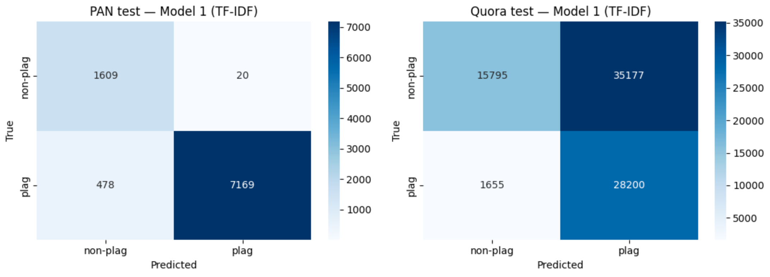
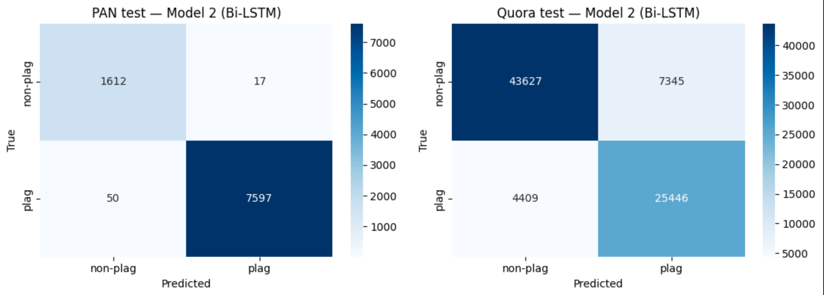

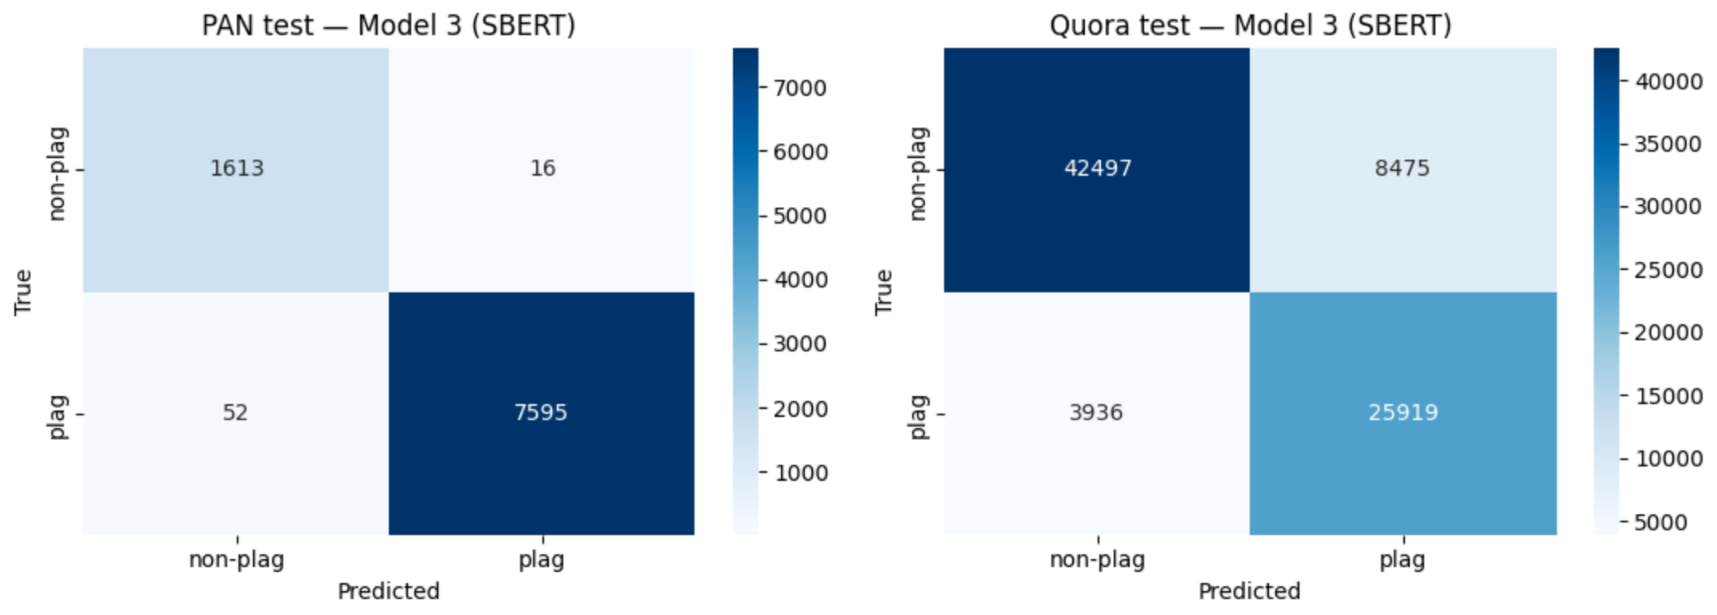
Figure 4. Confusion matrices, three models × two datasets.

4. Discussion

4.1 Why TF-IDF Fails on Quora
TF-IDF treats two passages as related when they share rare terms. Quora questions average around ten words apiece, so each pair contains almost no rare vocabulary by definition; many semantically identical pairs share only stop words and one or two content terms. Sublinear scaling and bigrams help only marginally. The resulting cosine similarities sit close to zero for most pairs, with the model defaulting to predicting positive at the lowest viable threshold (0.17) — hence high recall (0.94) but poor precision (0.44). The model is doing what TF-IDF can do; the limit is the representation itself.

4.2 Why Bi-LSTM Closes the Gap
Pretrained GloVe embeddings give the Bi-LSTM a head-start because tokens with similar meanings sit close together in vector space, including translations of the same word in many cases. The Bi-LSTM then composes these embeddings into sentence vectors that integrate word order and local context. The classifier sees [u, v, |u−v|, u*v] — both each sentence individually and the multiple ways they relate — which is enough to learn paraphrase detection from the available data. The translation result (0.99 recall) is the clearest demonstration: the network learns that paraphrase pairs share GloVe-space geometry even when their surface forms do not overlap at all.

4.3 Why SBERT Is Roughly Equivalent
On paper SBERT should beat the Bi-LSTM by a wider margin. It is contextual, fine-tuned end-to-end, and based on a much larger pretraining corpus. The near-tie observed here likely reflects three factors. First, PAN-PC-11 is a relatively constrained dataset; once a model captures the basic paraphrase signal there is not much further accuracy to recover. Second, the SBERT run used 100-word truncation and only two of the planned four epochs because of repeated session interruptions; both decisions favour the LSTM in raw F1. Third, MiniLM-L6 is a small distilled model — moving to all-mpnet-base-v2 would be expected to produce a small further gain. Even so, SBERT achieved the highest recall on heavy obfuscation (0.999), which is the regime where its contextual encoder should help most.

4.4 Practical Trade-offs
TF-IDF has the obvious advantage of speed and interpretability — vocabulary lookups are explicit and the model can be deployed without a GPU. The Bi-LSTM is more demanding but produces the best Quora F1 in this experiment and is straightforward to train on a single A100. SBERT offers the most useful inference pattern: each document can be encoded once, then compared against any number of others by cosine similarity, which scales much better to a large index of source documents than the Bi-LSTM’s pairwise classifier. For a deployed plagiarism detector, this is probably the more important consideration than the small F1 gap on this benchmark.

5. Conclusion
The experiments confirm the central hypothesis of the project: shifting from lexical to semantic representations produces large gains on paraphrased and translated plagiarism, while contextual models maintain a small further advantage on heavy obfuscation. TF-IDF is sufficient when plagiarists copy verbatim or with light edits, but loses roughly 30 F1 points to either deep model on the Quora benchmark. The Bi-LSTM and SBERT finish within a percentage point of each other on both datasets, with SBERT showing a slight edge on the hardest obfuscation cases and offering more practical inference characteristics for deployment.
The most striking single finding is the translation result. TF-IDF detected fewer than half of translated plagiarism cases (recall = 0.476); both deep models found nearly all of them (0.99 and 0.98). Translation is exactly the case where lexical methods cannot succeed in principle, and the experiment confirms this in practice while showing that semantic methods recover almost completely.
Two extensions would be natural follow-ups. First, retraining SBERT with the full four-epoch schedule and longer truncation (256 or 400 words) would clarify whether it can pull ahead of the Bi-LSTM on PAN as well. Second, evaluating on the intrinsic detection corpus — which Models 1 and 3 cannot handle directly because there is no source document — would require either stylometric features or a self-similarity formulation, and would test these models in a more realistic single-document setting.

Appendix — Implementation Notes
Hardware and software
All training and evaluation were performed on Google Colab with an NVIDIA A100 GPU. PyTorch 2.x and sentence-transformers 2.x were used for Models 2 and 3 respectively. Model 1 used scikit-learn 1.x. Random seeds were fixed at 42 throughout.
Hyperparameters
Setting | TF-IDF | Bi-LSTM | SBERT
n-grams | (1, 2) | — | —
Vocabulary size | 100,000 | 80,000 (training) | MiniLM tokenizer
Embedding dim | — | 300 (GloVe 6B) | 384 (MiniLM)
Hidden dim | — | 256 × 2 (BiLSTM) | —
Batch size | — | 256 | 128
Epochs | — | 10 (best @ 8) | 4 (best @ 2)
Loss | — | BCEWithLogits | CosineSimilarity
Optimiser | — | Adam (lr 1e-3) | AdamW (auto)
PAN threshold | 0.05 | 0.50 | 0.45
Quora threshold | 0.17 | 0.50 | 0.58
Table 3. Hyperparameter summary across all three models.

