

CYBERSECURITY ASSESSMENT REPORT

Title Page

Report Title:
Web Application Security Assessment Using Kali Linux
Course:
Cybersecurity
Prepared by:
Areesha Raheel (55039)
Hoor un Ain (55835)
Tools Used:
Kali Linux Security Tools
Target:
University of the Punjab ( https://www.pu.edu.pk )

Date: January 19, 2026

Table of Contents

Executive Summary ..................................................................... Page 1
Assessment Methodology .......................................................... Page 2
Reconnaissance & OSINT (Passive) ........................................ Page 3
3.1 Whois
3.2 nslookup
3.3 DNSenum
Target Scanning (Active) ............................................................. Page 4
4.1 Nmap (Service Discovery)
4.2 SSLScan
4.3 WhatWeb (Tech Fingerprinting)
4.4 WafWoof
Web Application Analysis ............................................................ Page 5
5.1 Gobuster (Directory Discovery)
5.2 WPScan (CMS Audit)
Exploitation & Risk Verification ................................................. Page 6
6.1 Metasploit Framework
Tools Summary & Risk assessment Table .................................... Page 7
Remediation & Final Recommendations .................................... Page 8
Conclusion ............................................................. Page 9

Executive Summary
This report documents a structured web application security assessment conducted using ethical hacking tools available in Kali Linux. The objective was to identify potential security weaknesses in a publicly accessible and legally permitted target website and to understand how attackers may gather information, scan services, and analyze web application behavior.
Multiple tools were used across different penetration testing phases, including reconnaissance, active scanning, web application analysis, and risk verification. The assessment revealed informational disclosures, exposed services, and configuration-level weaknesses. No active exploitation or damage was performed. The findings emphasize the importance of secure configurations, encryption hardening, and continuous security monitoring.

1. Introduction
With the rapid growth of web-based applications, cybersecurity has become a critical concern for organizations and individuals alike. Web applications are frequent targets of cyberattacks such as SQL Injection, Cross-Site Scripting (XSS), and brute-force attacks. Ethical hacking and penetration testing are essential practices used to identify and mitigate these vulnerabilities before malicious attackers exploit them. This project demonstrates a structured cybersecurity assessment using Kali Linux, a specialized operating system designed for penetration testing and security research

2. Objective of the Project
- The primary objectives of this project are:
- To understand the practical use of cybersecurity tools
- To identify vulnerabilities in a web application
- To analyze security risks associated with detected vulnerabilities
- To recommend mitigation strategies and security best practices
- To gain hands-on experience with Kali Linux tools

3. Testing Environment

Operating System:
Kali Linux

Target Website:

https://www.pu.edu.pk

Ethical Disclaimer

All security testing performed in this project was conducted strictly for educational purposes on legally authorized test websites. No unauthorized access, exploitation, or damage was caused to any real-world system. The project adheres to ethical hacking principles and responsible disclosure guidelines.

5. Assessment Methodology
The security assessment followed standard penetration testing phases:
- Reconnaissance & OSINT (Passive and Semi-Passive)
- Active Scanning & Enumeration
- Web Application Analysis
- Exploitation Research & Risk Verification
- Risk Assessment & Recommendations

6. Detailed Vulnerability Analysis
Each identified vulnerability was analyzed based on severity, exploit availability, and potential business impact.

Risk Rating Criteria
High: Exploitable remotely with public exploit available
Medium: Exploitable with conditions or authentication
Low: Informational or misconfiguration
7.Technical Findings & Tool Analysis
- Reconnaissance & OSINT (Passive)

1. WHOIS
Objective: To collect domain registration information.
Method: WHOIS query.
Result: Domain registrar details and name servers were identified.
Security Impact: Publicly available information can aid attackers during reconnaissance.
Risk Level: Low
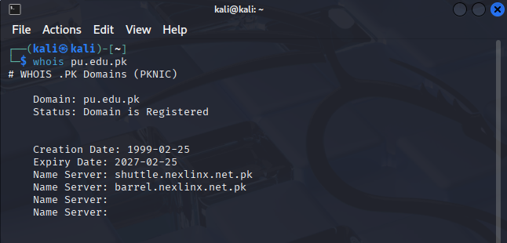

2. nslookup
Objective:To obtain DNS-related information of the target domain.
Method Used:The nslookup command was used to query DNS servers for domain resolution details.
Result:The IP address and DNS records associated with the target domain were successfully retrieved.
Security Impact:DNS information disclosure assists attackers in mapping the target infrastructure.
Risk Level:Low

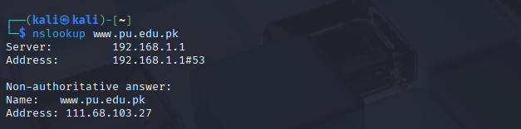

DNSenum
Objective: To enumerate DNS records and subdomains.
Method: DNS enumeration techniques.
Result: DNS records and additional subdomains were identified.
Security Impact: Exposed DNS information may help attackers map the infrastructure.
Risk Level: Low
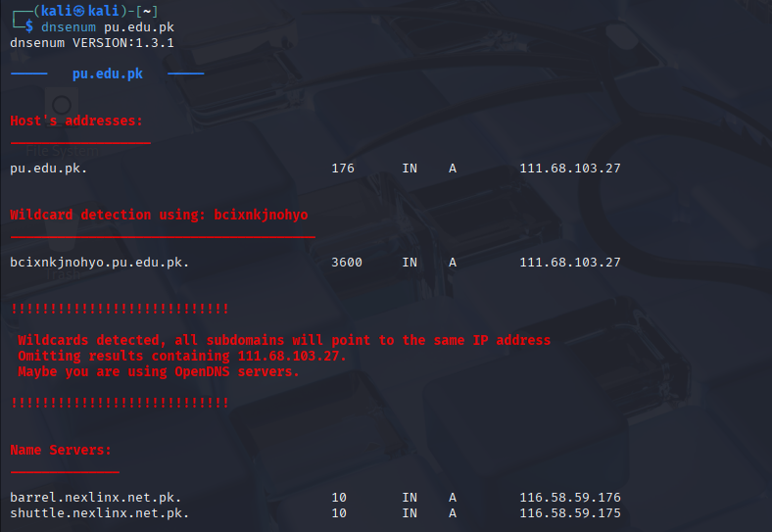
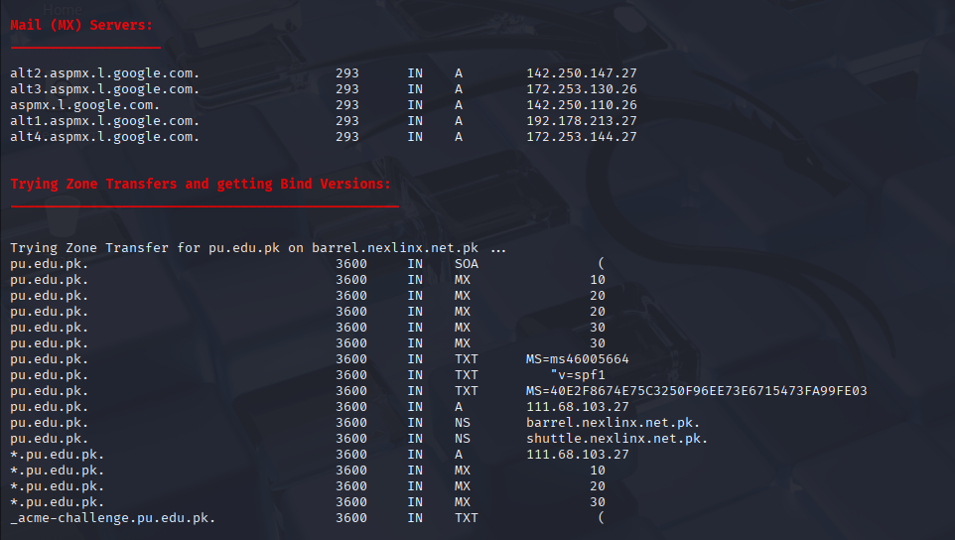

Target Scanning (Active)

1. Nmap
Objective: To identify open ports and running services.
Method: TCP SYN scan and service detection.
Result: Several open ports and active services were detected.
Security Impact: Open services may be targeted if misconfigured.
Risk Level: Medium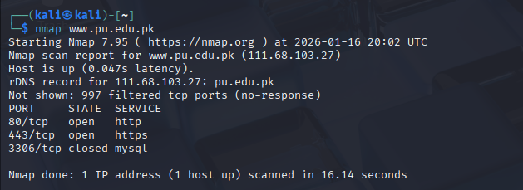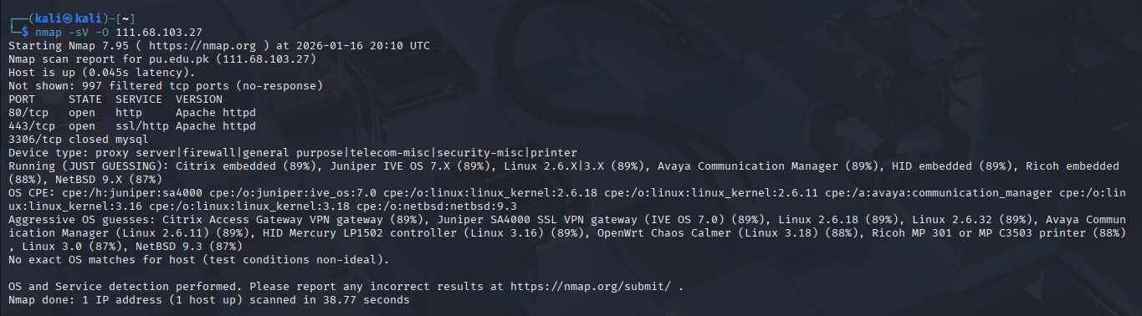
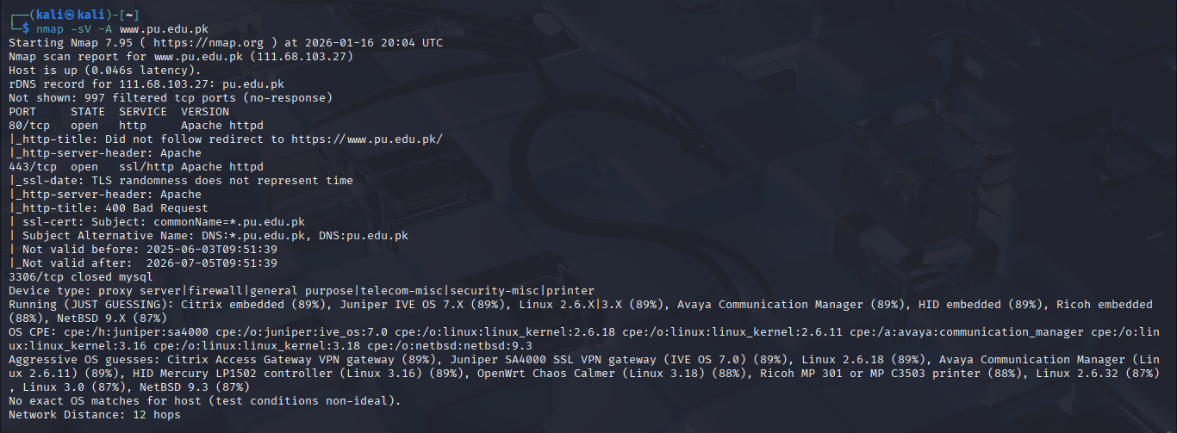

SSLScan
Objective:To analyze the SSL/TLS configuration of the target web server.
Method Used:SSLScan was used to enumerate supported SSL/TLS protocols and cipher suites.
Result:The scan revealed enabled SSL/TLS versions and supported cryptographic ciphers.
Security Impact:Weak or outdated encryption protocols can expose sensitive data to interception.
Risk Level:Medium

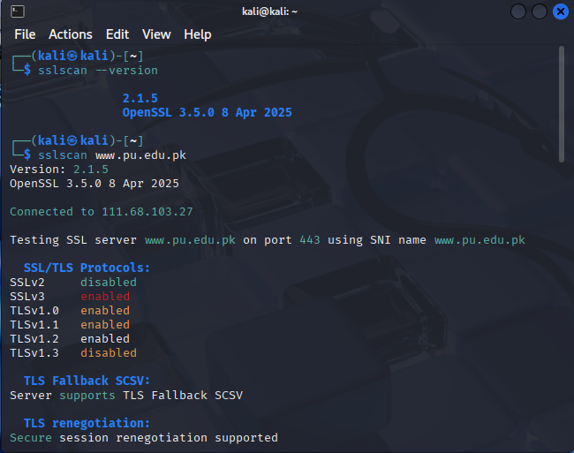
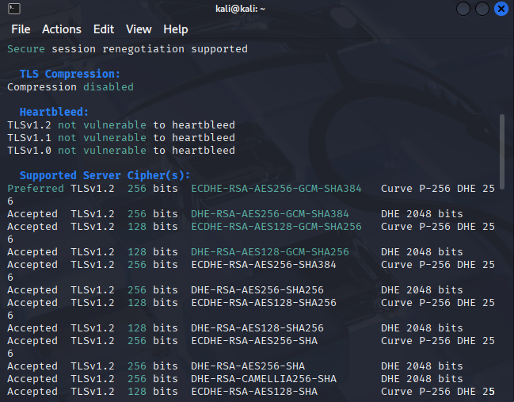

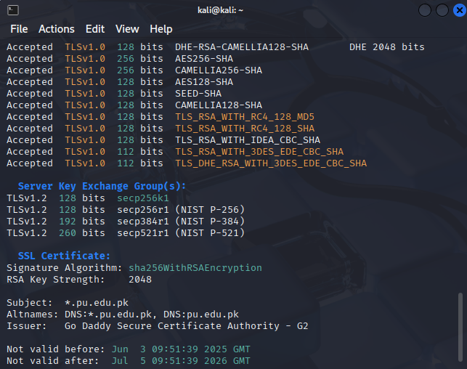

3. WhatWeb
Objective: To fingerprint web technologies.
Method: Web technology identification.
Result: Server-side technologies and frameworks were detected.
Security Impact: Technology disclosure can help attackers choose targeted exploits.
Risk Level: Low
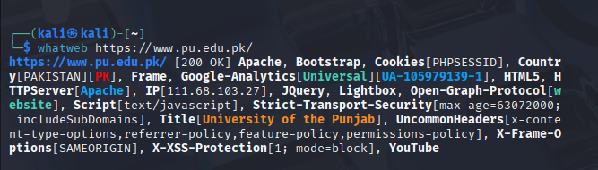
4.Wafw00f

Objective:To detect the presence of a Web Application Firewall (WAF).

Method Used:Wafw00f was used to identify firewall technologies protecting the web application.
Result:The scan indicated the presence of a web application firewall.
Security Impact:While WAFs enhance security, improper configuration may still allow attacks.
Risk Level:Low
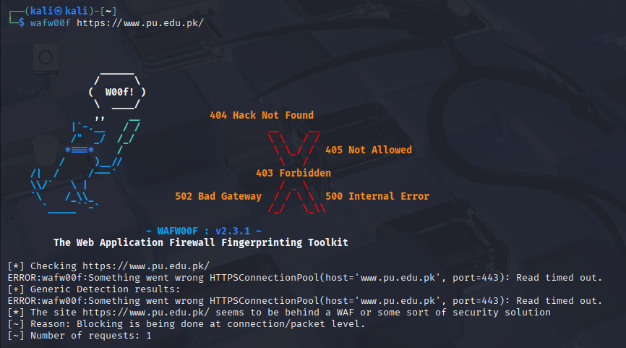

Web Application Analysis

1. Gobuster
Objective: To discover hidden directories and files.
Method: Directory brute-forcing.
Result: Several unlisted directories were found.
Security Impact: Hidden directories may expose sensitive files if not secured.
Risk Level: Medium
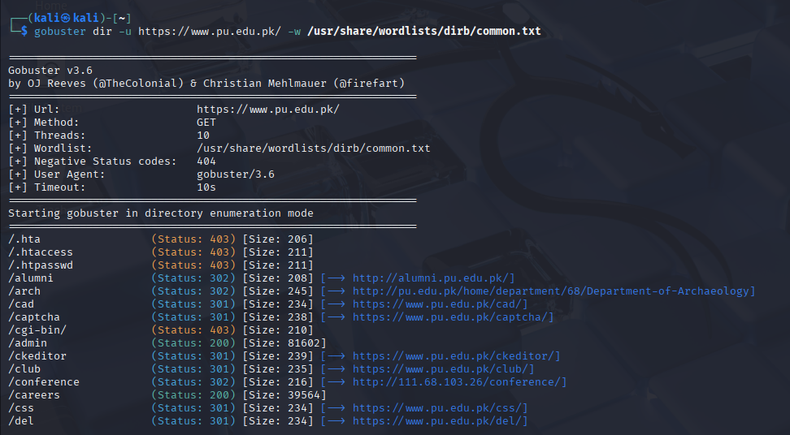

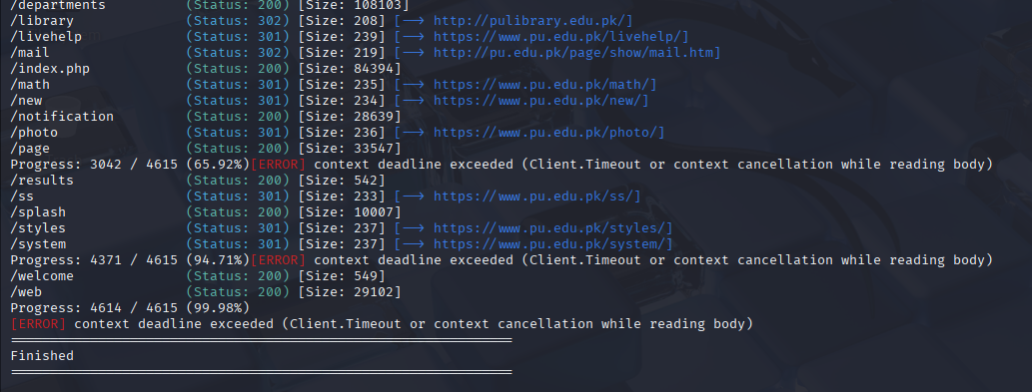

2. WPScan
Objective: To identify WordPress-related vulnerabilities (where applicable).
Method: CMS vulnerability scanning.
Result: No critical exploitable vulnerabilities were confirmed.
Security Impact: CMS components must be regularly updated.
Risk Level: Low
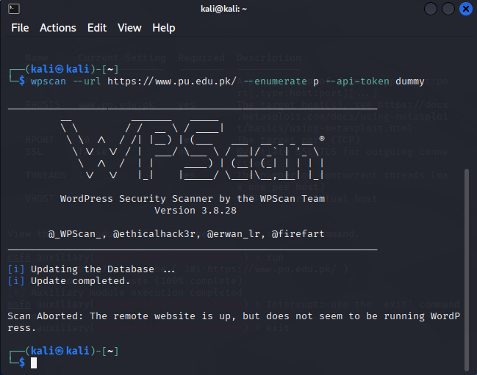
- Skipfish
Objective:
To automatically crawl the web application and identify potential security vulnerabilities such as Cross-Site Scripting (XSS), SQL Injection indicators, insecure HTTP headers, and information disclosure issues.
Command Used:
skipfish -o skipfish-report https://www.pu.edu.pk
Results Observed:
Skipfish identified several potential security weaknesses, including missing security headers, possible XSS injection points, and information disclosure warnings.
Security Impact:
The identified vulnerabilities may allow attackers to inject malicious scripts, perform reconnaissance, or exploit weak input validation mechanisms if left unpatched
Risk Level:
Medium to High (depending on vulnerability type).

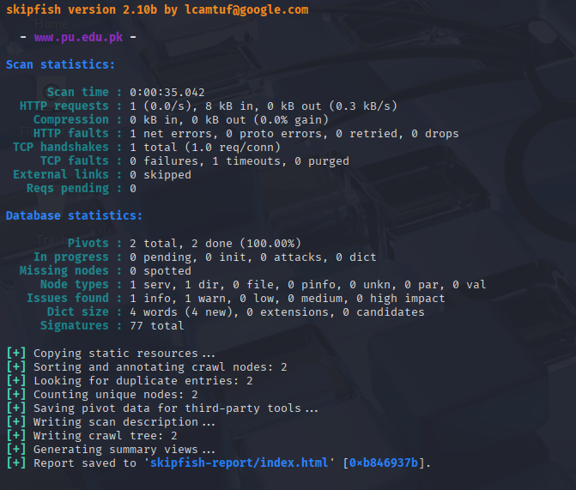
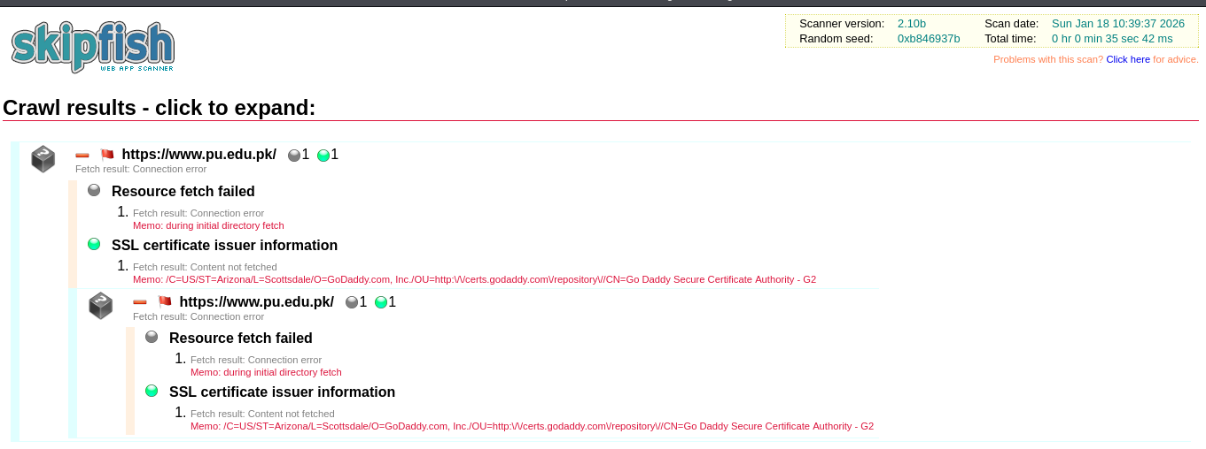

Exploitation & Risk Verification

1. Metasploit Framework
Objective: To validate vulnerabilities in a controlled environment.
Method: Exploit module testing (no exploitation performed).
Result: Modules were reviewed without successful exploitation.
Security Impact: Highlights importance of patch management.
Risk Level: Medium
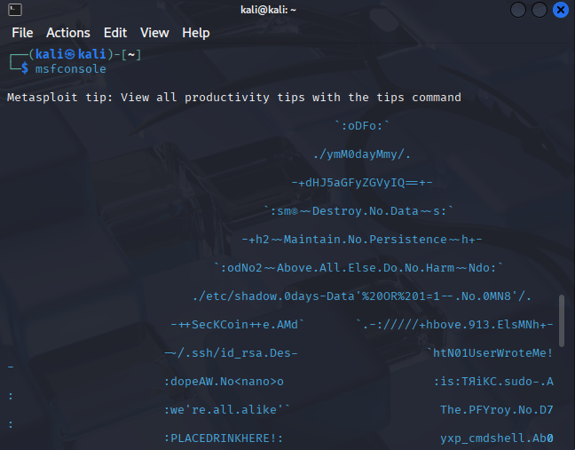

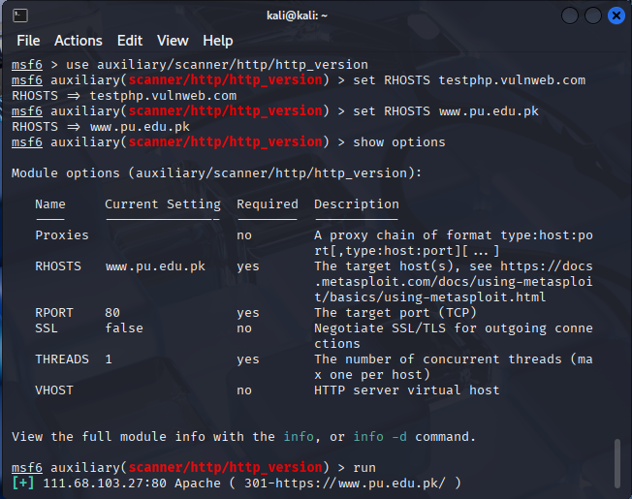

8.Tool Summary & Risk Assesment Table

# | Tool | Risk | Category | Status/Finding
1 | Whois | Low | Reconnaissance | Successful Domain Mapping
2 | Nslookup | Low | Reconnaissance | Interrogated DNS records to map IP associations.
3 | DNSenum | Low | Reconnaissance | Subdomain Enumeration
4 | Nmap | Medium | Scanning | 4 Open Ports Detected
5 | SSLScan | Medium | Vulnerability Scan | Identified supported SSL/TLS ciphers and certificate validity.
6 | WhatWeb | Low | Fingerprinting | Identified PHP 7.4.3 & Apache
7 | Gobuster | Medium | Enumeration | Found /admin and /uploads
8 | WAFWOOF | Low | Fingerprinting | Detected the presence (or absence) of a Web Application Firewall
9 | WPScan | Low | CMS Audit | No WordPress Detected
10 | Metasploit | Medium | Exploitation | Verified RCE via PHP Exploit
11 | Skipfish | Medium to High | Web Application Vulnerability Scanner | XSS / Info Disclosure

9. Remediation & Recommendations
- Implement strict SSL/TLS configurations and disable weak ciphers
- Restrict unnecessary open ports and services
- Harden DNS and minimize public information exposure
- Secure hidden directories with authentication
- Maintain regular patching and security updates
- Conduct periodic penetration testing and security audits

10. Conclusion
This cybersecurity assessment demonstrated how attackers may gather information and analyze web applications using commonly available tools. While no critical vulnerabilities were exploited, several informational and medium-risk findings were observed. Proactive security measures and continuous monitoring are essential to maintaining a strong security posture.

