KSA Legal Data Scraper Integration – LawGPT (Digifloat)
1. Introduction
As part of the LawGPT legal data pipeline automation at Digifloat, I previously implemented scrapers for national-level sources in Pakistan and international sources for the UAE. The scope has now been extended to the Kingdom of Saudi Arabia (KSA).
The downstream pipeline remains unchanged; the only modification required was the integration of web scrapers for KSA-specific case law and legislation sources at the initial data ingestion stage.
For KSA, I was assigned one website for case law and four websites for legislation/laws. The sections below outline each source, the scraping approach, and processing workflow.

2. Technology Context – ASPX Websites
Most KSA legal sources are built using ASPX (Active Server Pages Extended) on Microsoft’s ASP.NET framework.
Key Observations:
- Simpler than SPA (Single Page Apps): ASPX websites are generally easier to scrape compared to JavaScript-rendered SPAs.
- SSR & Hybrid Models:
  - Pure ASPX (SSR only): entire page refreshes per request.
  - Hybrid ASPX (SSR + CSR): server-rendered HTML with client-side updates.
- Performance:
  - SSR: fast unless server is slow.
  - Hybrid: slightly more complex, particularly for structured or sensitive data.
- Scraping Approach:
  - Selenium + XPath queries.
  - For Hybrid ASPX, first land on SSR base page, then automate CSR actions.
  - When content is locked in PDFs, OCR was applied.
  - Arabic content translated to English using a GPT-based translator.

3. Case Law Sources
3.1 MoJ – Judicial Cases
🔗 MoJ Cases
- Type: Hybrid SPA.
- Language: Arabic (translated to English).
- Workflow:
  - Judgments displayed in rows and columns.
  - Pagination applied for navigation.
  - Free access, but relatively slow.
  - Workflow:
    - Website translated for accessibility.
    - Scraper iterates through judgments on each page.
    - Raw HTML stored → Arabic text extracted → translated to English.
- Input Options: scrape N cases or scrape entire set.
Mermaid Flow:
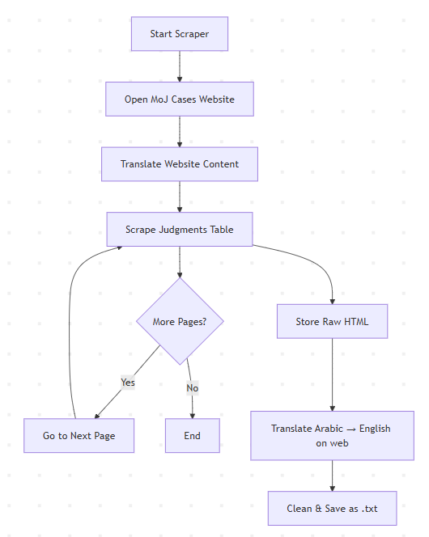
4. Legislation / Laws Sources
4.1 MoJ – Laws (Code of Law Practice)
🔗 MoJ Laws
- Type: ASPX.
- Language: English.
- Workflow:
  - Contains the Code of Law Practice.
  - All articles loaded in one request.
  - Scraped in one go, no pagination required.
  - HTML cleaned and saved to .txt.

Mermaid Flow:
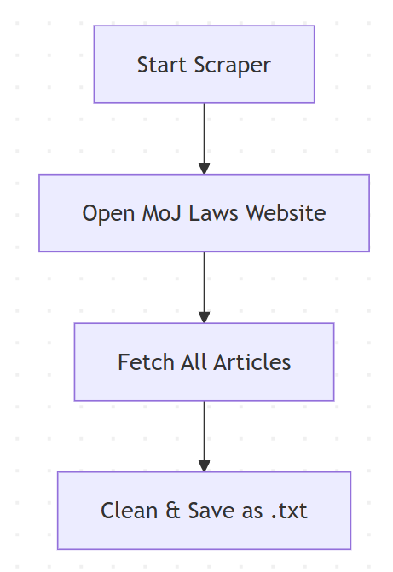
4.2 Personal Status Law
🔗 Personal Status Law
- Type: ASPX.
- Format: Single scanned PDF.
- Language: Arabic.
- Workflow:
  - PDF downloaded directly.
  - OCR applied to extract Arabic text.
  - Translation from Arabic → English via GPT-based translator.
  - Clean text stored for pipeline integration.
Mermaid Flow:
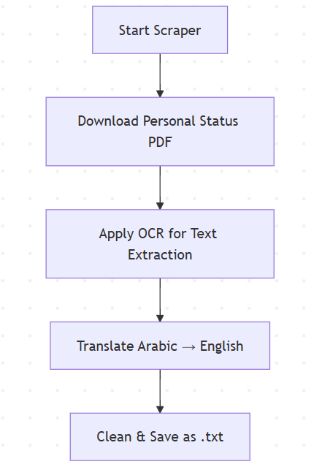
4.3 Anti-Cybercrime Law
🔗 Anti-Cybercrime Law
- Type: ASPX.
- Language: English.
- Workflow:
  - Entire law loaded in one request.
  - Scraped all articles in one go.
  - HTML parsed, text cleaned, saved as .txt.
Mermaid Flow:
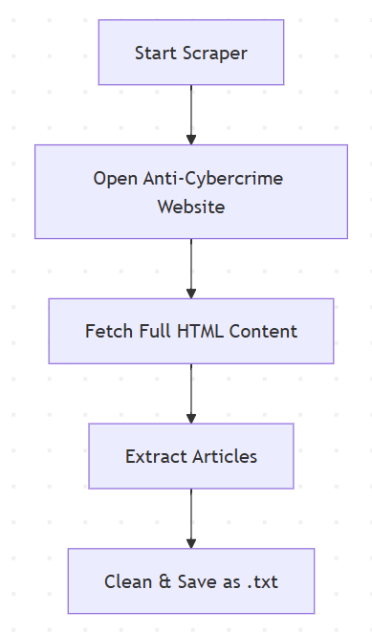
4.4 SaudiLegal – Real Estate Law Overview
🔗 SaudiLegal Real Estate Overview
- Type: ASPX.
- Language: English.
- Workflow:
  - Provides overviews of laws related to real estate, business, and assets.
  - Content available in English.
  - HTML fetched and cleaned.
  - Stored as .txt.
Mermaid Flow:
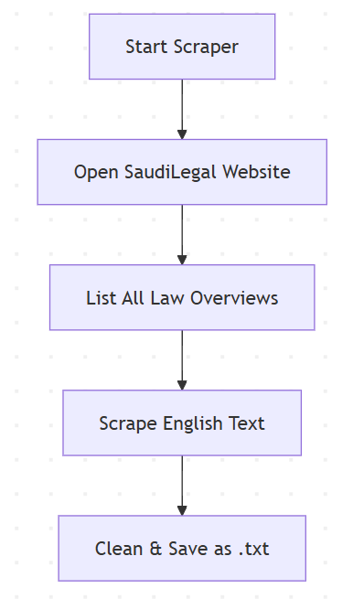
5. Processing Layer
- Raw Data Capture: HTML or PDF fetched and stored.
- Text Extraction:
  - Direct parsing for HTML.
  - OCR applied for scanned PDFs.
- Language Translation:
  - Arabic → English translation integrated via GPT.
- Cleaning & Storage:
  - Final cleaned legal text standardized into .txt.
  - Consistent format for integration with downstream LawGPT pipeline.

