UAE Legal Data Scraper Integration – LawGPT (Digifloat)
1. Introduction
As part of the LawGPT legal data pipeline automation at Digifloat, I previously implemented scrapers for national-level sources in Pakistan. Recently, I extended the scope to international sources, beginning with the United Arab Emirates (UAE).
The downstream pipeline remains the same; the only modification required was to integrate new web scrapers for UAE-specific case law and legislative sources at the initial data ingestion stage.
For UAE, I was assigned four websites for case law and three for legislation/laws. Out of these, one case-related website was excluded because it was an inquiry-based portal designed for tracking the status of ongoing or closed cases. Since it did not provide bulk access to legal texts, it was not aligned with the scraping requirements.
The final scope included three websites for cases and three websites for laws/legislation.

2. Technology Context – ASPX Websites
All UAE sources are built using ASPX (Active Server Pages Extended) under Microsoft’s ASP.NET framework.
Key Observations:
- Simpler than SPA (Single Page Apps): ASPX websites are more scraper-friendly compared to JavaScript-rendered SPAs.
- SSR & Hybrid Models:
  - Pure ASPX (SSR only) → full-page refreshes for each request.
  - Hybrid ASPX (SSR + CSR) → combines server-rendered HTML with client-side interactions.
- Performance:
  - SSR ASPX: generally fast, unless server response is slow.
  - Hybrid ASPX: slightly more complex, especially when sensitive or authenticated data is involved.
- Scraping Approach:
  - Primary method: Selenium + XPath queries.
  - Strategy: directly land on maximum SSR page, then automate CSR flows as required.
  - Mimicked human browsing behaviour to bypass unnecessary manual URL handling.

3. Case Law Sources
3.1 DIFC (Dubai International Financial Centre Courts)
🔗 DIFC Judgments & Orders
- Type: ASPX (SSR only).
- Language: English.
- Workflow:
  - Data available via pagination.
  - Scraper iterates through judgments on the current page, then navigates to the next page.
  - Input options: scrape N cases or scrape entire website.
- Performance:
  - Data freely available but response is slow.
- Implementation Note:
  - Used Selenium automation to replicate user navigation rather than relying on direct URL handling.
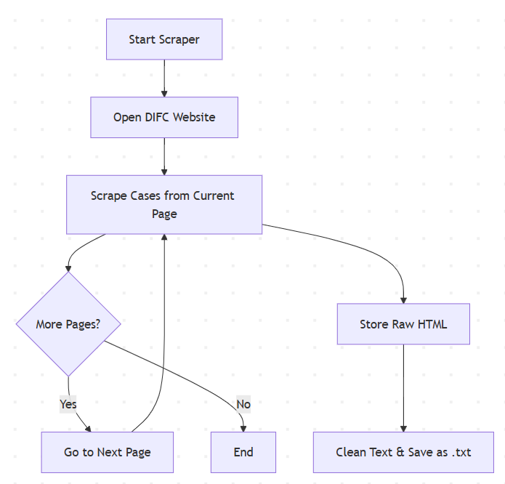
3.2 ADJD (Abu Dhabi Judicial Department)
🔗 ADJD Judgments
- Type: Hybrid ASPX (SSR + CSR).
- Language: Arabic (translated to English via GPT-4o).
- Workflow:
  - Accept Terms & Conditions.
  - Select Court Level.
  - Select Case Category.
  - Click Show Judgments → case list displayed.
  - Scrape all cases from the page, then paginate if required.
  - Input options: Court level, Case category, number of cases.
- Implementation Note:
  - Although UI appears like scanned PDFs, underlying HTML text is accessible.
- Translation Layer:
  - Arabic → English translation integrated using GPT-4o.
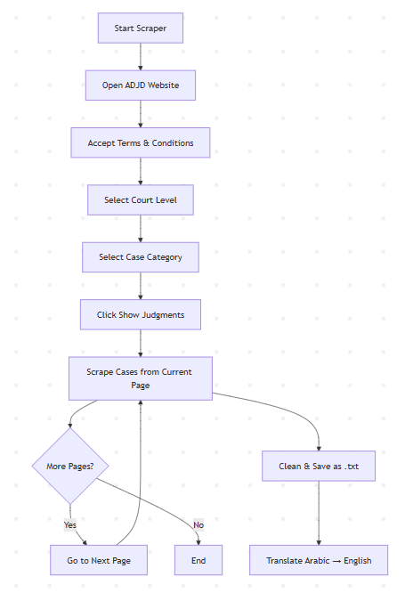

3.3 MoJ (Ministry of Justice – Federal Cases)
🔗 MoJ Federal Cases
- Type: Hybrid ASPX.
- Language: English.
- Workflow:
  - Lists all available cases sequentially (no pagination).
  - Scraper iterates through case list.
  - Input options: scrape N cases or all cases.
- Performance:
  - Slower than DIFC, but stable.
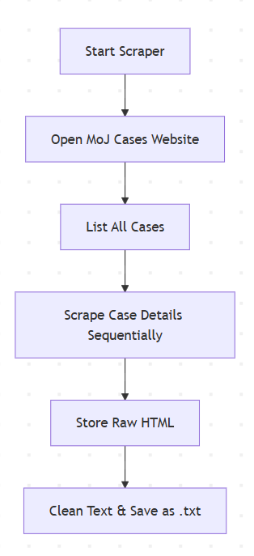
4. Legislation / Laws Sources
4.1 UAE Constitution
🔗 UAE Constitution
- Type: ASPX (SSR only).
- Language: English.
- Workflow:
  - Entire constitution retrieved in a single fetch (no pagination, no CSR).
  - HTML stored, cleaned, and saved as .txt.
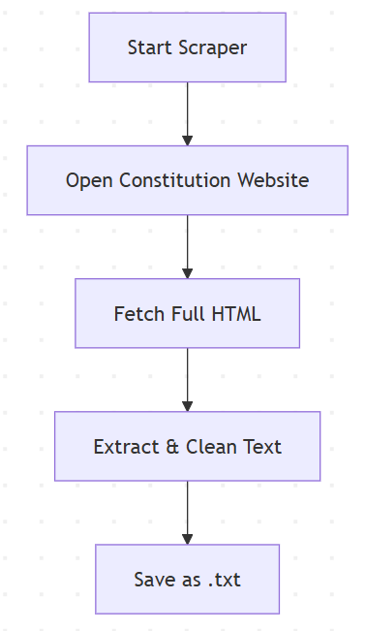
4.2 UAE Legislation Portal
🔗 UAE Legislation
- Type: ASPX (SSR only).
- Challenge: Strong bot protection (SSL + anti-automation).
- Mitigation Attempts:
  - Added realistic browser flags.
  - Used personal browser profile + cookies.
  - Headless mode disabled.
- Status: Unsuccessful in data access despite mitigation.
4.3 MoJ (Federal Laws)
🔗 MoJ Federal Laws
- Type: Hybrid ASPX.
- Language: English.
- Workflow:
  - Scrapes federal laws (non-paginated).
  - Extracts HTML → cleans → saves .txt.
- Performance: Slightly slow but consistent.
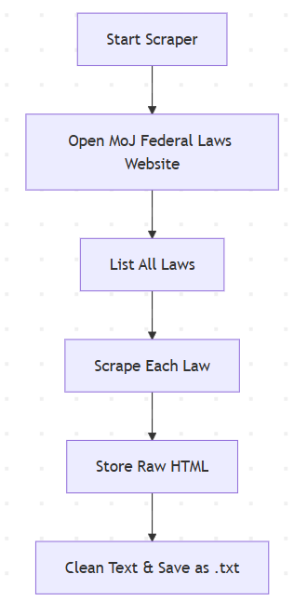

5. Processing Layer
- Raw HTML is fetched and stored for traceability.
- Cleaning stage extracts structured text from HTML.
- Language Processing:
  - Arabic content translated to English via GPT-4o.
- Final Output:
  - Clean text stored as .txt files.
  - Consistent format maintained for integration with the downstream pipeline.

