

**Project Name:**

University Management System

**Student Name: Roll no:**

Areesha Kaleem Butt 2022-CE-15

**Course Code:**

CMPE-112L

**Semester:**

2nd semester

**Submitted to:**

Engineer. Afeef Obaid

**Department of Computer Engineering**

**University of Engineering and Technology, Lahore**

Table of Contents

**Abstract:** 3

**Objective:** 3

**Project Details:** 3

**Plug-ins and Libraries Used:** 7

**Screenshots of GUI** 7

**References**: 7

# **Abstract:**

# A University Management System (UMS) developed in Python is introduced in this abstract. The UMS uses file handling, classes, GUI, data types, and libraries to streamline administrative processes in educational institutions. The UMS stores and retrieves data using file handling, which allows for easy access to student records, course details, and administrative data. The UMS uses classes in Python's object-oriented programming paradigm to organize entities such as students, faculty, courses, and staff. This promotes code modularity and reusability. The UMS uses a GUI to enhance the user experience. This provides an intuitive interface for tasks such as student enrollment, course registration, and record management. Python's versatile data types, such as strings, integers, floats, and lists, are used in the UMS to facilitate efficient data management. The UMS leverages Python libraries like Tkinter for GUI creation and PILLOW for image processing. This ensures enhanced functionality, performance, and usability. The UMS offers a comprehensive solution for efficient university administration by incorporating file handling, classes, GUI, data types, and libraries. It simplifies data management, enhances user experience, and promotes streamlined operations. [2][3][4]

# **Objective:**

The objective is to make easy to access and manage details of a bigger system. To secure the information and important data. Through this system anyone can perform their duties from anywhere. To introduce a user friendly GUI based system which may serve as LMS.

# **Project Details:**

The UMS comprises of the following features that are shown below. We will discuss each of them in detail.

The UMS has 4 main categories: Admin, Teacher, Student, Other. All the functions are related to these four types. There is also stuff related to departments. **Cli code has all these functionalities but GUI Doesn’t contain Others option where ecat and demo is taken else it contains all the functionalities mentioned.**

**Admin:**

The first is the admin. It deals with the management of the university. The admin category is further divided into further sub-categories. Each of them has their own functionality.

**Department Management:**

The first one is Department Management. It deals with all the duties that are related to a department. It has Following functionalities:

1) View All Details

2) Remove Teacher

3) Remove Student

4) change teacher subject

5) Add or Remove Courses

6) change student roll no

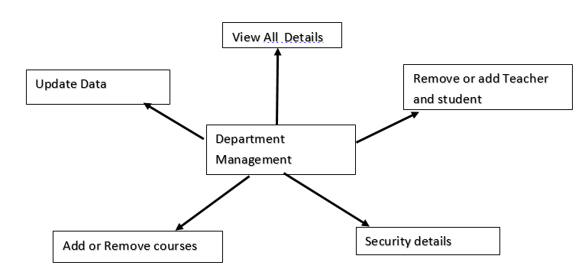

Remove teacher or student

Change student roll no

Change teacher subject

**Hostel Management:**

Next is the Hostel Management. Following are the functionalities:

1) Allot Room

2) Change room

3) Cancel Allotment

4) Check empty rooms list

5) Check Room Allotment Details

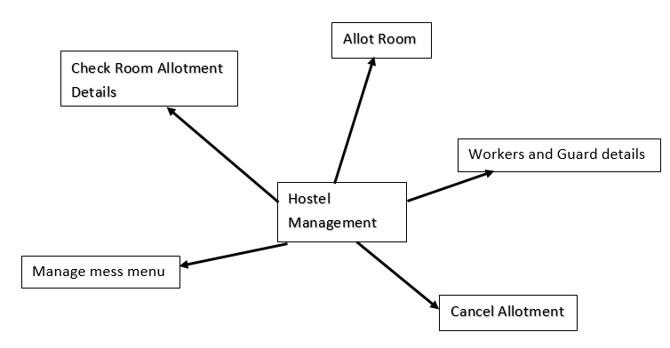

Check Empty Room

Change Room

**Library Management:**

Then is the Library Management with following functionalities:

1) Borrow books

2) Update Any details

3) Check location of book

4) Assign slot to new book

5) Add or Remove Book

6) return book

Return book

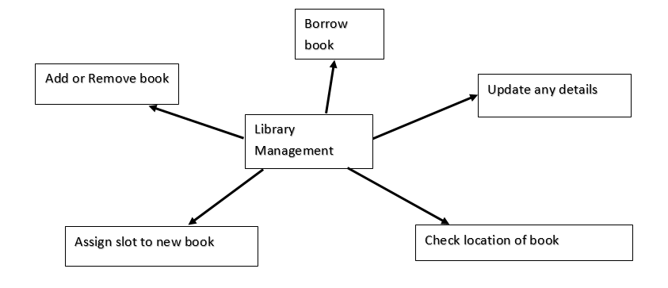

**Teacher:**

The second category is the teacher. It is made for teachers to do their tasks and duties related to their field. It includes:

1) Mark attendance

2) Mark GPA

3) View students

4) Resign

5) View and edit profile

**Student:**

Next category is of students. It is the LMS for students that enables them to perform following tasks:

1) Check attendance

2) check GPA

3) Register courses

4) Edit personal Details

5) Get challan form

**Others:**

Last category is made if the person is not in any of the above category. It has two sub categories i.e. teacher & student. It enables one to apply for the post of teacher and enroll as a student by giving the entrance exam. For teacher, there is a demo paper that evaluates whether one is capable of becoming teacher or not. All these functions would be carried out using classes, inheritance, UDF and more.

# **Plug-ins and Libraries Used:**

We are using Tkinter for GUI of this program.[1] [5]

1. Tkinter allows for the creation of a GUI for a university management system.
2. Design windows, frames, labels, buttons, and widgets to represent different functionalities.
3. Implement menus and navigation options for easy user navigation.
4. Validate user input for data accuracy using input fields, checkboxes, and dropdown menus.
5. Display information such as student records, course schedules, and academic data using labels, tables, and text widgets.
6. Handle user interactions and trigger actions through event handling.
7. Create an interactive and user-friendly interface for managing student records, course scheduling, grading, and administrative tasks in a university management system.

By utilizing Tkinter's capabilities, you can develop a comprehensive GUI for efficiently managing various aspects of a university.

# **Screenshots of GUI**

**Main Window:**

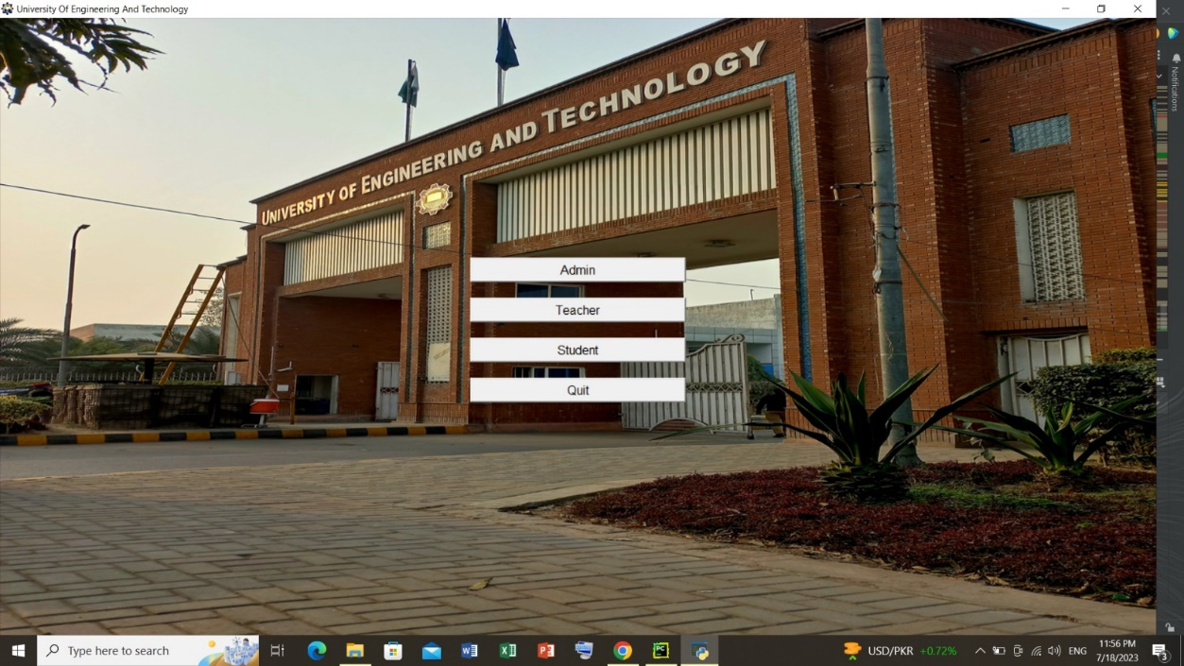

**Admin:**

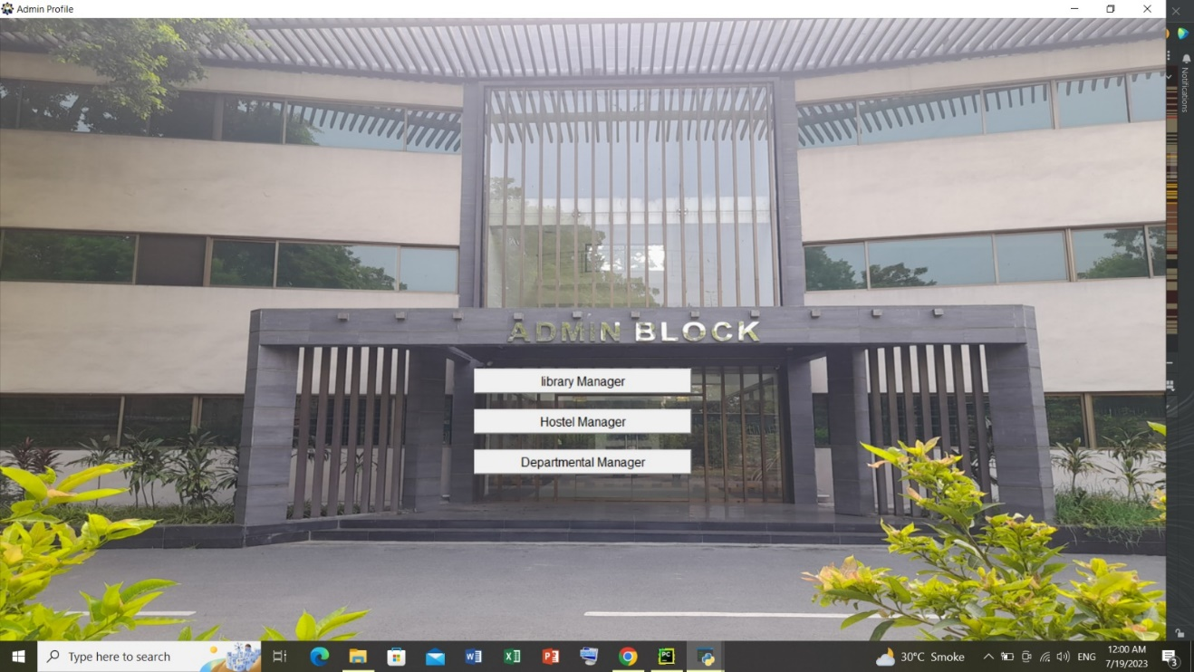

**Library Manager:**

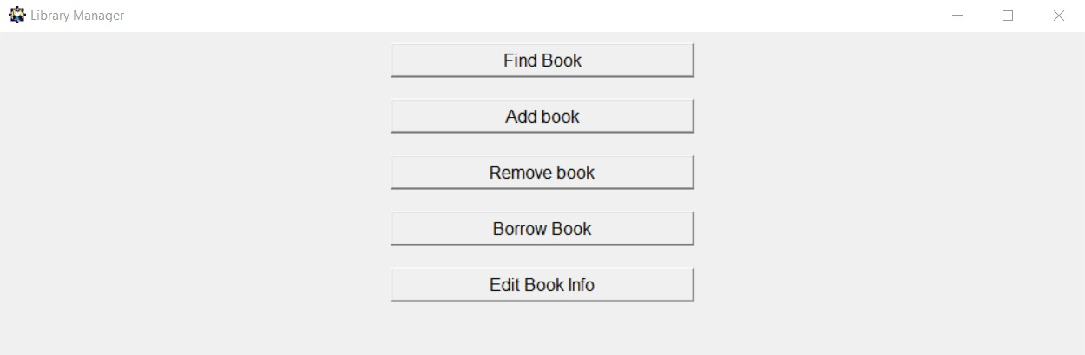

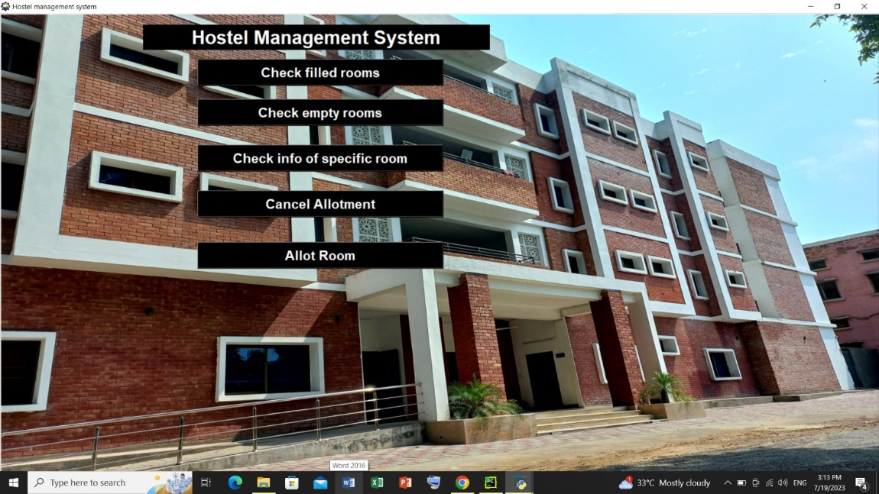**Hostel Manager:**

**Departmental Manager:**

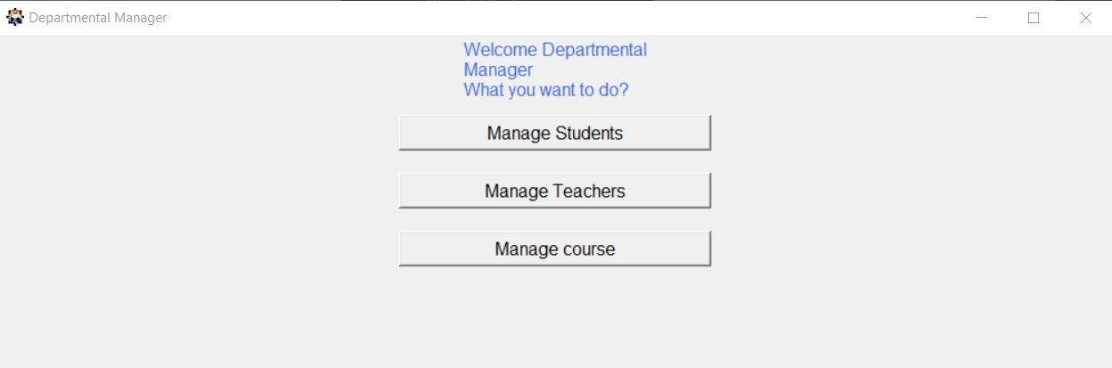

**Teacher:**

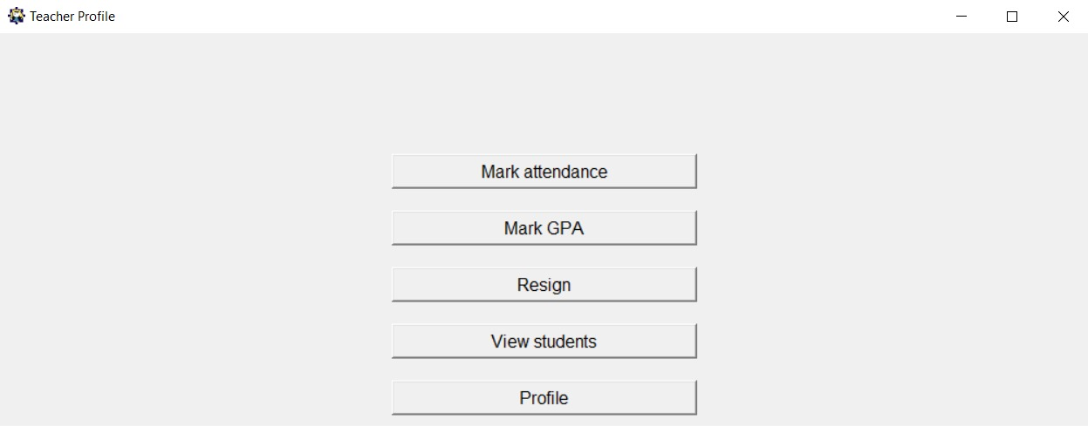**Student:**

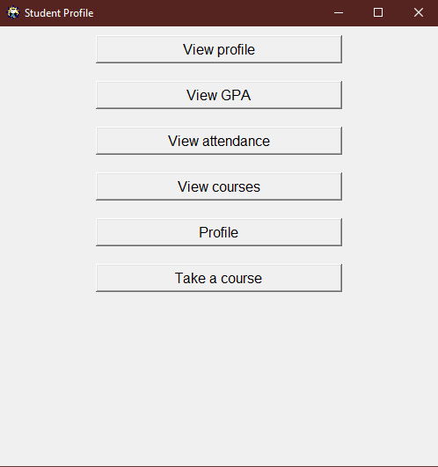

**References**:

1. <https://www.youtube.com/watch?v=ibf5cx221hk>
2. <https://www.youtube.com/watch?v=JeznW_7DlB0>
3. <https://www.youtube.com/watch?v=HQnoYzxOHMw>
4. <https://www.youtube.com/watch?v=eDBPlcWYses>
5. <https://www.youtube.com/watch?v=N3XFWrnkqek&list=PLyr3gkJ8OBxq3RIpte1XULEOaHukdh9pP>