

Assignment 01:

Git, Gitea, GitHub, Git LFS, and GitHub Pages

Task 1: Install Gitea and Push a Repository from the Ubuntu Server
In this task, Docker Engine and Docker Compose were installed on the Ubuntu server. A containerized Gitea and PostgreSQL instance was successfully deployed, and a local repository was initialized and pushed to the running Gitea server.

Step 1.1: Install and Run Gitea on the Ubuntu Server
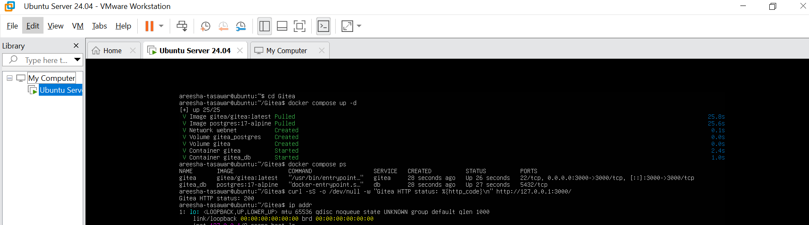
Figure1:task1_gitea_running.png

Step 1.2: Create and Push the Initial Repository
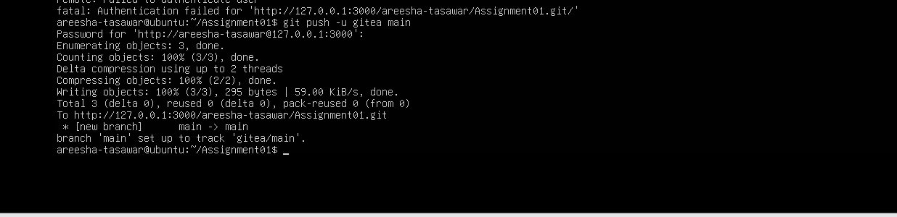
Figure2:task1_gitea_push.png

Step 1.3: Verify the Gitea Repository
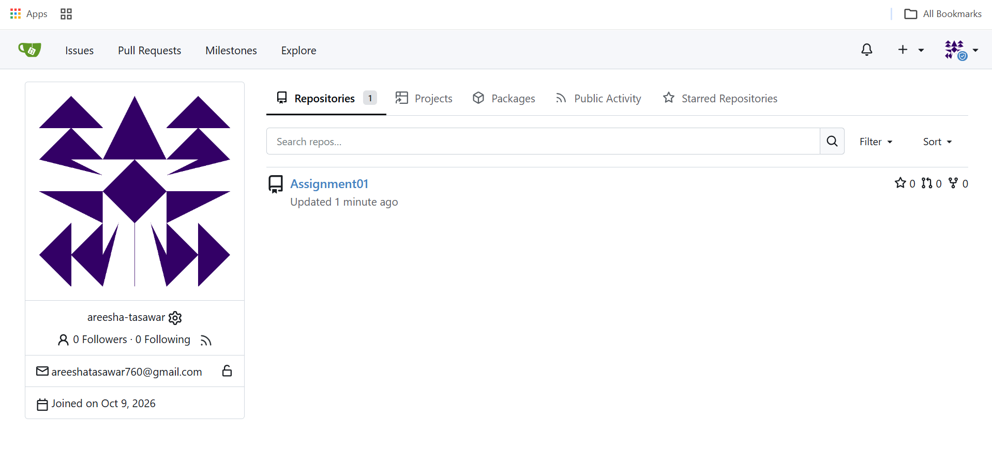
Figure3:task1_gitea_repository.png

Task 2: Push the Same Repository to GitHub
This task involved configuring dual remote URLs for the local Git repository on the Ubuntu server. The setup enables simultaneous code pushes and synchronization to both the self-hosted Gitea server and GitHub using secure SSH/HTTPS remotes.

Step 2.1: Create the GitHub Repository and Verify Both Remotes
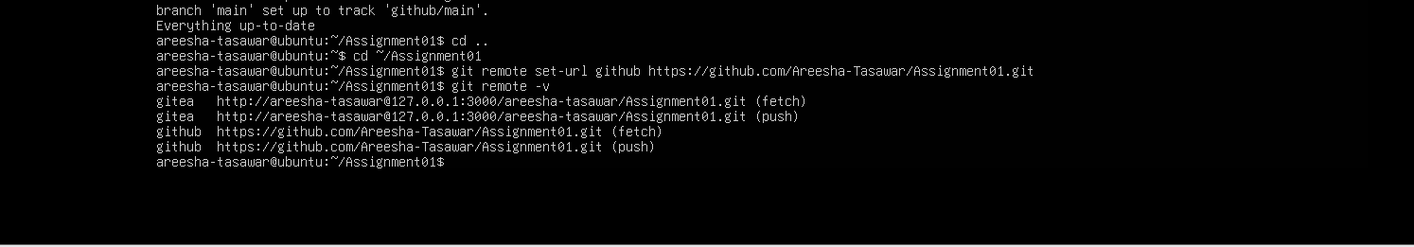
Figure4:task2_remotes.png

Step 2.2: Push to GitHub
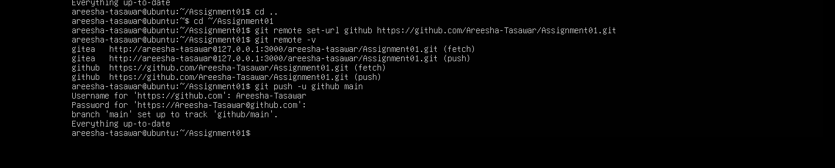
Figure5:task2_github_push.png

Step 2.3: Verify the GitHub Repository
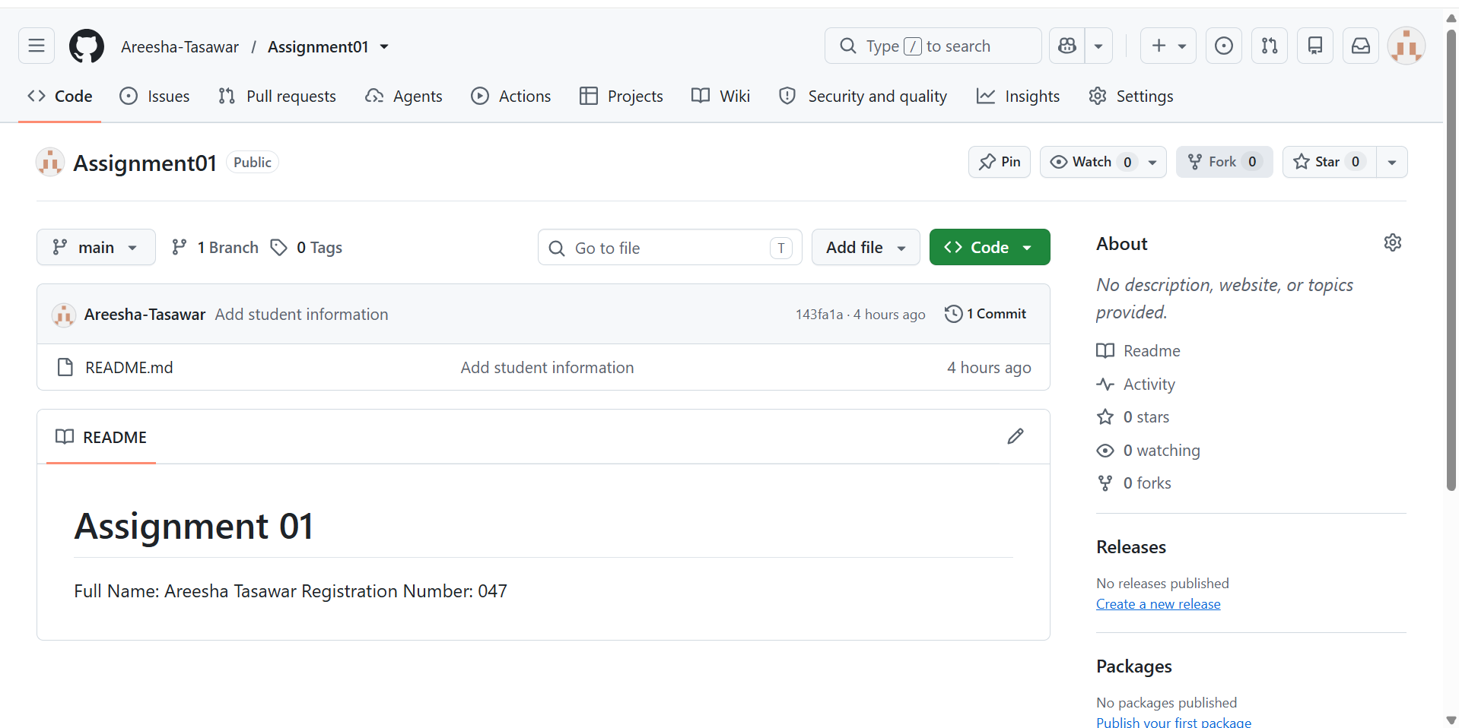
Figure6:task2_github_repository.png

Task 3: Track Three Large Files with Git LFS
Git LFS was initialized on the server repository to efficiently handle large binary assets (.bin files). Large files were successfully tracked, committed, and pushed to the remote repository without bloating the core Git history.

Step 3.1: Configure Git LFS
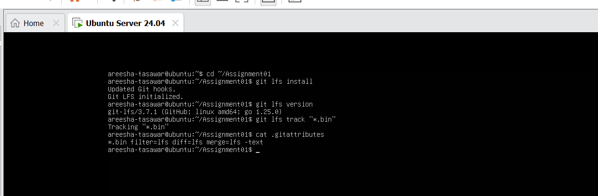
Figure7:task3_lfs_setup.png

Step 3.2: Create and Verify Three LFS Files
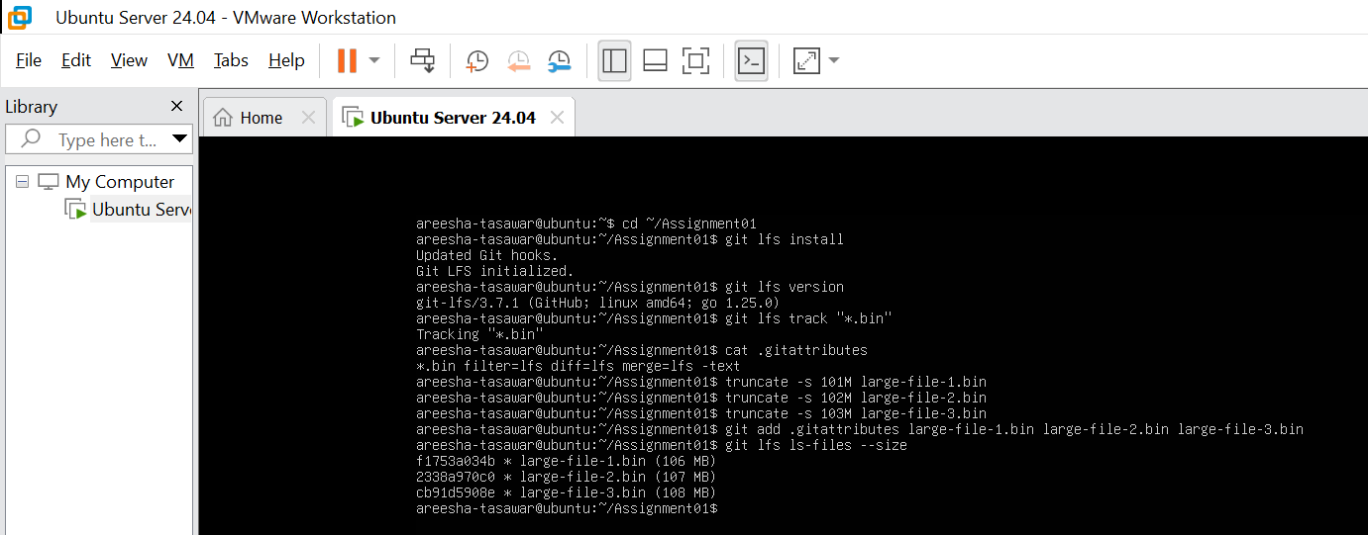
Figure8:task3_lfs_files.png

Step 3.3: Commit and Push the LFS Files
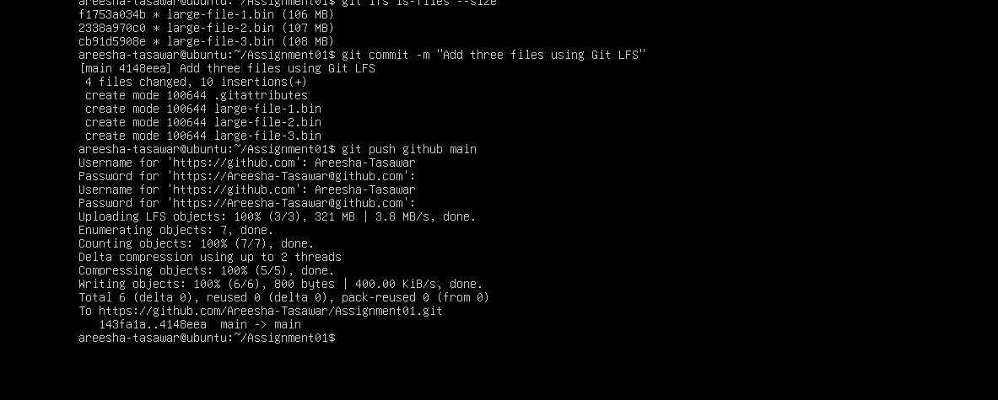
Figure9:task3_lfs_push.png

Task 4: Create a Portfolio or CV with GitHub Pages
A personal portfolio website featuring About Me, Education, Skills, and Projects sections was developed using HTML and CSS. The source files were pushed to a public GitHub repository and published live using GitHub Pages.

Step 4.1: Create and Push the Portfolio Repository
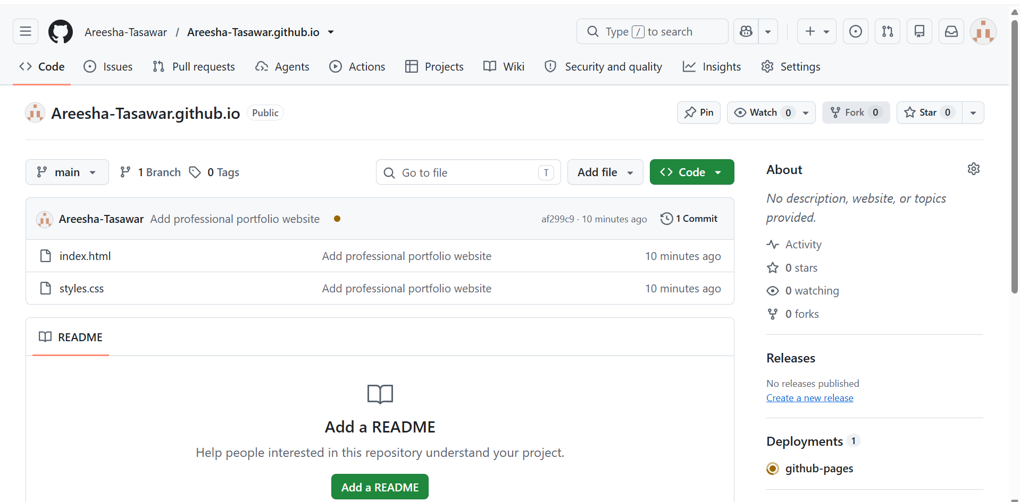
Figure10:task4_pages_repository.png

Step 4.2: Publish with GitHub Pages
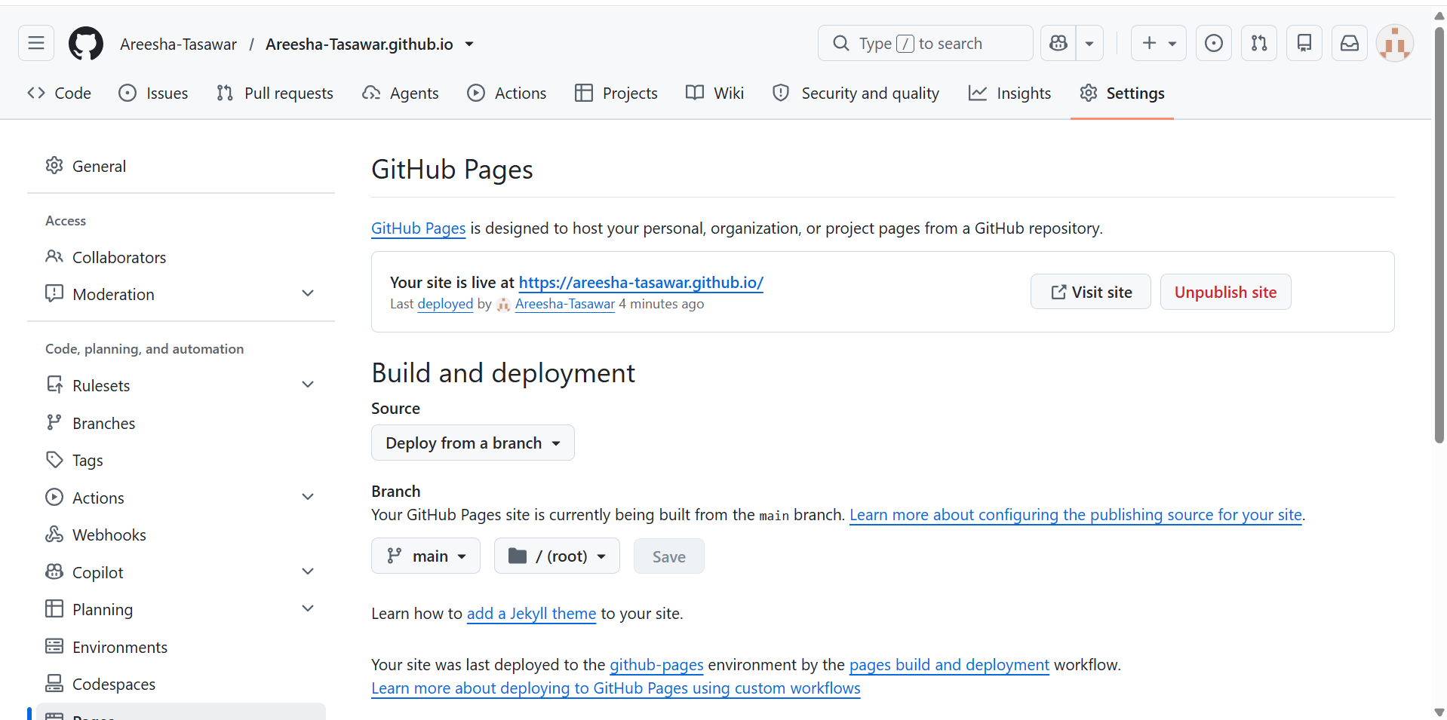
Figure11:task4_pages_deployment.png

Step 4.3: Verify the Live Portfolio
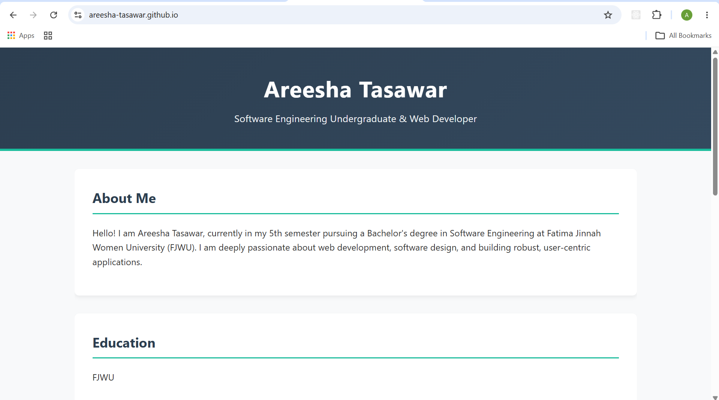
Figure12:task4_portfolio_live.png

Conclusion
This assignment successfully demonstrated essential software engineering and version control practices using an Ubuntu server environment. Key competencies achieved include self-hosting a version control service with Gitea, managing multi-remote repositories for synchronized code deployment, implementing Git Large File Storage (LFS) for efficient handling of large binary assets, and deploying a responsive personal portfolio using GitHub Pages. These hands-on tasks reinforced a comprehensive understanding of modern DevOps workflows, collaborative development, and professional deployment standards.

