

OS LAB PROJECT REPORT

“MEMORY ALLOCATION SIUMULATOR
(BEST FIT, FIRST FIT, WORST FIT)”

Prepared By:
Areesha Naeem (2480105)

Submitted To:
Ma’am Bushra

Date:
22-April-2026

1. Introduction:
Memory management is an important concept in an operating system. It is used to allocate memory to the processor efficiently. This project demonstrates 3 memory allocation techniques: First fit, Best fit and Worst fit. These algorithms decide that how memory block is assigned to the processor.
2. Programming Language Used:
This project is developed using the python programming language. For graphic interface Tkinter library is used, in which we create buttons, tables and user interactions.
3. Project Structure
The project is divided into two parts
- Algorithms Logic (First Fit, Best Fit, and Worst Fit)
- Graphical User Interface
The GUI allows users to:
- To enter number of blocks and processes
- Run different algorithms
- Compare results in table

4. Working Of Algorithms And Functions:
This explains how different memory allocation algorithms and the supporting functions work in our system.
-first_fit() : Allocates the first available block.
-best_fit() : Allocates the smallest block.
-worst_fit() : Allocates the largest available block.
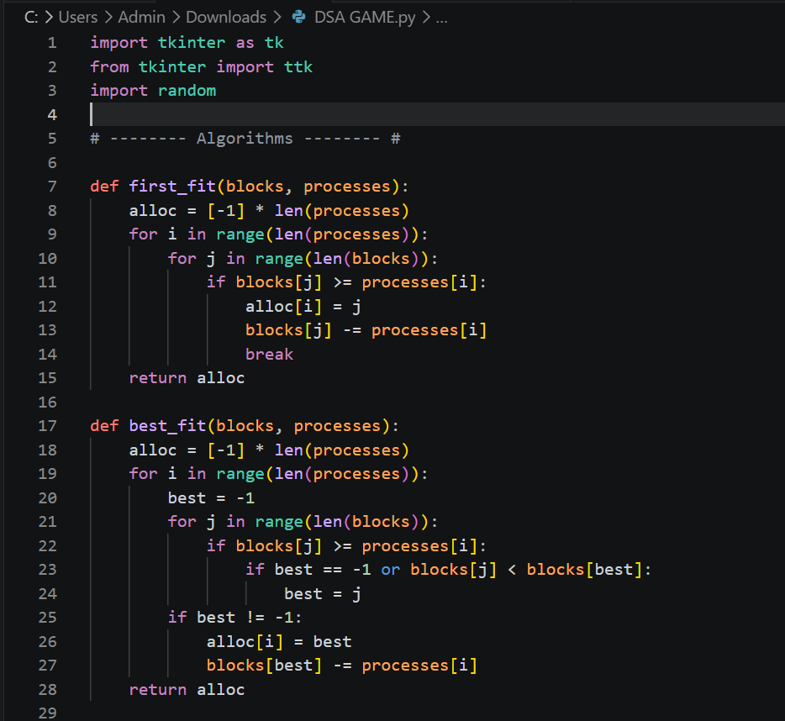
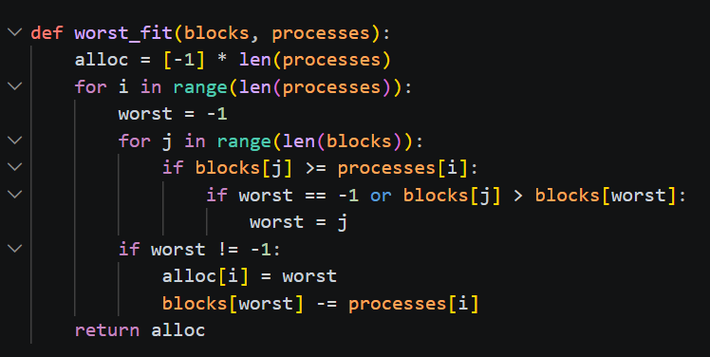
- calculate_waste() : Calculates memory wastage.
- fill_table() : Display results in the table.
- generate() : Creates random blocks and processes.
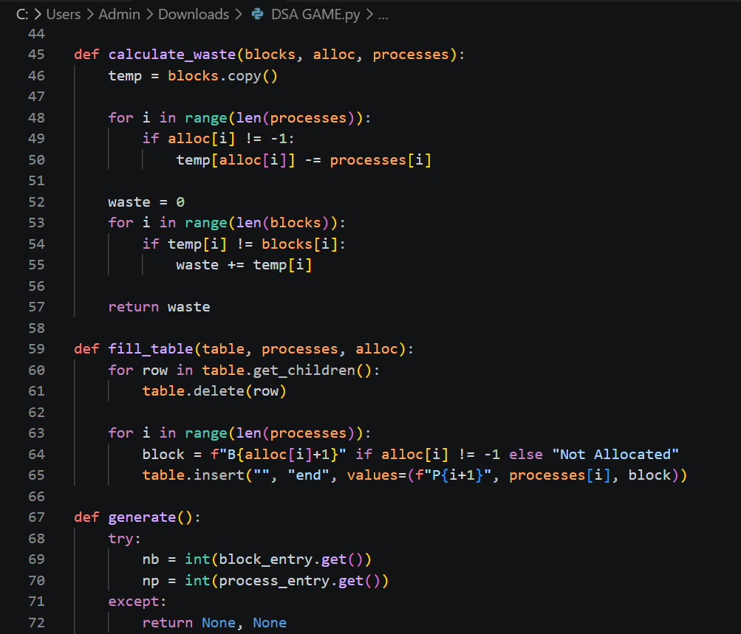

- run_first(), run_best(), run_worst() : Runs the individual algortithms.
- run_all() : Compare all algorithms.

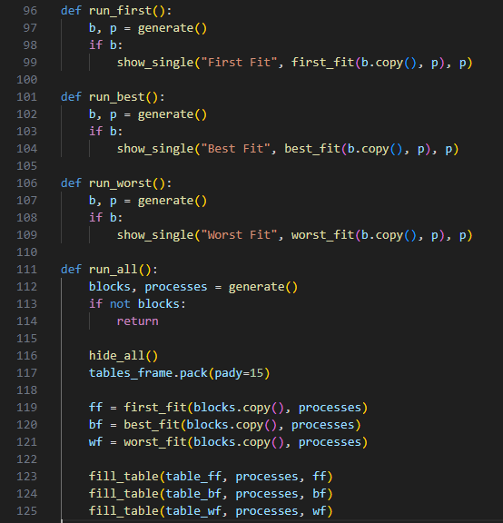

Output:
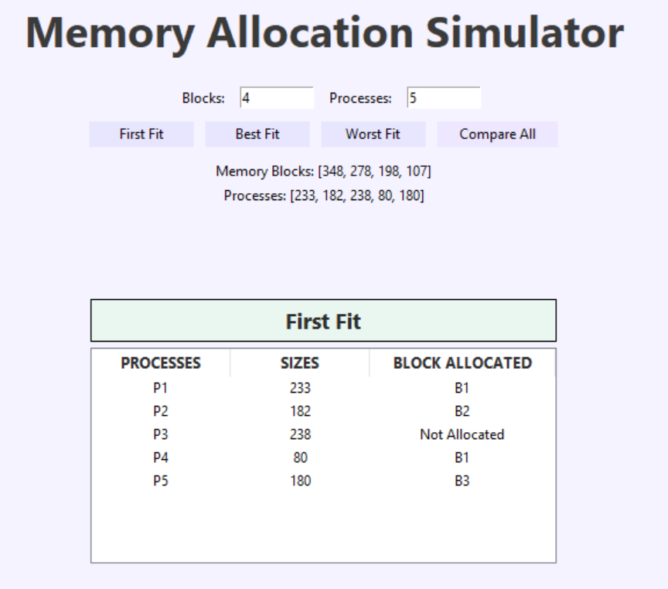
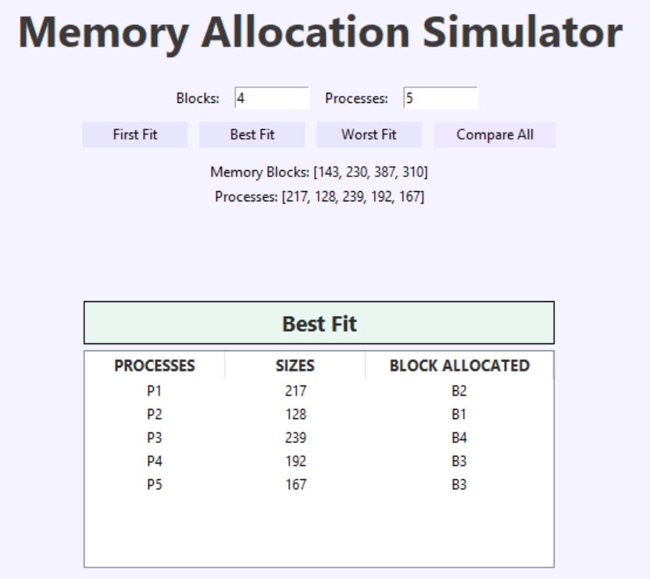
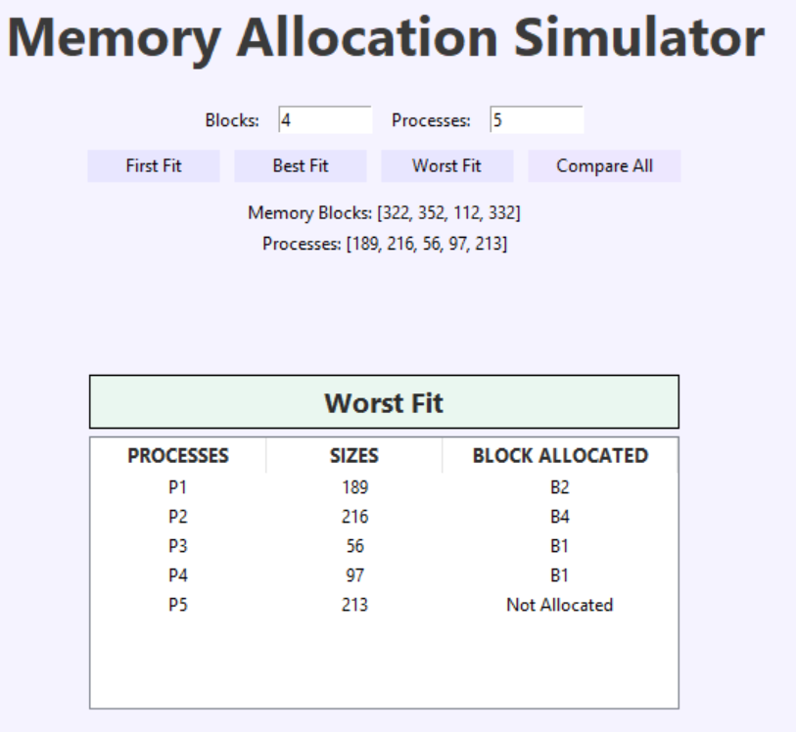
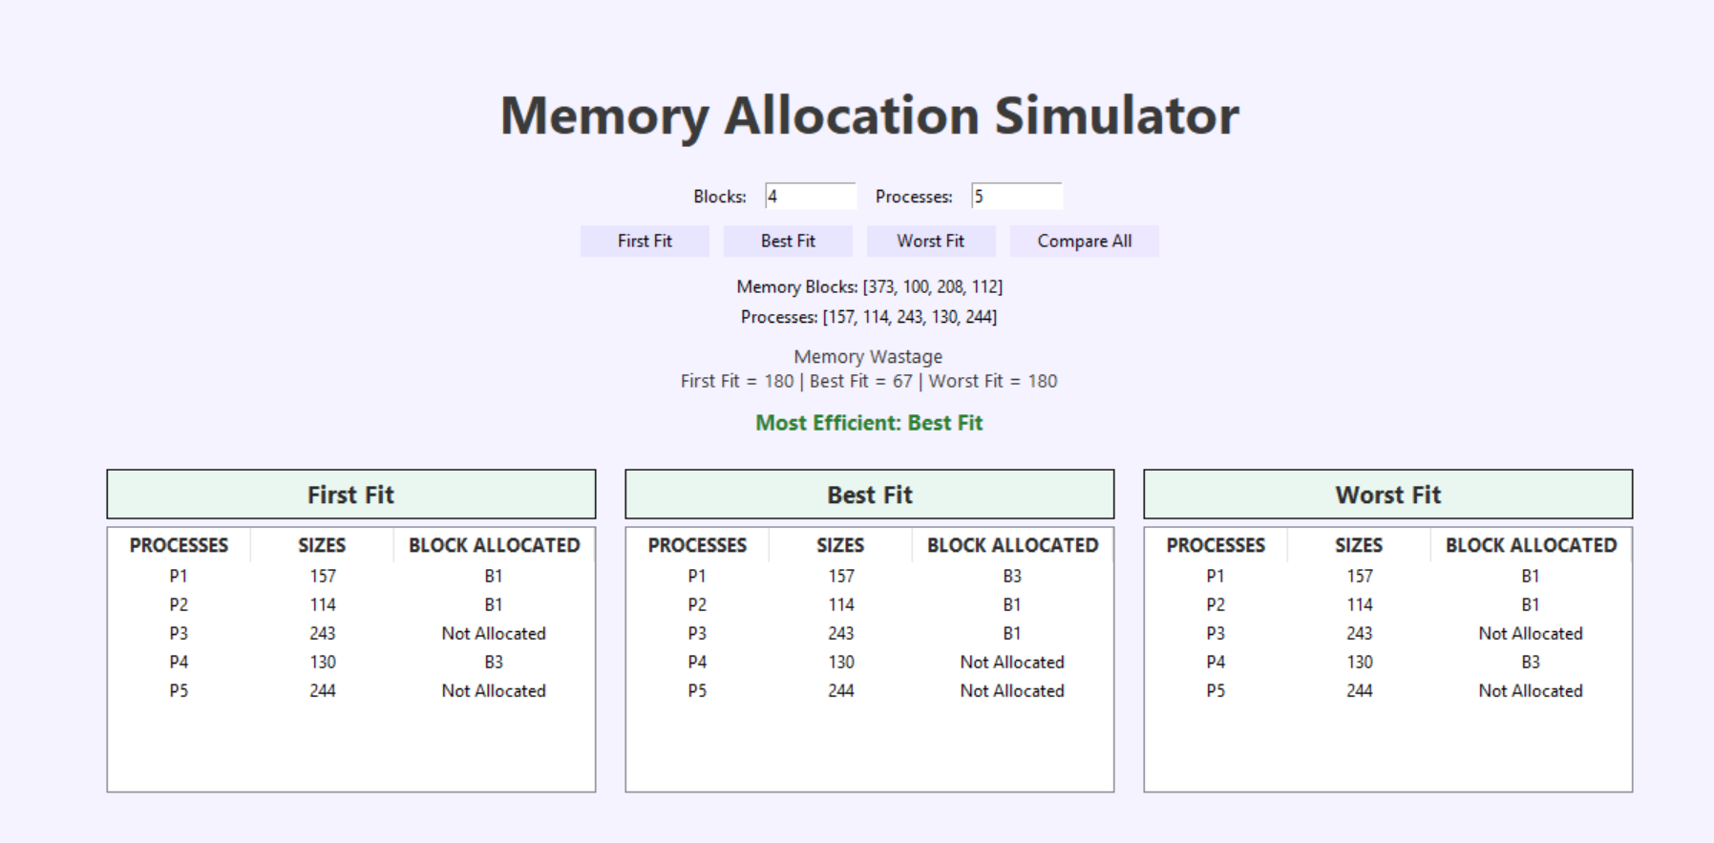
5. Features of the project
- It is user-friendly GUI
- Random generation of the memory blocks and processes
- Implementation of teen allocation techniques
- Comparison of the algorithms
- It displays the memory wastage
- It shows the most efficient algorithms
6. Conclusion
This project helps to understand that how a memory allocation works in an operating systems.
This shows that the different algorithms give the different results, and usually the best fit and the worst fit perform better to reduce the wastage.
7. Contribution
This work is divided between 3 members
Aisha: Implements the first fit and GUI integration
Areesha: Implements best fit algorithm and wastage calculation
Rameesha: Implements the worst fit algorithm and comparison logic.
8. References
1.https://www.geeksforgeeks.org/memory-allocation-strategies
2.https://www.tutorialspoint.com/operating_system/os_memory_management.htm

