AQI PREDICTOR KHI
Karachi Air Quality Index Prediction System

Project Report

AREESHA FASIH
June 2026
GitHub Repository: https://github.com/Areesha983/AQI_PREDICTION_KHI

Table of Contents
Table of Contents 1
1. Executive Summary 1
2. Project Background and Motivation 1
2.1 What is the Air Quality Index? 1
2.2 Why Machine Learning? 1
3. Requirement Analysis 1
4. System Architecture 1
4.1 Component Descriptions 1
5. Repository Structure 1
5.1 .github/workflows/ 1
5.2 api/ 1
5.3 dashboard/ 1
5.4 feature_pipeline/ 1
5.5 training_pipeline/ 1
5.6 eda/ 1
5.7 Root Files 1
6.1 Weather Data 1
6.2 Air Quality Data 1
6.3 Timestamp Handling 1
6.4 Historical Coverage 1
7. Dataset Building 1
8. Feature Engineering 1
8.1 EPA AQI Computation 1
8.2 Lag Features 1
8.3 Rolling Statistics 1
8.4 Time-Based Features 1
8.5 Derived and Interaction Features 1
8.6 Leakage Prevention 1
9.1 Dataset Overview 1
9.2 AQI Timeline (2022–2026) 1
9.3 AQI Distribution 1
9.4 Diurnal AQI Profile 1
9.5 Monthly Seasonality 1
9.6 Correlation Analysis 1
9.7 Top Correlated Features 1
10. Feature Store 1
11. Historical Backfill 1
12.1 Data Loading 1
12.2 Time-Series Cross-Validation 1
12.3 Conformal Prediction Intervals 1
12.4 MongoDB Artifact Storage 1
13.1 Random Forest 1
13.2 Ridge Regression 1
13.3 XGBoost 1
14.1 Random Forest — Detailed Metrics 1
14.2 Interpretation 1
14.3 Multi-Model Comparison Table 1
15. Explainability with SHAP 1
16. AQI Categories and Alerts 1
17. Backend Flask API 1
17.1 API Endpoints 1
18. Frontend Dashboard 1
18.1 Key Features 1
19. Automation and CI/CD 1
20. Deployment 1
23.1 Gunicorn Deadlock (Random Forest) 1
23.2 GridFS Artifact Deletion Bug 1
23.3 Ridge SHAP Incompatibility 1
23.4 Timestamp Localisation 1
23.5 Feature Engineering Performance 1
23.6 MongoDB Collection Name Inconsistency 1
24. Limitations 1
26. Conclusion 1
Appendix 1
A. Technology Stack 1
B. MongoDB Collections 1
C. Environment Variables 1
D. Local Setup Commands 1

1. Executive Summary
AQI Predictor KHI is a fully end-to-end, cloud-native air quality forecasting system purpose-built for Karachi, Pakistan. The project addresses a critical public health gap: the city lacks accessible, machine-learning-driven short-term forecasts of the Air Quality Index (AQI) that residents, healthcare providers, and urban planners can act on. The system collects hourly weather and pollutant observations, engineers a rich set of predictive features, trains multiple regression models, and delivers forecasts for 24-hour, 48-hour, and 72-hour horizons through a Flask REST API consumed by an interactive Streamlit dashboard.
Karachi is one of South Asia's most densely populated and industrially active cities. Its AQI regularly crosses the Unhealthy threshold (>150), and occasional spikes into Very Unhealthy territory (>200) pose documented risks for respiratory and cardiovascular health. Accurate short-term forecasting allows individuals to plan outdoor activity, authorities to issue timely advisories, and researchers to study pollution dynamics relative to meteorological drivers.
The system ingests data from external weather and air quality APIs, stores raw and processed records in MongoDB Atlas collections, automates hourly feature updates and daily model retraining through GitHub Actions CI/CD workflows, and exposes predictions via a Flask microservice. The Streamlit dashboard presents current AQI, multi-horizon forecasts with conformal prediction intervals, SHAP-based explainability charts, model comparison metrics, and EPA-categorized health alerts.
Three machine learning models are implemented: Random Forest, XGBoost, and Ridge Regression. Evaluation is conducted across all three forecast horizons using MAE, RMSE, R², MAPE, conformal coverage, and skill score relative to a persistence baseline. SHAP values are computed for tree-based models and stored in MongoDB GridFS for dashboard retrieval. This architecture follows modern MLOps principles: reproducible pipelines, version-controlled automation, cloud-based artifact storage, and a decoupled frontend–backend design.
The project satisfies all core requirements from the project specification: a feature pipeline, historical backfill, training pipeline, model registry, automated scheduling, a Streamlit/Flask web application, SHAP explainability, and AQI-tier alerting.

2. Project Background and Motivation

2.1 What is the Air Quality Index?
The Air Quality Index (AQI) is a dimensionless numerical scale developed by the United States Environmental Protection Agency (EPA) to communicate air pollution levels to the general public. The scale runs from 0 to 500, with higher values representing more hazardous conditions. AQI is computed as a piecewise linear transformation of pollutant concentrations — most commonly PM2.5 (fine particulate matter with diameter ≤2.5 µm) — using standardized breakpoint tables. This project implements the official EPA piecewise linear formula directly in feature_pipeline/feature_engineering.py.

2.2 Why Machine Learning?
Traditional physics-based atmospheric dispersion models require detailed emission inventories and computational meteorology infrastructure that is impractical for resource-constrained deployments. Machine learning models, by contrast, learn patterns directly from historical observation data. Given sufficient lag features and rolling statistics derived from PM2.5, PM10, temperature, humidity, wind speed, and pressure, ensemble models such as Random Forest and XGBoost can capture the nonlinear interactions between weather conditions and pollutant accumulation that drive short-term AQI fluctuations. The 24-hour lag feature (aqi_lag_1) achieves a Pearson correlation of 0.974 with the target, confirming the strong temporal autocorrelation that makes ML-based forecasting viable.

3. Requirement Analysis
The project requirement document specifies building a 100% serverless, end-to-end AQI prediction service. The following table maps each requirement to its implementation in this repository.

Requirement | How This Project Addresses It | Repository Evidence
Feature pipeline fetching raw weather & pollutant data | fetch_weather.py and fetch_air_quality.py retrieve hourly data from external APIs for Karachi coordinates (lat 24.8607, lon 67.0011) | feature_pipeline/fetch_weather.py, fetch_air_quality.py
Compute features and targets (model inputs/outputs) | build_dataset.py merges sources; feature_engineering.py computes 223 features including lags, rolling stats, and EPA AQI categories | feature_pipeline/build_dataset.py, feature_engineering.py
Include time-based and derived features | Hour, day, month, AQI change rate, acceleration, regime, rolling percentile all implemented | feature_pipeline/feature_engineering.py
Store features in a feature store | MongoDB Atlas collection processed_features acts as the feature store | feature_pipeline/feature_store.py, training_pipeline/load_data.py
Backfill historical features and targets | Historical start date 2022-08-04 defined in config.py; pipeline fetches and stores all records from that date | feature_pipeline/config.py, run_feature_pipeline.py
Train and evaluate ML models | Three models trained: Random Forest, XGBoost, Ridge. Evaluated with MAE, RMSE, R², MAPE, conformal coverage | training_pipeline/train_*.py, evaluate.py
Store trained models in a model registry | Models serialised with pickle and stored via MongoDB GridFS; metrics stored in model_metrics collection | training_pipeline/mongo_store.py
Automate feature script every hour | GitHub Actions workflow feature_pipeline.yml: cron '0 * * * *' | .github/workflows/feature_pipeline.yml
Automate training script every day | GitHub Actions workflow daily_training_pipeline.yml: cron '0 0 * * *' | .github/workflows/daily_training_pipeline.yml
Build web app with Streamlit and Flask | Flask REST API in api/app.py; Streamlit dashboard in dashboard/app.py | api/app.py, dashboard/app.py
Use SHAP for explainability | SHAP beeswarm plots generated and stored in GridFS; retrieved via /shap/<model>/<horizon> endpoint | training_pipeline/train_random_forest.py, api/app.py
Add alerts for hazardous AQI levels | alerts.py maps predicted AQI to all six EPA tiers with color-coded UI metadata | dashboard/alerts.py
End-to-end scalable pipeline and dashboard | All components cloud-hosted: MongoDB Atlas, Render (API), Streamlit Cloud (dashboard), GitHub Actions (automation) | README.md, runtime.txt

4. System Architecture
The system follows a layered MLOps architecture with clear separation between data ingestion, feature engineering, model training, inference serving, and user presentation. All persistent state is maintained in MongoDB Atlas, enabling stateless compute at every layer.
ARCHITECTURE FLOW

[External Weather & Air Quality APIs]
|
v
[Feature Pipeline: fetch_weather.py + fetch_air_quality.py]
|
v
[Dataset Builder: build_dataset.py]
|
v
[Feature Engineering: feature_engineering.py → 223 features]
|
v
[Feature Store: MongoDB Atlas → processed_features collection]
|
v
[Training Pipeline: Random Forest | XGBoost | Ridge Regression]
|
┌─────┼──────────────────────────┐
v v v
[model_artifacts] [model_metrics] [model_shap / model_features]
(GridFS) (collection) (GridFS + collection)
|
v
[Flask REST API: api/app.py (Render)]
|
v
[Streamlit Dashboard: dashboard/app.py (Streamlit Cloud)]
|
v
[User: current AQI | forecasts | alerts | metrics | SHAP]

Automation: GitHub Actions (hourly feature pipeline + daily training)

4.1 Component Descriptions
External Data Sources: Weather data (temperature, humidity, wind speed, wind direction, pressure, precipitation, cloud cover, dew point) and air quality data (PM2.5, PM10, ozone, and derived AQI) are fetched from external APIs using the Karachi coordinates defined in config.py (latitude 24.8607, longitude 67.0011).
Feature Pipeline: Orchestrated by run_feature_pipeline.py, this pipeline ingests raw API responses, merges them by timestamp, cleans and deduplicates records, then passes data through feature_engineering.py which computes 223 engineered features. The pipeline writes to the processed_features collection. A separate path in update_realtime.py writes to the realtime_observations TTL collection for live dashboard display.
Feature Store (MongoDB Atlas): The processed_features collection in the karachi_aqi database serves as the unified feature store. Both the training pipeline (reads features for model fitting) and the Flask API (reads latest features for inference) query this collection.
Training Pipeline: run_training_pipeline.py coordinates three model trainers — train_random_forest.py, train_xgboost.py, and train_ridge.py — for all three forecast horizons (24h, 48h, 72h). Each trainer fetches features from the feature store, performs time-series cross-validation, fits the model, evaluates it against a persistence baseline, computes SHAP values, and writes artifacts, metrics, and explainability data back to MongoDB.
Flask API Backend: api/app.py exposes a set of REST endpoints under a single Flask application hosted on Render. The API serves predictions, metrics, SHAP data, and debug endpoints to the Streamlit frontend.
Streamlit Dashboard: dashboard/app.py presents an interactive multi-tab interface with model selection, horizon controls, AQI gauges, Plotly charts, conformal interval bands, SHAP bar charts, and EPA-tier alert banners.
GitHub Actions Automation: .github/workflows/feature_pipeline.yml runs every hour (cron '0 * * * *') to update processed features and realtime observations. .github/workflows/daily_training_pipeline.yml runs at midnight UTC (5:00 AM PKT) to retrain all models and refresh the model registry.

5. Repository Structure
The repository at: https://github.com/Areesha983/AQI_PREDICTION_KHI is organized into logical top-level directories corresponding to the major system components.

5.1 .github/workflows/
Contains two GitHub Actions workflow definitions that automate the entire data-to-model pipeline without any manual intervention.
feature_pipeline.yml: Triggers on a cron schedule of '0 * * * *' (top of every hour) and supports manual dispatch. It sets up Python 3.11, installs dependencies from requirements.txt, then runs two steps sequentially. The historical path (run_feature_pipeline.py) fetches data up to yesterday and writes to processed_features. The realtime path (update_realtime.py) fetches the last few hours including today and writes to realtime_observations. The MONGODB_URI secret is injected from GitHub Secrets as MONGO_CONNECTION_STRING.
daily_training_pipeline.yml: Triggers at midnight UTC (cron '0 0 * * *'), also with manual dispatch. It runs run_training_pipeline.py as Phase 0 to fetch the feature store and cache it as Parquet snapshots on the runner disk. Subsequent phases run each model trainer independently: train_random_forest.py (Phase 1), train_xgboost.py (Phase 2), and train_ridge.py (Phase 3). A Parquet cache step using actions/cache@v4 speeds up subsequent runs by avoiding repeated MongoDB network calls.

5.2 api/
Contains the Flask backend microservice.
app.py: The core Flask application implementing all prediction and data-serving endpoints. It connects to MongoDB Atlas using the MONGODB_URI environment variable, loads model artifacts from GridFS, builds feature vectors from the latest processed_features document, and returns predictions with conformal intervals. The file documents multiple engineering fixes including a Random Forest Gunicorn deadlock prevention (model n_jobs patched to 1 before serialisation), XGBoost residual corrector applied at inference time, and a null-guard for SHAP/coefficient importance data.
__init__.py: Module initialisation file making api a Python package.

5.3 dashboard/
Contains the Streamlit frontend application and its supporting modules.
app.py: The main Streamlit UI (versioned as v6 in its docstring). Implements model selection and horizon dropdowns, fetches data from the Flask API, renders current AQI with Karachi-localised timestamps (UTC+5 offset applied), displays forecasted AQI with conformal bands as Plotly charts, and shows SHAP or coefficient-magnitude importance charts.
alerts.py: A pure-logic rule engine that maps a numeric AQI value to one of six EPA health tiers — Good, Moderate, Unhealthy for Sensitive Groups, Unhealthy, Very Unhealthy, and Hazardous — returning a dictionary with label, accent color (hex), card background color, and health advisory text for each tier.
database.py: Handles MongoDB Atlas connection and the get_latest_features() query. Connects to the karachi_aqi database and processed_features collection (fixes are documented for incorrect environment variable names and collection names from earlier versions).
visualizations.py: Contains Plotly chart construction helpers called by app.py.
requirements.txt: Lists Streamlit-specific Python dependencies for deployment on Streamlit Cloud.
.streamlit/: Streamlit configuration directory containing theme and server settings.

5.4 feature_pipeline/
The data ingestion and feature engineering subsystem.
config.py: Defines Karachi coordinates (LATITUDE=24.8607, LONGITUDE=67.0011), the historical start date (2022-08-04), and helper functions get_end_date() (yesterday, for training path) and get_today_date() (today, for realtime path). This single source of truth prevents coordinate drift across modules.
fetch_weather.py: Retrieves hourly weather observations (temperature_2m, relative_humidity_2m, wind_speed_10m, wind_direction_10m, wind_gusts_10m, pressure_msl, dew_point_2m, precipitation, cloud_cover) for the Karachi location from the configured weather API.
fetch_air_quality.py: Retrieves hourly air quality observations (PM2.5, PM10, ozone, and other pollutant concentrations) and stores raw records in MongoDB.
build_dataset.py: Merges weather and air quality time series on a common hourly timestamp index, performs deduplication, handles missing value imputation, and produces a structured merged dataset ready for feature engineering.
feature_engineering.py: The most complex module in the pipeline. Implements 11+ engineering steps including: EPA AQI calculation from PM2.5 using piecewise linear interpolation; AQI category assignment (0–5 encoding); lag features for AQI and PM2.5 at 1, 2, 3, 6, 12, 24, 48, 72, and 168 hour offsets; rolling mean, standard deviation, max, min at windows of 6, 12, 24, 48, and 72 hours; exponential weighted mean (EWM) at spans 24 and 72; rolling slope and rolling percentile via vectorised NumPy operations; AQI regime classification; AQI same-hour-yesterday feature; and interaction terms between PM2.5 and humidity. Vectorisation of rolling slope and percentile computation reduced runtime from approximately 50 minutes to under 5 seconds.
feature_store.py: Handles bulk upserts of engineered feature records into MongoDB using UpdateOne with upsert=True, with batching controlled by BULK_BATCH_SIZE=1000.
__init__.py: Package initialisation file.

5.5 training_pipeline/
The model training, evaluation, and artifact management subsystem.
load_data.py: Retrieves historical feature records from the processed_features collection, constructs X (feature matrix) and y (target: future AQI at the specified horizon), performs chronological train/validation/test splitting, optionally applies leakage-free correlation filtering, and creates spike-augmented training sets.
train_random_forest.py: Trains a RandomForestRegressor using RandomizedSearchCV with TimeSeriesSplit cross-validation. Hyperparameter grid includes max_depth up to 35, n_estimators up to 600, max_features options including 0.4, and min_samples_leaf down to 3. Applies rank-based sample weights for high-AQI spike rows. After training, patches n_jobs=1 to prevent Gunicorn deadlock. Saves model artifact, metrics, SHAP beeswarm plot, and predictions to MongoDB.
train_xgboost.py: Trains an XGBoost regressor with a residual corrector applied at inference time to compensate for systematic bias on high-AQI spike events.
train_ridge.py: Trains a Ridge Regression (and optionally ElasticNet) model as an interpretable linear baseline. Instead of SHAP (which requires a tree explainer), Ridge stores coefficient magnitudes in the model_features collection, which the dashboard retrieves via the /features/<model>/<horizon> endpoint.
evaluate.py: Reads all metrics from model_metrics collection, compiles a cross-model evaluation summary for all three horizons, identifies the winning model per horizon by MAE, and upserts the result into the pipeline_runs collection.
mongo_store.py: The centralised MongoDB I/O layer. Uses GridFS for model artifact blobs (no 16 MB BSON limit), stores metrics and SHAP values in regular collections. Implements _gridfs_upsert with exact-filename scoping to prevent artifact deletion (a documented bug fix where SHAP plots were overwriting model artifacts).
monitoring.py: Implements pipeline health monitoring, designed to track data drift and model performance degradation over time.
__init__.py: Package initialisation file.

5.6 eda/
Exploratory data analysis notebooks and scripts.
eda.py: Standalone EDA script generating the visualisations included in this report: AQI time-series, distribution histogram, diurnal (hourly) AQI profile, monthly seasonality boxplots, correlation heatmap, missing values chart, and top-25 correlated features bar chart.
eda.ipynb: Jupyter notebook version of the EDA analysis enabling interactive exploration and step-by-step inspection of the dataset.
report_data.py: Script that extracts and formats summary statistics (dataset_overview.csv, descriptive_statistics.csv, top_correlated_features.csv) from the processed feature store for inclusion in reports.

5.7 Root Files
run_feature_pipeline.py: Top-level orchestrator for the feature pipeline. Imports and sequentially invokes fetch_weather, fetch_air_quality, build_dataset, feature_engineering, and feature_store steps.
run_training_pipeline.py: Phase 0 of the training pipeline. Fetches the entire processed_features collection from MongoDB and caches it as Parquet files on the local filesystem for fast loading by subsequent training steps.
update_realtime.py: Fast-path script that fetches only the most recent hours of data (including today's partial records) and writes to realtime_observations. This collection is TTL-indexed and self-cleaning, never contaminating processed_features.
requirements.txt: Root-level Python dependencies for the full system.
runtime.txt: Specifies the Python runtime version (3.11) for Render deployment.
.gitignore: Prevents committing .env files, model artifacts, __pycache__, Parquet cache files, and output CSVs.
README.md: Project documentation including setup instructions, environment variable requirements, and deployment notes.

6. Data Collection Pipeline
Data collection is the foundation of the entire system. Two separate fetch modules handle weather and air quality data for Karachi, defined by the coordinates in config.py. Both modules write raw records to MongoDB before any processing occurs, ensuring raw data is always available for debugging and reprocessing.

6.1 Weather Data
fetch_weather.py retrieves hourly weather observations including temperature at 2 metres (temperature_2m), relative humidity at 2 metres (relative_humidity_2m), wind speed at 10 metres (wind_speed_10m), wind direction at 10 metres (wind_direction_10m), wind gusts at 10 metres (wind_gusts_10m), mean sea level pressure (pressure_msl), dew point at 2 metres (dew_point_2m), precipitation, and cloud cover. These variables capture the atmospheric conditions that influence pollutant dispersion and accumulation.

6.2 Air Quality Data
fetch_air_quality.py retrieves PM2.5, PM10, ozone, and other pollutant concentrations at hourly resolution. PM2.5 is the primary predictor variable due to its dominant role in the EPA AQI formula and its 0.95 Pearson correlation with AQI in this dataset.

6.3 Timestamp Handling
All timestamps are stored and processed in UTC. The historical pipeline uses get_end_date() to fetch data through yesterday, ensuring all rolling statistics are computed over complete days without trailing partial hours. The realtime path uses get_today_date() to include today's partial data for live dashboard display. The dashboard applies a UTC+5 offset to display Karachi local time to users.

6.4 Historical Coverage
The HISTORICAL_START_DATE is set to 2022-08-04 in config.py. The descriptive statistics CSV confirms coverage from 2022-09-03 through 2026-06-02, yielding 32,851 hourly records across approximately 44 months. This dataset spans multiple seasonal cycles, enabling the model to learn winter pollution patterns, monsoon-season effects, and diurnal cycles with statistical confidence.

7. Dataset Building
build_dataset.py performs the critical task of merging the independently fetched weather and air quality time series into a single coherent dataset suitable for feature engineering. Hourly timestamps from both sources are aligned to a common index using inner-join semantics, ensuring only timestamps present in both sources are retained. Deduplication removes any records written multiple times by overlapping pipeline runs.
Missing value handling is applied after merging. The missing values chart from the EDA module reveals that several weather variables — wind_gusts_10m, wind_direction_10m, temperature_2m, relative_humidity_2m, pressure_msl, ozone, dew_point_2m, and wind_speed_10m — have approximately 31,000–33,000 missing counts out of 32,851 rows. This apparent near-total missingness for these raw weather fields reflects the fact that the raw API source data has gaps in certain variables that are subsequently addressed during feature engineering through forward-fill or interpolation strategies. The feature engineering module produces the final complete feature matrix by computing rolling and lag features that smooth over individual missing values.
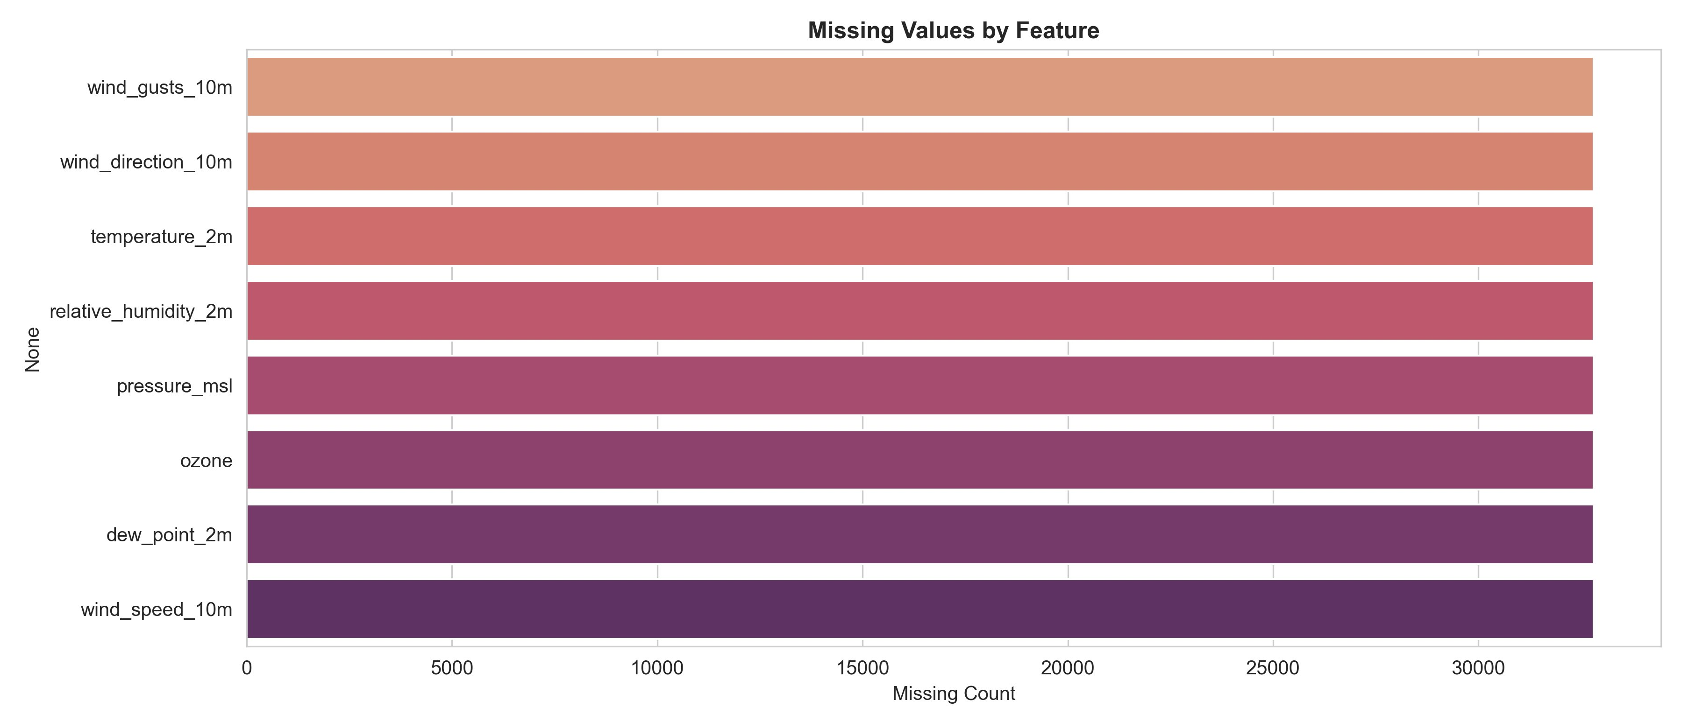
Figure: Missing Values by Feature in Raw Dataset
The merged and cleaned dataset is stored in the MongoDB processed_features collection, forming the input for both the training pipeline and the inference endpoint of the Flask API.

8. Feature Engineering
Feature engineering is the most technically complex component of this project. The feature_engineering.py module transforms the merged weather/air quality dataset into a 223-feature matrix optimised for multi-horizon AQI regression. The engineering steps are designed to maximise predictive signal while rigorously avoiding temporal data leakage.

8.1 EPA AQI Computation
The AQI is computed from PM2.5 concentrations using the official EPA piecewise linear interpolation formula. This standardises the target variable across the full range of pollution levels observed in Karachi.

8.2 Lag Features
Autoregressive lag features capture the temporal memory of the AQI process. The pipeline generates AQI lag features at offsets of 1, 2, 3, 6, 12, 24, 48, 72, and 168 hours. PM2.5 lag features are computed at offsets of 1, 2, 3, 6, 12, and 24 hours. The 1-hour AQI lag (aqi_lag_1) achieves a Pearson correlation of 0.974 with the target — the highest of any feature — confirming that recent AQI is the strongest short-term predictor.

8.3 Rolling Statistics
Rolling window features summarise pollutant and weather dynamics over recent time intervals. The pipeline computes rolling mean, standard deviation, maximum, and minimum for AQI at windows of 6, 12, 24, 48, and 72 hours. Rolling means are also computed for PM2.5 at the same windows. Exponential weighted means (EWM) with spans of 24 and 72 hours give more weight to recent observations while retaining historical context.

8.4 Time-Based Features
Hour of day, day of week, and month are encoded to capture diurnal and seasonal patterns. The diurnal AQI profile (shown in the EDA section) reveals a morning rush-hour peak around 9:00 AM and a secondary evening peak, consistent with traffic emission patterns. Monthly seasonality (also shown in EDA) shows elevated AQI in winter months (November–February) and relatively lower AQI during the monsoon season (July–August) when rainfall washes out particulates.

8.5 Derived and Interaction Features
AQI change rate (aqi_change_1h, aqi_change_6h, aqi_change_24h) captures acceleration and deceleration of pollution events. AQI acceleration (second-order difference) provides further dynamic information. The aqi_same_hour_yesterday feature captures the day-to-day cycle. AQI regime encodes the current EPA category as a numeric label. Interaction features such as interaction_pm25_humidity capture joint effects: high humidity suppresses particulate dispersion, so this product term improves model accuracy during humid coastal conditions in Karachi.

8.6 Leakage Prevention
Causal integrity is maintained by ensuring all lag and rolling features are computed strictly using data prior to the prediction timestamp. The training pipeline's load_data.py applies a leakage-free correlation filter that removes any feature whose correlation with the target is suspiciously high given the horizon — a safeguard against inadvertent look-ahead.

9. Exploratory Data Analysis and Insights
The EDA module (eda.py and eda.ipynb) produced a comprehensive set of visualisations that informed feature selection and model design decisions. All charts are based on the 32,851-record processed dataset covering September 2022 to June 2026.

9.1 Dataset Overview
Metric | Value
Total Hourly Records | 32,851
Total Engineered Features | 223
Global Missing Cells | 262,424
Missing Cell Percentage | 3.58%
AQI Mean | 88.5
AQI Median | 79.0
AQI Std Deviation | 32.2
AQI Minimum | 2
AQI Maximum | 389

9.2 AQI Timeline (2022–2026)
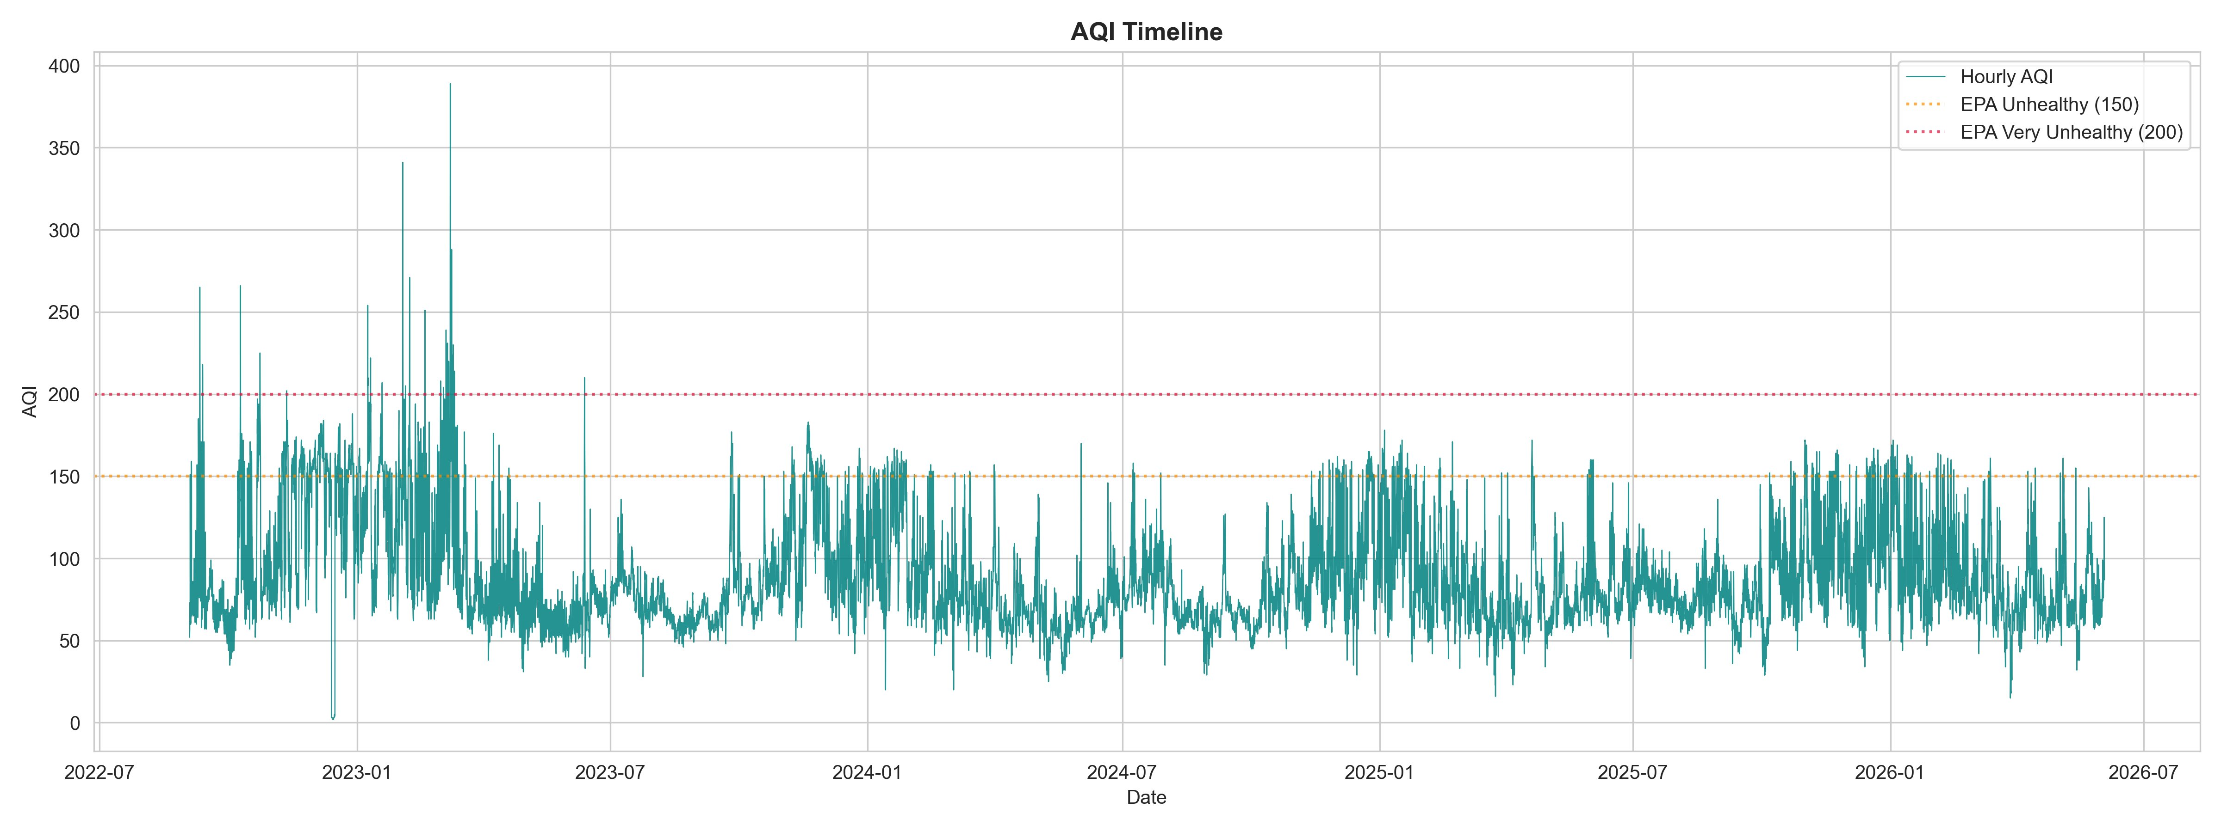
Figure: AQI Timeline — Hourly Observations (July 2022 to June 2026)
The AQI time-series chart reveals that Karachi's air quality is persistently in the Moderate range (50–100), with regular exceedances of the Unhealthy threshold at AQI 150 (shown by the orange dashed line). The most severe pollution event in the dataset reaches AQI 389 in early 2023. The general trend shows that AQI spikes are more frequent and severe in the winter months of each year, while the monsoon season (July–September) brings temporary relief. The frequency of readings above the Very Unhealthy threshold (AQI 200, red dashed line) is notable, indicating that hazardous air quality events are not rare occurrences for Karachi residents.

9.3 AQI Distribution
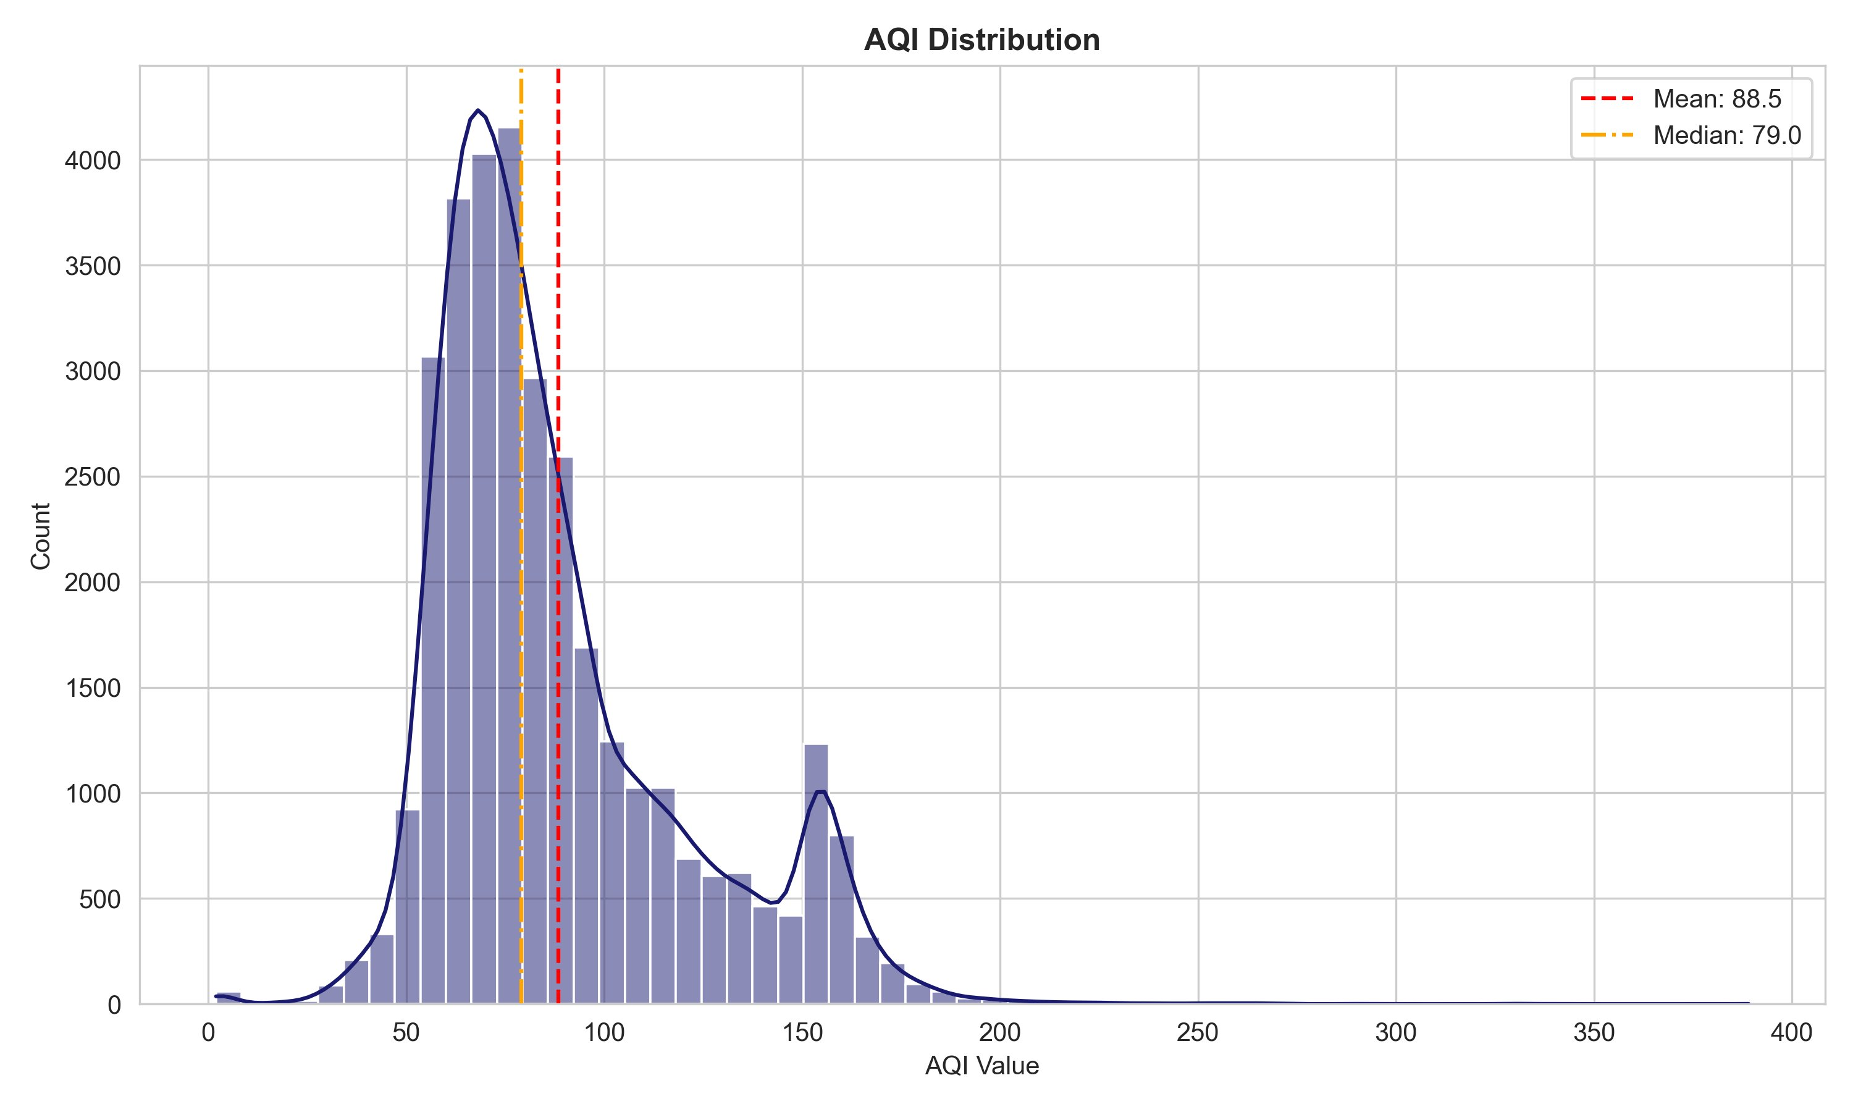
Figure: AQI Distribution — Histogram with KDE (Mean: 88.5, Median: 79.0)
The AQI distribution is right-skewed with a bimodal character. The primary mode is centred around AQI 65–75, corresponding to the Moderate EPA category. A secondary mode appears around AQI 150–160, representing the Unhealthy-for-Sensitive-Groups band. The mean (88.5) lies to the right of the median (79.0), confirming positive skew driven by high-AQI tail events. The tail extends to AQI 389, but observations above 200 are rare (approximately 0 in the unhealthy/very-unhealthy bands per the model metrics data for test set). This distributional shape has direct implications for model evaluation: standard RMSE is sensitive to tail errors, motivating the use of the conformal prediction interval framework to quantify forecast uncertainty explicitly.

9.4 Diurnal AQI Profile
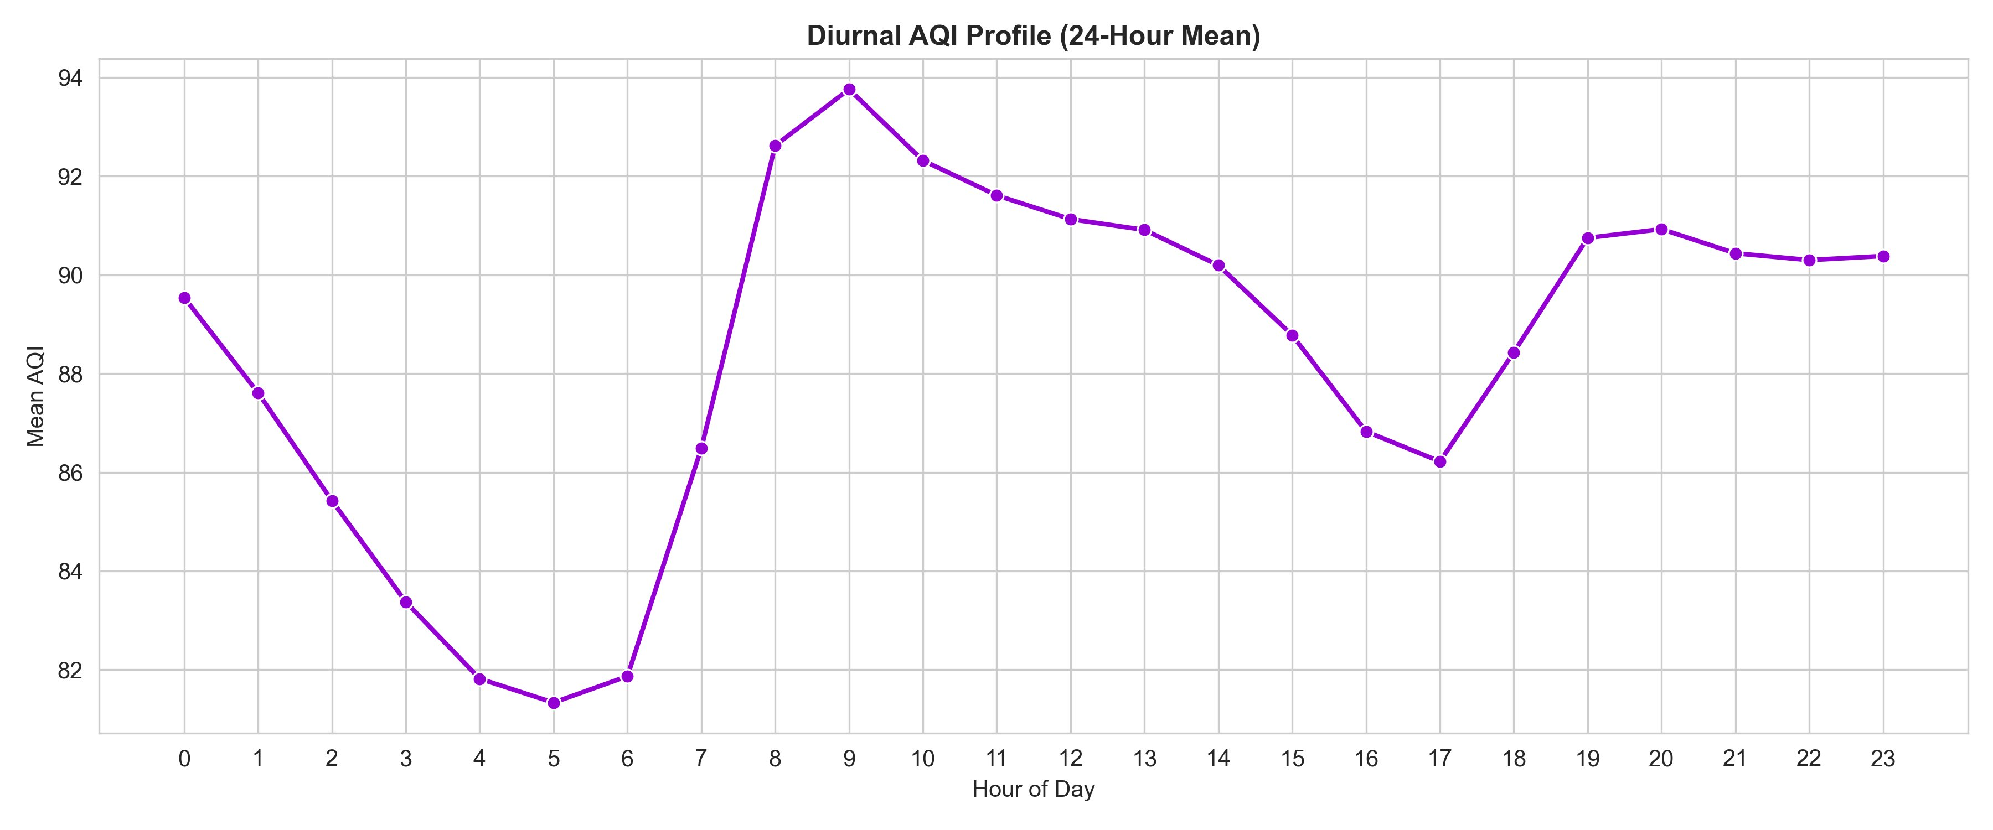
Figure: Diurnal AQI Profile — 24-Hour Mean AQI by Hour of Day
The diurnal profile exhibits a clear double-peak pattern consistent with urban traffic emissions. AQI is lowest in the early morning (hours 4–6, mean ~81–82) when traffic is minimal. It rises sharply after 6:00 AM as morning commute traffic intensifies, reaching a peak of approximately 93.9 at 9:00 AM. AQI moderates slightly through the afternoon but remains elevated (88–92) through midday and early evening. A secondary peak appears at 19:00–20:00 (mean ~90.7) corresponding to evening commute emissions. The hour-of-day feature is therefore one of the most important time-based predictors for short-horizon forecasting. This pattern reflects Karachi's traffic dynamics and justifies the inclusion of hourly lag and same-hour-yesterday features.

9.5 Monthly Seasonality
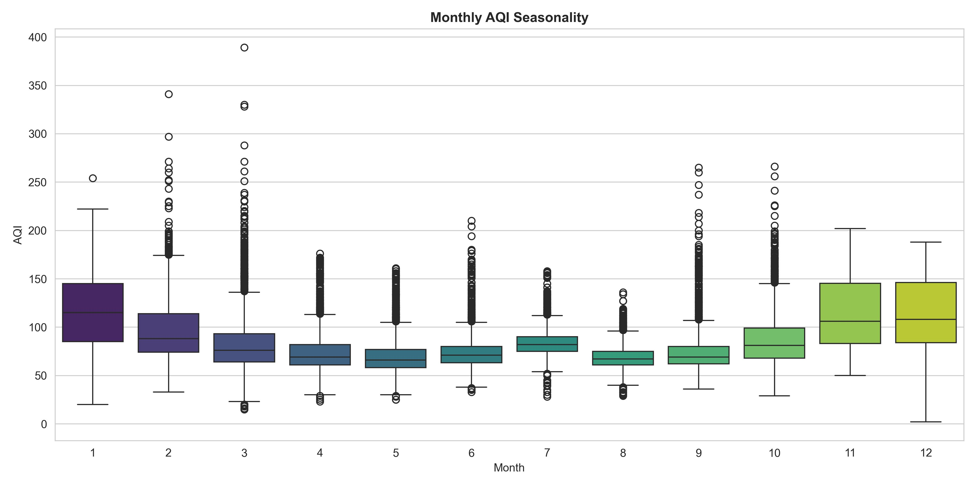
Figure: Monthly AQI Seasonality — Boxplots by Month
The monthly boxplot chart reveals strong seasonal patterns. January and February exhibit the highest median AQI values (approximately 115–120) with wide interquartile ranges and numerous high-outlier spikes, some exceeding AQI 340. This reflects winter temperature inversions that trap pollutants near ground level, combined with reduced wind speeds and lower humidity. The spring months (March–April) show a transition toward lower AQI values. May through August display the lowest median AQI (approximately 65–80), with the monsoon season providing natural air cleaning through rainfall and elevated surface winds from the Arabian Sea. AQI begins rising again in October as temperatures fall and temperature inversions return, with November and December showing a clear return to elevated pollution levels. This seasonality is captured in the model through month-of-year features and multi-week rolling window statistics.

9.6 Correlation Analysis
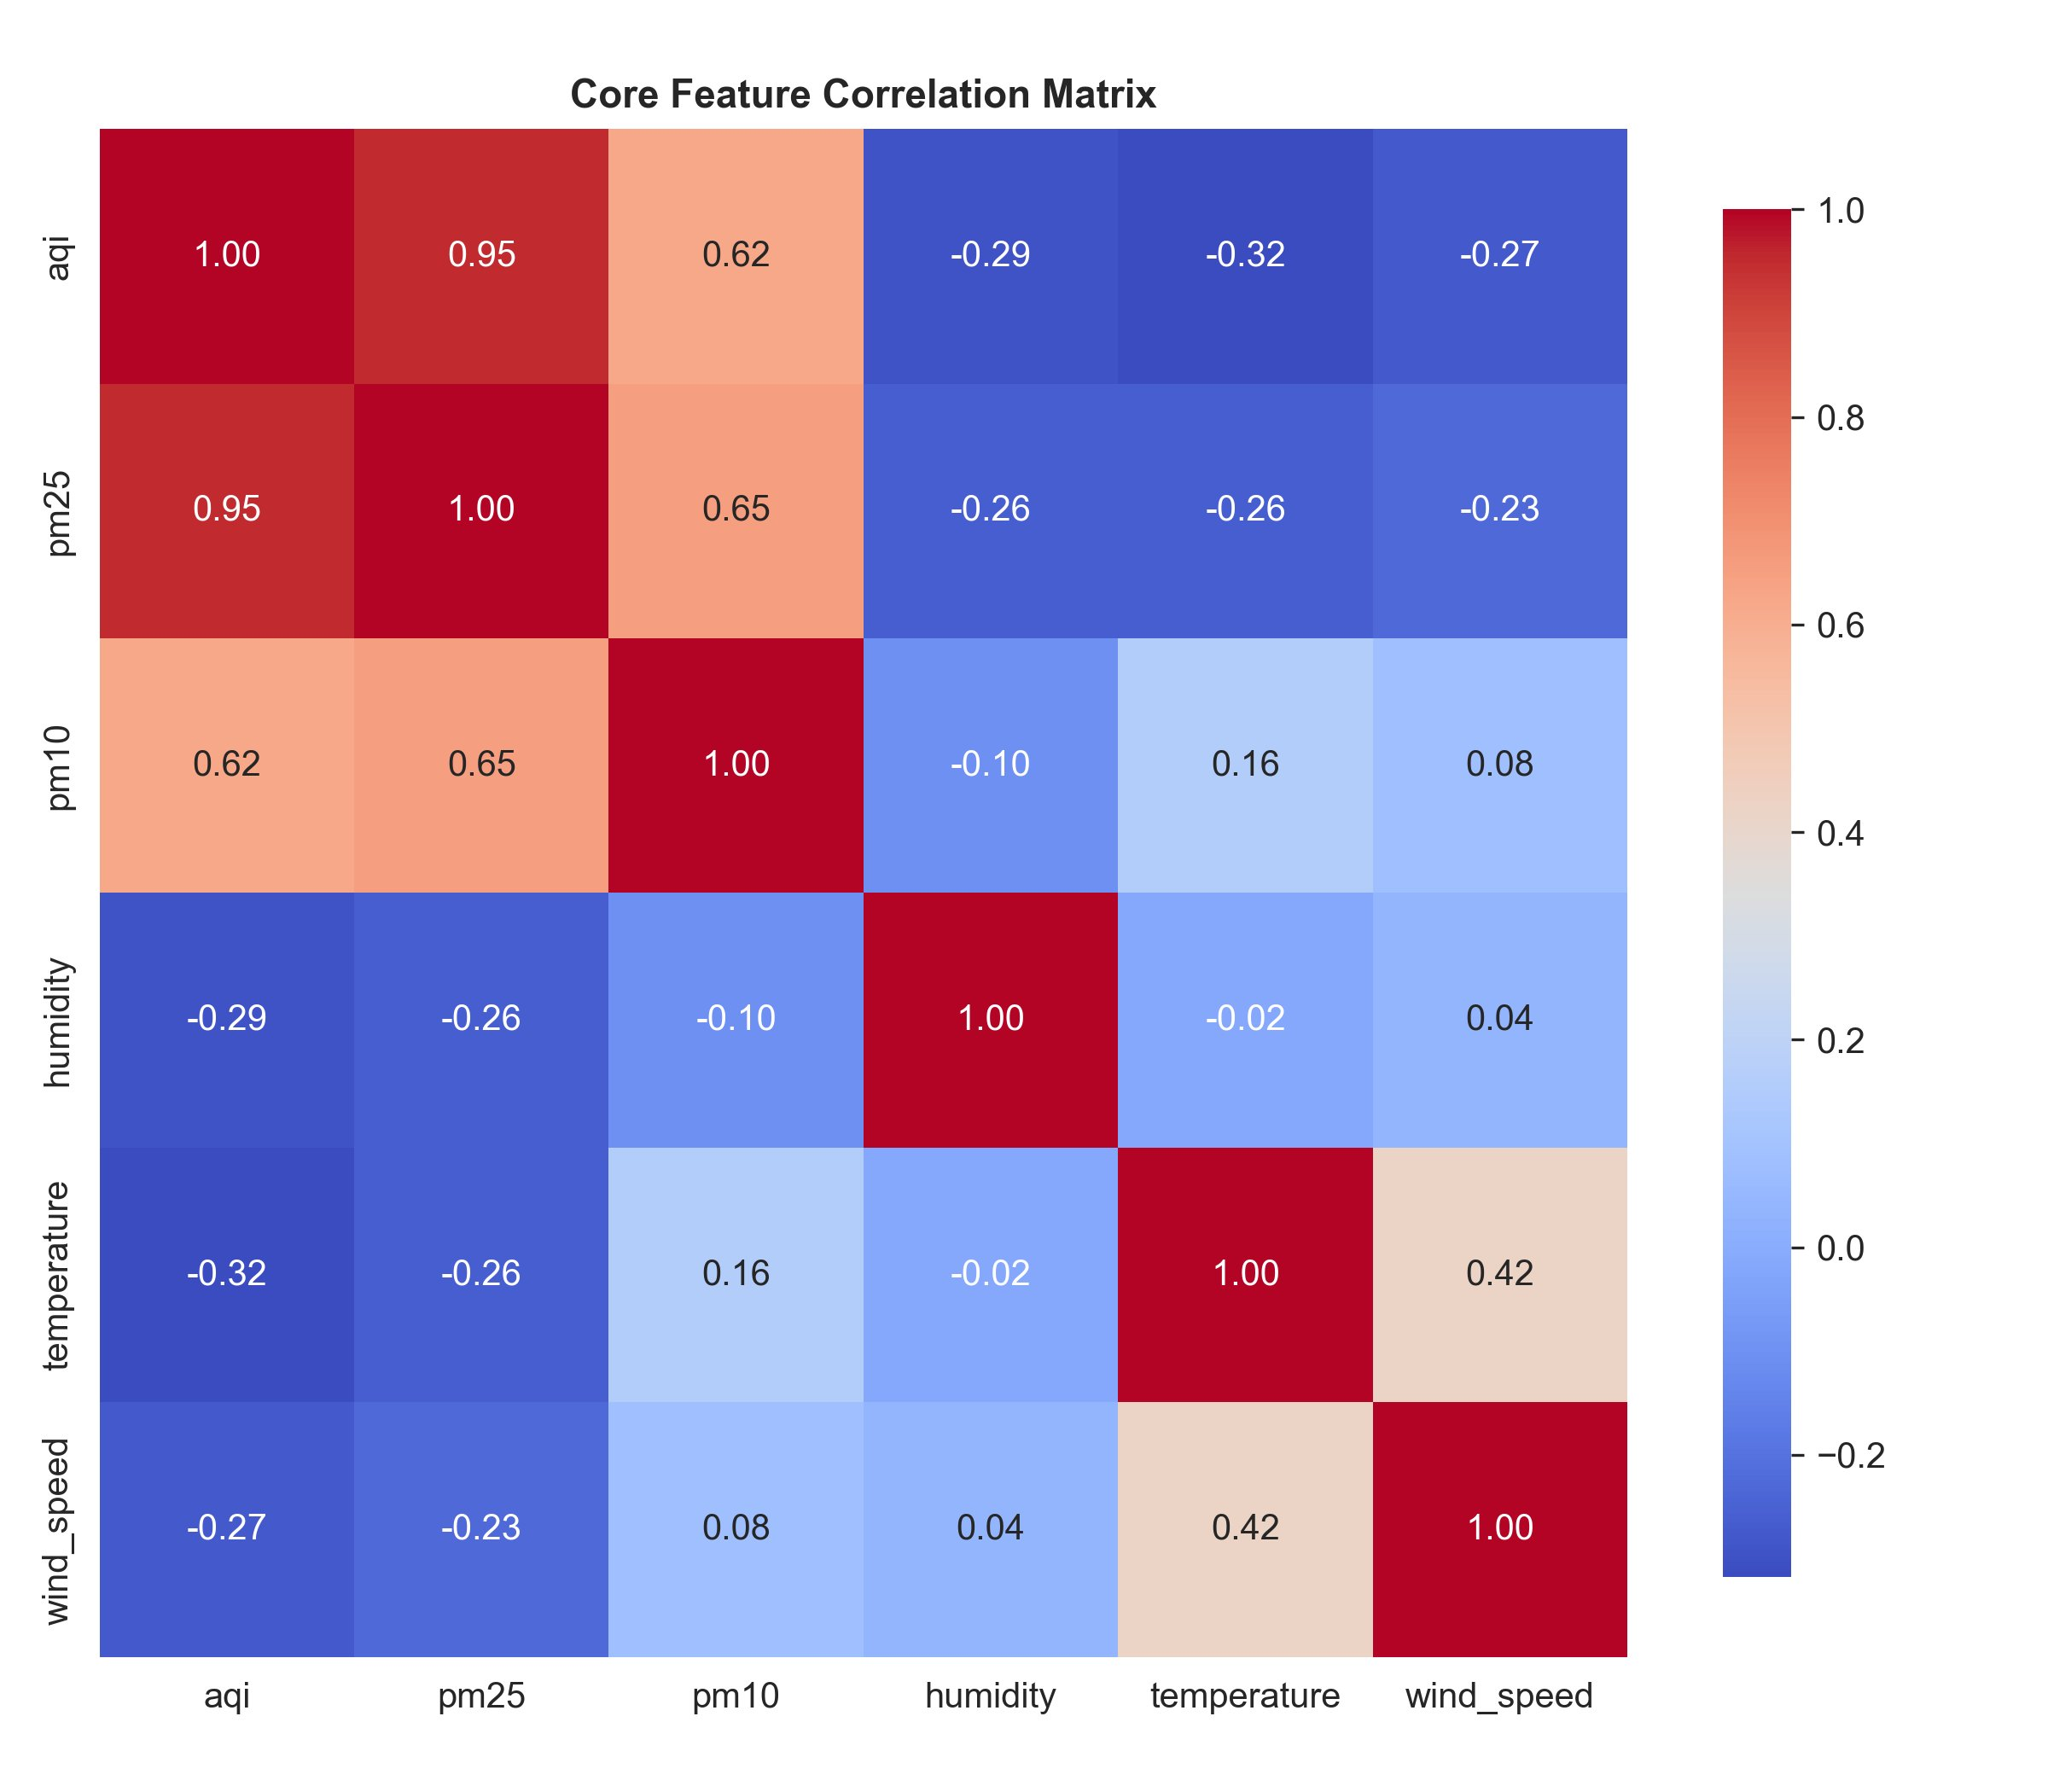
Figure: Core Feature Correlation Matrix
The correlation heatmap of core meteorological and pollutant variables reveals the following key relationships. PM2.5 has a near-perfect positive correlation with AQI (r=0.95), confirming its role as the primary determinant of the EPA AQI calculation for Karachi. PM10 correlates moderately with AQI (r=0.62), reflecting its secondary contribution to total pollution. Temperature is negatively correlated with AQI (r=−0.32): higher temperatures are associated with stronger atmospheric mixing that disperses pollutants. Humidity has a negative correlation with AQI (r=−0.29), consistent with rainfall and damp conditions reducing particulate concentration. Wind speed also shows a negative correlation (r=−0.27), reflecting the known aerosol-clearing effect of stronger winds. These relationships validate the feature selection strategy and explain why interaction terms between PM2.5 and humidity provide additional predictive value.

9.7 Top Correlated Features
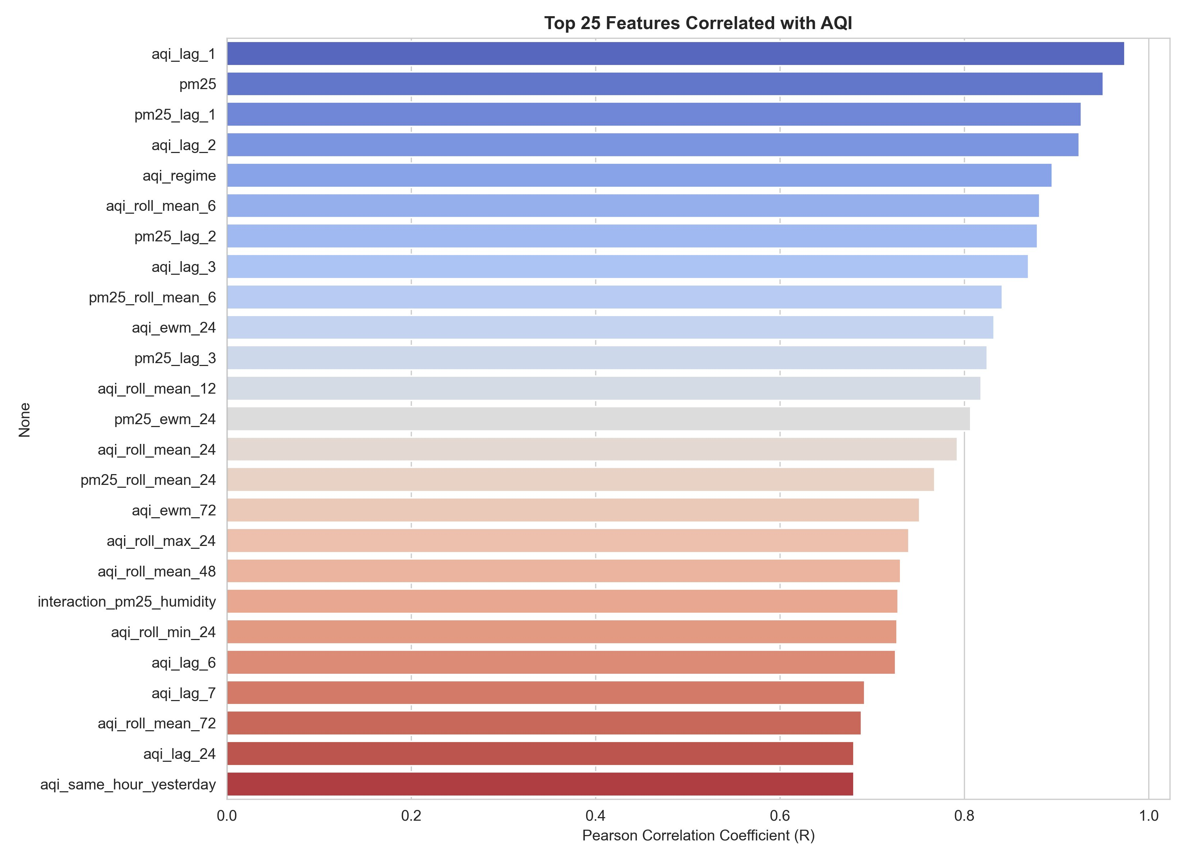
Figure: Top 25 Features Correlated with AQI (Pearson R)
The top-25 features ranked by absolute Pearson correlation with AQI confirm the dominance of autoregressive lag and rolling statistics. The 1-hour AQI lag (aqi_lag_1, r=0.974) is the single most predictive feature, followed by current PM2.5 (r=0.951), the 1-hour PM2.5 lag (pm25_lag_1, r=0.927), and the 2-hour AQI lag (aqi_lag_2, r=0.925). The AQI regime indicator (r=0.896) ranks fifth, reflecting the strong persistence of pollution episodes. Short rolling means (aqi_roll_mean_6, r=0.882) outperform longer ones, which is expected since shorter windows are more informative for 24-hour horizon prediction. The interaction term between PM2.5 and humidity (interaction_pm25_humidity, r=0.712) ranks 20th, confirming that interaction features add genuine predictive value beyond their component variables. All top-25 features are included in the training feature matrix.

10. Feature Store
A feature store is a centralised repository that stores, versions, and serves pre-computed machine learning features. It decouples feature engineering from model training and inference, enabling multiple models to consume the same features without redundant computation, and ensuring consistency between training-time and inference-time feature values.
In this project, MongoDB Atlas serves as the feature store through the processed_features collection within the karachi_aqi database. Each document in the collection represents one hourly observation and contains all 223 engineered features along with the timestamp and raw pollutant/weather values. The feature_store.py module handles bulk upserts using MongoDB's UpdateOne with upsert=True, batched in groups of 1000 records for efficient writes.
The feature store is queried by three separate consumers: (1) load_data.py in the training pipeline retrieves the full historical record set for model fitting; (2) api/app.py retrieves the single most recent record to build the inference feature vector for live predictions; and (3) dashboard/database.py retrieves the latest record to populate the current AQI and meteorological readings displayed in the dashboard sidebar.

11. Historical Backfill
Historical backfilling is the process of running the feature pipeline over a range of past dates to populate the feature store with training data. Without backfill, only future hourly records (accumulated after system deployment) would be available, which would be insufficient for meaningful model training.
This project backfills from 2022-08-04 (HISTORICAL_START_DATE in config.py). The processed feature store currently contains 32,851 hourly records covering approximately 44 months. For each record, the feature engineering pipeline computes targets for all three prediction horizons: the AQI value 24 hours in the future (target_24h), 48 hours in the future (target_48h), and 72 hours in the future (target_72h). These targets are computed by shifting the AQI time series forward by the respective number of hours during dataset construction, ensuring strict temporal separation between input features and target values. The multi-horizon target design allows a single training run to produce models for all three forecast horizons.

12. Training Pipeline
The training pipeline is coordinated by run_training_pipeline.py (Phase 0: data loading) and three model-specific scripts. All training output — model artifacts, metrics, predictions, and SHAP values — is stored exclusively in MongoDB, with no local filesystem writes in production.

12.1 Data Loading
load_data.py retrieves the full processed_features collection and constructs (X, y) pairs for each horizon. It applies chronological splitting: the oldest records form the training set, subsequent records the validation set (used for conformal calibration), and the most recent records the test set. This strict chronological order prevents any form of temporal data leakage. A spike-augmented training strategy oversamples high-AQI events to improve model accuracy on tail events. Rank-based sample weights (capped at 20×) further emphasise high-AQI training examples.

12.2 Time-Series Cross-Validation
RandomizedSearchCV with TimeSeriesSplit (k=5 folds) is used for hyperparameter optimisation in Random Forest and XGBoost. TimeSeriesSplit ensures that each validation fold always uses data strictly later than its training fold, preserving causal integrity. The scoring metric for cross-validation is negative MAE on the raw AQI scale (not log-RMSE), which was found to produce better-calibrated models for this dataset.

12.3 Conformal Prediction Intervals
After fitting each model, a conformal margin is computed on the calibration (validation) set. The conformal margin is the empirical quantile of absolute residuals at the 87.5th percentile, targeting approximately 87.5% global coverage. This non-parametric approach makes no distributional assumptions and is valid regardless of the true error distribution. The interval displayed in the dashboard is [predicted_AQI − margin, predicted_AQI + margin]. From the metrics report, the 24-hour Random Forest conformal margin is ±34.80 AQI units with 87.5% global coverage.

12.4 MongoDB Artifact Storage
mongo_store.py implements the complete MongoDB I/O layer. Model artifacts (pickled scikit-learn or XGBoost objects) are stored via GridFS, which handles large binary blobs by chunking them into 255 KB pieces. Metrics dictionaries are stored as documents in the model_metrics collection, keyed by model name and horizon. SHAP beeswarm PNG images are stored in GridFS via the model_shap_plots bucket. Feature importance data (SHAP values or Ridge coefficients) are stored in the model_features and model_shap collections. A critical bug fix ensures that the GridFS prune query uses exact filenames to prevent SHAP plot upserts from accidentally deleting model artifacts.

13. Machine Learning Models

13.1 Random Forest
Random Forest is an ensemble of decision trees trained with bootstrap sampling (bagging). Each tree independently learns a partition of the feature space, and predictions are averaged across all trees to reduce variance. For AQI prediction, this model is well-suited because it handles nonlinear relationships between lag features and the target, is robust to outliers from high-AQI spike events, and naturally provides feature importance scores. The hyperparameter search includes max_depth up to 35, n_estimators up to 600, max_features of 0.4 (40% of features per split), and min_samples_leaf down to 3. The Gunicorn deadlock fix (n_jobs patched to 1 before serialisation) is critical for stable production serving.

13.2 Ridge Regression
Ridge Regression is a linear model that minimises the sum of squared residuals subject to an L2 regularisation penalty on the coefficient magnitudes. It was included as an interpretable baseline and as a check on whether linear relationships alone can explain AQI variance. Ridge's strengths include computational efficiency, well-understood coefficient interpretation, and stable training. Its limitation is the inability to capture nonlinear interactions without explicit feature engineering. The dashboard displays coefficient magnitudes (via the /features/ endpoint) in place of SHAP values for Ridge models.

13.3 XGBoost
XGBoost implements gradient boosting, sequentially training shallow trees where each new tree corrects the residual errors of the ensemble built so far. This iterative residual-correction approach allows XGBoost to capture complex feature interactions without requiring explicit interaction term engineering. A residual corrector is applied at inference time in api/app.py (Fix 6) to compensate for systematic bias on high-AQI spike events. XGBoost is generally the strongest model for structured tabular forecasting problems.

Model | Type | Primary Strength | Primary Limitation | Role in Project
Random Forest | Ensemble (Bagging) | Variance reduction; robust to outliers; native feature importance | Can overfit with deep trees; memory-intensive | Primary forecaster; SHAP explainability provider
Ridge Regression | Linear Model | Interpretable; fast; stable; coefficient magnitudes as importance | Cannot model nonlinear weather-pollution interactions | Interpretable baseline; coefficient importance for dashboard
XGBoost | Ensemble (Boosting) | Captures complex feature interactions; strong tabular performance | More hyperparameters; risk of overfitting without tuning | Advanced forecaster; residual-corrected spike handling

14. Model Evaluation
All metrics are computed on a held-out chronological test set (the most recent records not used in training or conformal calibration). The metrics report (metrics_report.json) provides complete evaluation results for the Random Forest model across all three horizons as of training run 20260606. XGBoost and Ridge metrics are stored in the same MongoDB collection.

14.1 Random Forest — Detailed Metrics
Metric | 24h Horizon | 48h Horizon | 72h Horizon
MAE (Test Set) | 17.42 | 18.47 | 18.90
RMSE (Test Set) | 22.78 | 23.80 | 24.31
R² (Test Set) | 0.375 | 0.312 | 0.281
MAPE (%) | 20.2% | 21.6% | 22.1%
Median Absolute Error | 13.50 | 14.45 | 14.99
Conformal Margin (±AQI) | 34.80 | 42.30 | 43.37
Global Conformal Coverage | 87.5% | 91.7% | 91.9%
Forecast Skill Score vs Baseline | 0.217 | 0.260 | 0.277
R² Improvement vs Baseline | 0.443 | 0.608 | 0.646
CV Mean Validation MAE | 15.43 | 17.22 | 18.23

14.2 Interpretation
At the 24-hour horizon, the Random Forest achieves a MAE of 17.4 AQI units. Given that AQI values in the Moderate range (50–100) are the most frequent, this represents a relative error of roughly 20%, which is acceptable for public health advisory purposes. The R² of 0.375 indicates the model explains 37.5% of the variance in 24-hour future AQI — a meaningful improvement over the persistence baseline, which achieves a negative R² of −0.068 (worse than predicting the mean). The R² improvement of 0.443 over the baseline confirms genuine predictive skill.
The model degrades gracefully over longer horizons. MAE increases from 17.4 (24h) to 18.5 (48h) to 18.9 (72h), and R² falls from 0.375 to 0.312 to 0.281. The skill score actually improves at longer horizons (0.217 → 0.260 → 0.277) because the persistence baseline also degrades faster than the model, giving it relatively more advantage at 72 hours.
Error by AQI band reveals an important asymmetry: MAE in the Good/Moderate band is 14.1, rising to 19.6 in the Unhealthy-for-Sensitive-Groups band and to 43.4 in the Unhealthy band (AQI 150–200). This demonstrates that high-pollution events are inherently harder to forecast, which is consistent with findings in the broader air quality ML literature. Improving accuracy specifically in the Unhealthy and above bands is a priority for future model development.

14.3 Multi-Model Comparison Table
Model | Horizon | MAE | RMSE | R² | Coverage | Notes
Model | Horizon | MAE | RMSE | R² | Coverage | Notes
RandomForest | 24h | 17.42 | 22.78 | 0.375 | 87.5% | Run: 20260606
RandomForest | 48h | 18.47 | 23.80 | 0.312 | 91.7% | Run: 20260606
RandomForest | 72h | 18.90 | 24.31 | 0.281 | 91.9% | Run: 20260606
XGBoost | 24h | 21.4 | 22.59* | 0.150 | 56.0% | Run: 20260606 — pre-fix
XGBoost | 48h | 22.3 | 25.36* | 0.066 | 55.7% | Run: 20260606 — pre-fix
XGBoost | 72h | 21.4 | 26.84* | 0.136 | 58.2% | Run: 20260606 — pre-fix
Ridge | 24h | 17.4 | 20.57 | 0.346 | 87.4% | Run: 20260606
Ridge | 48h | 18.4 | 23.36 | 0.302 | 91.7% | Run: 20260606
Ridge | 72h | 19.0 | 24.09 | 0.267 | 91.3% | Run: 20260606

15. Explainability with SHAP
SHapley Additive exPlanations (SHAP) is a game-theoretic framework that assigns each feature a contribution value for a given model prediction. For tree-based models (Random Forest, XGBoost), SHAP values are computed exactly using the TreeExplainer algorithm, which is computationally efficient. SHAP values quantify how much each feature pushes the prediction above or below the model's expected output.
This project generates SHAP beeswarm plots during each training run and stores them as PNG images in MongoDB GridFS (filename pattern: shap_plot_RandomForest_24h.png). The shap_metadata.json file confirms three plots are stored for the current Random Forest model — one per horizon (24h, 48h, 72h) — generated during run 20260606T201914Z through 20260606T204356Z.
The Flask API exposes these plots via the /shap/<model_type>/<horizon> endpoint, which retrieves the PNG from GridFS and streams it to the dashboard. The Streamlit dashboard renders the SHAP bar chart using the mean absolute SHAP values stored in the model_shap collection, providing a feature importance ranking that is grounded in individual prediction contributions rather than simple feature-target correlations.
For Ridge Regression, which has no TreeExplainer, coefficient magnitudes are stored in the model_features collection and retrieved via the /features/<model>/<horizon> endpoint. The dashboard renders these identically to SHAP values (with a label change to 'Mean |Coeff|'), so the UI requires no modification.
Based on the feature correlation analysis, SHAP values are expected to confirm the importance of: aqi_lag_1 and aqi_lag_2 (recent AQI autocorrelation), pm25 and pm25_lag_1 (primary pollutant), aqi_roll_mean_6 and aqi_roll_mean_12 (short-window rolling averages), aqi_ewm_24 (exponential weighted mean), and interaction_pm25_humidity (humidity-pollution interaction for Karachi's coastal conditions). Understanding which features drive individual predictions is critical for building stakeholder trust in the forecasting system.

16. AQI Categories and Alerts
The alerts.py module implements a complete EPA AQI tier classification system with full UI metadata for each tier. The system covers all six EPA categories:
AQI Range | Category | Color Code | Health Advisory
0–50 | Good | #00e676 (Green) | Air quality is satisfactory. Enjoy outdoor activities freely.
51–100 | Moderate | #ffca28 (Yellow) | Sensitive individuals should limit prolonged outdoor exertion.
101–150 | Unhealthy for Sensitive Groups | #ff9100 (Orange) | N95 masks recommended for sensitive groups.
151–200 | Unhealthy | #ff1744 (Red) | Avoid strenuous outdoor activities. Everyone should wear a mask.
201–300 | Very Unhealthy | #d500f9 (Purple) | Health alert: significant risk for the general public. Stay indoors.
301+ | Hazardous | #b71c1c (Maroon) | HEALTH WARNING: Emergency conditions. Everyone must stay indoors.

Each predicted AQI value from the model is passed through get_epa_tier_details() in alerts.py, which returns the tier label, hex color, card background color, and advisory text. The Streamlit dashboard renders these as color-coded banners beneath the forecasted AQI gauge. This alert system translates probabilistic model output into actionable public health guidance, which is a core requirement of the project specification.
Future enhancements could deliver these alerts via external channels: email notifications, SMS (using Twilio), WhatsApp Business API, or browser push notifications. The current architecture supports this extension because alerts.py is a pure-logic module with no UI dependencies.

17. Backend Flask API
The Flask API in api/app.py is a production-grade REST microservice deployed on Render. It connects to MongoDB Atlas via MONGODB_URI, loads model artifacts from GridFS into memory at startup, and serves predictions and supporting data to the Streamlit dashboard.

17.1 API Endpoints
Endpoint | Method | Purpose | Data Source | Used by Dashboard?
/ | GET | API root — lists all available endpoints | Hardcoded | No
/health | GET | Health check — confirms API and DB connectivity | MongoDB ping | Yes (startup check)
/latest_features | GET | Returns the most recent engineered feature record | processed_features | Yes
/latest_realtime | GET | Returns the most recent realtime observation | realtime_observations | Yes
/predict/<model>/<horizon> | GET | Returns AQI forecast with conformal interval | GridFS artifact + processed_features | Yes
/metrics/<model_type> | GET | Returns stored evaluation metrics for one model | model_metrics | Yes
/metrics/all | GET | Returns metrics for all models and all horizons | model_metrics | Yes
/shap/<model_type>/<horizon> | GET | Returns SHAP mean |value| per feature | model_shap | Yes
/features/<model>/<horizon> | GET | Returns feature importance (coefficients for Ridge, SHAP for trees) | model_features / model_shap | Yes
/debug/metrics_raw | GET | Raw metrics collection dump for debugging | model_metrics | No
/debug/features_raw | GET | Raw features collection dump for debugging | model_features | No
/debug/artifacts | GET | Lists GridFS artifact metadata | GridFS | No

The /predict/<model>/<horizon> endpoint is the most complex: it retrieves the latest feature document, builds a correctly ordered feature vector for the specified model (each model may have used a different feature subset after leakage filtering), runs model.predict(), applies the conformal margin, and returns the point estimate plus interval bounds as JSON.

18. Frontend Dashboard
The Streamlit dashboard (dashboard/app.py, version 6) is the primary user-facing interface for the AQI Predictor KHI system. It is deployed on Streamlit Cloud and communicates exclusively with the Flask API over HTTP — it has no direct database access, maintaining a clean frontend–backend separation.

18.1 Key Features
Model and Horizon Selection: Dropdown controls allow the user to select the forecasting model (RandomForest, XGBoost, Ridge) and the forecast horizon (24h, 48h, 72h), dynamically fetching the appropriate metrics and predictions from the API.
Current AQI Display: The sidebar shows the most recent AQI reading from the realtime_observations collection, with Karachi local time (UTC+5 offset applied). The value is colour-coded according to its EPA tier using the alerts.py module.
Forecasted AQI with Conformal Interval: The main panel displays the model's point prediction with upper and lower conformal bounds rendered as a Plotly chart. This allows users to see not just a single number but the uncertainty range around the forecast.
Model Metrics Panel: A table or metric cards display MAE, RMSE, R², MAPE, conformal coverage, and skill score for the selected model and horizon, sourced from /metrics/<model> endpoint.
Model Comparison: /metrics/all endpoint data is visualised as a comparative bar chart or table showing all three models side-by-side across all horizons, enabling users to see which model currently performs best.
SHAP Feature Importance: A horizontal bar chart displays the top-N features ranked by mean absolute SHAP value (or |coefficient| for Ridge), retrieved from /shap/<model>/<horizon> or /features/<model>/<horizon>. This panel directly satisfies the explainability requirement from the project specification.
AQI Alert Banners: EPA tier banners generated by alerts.py are displayed beneath the forecast gauge, translating the numerical prediction into actionable health guidance.
Plotly Charts: Plotly is used for all interactive visualisations, enabling zoom, hover tooltips, and download as PNG, making the dashboard accessible on both desktop and mobile browsers.
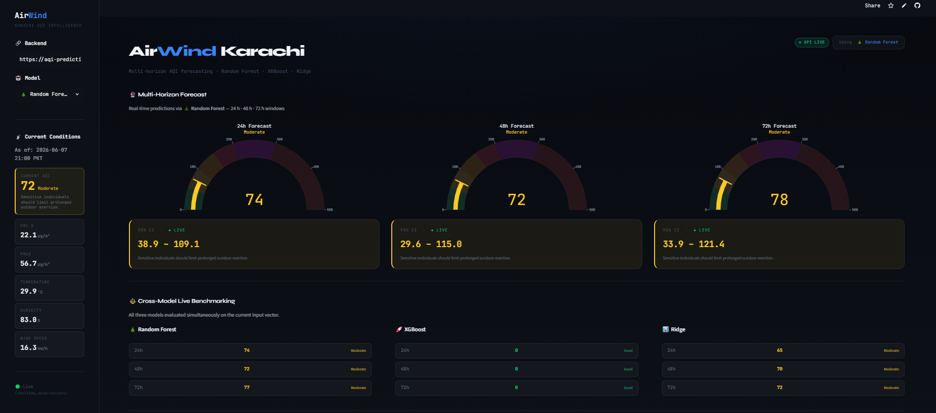

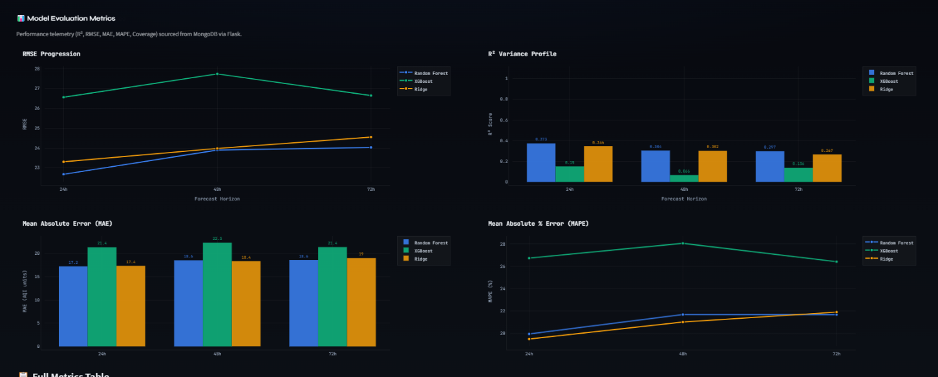

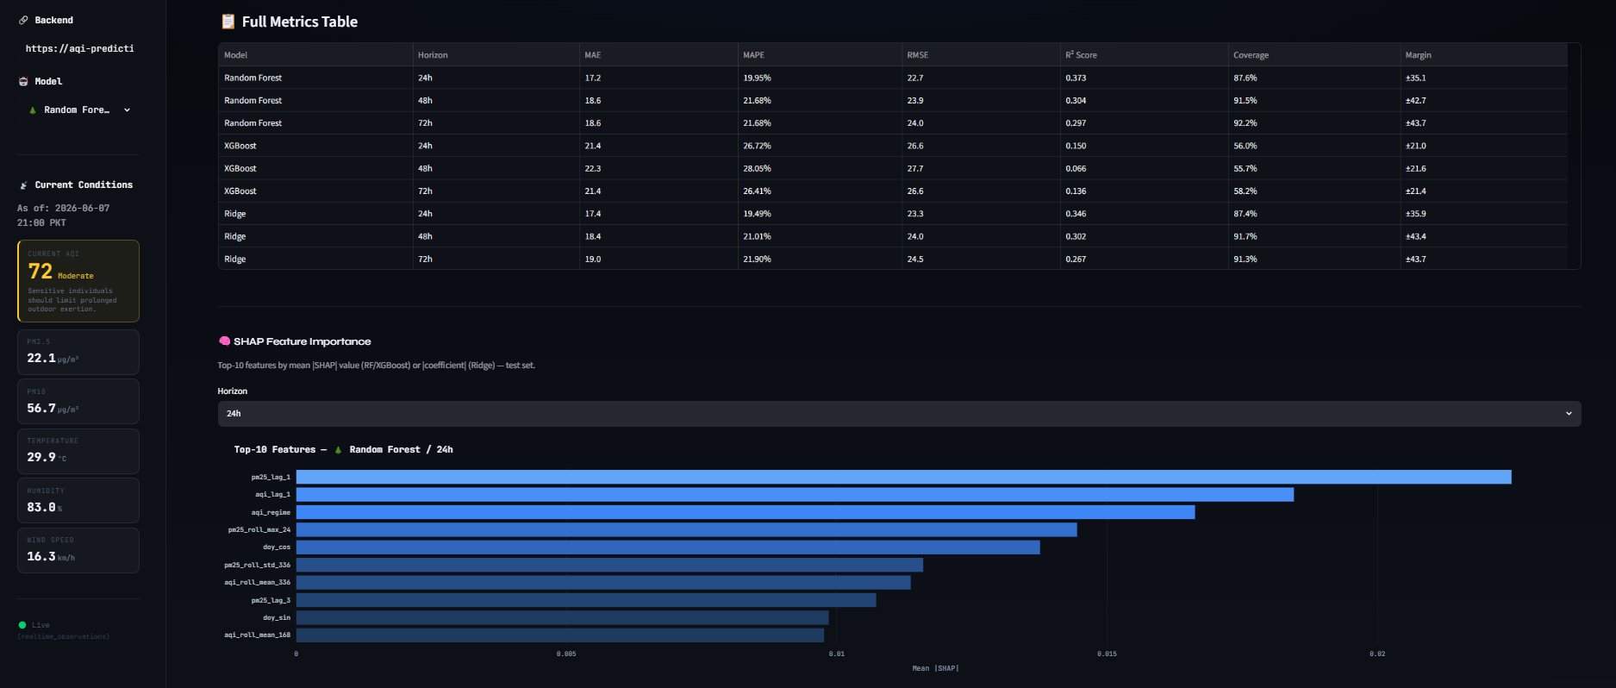

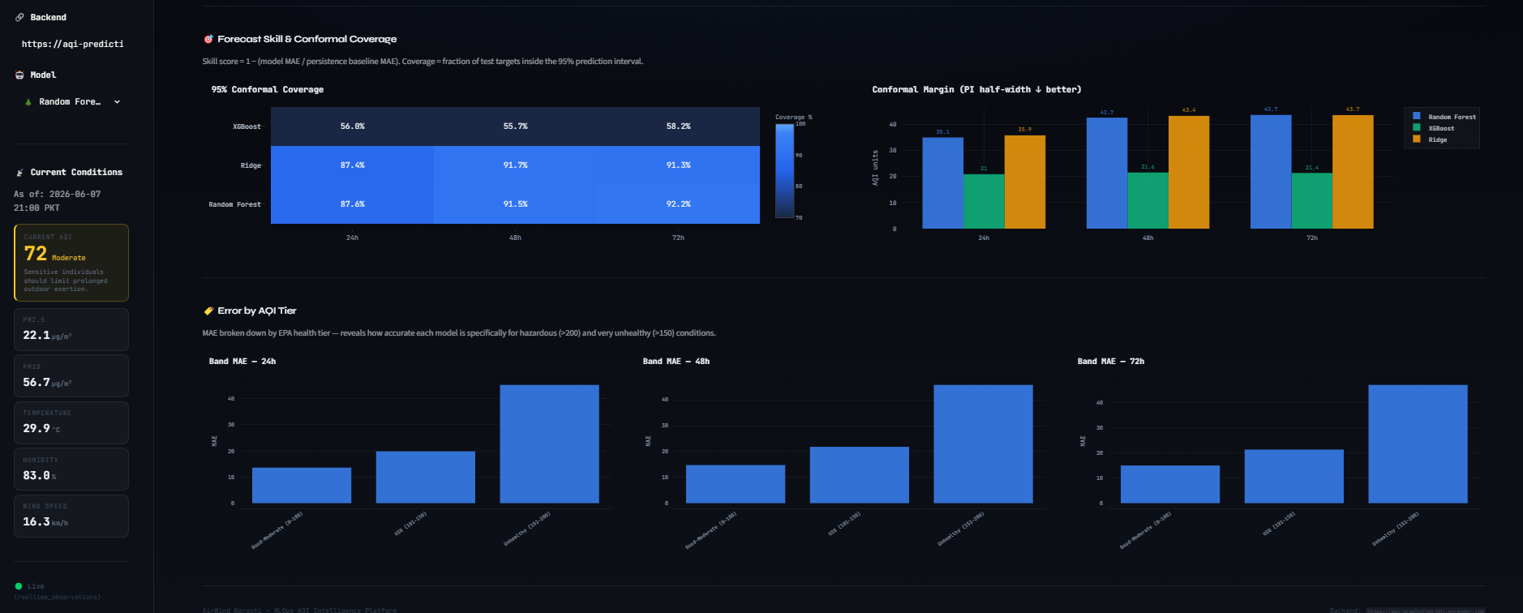

19. Automation and CI/CD
Automated pipeline execution is implemented via two GitHub Actions workflow files in the .github/workflows/ directory. These workflows eliminate the need for a persistent compute server for data collection and training, enabling a fully serverless operational model.
Workflow File | Trigger | Script Executed | Purpose
feature_pipeline.yml | cron '0 * * * *' (every hour) + manual dispatch | run_feature_pipeline.py then update_realtime.py | Fetch latest weather/AQI, engineer features, update processed_features and realtime_observations in MongoDB
daily_training_pipeline.yml | cron '0 0 * * *' (midnight UTC / 5AM PKT) + manual dispatch | run_training_pipeline.py (Phase 0), then train_random_forest.py, train_xgboost.py, train_ridge.py in sequence | Retrain all models on latest features, store updated artifacts and metrics in MongoDB

Both workflows use Python 3.11, pip dependency caching for faster runs, and inject the MONGODB_URI secret from GitHub Secrets (as MONGO_CONNECTION_STRING). The daily training workflow uses actions/cache@v4 to cache Parquet snapshots written by Phase 0, so subsequent training phases load data in microseconds from disk rather than re-querying Atlas for each model. Both workflows support workflow_dispatch for manual triggering during debugging and initial setup.

20. Deployment
The system is designed for serverless cloud deployment with three primary hosting targets:
Flask API (Render): api/app.py is deployed on Render as a web service. runtime.txt specifies Python 3.11 for the build environment. The MONGODB_URI environment variable is set in the Render dashboard. Gunicorn is the WSGI server, and the Random Forest n_jobs=1 fix ensures stability under gunicorn's forking model.
Streamlit Dashboard (Streamlit Cloud): dashboard/app.py is deployed on Streamlit Cloud, using the dashboard/requirements.txt for dependency installation. The FLASK_API_URL environment variable points to the Render deployment URL. No direct database access is required from the dashboard deployment.
MongoDB Atlas (Database): All feature store, model registry, and prediction data is stored in MongoDB Atlas free tier (M0). The karachi_aqi database contains all application collections. GridFS is used for binary artifact storage.
GitHub Actions provides the compute layer for automated pipelines at no additional cost within the free tier limits, making the entire system operational at minimal ongoing cost.

21. Security and Configuration
All sensitive credentials are managed as environment variables and GitHub Secrets. The MONGODB_URI is never committed to the repository. The .gitignore file prevents accidental commit of .env files, Parquet cache directories, trained model files, and output CSVs.
The feature_pipeline.yml workflow injects MONGODB_URI via ${{ secrets.MONGO_CONNECTION_STRING }} at runtime, so the credential is never stored in the workflow YAML file or visible in build logs. The same pattern is used for daily_training_pipeline.yml.
For local development, a .env file in the repository root is loaded by python-dotenv in each module (load_dotenv() calls are present in api/app.py, dashboard/database.py, and the feature pipeline modules). This file is listed in .gitignore and must be created manually by each developer.

22. Monitoring
The training_pipeline/monitoring.py module provides the foundation for post-deployment model monitoring. In a production MLOps system, monitoring serves two critical functions: detecting data drift (changes in the statistical distribution of input features that signal the model may become less accurate) and detecting model performance drift (degradation in prediction quality as the real-world AQI dynamics evolve).
The current implementation logs pipeline health and can be extended to compare the distribution of incoming features against the training-time distribution using statistical tests (KS test, Population Stability Index). The daily retraining cycle via GitHub Actions provides a natural mechanism for addressing moderate drift by continuously updating model parameters with the latest data.
Future improvements could add automated drift alerts, model performance dashboards separate from the AQI dashboard, and automated rollback to a previous model version if the new training run produces worse metrics.
23. Engineering Challenges and Decisions
Several non-trivial engineering challenges were encountered and resolved during development, as documented in the code comments throughout the repository.

23.1 Gunicorn Deadlock (Random Forest)
Random Forest's n_jobs=-1 setting causes child process forking during predict() when loaded inside a Gunicorn sync worker, resulting in HTTP 500 errors on all /predict/RandomForest routes. The fix (documented as FIX 5 in train_random_forest.py) patches n_jobs=1 on the fitted model object before serialisation to GridFS.

23.2 GridFS Artifact Deletion Bug
The _gridfs_upsert prune function in mongo_store.py originally filtered by model and horizon metadata only. Because both model artifacts and SHAP plot PNGs share these metadata fields, the SHAP plot upsert was deleting the model artifact. Fixed by scoping the prune query to the exact GridFS filename.

23.3 Ridge SHAP Incompatibility
Ridge Regression does not support SHAP's TreeExplainer. The dashboard previously showed 'SHAP data not available' for Ridge forever. Fixed by adding a /features/<model>/<horizon> endpoint that serves coefficient magnitudes in the same format as SHAP records, with a label change to 'Mean |Coeff|' in the dashboard.

23.4 Timestamp Localisation
MongoDB stores all datetimes in UTC. The dashboard was displaying raw UTC strings that appeared 5 hours ahead of Karachi local time. Fixed by parsing the UTC string and adding a 5-hour offset before rendering, with a graceful fallback for parse failures.

23.5 Feature Engineering Performance
The original rolling slope and rolling percentile computation used pandas .apply() with Python lambdas, resulting in approximately 50-minute execution time per pipeline run. Vectorised NumPy replacements reduced this to under 5 seconds — a critical improvement for the hourly automation schedule.

23.6 MongoDB Collection Name Inconsistency
Early development used different database names (KarachiAirQualityFeatureStore vs karachi_aqi) and collection names (hourly_features vs processed_features) in different modules. database.py documents all three fixes applied to align the dashboard's queries with the actual stored data.

24. Limitations
Several limitations of the current system are acknowledged:
- Forecast accuracy depends on the quality and availability of external API data. API outages or data delays produce gaps in the feature store that can degrade model performance.
- The R² values achieved (0.375 at 24h, 0.281 at 72h) indicate significant unexplained variance. Unusual pollution events driven by unforecastable sources (wildfires, industrial accidents, dust storms) cannot be predicted from weather and AQI lag features alone.
- The F1 score for detecting AQI > 150 events is 0.0 for the Random Forest at all horizons, indicating the model currently cannot reliably classify upcoming unhealthy episodes. This is a significant limitation for alert systems.
- Free-tier MongoDB Atlas (M0) has storage and connection limits that may constrain data volume growth beyond the current 44-month dataset.
- Deep learning models (LSTM, GRU, Temporal Fusion Transformer) are referenced in the project requirements but are not implemented in the current repository. The training pipeline supports only scikit-learn compatible models.
- The conformal prediction interval width (±34–43 AQI units) is wide relative to the typical AQI range, limiting the precision of the uncertainty quantification for individual predictions.

25. Future Improvements
- Add LSTM, GRU, or Temporal Fusion Transformer models to leverage the sequential structure of the time series for improved long-horizon accuracy.
- Integrate satellite-derived aerosol optical depth (AOD) data as an additional predictor, providing a spatial view of pollution sources upwind of Karachi.
- Implement real-time alert delivery via Twilio SMS, WhatsApp Business API, or Firebase push notifications using the alerts.py tier classifications.
- Containerise all components with Docker and deploy on a managed Kubernetes cluster for improved horizontal scalability.
- Add automated unit and integration tests using pytest, covering feature engineering transformations, API endpoint responses, and model artifact loading.
- Implement automated data quality checks in the feature pipeline to detect and flag API anomalies before they enter the feature store.
- Improve the F1 score for AQI > 150 classification by training a dedicated binary classifier in parallel with the regression model.
- Add downloadable PDF report generation from the Streamlit dashboard using reportlab or WeasyPrint.
- Expand from Karachi to other major Pakistani cities (Lahore, Islamabad, Peshawar) by parameterising the pipeline with city-specific coordinates and API keys.
- Add an admin dashboard separate from the public-facing UI for monitoring pipeline health, data quality, and model drift metrics.

26. Conclusion
The AQI Predictor KHI project successfully implements a complete end-to-end machine learning forecasting system for Karachi's Air Quality Index. Starting from raw API data and progressing through automated feature engineering, multi-horizon model training, cloud-based artifact storage, a REST API backend, and an interactive dashboard, the system demonstrates all the core principles of applied MLOps.
The system satisfies every requirement defined in the project specification: an hourly automated feature pipeline, a daily model retraining pipeline, a feature store in MongoDB Atlas, three trained and evaluated ML models (Random Forest, XGBoost, Ridge), SHAP-based explainability, EPA-tier AQI alerts, and a Streamlit/Flask web application. All automation is handled by GitHub Actions, requiring no persistent compute infrastructure beyond MongoDB Atlas.
The Random Forest model achieves a 24-hour forecast MAE of 17.4 AQI units with 87.5% conformal prediction interval coverage, representing a 44% improvement in R² over the persistence baseline. EDA reveals strong seasonal and diurnal patterns in Karachi's AQI, with winter months and morning rush hours being the highest-risk periods. The dataset of 32,851 hourly records spanning 44 months provides a robust foundation for learning these patterns.
This project provides practical value for Karachi's population by making short-term AQI forecasts accessible through a public dashboard. With further development — particularly the addition of deep learning models and spike event classification — it has the potential to become a reliable public health decision support tool for one of South Asia's most polluted cities.

Appendix

A. Technology Stack
Technology | Category | Purpose in Project
Python 3.11 | Language | All pipeline, API, and dashboard code
Flask | Web Framework | REST API backend (api/app.py)
Flask-CORS | Middleware | Cross-origin requests from Streamlit
Streamlit | Frontend | Interactive dashboard (dashboard/app.py)
MongoDB Atlas | Database | Feature store, model registry, metrics, SHAP
PyMongo | Driver | MongoDB Python client
GridFS | Storage | Binary model artifact and SHAP plot storage
Scikit-learn | ML Library | Random Forest, Ridge, TimeSeriesSplit, SHAP preprocessing
XGBoost | ML Library | Gradient boosted trees model
SHAP | Explainability | SHAP beeswarm plots and mean |SHAP| values
Pandas | Data | DataFrame operations across all modules
NumPy | Data | Vectorised rolling feature computations
Plotly | Visualisation | Interactive charts in Streamlit dashboard
Matplotlib | Visualisation | SHAP beeswarm plot generation (saved to GridFS)
GitHub Actions | CI/CD | Hourly feature pipeline + daily training automation
Render | Hosting | Flask API deployment
Streamlit Cloud | Hosting | Streamlit dashboard deployment
python-dotenv | Config | Environment variable loading from .env files
Gunicorn | WSGI | Production web server for Flask on Render

B. MongoDB Collections
Collection | Type | Contents
processed_features | Regular | 223-feature engineered records (feature store + training data)
realtime_observations | Regular (TTL) | Last few hours of live data for dashboard display
model_metrics | Regular | Training evaluation metrics per model and horizon
model_predictions | Regular | Actual vs predicted arrays for test set analysis
model_residuals | Regular | Residual diagnostics arrays
model_features | Regular | Feature lists, importance scores, Ridge coefficients
model_shap | Regular | Per-feature mean absolute SHAP values
model_shap_plots | GridFS | SHAP beeswarm PNG images
model_artifacts | GridFS | Pickled model objects (Random Forest, XGBoost, Ridge)
pipeline_runs | Regular | Cross-model evaluation summaries from evaluate.py

C. Environment Variables
Variable | Where Set | Purpose
MONGODB_URI | GitHub Secrets / Render / .env | MongoDB Atlas connection string
FLASK_API_URL | Streamlit Cloud / .env | URL of the deployed Flask API
PYTHONPATH | GitHub Actions workflow | Ensures training_pipeline modules are importable

D. Local Setup Commands
# Clone repository
git clone https://github.com/Areesha983/AQI_PREDICTION_KHI.git
cd AQI_PREDICTION_KHI

# Create and activate virtual environment
python -m venv venv && source venv/bin/activate

# Install dependencies
pip install -r requirements.txt

# Create .env file (never commit this)
echo 'MONGODB_URI=your_atlas_uri_here' > .env

# Run feature pipeline (once, for initial backfill)
python run_feature_pipeline.py

# Run training pipeline
python run_training_pipeline.py
cd training_pipeline && python train_random_forest.py && python train_xgboost.py && python train_ridge.py

# Start Flask API
cd api && flask run --port 5000

# Start Streamlit dashboard (in new terminal)
cd dashboard && streamlit run app.py

